HEPYPRD_xhepydbm21p - Primary database

HEPYPRD_xhepydbw21p - Physical standby database

Depending on start time Level0 may need to be rescheduled to start early.

Once Level0 completes sometime mid day Saturday, Run Level 1

Keep running Archive logs and suspend before 9 PM

Make sure recent successfully Level0, Level1 and archivelog backups completed.

1. **Decouple Standby**

Suspend Primary DB OEM jobs

BACKUP_HEPYPRD_XHEPYDBM21P_ARCHIVE_LOG

BACKUP_HEPYPRD_XHEPYDBM21P_DAILY_LEVEL_1

BACKUP_HEPYPRD_XHEPYDBM21P_WEEKLY_LEVEL_0

HEPYPRD_CHANGE_DATAGUARD_SYS_PWD

Comment out any jobs in cron for Primary DB

Disable Sunday Scheduler job

select

job_name,

owner,

state,

enabled,

next_run_date

from

dba_scheduler_jobs where job_name = 'BSLN_MAINTAIN_STATS_JOB'

execute dbms_scheduler.disable('SYS.BSLN_MAINTAIN_STATS_JOB');

Suspend Standby DB OEM jobs

HEPYPRD_STDBY2_ARCHIVE_LOG_PURGE

PURGE_AND_TRIM_LOGS_HEPYPRD_XHEPYDBW21P

Confirm Apps down on **Primary**

**Call mission control and tell them that CHG0234171 started and ignore any alerts. 860-636-9854**

Run heartbeat script on **Primary**

cd /home/oracle/tls/rman/

./heartbeat.ksh HEPYPRD AEDBA

note time of last heartbeat before decoupling: 03-06-2021 09:26:44 PM

Log switch on **Primary** and check to make sure log was applied over on Standby

sqlplus / as sysdba

alter system switch logfile;

SELECT DB_NAME, HOSTNAME, LOG_ARCHIVED, LOG_APPLIED,APPLIED_TIME,

LOG_ARCHIVED-LOG_APPLIED LOG_GAP

FROM

(

SELECT NAME DB_NAME

FROM V$DATABASE

),

(

SELECT UPPER(SUBSTR(HOST_NAME,1,(DECODE(INSTR(HOST_NAME,'.'),0,LENGTH(HOST_NAME),

(INSTR(HOST_NAME,'.')-1))))) HOSTNAME

FROM V$INSTANCE

),

(

SELECT MAX(SEQUENCE#) LOG_ARCHIVED

FROM V$ARCHIVED_LOG WHERE DEST_ID=1 AND ARCHIVED='YES'

),

(

SELECT MAX(SEQUENCE#) LOG_APPLIED

FROM V$ARCHIVED_LOG WHERE DEST_ID=3 AND APPLIED='YES'

),

(

SELECT TO_CHAR(MAX(COMPLETION_TIME),'DD-MON/HH24:MI') APPLIED_TIME

FROM V$ARCHIVED_LOG WHERE DEST_ID=3 AND APPLIED='YES'

);

--Capture output before index rebuild.

select table_name, index_name,blevel from dba_indexes where table_name in

(

'UNMATCHED_SERV_DEF_REF',

'UNMATCHED_DATE_RANGE',

'UDT_VALUE',

'TRANSFORMED_DELIVERED_SERVICE',

'TRANSFOR_RD_SERV_X_SEARCH_OSES',

'TELEPHONE',

'SUPPLIER_X_SUPPLIER_CLASS_TYPE',

'PRACTITIONER_ROLE',

'PRACTITIONER_MEMBER',

'PRACT_ROLE_X_BNFT_NETWORKS',

'POSTAL_ADDRESS',

'PAYABLE',

'OPS_VALUE_REFERENCE',

'MESSAGE_CODE',

'MBRSHP_X_OTHR_ID_NBR_LST',

'IDENTIFICATION_NUMBER',

'HCFA1500',

'GENERIC_VERSION_REFERENCE',

'GENERIC_REFERENCE',

'FEE_DETAIL',

'CVC_STEP',

'CVC_INSTANCE_CONTEXT',

'CONSOLIDATED_CLAIM',

'CONSLTD_ERV_DEF_CURRENT_V_DEF',

'CLAIM_LINE_ADJUDICATION_RESULT',

'CHANGE_LOG_ENTRY',

'AUDIT_LOG_ENTRY',

'ATTACHMENT'

) and blevel > 3

order by 1,2

Suspend log shipping from **Primary**

cd $SCRIPTS

./DISable_log_shipping.sh HEPYPRD

Run this on **Standby** to see if log being applied.

select max(sequence#) as "REDO LOG APPLIED ON STANDBY"

from v$archived_log

where applied = 'YES';

select thread#,

sequence# as "REDO LOG BEING APPLIED",

process,

status,

block#,

blocks

from v$managed_standby

where sequence# in

(select max(sequence#) from v$managed_standby);

Turn off log applied on **Standby**

dgmgrl /

edit database 'HEPYPRD_xhepydbw21p' set state=apply-off;

Bring **Standby** down

srvctl stop database -d HEPYPRD_xhepydbw21p

Create restore point on **Primary**

cd /home/oracle/tls/rman

./create_restore_point_new.sh HEPYPRD B4BIGFILE20210306

B4BIGFILE20210306 13583980597150 06-MAR-21 09.38.14.000000000 PM

select * from aedba.RMAN_HEARTBEAT

note time of last heartbeat: 06-MAR-2021 21:38:14

Archive log backup on **Primary**

cd /orahome/u01/app/oracle/local/scripts/

./backup_archive_logs.sh HEPYPRD

Bring **Standby** up

srvctl start database -d HEPYPRD_xhepydbw21p

Remove StandBy configuration from **Primary**

sqlplus / as sysdba

show parameter log_archive_dest_3

service="(DESCRIPTION=(ADDRESS=(PROTOCOL=TCP)(HOST=xhepydbw21p)(PORT=1574))(CONNECT_DATA=(SID=HEPYPRD)))", ASYNC NOAFFIRM delay=0 optional compression=disable max_failure=0 max_connections=1 reopen=300 db_unique_name="HEPYPRD_xhepydbw21p" net_timeout=30, valid_for=(online_logfile,all_roles)

show parameter log_archive_config;

dg_config=(HEPYPRD_xhepydbm21p,HEPYPRD_xhepydbw21p)

dgmgrl /

show configuration;

Welcome to DGMGRL, type "help" for information.

Connected as SYSDBA.

DGMGRL> show configuration;

Configuration - HEPYPRD

Protection Mode: MaxPerformance

Members:

HEPYPRD_xhepydbm21p - Primary database

HEPYPRD_xhepydbw21p - Physical standby database

Fast-Start Failover: DISABLED

Configuration Status:

SUCCESS (status updated 15 seconds ago)

disable database 'HEPYPRD_xhepydbw21p';

Disabled.

remove database 'HEPYPRD_xhepydbw21p';

Warning: ORA-16620: one or more databases could not be reached for a delete operation

Removed database "HEPYPRD_xhepydbw21p" from the configuration

sqlplus / as sysdba

alter system set log_archive_dest_3='' scope=both;

alter system set LOG_ARCHIVE_CONFIG='' scope=both;

Remove broker from **Standby**

sqlplus / as sysdba

show parameter dg_broker_config_file

dg_broker_config_file1 string

/orahome/u01/app/oracle/product/12.1.0.2.200414/db_1/dbs/dr1HEPYPRD_xhepydbw21p.dat

dg_broker_config_file2 string

/orahome/u01/app/oracle/product/12.1.0.2.200414/db_1/dbs/dr2HEPYPRD_xhepydbw21p.dat

cd $ORACLE_HOME/dbs

mv dr1HEPYPRD_xhepydbw21p.dat dr1HEPYPRD_xhepydbw21p.dat_20210306

mv dr2HEPYPRD_xhepydbw21p.dat dr2HEPYPRD_xhepydbw21p.dat_20210306

Run from **StandBy**

sqlplus / as sysdba

ALTER DATABASE RECOVER MANAGED STANDBY DATABASE FINISH;

ALTER DATABASE ACTIVATE PHYSICAL STANDBY DATABASE;

ALTER SYSTEM SET DG_BROKER_START = FALSE;

SHUTDOWN IMMEDIATE;

STARTUP;

SELECT OPEN_MODE,PROTECTION_MODE,DATABASE_ROLE FROM V$DATABASE;

OPEN_MODE

----------------------

PROTECTION_MODE

----------------------

DATABASE_ROLE

----------------------

READ WRITE

MAXIMUM PERFORMANCE

PRIMARY

SELECT * from AEDBA.RMAN_HEARTBEAT;

HEPYPRD 06-MAR-2021 21:26:44

srvctl config database -d HEPYPRD_xhepydbw21p

srvctl modify database -d HEPYPRD_xhepydbw21p -s open -r PRIMARY

srvctl stop database -d HEPYPRD_xhepydbw21p

srvctl start database -d HEPYPRD_xhepydbw21p

srvctl config database -d HEPYPRD_xhepydbw21p

HEPYPRD> srvctl config database -d HEPYPRD_xhepydbw21p

Database unique name: HEPYPRD_xhepydbw21p

Database name:

Oracle home: /orahome/u01/app/oracle/product/12.1.0.2.200414/db_1

Oracle user: oracle

Spfile: /orahome/u01/app/oracle/product/12.1.0.2.200414/db_1/dbs/spfileHEPYPRD.ora

Password file:

Domain:

Start options: open

Stop options: immediate

Database role: PRIMARY

Management policy: AUTOMATIC

Disk Groups: DATA_01,REDOA_01,REDOB_01,FLASH_01,IND_01

Services:

OSDBA group: dba

OSOPER group: dba

Database instance: HEPYPRD

Bounce AGENT on **Standby**

~~. oraenv~~

~~GCAGENT~~

~~emctl stop agent~~

~~emctl start agent~~

. oraenv

HEPYPRD

cd /orahome/u01/app/oracle/product/agent12c/agent_13.2.0.0.0/bin

./emctl stop agent

./emctl start agent

. oraenv

HEPYPRD

cd $BDUMP

Check to make sure no trace files generating

Check alert.log file

Bounce AGENT on **Primary**

~~. oraenv~~

~~GCAGENT~~

~~emctl stop agent~~

~~emctl start agent~~

. oraenv

HEPYPRD

cd /orahome/u01/app/oracle/product/agent12c/agent_13.2.0.0.0/bin

./emctl stop agent

./emctl start agent

. oraenv

HEPYPRD

cd $BDUMP

Check to make sure no trace files generating

Check alert.log file

Check to make sure we can run AWR in OEM for HEPYPRD on xhepydbw21p

Change RMAN deletion policy on Primary HEPYPRD (xhepydbm21p)

rmanc

CONFIGURE ARCHIVELOG DELETION POLICY TO BACKED UP 1 TIMES TO 'SBT_TAPE';

Move HEPYPRD on xhepydbm21p to noarchivelog mode.

ALTER DATABASE NO FORCE LOGGING;

shutdown immediate;

startup mount;

alter database noarchivelog;

alter database NOARCHIVELOG;

alter database open;

archive log list;

sqlplus /as sysdba

## make sure TEMP tbs as large as largest index that will be rebuild

alter tablespace TEMP add TEMPFILE '+DATA_01' SIZE 31744m; x 8 times

Resize INDX3 to 2500 G

Resize DATA4 to 4000 G

Resize INDX4 to 8000 G

## I just used opportunity of this downtime to turn monitoring off.

~~ALTER INDEX PROD.CVC_CNTX_HCC_ID_UPPER NOMONITORING USAGE;~~

~~ALTER INDEX PROD.CVC_CTXT_IDX NOMONITORING USAGE;~~

~~ALTER INDEX PROD.CVC_CVC_TYPE NOMONITORING USAGE;~~

~~ALTER INDEX PROD.CVC_ID_TRIGGER_TIME NOMONITORING USAGE;~~

~~ALTER INDEX PROD.CVC_ID_VER_ENDOR NOMONITORING USAGE;~~

~~ALTER INDEX PROD.CVC_INSTANCE_CONTEXT_AEDBA_1 NOMONITORING USAGE;~~

~~ALTER INDEX PROD.CVC_INSTANCE_CONTEXT_AEDBA_3 NOMONITORING USAGE;~~

~~ALTER INDEX PROD.CVC_INST_CONTEXT NOMONITORING USAGE;~~

~~ALTER INDEX PROD.CVC_LATEST_ID_TYPE_TXT NOMONITORING USAGE;~~

~~ALTER INDEX PROD.CVC_LATES_ENDOR_EFF NOMONITORING USAGE;~~

~~ALTER INDEX PROD.CVC_OWNER_TYPE_OPS_STATE_TXT NOMONITORING USAGE;~~

~~ALTER INDEX PROD.CVC_STEP NOMONITORING USAGE;~~

~~ALTER INDEX PROD.CVC_STEP_HCC_ID_UPPER NOMONITORING USAGE;~~

~~ALTER INDEX PROD.CVC_STEP_LATEST_ID_TYPE_TXT NOMONITORING USAGE;~~

~~ALTER INDEX PROD.CVC_STEP_TYPE_ID_ACTIVE NOMONITORING USAGE;~~

~~ALTER INDEX PROD.CVC_UPPER_TYPE_TXT NOMONITORING USAGE;~~

~~ALTER INDEX PROD.FK_MEMBERSHIP_AUDIT_LOG NOMONITORING USAGE;~~

~~ALTER INDEX PROD.FK_MEMBERSHIP_CODE_ENTRY_UNITS NOMONITORING USAGE;~~

~~ALTER INDEX PROD.FK_MEMBERSHIP_DEPARTMENT NOMONITORING USAGE;~~

~~ALTER INDEX PROD.FK_MEMBERSHIP_DIAGNOSIS NOMONITORING USAGE;~~

~~ALTER INDEX PROD.FK_MEMBERSHIP_INDIVIDUAL NOMONITORING USAGE;~~

~~ALTER INDEX PROD.FK_MEMBERSHIP_PERSON_NAME NOMONITORING USAGE;~~

~~ALTER INDEX PROD.FK_MEMBERSHIP_POSTAL_ADDRESS NOMONITORING USAGE;~~

~~ALTER INDEX PROD.FK_MEMBERSHIP_SUBSCRIPTION NOMONITORING USAGE;~~

~~ALTER INDEX PROD.FK_M_HP_CD_E_RY_HLTH_ST_S_RSN NOMONITORING USAGE;~~

~~ALTER INDEX PROD.FK_M_HP_CD_E_RY_SALARY_ADE_CD NOMONITORING USAGE;~~

~~ALTER INDEX PROD.FK_M_HP_CD_TRY_EMPMNT_TUS_CD NOMONITORING USAGE;~~

~~ALTER INDEX PROD.FK_M_HP_POSTA_DDR_RECIPI_ADDR NOMONITORING USAGE;~~

~~ALTER INDEX PROD.MBRSHP NOMONITORING USAGE;~~

~~ALTER INDEX PROD.MEMBERSHIP_AEDBA_1 NOMONITORING USAGE;~~

~~ALTER INDEX PROD.MEMBERSHIP_CONCEPT_FULFIL_IDX NOMONITORING USAGE;~~

~~ALTER INDEX PROD.MEMBER_HCC_ID NOMONITORING USAGE;~~

~~ALTER INDEX PROD.PKDATES_MBRSHP NOMONITORING USAGE;~~

~~ALTER INDEX PROD.STEP_ACTIVE_ID NOMONITORING USAGE;~~

~~ALTER INDEX PROD.STEP_ACTIVE_LAST_DT NOMONITORING USAGE;~~

~~ALTER INDEX PROD.STEP_ACTIVE_LTST_TYP_NM NOMONITORING USAGE;~~

~~ALTER INDEX PROD.STEP_ACTIVE_OPS NOMONITORING USAGE;~~

~~ALTER INDEX PROD.STEP_ACTIVE_STATE_TXT NOMONITORING USAGE;~~

~~ALTER INDEX PROD.STEP_CONTEXT_ID NOMONITORING USAGE;~~

~~ALTER INDEX PROD.STEP_END_TIME NOMONITORING USAGE;~~

~~ALTER INDEX PROD.STEP_LATEST_ID_TYPE NOMONITORING USAGE;~~

~~ALTER INDEX PROD.TENANTID_CONSLTD_CLM NOMONITORING USAGE;~~

~~ALTER INDEX PROD.TENANTID_CVC_INSTANCE_CONTEXT NOMONITORING USAGE;~~

~~ALTER INDEX PROD.TENANTID_CVC_STEP NOMONITORING USAGE;~~

~~ALTER INDEX PROD.TENANTID_MBRSHP NOMONITORING USAGE;~~

~~ALTER INDEX PROD.VIDDATES_MBRSHP NOMONITORING USAGE;~~

ALTER USER S032249

ACCOUNT LOCK

/

Create scripts and ftp over to xhepydbm21p Server for other tables moves.

!! Make sure index rebuild portion have NOLOGGING. Example below

prompt Rebuilding (Index 5 of 24);

ALTER INDEX PROD.CVC_ID_TRIGGER_TIME REBUILD **NOLOGGING** PARALLEL 12 TABLESPACE INDX3;

ALTER INDEX PROD.CVC_ID_TRIGGER_TIME **LOGGING** NOPARALLEL;

prompt

Create scripts

!! chmod 777 *.sh

cd $HOME/eb/tblmove

~~nohup move_GENERIC_VERSION_REFERENCE.sh HEPYPRD > move_GENERIC_VERSION_REFERENCE.stdout 2>&1 &~~

5 min in stress

~~nohup move_GENERIC_REFERENCE.sh HEPYPRD > move_GENERIC_REFERENCE.stdout 2>&1 &~~

7 min in stress

~~nohup move_CVC_STEP.sh HEPYPRD > move_CVC_STEP.stdout 2>&1 &~~

3.5 hours in stress

~~nohup move_CVC_INSTANCE_CONTEXT.sh HEPYPRD > move_CVC_INSTANCE_CONTEXT.stdout 2>&1 &~~

2.1 hours in stress

~~nohup move_AUDIT_LOG_ENTRY.sh HEPYPRD > move_AUDIT_LOG_ENTRY.stdout 2>&1 &~~

30 min in stress

~~nohup move_ATTACHMENT.sh HEPYPRD > move_ATTACHMENT.stdout 2>&1 &~~

10 min in stress

nohup move_OPS_VALUE_REFERENCE.sh HEPYPRD > move_OPS_VALUE_REFERENCE.stdout 2>&1 &

12 min in stress

nohup move_MESSAGE_CODE.sh HEPYPRD > move_MESSAGE_CODE.stdout 2>&1 &

15 min in stress

nohup move_FEE_DETAIL.sh HEPYPRD > move_FEE_DETAIL.stdout 2>&1 &

1 hour 15 min in stress

nohup move_PRACTITIONER_MEMBER.sh HEPYPRD > move_PRACTITIONER_MEMBER.stdout 2>&1 &

2.5 hours in stress

nohup move_IDENTIFICATION_NUMBER.sh HEPYPRD > move_IDENTIFICATION_NUMBER.stdout 2>&1 &

30 min in stress

nohup move_CONSOLIDATED_CLAIM.sh HEPYPRD > move_CONSOLIDATED_CLAIM.stdout 2>&1 &

nohup move_POSTAL_ADDRESS.sh HEPYPRD > move_POSTAL_ADDRESS.stdout 2>&1 &

nohup move_TRANSFORMED_DELIVERED_SERVICE.sh HEPYPRD > move_TRANSFORMED_DELIVERED_SERVICE.stdout 2>&1 &

nohup move_CONSOLIDATED_CLAIM.sh HEPYPRD > move_CONSOLIDATED_CLAIM.stdout 2>&1 &

nohup move_UDT_VALUE.sh HEPYPRD > move_UDT_VALUE.stdout 2>&1 &

nohup move_UNMATCHED_DATE_RANGE.sh HEPYPRD > move_UNMATCHED_DATE_RANGE.stdout 2>&1 &

nohup move_PRACTITIONER_ROLE.sh HEPYPRD > move_PRACTITIONER_ROLE.stdout 2>&1 &

nohup move_SUPPLIER_X_SUPPLIER_CLASS_TYPE.sh HEPYPRD > move_SUPPLIER_X_SUPPLIER_CLASS_TYPE.stdout 2>&1 &

nohup move_CONSLTD_ERV_DEF_CURRENT_V_DEF.sh HEPYPRD > move_CONSLTD_ERV_DEF_CURRENT_V_DEF.stdout 2>&1 &

nohup move_TRANSFOR_RD_SERV_X_SEARCH_OSES.sh HEPYPRD > move_TRANSFOR_RD_SERV_X_SEARCH_OSES.stdout 2>&1 &

nohup move_UNMATCHED_SERV_DEF_REF.sh HEPYPRD > move_UNMATCHED_SERV_DEF_REF.stdout 2>&1 &

nohup move_TELEPHONE.sh HEPYPRD > move_TELEPHONE.stdout 2>&1 &

nohup move_MBRSHP_X_OTHR_ID_NBR_LST.sh HEPYPRD > move_MBRSHP_X_OTHR_ID_NBR_LST.stdout 2>&1 &

nohup move_CLAIM_LINE_ADJUDICATION_RESULT.sh HEPYPRD > move_CLAIM_LINE_ADJUDICATION_RESULT.stdout 2>&1 &

nohup move_CHANGE_LOG_ENTRY.sh HEPYPRD > move_CHANGE_LOG_ENTRY.stdout 2>&1 &

nohup move_PAYABLE.sh HEPYPRD > move_PAYABLE.stdout 2>&1 &

nohup move_PRACT_ROLE_X_BNFT_NETWORKS.sh HEPYPRD > move_PRACT_ROLE_X_BNFT_NETWORKS.stdout 2>&1 &

nohup move_HCFA1500.sh HEPYPRD > move_HCFA1500.stdout 2>&1 &

1. **If no issues with BifFile Tbs moves**

Move DB back to archivelog mode

shutdown immediate;

startup mount;

alter database archivelog;

alter database open;

archive log list;

**alter database force logging;**

**ALTER USER S032249**

**ACCOUNT UNLOCK**

**/**

Let team to bring apps up and proceed with checkout.

If OEM targets were in red.

Restart the agent

~~. oraenv~~

~~GCAGENT~~

~~emctl stop agent~~

~~emctl start agent~~

. oraenv

HEPYPRD

cd /orahome/u01/app/oracle/product/agent12c/agent_13.2.0.0.0/bin

./emctl stop agent

./emctl start agent

Run Level 0 backup - **Create new Level0 backup job with SECTION SIZE – 80 GB**

http://www.dba-oracle.com/t_rman_section_size.htm

<https://docs.oracle.com/database/121/BRADV/rcmbckad.htm#BRADV89543>

**BACKUP_HEPYPRD_XHEPYDBM21P_DAILY_LEVEL_1**

**Weekly every day except Saturday**

**Start 10:40 PM**

**backup incremental level 1 device type sbt tag '%TAG' database;**

**!!! SECTION SIZE = 80 GB**

**BACKUP_HEPYPRD_XHEPYDBM21P_WEEKLY_LEVEL_0**

**Weekly only on Saturday**

**Start 1 AM**

**backup incremental level 0 cumulative device type sbt tag '%TAG' database;**

**delete noprompt obsolete device type 'SBT_TAPE';**

**!!! SECTION SIZE = 80 GB**

Enable other OEM backup jobs and cron jobs

Enable scheduler Sunday stats job

select

job_name,

owner,

state,

enabled,

next_run_date

from

dba_scheduler_jobs where job_name = 'BSLN_MAINTAIN_STATS_JOB'

execute dbms_scheduler.enable('SYS.BSLN_MAINTAIN_STATS_JOB');

Once Level0 completed go ahead and drop HEPYPRD_xhepydbw21p and create new standby

Login to Standby - xhepydbw21p

. oraenv

HEPYPRD

cd $SCRIPTS

drop_database.sh HEPYPRD

## Get sys password from TPAM

nohup ./create_standby_db.sh HEPYPRD 1574 xhepydbm21p <<< $'6\xxx\n' &

cd /orahome/u01/app/oracle/local/logs

tail -f create_standby_db_*

cd /orahome/u01/app/oracle/admin/HEPYPRD/rman

tail -f xxx.xxx

--Steps in case clone failed and needs to be restarted

1.Shutdown the instance

2.Remove instance files from $DBS (rm *HEPYPRD)

3.Remove the database entry from the oratab

4.Remove the database directories from +asm. In asmcmd rm -r */HEPYPRD_XHEPYDBW21P

1. **If issues encountered during BigFile Tbs moves and Backout needed**

Drop HEPYPRD from **Primary** - xhepydbm21p Server

cd $SCRIPTS

drop_database.sh HEPYPRD

Create Standby on xhepydbm21p Server from New Primary (original Standby) on xhepydbw21p

SSH to xhepydbm21p

cd $SCRIPTS

## Get sys password from TPAM

nohup ./create_standby_db.sh HEPYPRD 1574 xhepydbw21p <<< $'6\xxx\n' &

Post Standby create steps: update OEM Role to SYSDBA with sys password

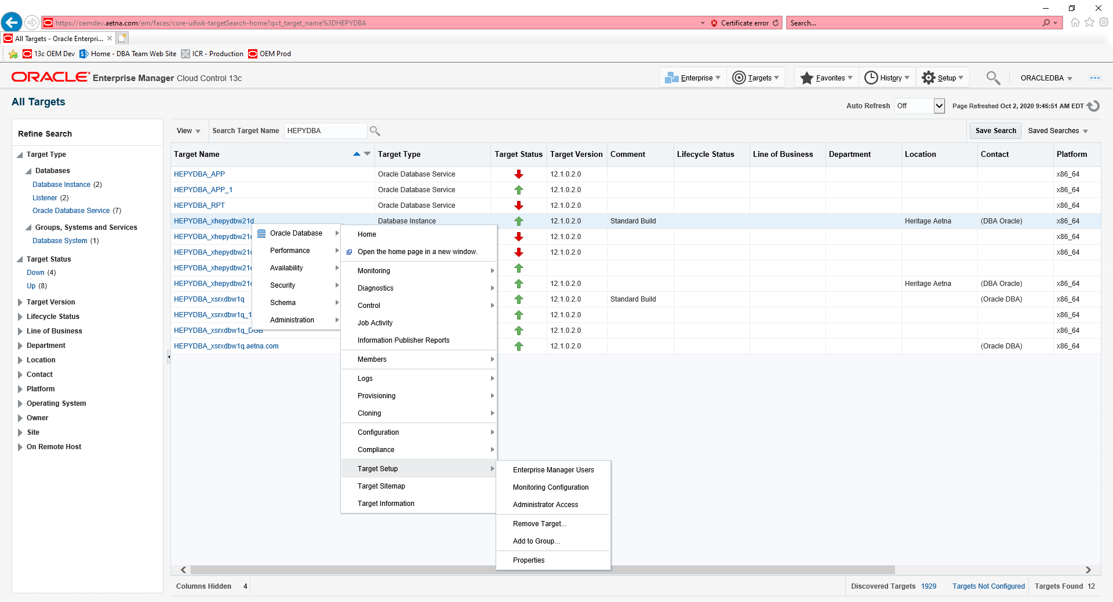

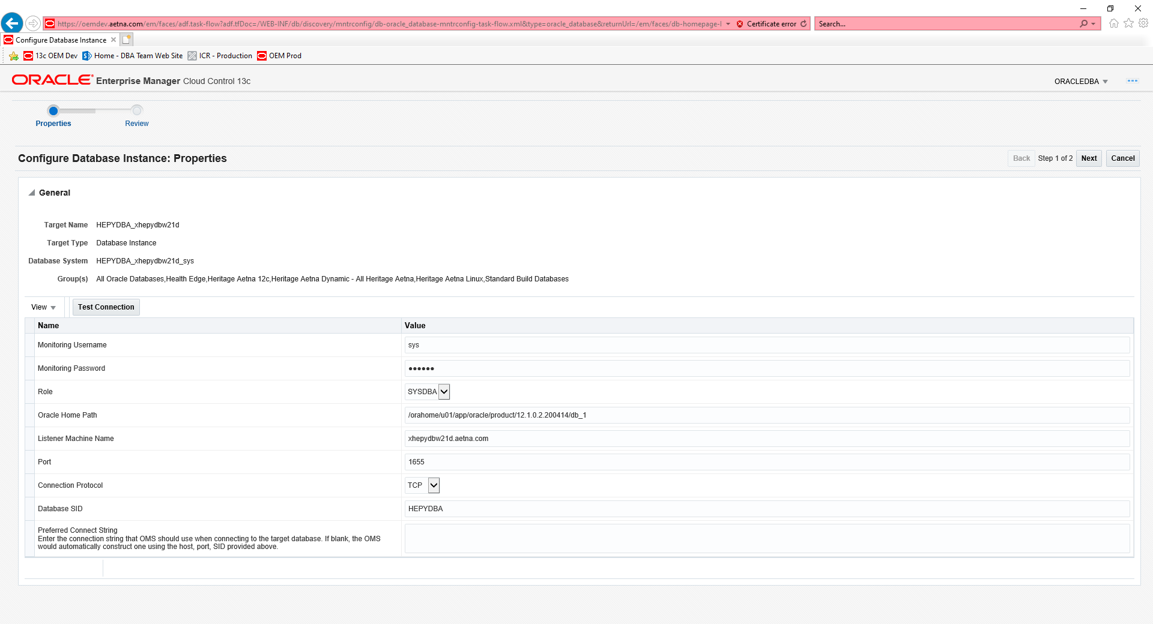

Click Test Connection and it worked click Next/Submit

Switchover to make HEPYDBA on xhepydbm21p Primary again and HEPYPRD on xhepydbw21p Standby

~~Switchover to make HEPYPRD on xhepydbw21d Primary again and HEPYDBA on xsrxdbw1q~~

Search for database in All Targets screen

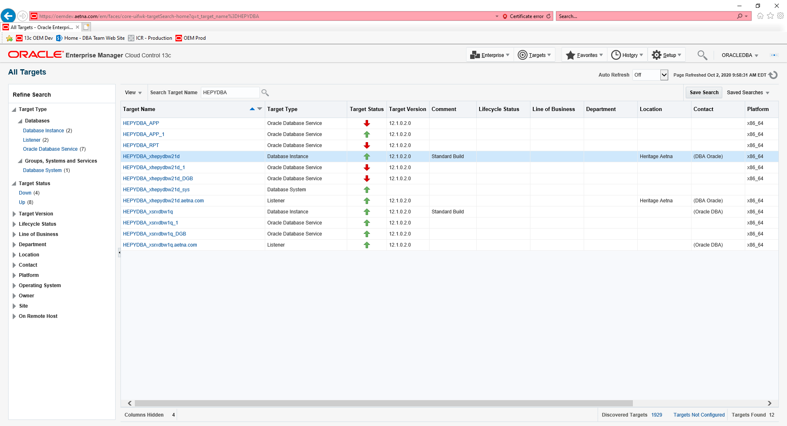

Choose Standby DB (HEPYPRD on xhepydbm21p) go to the Data Guard Administration page under the Availability pull down.

~~Choose Standby DB (HEPYDBA on xhepydbw21d) go to the Data Guard Administration page under the Availability pull down.~~

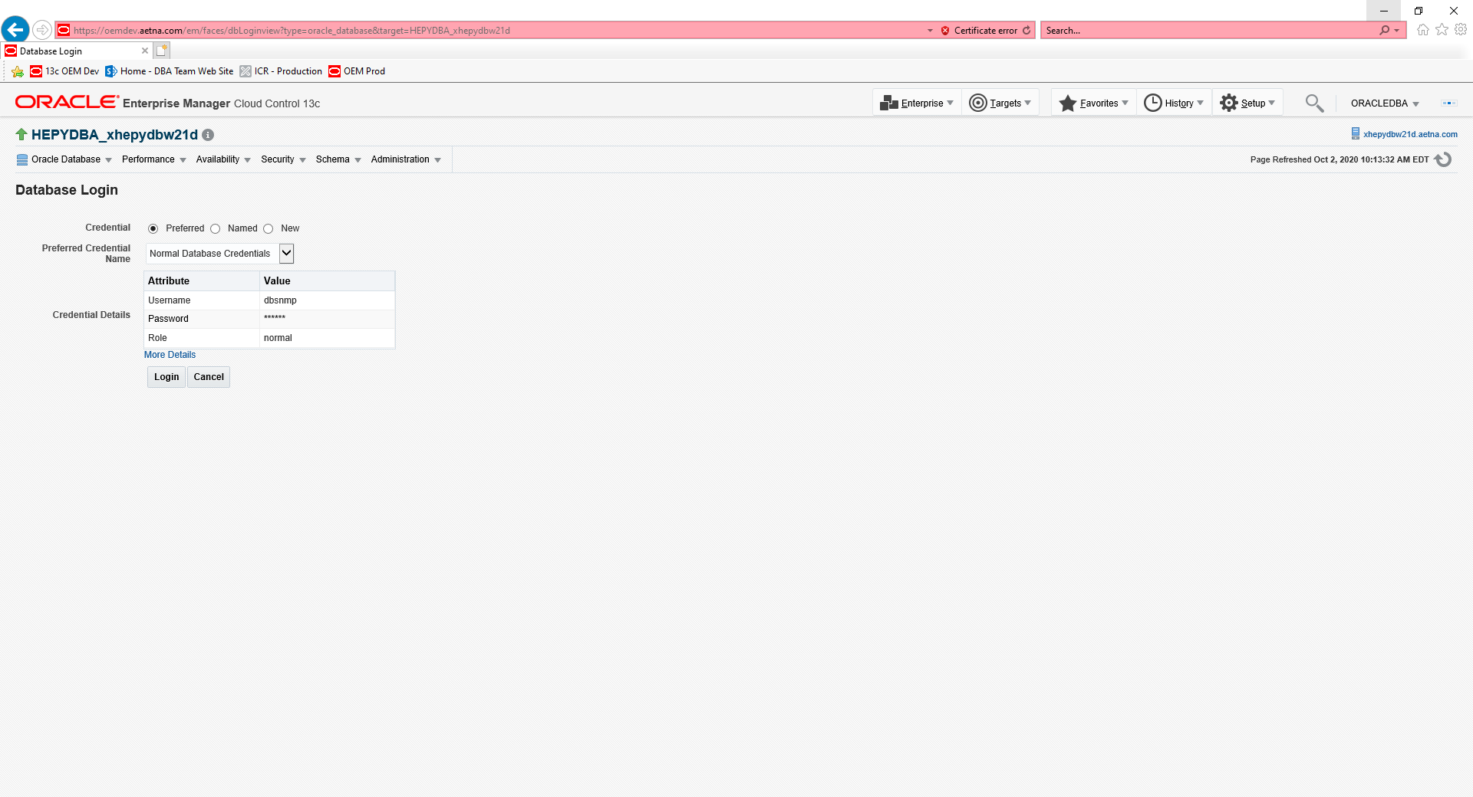

Login to the database with SYS credentials. (Password: xxx)

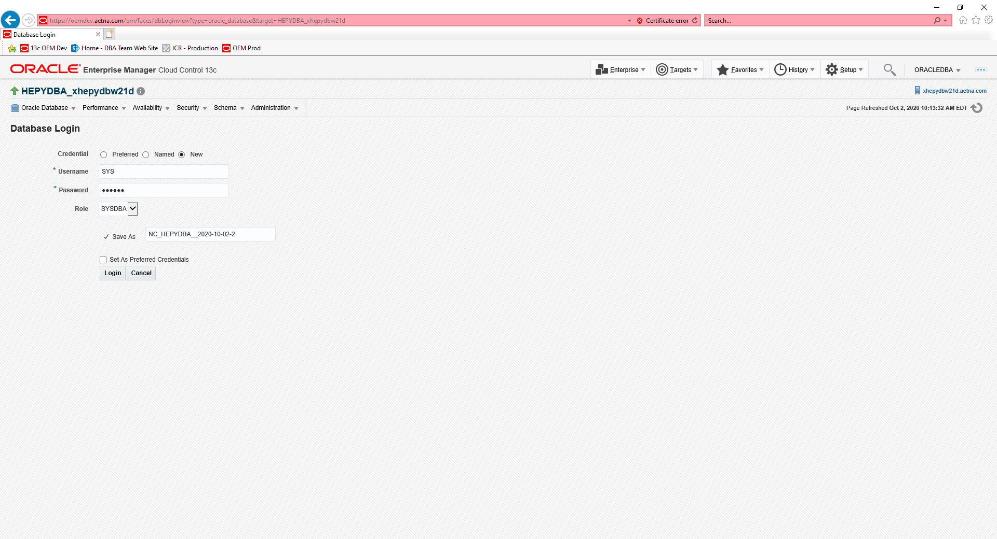

Select the standby database and press the switchover button

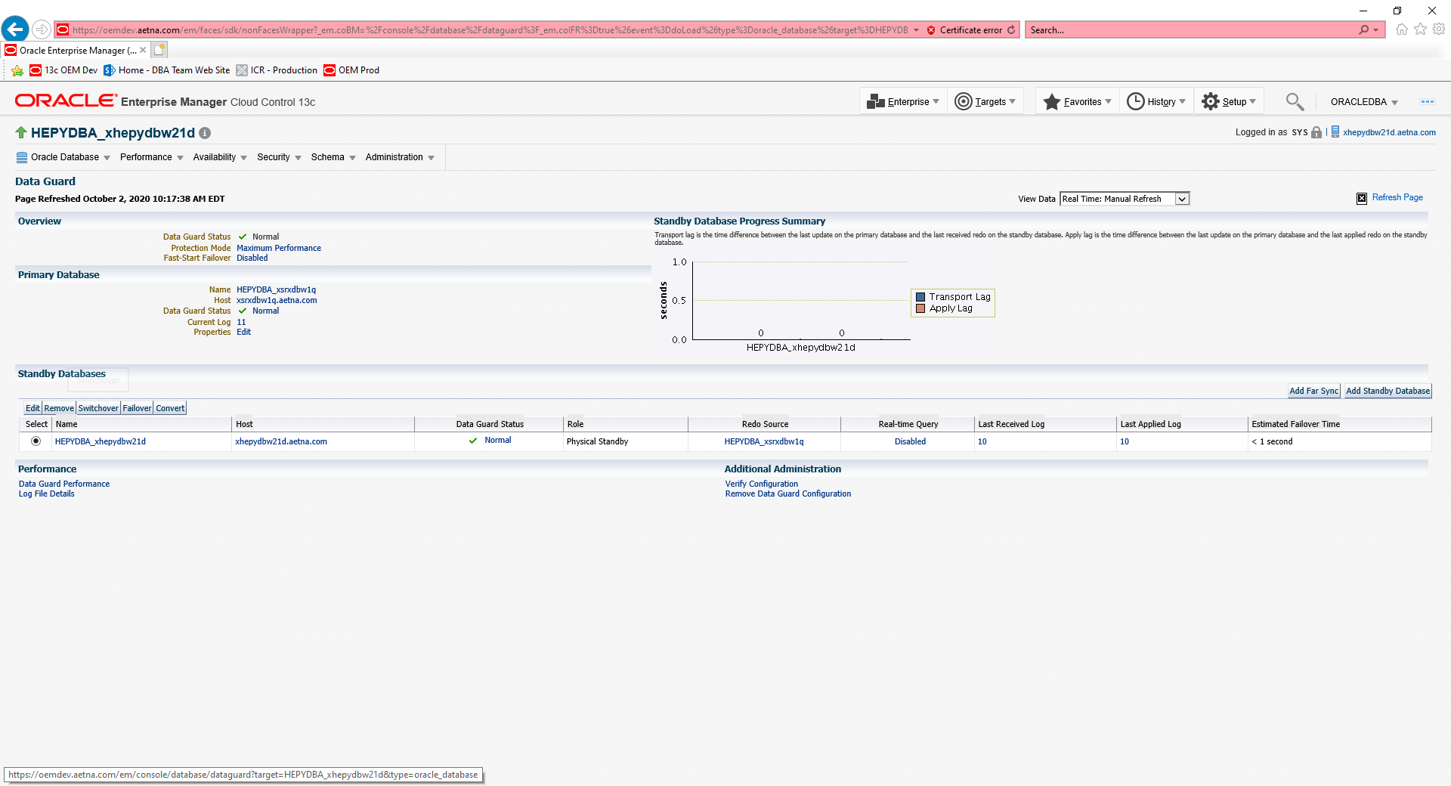

Select the SSH_ORACLE_CREDENTIALS for the standby host credentials

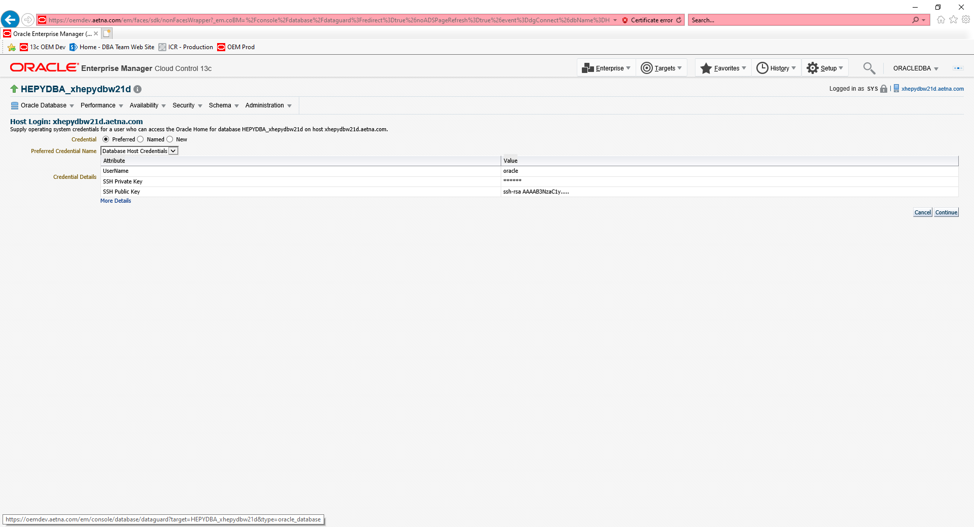

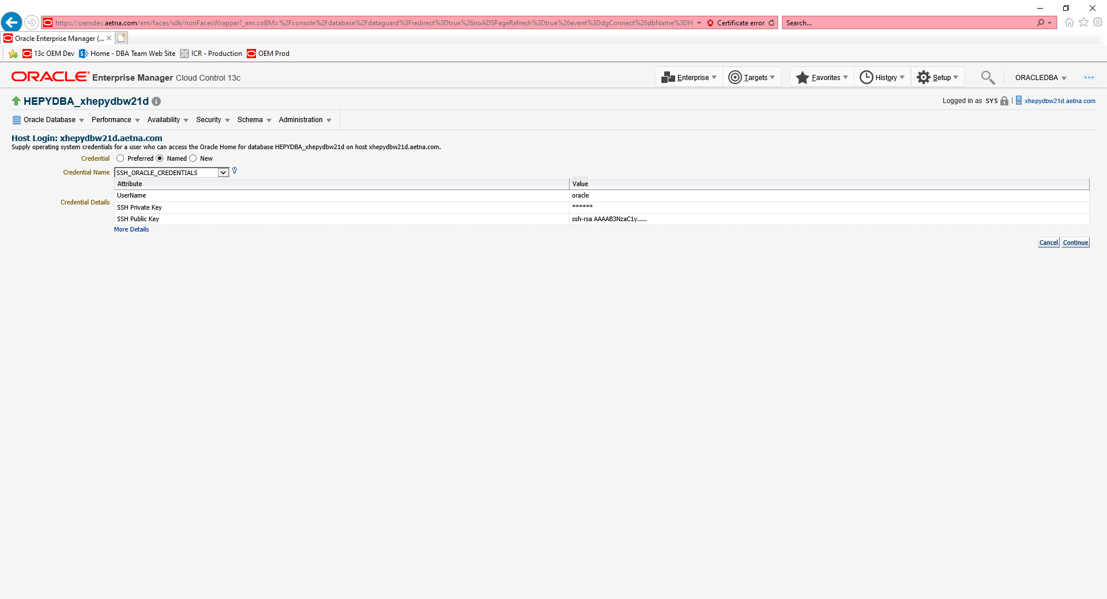

Select the SSH_ORACLE_CREDENTIALS for the primary host credentials

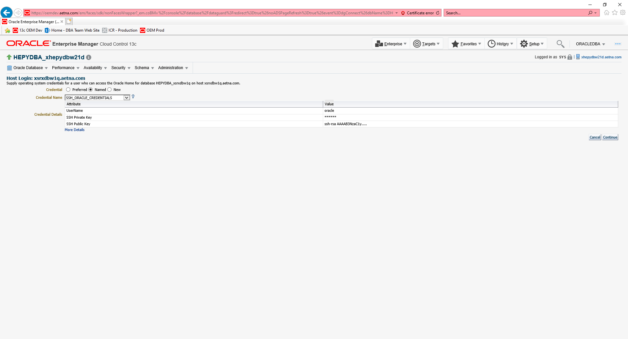

Select Swap Monitoring Settings and Transfer Jobs, then press yes

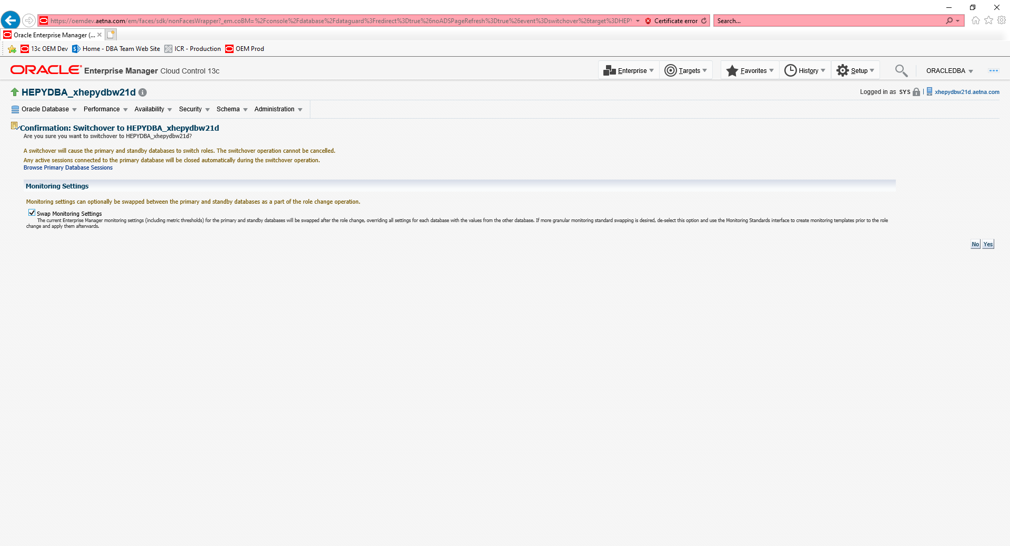

Switch over progress screen appears

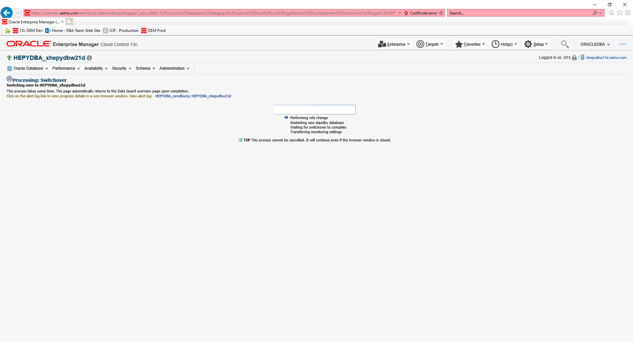

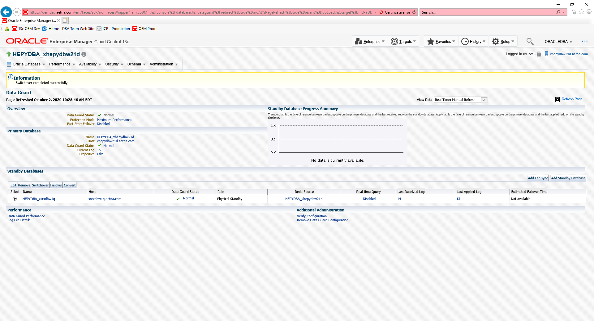

Go to Job activity for the new primary and modify the STDBY_ARCHVE_LOG_PURGE to run on the new standby if needed

Go to the Job activity screen for the new standby and modify the CHANGE_DATAGUARD_SYS_PWD job to execute on the new primary if needed.