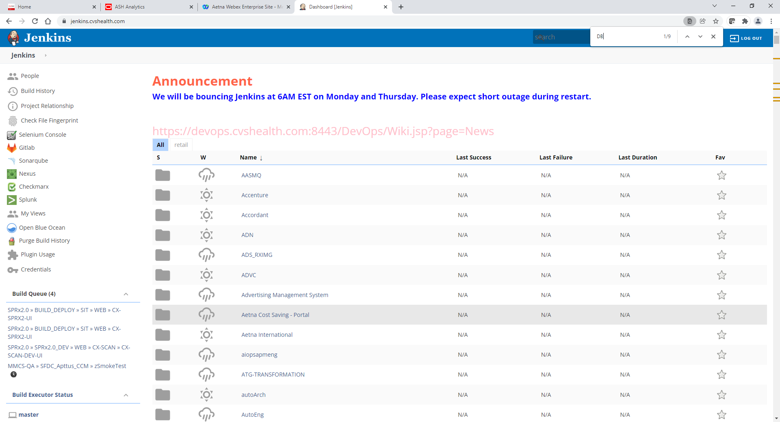

Scroll down and click on DBEngineering

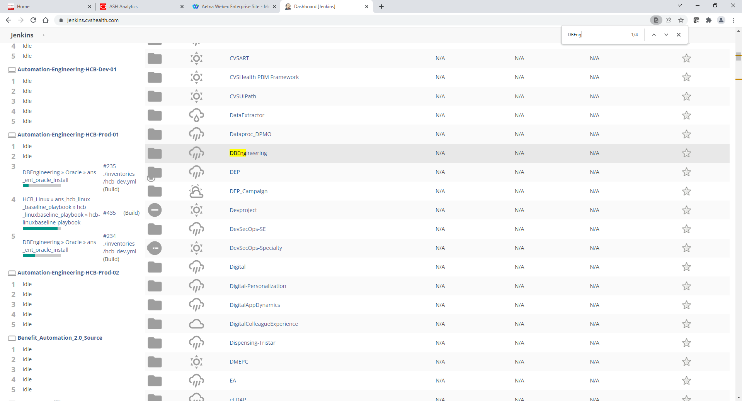

Scroll down and click on Oracle

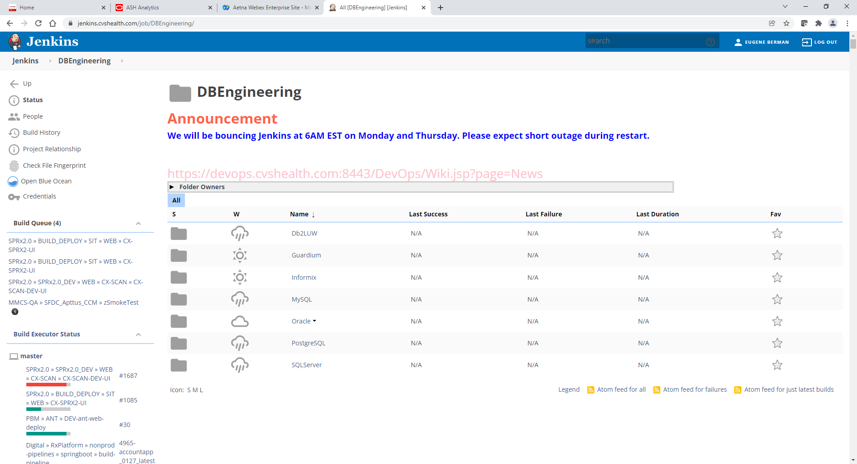

Scroll down and click on ans_ent_oracle_deinstall

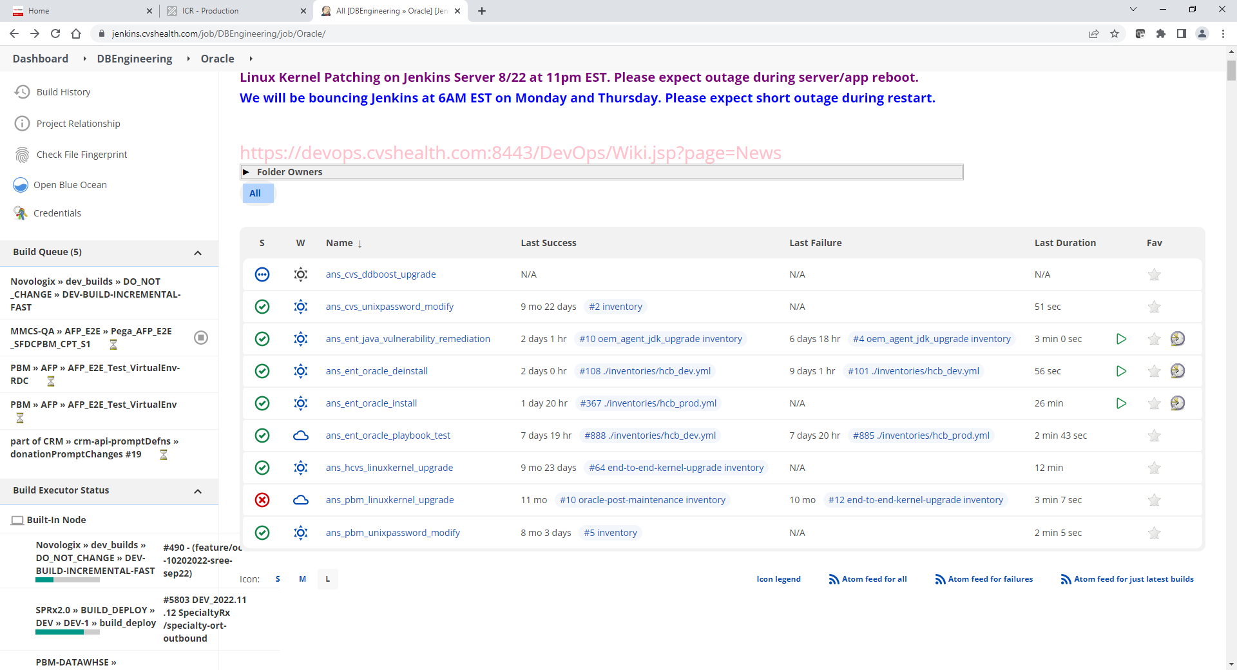

On Left click Build with Parameters

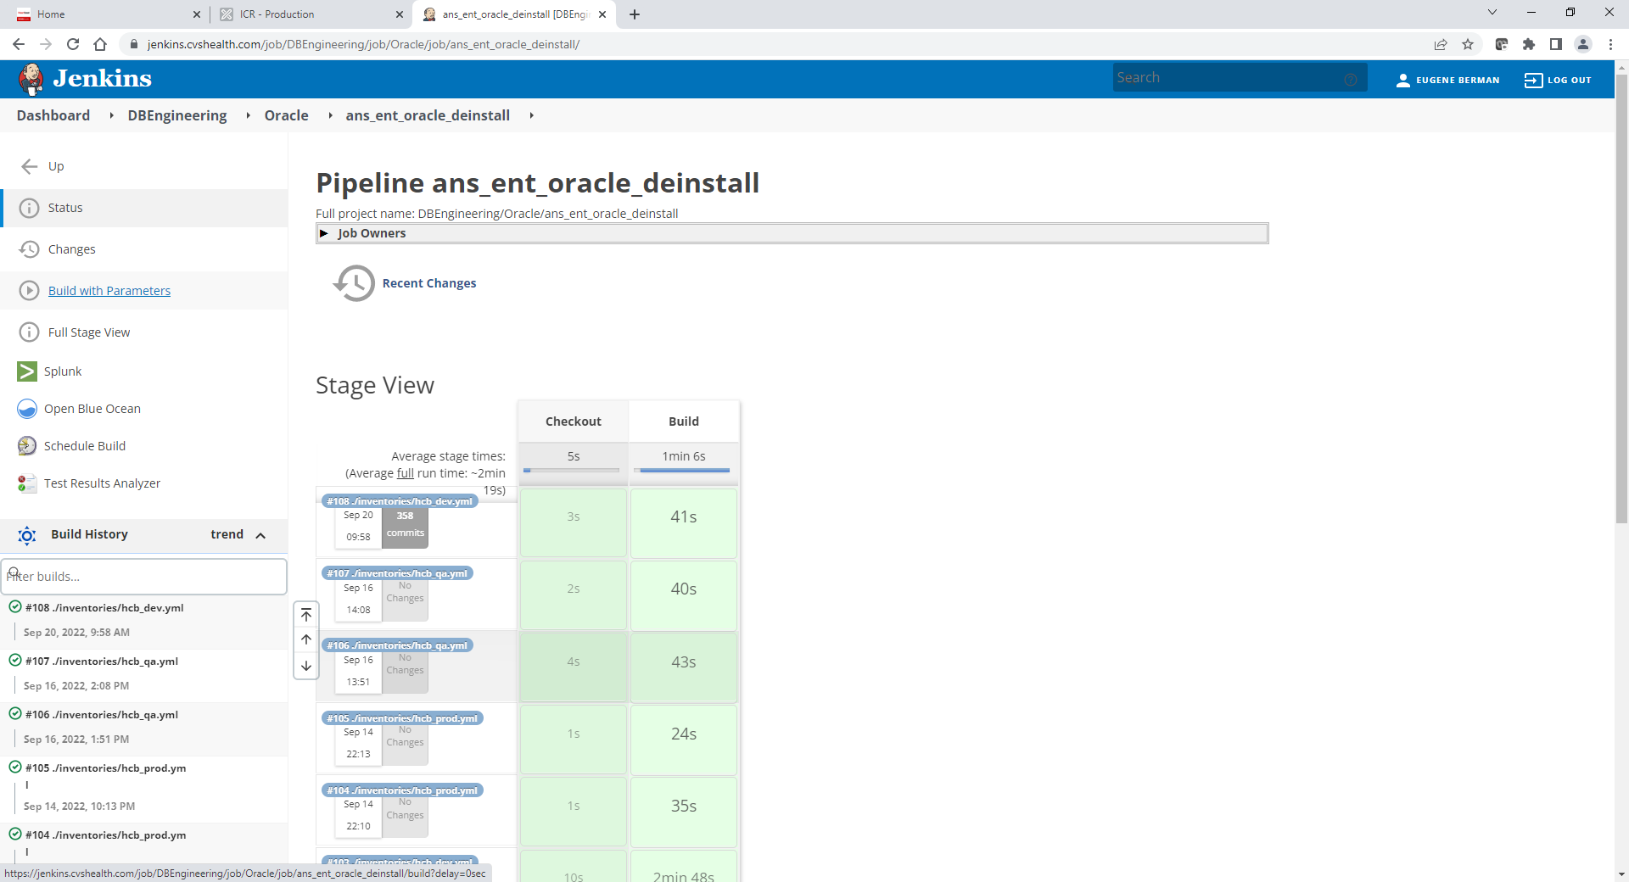

Default screen values below

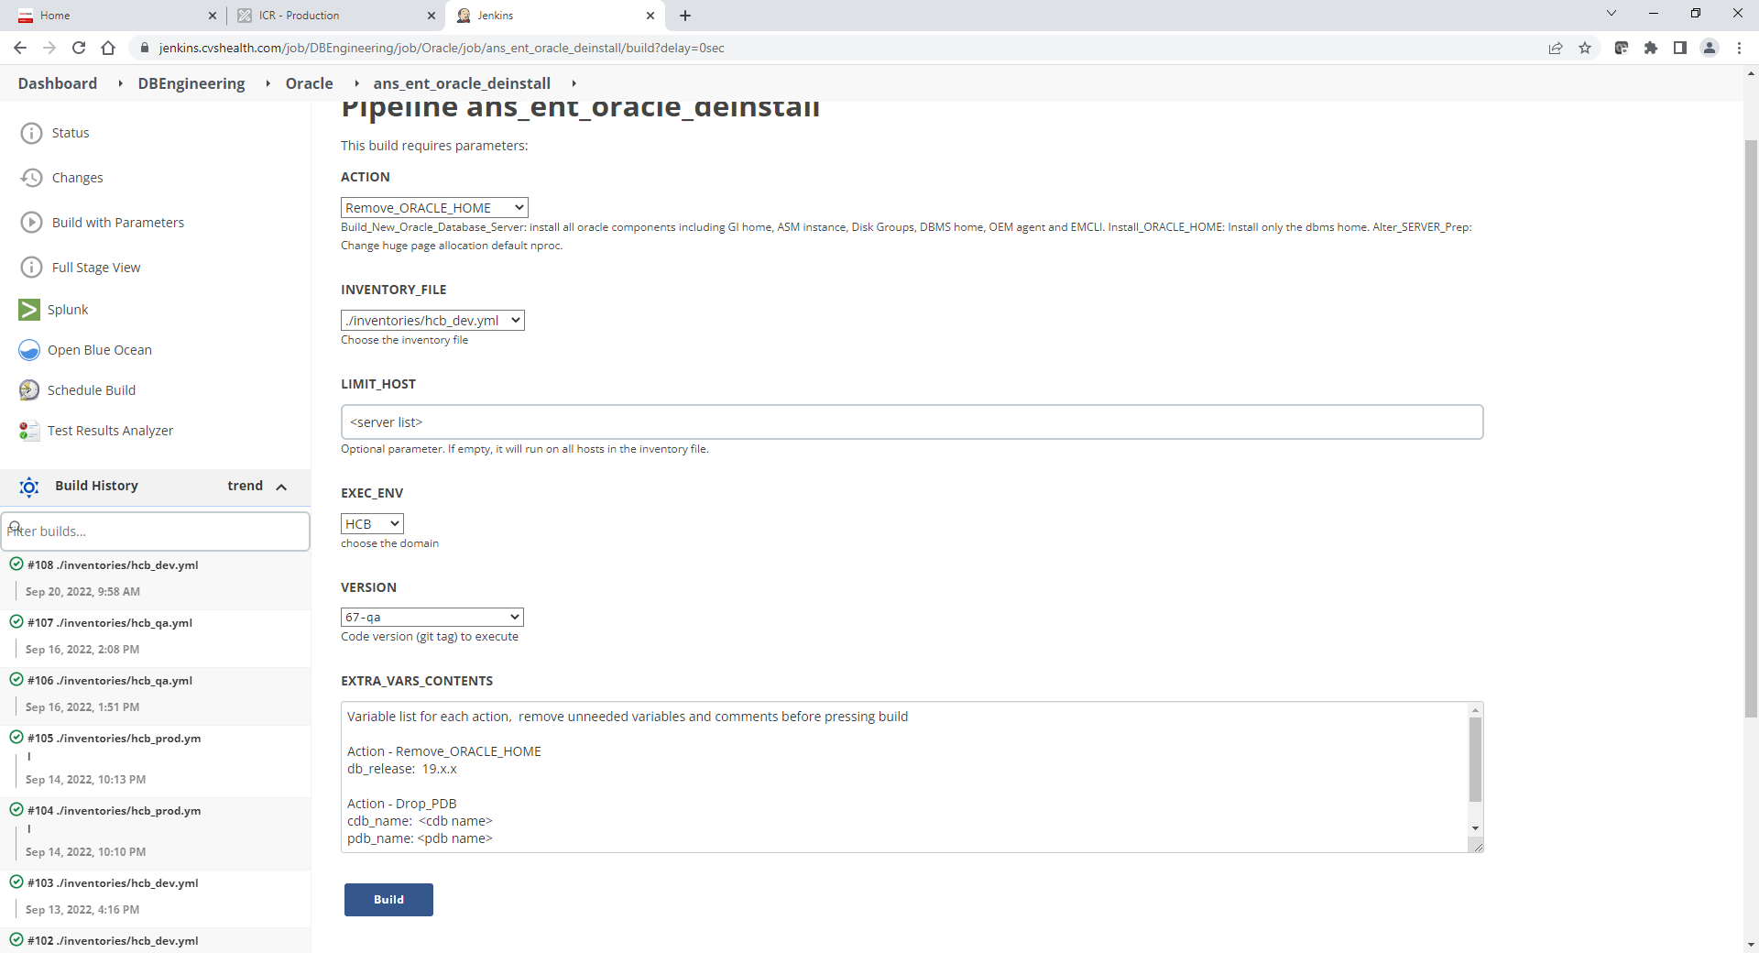

Use following values in screen below:

ACTION: Cleanup_Oracle_Installation

INVENTORY_FILE: /inventories/hcb_dev.yml or /inventories/hcb_qa.yml or /inventories/hcb_prod.yml

!! Note that stress servers are belong to /inventories/hcb_qa.yml

LIMIT_HOST: xhepydbw24d.aetna.com or xhepydbw26d.aetna.com,xhepydbw25d.aetna.com

EXEC_ENV: HCB

VERSION: 32- qa

EXTRA_VARS_CONTENS: db_release: 19.14.0 (remove all space below and on left of it)

Or

if this complete server decommision leave EXTRA_VARS_CONTENS blank (remove all space below and on left of it)

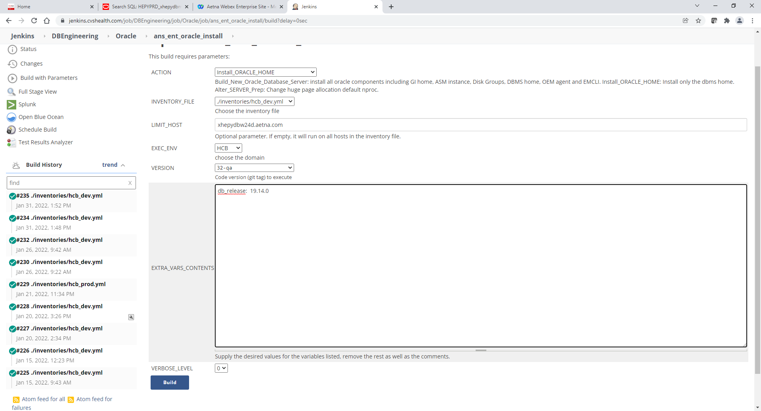

Click Build button and monitor spinning build job on left under Build History. You can click on it to see more details.

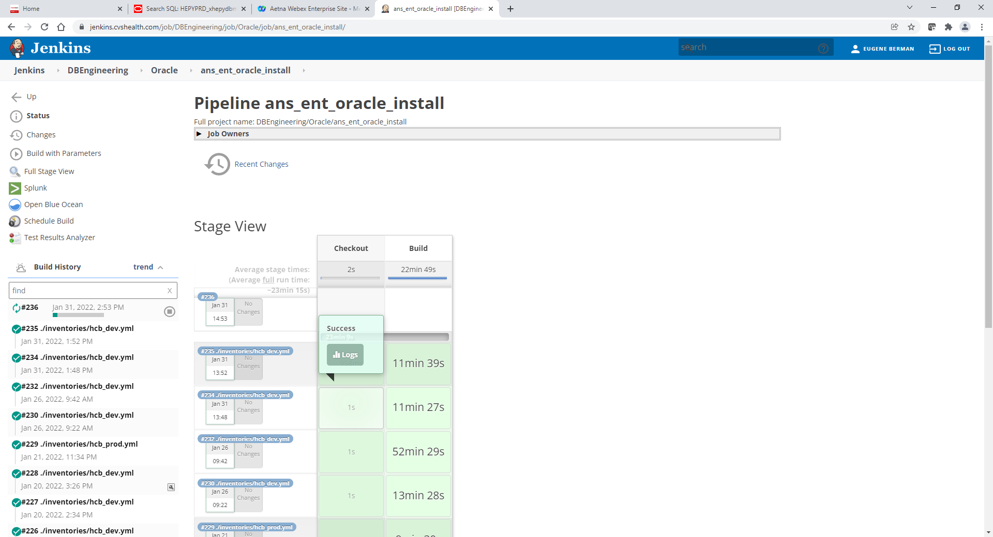

Once Install completed job will stop spining and turn green

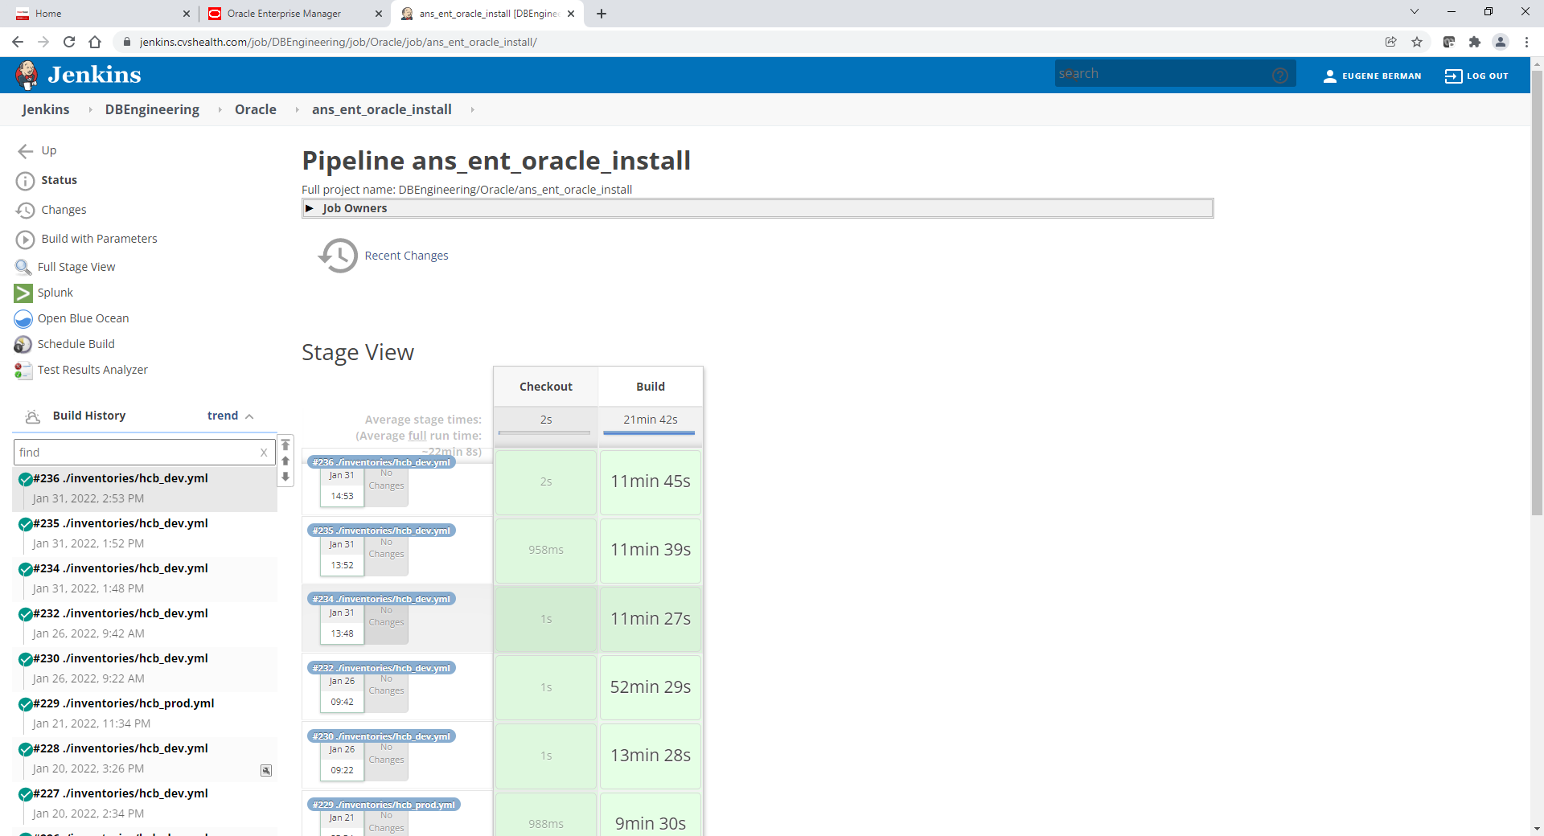

If above failed inspect log file and if this related Grid/Agent. Start over with same paramerers exececpt use those for EXTRA_VARS_CONTENS

agent_base: /orahome/u01/app/oracle/product/agent12c

agent_home: /orahome/u01/app/oracle/product/agent12c/agent_13.4.0.0.0