!! Make sure all app servers down for particular env/server. GI Patching will bounce regular database.

1. On your computer, open Chrome.

2. At the top right, click More New Incognito Window.

3. A new window appears. In the top corner, check for the Incognito icon .

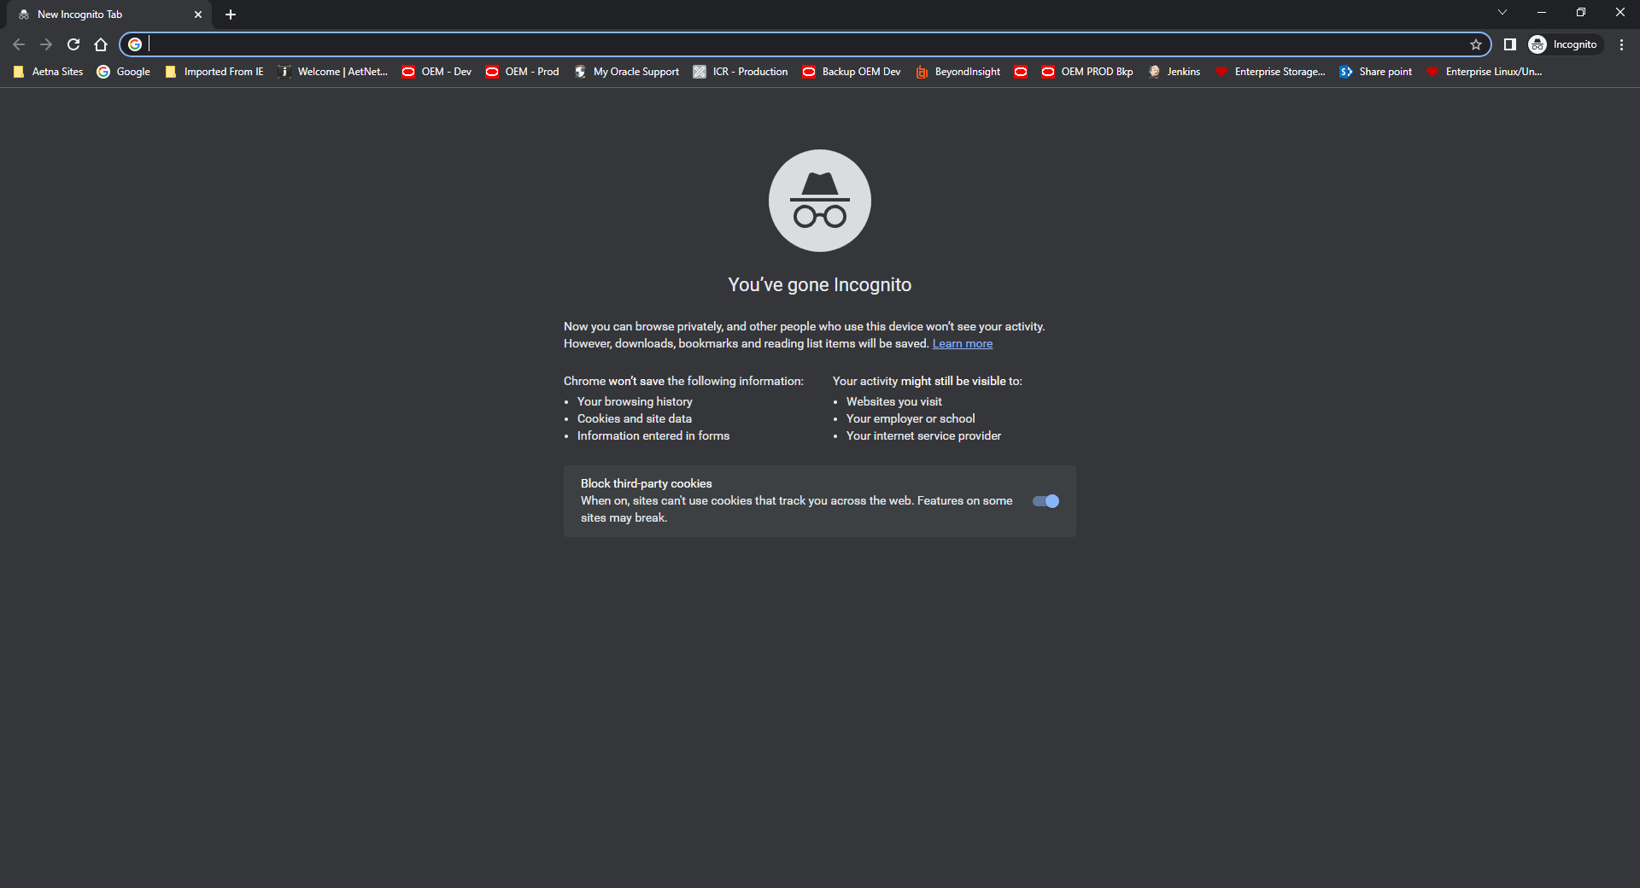

Paste link to URL: <https://ci-autoeng.cvshealth.com/jenkins/>

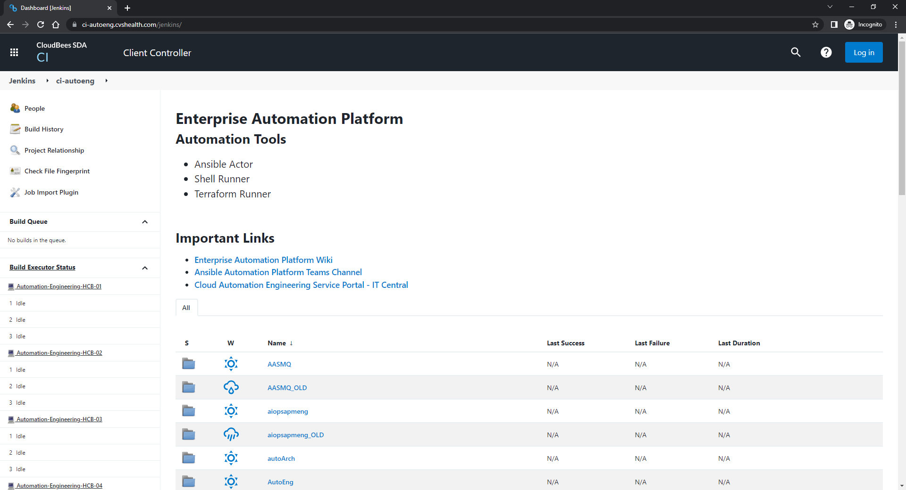

Click Blue Login button on top Right corner

Sign in under your cvshealth.com email: [YOUREMAIL@cvshealth.com](mailto:YOUREMAIL@cvshealth.com)

Use regular network P to login.

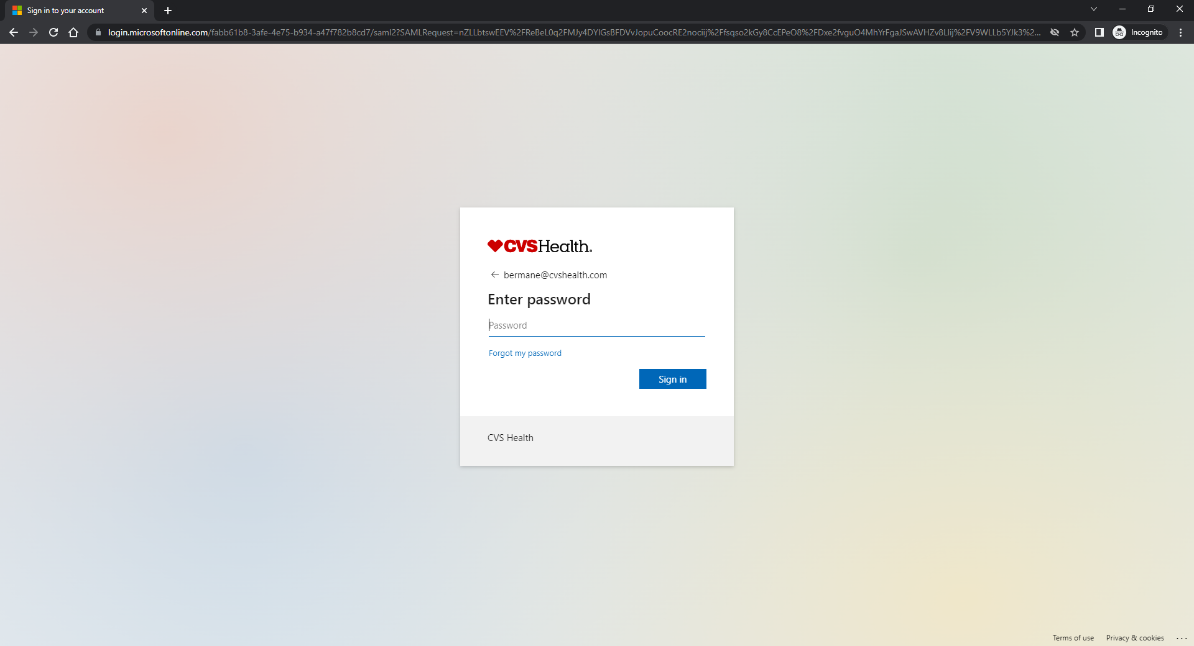

Click DBEngineering 🡪 Oracle 🡪 ans_ent_oracle_install

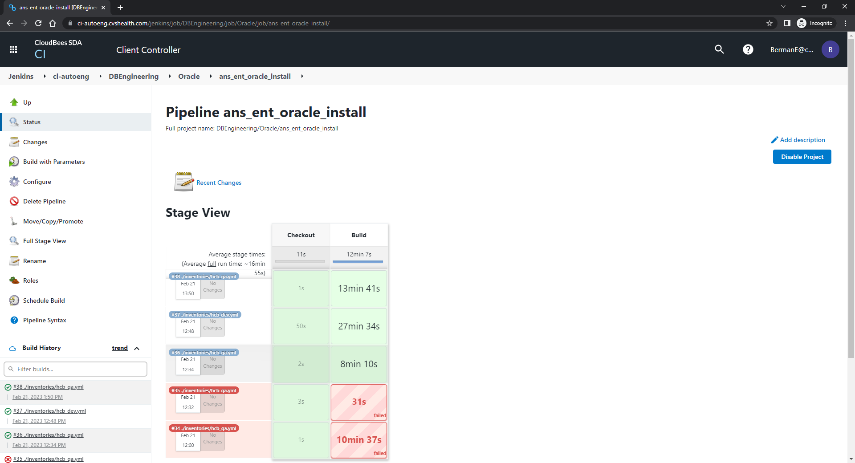

Click Build with Parameters on left

**Step 1: Patch GI**

ACTION: Patch GI

INVENTORY_FILE: select based on env.

LIMIT_HOST: servername.aetna.com

EXEC_ENVL: HCB (default)

VERSION: whatever default

EXTRA_VARS_CONTENTS: gi_patch_release: 19.18.0

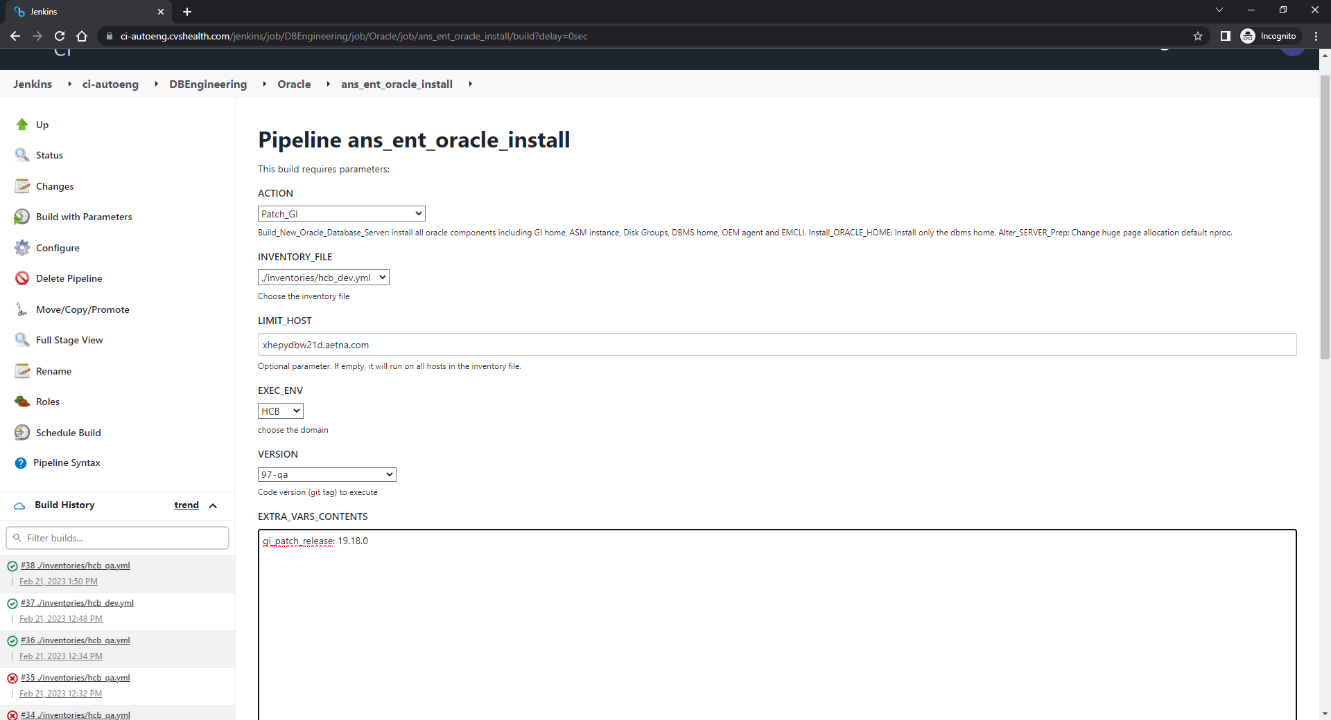

**Step 2: Apply GI Patch**

ACTION: Apply_GI_patch_34932268

INVENTORY_FILE: select based on env.

LIMIT_HOST: servername.aetna.com

EXEC_ENVL: HCB (default)

VERSION: whatever default

EXTRA_VARS_CONTENTS: leave empty

