# In new incognito window open below link

<https://ci-autoeng.cvshealth.com/jenkins/>

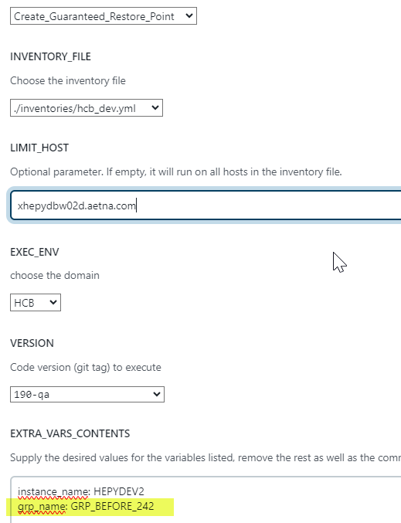

instance_name: HEPYDEV2

grp_name: GRP_BEFORE_242

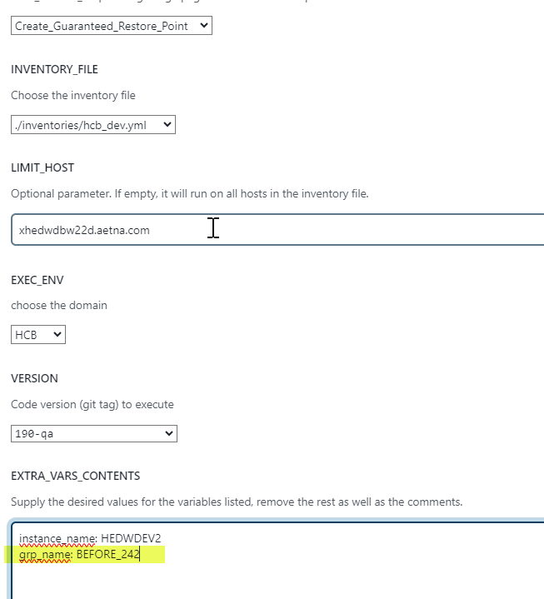

instance_name: HEDWDEV2

grp_name: BEFORE_242