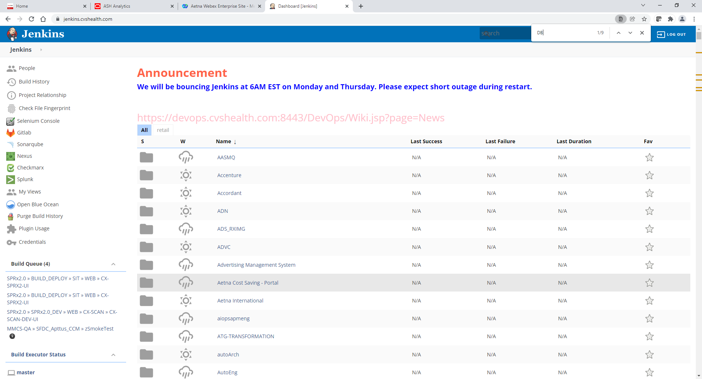

Scroll down and click on DBEngineering

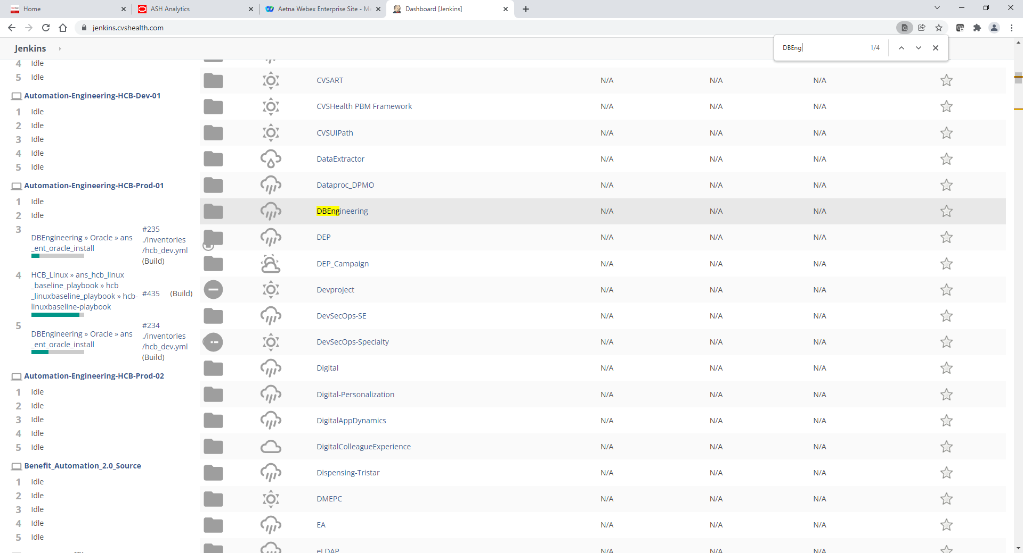

Scroll down and click on Oracle

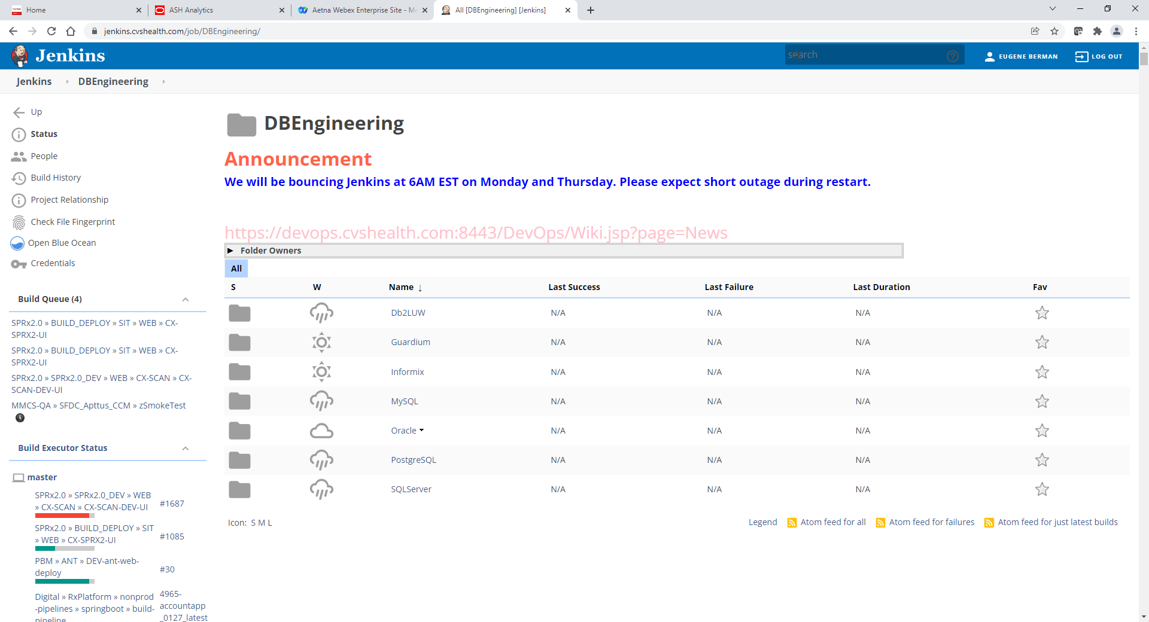

Scroll down and click on ans_ent_oracle_install

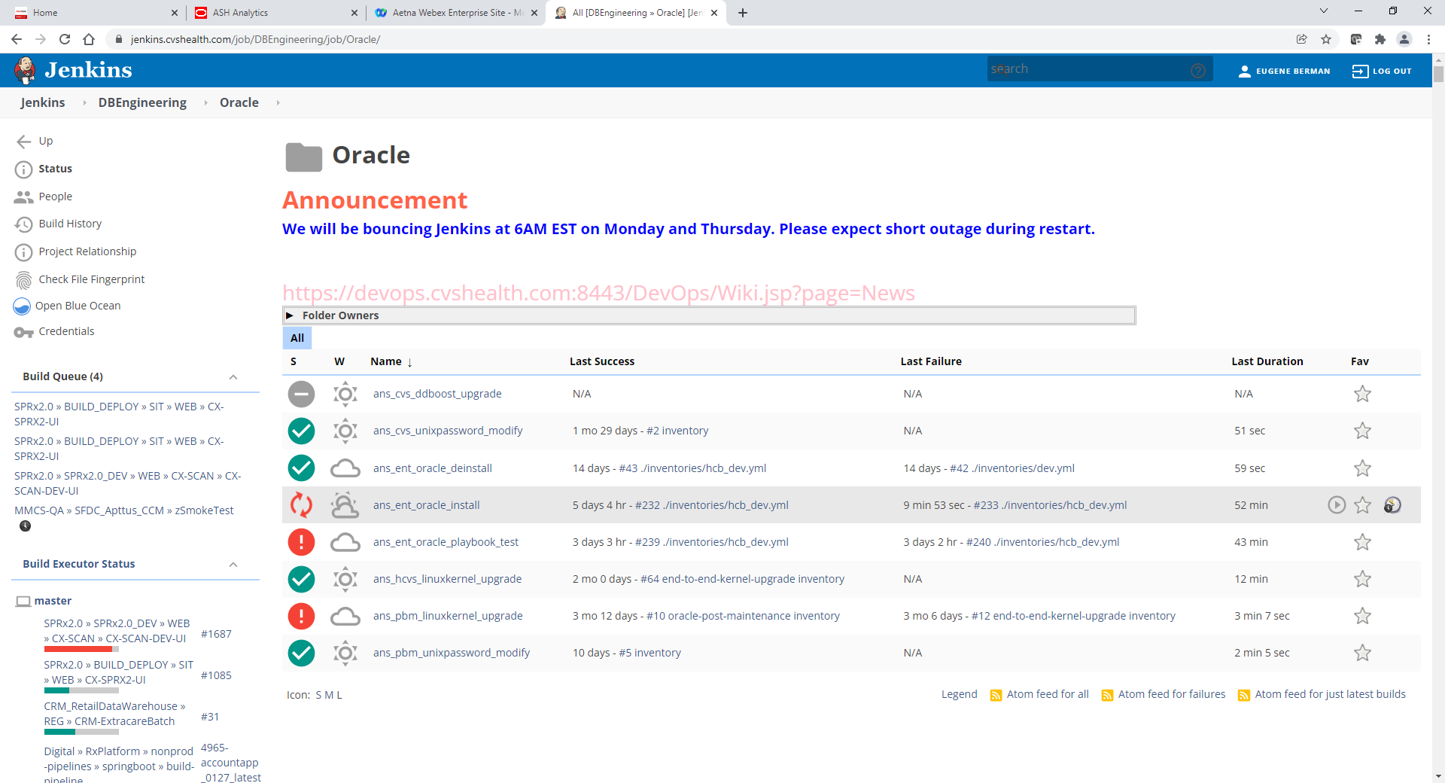

On Left click Build with Parameters

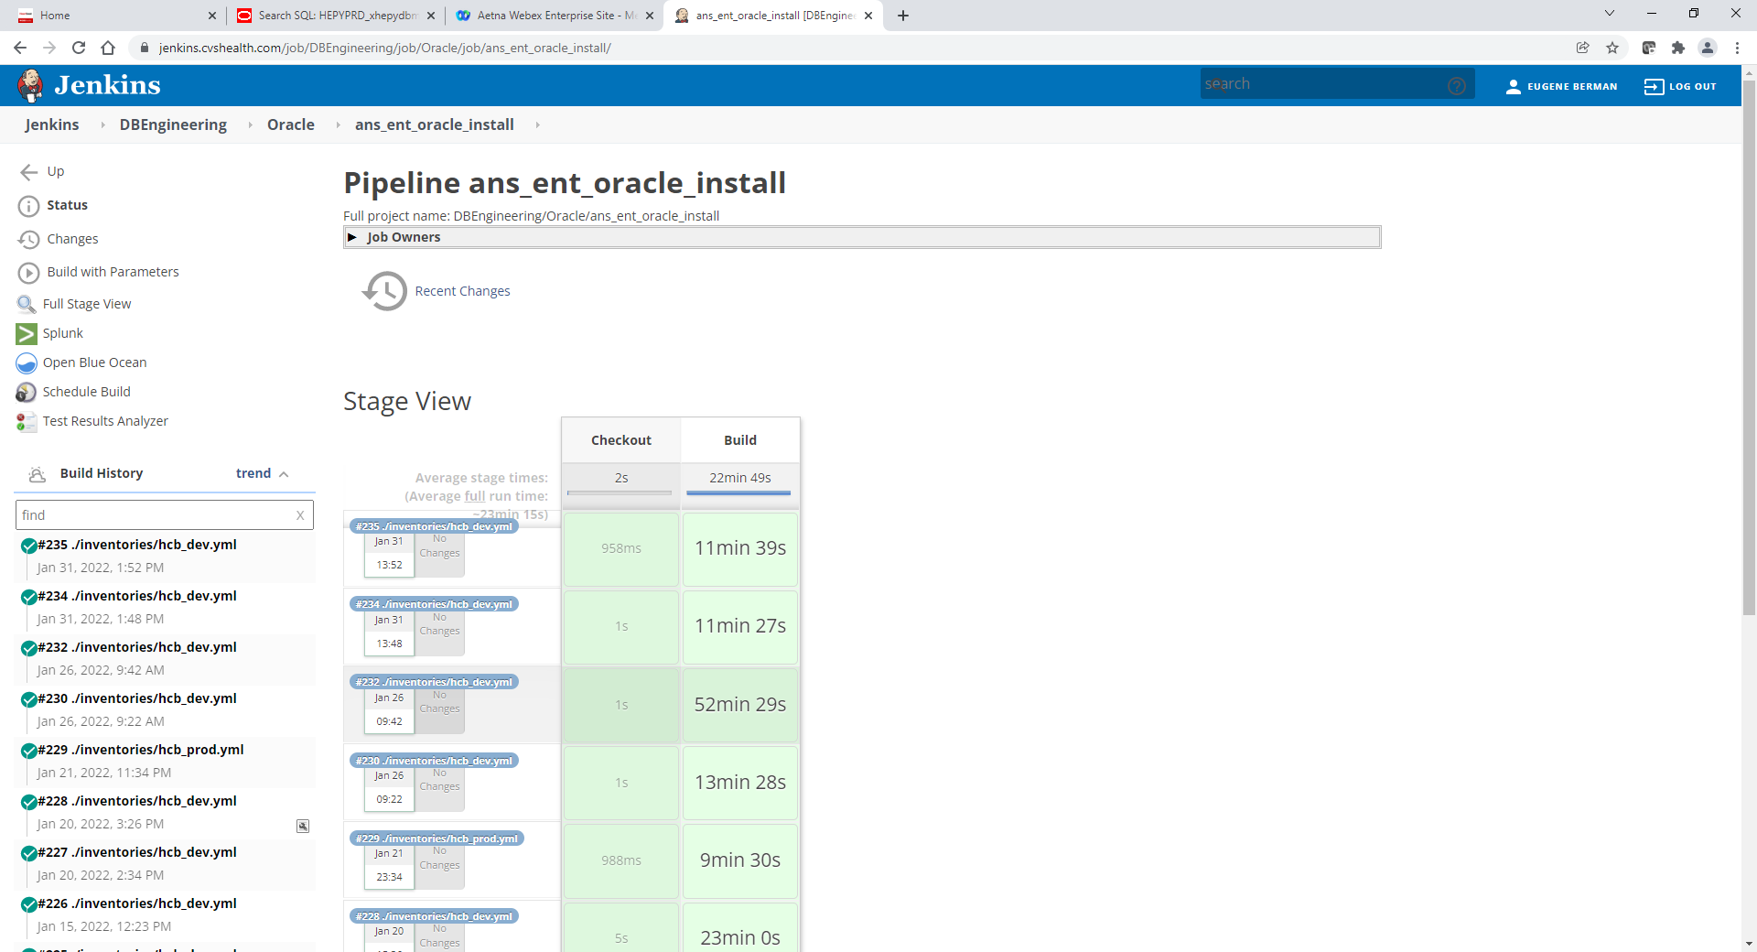

Default screen values below

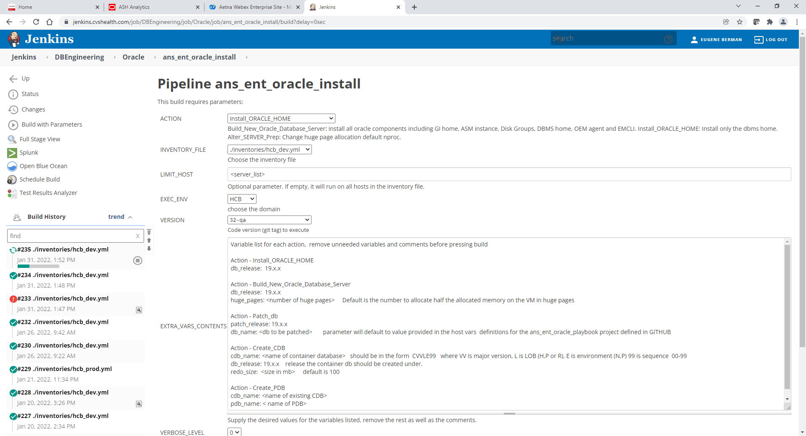

Use following values in screen below:

ACTION: Patch_DB

INVENTORY_FILE: /inventories/hcb_dev.yml or /inventories/hcb_qa.yml or /inventories/hcb_prod.yml

!! Note that stress servers are belong to /inventories/hcb_qa.yml

LIMIT_HOST: xhepydbw24d.aetna.com or xhepydbw26d.aetna.com,xhepydbw25d.aetna.com

EXEC_ENV: HCB

VERSION: 32- qa

EXTRA_VARS_CONTENS: patch_release: 19.14.0 (remove all space below and on left of it)

!! if you not specify Database name under EXTRA_VARS_CONTENTS it will patch all databases on specified server. For example db_name: HEPYDBA

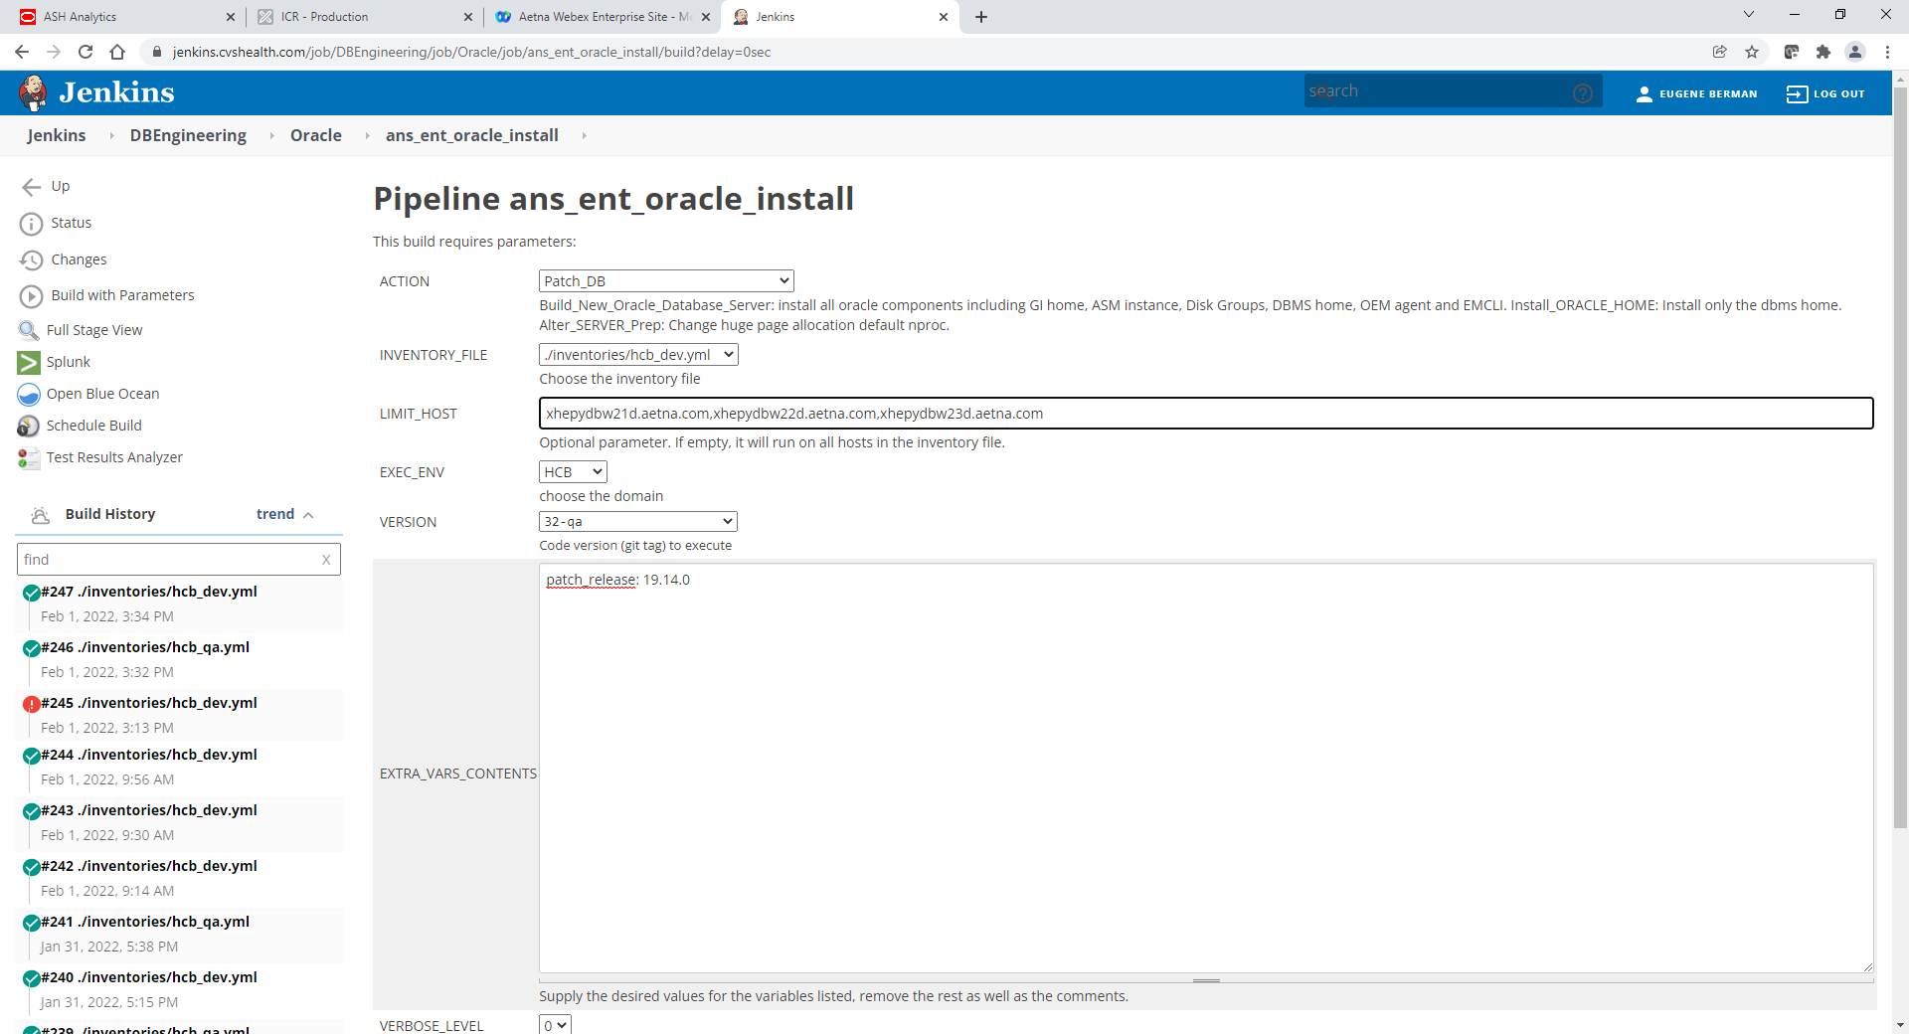

Click Build button and monitor spinning build job on left under Build History. You can click on it to see more details.

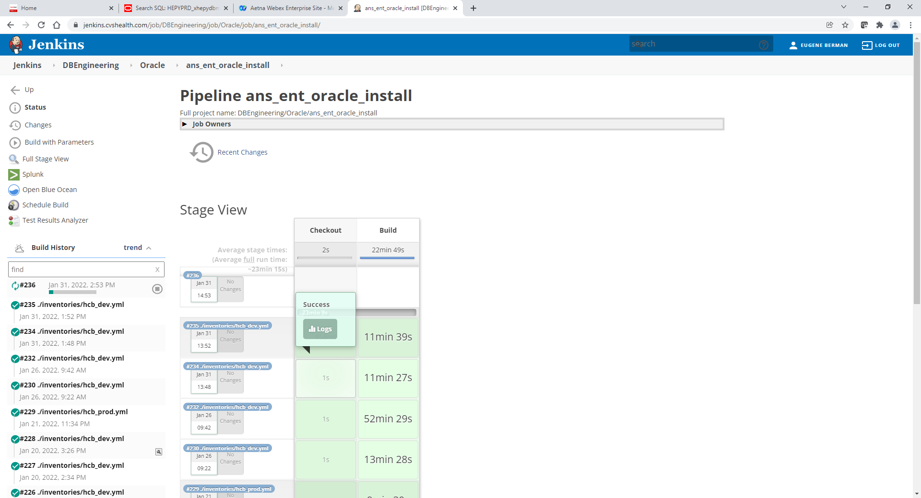

Once Install completed job will stop spining and turn green

