1. On your computer, open Chrome.

2. At the top right, click More New Incognito Window.

3. A new window appears. In the top corner, check for the Incognito icon .

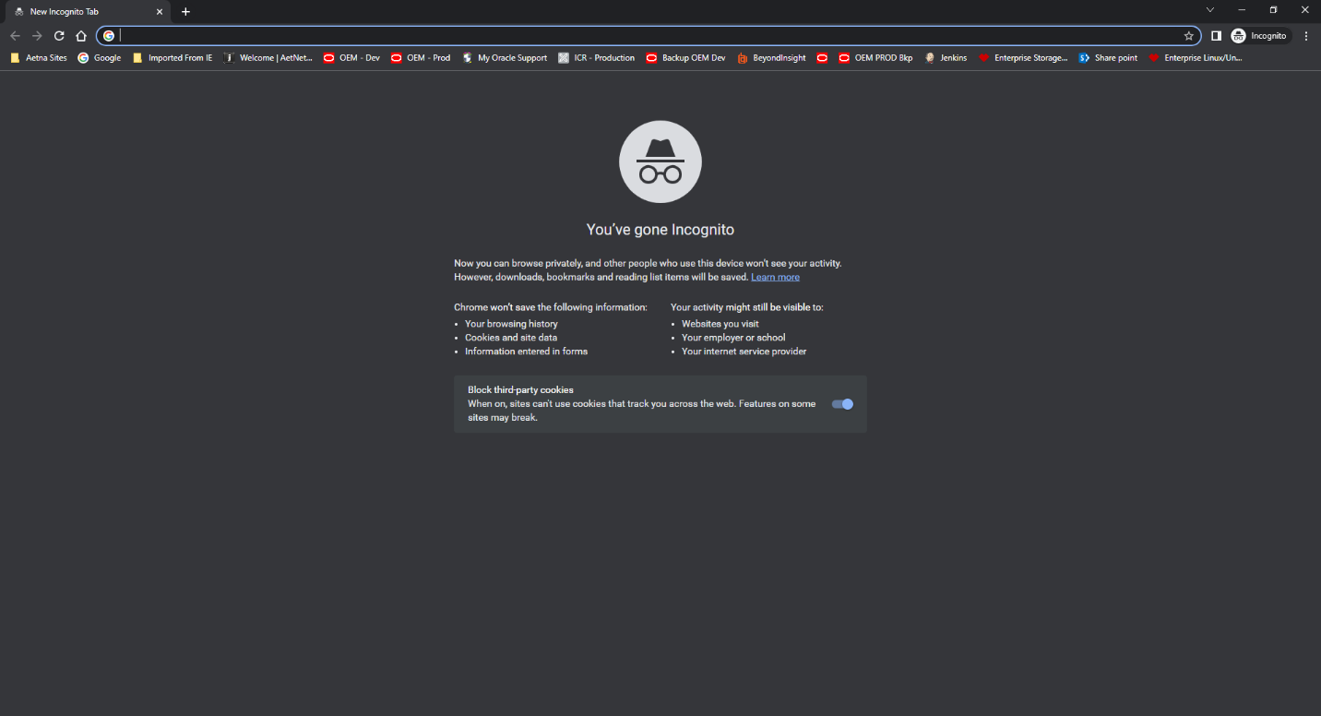

Paste link to URL: <https://ci-autoeng.cvshealth.com/jenkins/>

Scroll down and click on DBEngineering

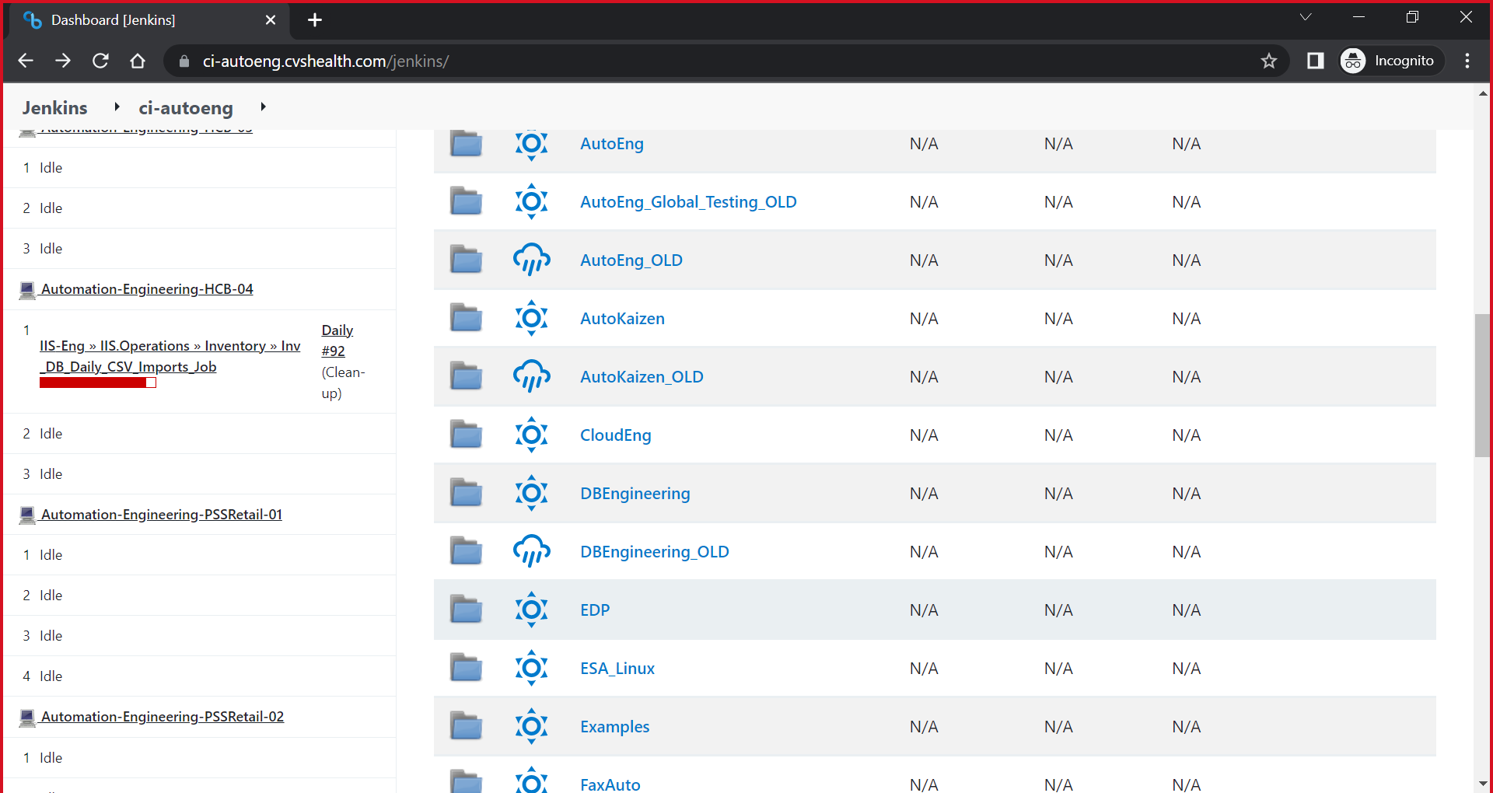

Scroll down and click on Oracle

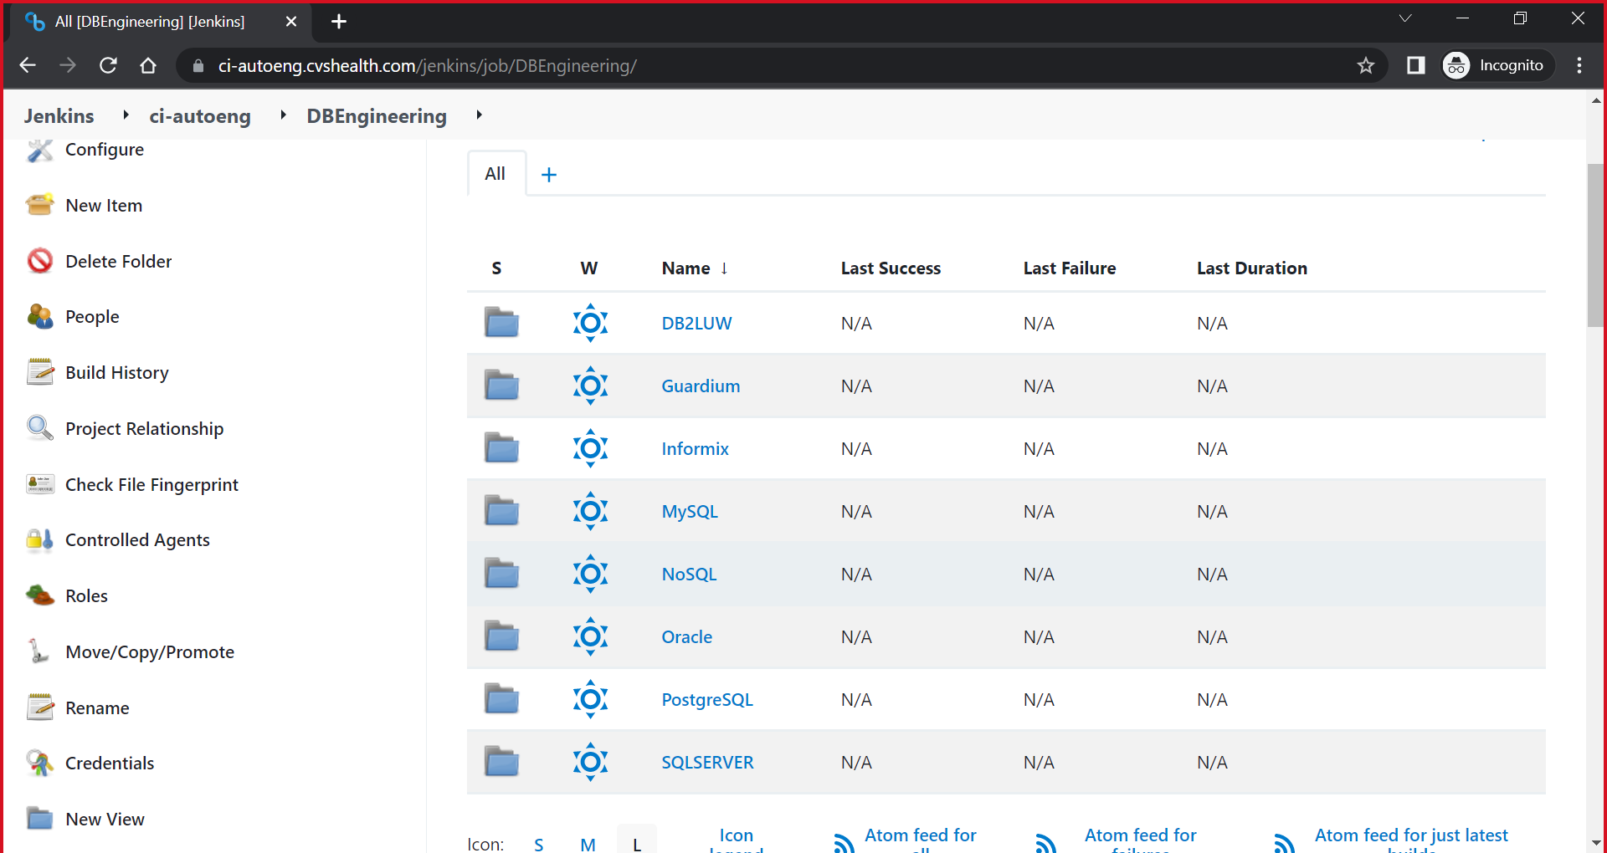

Scroll down and click on ans_ent_oracle_install

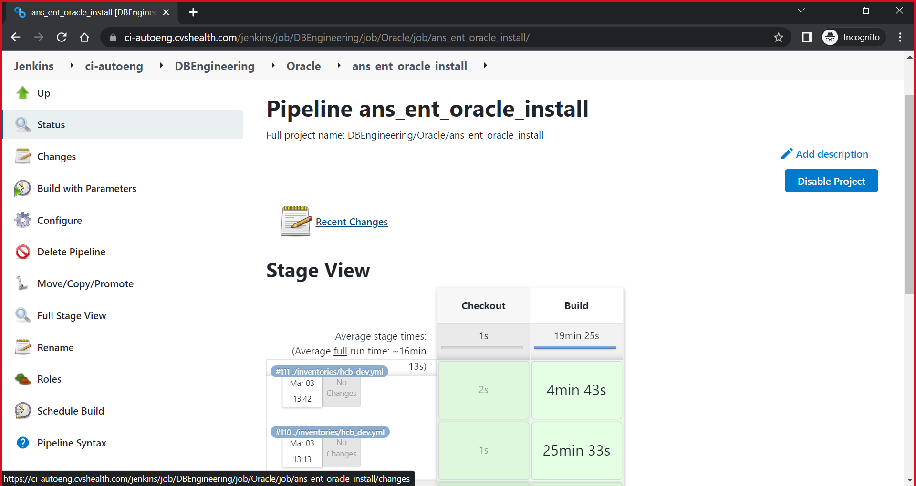

On Left click Build with Parameters

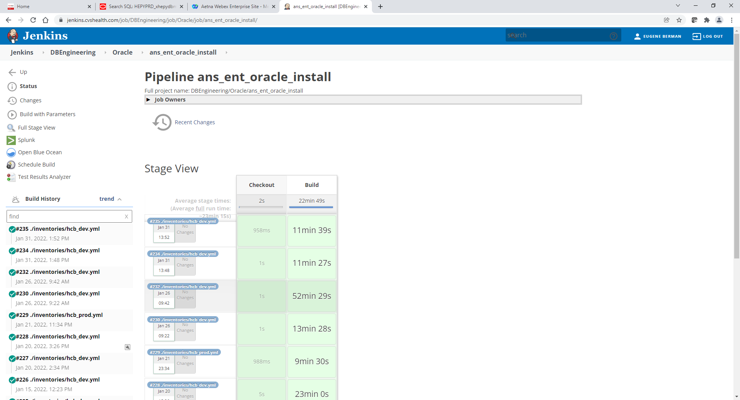

Scroll down to see below

Use following values in screen below:

ACTION: Patch_DB

INVENTORY_FILE: ./inventories/hcb_qa.yml

LIMIT_HOST: xpsdbw1q.aetna.com

EXEC_ENV: HCB

VERSION: 97- qa

EXTRA_VARS_CONTENS: patch_release: 19.18.0 (remove all space below and on left of it)  
 db_name: PSPREPR8

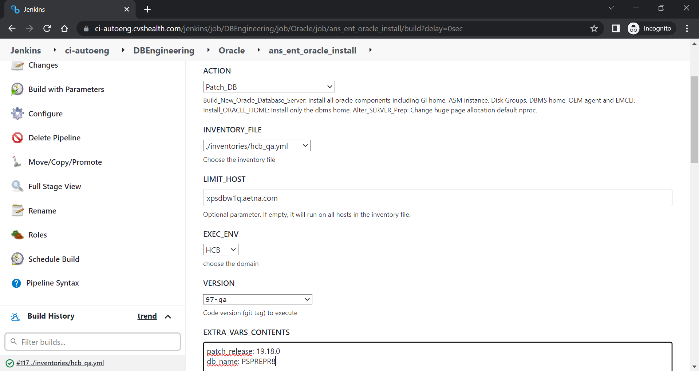

Click Build button and monitor spinning build job on left under Build History. You can click on it to see more details.

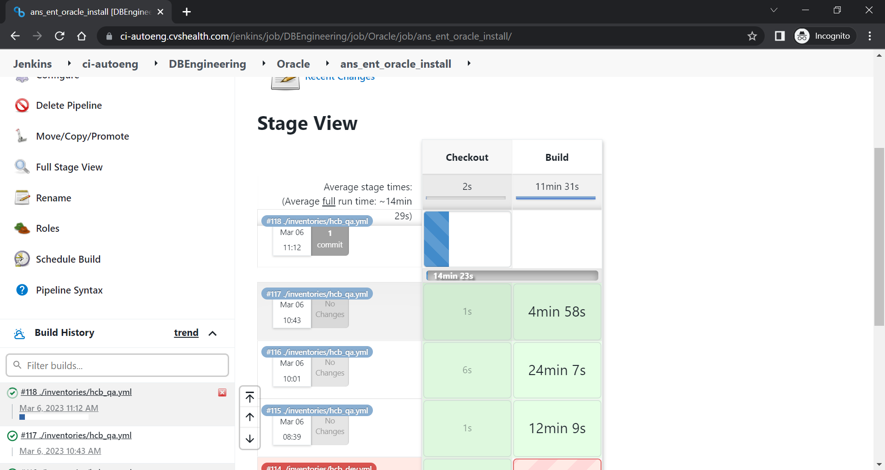

Once Install completed job will stop spinning and turn green

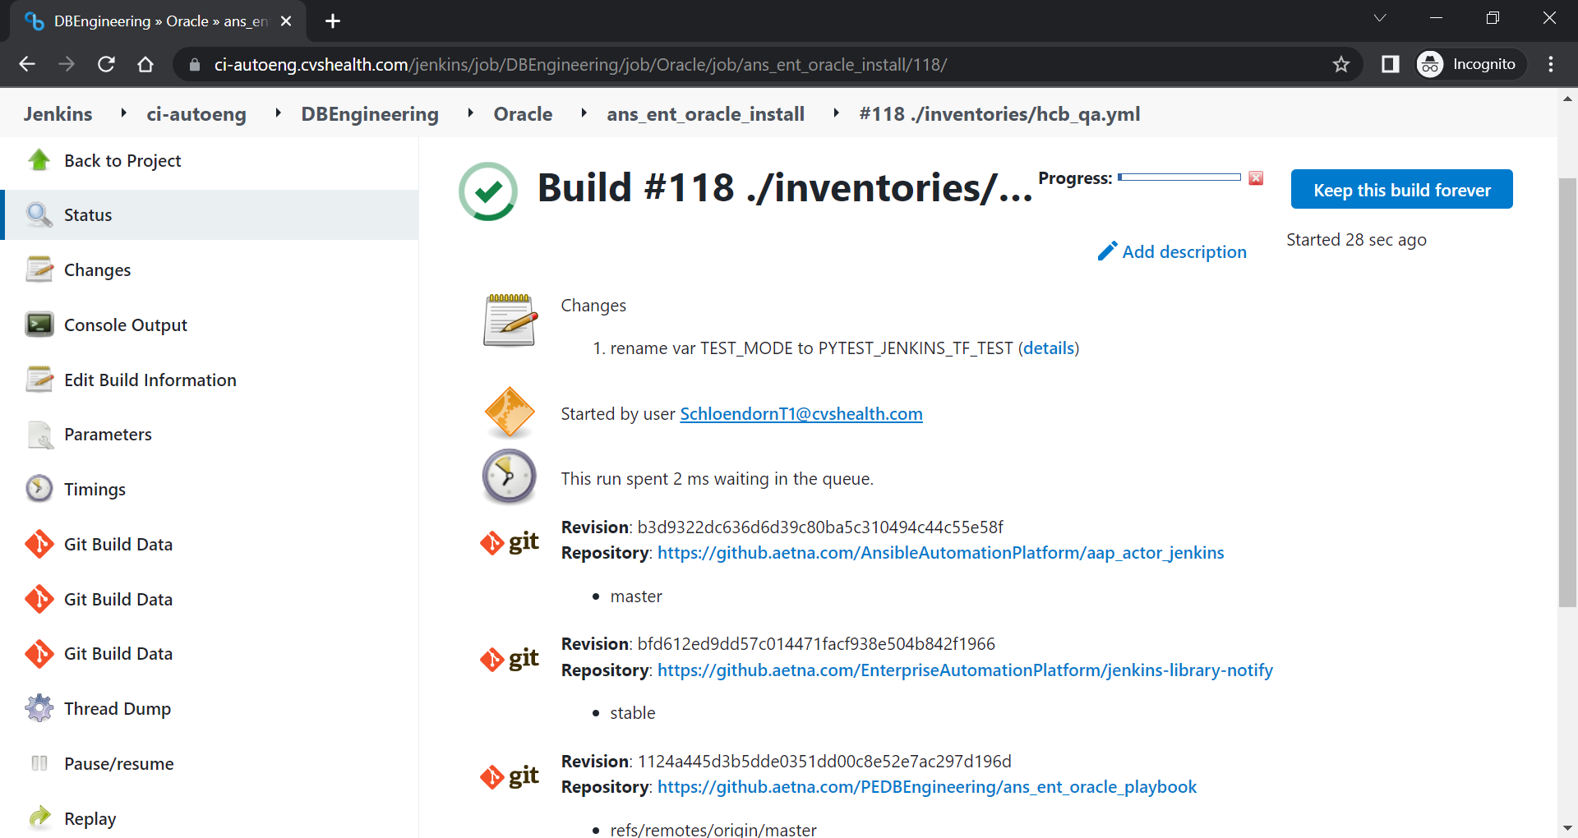

Select console output or tail the log in the $LOGS directory on the database server