None Prod: xtnsldapw1d.aetna.com

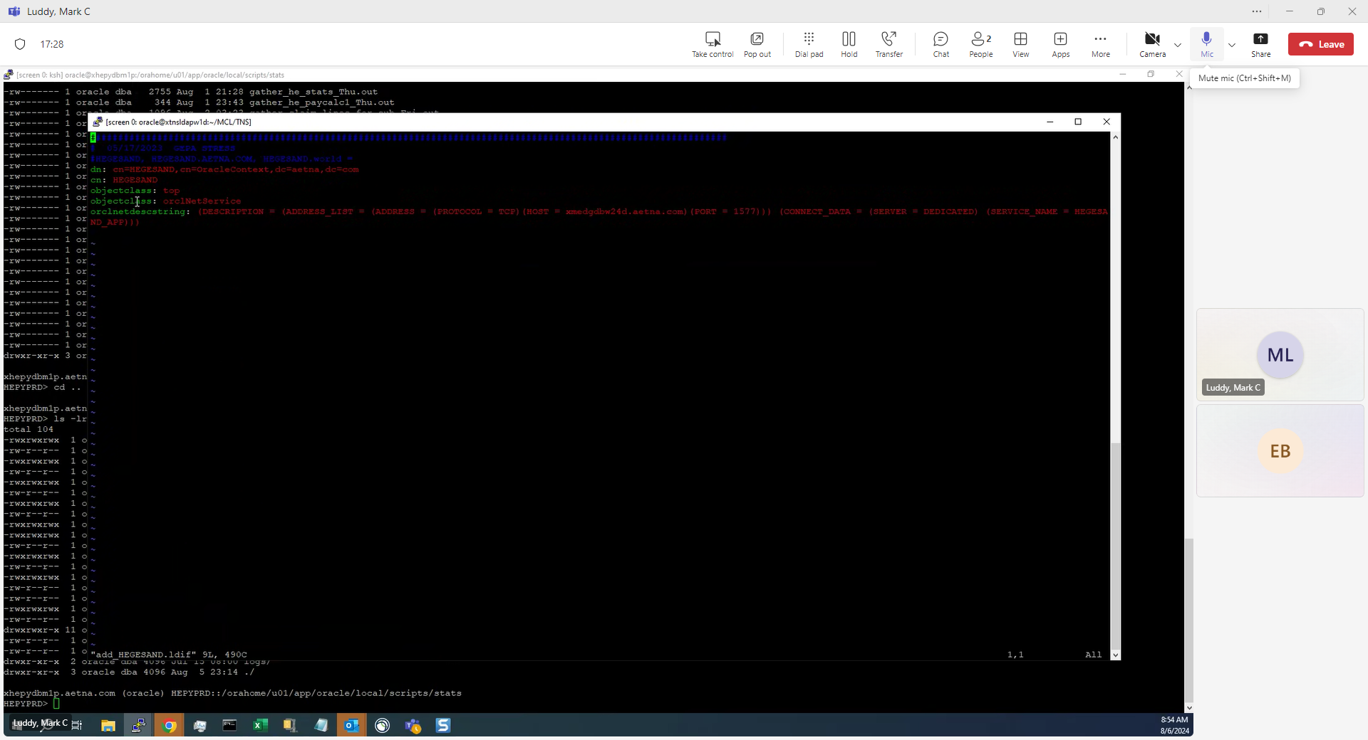

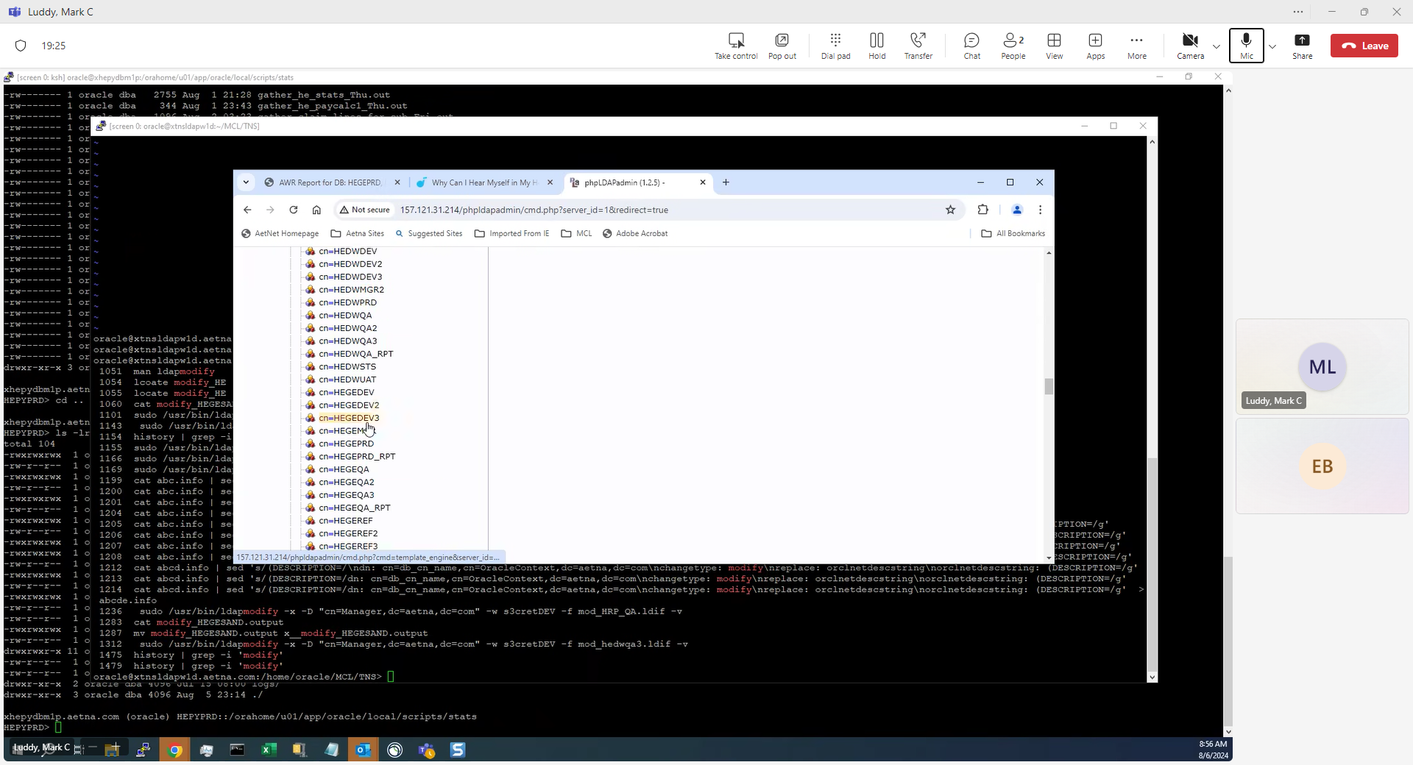

oracle@xtnsldapw1d.aetna.com:**/home/oracle/MCL/TNS**> ls -altr *.ldif

Example: mod_HECVDEV.ldif

#HECVDEV,HECVDEV.AETNA.COM,HECVDEV.world=

dn: cn=HECVDEV,cn=OracleContext,dc=aetna,dc=com

changetype: modify

replace: orclnetdescstring

orclnetdescstring: (DESCRIPTION=(ADDRESS_LIST=(ADDRESS=(PROTOCOL=TCP)(HOST=xhecvdbw01d.aetna.com)(PORT=1567))(ADDRESS=(PROTOCOL=TCP)(H

OST=xhecvdbw21d.aetna.com)(PORT=1567)))(CONNECT_DATA=(SERVER=DEDICATED)(SERVICE_NAME=HECVDEV_APP)))

#HECVDEV2,HECVDEV2.AETNA.COM,HECVDEV2.world=

dn: cn=HECVDEV2,cn=OracleContext,dc=aetna,dc=com

changetype: modify

replace: orclnetdescstring

orclnetdescstring: (DESCRIPTION=(ADDRESS_LIST=(ADDRESS=(PROTOCOL=TCP)(HOST=xhecvdbw02d.aetna.com)(PORT=1567))(ADDRESS=(PROTOCOL=TCP)(H

OST=xhecvdbw22d.aetna.com)(PORT=1567)))(CONNECT_DATA=(SERVER=DEDICATED)(SERVICE_NAME=HECVDEV2_APP)))

#HECVDEV3,HECVDEV3.AETNA.COM,HECVDEV3.world=

dn: cn=HECVDEV3,cn=OracleContext,dc=aetna,dc=com

changetype: modify

replace: orclnetdescstring

orclnetdescstring: (DESCRIPTION=(ADDRESS_LIST=(ADDRESS=(PROTOCOL=TCP)(HOST=xhecvdbw03d.aetna.com)(PORT=1567))(ADDRESS=(PROTOCOL=TCP)(H

OST=xhecvdbw23d.aetna.com)(PORT=1567)))(CONNECT_DATA=(SERVER=DEDICATED)(SERVICE_NAME=HECVDEV3_APP)))

Example: add_HEGEPRD.ldif

##################################################################################################################

# 05/17/2023 GEPA PRD

#HEGEPRD, HEGEPRD.AETNA.COM, HEGEPRD.world =

dn: cn=HEGEPRD,cn=OracleContext,dc=aetna,dc=com

cn: HEGEPRD

objectclass: top

objectclass: orclNetService

orclnetdescstring: (DESCRIPTION = (ADDRESS_LIST = (ADDRESS = (PROTOCOL = TCP)(HOST = xmedgdbm21p.aetna.com)(PORT = 1577)) (ADDRESS = (

PROTOCOL = TCP)(HOST = xmedgdbw21p.aetna.com)(PORT = 1577))) (CONNECT_DATA = (SERVER = DEDICATED) (SERVICE_NAME = HEGEPRD_APP)))

Example: del_HEGESAND.ldif

cn=HEGESAND,cn=OracleContext,dc=aetna,dc=com

**Use ldapmodify utility to make changes per example below**

