Go to Metrics and collectin settings

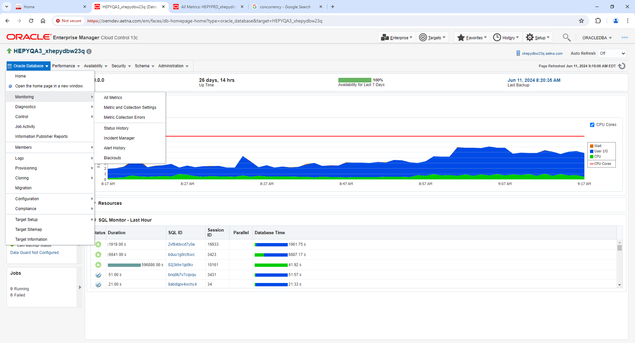

View: All Metrics

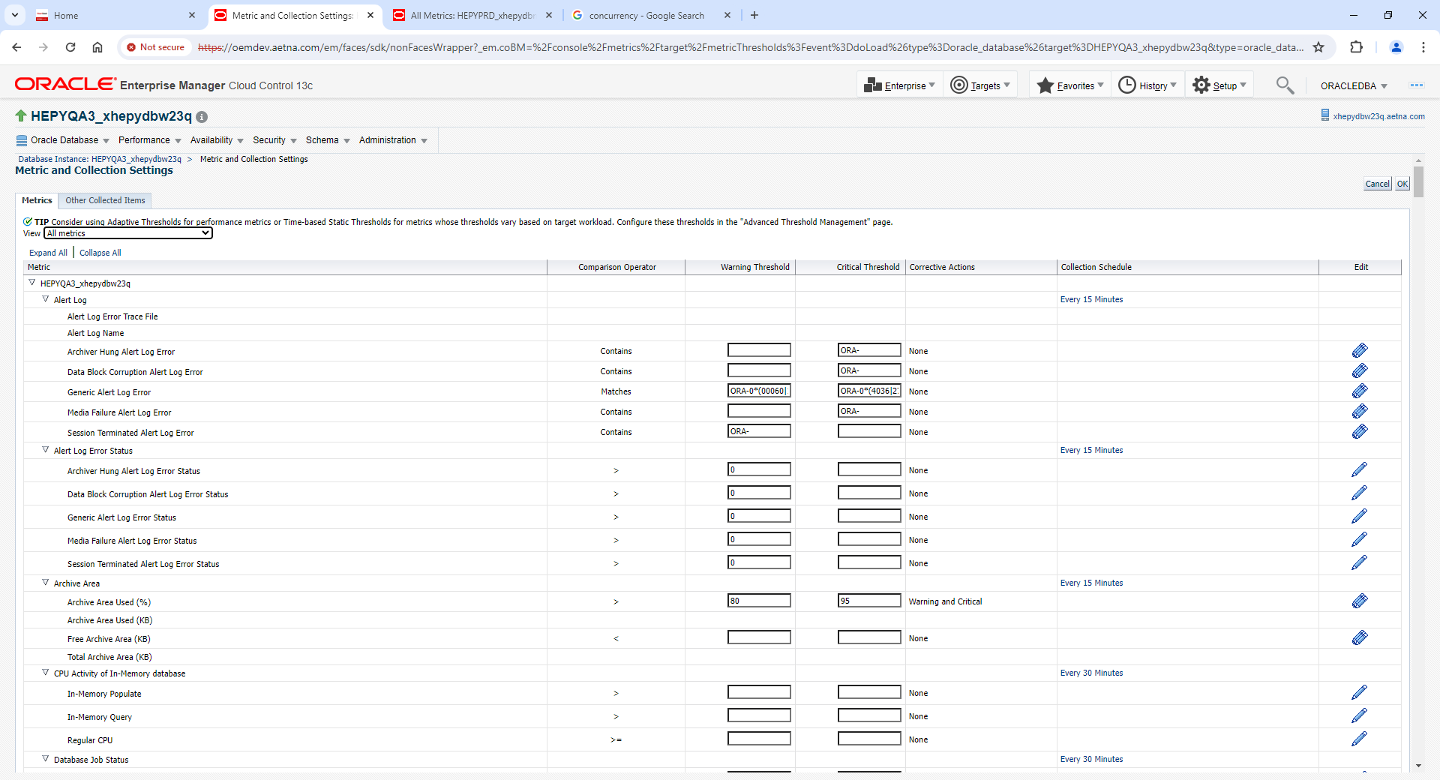

Scroll down to Waits by Wait Class section

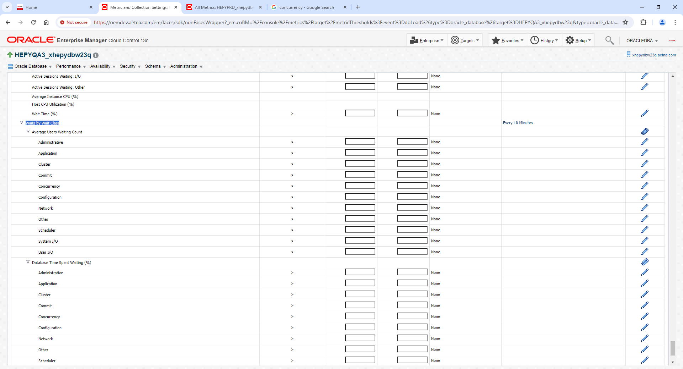

Type values for Concurrency Warning and Critical Thresholds

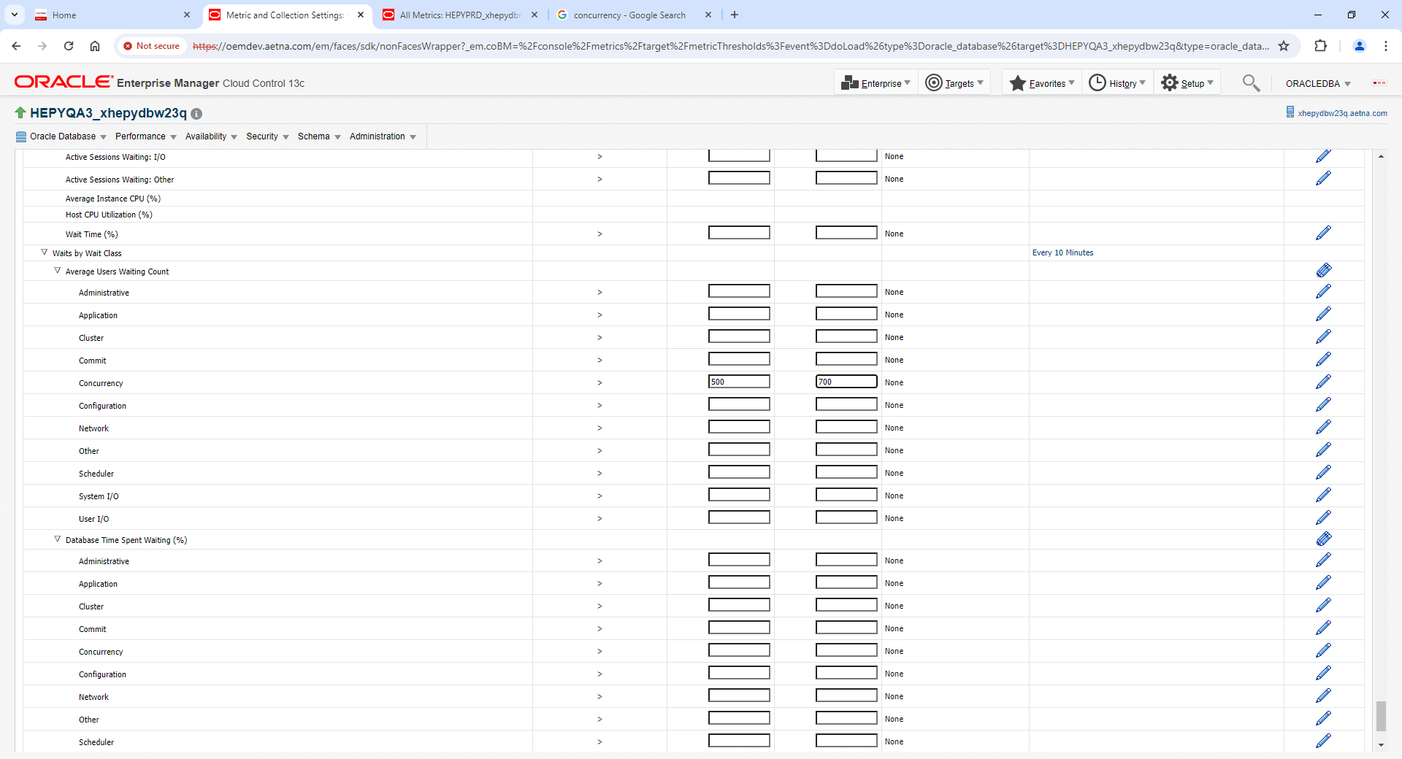

Click ok on Top to save

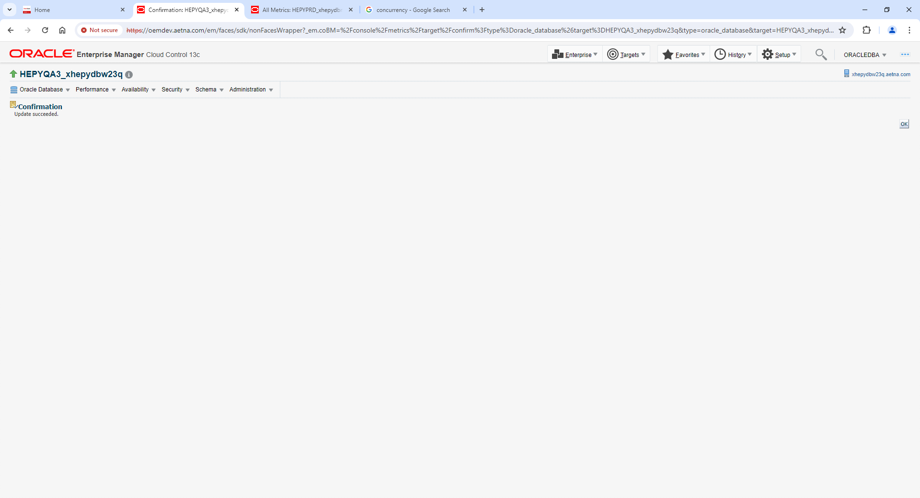

Go back to All Metrics View

Scroll down to Waits by Wait Class and hit Every 10 min link

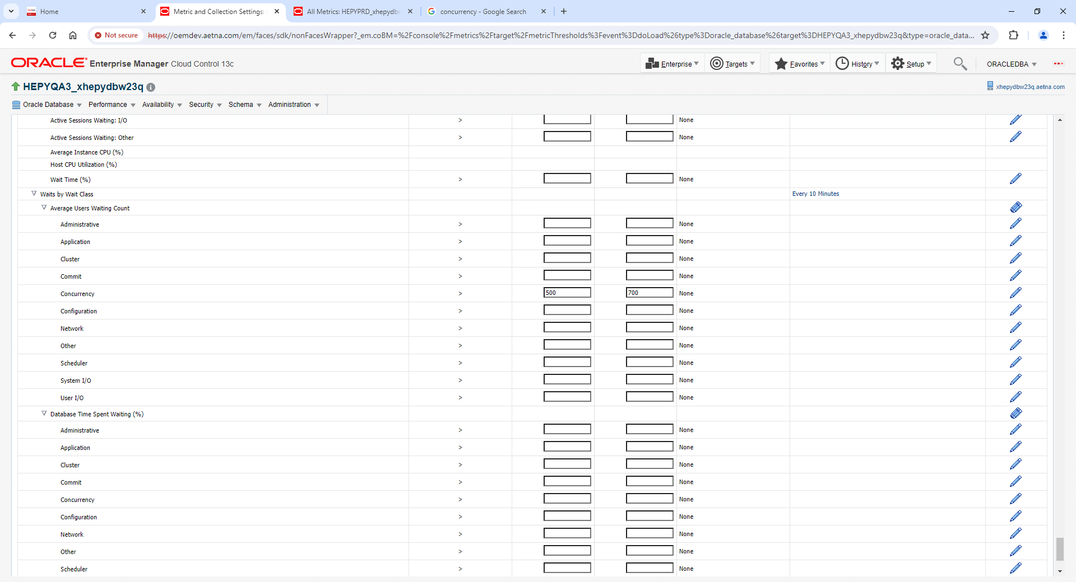

Change value to every 2 min and click Continue

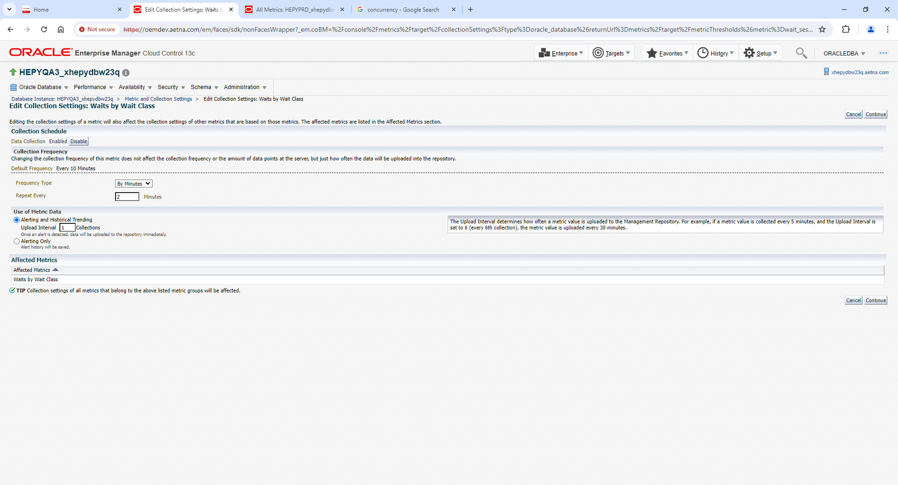

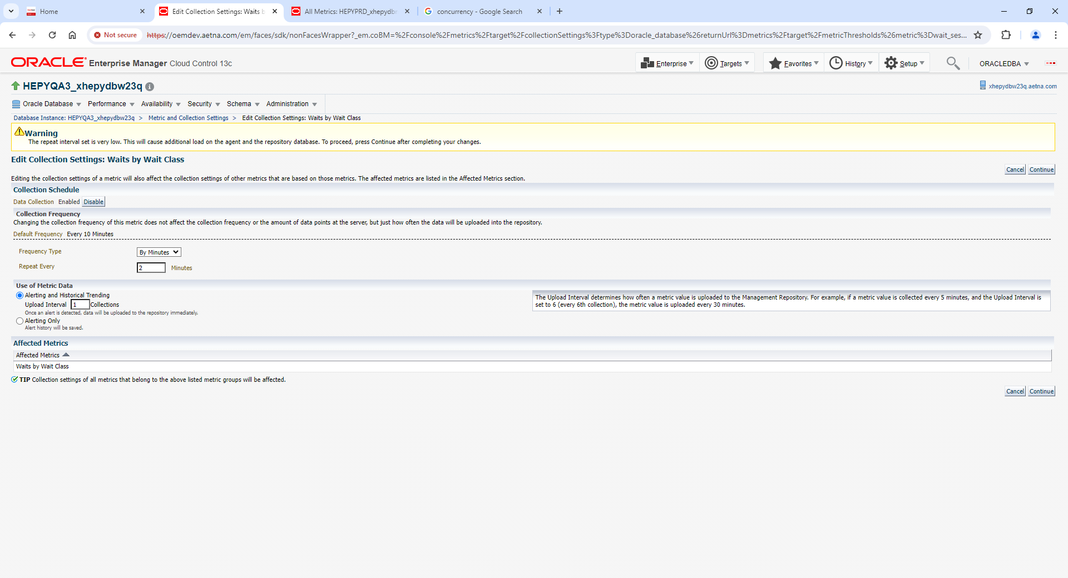

Click Ok to save (on top right)

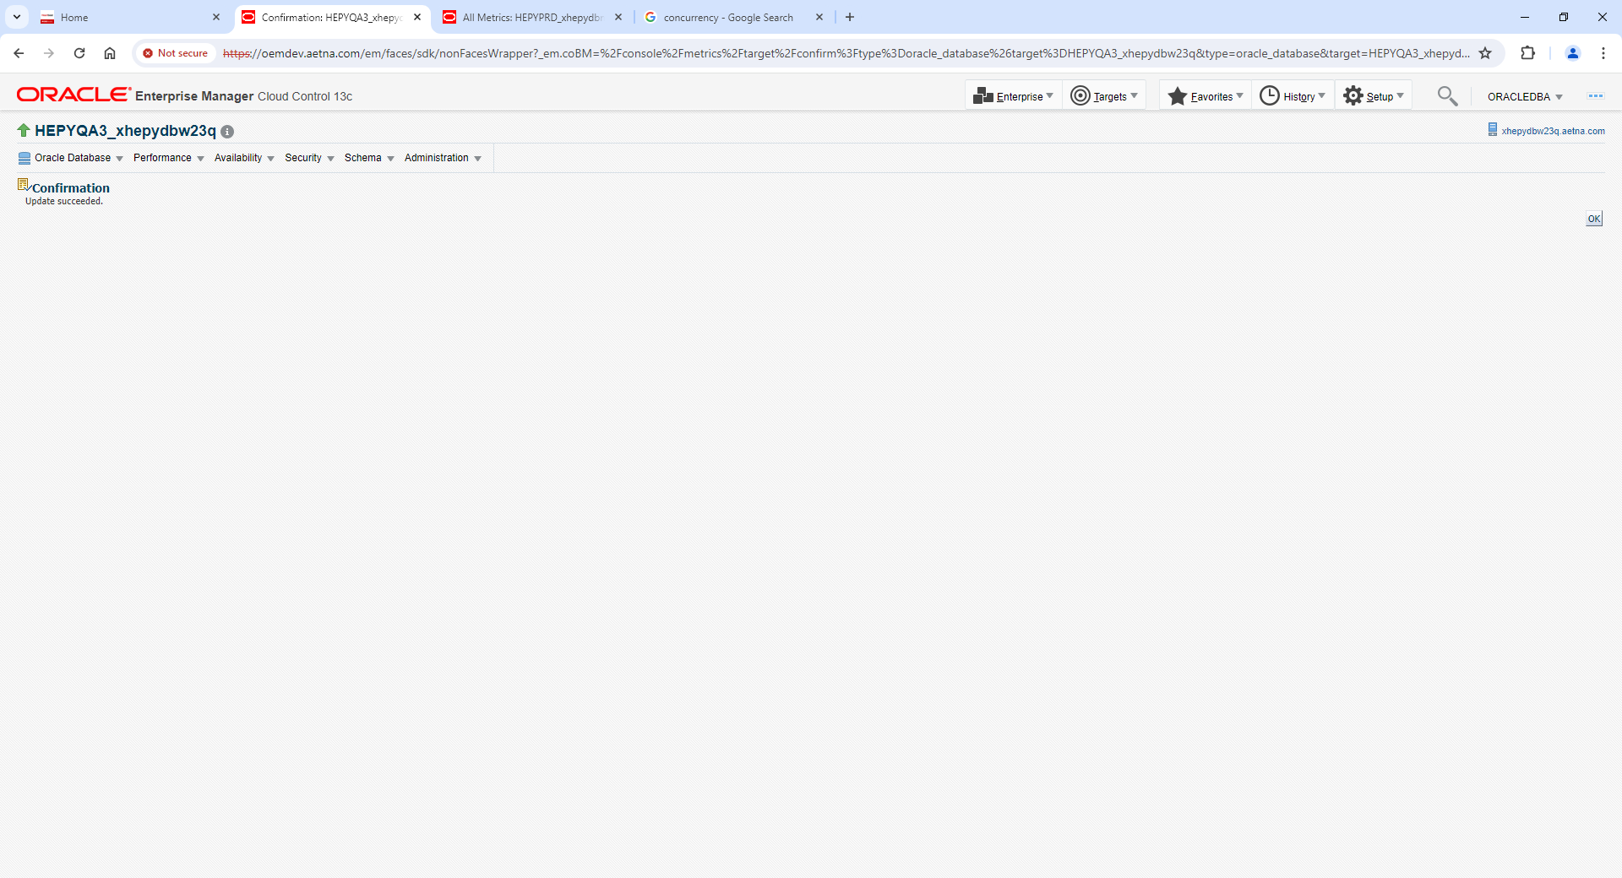

Go back to All Metrics view

Scroll down to Waits by Wait Class

Hit blue pencil on Concurrency row

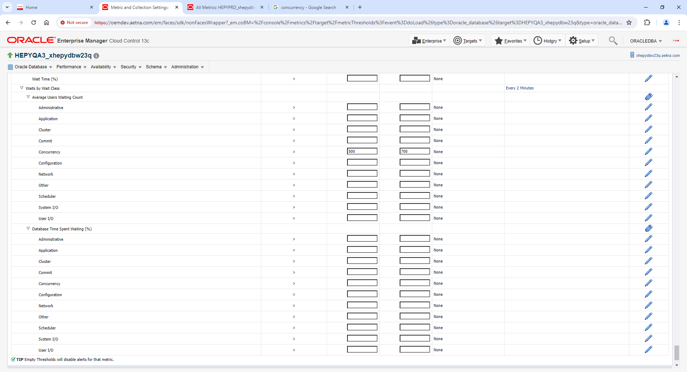

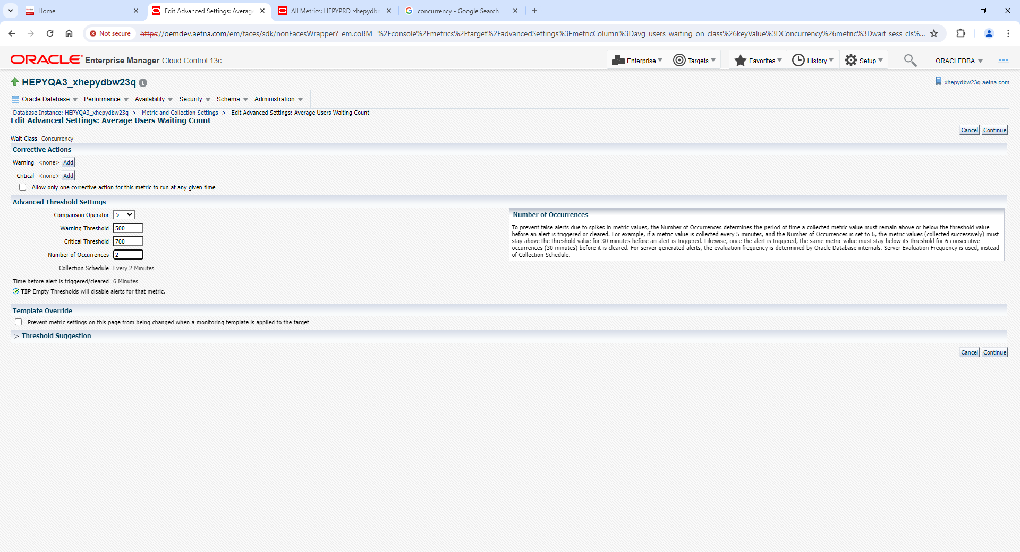

Change Number of Occurrences to 2 and click Continue

Click Ok on top left to save (top right)

