***** DB names and server names just for references *****

~~PY Primary Server :~~ **~~xhepydbm1p~~** ~~(~~**~~HEPYPRD~~**~~)~~

~~PY StandBy Server:~~ **~~xhepydbw21p~~** ~~(~~**~~HEPYPRD~~**~~)~~

~~DW Primary Server:~~ **~~xhedwdbm21p~~** ~~(~~**~~HEDWPRD~~**~~)~~

~~DW Standby Server:~~ **~~xhedwdbw21p~~** ~~(~~**~~HEDWPRD~~**~~)~~

PY Primary Server: **xhepydbm2ap (HEPYPRD_1)**

PY Standby Servers: **xhepydbw2ap (HEPYPRD_1)**

**xhepydbm1p (HEPYPRD)**

**xhepydbw21p (HEPYPRD)**

DW Primary Server: **xhedwdbm2ap (HEDWPRD_1)**

DW Standby Servers: **xhedwdbw2ap (HEDWPRD_1)**

**xhedwdbm21p (HEDWPRD)**

**xhedwdbw21p (HEDWPRD)**

************************************************

**PY and DW Friday pre steps or any time during the week prior to weekend upgrade**

**Adjust schedule for both HEPYPRD and HEDWPRD backup Level 0 jobs to start earlier on Saturday**. Based on latest average completion time figure out best time to start with goal to finish at least 1 hour prior to start of HRP upgrade.

**Adjust schedule for both HEPYPRD and HEDWPRD backup Archivelog jobs schedule** so they can finish right before HRP Upgrade start time. This will ensure FLASH_01 Disk space freed up.

**Adjust schedule for both HEPYRD (StandBy) and HEDWRPD (StandBy) archive purge jobs** **schedule** so they can finish right before HRP Upgrade start time. This will ensure ARCH Disk space freed up.

**Disable OEM Saturday and Sunday and Automated Maintenance Tasks for both HEPYPRD and HEDWPRD.** See example below

Navigate to appropriate database from appropriate Cluster Database OEM Target then select menu **Administration 🡪 Oracle Scheduler 🡪 Automated Maintenance Tasks (You will need to log to Database in OEM under your AID/NID).**

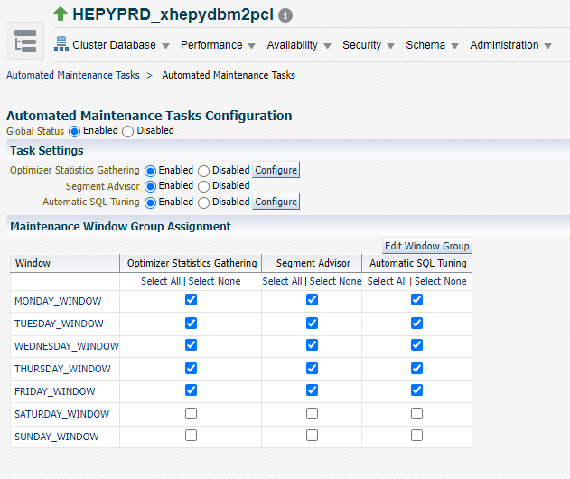

**PY and DW Saturday steps you can do this while HRP bringing apps down**

-- Check make sure PY Level 0 and DW Level 0 completed (should start earlier on Saturday and should be completed before HRP upgrade start). **If Level 0 backup still running prior to Upgrade start time kill it**

-- Check make sure ARCH/FLASH_01 space freed up on both PY Primary, PY Standby and DW Primary, DW Standby servers.

--Example below. Look for ARCH/FLASH_01 DISK space.

+ASM> asmcmd lsdg

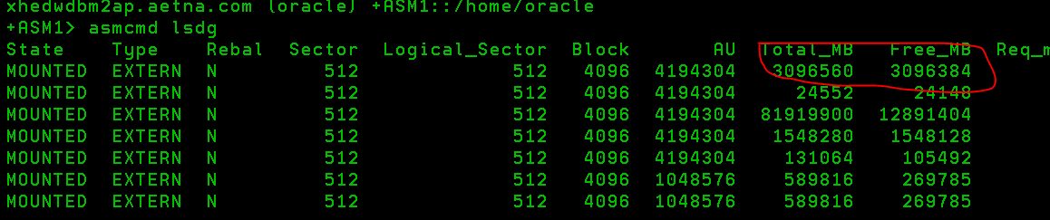

**** HEPYPRD ******

PLACE HOLDER FOR EXTRA DBA TASKS THAT NEEDS TO BE DONE PRIOR TO UPGRADE. Like changing DB parameters, bounce DB, index related work A lot of times DBA’s assigned extra tasks during HRP upgrade window to make changes not related to HRP upgrade…

Should be part of CREATE_GRP.sql. Just everify

**** HEDWPRD ******

PLACE HOLDER FOR EXTRA DBA TASKS THAT NEEDS TO BE DONE PRIOR TO UPGRADE. Like changing DB parameters, bounce DB, index related work A lot of times DBA’s assigned extra tasks during HRP upgrade window to make changes not related to HRP upgrade…

Comment out Sunday job

###00 03 * * 0 /oradb/app/oracle/local/scripts/stats/gather_tran_step_fact.sh HEDWPRD > /dev/null 2>&1

**PY Saturday upgrade steps (after apps down)**

Login to **xhepydbw2ap** as oracle

. oraenv

HEPYPRD_1

cd $SCRIPTS/HRP_upgrade

sqlplus / as sysdba

@CREATE_GRP.sql

exit

You should get email within several minutes with following title:

**Pre HRP Upgrade steps completed with Success**

If title has an error this mean something did not work correctly and need further investigation…

Proceed with GRP step

Prior to that check make sure current sys password not expired. If yes change password back to existing.

# In new incognito window open below link

<https://ci-autoeng.cvshealth.com/jenkins/>

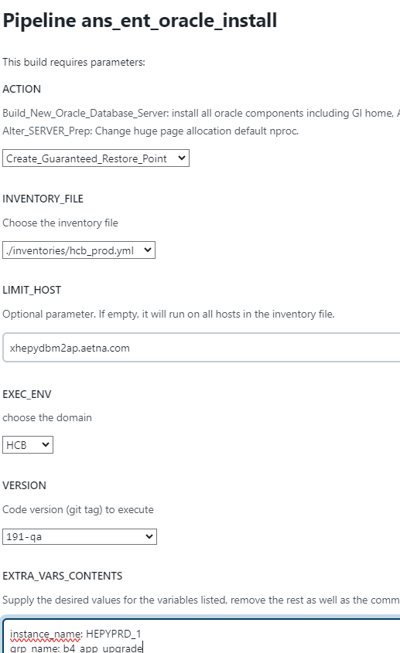

Manually suspend Standby PURGE job if it was not suspended by Jenkins action above

**DW Saturday upgrade steps (after apps down)**

Login to **xhedwdbm2ap** as oracle

. oraenv

HEDWPRD_1

cd $SCRIPTS/HRP_upgrade

sqlplus / as sysdba

@CREATE_GRP.sql

exit

You should get email within several minutes with following title:

**Pre HRP Upgrade steps completed with Success**

If title has an error this mean something did not work correctly and need further investigation…

Proceed with GRP step

Prior to that check make sure current sys password not expired. If yes change password back to existing.

# In new incognito window open below link

<https://ci-autoeng.cvshealth.com/jenkins/>

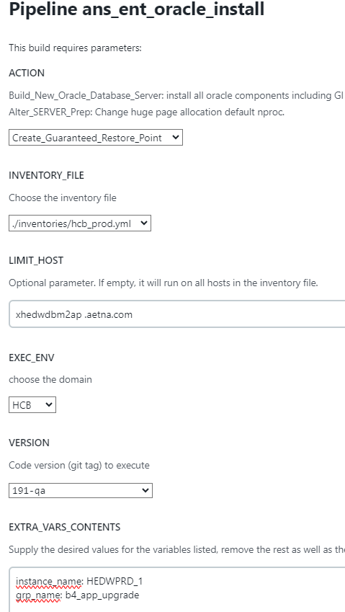

instance_name: HEDWPRD_1

grp_name: b4_app_upgrade

Manually suspend Standby PURGE job if it was not suspended by Jenkins action above

**Sunday morning post upgrade steps (whenever time you get green light after checkout).**

**PY Sunday steps**

--To Check flashback logs size that being generated during upgrade

Login to **xhepydbw2ap** as oracle

. oraenv

HEPYPRD_1

sqlplus / as sysdba

SELECT

SUM(bytes/1024/1024/1024) as "Size(GB)"

FROM

v$flashback_database_logfile;

**Get total from Size(GB) column and note size here for reference: 500 GB**

. oraenv

HEPYPRD_1

cd $SCRIPTS/HRP_upgrade

sqlplus / as sysdba

@DROP_GRP.sql

exit

You should get email within several minutes with following title:

**Post HRP Steps completed with Success**

If title has an error this mean something did not work correctly and need further investigation…

Proceed with GRP step

Prior to that check make sure current sys password not expired (by login to database remotely under sys account as sysdba). If it expired change password back to existing.

# In new incognito window open below link

<https://ci-autoeng.cvshealth.com/jenkins/>

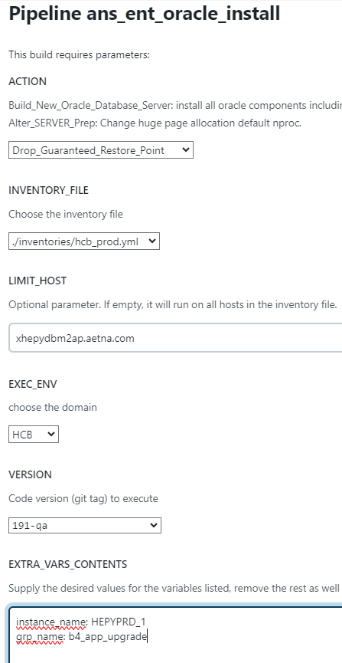

Manually enable Standby PURGE job if it was not suspended by Jenkins action above

***** HEPYPRD*****

PLACE HOLDER FOR EXTRA DBA TASKS. Like changing DB parameters, bounce DB, index related work, BLOB table migration to Big File Tablespaces etc. A lot of times DBA’s assigned extra tasks during HRP upgrade window to make changes not related to HRP upgrade…

#Idenfity new indexes that part of Locked stats tables. Gather stats on those.

. oraenv

HEPYPRD_1

cd $HOME/eb/misc

@gather_index_stats.sql

**DW Sunday steps**

Login to **xhedwdbm2ap** as oracle

-- To Check flashback logs size that being generated during upgrade

. oraenv

HEDWPRD_1

sqlplus / as sysdba

SELECT

SUM(bytes/1024/1024/1024) as "Size(GB)"

FROM

v$flashback_database_logfile;

**Get total from Size(GB) column and note size here for reference: xxx**

. oraenv

HEDWPRD_1

cd $SCRIPTS/HRP_upgrade

sqlplus / as sysdba

@DROP_GRP.sql

exit

You should get email within several minutes with following title:

**Post HRP Steps completed with Success**

If title has an error this mean something did not work correctly and need further investigation…

Proceed with GRP step

Prior to that check make sure current sys password not expired (by login to database remotely under sys account as sysdba). If it expired change password back to existing.

# In new incognito window open below link

<https://ci-autoeng.cvshealth.com/jenkins/>

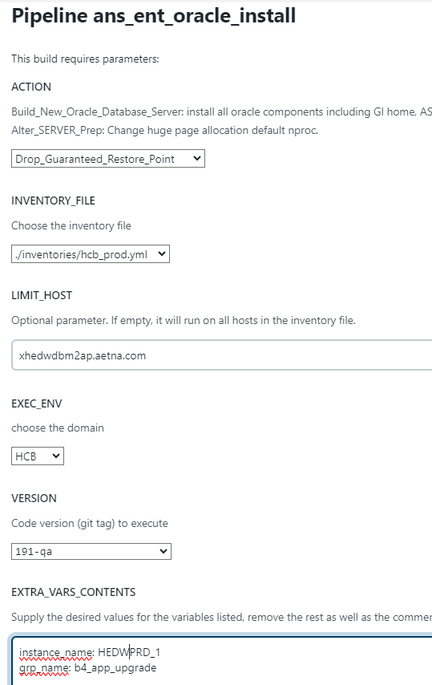

Manually enable Standby PURGE job if it was not suspended by Jenkins action above

***** HEDWPRD*****

PLACE HOLDER FOR EXTRA DBA TASKS. Like changing DB parameters, bounce DB, index related work, BLOB table migration to Big File Tablespaces etc. A lot of times DBA’s assigned extra tasks during HRP upgrade window to make changes not related to HRP upgrade…

N/A

**Enable OEM Saturday and Sunday and Automated Maintenance Tasks for both HEPYPRD and HEDWPRD.** See example below

Navigate to appropriate database then select menu **Administration 🡪 Oracle Scheduler 🡪 Automated Maintenance Tasks (You will need to log to Database in OEM under your AID or system)**

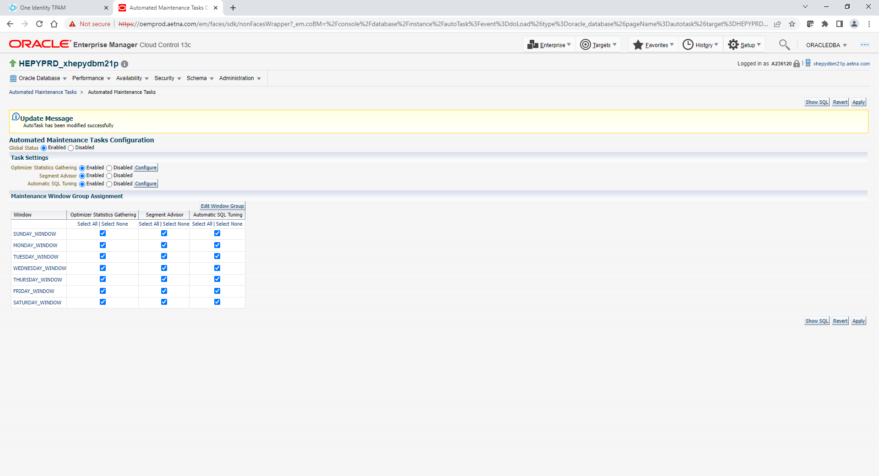

************* Post HRP upgrade tasks after GRP’s dropped ***************************************

**Change PY and DW Level0 start time back to original (11:59 PM each Saturday)**





Important note:

After GRP dropped in PY it will enable all crontab stats jobs (put back original crontab entries)

**Which means it will miss start of job below. You will need manually kick off this job via changing start time in crontab**

**!! Once job started please put original time back**

**# Gather Stats on CVC Tables Sunday Only**

**30 02 * * 0 /oradb/app/oracle/local/scripts/stats/gather_cvc_stats_wkly.sh HEPYPRD > /dev/null 2>&1**

Uncomment out cron job

0 * * * * /oradb/app/oracle/local/scripts/monitor/orasupp/load_hang_analyze.ksh HEPYPRD > /dev/null 2>&1

Uncomment out Sunday job on DW server

00 03 * * 0 /oradb/app/oracle/local/scripts/stats/gather_tran_step_fact.sh HEDWPRD > /dev/null 2>&1

