**Pre Oracle Software Install steps:**

**Update /etc/hosts file on both nodes**

URL for reference

<https://docs.oracle.com/en/storage/storage-software/acsls/8.5/acshl/configuring-etc-hosts.html>

**# NODE A /etc/hosts example**

127.0.0.1 localhost localhost.localdomain localhost4 localhost4.localdomain4

::1 localhost localhost.localdomain localhost6 localhost6.localdomain6

############Base IPs

157.121.124.136 xhepydbw2as.aetna.com xhepydbw2as

157.121.124.140 xhepydbw2bs.aetna.com xhepydbw2bs

#############Interconnect IP ic1

192.168.218.53 xhepydbw2as-priv-ci1

192.168.218.30 xhepydbw2bs-priv-ci1

############Interconnect IP ic2

192.168.150.53 xhepydbw2as-priv-ci2

192.168.150.35 xhepydbw2bs-priv-ci2

############VIP for RAC

157.121.124.85 xhepydbw2as-vip.aetna.com xhepydbw2as-vip

157.121.124.86 xhepydbw2bs-vip.aetna.com xhepydbw2bs-vip

**# NODE B /etc/hosts example**

127.0.0.1 localhost localhost.localdomain localhost4 localhost4.localdomain4

::1 localhost localhost.localdomain localhost6 localhost6.localdomain6

############Base IPs

157.121.124.136 xhepydbw2as.aetna.com xhepydbw2as

157.121.124.140 xhepydbw2bs.aetna.com xhepydbw2bs

############Interconnect IP ic1

192.168.218.53 xhepydbw2as-priv-ci1

192.168.218.30 xhepydbw2bs-priv-ci1

############Interconnect IP ic2

192.168.150.53 xhepydbw2as-priv-ci2

192.168.150.35 xhepydbw2bs-priv-ci2

############VIP for RAC

157.121.124.85 xhepydbw2as-vip.aetna.com xhepydbw2as-vip

157.121.124.86 xhepydbw2bs-vip.aetna.com xhepydbw2bs-vip

**Setup Trusted SSH keys on each node**

**!! Make sure both oracle and grid have proper selinux context configured by Linux Admin if not ssh handshake may not work even if keys setup correct.**

# Repeat these steps for both users oracle and grid

#From Node A server

cd .ssh

ssh-keygen -t rsa

#Copy the public DSA key from Node A server to Node B Server

cd .ssh

scp /home/<OSuser>/.ssh/id_rsa.pub <servernameNodeB>:/home/<OSuser>/.ssh/id_rsa.pub_A

#From Node B Server

#Append the “authorized_keys” file with the DSA public key

cd .ssh

cat id_rsa.pub_A >> authorized_keys

#Test user equivalence (trusted ssh connection)

#From Node A server

ssh <servernameNodeB>

#If the hostname of the target comes back without prompting for a password, then the configuration is complete.

#From Node B server

#Copy the public DSA key from Node B server to Node A Server

cd .ssh

ssh-keygen -t rsa

cd .ssh

scp /home/<OSuser>/.ssh/id_rsa.pub <servernameNodeA>:/home/<OSuser>/.ssh/id_rsa.pub_B

#From Node A Server

#Append the “authorized_keys” file with the DSA public key

cd .ssh

cat id_rsa.pub_B >> authorized_keys

#Test user equivalence (trusted ssh connection)

#From Node B server

ssh <servernameNodeA>

If the hostname of the target comes back without prompting for a password, then the configuration is complete.

**Oracle Software Install steps:**

**Verify storage availability on the server before Install.**

df -m (to make sure all mount points available)

ls -l /dev/oracleasm/disks/* (to make sure asm disks in place)

**Install packages, set ulimits, create directories, etc……**

# In new incognito window open below link

<https://ci-autoeng.cvshealth.com/jenkins/>

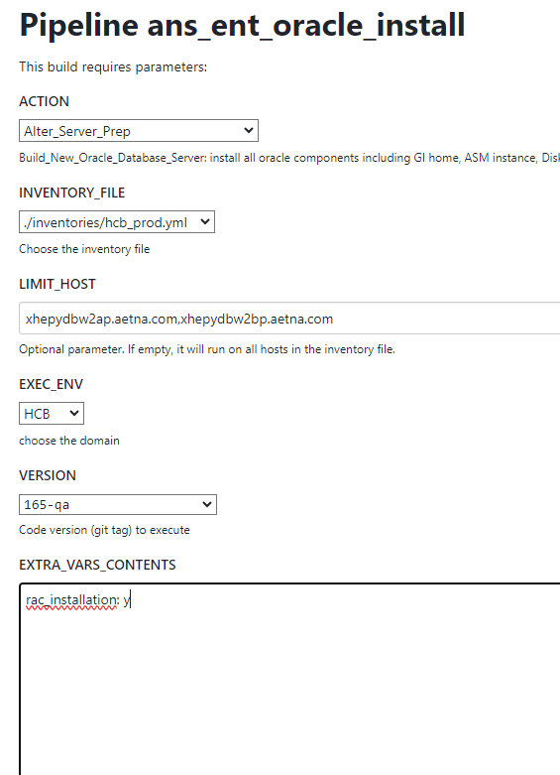

rac_installation: y

**Download the GI software from the Nexus repo using a curl command**

**# As grid user (Do this only for NodeA because GI Install will take care this on NodeB)**

cd   /oraauto

curl -o grid_home_19230.tar.gz <https://nexus-sdi.cvshealth.com/nexus/repository/cvs-raw-internal-release-hosted-oracle-dba/linux%2Fgrid_home_19230.tar.gz>

cd /oragrid/app/grid/product

gtar -xvf /oraauto/grid_home_19230.tar.gz

#Upon completion run Cluster Verification Utility

cd /oragrid/app/grid/product/19.23.0/gi

./runcluvfy.sh stage -pre crsinst -n <server_name_NodeA>,<server_name_NodeB>

**#If following comes up ask Linux Admin to install**

Package: cvuqdisk-1.0.10-1 ...FAILED

xhepydbm2bp: PRVG-11550 : Package "cvuqdisk" is missing on node "xhepydbm2bp"

following comes back send Linux Admin email with request

Multicast or broadcast check ...FAILED

xhepydbm2bp: PRVG-11138 : Interface "ens1f1np1" on node "xhepydbm2bp" is not

able to communicate with interface "ens1f1np1" on node

"xhepydbm2bp" over multicast group "224.0.0.251"

xhepydbm2bp: PRVG-11138 : Interface "eno12409np1" on node "xhepydbm2bp" is not

able to communicate with interface "eno12409np1" on node

"xhepydbm2bp" over multicast group "224.0.0.251"

xhepydbm2bp: PRVG-11138 : Interface "bond0.657" on node "xhepydbm2bp" is not

able to communicate with interface "bond0.657" on node

"xhepydbm2bp" over multicast group "224.0.0.251"

Can you please add the following firewall ports and add them to aenta.info so chef does not close them?

firewall-cmd --zone=public --add-port=1024-65535/tcp --permanent

firewall-cmd --zone=public --add-port=1024-65535/udp --permanent

firewall-cmd –reload

IF only those left it’s good to go they could be ignored

Pre-check for cluster services setup was unsuccessful on all the nodes.

Failures were encountered during execution of CVU verification request "stage -pre crsinst".

RPM Package Manager database ...INFORMATION

PRVG-11250 : The check "RPM Package Manager database" was not performed because

it needs 'root' user privileges.

Refer to My Oracle Support notes "2548970.1" for more details regarding errors

PRVG-11250".

zeroconf check ...FAILED

xhedwdbm2bp: PRVE-10077 : NOZEROCONF parameter was not specified or was not

set to 'yes' in file "/etc/sysconfig/network" on node

"xhedwdbm2bp.aetna.com"

xhedwdbm2ap: PRVE-10077 : NOZEROCONF parameter was not specified or was not

set to 'yes' in file "/etc/sysconfig/network" on node

"xhedwdbm2ap.aetna.com"

ORAchk checks ...INFORMATION

PRVH-1507 : ORAchk/EXAchk checks are skipped.

**Manual steps to install the software, configure the cluster and create the asm disk groups (Initiate Install from Node A and it will take care Node B. No need to install on Node B)**

# **ipconfig** to get local Ip address (example below)

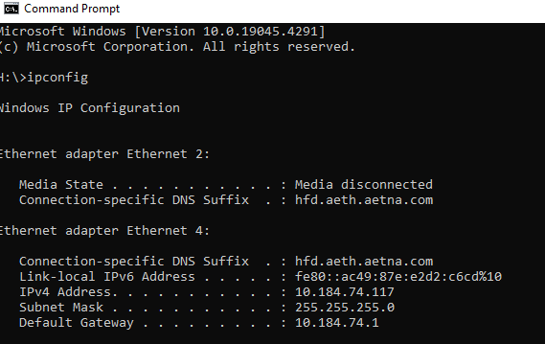

export DISPLAY=<ip of your workstation>:0.0

# example below

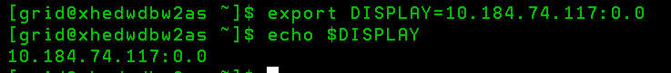

# Start Exceed **(you may need to use VPN cisco instead of Zscaler)**

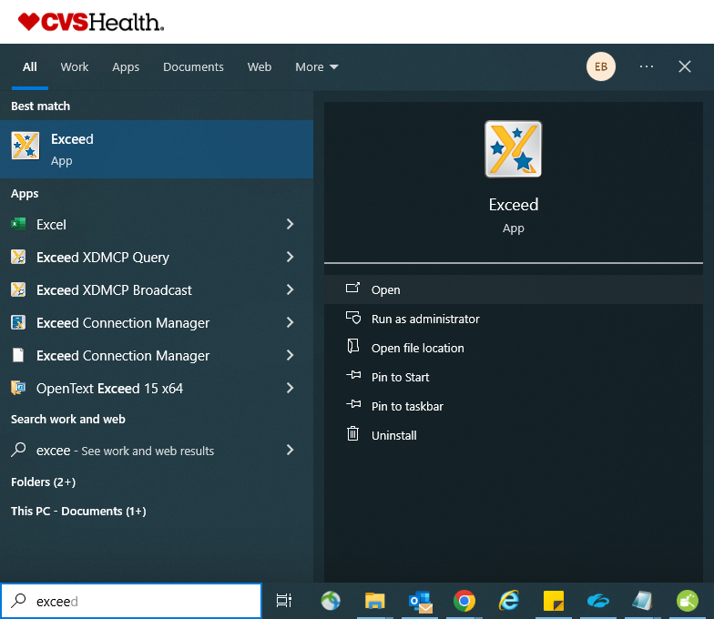

# Navigate to location on the database server where Oracle Universal Installer located and run following command, if GUI screen below comes up you are good to start intall.

cd /oragrid/app/grid/product/19.23.0/gi

./gridSetup.sh

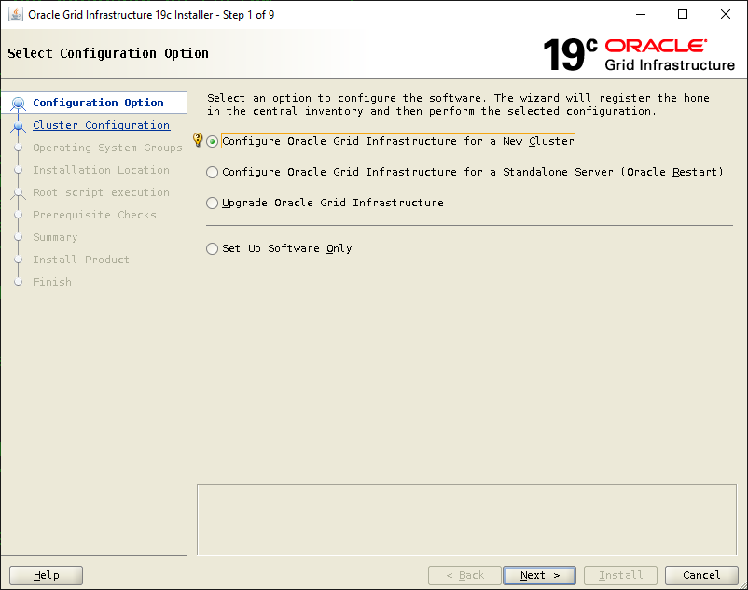

See **GI_Installation_screens.doc** for more details.

**Verify GI installation.**

[grid@xhepydbw2as ~]$ export ORACLE_HOME=/oragrid/app/grid/product/19.23.0/gi

[grid@xhepydbw2as ~]$ export PATH=$ORACLE_HOME/bin:$PATH

[grid@xhepydbw2as ~]$ export ORACLE_SID=+ASM1

cd /oragrid/app/grid/product/19.23.0/gi

./runcluvfy.sh stage -post crsinst -n <server_name_NodeA>,<server_name_NodeB>

**In case failure below follow these steps**

Post-check for cluster services setup was unsuccessful.

Checks did not pass for the following nodes:

ASM(+ASM1),ASM(+ASM2)

Failures were encountered during execution of CVU verification request "stage -post crsinst".

ORAchk checks ...FAILED

Check the integrity of key GI startup files ...FAILED

ASM(+ASM1): AHF-8608: The integrity check of key GI startup files did not succeed

succeed

ASM(+ASM2): AHF-8608: The integrity check of key GI startup files did not

succeed

**Have Linux Admin run this on NodeA**

/oragrid/app/grid/product/19.23.0/gi/bin/ ocrconfig -manualbackup

**Have Linux Admin bounce cluster**

/oragrid/app/grid/product/19.23.0/gi/bin/crsctl stop crs

/oragrid/app/grid/product/19.23.0/gi/bin/crsctl start crs

**Run following commands to valiate basics.**

srvctl status asm

ps -ef|grep smon

crsctl stat res -t -init

crsctl stat res -t

crsctl stat check crs

crsctl check cluster -all

crsctl query crs activeversion

crsctl query crs releasepatch

crsctl query crs releaseversion

crsctl disable crs

crsctl enable crs

**Create ASM Groups**

cd /oragrid/app/grid/product/19.23.0/gi

Invoke: asmca (make sure export $DISPLAY and start Exceed)

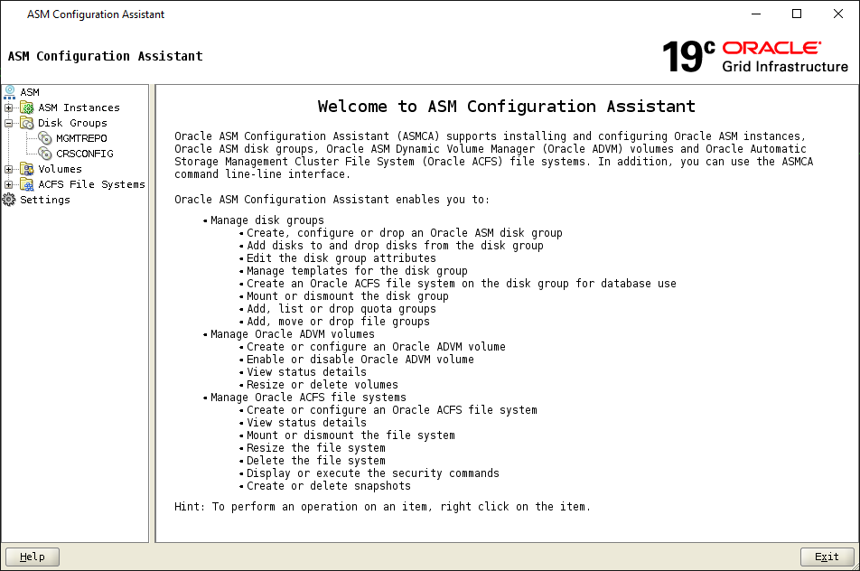

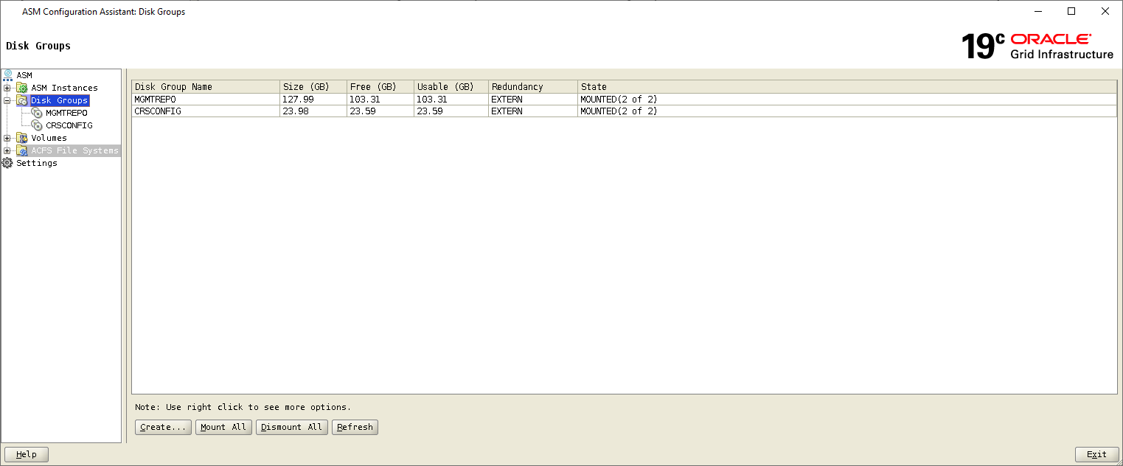

Select Disk Groups and click Create

Disk Group: DATA1

Redundancy: External

Allocation Unit: 4 M

Select All data disks (ASMD1001 till ASMDxxxx) and click OK

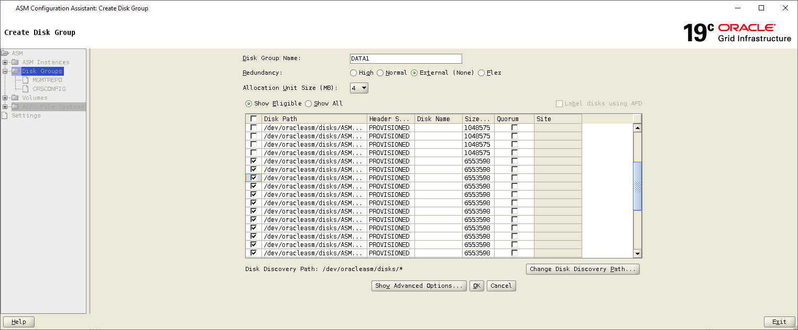

Select Disk Groups and click Create

Disk Group: REDO1

Redundancy: External

Allocation size 1 MB

Select All ASMR1xxx disks and click OK

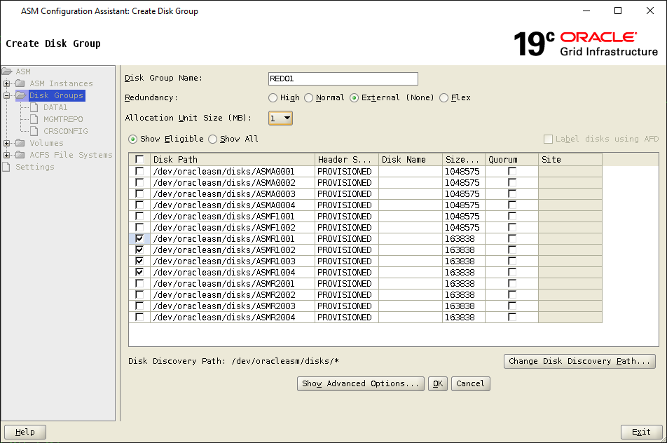

Select Disk Groups and click Create

Disk Group: REDO2

Redundancy: External

Allocation size 1 MB

Select All ASMR2xxx disks and click OK

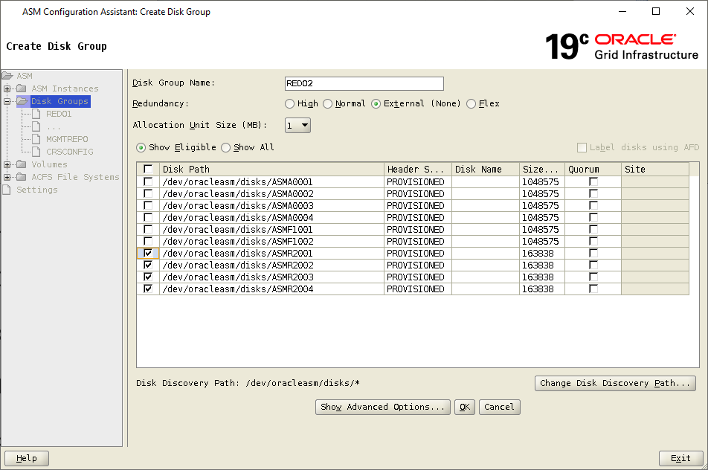

Select Disk Groups and click Create

Disk Group: FRA

Redundancy: External

Allocation size 4 MB

Select All ASMF1xxx disks and click OK

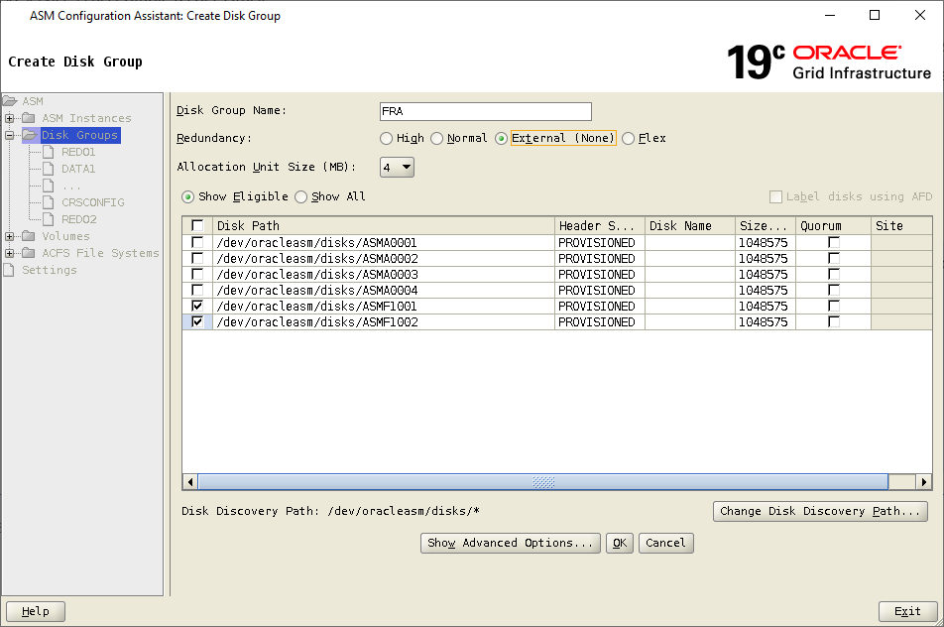

Select Disk Groups and click Create

Disk Group: ARCH

Redundancy: External

Allocation size 4 MB

Select All ASMA0xxx disks and click OK

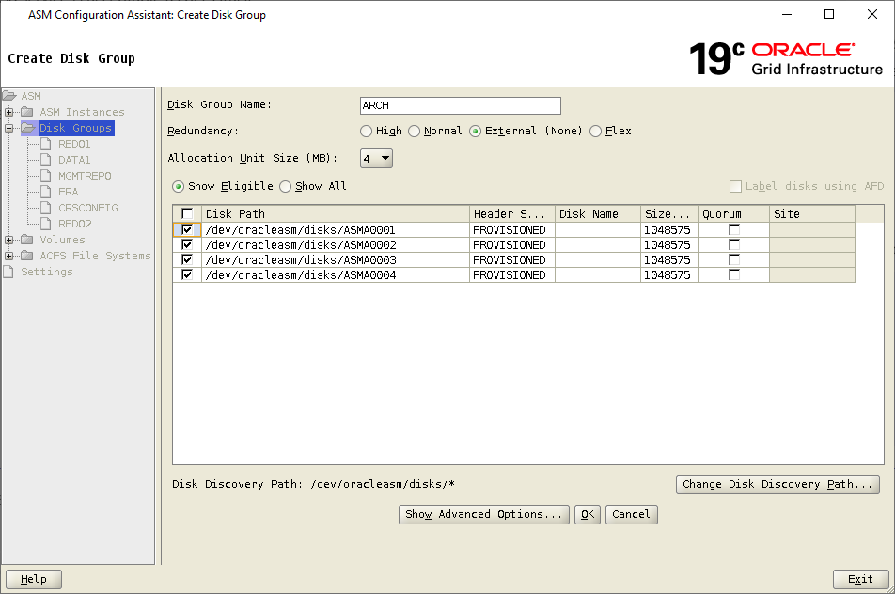

**Install Oracle DBMS Software**

Add +ASM (dummy) entry into /etc/oratab to get this install working

Add +ASM1 entry if not already there on Node A server

Add +ASM2 entry if not already there on Node B server

Node A example:

+ASM1:/oragrid/app/grid/product/19.23.0/gi:N

+ASM:/oragrid/app/grid/product/19.23.0/gi:N

-MGMTDB:/oragrid/app/grid/product/19.23.0/gi:N

Node B example:

+ASM2:/oragrid/app/grid/product/19.23.0/gi:N

+ASM:/oragrid/app/grid/product/19.23.0/gi:N

# In new incognito window open below link

<https://ci-autoeng.cvshealth.com/jenkins/>

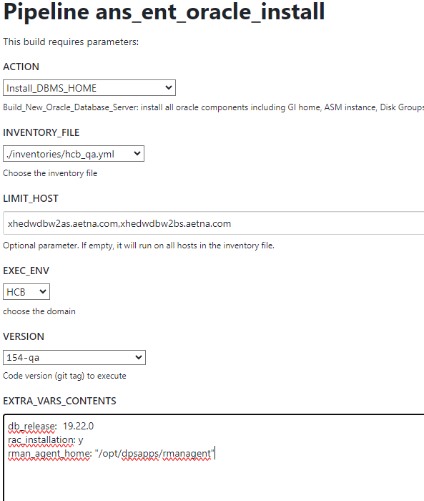

db_release: 19.22.0

rac_installation: y

rman_agent_home: "/opt/dpsapps/rmanagent"

Verify if Oracle Binary is RAC Enabled

ar -t $ORACLE_HOME/rdbms/lib/libknlopt.a|grep kcsm.o

**Install EMCLI and OEM Agent**

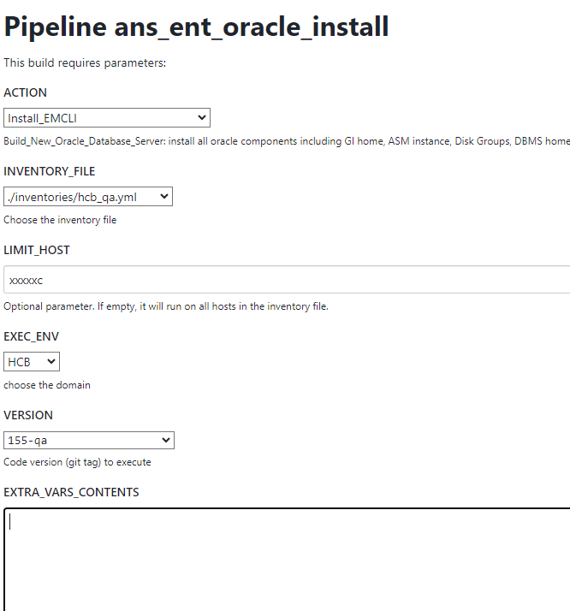

**For prod servers for now**

**oem_release: 13.4.0.0**

# In new incognito window open below link

<https://ci-autoeng.cvshealth.com/jenkins/>

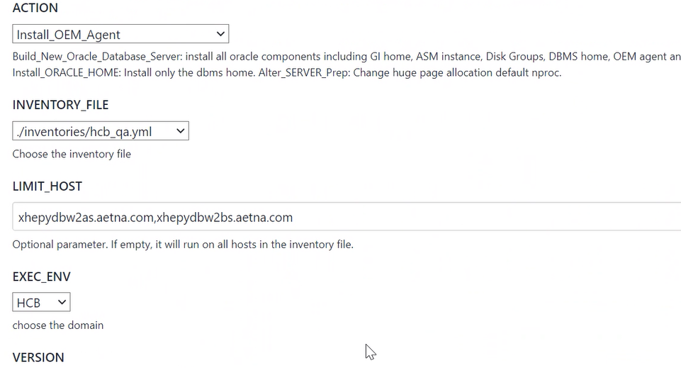

**For prod servers for now**

**oem_release: 13.4.0.0**

**Database related steps:**

**Create standby**

**!!! Sent out email to install ddboost agent with appropriate permissions** (Toelken, William <ToelkenW@cvshealth.com>; Enaganti, Sandeep <Sandeep.Enaganti@omnicare.com>; O'shaughnessy, Daniel [ddoshaughnes@cvshealth.com](mailto:ddoshaughnes@cvshealth.com))

xhedwdbw2as.aetna.com (oracle) 19220::/oradb/app/oracle/product/19.22.0/db_1/config

19220> ls /opt/dpsapps/rmanagent

ls: cannot access '/opt/dpsapps/rmanagent': Permission denied

**The appropriate permissions have been modified for all four systems.**

chown oracle:oinstall -R /opt/dpsapps/rmanagent

chmod 775 -R /opt/dpsapps/rmanagent

chmod 775 -R /opt/dpsapps

**!!! Make sure huge pages updated accordingly.**

**!!! Make sure latest .bash_profile is in place (run action below to update, check with Rich Ryan before, so he can update Nexus with correct script)**

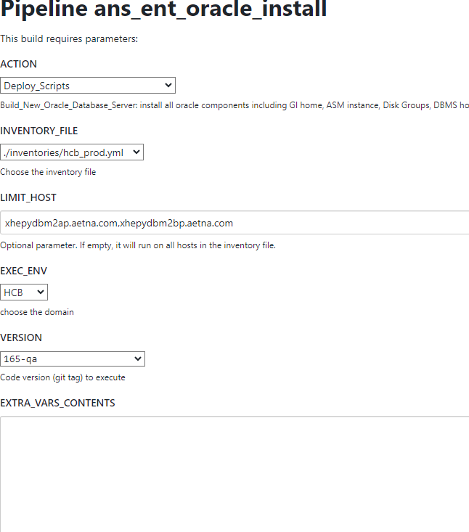

**!!! Make sure +ASM1/+ASM2 oratab entries do not have “#” at the end. Remove if it’s there.**

**!!! Suspend archivlog job on Primary to avoid gap at the end (make decision before PROD standby creation if suspend or not)**

# In new incognito window open below link

<https://ci-autoeng.cvshealth.com/jenkins/>

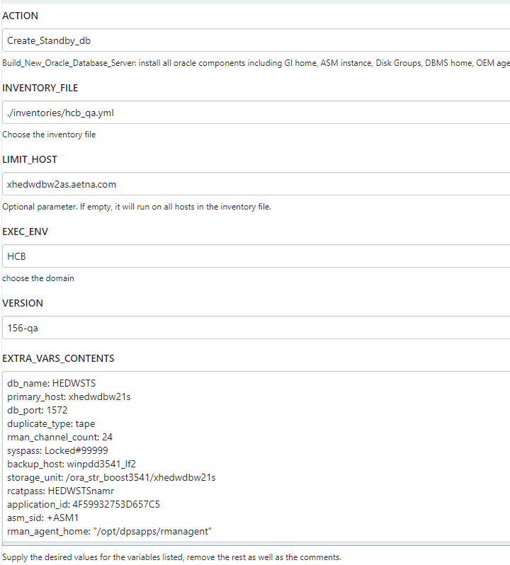

db_name: HEDWSTS

primary_host: xhedwdbw21s

db_port: 1573

duplicate_type: tape

rman_channel_count: 24

syspass: Locked#99999

backup_host: winpdd3541_lf2

storage_unit: /ora_str_boost3541/xhedwdbw21s

rcatpass: HEDWSTSnamr

application_id: 4F59932753D657C5

asm_sid: +ASM1

rman_agent_home: "/opt/dpsapps/rmanagent"

db_unique_name: HEDWSTS_xhedwdbw2scl

**Clone/Standby monitor**:

tail log under /oradb/app/oracle/admin/<DB_NAME>/rman

**Upon standby creation completion do quick check standby config checkout and resolve GAP if exist**

**From Primary**

dgmgrl /

show configuration

show database verbose '<DB_NAME>_<PrimaryServerName>'

--## check what was last applied on primary and standby

cd $SQLPATH

sqlplus / as sysdba

@check_dg_parms.sql

@check_dg_logs.sql

## Resolve Gap if exists example

**From Standby on NodeA to determine a gap**

select * from v$archive_gap;

**From Primary to restore**

rmanc

restore archivelog sequence between xxx and xxx;

alter system switch logfile;

**From Standby**

dgmgrl /

show configuration

show database verbose '<DB_NAME>_<NodeAClusterName>';

**Check alert.log for any post standby creation errors.**

ORA-00132: syntax error or unresolved network name ' xhedwdbw2s-scan:1521'

REMOTE_LISTENER: ORA-00119 ORA-00132: syntax error or unresolved network name 'scan1.xxx.xxx.xxx:1521' (Doc ID 2170004.1)

Add EZCONNECT to $TNS_ADMIN/sqlnet.ora and bounce database

**Check to make sure Standby Purge job working properly.**

**Convert to RAC ONE Steps:**

**🡪HEDWPRD**

**Open Standby on NodeA as read only**

**From DW standby in Middletown**

srvctl modify database -d HEDWPRD_xhedwdbm2pcl -startoption "READ ONLY"

srvctl stop database -d HEDWPRD_xhedwdbm2pcl

srvctl start database -d HEDWPRD_xhedwdbm2pcl

srvctl config database -d HEDWPRD_xhedwdbm2pcl

**From DW standby in Windsor**

srvctl modify database -d HEDWPRD_xhedwdbw2pcl -startoption "READ ONLY"

srvctl stop database -d HEDWPRD_xhedwdbw2pcl

srvctl start database -d HEDWPRD_xhedwdbw2pcl

srvctl config database -d HEDWPRD_xhedwdbw2pcl

**From the current w21p DW standby in Windsor (should be already in read only)**

srvctl config database -d HEDWPRD_xhedwdbw21p

**Create UNDOTBS2 tablespace**

**From DW Primary**

create BIGFILE undo tablespace UNDOTBS2 datafile '+DATA_01' size 30G;

**Resize UNDOTBS2 to match UNDOTBS1 size (do this after switchover and even after old Primary dropped. If space limited)**

**Create redo threads 2**

**From DW Primary (check what is out there currently and add accordingly)**

select GROUP#,THREAD#,BYTES/1024/1024 from v$log;

GROUP# THREAD# BYTES/1024/1024

20 1 12288

21 1 12288

22 1 12288

23 1 12288

24 1 12288

25 1 12288

SELECT group#, type, member FROM v$logfile order by group#;

GROUP# TYPE MEMBER

20 ONLINE +REDOA_01/HEDWPRD_XHEDWDBM21P/ONLINELOG/group_20.259.1046764621

20 ONLINE +REDOB_01/HEDWPRD_XHEDWDBM21P/ONLINELOG/group_20.259.1046764629

21 ONLINE +REDOB_01/HEDWPRD_XHEDWDBM21P/ONLINELOG/group_21.260.1046764643

21 ONLINE +REDOA_01/HEDWPRD_XHEDWDBM21P/ONLINELOG/group_21.260.1046764635

22 ONLINE +REDOB_01/HEDWPRD_XHEDWDBM21P/ONLINELOG/group_22.261.1046764657

22 ONLINE +REDOA_01/HEDWPRD_XHEDWDBM21P/ONLINELOG/group_22.261.1046764649

23 ONLINE +REDOB_01/HEDWPRD_XHEDWDBM21P/ONLINELOG/group_23.262.1046765057

23 ONLINE +REDOA_01/HEDWPRD_XHEDWDBM21P/ONLINELOG/group_23.262.1046765051

24 ONLINE +REDOB_01/HEDWPRD_XHEDWDBM21P/ONLINELOG/group_24.263.1046764671

24 ONLINE +REDOA_01/HEDWPRD_XHEDWDBM21P/ONLINELOG/group_24.263.1046764663

25 ONLINE +REDOA_01/HEDWPRD_XHEDWDBM21P/ONLINELOG/group_25.264.1046764677

25 ONLINE +REDOB_01/HEDWPRD_XHEDWDBM21P/ONLINELOG/group_25.264.1046764683

30 STANDBY +REDOA_01/HEDWPRD_XHEDWDBM21P/ONLINELOG/group_30.265.1046764691

31 STANDBY +REDOB_01/HEDWPRD_XHEDWDBM21P/ONLINELOG/group_31.266.1046764697

32 STANDBY +REDOA_01/HEDWPRD_XHEDWDBM21P/ONLINELOG/group_32.267.1046764705

33 STANDBY +REDOB_01/HEDWPRD_XHEDWDBM21P/ONLINELOG/group_33.268.1046764713

34 STANDBY +REDOA_01/HEDWPRD_XHEDWDBM21P/ONLINELOG/group_34.269.1046764721

35 STANDBY +REDOB_01/HEDWPRD_XHEDWDBM21P/ONLINELOG/group_35.270.1046764727

36 STANDBY +REDOA_01/HEDWPRD_XHEDWDBM21P/ONLINELOG/group_36.271.1046764735

select GROUP#,THREAD# ,BYTES/1024/1024, status from v$standby_log;

GROUP# THREAD# BYTES/1024/1024 STATUS

30 1 12288 UNASSIGNED

31 1 12288 UNASSIGNED

32 1 12288 UNASSIGNED

33 1 12288 UNASSIGNED

34 1 12288 UNASSIGNED

35 1 12288 UNASSIGNED

36 1 12288 UNASSIGNED

ALTER DATABASE ADD LOGFILE thread 2 GROUP 26 ('+REDOA_01','+REDOB_01') SIZE 12288M BLOCKSIZE 4096;

ALTER DATABASE ADD LOGFILE thread 2 GROUP 27 ('+REDOA_01','+REDOB_01') SIZE 12288M BLOCKSIZE 4096;

ALTER DATABASE ADD LOGFILE thread 2 GROUP 28 ('+REDOA_01','+REDOB_01') SIZE 12288M BLOCKSIZE 4096;

ALTER DATABASE ADD LOGFILE thread 2 GROUP 29 ('+REDOA_01','+REDOB_01') SIZE 12288M BLOCKSIZE 4096;

ALTER DATABASE ADD LOGFILE thread 2 GROUP 37 ('+REDOA_01','+REDOB_01') SIZE 12288M BLOCKSIZE 4096;

ALTER DATABASE ADD LOGFILE thread 2 GROUP 38 ('+REDOA_01','+REDOB_01') SIZE 12288M BLOCKSIZE 4096;

alter database enable public thread 2;

**From DW standby in Middletown**

##To prevent error below turn off Redo apply

ERROR at line 1:

ORA-01156: recovery or flashback in progress may need access to files

##Turn off log applied on Standby (NodeA)

dgmgrl /

edit database 'HEDWPRD_xhedwdbm2pcl' set state=apply-off;

show database verbose 'HEDWPRD_xhedwdbm2pcl';

## To prevent error below do following

ORA-01275: Operation ADD LOGFILE is not allowed if standby file management is automatic.

sqlplus / as sysdba

alter system set standby_file_management='MANUAL' scope=memory;

**From DW standby in Windsor**

##To prevent error below turn off Redo apply

ERROR at line 1:

ORA-01156: recovery or flashback in progress may need access to files

##Turn off log applied on Standby (NodeA)

dgmgrl /

edit database 'HEDWPRD_xhedwdbw2pcl' set state=apply-off;

show database verbose 'HEDWPRD_xhedwdbw2pcl';

## To prevent error below do following

ORA-01275: Operation ADD LOGFILE is not allowed if standby file management is automatic.

sqlplus / as sysdba

alter system set standby_file_management='MANUAL' scope=memory;

**From the current w21p DW standby in Windsor**

##To prevent error below turn off Redo apply

ERROR at line 1:

ORA-01156: recovery or flashback in progress may need access to files

##Turn off log applied on Standby (NodeA)

dgmgrl /

edit database 'HEDWPRD_xhedwdbw21p' set state=apply-off;

show database verbose 'HEDWPRD_xhedwdbw21p';

## To prevent error below do following

ORA-01275: Operation ADD LOGFILE is not allowed if standby file management is automatic.

sqlplus / as sysdba

alter system set standby_file_management='MANUAL' scope=memory;

**From DW standby in Middletown (check what is out there currently and add accordingly)**

## check what is already in place

SELECT group#, thread#, status, members FROM v$log order by group#,THREAD# ;

GROUP# THREAD# STATUS MEMBERS

---------- ---------- ------------------------------------------------ ----------

20 1 UNUSED 2

21 1 UNUSED 2

22 1 UNUSED 2

23 1 UNUSED 2

24 1 UNUSED 2

25 1 UNUSED 2

## if for some reason logs with Thread 2 already exist, drop them

# Add regular new logs

ALTER DATABASE ADD LOGFILE thread 2 GROUP 26 ('+REDO1','+REDO2') SIZE 12288M BLOCKSIZE 4096;

ALTER DATABASE ADD LOGFILE thread 2 GROUP 27 ('+REDO1','+REDO2') SIZE 12288M BLOCKSIZE 4096;

ALTER DATABASE ADD LOGFILE thread 2 GROUP 28 ('+REDO1','+REDO2') SIZE 12288M BLOCKSIZE 4096;

ALTER DATABASE ADD LOGFILE thread 2 GROUP 29 ('+REDO1','+REDO2') SIZE 12288M BLOCKSIZE 4096;

ALTER DATABASE ADD LOGFILE thread 2 GROUP 37 ('+REDO1','+REDO2') SIZE 12288M BLOCKSIZE 4096;

ALTER DATABASE ADD LOGFILE thread 2 GROUP 38 ('+REDO1','+REDO2') SIZE 12288M BLOCKSIZE 4096;

# Add Standby logs

select GROUP#,THREAD# ,BYTES/1024/1024, status from v$standby_log;

GROUP# THREAD# BYTES/1024/1024 STATUS

---------- ---------- --------------- ------------------------------

30 1 12288 UNASSIGNED

31 1 12288 ACTIVE

32 1 12288 UNASSIGNED

33 1 12288 UNASSIGNED

34 1 12288 UNASSIGNED

35 1 12288 UNASSIGNED

36 1 12288 UNASSIGNED

ALTER DATABASE ADD STANDBY LOGFILE thread 2 GROUP 39 ('+REDO1','+REDO2') SIZE 12288M BLOCKSIZE 4096;

ALTER DATABASE ADD STANDBY LOGFILE thread 2 GROUP 40 ('+REDO1','+REDO2') SIZE 12288M BLOCKSIZE 4096;

ALTER DATABASE ADD STANDBY LOGFILE thread 2 GROUP 41 ('+REDO1','+REDO2') SIZE 12288M BLOCKSIZE 4096;

ALTER DATABASE ADD STANDBY LOGFILE thread 2 GROUP 42 ('+REDO1','+REDO2') SIZE 12288M BLOCKSIZE 4096;

ALTER DATABASE ADD STANDBY LOGFILE thread 2 GROUP 43 ('+REDO1','+REDO2') SIZE 12288M BLOCKSIZE 4096;

ALTER DATABASE ADD STANDBY LOGFILE thread 2 GROUP 44 ('+REDO1','+REDO2') SIZE 12288M BLOCKSIZE 4096;

ALTER DATABASE ADD STANDBY LOGFILE thread 2 GROUP 45 ('+REDO1','+REDO2') SIZE 12288M BLOCKSIZE 4096;

## put this back to auto

sqlplus / as sysdba

alter system set standby_file_management='AUTO' scope=memory;

exit

## turn ON Redo apply

dgmgrl /

edit database 'HEDWPRD_xhedwdbm2pcl' set state=apply-on;

show database verbose 'HEDWPRD_xhedwdbm2pcl';

**From DW standby in Windsor (check what is out there currently and add accordingly)**

## check what is already in place

SELECT group#, thread#, status, members FROM v$log order by group#,THREAD# ;

GROUP# THREAD# STATUS MEMBERS

---------- ---------- ------------------------------------------------ ----------

20 1 UNUSED 2

21 1 UNUSED 2

22 1 UNUSED 2

23 1 UNUSED 2

24 1 UNUSED 2

25 1 UNUSED 2

## if for some reason logs with Thread 2 already exist, drop them

# Add regular new logs

ALTER DATABASE ADD LOGFILE thread 2 GROUP 26 ('+REDO1','+REDO2') SIZE 12288M BLOCKSIZE 4096;

ALTER DATABASE ADD LOGFILE thread 2 GROUP 27 ('+REDO1','+REDO2') SIZE 12288M BLOCKSIZE 4096;

ALTER DATABASE ADD LOGFILE thread 2 GROUP 28 ('+REDO1','+REDO2') SIZE 12288M BLOCKSIZE 4096;

ALTER DATABASE ADD LOGFILE thread 2 GROUP 29 ('+REDO1','+REDO2') SIZE 12288M BLOCKSIZE 4096;

ALTER DATABASE ADD LOGFILE thread 2 GROUP 37 ('+REDO1','+REDO2') SIZE 12288M BLOCKSIZE 4096;

ALTER DATABASE ADD LOGFILE thread 2 GROUP 38 ('+REDO1','+REDO2') SIZE 12288M BLOCKSIZE 4096;

# Add Standby logs

select GROUP#,THREAD# ,BYTES/1024/1024, status from v$standby_log;

GROUP# THREAD# BYTES/1024/1024 STATUS

---------- ---------- --------------- ------------------------------

30 1 12288 UNASSIGNED

31 1 12288 ACTIVE

32 1 12288 UNASSIGNED

33 1 12288 UNASSIGNED

34 1 12288 UNASSIGNED

35 1 12288 UNASSIGNED

36 1 12288 UNASSIGNED

ALTER DATABASE ADD STANDBY LOGFILE thread 2 GROUP 39 ('+REDO1','+REDO2') SIZE 12288M BLOCKSIZE 4096;

ALTER DATABASE ADD STANDBY LOGFILE thread 2 GROUP 40 ('+REDO1','+REDO2') SIZE 12288M BLOCKSIZE 4096;

ALTER DATABASE ADD STANDBY LOGFILE thread 2 GROUP 41 ('+REDO1','+REDO2') SIZE 12288M BLOCKSIZE 4096;

ALTER DATABASE ADD STANDBY LOGFILE thread 2 GROUP 42 ('+REDO1','+REDO2') SIZE 12288M BLOCKSIZE 4096;

ALTER DATABASE ADD STANDBY LOGFILE thread 2 GROUP 43 ('+REDO1','+REDO2') SIZE 12288M BLOCKSIZE 4096;

ALTER DATABASE ADD STANDBY LOGFILE thread 2 GROUP 44 ('+REDO1','+REDO2') SIZE 12288M BLOCKSIZE 4096;

ALTER DATABASE ADD STANDBY LOGFILE thread 2 GROUP 45 ('+REDO1','+REDO2') SIZE 12288M BLOCKSIZE 4096;

## put this back to auto

sqlplus / as sysdba

alter system set standby_file_management='AUTO' scope=memory;

exit

## turn ON Redo apply

dgmgrl /

edit database 'HEDWPRD_xhedwdbw2pcl' set state=apply-on;

show database verbose 'HEDWPRD_xhedwdbw2pcl';

**From the current w21p DW standby in Windsor (check what is out there currently and add accordingly)**

## check what is already in place

SELECT group#, thread#, status, members FROM v$log order by group#,THREAD# ;

GROUP# THREAD# STATUS MEMBERS

---------- ---------- ------------------------------------------------ ----------

20 1 UNUSED 2

21 1 UNUSED 2

22 1 UNUSED 2

23 1 UNUSED 2

24 1 UNUSED 2

25 1 UNUSED 2

## if for some reason logs with Thread 2 already exist, drop them

# Add regular new logs

ALTER DATABASE ADD LOGFILE thread 2 GROUP 26 ('+REDOA_01','+REDOB_01') SIZE 12288M BLOCKSIZE 4096;

ALTER DATABASE ADD LOGFILE thread 2 GROUP 27 ('+REDOA_01','+REDOB_01') SIZE 12288M BLOCKSIZE 4096;

ALTER DATABASE ADD LOGFILE thread 2 GROUP 28 ('+REDOA_01','+REDOB_01') SIZE 12288M BLOCKSIZE 4096;

ALTER DATABASE ADD LOGFILE thread 2 GROUP 29 ('+REDOA_01','+REDOB_01') SIZE 12288M BLOCKSIZE 4096;

ALTER DATABASE ADD LOGFILE thread 2 GROUP 37 ('+REDOA_01','+REDOB_01') SIZE 12288M BLOCKSIZE 4096;

ALTER DATABASE ADD LOGFILE thread 2 GROUP 38 ('+REDOA_01','+REDOB_01') SIZE 12288M BLOCKSIZE 4096;

# Add Standby logs

select GROUP#,THREAD# ,BYTES/1024/1024, status from v$standby_log;

GROUP# THREAD# BYTES/1024/1024 STATUS

---------- ---------- --------------- ------------------------------

30 1 12288 UNASSIGNED

31 1 12288 ACTIVE

32 1 12288 UNASSIGNED

33 1 12288 UNASSIGNED

34 1 12288 UNASSIGNED

35 1 12288 UNASSIGNED

36 1 12288 UNASSIGNED

ALTER DATABASE ADD STANDBY LOGFILE thread 2 GROUP 39 ('+REDOA_01','+REDOB_01') SIZE 12288M BLOCKSIZE 4096;

ALTER DATABASE ADD STANDBY LOGFILE thread 2 GROUP 40 ('+REDOA_01','+REDOB_01') SIZE 12288M BLOCKSIZE 4096;

ALTER DATABASE ADD STANDBY LOGFILE thread 2 GROUP 41 ('+REDOA_01','+REDOB_01') SIZE 12288M BLOCKSIZE 4096;

ALTER DATABASE ADD STANDBY LOGFILE thread 2 GROUP 42 ('+REDOA_01','+REDOB_01') SIZE 12288M BLOCKSIZE 4096;

ALTER DATABASE ADD STANDBY LOGFILE thread 2 GROUP 43 ('+REDOA_01','+REDOB_01') SIZE 12288M BLOCKSIZE 4096;

ALTER DATABASE ADD STANDBY LOGFILE thread 2 GROUP 44 ('+REDOA_01','+REDOB_01') SIZE 12288M BLOCKSIZE 4096;

ALTER DATABASE ADD STANDBY LOGFILE thread 2 GROUP 45 ('+REDOA_01','+REDOB_01') SIZE 12288M BLOCKSIZE 4096;

## put this back to auto

sqlplus / as sysdba

alter system set standby_file_management='AUTO' scope=memory;

exit

## turn ON Redo apply

dgmgrl /

edit database 'HEDWPRD_xhedwdbw21p' set state=apply-on;

show database verbose 'HEDWPRD_xhedwdbw21p';

**Create SPFILE steps**

**\*\*\*\* DW Middletown cluster RAC conversion\*\*\*\*\*\***

**From DW standby in Middletown**

cd $DBS

sqlplus / as sysdba

create pfile from spfile;

exit

sqlplus / as sysdba

shutdown immediate

exit

**!! No need to add new parameters at this point**

mv spfileHEDWPRD.ora spfileHEDWPRD.ora_B4_RAC

cp initHEDWPRD.ora initHEDWPRD.ora_B4_RAC

sqlplus / as sysdba

startup pfile=/oradb/app/oracle/product/19.22.0/db_1/dbs/initHEDWPRD.ora;

create spfile='+CRSCONFIG' from PFILE='/oradb/app/oracle/product/19.22.0/db_1/dbs/initHEDWPRD.ora';

shutdown immediate

startup

show parameter spfile

+CRSCONFIG/HEDWPRD_XHEDWDBM2PCL/PARAMETERFILE/spfile.257.1177413841

exit

srvctl config database -d HEDWPRD_xhedwdbm2pcl

Database unique name: HEDWPRD_xhedwdbm2pcl

Database name:

Oracle home: /oradb/app/oracle/product/19.22.0/db_1

Oracle user: oracle

Spfile: +CRSCONFIG/HEDWPRD_XHEDWDBM2PCL/PARAMETERFILE/spfile.257.1177413841

Password file:

Domain:

Start options: read only

Stop options: immediate

Database role: PRIMARY

Management policy: AUTOMATIC

Server pools:

Disk Groups: DATA1,REDO1,REDO2,ARCH,CRSCONFIG

Mount point paths:

Services:

Type: SINGLE

OSDBA group: dba

OSOPER group: oper

Database instance: HEDWPRD

Configured nodes: xhedwdbm2ap

CSS critical: no

CPU count: 0

Memory target: 0

Maximum memory: 0

Default network number for database services:

Database is administrator managed

**Copy the Oracle password file from NodeA to NodeB**

**From DW standby in Middletown NodeA**

scp /oradb/app/oracle/product/19.22.0/db_1/dbs/orapwHEDWPRD xhedwdbm2bp:/oradb/app/oracle/product/19.22.0/db_1/dbs/orapwHEDWPRD

**Set the REMOTE_LISTENER parameter to the single client access name (SCAN) and port.**

**This should be already in place. Just verify.**

sqlplus / as sysdba

show parameter REMOTE_LISTENER

## should be like below

xhedwdbm2p-scan:1521

exit

**Configure the net service entries for the database and instances, and address entries for the LOCAL_LISTENER for each instance and for the REMOTE_LISTENER in the tnsnames.ora file, and copy the tnsnames.ora file to all nodes.**

**add EZCONNECT to $TNS_ADMIN/sqlnet.ora on NodeA and NodeB**

Should be like below

NAMES.DIRECTORY_PATH= (LDAP, TNSNAMES,EZCONNECT)

**Add Oracle RAC One Node database and its instance-to-node mapping using SRVCTL**

ps -ef| grep pmon

srvctl stop database -d HEDWPRD_xhedwdbm2pcl

srvctl remove database -db HEDWPRD_xhedwdbm2pcl

~~srvctl add database -dbname HEPYSTS -db HEPYSTS_xhepydbw2scl -instance HEPYSTS -dbtype RACONENODE -server xhepydbw2as,xhepydbw2bs -oraclehome /oradb/app/oracle/product/19.22.0/db_1 -spfile '+CRSCONFIG/HEPYSTS_XHEPYDBW2SCL/PARAMETERFILE/spfile.257.1172661525'~~

srvctl add database -dbname HEDWPRD -db HEDWPRD_xhedwdbm2pcl -instance HEDWPRD -dbtype RACONENODE -server xhedwdbm2ap,xhedwdbm2bp -oraclehome /oradb/app/oracle/product/19.22.0/db_1 -spfile '+CRSCONFIG/XXXXXX'

srvctl start database -d HEDWPRD_xhedwdbm2pcl

srvctl config database -d HEDWPRD_xhedwdbm2pcl

**#Double check and modify if needed**

srvctl config database -d HEDWPRD_xhedwdbm2pcl

srvctl modify database -d HEDWPRD_xhedwdbm2pcl -role PHYSICAL_STANDBY

~~srvctl modify database -d HEDWPRD_xhedwdbm2pcl -startoption "READ ONLY";~~

srvctl modify database -d HEDWPRD_xhedwdbm2pcl -startoption "MOUNT";

srvctl stop database -d HEDWPRD_xhedwdbm2pcl

srvctl start database -d HEDWPRD_xhedwdbm2pcl

srvctl config database -d HEDWPRD_xhedwdbm2pcl

ps -ef| grep pmon

## to make sure DBNAME_1 added by agent to /etc/oratab – do this on both NodeA and NodeB

## add DBNAME_2 as well manually

vi /etc/oratab

HEDWPRD_1:/oradb/app/oracle/product/19.22.0/db_1:N

HEDWPRD_2:/oradb/app/oracle/product/19.22.0/db_1:N

. oraenv

HEDWPRD_1

sqlplus / as sysdba

alter system set cluster_database=TRUE scope=spfile;

alter system set UNDO_TABLESPACE = 'UNDOTBS1' sid='HEDWPRD_1' scope=spfile;

alter system set UNDO_TABLESPACE = 'UNDOTBS2' sid='HEDWPRD_2' scope=spfile;

exit

srvctl stop database -d HEDWPRD_xhedwdbm2pcl

srvctl start database -d HEDWPRD_xhedwdbm2pcl

ps -ef| grep pmon

dgmgrl /

show configuration

show database verbose 'HEDWPRD_xhedwdbm2pcl'

**Local listener changes**

HEDWPRD_1> srvctl setenv database -d HEDWPRD_xhedwdbm2pcl -envs "TNS_ADMIN=$TNS_ADMIN"

HEDWPRD_1> srvctl getenv database -d HEDWPRD_xhedwdbm2pcl

TNS_ADMIN=/oradb/app/oracle/product/19.22.0/db_1/network/admin

**#add to tnsnames.ora on NodeA (to the top of the file)**

local_listener = (ADDRESS = (PROTOCOL = TCP)(HOST = xhedwdbm2ap)(PORT = 1521))

**#add to tnsnames.ora on NodeB (to the top of the file)**

local_listener = (ADDRESS = (PROTOCOL = TCP)(HOST = xhedwdbm2bp)(PORT = 1521))

sqlplus / as sysdba

alter system set local_listener='local_listener' scope= BOTH;

exit

**dg broker files relocation to ASM**

**From DW Primary**

dgmgrl /

Connected to "HEDWPRD_ xhedwdbm21p"

Connected as SYSDG.

DGMGRL> show configuration;

Configuration - HEDWPRD

Protection Mode: MaxPerformance

Members:

HEDWPRD_ xhepydbm1p - Primary database

Error: ORA-16778: redo transport error for one or more members

HEDWPRD_xhedwdbm2pcl - Physical standby database

Error: ORA-1034: ORACLE not available

Fast-Start Failover: Disabled

Configuration Status:

ERROR (status updated 47 seconds ago)

DGMGRL> disable database 'HEDWPRD_xhedwdbm2pcl';

Disabled.

DGMGRL>

**From NodeA**

alter system set dg_broker_start=false;

~~alter system set dg_broker_config_file1 = '+DATA1/HEPYSTS_XHEPYDBW2SCL/DATAGUARDCONFIG/dr1HEPYSTS_xhepydbw2scl.dat' sid='*';~~

!!! double check path and file name

alter system set dg_broker_config_file1 = '+DATA1/HEDWPRD_XHEDWDBM2PCL/DATAGUARDCONFIG/dr1HEDWPRD_xhedwdbm2pcl.dat' sid='*';

~~alter system set dg_broker_config_file2 = '+DATA1/HEPYSTS_XHEPYDBW2SCL/DATAGUARDCONFIG/dr2HEPYSTS_xhepydbw2scl.dat' sid='*';~~

alter system set dg_broker_config_file2 = '+DATA1/HEDWPRD_XHEDWDBM2PCL/DATAGUARDCONFIG/dr2HEDWPRD_xhedwdbm2pcl.dat' sid='*';

alter system set dg_broker_start=true;

**From DW Primary**

dgmgrl /

Connected to "HEDWPRD_ xhedwdbm21p"

Connected as SYSDG.

DGMGRL> show configuration;

Configuration - HEDWPRD

Protection Mode: MaxPerformance

Members:

HEDWPRD_ xhedwdbm21p - Primary database

Error: ORA-16778: redo transport error for one or more members

HEDWPRD_xhedwdbm2pcl - Physical standby database

Error: ORA-1034: ORACLE not available

Fast-Start Failover: Disabled

Configuration Status:

SUCCESS (status updated 46 seconds ago)

DGMGRL> enable database 'HEDWPRD_xhedwdbm2pcl';

Enabled.

DGMGRL>

**Listener port changes steps and service configuration**

See **Listener_and_Service_v2.doc** for more details.

**\*\*\*\* DW Windsor cluster RAC conversion\*\*\*\*\*\***

**From DW standby in Windsor**

cd $DBS

sqlplus / as sysdba

create pfile from spfile;

exit

sqlplus / as sysdba

shutdown immediate

exit

**!! No need to add new parameters at this point**

mv spfileHEDWPRD.ora spfileHEDWPRD.ora_B4_RAC

cp initHEDWPRD.ora initHEDWPRD.ora_B4_RAC

sqlplus / as sysdba

startup pfile=/oradb/app/oracle/product/19.22.0/db_1/dbs/initHEDWPRD.ora;

create spfile='+CRSCONFIG' from PFILE='/oradb/app/oracle/product/19.22.0/db_1/dbs/initHEDWPRD.ora';

shutdown immediate

startup

show parameter spfile

+CRSCONFIG/HEDWPRD_XHEDWDBW2PCL/PARAMETERFILE/spfile.257.1177488131

exit

srvctl config database -d HEDWPRD_xhedwdbw2pcl

**Copy the Oracle password file from NodeA to NodeB**

**From DW standby in Windsor NodeA**

scp /oradb/app/oracle/product/19.22.0/db_1/dbs/orapwHEDWPRD xhedwdbw2bp:/oradb/app/oracle/product/19.22.0/db_1/dbs/orapwHEDWPRD

**Set the REMOTE_LISTENER parameter to the single client access name (SCAN) and port.**

**This should be already in place. Just verify.**

sqlplus / as sysdba

show parameter REMOTE_LISTENER

## should be like below

xhedwdbw2p-scan:1521

exit

**Configure the net service entries for the database and instances, and address entries for the LOCAL_LISTENER for each instance and for the REMOTE_LISTENER in the tnsnames.ora file, and copy the tnsnames.ora file to all nodes.**

**add EZCONNECT to $TNS_ADMIN/sqlnet.ora on NodeA and NodeB**

Should be like below

NAMES.DIRECTORY_PATH= (LDAP, TNSNAMES,EZCONNECT)

**Add Oracle RAC One Node database and its instance-to-node mapping using SRVCTL**

ps -ef| grep pmon

srvctl stop database -d HEDWPRD_xhedwdbw2pcl

srvctl remove database -db HEDWPRD_xhedwdbw2pcl

~~srvctl add database -dbname HEDWPRD -db HEDWPRD_xhedwdbm2pcl -instance HEDWPRD -dbtype RACONENODE -server xhedwdbm2ap,xhedwdbm2bp -oraclehome /oradb/app/oracle/product/19.22.0/db_1 -spfile '+CRSCONFIG/XXXXXX'~~

srvctl add database -dbname HEDWPRD -db HEDWPRD_xhedwdbw2pcl -instance HEDWPRD -dbtype RACONENODE -server xhedwdbw2ap,xhedwdbw2bp -oraclehome /oradb/app/oracle/product/19.22.0/db_1 -spfile '+CRSCONFIG/HEDWPRD_XHEDWDBW2PCL/PARAMETERFILE/spfile.257.1177488131'

srvctl start database -d HEDWPRD_xhedwdbw2pcl

srvctl config database -d HEDWPRD_xhedwdbw2pcl

**#Double check and modify if needed**

srvctl config database -d HEDWPRD_xhedwdbw2pcl

srvctl modify database -d HEDWPRD_xhedwdbw2pcl -role PHYSICAL_STANDBY

~~srvctl modify database -d HEDWPRD_xhedwdbm2pcl -startoption "READ ONLY";~~

srvctl modify database -d HEDWPRD_xhedwdbw2pcl -startoption "MOUNT";

srvctl stop database -d HEDWPRD_xhedwdbw2pcl

srvctl start database -d HEDWPRD_xhedwdbw2pcl

srvctl config database -d HEDWPRD_xhedwdbw2pcl

ps -ef| grep pmon

## to make sure DBNAME_1 and DNAME_2 added by agent to /etc/oratab

## if not added do that manually on both NodeA and NodeB

vi /etc/oratab

HEDWPRD_1:/oradb/app/oracle/product/19.22.0/db_1:N

HEDWPRD_2:/oradb/app/oracle/product/19.22.0/db_1:N

. oraenv

HEDWPRD_1

sqlplus / as sysdba

alter system set cluster_database=TRUE scope=spfile;

alter system set UNDO_TABLESPACE = 'UNDOTBS1' sid='HEDWPRD_1' scope=spfile;

alter system set UNDO_TABLESPACE = 'UNDOTBS2' sid='HEDWPRD_2' scope=spfile;

exit

srvctl stop database -d HEDWPRD_xhedwdbw2pcl

srvctl start database -d HEDWPRD_xhedwdbw2pcl

ps -ef| grep pmon

**!!!(errors expected at this point)**

dgmgrl /

show configuration

show database verbose 'HEDWPRD_xhedwdbw2pcl'

**Local listener changes**

HEDWPRD_1> srvctl setenv database -d HEDWPRD_xhedwdbw2pcl -envs "TNS_ADMIN=$TNS_ADMIN"

HEDWPRD_1> srvctl getenv database -d HEDWPRD_xhedwdbw2pcl

TNS_ADMIN=/oradb/app/oracle/product/19.22.0/db_1/network/admin

**## Copy tnsnames.ora to NodeB**

scp tnsnames.ora xhedwdbw2bp:/oradb/app/oracle/product/19.22.0/db_1/network/admin/tnsnames.ora

**#add to tnsnames.ora on NodeA (to the top of the file)**

local_listener = (ADDRESS = (PROTOCOL = TCP)(HOST = xhedwdbw2ap)(PORT = 1521))

**#add to tnsnames.ora on NodeB (to the top of the file)**

local_listener = (ADDRESS = (PROTOCOL = TCP)(HOST = xhedwdbw2bp)(PORT = 1521))

sqlplus / as sysdba

alter system set local_listener='local_listener' scope= BOTH;

exit

**dg broker files relocation to ASM**

**From DW Primary (errors expected at this point)**

dgmgrl /

Connected to "HEDWPRD_ xhedwdbm21p"

Connected as SYSDG.

DGMGRL> show configuration;

Configuration - HEDWPRD

Protection Mode: MaxPerformance

Members:

HEDWPRD_xhedwdbm21p - Primary database

HEDWPRD_xhedwdbw21p - Physical standby database

HEDWPRD_xhedwdbm2pcl - Physical standby database

HEDWPRD_xhedwdbw2pcl - Physical standby database (disabled)

ORA-16906: The member was shutdown.

Fast-Start Failover: Disabled

Configuration Status:

SUCCESS (status updated 56 seconds ago)

DGMGRL> disable database 'HEDWPRD_xhedwdbw2pcl';

Disabled.

DGMGRL>

**From NodeA**

alter system set dg_broker_start=false;

!!! double check path and file name

alter system set dg_broker_config_file1 = '+DATA1/HEDWPRD_XHEDWDBW2PCL/DATAGUARDCONFIG/dr1HEDWPRD_xhedwdbw2pcl.dat' sid='*';

alter system set dg_broker_config_file2 = '+DATA1/HEDWPRD_XHEDWDBW2PCL/DATAGUARDCONFIG/dr2HEDWPRD_xhedwdbw2pcl.dat' sid='*';

alter system set dg_broker_start=true;

**From DW Primary (errors still expected at this point)**

dgmgrl /

Connected to "HEDWPRD_ xhedwdbw21p"

Connected as SYSDG.

DGMGRL> show configuration;

Configuration - HEDWPRD

Protection Mode: MaxPerformance

Members:

HEDWPRD_xhedwdbm21p - Primary database

HEDWPRD_xhedwdbw21p - Physical standby database

HEDWPRD_xhedwdbm2pcl - Physical standby database

HEDWPRD_xhedwdbw2pcl - Physical standby database (disabled)

ORA-16749: The member was disabled manually.

Fast-Start Failover: Disabled

Configuration Status:

SUCCESS (status updated 57 seconds ago)

DGMGRL> enable database 'HEDWPRD_xhedwdbw2pcl';

Warning: ORA-16614: Oracle Data Guard broker configuration is disabled

DGMGRL>

**Listener port changes steps and service configuration**

See **Listener_and_Service_v2.doc** for more details.

**🡪HEPYPRD**

**From PY standby in Middletown**

srvctl modify database -d HEPYPRD_xhepydbm2pcl -startoption "READ ONLY"

srvctl stop database -d HEPYPRD_xhepydbm2pcl

srvctl start database -d HEPYPRD_xhepydbm2pcl

srvctl config database -d HEPYPRD_xhepydbm2pcl

**From PY standby in Windsor**

srvctl modify database -d HEPYPRD_xhepydbw2pcl -startoption "READ ONLY"

srvctl stop database -d HEPYPRD_xhepydbw2pcl

srvctl start database -d HEPYPRD_xhepydbw2pcl

srvctl config database -d HEPYPRD_xhepydbw2pcl

**From the current w21p PY standby in Windsor (should be already in read only)**

srvctl config database -d HEPYPRD_xhepydbw21p

**Create UNDOTBS2 tablespace**

**From PY Primary**

create BIGFILE undo tablespace UNDOTBS2 datafile '+DATA_01' size 30G;

**Resize UNDOTBS2 to match UNDOTBS1 size (do this after switchover and even after old Primary dropped. If space limited)**

**Create redo threads 2**

**From PY Primary (check what is out there currently and add accordingly)**

select GROUP#,THREAD#,BYTES/1024/1024 from v$log;

GROUP# THREAD# BYTES/1024/1024

1 1 6144

2 1 6144

3 1 6144

4 1 6144

5 1 6144

6 1 6144

SELECT group#, type, member FROM v$logfile order by group#;

GROUP# TYPE MEMBER

1 ONLINE +REDOA_01/HEPYPRD_XHEPYDBM1P/ONLINELOG/group_1.269.1113729929

1 ONLINE +REDOB_01/HEPYPRD_XHEPYDBM1P/ONLINELOG/group_1.268.1113729933

2 ONLINE +REDOB_01/HEPYPRD_XHEPYDBM1P/ONLINELOG/group_2.269.1113729849

2 ONLINE +REDOA_01/HEPYPRD_XHEPYDBM1P/ONLINELOG/group_2.268.1113729845

3 ONLINE +REDOB_01/HEPYPRD_XHEPYDBM1P/ONLINELOG/group_3.267.1113729841

3 ONLINE +REDOA_01/HEPYPRD_XHEPYDBM1P/ONLINELOG/group_3.267.1113729837

4 ONLINE +REDOB_01/HEPYPRD_XHEPYDBM1P/ONLINELOG/group_4.266.1113729941

4 ONLINE +REDOA_01/HEPYPRD_XHEPYDBM1P/ONLINELOG/group_4.266.1113729937

5 ONLINE +REDOA_01/HEPYPRD_XHEPYDBM1P/ONLINELOG/group_5.265.1113729945

5 ONLINE +REDOB_01/HEPYPRD_XHEPYDBM1P/ONLINELOG/group_5.265.1113729949

6 ONLINE +REDOA_01/HEPYPRD_XHEPYDBM1P/ONLINELOG/group_6.264.1113729953

6 ONLINE +REDOB_01/HEPYPRD_XHEPYDBM1P/ONLINELOG/group_6.264.1113729957

11 STANDBY +REDOA_01/HEPYPRD_XHEPYDBM1P/ONLINELOG/group_11.256.1115599113

11 STANDBY +REDOB_01/HEPYPRD_XHEPYDBM1P/ONLINELOG/group_11.256.1115599119

12 STANDBY +REDOA_01/HEPYPRD_XHEPYDBM1P/ONLINELOG/group_12.262.1115599127

12 STANDBY +REDOB_01/HEPYPRD_XHEPYDBM1P/ONLINELOG/group_12.262.1115599131

13 STANDBY +REDOB_01/HEPYPRD_XHEPYDBM1P/ONLINELOG/group_13.261.1115599143

13 STANDBY +REDOA_01/HEPYPRD_XHEPYDBM1P/ONLINELOG/group_13.261.1115599137

14 STANDBY +REDOA_01/HEPYPRD_XHEPYDBM1P/ONLINELOG/group_14.259.1115599149

14 STANDBY +REDOB_01/HEPYPRD_XHEPYDBM1P/ONLINELOG/group_14.259.1115599157

15 STANDBY +REDOB_01/HEPYPRD_XHEPYDBM1P/ONLINELOG/group_15.258.1115599173

15 STANDBY +REDOA_01/HEPYPRD_XHEPYDBM1P/ONLINELOG/group_15.260.1115599167

16 STANDBY +REDOB_01/HEPYPRD_XHEPYDBM1P/ONLINELOG/group_16.260.1115599185

16 STANDBY +REDOA_01/HEPYPRD_XHEPYDBM1P/ONLINELOG/group_16.258.1115599179

17 STANDBY +REDOB_01/HEPYPRD_XHEPYDBM1P/ONLINELOG/group_17.270.1115599199

17 STANDBY +REDOA_01/HEPYPRD_XHEPYDBM1P/ONLINELOG/group_17.270.1115599193

select GROUP#,THREAD# ,BYTES/1024/1024, status from v$standby_log;

GROUP# THREAD# BYTES/1024/1024 STATUS

11 1 6144 UNASSIGNED

12 1 6144 UNASSIGNED

13 1 6144 UNASSIGNED

14 1 6144 UNASSIGNED

15 1 6144 UNASSIGNED

16 1 6144 UNASSIGNED

17 1 6144 UNASSIGNED

ALTER DATABASE ADD LOGFILE thread 2 GROUP 18 ('+REDOA_01','+REDOB_01') SIZE 6144M BLOCKSIZE 4096;

ALTER DATABASE ADD LOGFILE thread 2 GROUP 19 ('+REDOA_01','+REDOB_01') SIZE 6144M BLOCKSIZE 4096;

ALTER DATABASE ADD LOGFILE thread 2 GROUP 20 ('+REDOA_01','+REDOB_01') SIZE 6144M BLOCKSIZE 4096;

ALTER DATABASE ADD LOGFILE thread 2 GROUP 21 ('+REDOA_01','+REDOB_01') SIZE 6144M BLOCKSIZE 4096;

ALTER DATABASE ADD LOGFILE thread 2 GROUP 22 ('+REDOA_01','+REDOB_01') SIZE 6144M BLOCKSIZE 4096;

ALTER DATABASE ADD LOGFILE thread 2 GROUP 23 ('+REDOA_01','+REDOB_01') SIZE 6144M BLOCKSIZE 4096;

alter database enable public thread 2;

**From PY standby in Middletown**

##To prevent error below turn off Redo apply

ERROR at line 1:

ORA-01156: recovery or flashback in progress may need access to files

##Turn off log applied on Standby (NodeA)

dgmgrl /

edit database 'HEPYPRD_xhepydbm2pcl' set state=apply-off;

show database verbose 'HEPYPRD_xhepydbm2pcl';

## To prevent error below do following

ORA-01275: Operation ADD LOGFILE is not allowed if standby file management is automatic.

sqlplus / as sysdba

alter system set standby_file_management='MANUAL' scope=memory;

**From PY standby in Windsor**

##To prevent error below turn off Redo apply

ERROR at line 1:

ORA-01156: recovery or flashback in progress may need access to files

##Turn off log applied on Standby (NodeA)

dgmgrl /

edit database 'HEPYPRD_xhepydbw2pcl' set state=apply-off;

show database verbose 'HEPYPRD_xhepydbw2pcl';

## To prevent error below do following

ORA-01275: Operation ADD LOGFILE is not allowed if standby file management is automatic.

sqlplus / as sysdba

alter system set standby_file_management='MANUAL' scope=memory;

**From the current w21p PY standby in Windsor**

##To prevent error below turn off Redo apply

ERROR at line 1:

ORA-01156: recovery or flashback in progress may need access to files

##Turn off log applied on Standby (NodeA)

dgmgrl /

edit database 'HEPYPRD_xhepydbw21p' set state=apply-off;

show database verbose 'HEPYPRD_xhepydbw21p';

## To prevent error below do following

ORA-01275: Operation ADD LOGFILE is not allowed if standby file management is automatic.

sqlplus / as sysdba

alter system set standby_file_management='MANUAL' scope=memory;

**From PY standby in Middletown (check what is out there currently and add accordingly)**

## check what is already in place (Login to xhepydbm2ap)

SELECT group#, thread#, status, members FROM v$log order by group#,THREAD# ;

GROUP# THREAD# STATUS MEMBERS

---------- ---------- ------------------------------------------------ ----------

1 1 UNUSED 2

2 1 UNUSED 2

3 1 UNUSED 2

4 1 UNUSED 2

5 1 UNUSED 2

6 1 UNUSED 2

# Add regular new logs

ALTER DATABASE ADD LOGFILE thread 2 GROUP 18 ('+REDO1','+REDO2') SIZE 6144M BLOCKSIZE 4096;

ALTER DATABASE ADD LOGFILE thread 2 GROUP 19 ('+REDO1','+REDO2') SIZE 6144M BLOCKSIZE 4096;

ALTER DATABASE ADD LOGFILE thread 2 GROUP 20 ('+REDO1','+REDO2') SIZE 6144M BLOCKSIZE 4096;

ALTER DATABASE ADD LOGFILE thread 2 GROUP 21 ('+REDO1','+REDO2') SIZE 6144M BLOCKSIZE 4096;

ALTER DATABASE ADD LOGFILE thread 2 GROUP 22 ('+REDO1','+REDO2') SIZE 6144M BLOCKSIZE 4096;

ALTER DATABASE ADD LOGFILE thread 2 GROUP 23 ('+REDO1','+REDO2') SIZE 6144M BLOCKSIZE 4096;

# Add Standby logs

select GROUP#,THREAD# ,BYTES/1024/1024, status from v$standby_log;

GROUP# THREAD# BYTES/1024/1024 STATUS

---------- ---------- --------------- ------------------------------

11 1 6144 ACTIVE

12 1 6144 UNASSIGNED

13 1 6144 UNASSIGNED

14 1 6144 UNASSIGNED

15 1 6144 UNASSIGNED

16 1 6144 UNASSIGNED

17 1 6144 UNASSIGNED

## Because of luck of space add only 6 standby logs

ALTER DATABASE ADD STANDBY LOGFILE thread 2 GROUP 24 ('+REDO1','+REDO2') SIZE 6144M BLOCKSIZE 4096;

ALTER DATABASE ADD STANDBY LOGFILE thread 2 GROUP 25 ('+REDO1','+REDO2') SIZE 6144M BLOCKSIZE 4096;

ALTER DATABASE ADD STANDBY LOGFILE thread 2 GROUP 26 ('+REDO1','+REDO2') SIZE 6144M BLOCKSIZE 4096;

ALTER DATABASE ADD STANDBY LOGFILE thread 2 GROUP 27 ('+REDO1','+REDO2') SIZE 6144M BLOCKSIZE 4096;

ALTER DATABASE ADD STANDBY LOGFILE thread 2 GROUP 28 ('+REDO1','+REDO2') SIZE 6144M BLOCKSIZE 4096;

ALTER DATABASE ADD STANDBY LOGFILE thread 2 GROUP 29 ('+REDO1','+REDO2') SIZE 6144M BLOCKSIZE 4096;

~~ALTER DATABASE ADD STANDBY LOGFILE thread 2 GROUP 30 ('+REDO1','+REDO2') SIZE6144M BLOCKSIZE 4096;~~

## put this back to auto

sqlplus / as sysdba

alter system set standby_file_management='AUTO' scope=memory;

exit

## turn ON Redo apply

dgmgrl /

edit database 'HEPYPRD_xhepydbm2pcl' set state=apply-on;

show database verbose 'HEPYPRD_xhepydbm2pcl';

**From PY standby in Windsor (check what is out there currently and add accordingly)**

## check what is already in place (Login to xhepydbw2ap)

SELECT group#, thread#, status, members FROM v$log order by group#,THREAD# ;

GROUP# THREAD# STATUS MEMBERS

---------- ---------- ------------------------------------------------ ----------

1 1 UNUSED 2

2 1 UNUSED 2

3 1 UNUSED 2

4 1 UNUSED 2

5 1 UNUSED 2

6 1 UNUSED 2

# Add regular new logs

ALTER DATABASE ADD LOGFILE thread 2 GROUP 18 ('+REDO1','+REDO2') SIZE 6144M BLOCKSIZE 4096;

ALTER DATABASE ADD LOGFILE thread 2 GROUP 19 ('+REDO1','+REDO2') SIZE 6144M BLOCKSIZE 4096;

ALTER DATABASE ADD LOGFILE thread 2 GROUP 20 ('+REDO1','+REDO2') SIZE 6144M BLOCKSIZE 4096;

ALTER DATABASE ADD LOGFILE thread 2 GROUP 21 ('+REDO1','+REDO2') SIZE 6144M BLOCKSIZE 4096;

ALTER DATABASE ADD LOGFILE thread 2 GROUP 22 ('+REDO1','+REDO2') SIZE 6144M BLOCKSIZE 4096;

ALTER DATABASE ADD LOGFILE thread 2 GROUP 23 ('+REDO1','+REDO2') SIZE 6144M BLOCKSIZE 4096;

# Add Standby logs

select GROUP#,THREAD# ,BYTES/1024/1024, status from v$standby_log;

GROUP# THREAD# BYTES/1024/1024 STATUS

---------- ---------- --------------- ---------------------

11 1 6144 UNASSIGNED

12 1 6144 ACTIVE

13 1 6144 UNASSIGNED

14 1 6144 UNASSIGNED

15 1 6144 UNASSIGNED

16 1 6144 UNASSIGNED

17 1 6144 UNASSIGNED

## Because of luck of space add only 6 standby logs

ALTER DATABASE ADD STANDBY LOGFILE thread 2 GROUP 24 ('+REDO1','+REDO2') SIZE 6144M BLOCKSIZE 4096;

ALTER DATABASE ADD STANDBY LOGFILE thread 2 GROUP 25 ('+REDO1','+REDO2') SIZE 6144M BLOCKSIZE 4096;

ALTER DATABASE ADD STANDBY LOGFILE thread 2 GROUP 26 ('+REDO1','+REDO2') SIZE 6144M BLOCKSIZE 4096;

ALTER DATABASE ADD STANDBY LOGFILE thread 2 GROUP 27 ('+REDO1','+REDO2') SIZE 6144M BLOCKSIZE 4096;

ALTER DATABASE ADD STANDBY LOGFILE thread 2 GROUP 28 ('+REDO1','+REDO2') SIZE 6144M BLOCKSIZE 4096;

ALTER DATABASE ADD STANDBY LOGFILE thread 2 GROUP 29 ('+REDO1','+REDO2') SIZE 6144M BLOCKSIZE 4096;

~~ALTER DATABASE ADD STANDBY LOGFILE thread 2 GROUP 30 ('+REDO1','+REDO2') SIZE6144M BLOCKSIZE 4096;~~

## put this back to auto

sqlplus / as sysdba

alter system set standby_file_management='AUTO' scope=memory;

exit

## turn ON Redo apply

dgmgrl /

edit database 'HEPYPRD_xhepydbw2pcl' set state=apply-on;

show database verbose 'HEPYPRD_xhepydbw2pcl';

**From the current w21p PY standby in Windsor (check what is out there currently and add accordingly)**

## check what is already in place (Login to xhepydbw21p)

SELECT group#, thread#, status, members FROM v$log order by group#,THREAD# ;

GROUP# THREAD# STATUS MEMBERS

---------- ---------- ------------------------------------------------ ----------

1 1 UNUSED 2

2 1 UNUSED 2

3 1 UNUSED 2

4 1 UNUSED 2

5 1 UNUSED 2

6 1 UNUSED 2

# Add regular new logs

ALTER DATABASE ADD LOGFILE thread 2 GROUP 18 ('+REDOA_01','+REDOB_01') SIZE 6144M BLOCKSIZE 4096;

ALTER DATABASE ADD LOGFILE thread 2 GROUP 19 ('+REDOA_01','+REDOB_01') SIZE 6144M BLOCKSIZE 4096;

ALTER DATABASE ADD LOGFILE thread 2 GROUP 20 ('+REDOA_01','+REDOB_01') SIZE 6144M BLOCKSIZE 4096;

ALTER DATABASE ADD LOGFILE thread 2 GROUP 21 ('+REDOA_01','+REDOB_01') SIZE 6144M BLOCKSIZE 4096;

ALTER DATABASE ADD LOGFILE thread 2 GROUP 22 ('+REDOA_01','+REDOB_01') SIZE 6144M BLOCKSIZE 4096;

ALTER DATABASE ADD LOGFILE thread 2 GROUP 23 ('+REDOA_01','+REDOB_01') SIZE 6144M BLOCKSIZE 4096;

# Add Standby logs

select GROUP#,THREAD# ,BYTES/1024/1024, status from v$standby_log;

GROUP# THREAD# BYTES/1024/1024 STATUS

---------- ---------- --------------- --------------------

11 1 6144 ACTIVE

12 1 6144 UNASSIGNED

13 1 6144 UNASSIGNED

14 1 6144 UNASSIGNED

15 1 6144 UNASSIGNED

16 1 6144 UNASSIGNED

17 1 6144 UNASSIGNED

## Because of luck of space add only 6 standby logs

ALTER DATABASE ADD STANDBY LOGFILE thread 2 GROUP 24 ('+REDOA_01','+REDOB_01') SIZE 6144M BLOCKSIZE 4096;

ALTER DATABASE ADD STANDBY LOGFILE thread 2 GROUP 25 ('+REDOA_01','+REDOB_01') SIZE 6144M BLOCKSIZE 4096;

ALTER DATABASE ADD STANDBY LOGFILE thread 2 GROUP 26 ('+REDOA_01','+REDOB_01') SIZE 6144M BLOCKSIZE 4096;

ALTER DATABASE ADD STANDBY LOGFILE thread 2 GROUP 27 ('+REDOA_01','+REDOB_01') SIZE 6144M BLOCKSIZE 4096;

ALTER DATABASE ADD STANDBY LOGFILE thread 2 GROUP 28 ('+REDOA_01','+REDOB_01') SIZE 6144M BLOCKSIZE 4096;

!!! Group 29 was dropped. Do we need to add it back before switchover ?

ALTER DATABASE ADD STANDBY LOGFILE thread 2 GROUP 29 ('+REDOA_01','+REDOB_01') SIZE 6144M BLOCKSIZE 4096;

~~ALTER DATABASE ADD STANDBY LOGFILE thread 2 GROUP 30 ('+REDO1','+REDO2') SIZE6144M BLOCKSIZE 4096;~~

## put this back to auto

sqlplus / as sysdba

alter system set standby_file_management='AUTO' scope=memory;

exit

## turn ON Redo apply

dgmgrl /

edit database 'HEPYPRD_xhepydbw21p'set state=apply-on;

show database verbose 'HEPYPRD_xhepydbw21p';

**Create SPFILE steps**

**\*\*\*\* PY Middletown cluster RAC conversion\*\*\*\*\*\***

**From PY Middletown standby**

cd $DBS

sqlplus / as sysdba

create pfile from spfile;

shutdown immediate

exit

**!! No need to add new parameters at this point**

mv spfileHEPYPRD.ora spfileHEPYPRD.ora_B4_RAC

cp initHEPYPRD.ora initHEPYPRD.ora_B4_RAC

sqlplus / as sysdba

startup pfile=/oradb/app/oracle/product/19.22.0/db_1/dbs/initHEPYPRD.ora;

create spfile='+CRSCONFIG' from PFILE='/oradb/app/oracle/product/19.22.0/db_1/dbs/initHEPYPRD.ora';

shutdown immediate

startup

show parameter spfile

+CRSCONFIG/HEPYPRD_XHEPYDBM2PCL/PARAMETERFILE/spfile.257.1178111281

exit

srvctl config database -d HEPYPRD_xhepydbm2pcl

**Copy the Oracle password file from NodeA to NodeB**

**From PY standby in Middletown NodeA to NodeB**

scp /oradb/app/oracle/product/19.22.0/db_1/dbs/orapwHEPYPRD xhepydbm2bp:/oradb/app/oracle/product/19.22.0/db_1/dbs/orapwHEPYPRD

**Set the REMOTE_LISTENER parameter to the single client access name (SCAN) and port.**

**This should be already in place. Just verify.**

sqlplus / as sysdba

show parameter REMOTE_LISTENER

## should be like below

xhepydbm2p-scan:1521

xhepydbm2p-scan:1521

exit

**Configure the net service entries for the database and instances, and address entries for the LOCAL_LISTENER for each instance and for the REMOTE_LISTENER in the tnsnames.ora file, and copy the tnsnames.ora file to all nodes.**

**add EZCONNECT to $TNS_ADMIN/sqlnet.ora on NodeA and NodeB**

Should be like below

NAMES.DIRECTORY_PATH= (LDAP, TNSNAMES,EZCONNECT)

**Add Oracle RAC One Node database and its instance-to-node mapping using SRVCTL**

ps -ef| grep pmon

srvctl stop database -d HEPYPRD_xhepydbm2pcl

srvctl remove database -db HEPYPRD_xhepydbm2pcl

~~srvctl add database -dbname HEDWPRD -db HEDWPRD_xhedwdbm2pcl -instance HEDWPRD -dbtype RACONENODE -server xhedwdbm2ap,xhedwdbm2bp -oraclehome /oradb/app/oracle/product/19.22.0/db_1 -spfile '+CRSCONFIG/XXXXXX'~~

srvctl add database -dbname HEPYPRD -db HEPYPRD_xhepydbm2pcl -instance HEPYPRD -dbtype RACONENODE -server xhepydbm2ap,xhepydbm2bp -oraclehome /oradb/app/oracle/product/19.22.0/db_1 -spfile '+CRSCONFIG/HEPYPRD_XHEPYDBM2PCL/PARAMETERFILE/spfile.xxx'

srvctl start database -d HEPYPRD_xhepydbm2pcl

srvctl config database -d HEPYPRD_xhepydbm2pcl

**#Double check and modify if needed**

srvctl config database -d HEPYPRD_xhepydbm2pcl

srvctl modify database -d HEPYPRD_xhepydbm2pcl -role PHYSICAL_STANDBY

~~srvctl modify database -d HEDWPRD_xhedwdbm2pcl -startoption "READ ONLY";~~

srvctl modify database -d HEPYPRD_xhepydbm2pcl -startoption "MOUNT";

srvctl stop database -d HEPYPRD_xhepydbm2pcl

srvctl start database -d HEPYPRD_xhepydbm2pcl

srvctl config database -d HEPYPRD_xhepydbm2pcl

ps -ef| grep pmon

## to make sure DBNAME_1 and DNAME_2 added by agent to /etc/oratab

## if not added do that manually on both NodeA and NodeB

vi /etc/oratab

HEPYPRD_1:/oradb/app/oracle/product/19.22.0/db_1:N

HEPYPRD_2:/oradb/app/oracle/product/19.22.0/db_1:N

. oraenv

HEPYPRD_1

sqlplus / as sysdba

alter system set cluster_database=TRUE scope=spfile;

alter system set UNDO_TABLESPACE = 'UNDOTBS1' sid='HEPYPRD_1' scope=spfile;

alter system set UNDO_TABLESPACE = 'UNDOTBS2' sid='HEPYPRD_2' scope=spfile;

exit

srvctl stop database -d HEPYPRD_xhepydbm2pcl

srvctl start database -d HEPYPRD_xhepydbm2pcl

ps -ef| grep pmon

**!!!(errors expected at this point)**

dgmgrl /

show configuration

show database verbose 'HEPYPRD_xhepydbm2pcl'

**Local listener changes**

HEPYPRD_1> srvctl setenv database -d HEPYPRD_xhepydbm2pcl -envs "TNS_ADMIN=$TNS_ADMIN"

HEPYPRD_1> srvctl getenv database -d HEPYPRD_xhepydbm2pcl

TNS_ADMIN=/oradb/app/oracle/product/19.22.0/db_1/network/admin

**## Copy tnsnames.ora to NodeB**

scp tnsnames.ora xhepydbm2bp:/oradb/app/oracle/product/19.22.0/db_1/network/admin/tnsnames.ora

**#add to tnsnames.ora on NodeA (to the top of the file)**

local_listener = (ADDRESS = (PROTOCOL = TCP)(HOST = xhepydbm2ap)(PORT = 1521))

**#add to tnsnames.ora on NodeB (to the top of the file)**

local_listener = (ADDRESS = (PROTOCOL = TCP)(HOST = xhepydbm2bp)(PORT = 1521))

sqlplus / as sysdba

alter system set local_listener='local_listener' scope= BOTH;

exit

**dg broker files relocation to ASM**

**From PY Primary (errors expected at this point)**

dgmgrl /

Connected to "HEPYPRD_ xhepydbm1p"

Connected as SYSDG.

DGMGRL> show configuration;

Configuration - HEPYPRD

Protection Mode: MaxPerformance

Members:

HEPYPRD_xhepydbm1p - Primary database

HEPYPRD_xhepydbw21p - Physical standby database

Warning: ORA-16853: apply lag has exceeded specified threshold

HEPYPRD_xhepydbm2pcl - Physical standby database (disabled)

ORA-16906: The member was shutdown.

HEPYPRD_xhepydbw2pcl - Physical standby database

Fast-Start Failover: Disabled

Configuration Status:

WARNING (status updated 52 seconds ago)

Configuration Status:

SUCCESS (status updated 56 seconds ago)

DGMGRL> disable database 'HEPYPRD_xhepydbm2pcl';

Disabled.

DGMGRL>

**From NodeA**

alter system set dg_broker_start=false;

!!! double check path and file name

alter system set dg_broker_config_file1 = '+DATA1/HEPYPRD_XHEPYDBM2PCL/DATAGUARDCONFIG/dr1HEPYPRD_xhepydbm2pcl.dat' sid='*';

alter system set dg_broker_config_file2 = '+DATA1/HEPYPRD_XHEPYDBM2PCL/DATAGUARDCONFIG/dr2HEPYPRD_xhepydbm2pcl.dat' sid='*';

alter system set dg_broker_start=true;

**From PY Primary (errors still expected at this point)**

dgmgrl /

Connected to "HEPYPRD_ xhepydbm1p"

Connected as SYSDG.

DGMGRL> show configuration;

Configuration - HEPYPRD

Protection Mode: MaxPerformance

Members:

HEDWPRD_xhedwdbm21p - Primary database

HEDWPRD_xhedwdbw21p - Physical standby database

HEDWPRD_xhedwdbm2pcl - Physical standby database

HEDWPRD_xhedwdbw2pcl - Physical standby database (disabled)

ORA-16749: The member was disabled manually.

Fast-Start Failover: Disabled

Configuration Status:

SUCCESS (status updated 57 seconds ago)

DGMGRL> enable database 'HEPYPRD_xhepydbm2pcl';

Warning: ORA-16614: Oracle Data Guard broker configuration is disabled

DGMGRL>

**Listener port changes steps and service configuration**

See **Listener_and_Service_v2.doc** for more details.

**\*\*\*\* PY Windsor cluster RAC conversion\*\*\*\*\*\***

**From PY standby in Windsor**

cd $DBS

sqlplus / as sysdba

create pfile from spfile;

shutdown immediate

exit

**!! No need to add new parameters at this point**

mv spfileHEPYPRD.ora spfileHEPYPRD.ora_B4_RAC

cp initHEPYPRD.ora initHEPYPRD.ora_B4_RAC

sqlplus / as sysdba

startup pfile=/oradb/app/oracle/product/19.22.0/db_1/dbs/initHEPYPRD.ora;

create spfile='+CRSCONFIG' from PFILE='/oradb/app/oracle/product/19.22.0/db_1/dbs/initHEPYPRD.ora';

shutdown immediate

startup

show parameter spfile

+CRSCONFIG/HEPYPRD_XHEPYDBW2PCL/PARAMETERFILE/spfile.257.1178265839

exit

srvctl config database -d HEPYPRD_xhepydbw2pcl

**Copy the Oracle password file from NodeA to NodeB**

**From PY standby in Middletown NodeA to NodeB**

scp /oradb/app/oracle/product/19.22.0/db_1/dbs/orapwHEPYPRD xhepydbw2bp:/oradb/app/oracle/product/19.22.0/db_1/dbs/orapwHEPYPRD

**Set the REMOTE_LISTENER parameter to the single client access name (SCAN) and port.**

**This should be already in place. Just verify.**

sqlplus / as sysdba

show parameter REMOTE_LISTENER

## should be like below

xhepydbw2p-scan:1521

exit

**Configure the net service entries for the database and instances, and address entries for the LOCAL_LISTENER for each instance and for the REMOTE_LISTENER in the tnsnames.ora file, and copy the tnsnames.ora file to all nodes.**

**add EZCONNECT to $TNS_ADMIN/sqlnet.ora on NodeA and NodeB**

Should be like below

NAMES.DIRECTORY_PATH= (LDAP, TNSNAMES,EZCONNECT)

**Add Oracle RAC One Node database and its instance-to-node mapping using SRVCTL**

ps -ef| grep pmon

srvctl stop database -d HEPYPRD_xhepydbw2pcl

srvctl remove database -db HEPYPRD_xhepydbw2pcl

~~srvctl add database -dbname HEDWPRD -db HEDWPRD_xhedwdbm2pcl -instance HEDWPRD -dbtype RACONENODE -server xhedwdbm2ap,xhedwdbm2bp -oraclehome /oradb/app/oracle/product/19.22.0/db_1 -spfile '+CRSCONFIG/XXXXXX'~~

srvctl add database -dbname HEPYPRD -db HEPYPRD_xhepydbw2pcl -instance HEPYPRD -dbtype RACONENODE -server xhepydbw2ap,xhepydbw2bp -oraclehome /oradb/app/oracle/product/19.22.0/db_1 -spfile '+CRSCONFIG/HEPYPRD_XHEPYDBW2PCL/PARAMETERFILE/spfile.xxx'

srvctl start database -d HEPYPRD_xhepydbw2pcl

srvctl config database -d HEPYPRD_xhepydbw2pcl

**#Double check and modify if needed**

srvctl modify database -d HEPYPRD_xhepydbw2pcl -role PHYSICAL_STANDBY

~~srvctl modify database -d HEDWPRD_xhedwdbm2pcl -startoption "READ ONLY";~~

srvctl modify database -d HEPYPRD_xhepydbw2pcl -startoption "MOUNT";

srvctl stop database -d HEPYPRD_xhepydbw2pcl

srvctl start database -d HEPYPRD_xhepydbw2pcl

!!! To make sure all is configured as expected:

srvctl config database -d HEPYPRD_xhepydbw2pcl

Database unique name: HEPYPRD_xhepydbw2pcl

Database name: HEPYPRD

Oracle home: /oradb/app/oracle/product/19.22.0/db_1

Oracle user: oracle

Spfile: +CRSCONFIG/HEPYPRD_XHEPYDBW2PCL/PARAMETERFILE/spfile.257.1178265839

Password file:

Domain:

Start options: mount

Stop options: immediate

Database role: PHYSICAL_STANDBY

Management policy: AUTOMATIC

Server pools:

Disk Groups: REDO1,REDO2,DATA1,CRSCONFIG

Mount point paths:

Services:

Type: RACOneNode

Online relocation timeout: 30

Instance name prefix: HEPYPRD

Candidate servers: xhepydbw2ap,xhepydbw2bp

OSDBA group: dba

OSOPER group: oper

Database instances: HEPYPRD_1

CSS critical: no

CPU count: 0

Memory target: 0

Maximum memory: 0

Default network number for database services:

Database is administrator managed

ps -ef| grep pmon

## to make sure DBNAME_1 and DNAME_2 added by agent to /etc/oratab

## if not added do that manually on both NodeA and NodeB

vi /etc/oratab

HEPYPRD_1:/oradb/app/oracle/product/19.22.0/db_1:N

HEPYPRD_2:/oradb/app/oracle/product/19.22.0/db_1:N

. oraenv

HEPYPRD_1

sqlplus / as sysdba

alter system set cluster_database=TRUE scope=spfile;

alter system set UNDO_TABLESPACE = 'UNDOTBS1' sid='HEPYPRD_1' scope=spfile;

alter system set UNDO_TABLESPACE = 'UNDOTBS2' sid='HEPYPRD_2' scope=spfile;

exit

srvctl stop database -d HEPYPRD_xhepydbw2pcl

srvctl start database -d HEPYPRD_xhepydbw2pcl

ps -ef| grep pmon

**!!!(errors expected at this point)**

dgmgrl /

show configuration

show database verbose 'HEPYPRD_xhepydbw2pcl'

**Local listener changes**

HEPYPRD_1> srvctl setenv database -d HEPYPRD_xhepydbw2pcl -envs "TNS_ADMIN=$TNS_ADMIN"

HEPYPRD_1> srvctl getenv database -d HEPYPRD_xhepydbw2pcl

TNS_ADMIN=/oradb/app/oracle/product/19.22.0/db_1/network/admin

**## Copy tnsnames.ora to NodeB**

scp tnsnames.ora xhepydbw2bp:/oradb/app/oracle/product/19.22.0/db_1/network/admin/tnsnames.ora

**#add to tnsnames.ora on NodeA (to the top of the file)**

local_listener = (ADDRESS = (PROTOCOL = TCP)(HOST = xhepydbw2ap)(PORT = 1521))

**#add to tnsnames.ora on NodeB (to the top of the file)**

local_listener = (ADDRESS = (PROTOCOL = TCP)(HOST = xhepydbw2bp)(PORT = 1521))

sqlplus / as sysdba

alter system set local_listener='local_listener' scope= BOTH;

exit

**dg broker files relocation to ASM**

**From PY Primary (errors expected at this point)**

dgmgrl /

Connected to "HEPYPRD_ xhepydbw1p"

Connected as SYSDG.

DGMGRL> show configuration;

Configuration - HEPYPRD

Protection Mode: MaxPerformance

Members:

HEPYPRD_xhepydbm1p - Primary database

HEPYPRD_xhepydbw21p - Physical standby database

HEPYPRD_xhepydbm2pcl - Physical standby database

HEPYPRD_xhepydbw2pcl - Physical standby database

Warning: ORA-16631: operation requires shutdown of database or instance ""

DGMGRL> disable database 'HEPYPRD_xhepydbw2pcl';

Disabled.

DGMGRL>

**From NodeA**

alter system set dg_broker_start=false;

!!! double check path and file name

alter system set dg_broker_config_file1 = '+DATA1/HEPYPRD_XHEPYDBW2PCL/DATAGUARDCONFIG/dr1HEPYPRD_xhepydbw2pcl.dat' sid='*';

alter system set dg_broker_config_file2 = '+DATA1/HEPYPRD_XHEPYDBW2PCL/DATAGUARDCONFIG/dr2HEPYPRD_xhepydbw2pcl.dat' sid='*';

alter system set dg_broker_start=true;

**From PY Primary (errors still expected at this point)**

dgmgrl /

Connected to "HEPYPRD_ xhepydbw1p"

Connected as SYSDG.

DGMGRL> show configuration;

Configuration - HEPYPRD

Protection Mode: MaxPerformance

Members:

HEPYPRD_xhepydbm1p - Primary database

HEPYPRD_xhepydbw21p - Physical standby database

HEPYPRD_xhepydbm2pcl - Physical standby database

HEPYPRD_xhepydbw2pcl - Physical standby database

Warning: ORA-16749: The member was disabled manually.

Fast-Start Failover: Disabled

Configuration Status:

WARNING (status updated 151 seconds ago)

DGMGRL> enable database 'HEPYPRD_xhepydbw2pcl';

Warning: ORA-16614: Oracle Data Guard broker configuration is disabled

Error: ORA-16664: unable to receive the result from a member

DGMGRL>

**Listener port changes steps and service configuration**

See **Listener_and_Service_v2.doc** for more details.

**Relocation testing steps:**

HEDWSTS example:

ps -ef| grep pmon

srvctl relocate database -d HEDWSTS_xhedwdbw2scl -n xhedwdbw2bs

**Misc. pre switchover tasks that could be done few weeks prior**:

adump (pre create directories, change spfile, bounce database (including ASM and MNGMT)

.bash_profile changes to reflect env variables pointing to new dir

Stage all appropriate crontab jobs, add them to crontab just comment out for now.

Add OEM monitoring thresholds that are not default:

Tablespace Full (Tablespace Free space MB and Tablespace Sapce Used %)

Waits by Wait Class (Concurrency)

Prior to switchover double check to make sure **max user processes** parameter set correctly on new server

ulimit -a

PY

max user processes (-u) 8800

if not run **Alter_Server_Prep** Jenkins Action

**rac_installation: y**

**noproc: 8800**

**DW**

max user processes (-u) 3300

if not run Alter_Server_Prep Jenkins Action

**rac_installation: y**

**noproc: 3300**

**Switchover:**

Reference RACONE_Switchover_runbook.docx