**Pre switchover tasks that has to be done on Friday/Saturday prior cutover Sunday**:

1. Reschedule OEM Level 0 backup jobs for both HEPYPRD and HEDWPRD

Start time 3 AM on Saturday will insure completion by Sunday Morning.

1. Disable Weekend Oracle Automated Maintenance Tasks for both HEPYPRD and HEDWPRD

Navigate to appropriate database then select menu **Administration** 🡪 **Oracle Scheduler** 🡪 **Automated Maintenance Tasks (You will need to log to Database in OEM under your AID/NID)**

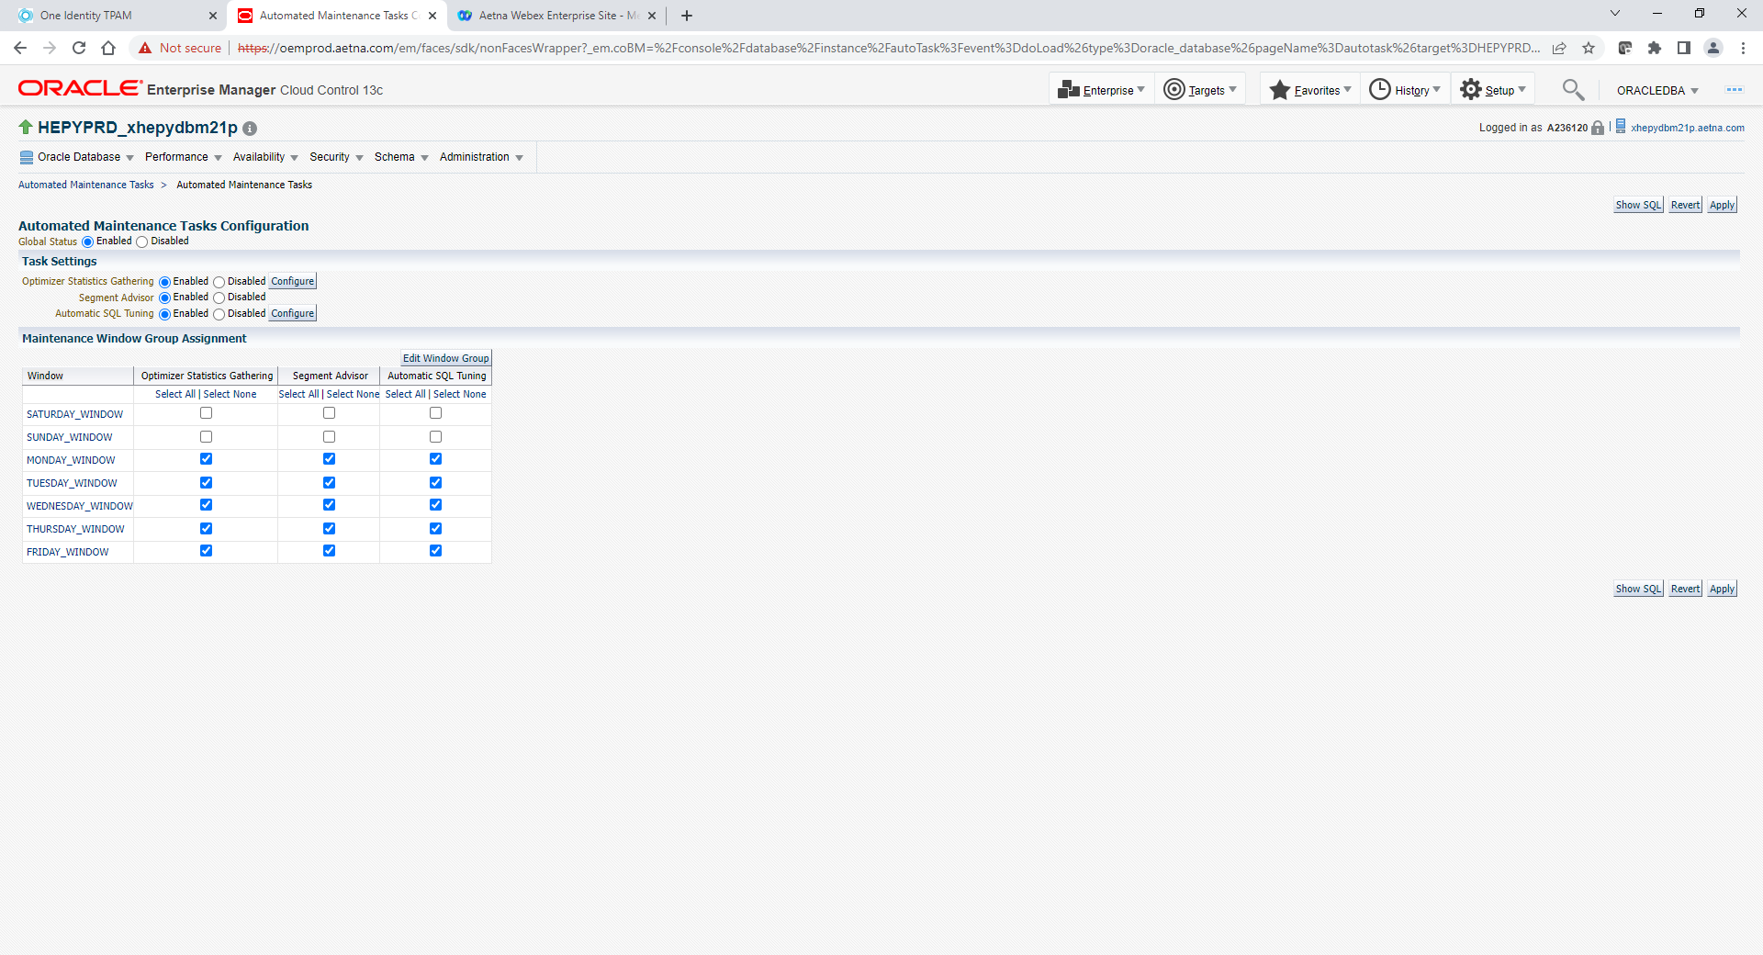

1. Make appropriate crontab changes to suspend any stats jobs that could start on Sunday morning both HEPYPRD and HEDWPRD

**Switchover steps:**

**After confirmation that application is down add one extra thread 2 standby log that was dropped during w21p lag issues.**

**From the current xhepydbw21p PY standby in Windsor**

dgmgrl /

edit database 'HEPYPRD_xhepydbw21p' set state=apply-off;

show database verbose 'HEPYPRD_xhepydbw21p';

sqlplus / as sysdba

alter system set standby_file_management='MANUAL' scope=memory;

ALTER DATABASE ADD STANDBY LOGFILE thread 2 GROUP 29 ('+REDOA_01','+REDOB_01') SIZE 6144M BLOCKSIZE 4096;

alter system set standby_file_management='AUTO' scope=memory;

dgmgrl /

edit database 'HEPYPRD_xhepydbw21p'set state=apply-on;

show database verbose 'HEPYPRD_xhepydbw21p';

**From current xhepydbm1p PY Primary**

alter system set db_writer_processes=12 scope=spfile;

!! Database will be bounced during switchover

~~srvctl stop database -d HEPYPRD_xhepydbm1p~~

~~srvctl start database -d HEPYPRD_xhepydbm1p~~

**If Windsor standby not in READ ONLY already you will need to change it.**

**From xhepydbw2ap server**

srvctl config database -d HEPYPRD_xhepydbw2pcl

srvctl modify database -d HEPYPRD_xhepydbw2pcl -startoption "READ ONLY";

srvctl stop database -d HEPYPRD_xhepydbw2pcl

srvctl start database -d HEPYPRD_xhepydbw2pcl

**From xhedwdbw2ap server**

srvctl config database -d HEDWPRD_xhedwdbw2pcl

srvctl modify database -d HEDWPRD_xhedwdbw2pcl -startoption "READ ONLY";

srvctl stop database -d HEDWPRD_xhedwdbw2pcl

srvctl start database -d HEDWPRD_xhedwdbw2pcl

**Disable RPT services.**

**From the current xhepydbw21p PY standby in Windsor**

exec DBMS_SERVICE.STOP_SERVICE('HEPYPRD_RPT');

**From the current xhedwdbw21p DW standby in Windsor**

exec DBMS_SERVICE.STOP_SERVICE('HEDWPRD_RPT');

1. **Disable start trigger on current Primary (xhepydbm1p and xhedwdbm21p)**

ALTER TRIGGER "SYS"."STARTDGSERVICES" DISABLE;

1. **Comment out all crontab entries on current Primary (xhepydbm1p and xhedwdbm21p)**
2. **Suspend OEM backup jobs on current Primary (HEPYPRD and HEDWPRD)**
3. **Double check make sure no stats jobs or backup running. Kill if anything still active. Current Primary (HEPYPRD and HEDWPRD)**
4. **Double check make sure sys password not expired. Just login as sysdba remotely to make sure. Current Primary (HEPYPRD and HEDWPRD)**
5. **Issue switchover command from current Primary**

dgmgrl

connect sys/xxx

switchover to '<DBNAME_CLUSTERNAME>';

HEPYPRD example

dgmgrl

connect sys/xxx

switchover to 'HEPYPRD_xhepydbm2pcl';

HEDWPRD example

dgmgrl

connect sys/xxx

switchover to 'HEDWPRD_xhedwdbm2pcl';

1. **Post switchover checks**

dgmgrl /

show configuration

For new Primary (RacOne NodeA)

show database verbose '<DBNAME_CLUSTERNAME> '

For new Standby (old Primary)

show database verbose '<DBNAME_SERVERNAME> '

From new Standby (old Primary) just to make sure or if any warnings from above command.

select * from v$archive_gap;

1. **Login remotely from sqlplus or (from DBArtsian, SQL Developer etc) - to make sure you can connect with your AID**
2. **If need to change S011890 (AppD) password and unlock account (AppD Admin will reach out to you if needed)**
3. **Check if any DB connections in original Standby’s (RPT)**

**From the xhepydbw21p PY standby in Windsor**

Kill if any connections still out there

**From the xhedwdbw21p DW standby in Windsor**

Kill if any connections still out there

1. **~~Suspend OEM Backup jobs on old Primary (new Standby)~~**
2. **Select appropriate Recovery Catalog for each Cluster Instance target. New Primary (HEPYPRD and HEDWPRD)**

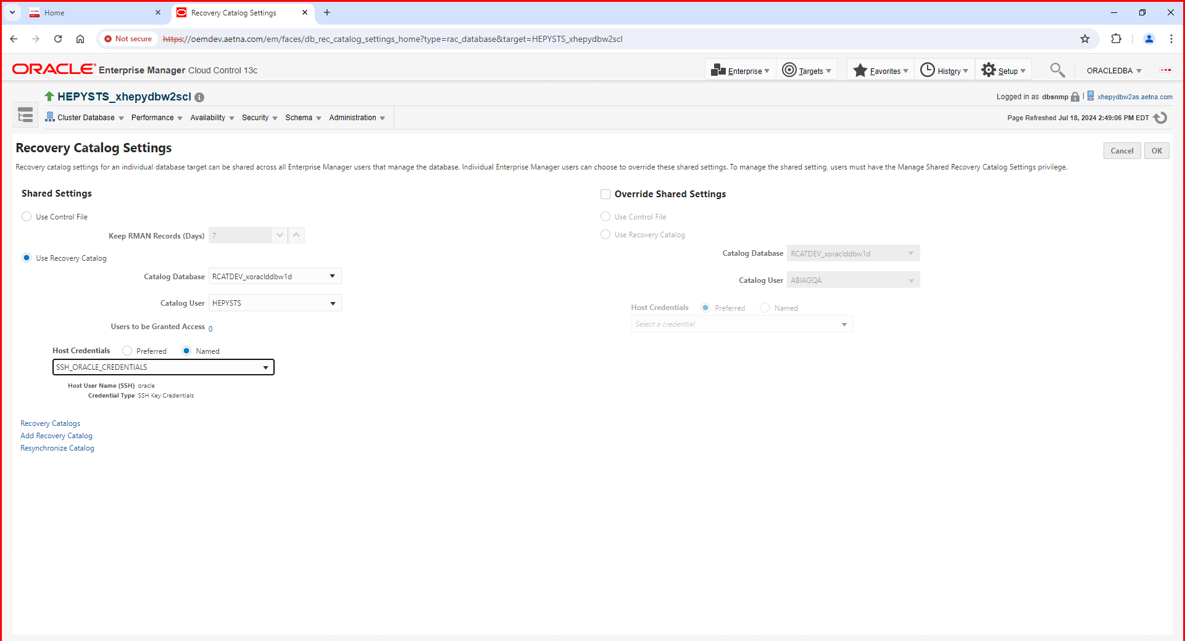

**13. Configure RMAN for both New Primary (HEPYPRD and HEDWPRD)**

--New Primary

#Retrieve new host and unit values

cat $HOME/std.env

STD_BACKUP_HOST=xxx

STD_STORAGE_UNIT=xxx

#Make highlighted changes based on database

CONFIGURE CHANNEL DEVICE TYPE 'SBT_TAPE' PARMS 'BLKSIZE=1048576,SBT_LIBRARY=/opt/dpsapps/rmanagent/lib/libddobk.so,ENV=(STORAGE_UNIT=xxx,BACKUP_HOST=xxx,ORACLE_HOME=/oradb/app/oracle/admin/DBNAME/oracle_home)' FORMAT'./%d/bk_%d_%I_%T/%U';

# Update rman configurations

--New Primary

rman

connect target /

CONFIGURE ARCHIVELOG DELETION POLICY TO SHIPPED TO ALL STANDBY BACKED UP 1 TIMES TO 'SBT_TAPE';

CONFIGURE DEVICE TYPE 'SBT_TAPE' PARALLELISM 8 BACKUP TYPE TO BACKUPSET;

CONFIGURE CHANNEL DEVICE TYPE 'SBT_TAPE' PARMS 'BLKSIZE=1048576,SBT_LIBRARY=/opt/dpsapps/rmanagent/lib/libddobk.so,ENV=(STORAGE_UNIT=xxx,BACKUP_HOST=xxx,ORACLE_HOME=/oradb/app/oracle/admin/DBNAME/oracle_home)' FORMAT'./%d/bk_%d_%I_%T/%U';

ALTER DATABASE ENABLE BLOCK CHANGE TRACKING;

--New Standby

rmanc

CONFIGURE ARCHIVELOG DELETION POLICY TO APPLIED ON STANDBY;

Create and schedule to run archive log backup to validate rman configuration. Follow our regular OEM create backup job process here.

**HEPYPRD**

**##Archive log backup (every 1 hour)**

**backup device type sbt tag '%TAG' archivelog all not backed up delete all input;**

**##Level 0 (Weekly: Saturday starts at 11:59 PM)**

**backup incremental level 0 cumulative device type sbt tag '%TAG' section size 128 G database;**

**delete noprompt obsolete device type 'SBT_TAPE';**

**##Level1 (Weekly: Except Friday and Saturday starts at 11 PM)**

**backup incremental level 1 device type sbt tag '%TAG' section size 128 G database;**

**HEDWPRD**

**##Archive log backup (every 1 hour)**

**backup device type sbt tag '%TAG' archivelog all not backed up delete all input;**

**##Level 0 (Weekly: Saturday starts at 10:00 AM)**

**backup incremental level 0 cumulative device type sbt tag '%TAG' section size 80 G database;**

**delete noprompt obsolete device type 'SBT_TAPE';**

**##Level1 (Weekly: Except Saturday and Sunday starts at 1:45 AM)**

**backup incremental level 1 device type sbt tag '%TAG' section size 80 G database;**

1. **Flip Standby PURGE Job (HEPYPRD and HEDWPRD)**

**In OEM go to New Primary target jobs and select <DBNAME>_STDBY_ARCHIVE_LOG_PURGE job. Select Create Like , remove old host and add new host (new Standby). Click Ok**

**After that stop and delete this job on new Primary. New Primary should not have STDBY ARCHIVE LOG PURGE job after that.**

**Go back to new Standby and check to make sure <DBNAME>_STDBY_ARCHIVE_LOG_PURGE that was created above exist and scheduled.**

1. **Enable crontab jobs.**

**Login to PY Middletown NodeA: xhepydbm2ap**

**cd $HOME/eb/crontab**

**crontab crontab_HEPYPRD.txt**

**crontab -e**

**Login to PY Windsor NodeA: xhepydbw2ap**

**cd $HOME/eb/crontab**

**crontab crontab_HEPYPRD_Standby.txt**

**crontab -e**

**Login to DW Middletown NodeA: xhedwdbm2ap**

**cd $HOME/eb/crontab**

**crontab crontab_HEDWPRD.txt**

**crontab -e**

**Login to DW Windsor NodeA: xhedwdbw2ap**

**cd $HOME/eb/crontab**

**crontab crontab_HEDWPRD_Standby.txt**

**crontab -e**

1. **Check to make sure all** Oracle Automated Maintenance Tasks enabled. Enable if needed. **(HEPYPRD and HEDWPRD)**
2. **Check heartbeat updates on new RACONE databases. (HEPYPRD and HEDWPRD)**