**Initial steps:**

1. **Upon database VM(s) hand over from Linux Build team to DBA start with following actions:**

Ask Linux build technician to provide you with **oracle** and **grid** OS Users initial credentials.

Verify SSH connectivity under OS **oracle** and **grid** users. Change initial password for each user upon first login.

1. Check to make sure appropriate oracle mount points in place.

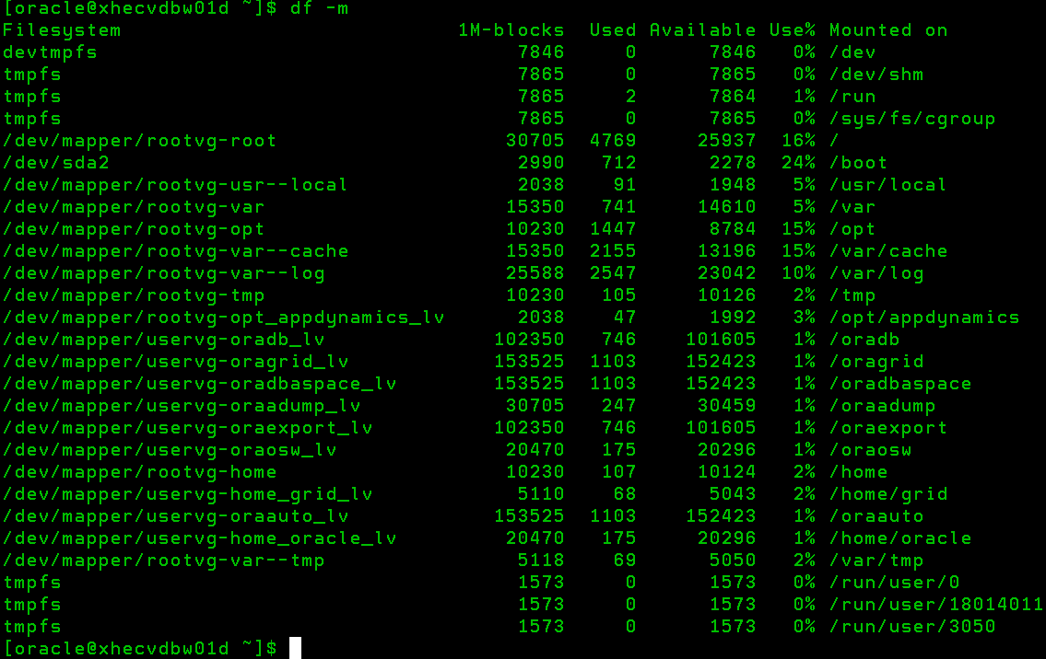

1. Check to make sure ASM disks in place and permissions set correctly

ls -l /dev/oracleasm/disks/*

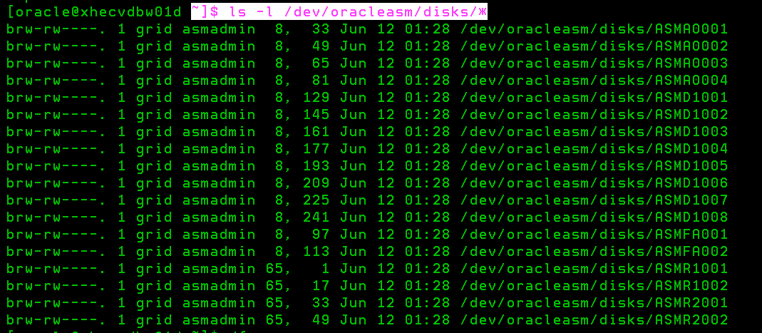

**Correct permissions example below**

brw-rw-r--. 1 grid asmadmin 8, 225 Oct 8 21:33 /dev/oracleasm/disks/ASMD1013

brw-rw-r--. 1 grid asmadmin 8, 241 Oct 8 21:33 /dev/oracleasm/disks/ASMD1014

**Incorrect permissions example below**

brw-r-----. 1 grid asmadmin 65, 224 Oct 8 19:37 /dev/oracleasm/disks/ASMD1019

brw-r-----. 1 grid asmadmin 65, 240 Oct 8 19:37 /dev/oracleasm/disks/ASMD1020

1. Check group permissions

Configure grid and oracle users with the following UIDs/GIDs.

id oracle

id grid

uid=2232(grid) gid=54324oinstall)

1250(dba),54324(oinstall),54326(asmdba),54327(asmoper),54328(asmadmin)

uid=3050(oracle) gid=54324(oinstall)

1250(dba),54324(oinstall),54326(asmdba),54329(oper)

1. Reach out to Rich Ryan to add new RHEL8 VM(s) to Jenkins Inventory, so you can utilize automation.
2. Send out email to (Toelken, William <ToelkenW@cvshealth.com>; Enaganti, Sandeep <Sandeep.Enaganti@omnicare.com>; O'shaughnessy, Daniel [ddoshaughnes@cvshealth.com](mailto:ddoshaughnes@cvshealth.com)) to install ddboost on new server(s). **(It may several days, escalate if needed)**

Once you received confirmation that ddboost installed continue with next steps below

How to verify ddboost install

cd /opt/dpsapps/rmanagent/bin

./ddutil -i

RMAN Agent Version: 19.5.0.0(40)

**Install Oracle Software via Jenkins:**

# In new incognito window open below link

<https://ci-autoeng.cvshealth.com/jenkins/>

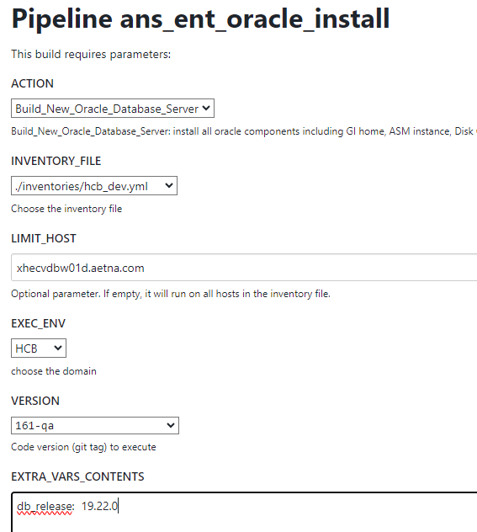

db_release: 19.22.0

~~rman_agent_home: "/opt/dpsapps/rmanagent"~~

For PROD until OEM upgraded use following extra parameter

oem_release: 13.4.0.0

Compare huge pages between Source VM and new RHEL8 target VM

If it needs to be adjusted use following extra parameter

huge_pages: <desired number of huge pages>

**Create Standby DB via Jenkins:**

**!!! Check storage (size) allocation on new RHEL8 target VM, compare to what is currently allocated on Source VM.**

**If they allocated less on new RHEL8 VM reach out to Linux Admin to fix it, before starting Standby creation.**

**!!! Compare HUGE pages between Source VM and new RHEL8. (If this step was not completed with software install)**

**If HUGE pages on new RHEL8 server less than what currently on Source Server execute following Jenkins action:**

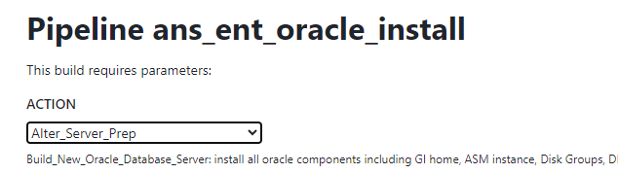

**huge_pages: <desired number of huge pages>**

**!!! Double check to make sure max user processes parameter set correctly on target RHEL8 server compare to source RHEL7 server**

ulimit -a

max user processes (-u) xxx

**if not run Alter_Server_Prep Jenkins Action**



**noproc: xxx**

**!! Double check to make sure $HOME/std.env file owned by oracle if it’s own by root run Deploy scripts and specify the storage unit in VARS**

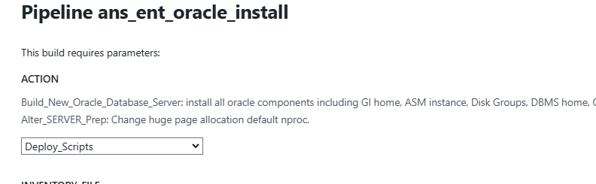

**storage_unit: ora_str_boost0821**

**Example if you need to update lockbox before clone for standby**

**cd /oradb/app/oracle/product/19.22.0/db_1/dbs**

**vi initORCL.ora**

**db_name='ORCL'**

**memory_target=1G**

**processes = 150**

**export ORACLE_SID=ORCL**

**sqlplus / as sysdba**

**startup nomount pfile="/oradb/app/oracle/product/19.22.0/db_1/dbs/initORCL.ora";**

**exit**

**rman**

**connect target /**

**run {**

**allocate channel dd01 type 'sbt_tape' parms 'SBT_LIBRARY=/opt/dpsapps/rmanagent/lib/libddobk.so,ENV=(BACKUP_HOST=winpdd0821_v20.aetna.com,RMAN_AGENT_HOME=/opt/dpsapps/rmanagent)';**

**send 'set username ddboost_ora password ddb00st servername winpdd0821_v20.aetna.com storageunit ora_str_boost0821';**

**release channel dd01;**

**}**

**exit**

**Sqlplus / as sysdba**

**shutdown abort**

**exit**

**!!! Check make sure Source DB sys password not expired.**

**Login to Source database under sys and if expired just change password to the same.**

# In new incognito window open below link

<https://ci-autoeng.cvshealth.com/jenkins/>

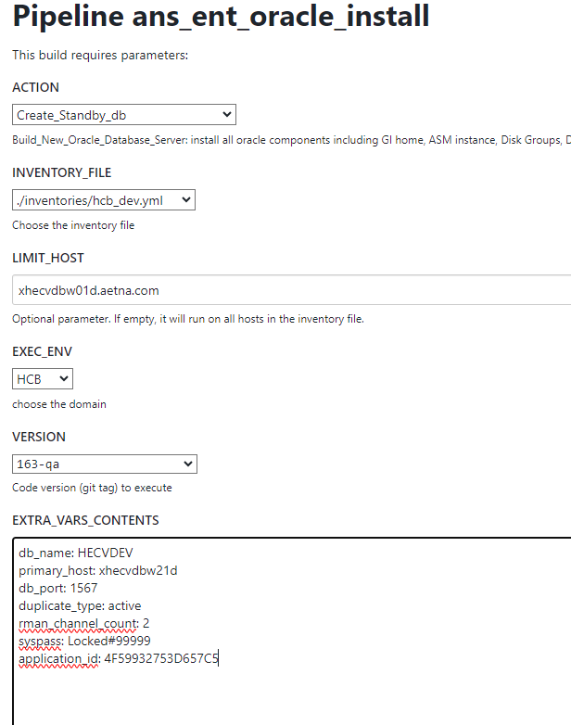

**### !!! Below is an example only. You will need to determine each parameter value based on environment that you are working on…**

**### !!! Obtain appropriate application ID from service now. Locate your source database and go to Application Relationships Tab as shown per example below**

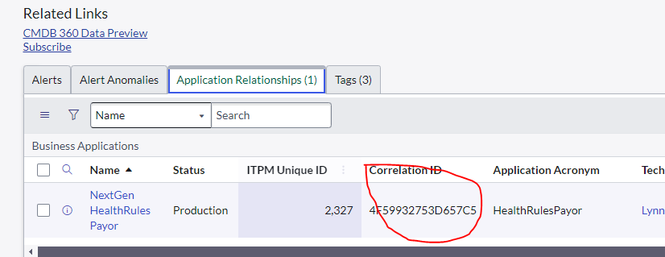

**EXTRA_VARS_CONTENTS example below**

db_name: DBNAME

primary_host: xhedwdbw23d

db_port: xxxx

duplicate_type: active

rman_channel_count: 4

syspass: XXXXXXXXXXXXXXXXXXXXXXXXXXXX

application_id: 4F59932753D657C5

**Clone/Standby monitor**:

tail log under /oradb/app/oracle/admin/<DB_NAME>/rman

**If it fails and depends on where It fails do one or more of those things. You will need to figure out if each step needed or not based which Jenkins step failed.**

1.Shutdown the instance (shutdown abort) or kill pmon of auxiliary database

2.Remove instance files from $DBS (rm *<DBNAME>*)

3.Remove the database entry from the /etc/oratab if exists

4.Remove the database directories from asm. In asmcmd rm -r */<DBNAME_SERVERNAME>

5. Stop and remove listener if running

srvctl stop listener -l <DBNAME>

srvctl remove listener -l <DBNAME>

6. OEM backup jobs could be still suspended. Resume one by one.

**Post Create Standby checks**

dgmgrl /

show configuration

show database verbose '<DBNAME>_<SERVERNAME>'

Run this from Standby side to check for gap

select * from v$archive_gap;

**OEM Patch:**

**!!! Check with Rich Ryan and/or OEM Admins if step below still needed.**

For your newly built RHEL 8 VMs,  please execute the following to apply the latest agent RU.   This applies to non-prod only.

. oraenv

GCAGENT

emctl stop agent

/oradb/app/oracle/product/oem_agent/agent_13.5.0.0.0/OPatch/opatch napply /oradb/app/oracle/product/oem_agent/oneoffs/36459164 -oh /oradb/app/oracle/product/oem_agent/agent_13.5.0.0.0 -invptrLoc /oradb/app/oracle/product/oem_agent/agent_13.5.0.0.0/oraInst.loc

emctl start agent

If you encounter a problem on any VM, it probably means the install was performed prior to the patch being staged on the OEM OMS.    In this case we will need to take additional steps.

**Pre Switchover and Switchover steps:**

**Pre Switchover steps:**

1. **Send revised jdbc connections strings to Application team to reflect new server name to allow this work to be staged in preparation of switchover.**
2. **Stage tnsnames.ora entries in app store. (Work with Mark Luddy on that step)**
3. **Inform your application team to install from App Store latest tnsnames.ora, ldap.ora and sqlnet.ora**
4. **Copy wallet to new server (where applicable).**
5. **Staged all appropriate crontab jobs and other scripts on new RHEL8 VM. You can add entries in crontab just keep them commented out for now.**

**Switchover steps:**

1. **Notify App. team to stop all connections to all databases being migrated and log out individual connections (pre Request to switchover)**
2. **Before attempting a switchover, you must ensure the following GLOBAL_DBNAME entry is added to the listener.ora on current Primary (Example below)**

cd $ORACLE_HOME/network/admin

vi listener.ora

(GLOBAL_DBNAME = <DBNAME>_<SERVERNAME>_dgmgrl)

lsnrctl reload <DBNAME>

1. **Disable all applicable database jobs in cron and OEM backups just prior to DB switchover (Current Primary)**

!!! Prior to switchover comment out all crontab jobs on RHEL7 database server

!!! Prior to switchover suspend OEM Backup jobs on current Primary RHEL7

1. **Issue switchover command from current Primary**

#before switchover check to make sure not gap

#Run from Standby side

select * from v$archive_gap;

#if gap exist resolve it first before switchover…

**From Primary to restore**

rmanc

restore archivelog sequence between xxx and xxx;

alter system switch logfile;

dgmgrl

connect sys/xxx

switchover to '<DBNAME>_<STANDBY_SERVERNAME>';

1. **Post switchover check commands**

To make sure all SUCCESS and looks as expected. And no Warnings.

!!! It may report errors. You may need to wait a few min and try again. It takes time broker to catchup.

dgmgrl /

show configuration

show database verbose '<DBNAME>_<SERVERNAME>'

## To check if gap exists. Run from Standby side

select * from v$archive_gap;

1. **DBA confirm remote connectivity to all migrated databases.**

(Login from SQL Developer or DBArtisan)

!!! In some cases you may run into following errors while connecting from DBArtisan or simply querying DBA_TEMP_FILES table.

ORA-01157: cannot identif

ORA-01110

**query to dba_temp_files fails with ORA-01157 and ORA-01110 (Doc ID 2929591.1)**

1. **DBA notify Application team to start all connections to migrated databases and proceed with checkout.**
2. **Define RMAN CATALOG for database under Recover Catalog Settings. See example below**

Select Database Instance Target for which you are defining Catalog and go to Recovery Catalog Settings per screen shot below

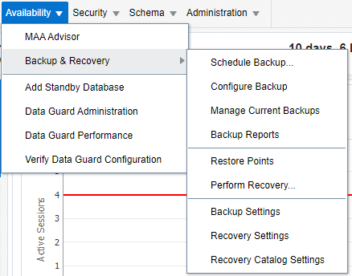

Choose **Recovery Catalog** option and find your database catalog name under Catalog User Drop down

If database catalog found select Named for Host Credentials and pick SSH_ORACLE_CREDENTIALS per screen shot example below

Click OK.

**At this point you can start creating OEM Rman backups as normal.**

If database catalog for database was not found in Catalog User drop down follow steps to **Add Recovery Catalog.**

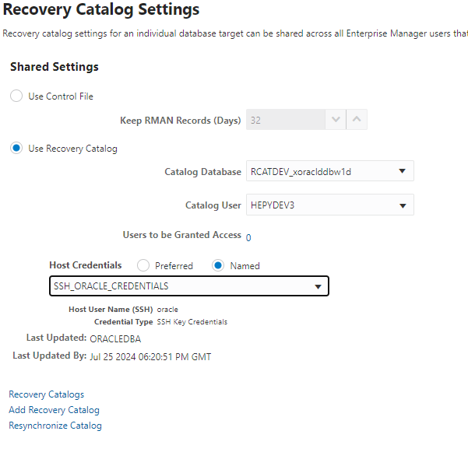

Click on Add Recovery Catalog link



Select magnified glass icon on the right side of Database Target field.

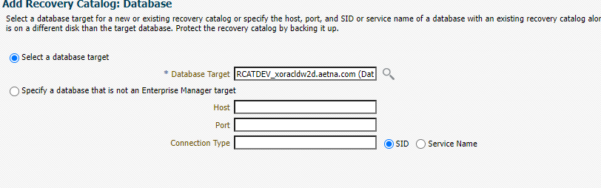

Type RCATDEV and hit enter or Go

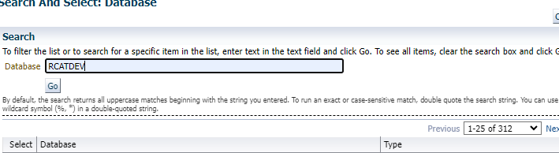

Select following database

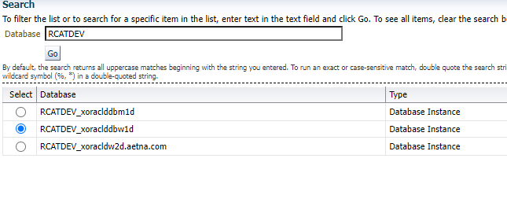

Click Next

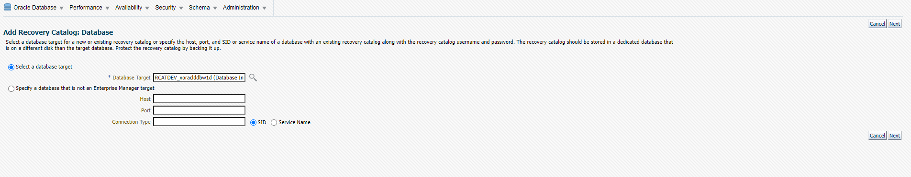

Type your catalog database name in following format: DBNAME_RCAT and click Search button

If following message appears: **There are no named credentials defined**. Follow next screen shots on how to fixed.

Click cancel for now.

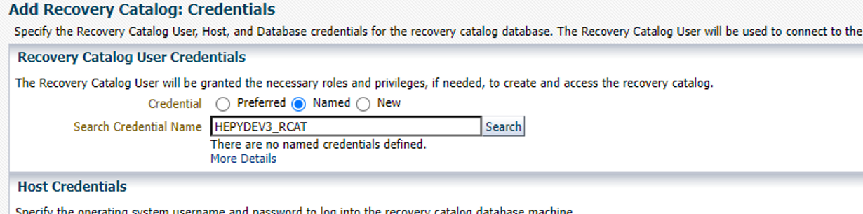

Go to Setup🡪 Security🡪 Named Credentials

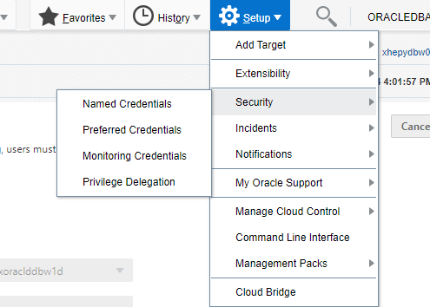

**Click on Blue square and type DBNAME_RCAT and hit enter**

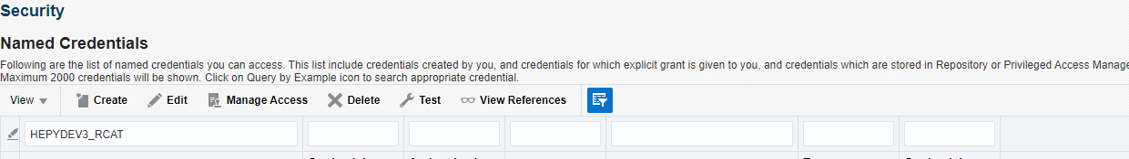

**Click Edit**

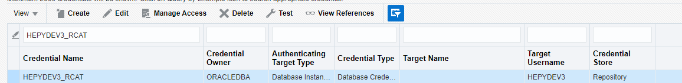

**Select Global and save**

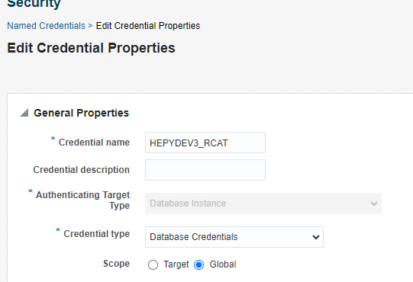

**GO back to add recovery screen and make sure no messages after hitting Search in first section. You should see DBNAME_RAC appear in dropdown below.**

**Complete other section as example below**

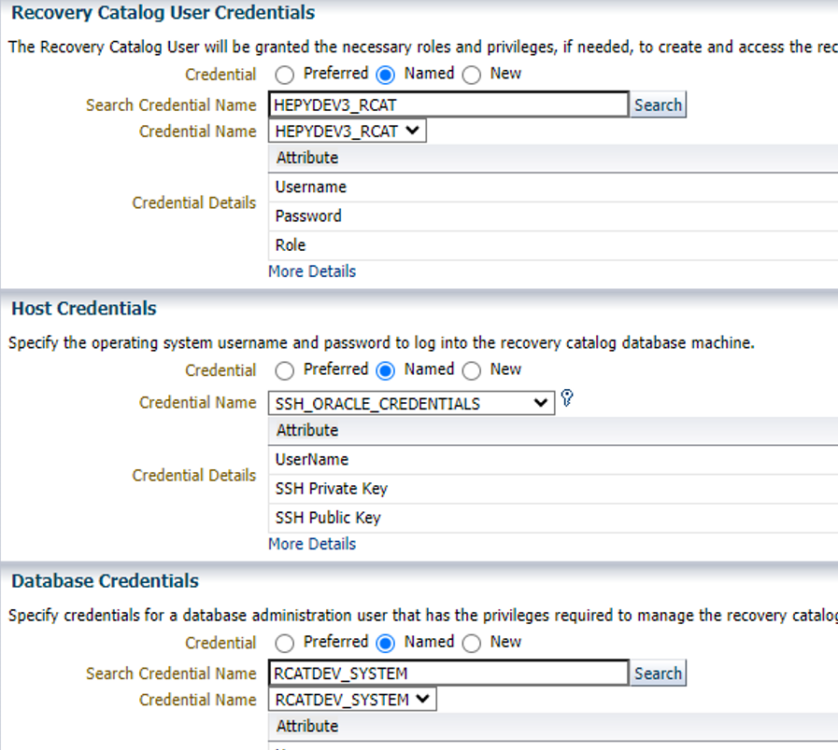

**Click Continue and then Finish on other screen and go back to Recover catalog Setting screen where you should find your database**



1. **Once apps are up DBA confirms no application connections to Standby (OLD Primary) database.**
2. **Flip RMAN Archivelog Deletion Policies due to switchover activity, Enable Block Change Tracking in new Primary DataBase, make changes to CONFIGURE CHANNEL DEVICE TYPE 'SBT_TAPE' PARMS**

New Primary

#Retrieve new host and unit values

cat $HOME/std.env

STD_BACKUP_HOST=xxx

STD_STORAGE_UNIT=xxx

#Prepare command and update highlighted in red with real values. Do not execute this at this point.

CONFIGURE CHANNEL DEVICE TYPE 'SBT_TAPE' PARMS 'BLKSIZE=1048576,SBT_LIBRARY=/opt/dpsapps/rmanagent/lib/libddobk.so,ENV=(STORAGE_UNIT=xxx,BACKUP_HOST=xxx,ORACLE_HOME=/oradb/app/oracle/admin/DBNAME/oracle_home)' FORMAT'./%d/bk_%d_%I_%T/%U';

#update following file

cd /oradb/app/oracle/product/19.22.0/db_1/config

vi rman_agent_home.cfg

RMAN_AGENT_HOME=/opt/dpsapps/rmanagent

# Update rman configurations

--New Primary

rmanc

CONFIGURE ARCHIVELOG DELETION POLICY TO SHIPPED TO ALL STANDBY BACKED UP 1 TIMES TO 'SBT_TAPE';

CONFIGURE CHANNEL DEVICE TYPE 'SBT_TAPE' PARMS 'BLKSIZE=1048576,SBT_LIBRARY=/opt/dpsapps/rmanagent/lib/libddobk.so,ENV=(STORAGE_UNIT=xxx,BACKUP_HOST=xxx,ORACLE_HOME=/oradb/app/oracle/admin/DBNAME/oracle_home)' FORMAT'./%d/bk_%d_%I_%T/%U';

ALTER DATABASE ENABLE BLOCK CHANGE TRACKING;

--New Standby

rmanc

CONFIGURE ARCHIVELOG DELETION POLICY TO APPLIED ON STANDBY;

1. **In OEM go to New Primary target jobs and select <DBNAME>_STDBY1_ARCHIVE_LOG_PURGE job. Select Create Like , remove old host and add new host (new Standby). Click Ok**
2. **After that stop and delete this job on new Primary. New Primary should not have STDBY ARCHIVE LOG PURGE job after that.**
3. **Go back to new Standby and check to make sure PURGE JOB that was created above exist and scheduled.**
4. **On new Standby you may note existing schedule of existing Level0, Level1 and Archvielog backup jobs. Then stop and delete them. New Standby should still have <DBNAME>_STDBY1_ARCHIVE_LOG_PURGE as expected.**
5. **Create and schedule to run archive log backup to validate rman configuration. Follow our regular OEM create backup job process here.**
6. **Create and schedule Level 0 and Level 1 backup jobs. Follow our regular OEM create backup job process here.**
7. **Activate appropriate crontab jobs. Those could be staged prior to switchover**

**Post Switchover steps:**

1. **Create standby database where applicable (QA1 and PROD) on new RHEL8 Standby VM**

**Decommission old RHEL7 VM steps:**

1. Drop original primary (New Standby) database after some agreed timeframe.
2. Decommission original RHEL7 VM following Jenkins actions from **ans_ent_oracle_deinstall** pipeline

# In new incognito window open below link

<https://ci-autoeng.cvshealth.com/jenkins/>

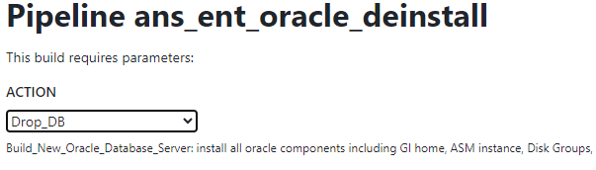

**Example:**

**instance_name: HEPYDEV3**

**syspass: Locked#99999**

**rcatpass: HEPYDEV3namr**

**backup_archived_logs: n**

**remove_from_oem: y**

**remove_backups: n**

**remove_diag_files: y**

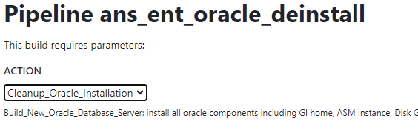

**!! leave empty parameter section. Make sure no spaces.**

**Last step once all above completed submit decommission request to Linux team**

https://aetnaprod1.service-now.com/sp_home?id=sc_cat_item&sys_id=56fcceaa1b553890235015ff034bcb1d&sysparm_category=b55bebe26f8b150007a5f00dba3ee459