**Before increase datafile size check make sure you have free physical space on DISK**

xhepydbm21p.aetna.com (oracle) +**ASM**::/home/oracle

+ASM> sqlplus / as sysdba

SQL*Plus: Release 19.0.0.0.0 - Production on Wed Mar 16 12:54:23 2022

Version 19.10.0.0.0

Copyright (c) 1982, 2020, Oracle. All rights reserved.

Connected to:

Oracle Database 19c Enterprise Edition Release 19.0.0.0.0 - Production

Version 19.10.0.0.0

SQL> @showasm

MOUNT_STATUS HEADER_STATUS OS_MB TOTAL_MB FREE_MB SECTOR_SIZE LOGICAL_SECTOR_SIZE Name Label Path

------------ -------------- ---------- ---------- ---------- ----------- ------------------- ------------------ ------------ ---------

CACHED MEMBER 3276800 3276800 270284 512 512 DATA_01_0004 VOLDAT01 /dev/ora1

CACHED MEMBER 3276800 3276800 270292 512 512 DATA_01_0007 VOLDAT02 /dev/ora2

CACHED MEMBER 3276800 3276800 270288 512 512 DATA_01_0003 VOLDAT03 /dev/ora3

CACHED MEMBER 3276800 3276800 270292 512 512 DATA_01_0006 VOLDAT04 /dev/ora4

CACHED MEMBER 3276800 3276800 270292 512 512 DATA_01_0002 VOLDAT05 /dev/ora5

CACHED MEMBER 3276800 3276800 270296 512 512 DATA_01_0001 VOLDAT06 /dev/ora6

CACHED MEMBER 3276800 3276800 270300 512 512 DATA_01_0000 VOLDAT07 /dev/ora7

CACHED MEMBER 3276800 3276800 270296 512 512 DATA_01_0005 VOLDAT08 /dev/ora8

CACHED MEMBER 3276800 3276800 270304 512 512 DATA_01_0008 VOLDAT09 /dev/ora9

CACHED MEMBER 3276800 3276800 270292 512 512 DATA_01_0009 VOLDAT10 /dev/ora0

CACHED MEMBER 3276800 3276800 270300 512 512 DATA_01_0010 VOLDAT11 /dev/ora1

CACHED MEMBER 3276800 3276800 270296 512 512 DATA_01_0011 VOLDAT12 /dev/ora2

CACHED MEMBER 3276800 3276800 270292 512 512 DATA_01_0012 VOLDAT13 /dev/ora3

CACHED MEMBER 3276800 3276800 270304 512 512 DATA_01_0013 VOLDAT14 /dev/ora4

CACHED MEMBER 358400 358400 352652 512 512 FLASH_01_0003 VOLFLSH1 /dev/ora1

CACHED MEMBER 358400 358400 352644 512 512 FLASH_01_0000 VOLFLSH2 /dev/ora2

CACHED MEMBER 358400 358400 352640 512 512 FLASH_01_0002 VOLFLSH3 /dev/ora3

CACHED MEMBER 358400 358400 352640 512 512 FLASH_01_0001 VOLFLSH4 /dev/ora4

CACHED MEMBER 3276800 3276800 1011164 512 512 IND_01_0007 VOLIND01 /dev/ora1

CACHED MEMBER 3276800 3276800 1011172 512 512 IND_01_0003 VOLIND02 /dev/ora2

CACHED MEMBER 3276800 3276800 1011172 512 512 IND_01_0006 VOLIND03 /dev/ora3

CACHED MEMBER 3276800 3276800 1011160 512 512 IND_01_0002 VOLIND04 /dev/ora4

CACHED MEMBER 3276800 3276800 1011164 512 512 IND_01_0005 VOLIND05 /dev/ora5

CACHED MEMBER 3276800 3276800 1011168 512 512 IND_01_0001 VOLIND06 /dev/ora6

CACHED MEMBER 3276800 3276800 1011152 512 512 IND_01_0004 VOLIND07 /dev/ora7

CACHED MEMBER 3276800 3276800 1011148 512 512 IND_01_0000 VOLIND08 /dev/ora8

CACHED MEMBER 79872 79872 49038 512 512 REDOA_01_0000 VOLREDO1 /dev/ora1

MOUNT_STATUS HEADER_STATUS OS_MB TOTAL_MB FREE_MB SECTOR_SIZE LOGICAL_SECTOR_SIZE Name Label Path

------------ -------------- ---------- ---------- ---------- ----------- ------------------- ------------------ ------------ ---------

CACHED MEMBER 79872 79872 49038 512 512 REDOA_01_0001 VOLREDO2 /dev/ora2

CACHED MEMBER 79872 79872 52112 512 512 REDOB_01_0000 VOLREDO3 /dev/ora3

CACHED MEMBER 79872 79872 52110 512 512 REDOB_01_0001 VOLREDO4 /dev/ora4

From above you can see that we have about 3.7 TB free on DATA_01 Disk group and about 8 TB free on IND_01 Disk group

Example below how to resize DATA4 tablespace

Login to DBAartisan under your AID or sys or system

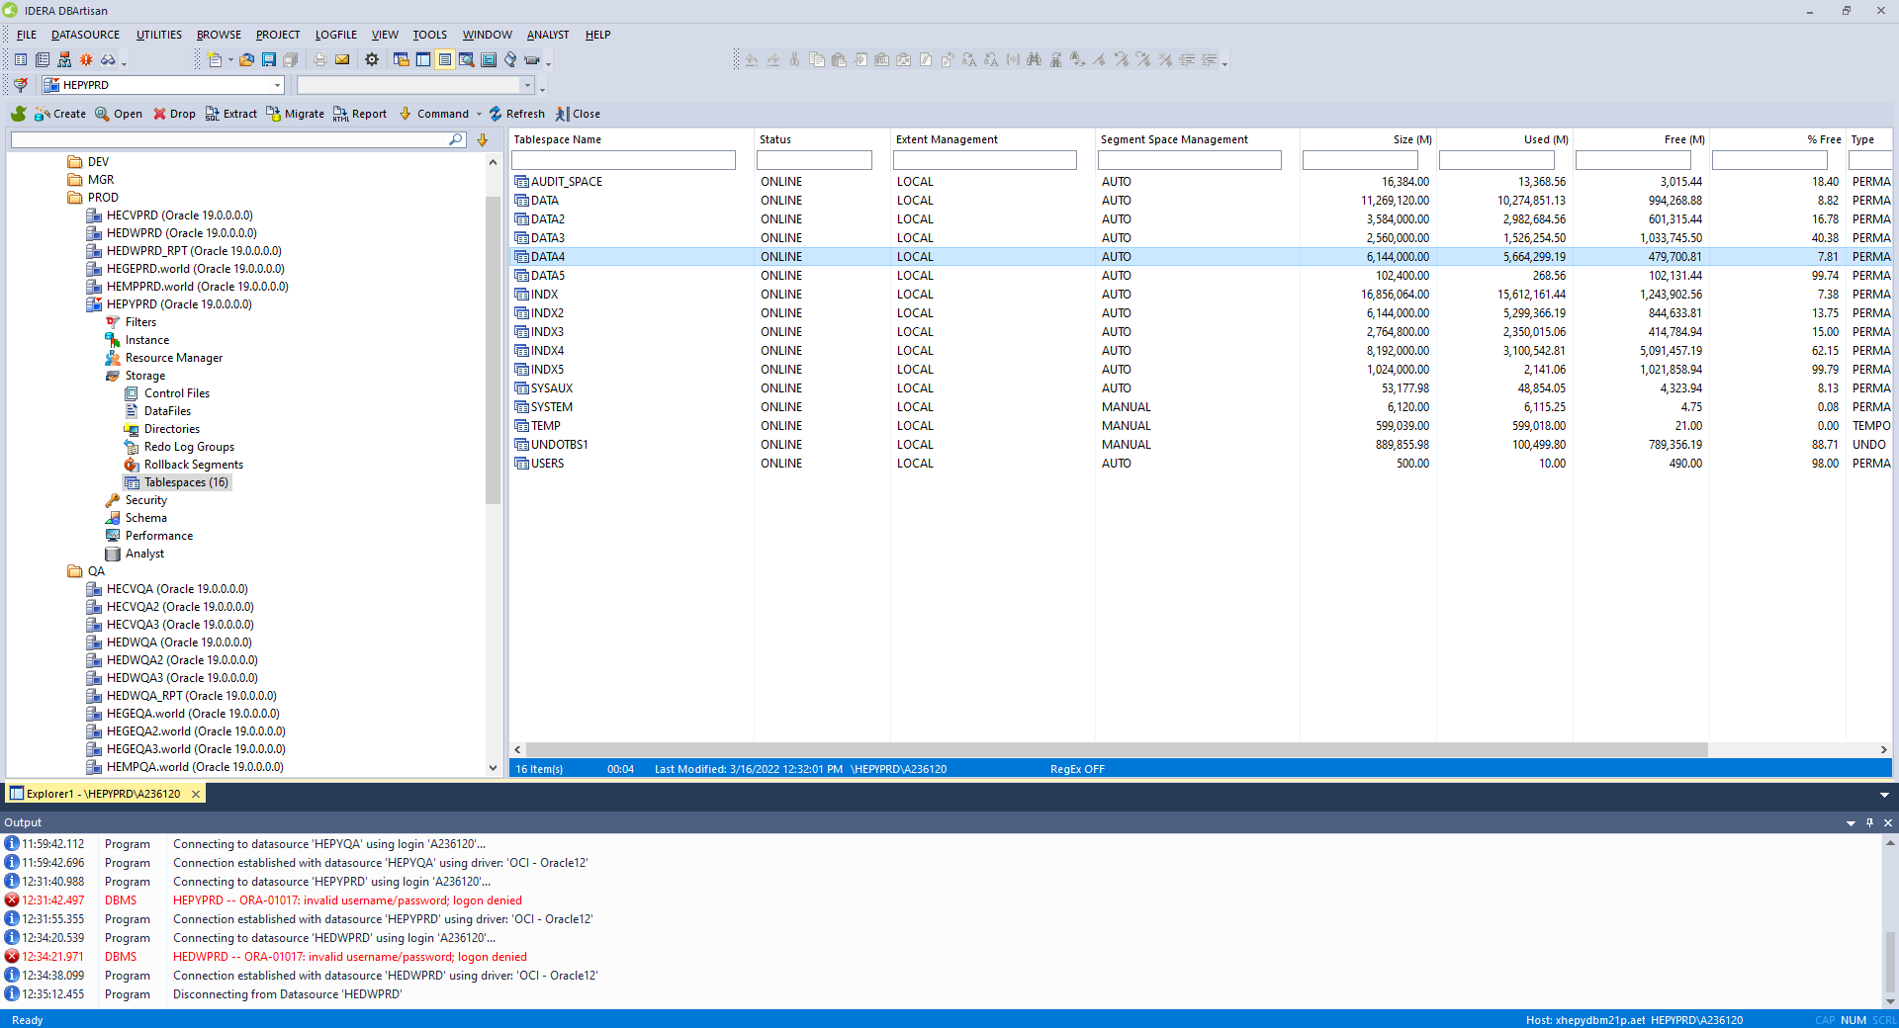

Select appropriate tablespace and double click

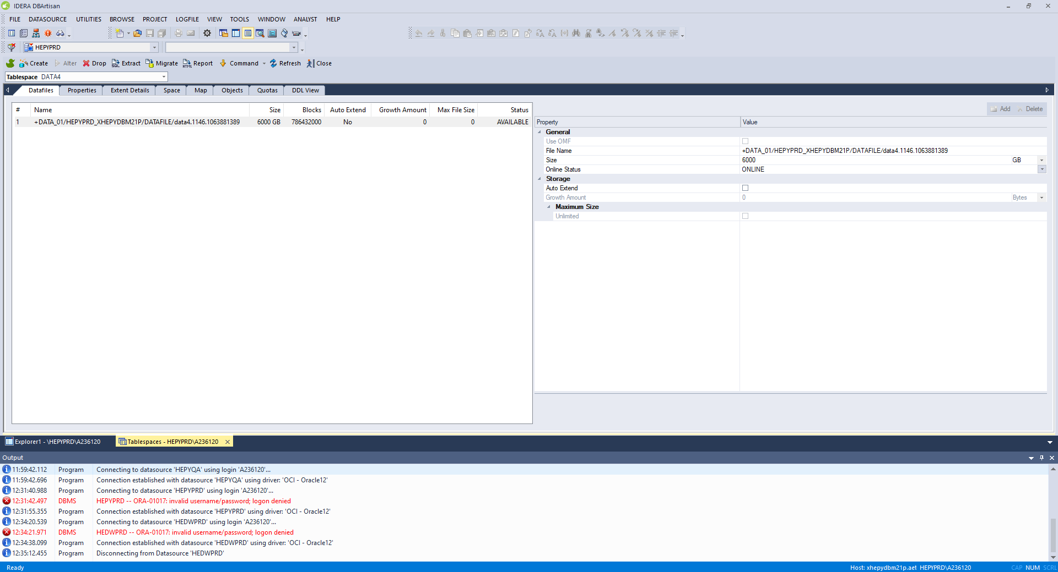

Only resize 100 G at the time. You can resize more, but it will take longer time and you may have lag with logs shipping over to standby. Which may generate OEM alerts.

I tried different sizes like resize 500 G at the time, but 100 G is most optimal

Change size on right from 6000 to 6100

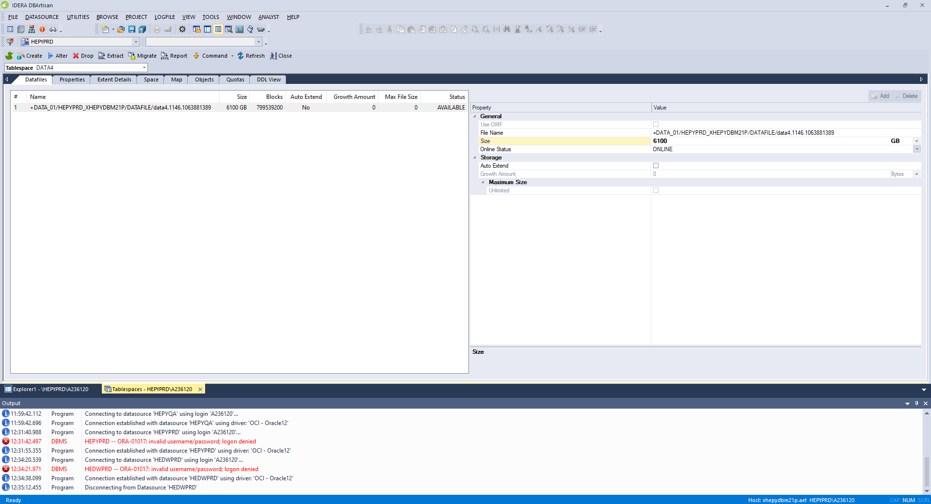

Click Alter button on top left. DO NOT HIT EXECUTE

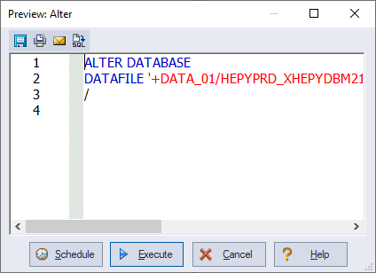

Just copy DDL to your script or notepad. Click Cancel button.

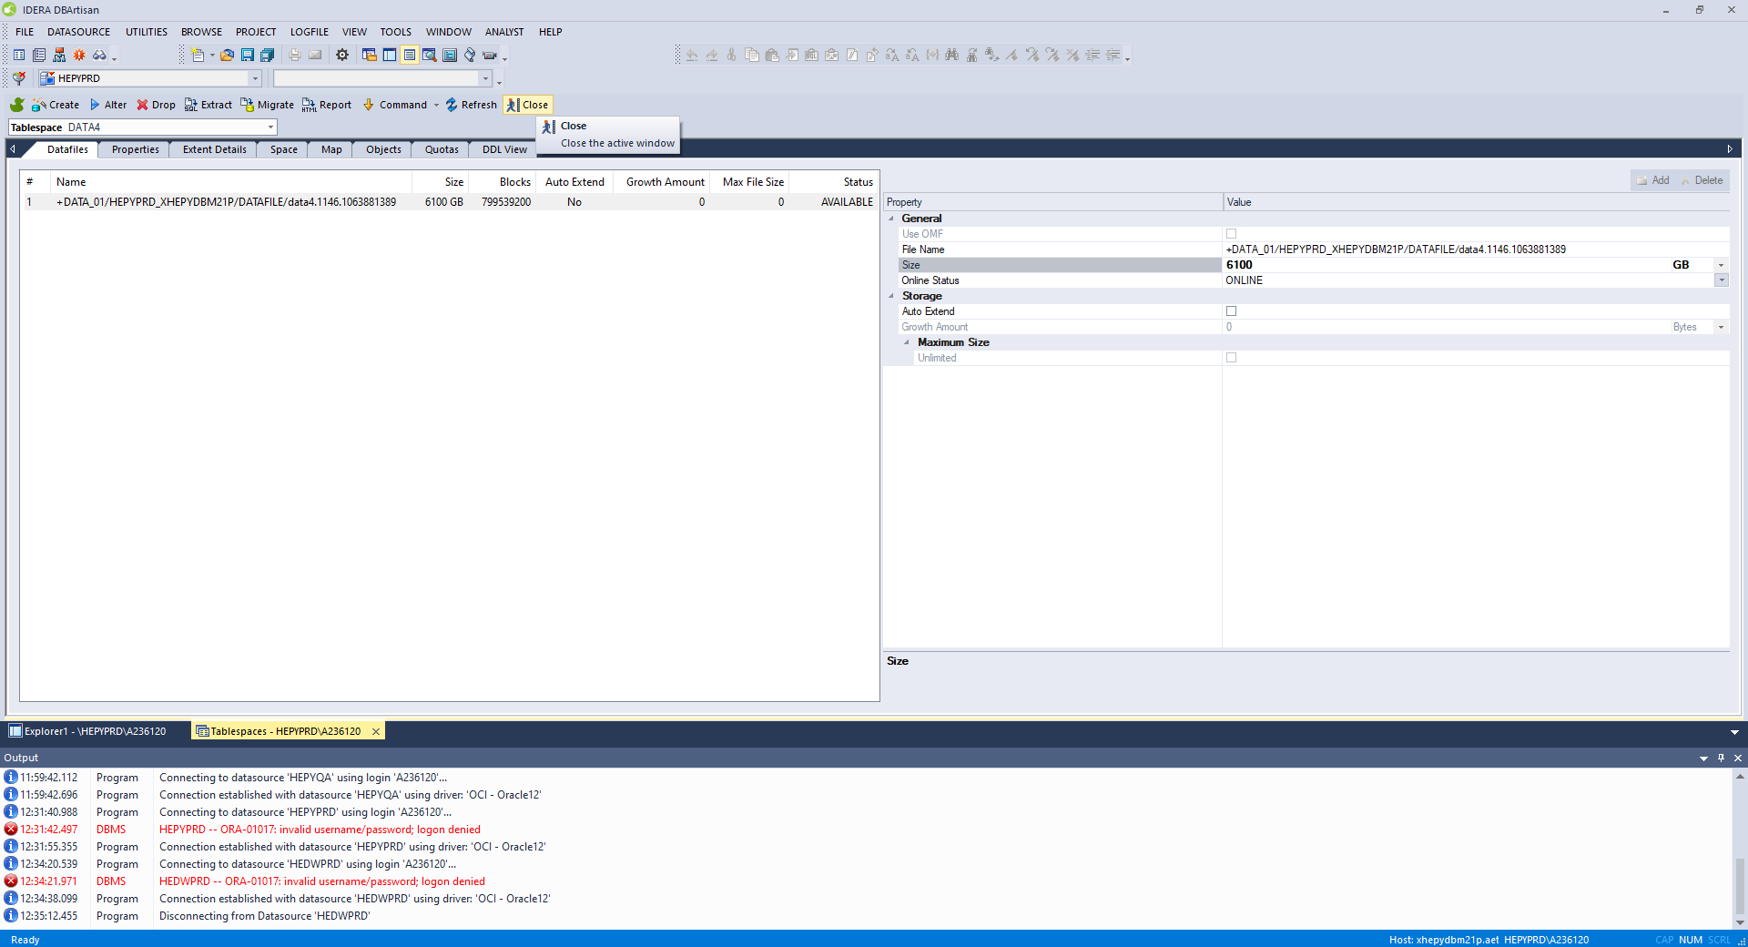

Click Close button.

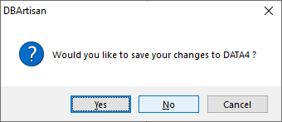

Click No

Login to Linux server make sure you set database environment

+ASM> . oraenv

ORACLE_SID = [+ASM] ? HEPYPRD

sqlplus / as sysdba

ALTER DATABASE

DATAFILE '+DATA_01/HEPYPRD_XHEPYDBM21P/DATAFILE/data4.1146.1063881389' RESIZE 6100G

/

After that repeat above just increase resize 100 G at the time until you reach desire size.