DPP PeopleSoft Database Upgrade from 11.2.0.3 to 11.2.0.4

This document includes only Software Installation and Cloning procedures.

PREWORK

- Stage 11.2.0.4 Software on database server

- 11.2.0.4 Oracle DB Software
p13390677_112040_AIX64-5L_1of7.zip
p13390677_112040_AIX64-5L_2of7.zip
p13390677_112040_AIX64-5L_7of7.zip

- Latest PSU (Jan 2015)
p19769489_112040_AIX64-5L.zip

- Recommended Patches
p16188701_112040_AIX64-5L.zip
p17551261_112040_AIX64-5L.zip
p18255105_112040_Generic.zip

- Latest OPatch Utility version (11.2.0.3.6)
p6880880_112000_AIX64-5L.zip

--DPPDEV
cd /u11/
mkdir Ora11204_stage

FTP zip files over….

--Unzip files
cd /u11/Ora11204_stage
unzip p13390677_112040_AIX64-5L_1of7.zip
unzip p13390677_112040_AIX64-5L_2of7.zip
unzip p13390677_112040_AIX64-5L_7of7.zip

unzip p16188701_112040_AIX64-5L.zip
unzip p17551261_112040_AIX64-5L.zip
unzip p18255105_112040_Generic.zip

unzip p19769489_112040_AIX64-5L.zip

unzip p6880880_112000_AIX64-5L.zip

cp -r OPatch /u01/app/oracle/product/11.2.0.4/db_1/

- Install Software and apply patches

--Create dummy Database Entry in oratab file to start 11.2.0.4 environment

--Pre create directory:

cd /u01/app/oracle/product
mkkir 11.2.0.4
cd /11.2.0.4
mkdir db_1
mkdir db_2

cd /etc
vi oratab

ORA11204_1:/u01/app/oracle/product/11.2.0.4/db_1:N
ORA11204_2:/u01/app/oracle/product/11.2.0.4/db_2:N

cd $HOME/aetna/scripts

cp -p oraprof oraprof_20141216

---Add following entries to oraprof

vi oraprof

"ORA11204_1")
NLS_LANG=AMERICAN_AMERICA.WE8ISO8859P15; export NLS_LANG
;;

"ORA11204_2")
NLS_LANG=AMERICAN_AMERICA.WE8ISO8859P15; export NLS_LANG
;;

. ~/.profile

ORA11204_1

--If needed
export ORACLE_HOME=/u01/app/oracle/product/11.2.0.4/db_1
--Get Your local IP address. :

ipconfig
172.21.125.28

--Start Exceed
Start-> Programs -> Aetna Applications -> Open Text Exceed 14 -> Exceed

-- Go back to ssh window
cd /usr/bin/X11

xterm -display 172.21.125.28:0 &

-- This should bring up new xWindow

-- Go to xwindow

cd /u11/Ora11204_stage/database

export DISPLAY=172.21.125.28:0

./runInstaller

It should ask about rootpre.sh. Respond (y)
No need to run since server has existing 11.2.0.3 Software

(Use Copy All to Clipboard option and paste to this document to capture screens)

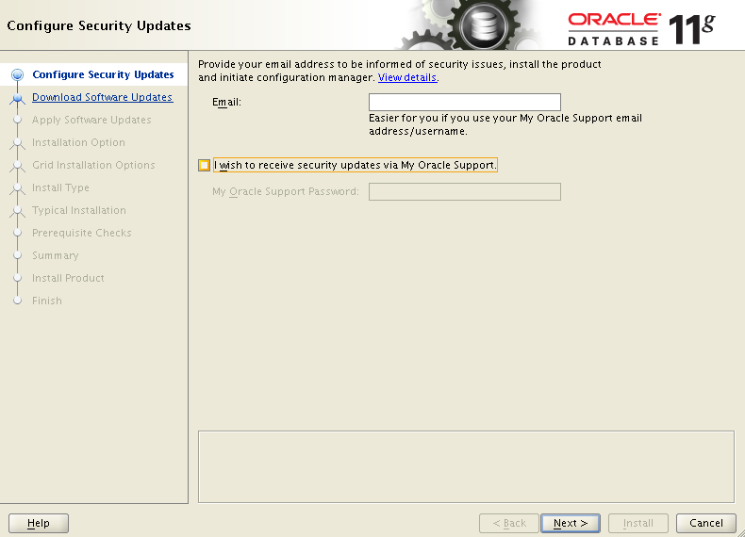

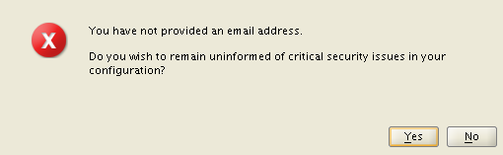

Say Yes

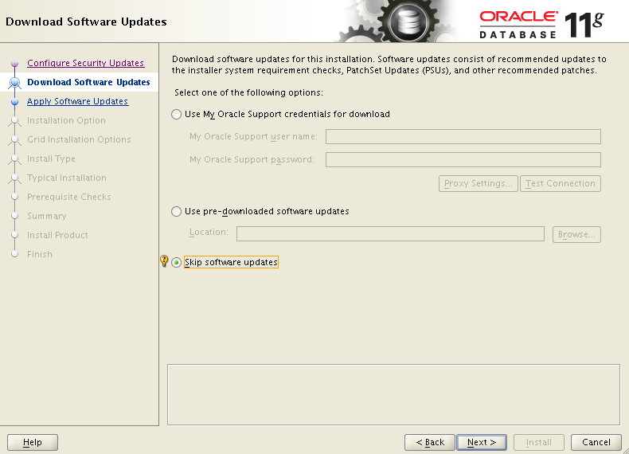

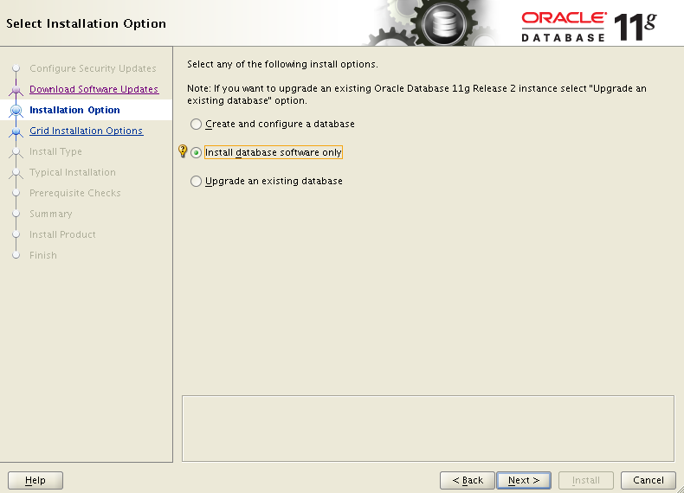

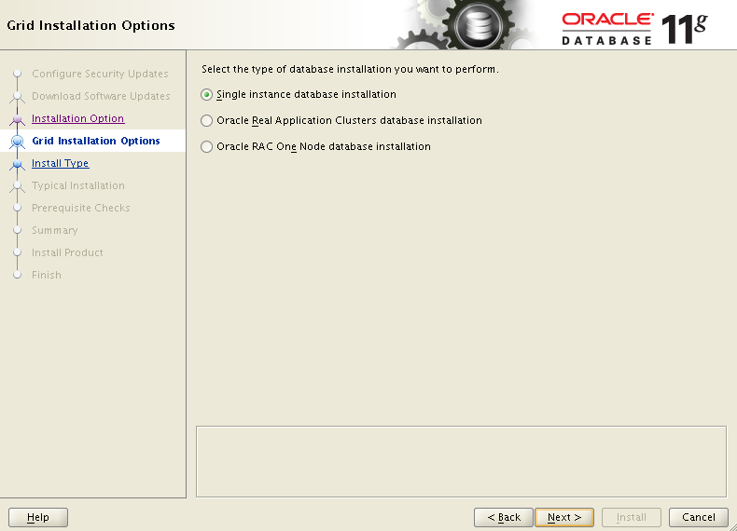
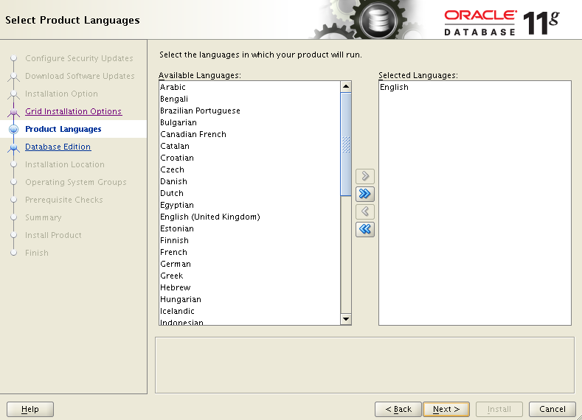

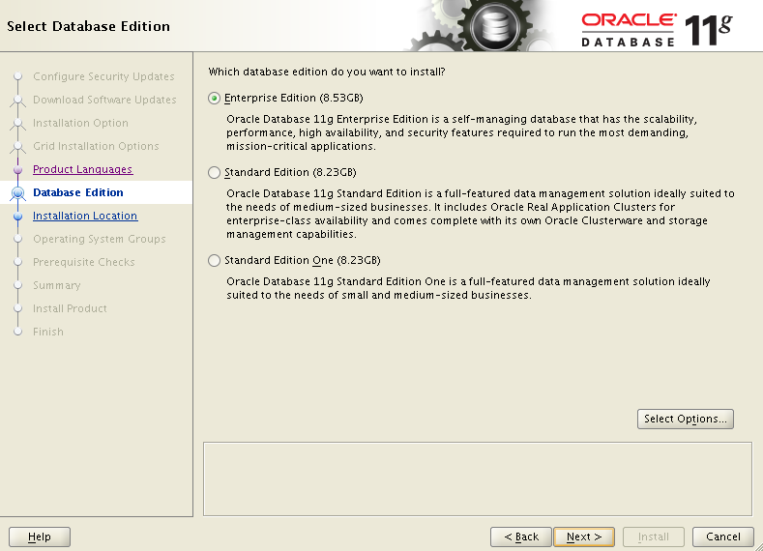

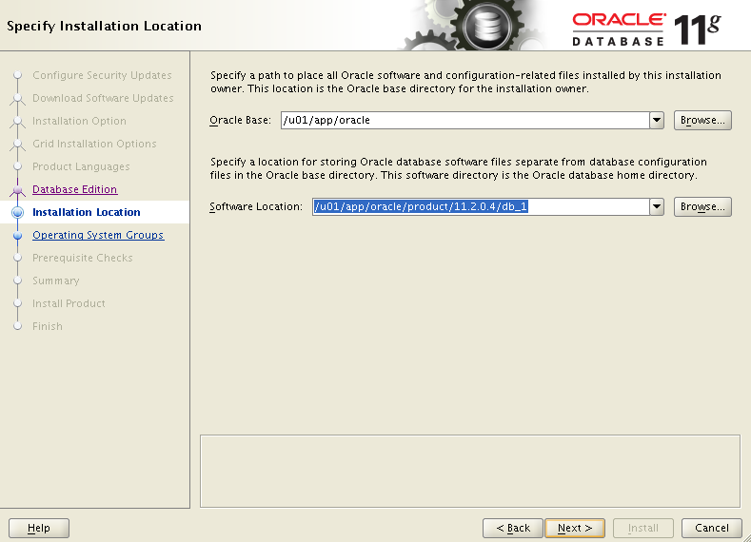

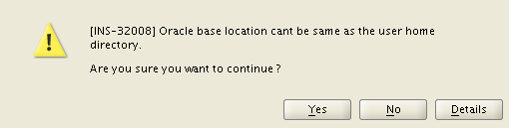

Say Yes

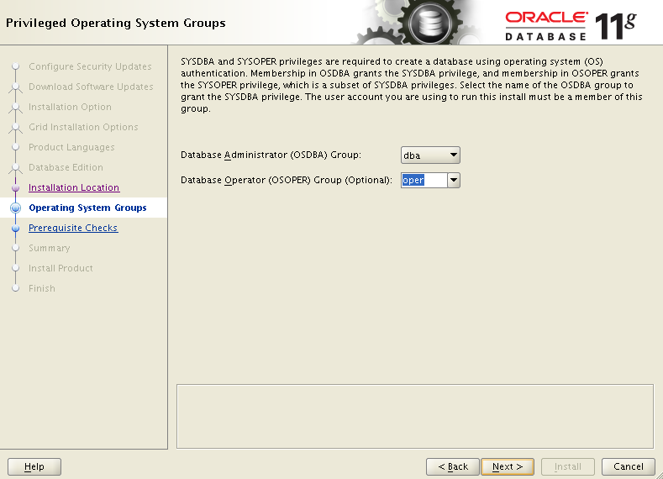

First time got Prerequisite warning see below. Aborted Installation .Contacted Storeman/unix Admin to correct. Then started over.

--dppdev

Expected Value
: 1GB
Actual Value
: 258.9883MB

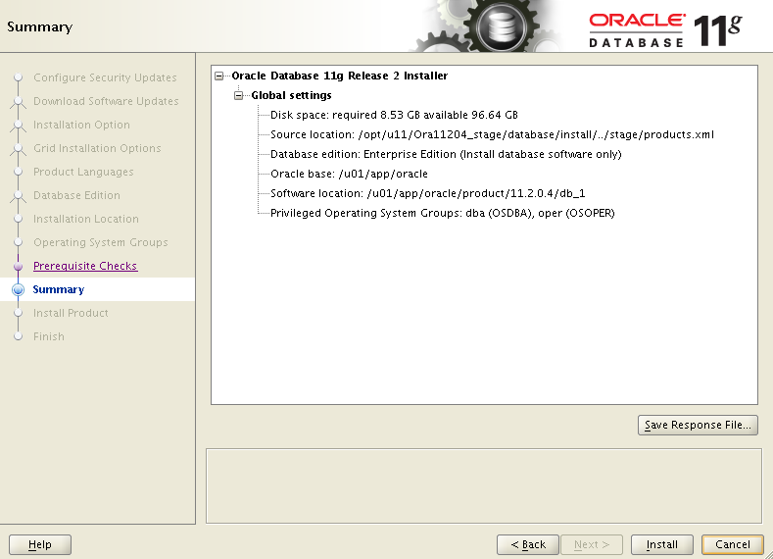

Click Install

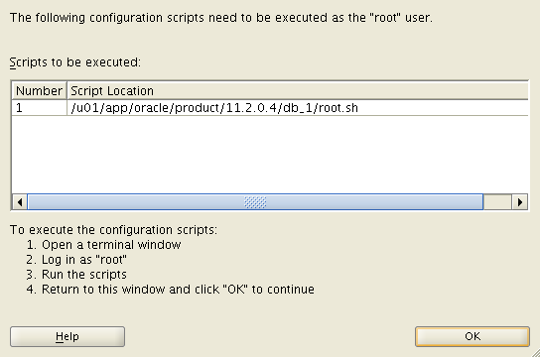

Contact Unix Admin to execute script above.

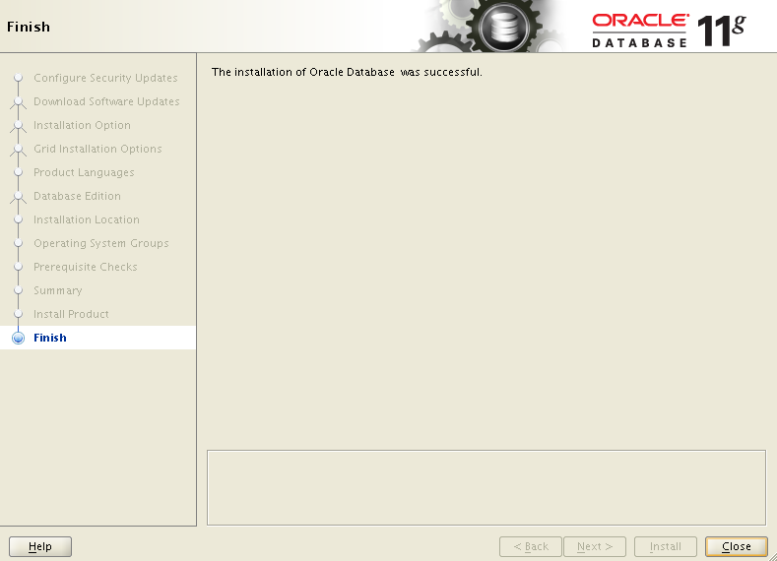

- Install Recommended Patches
Confirm inventory
Put opatch into path:
Ensure $ORACLE_HOME set to home being patched

export PATH=$PATH:$ORACLE_HOME/OPatch

opatch version
OPatch Version: 11.2.0.3.4
OPatch succeeded.

opatch lsinventory
Oracle Interim Patch Installer version 11.2.0.3.4
Copyright (c) 2012, Oracle Corporation. All rights reserved.

Oracle Home : /u01/app/oracle/product/11.2.0.4/db_1
Central Inventory : /u01/app/oracle/oraInventory
from : /u01/app/oracle/product/11.2.0.4/db_1/oraInst.loc
OPatch version : 11.2.0.3.4
OUI version : 11.2.0.4.0
Log file location : /u01/app/oracle/product/11.2.0.4/db_1/cfgtoollogs/opatch/opa
tch2014-12-18_11-10-31AM_1.log

Lsinventory Output file location : /u01/app/oracle/product/11.2.0.4/db_1/cfgtool
logs/opatch/lsinv/lsinventory2014-12-18_11-10-31AM.txt

--------------------------------------------------------------------------------
Installed Top-level Products (1):

Oracle Database 11g 11.2.0.4.0
There are 1 products installed in this Oracle Home.

There are no Interim patches installed in this Oracle Home.

--------------------------------------------------------------------------------

OPatch succeeded.

--Take Inventory backup first
cd $ORACLE_BASE
cp -rp oraInventory oraInventory_` date '+%Y%m%d'`_b4RecomPatches_11204_db1

cd /u11/Ora11204_stage/16188701

opatch apply

cd /u11/Ora11204_stage/17551261

opatch apply

cd /u11/Ora11204_stage/18255105

opatch apply

-Verify to make sure Patches applied

$ORACLE_HOME/OPatch/opatch lsinventory -patch | grep "applied on" | sort

Patch 16188701 : applied on Thu Dec 18 11:17:43 EST 2014
Patch 17551261 : applied on Thu Dec 18 11:20:31 EST 2014
Patch 18255105 : applied on Thu Dec 18 11:22:57 EST 2014

- Install latest PSU (normal procedures)

. ~/.profile

ORA11204_1

Determine if patch conflict exists with existing patches for db_1

Put opatch into path:
export PATH=$PATH:$ORACLE_HOME/OPatch

cd /u11/Ora11204_stage/19769489

opatch prereq CheckConflictAgainstOHWithDetail -ph ./

Invoking prereq "checkconflictagainstohwithdetail"

ZOP-40: The patch(es) has conflicts with other patches installed in the Oracle H
ome (or) among themselves.

Prereq "checkConflictAgainstOHWithDetail" failed.

Summary of Conflict Analysis:

There are no patches that can be applied now.

Following patches have conflicts. Please contact Oracle Support and get the merg
ed patch of the patches :
18255105, 19769489

Following patches will be rolled back from Oracle Home on application of the pat
ches in the given list :
18255105

Conflicts/Supersets for each patch are:

Patch : 19769489

Conflict with 18255105
Conflict details:
/u01/app/oracle/product/11.2.0.4/db_1/rdbms/admin/c1102000.sql

OPatch succeeded.

--Per PSU readme use following note to search for merge patch
Database Patch Conflict Resolution (Doc ID 1321267.1)

Download Merge Patch: Description WRONG CARDINALITY FOR A CHARACTER COLUMN
https://updates.oracle.com/download/18255105.html
(Filename : p18255105_112044_Generic.zip)

cd /u11/Ora11204_stage

unzip p18255105_112044_Generic.zip

cd $ORACLE_BASE
cp -rp oraInventory oraInventory_` date '+%Y%m%d'`_bJan2015PSU_db1

cd $ORACLE_HOME

###for /u01/app/oracle/product/11.2.0.4/db_1 Oracle Home:
nohup tar cvf /opt/u10/oraback/tar/tar_11204_db1_any_`date '+%Y%m%d'`_b4patch_Jan2015PSU.tar . |tee /opt/u10/oraback/tar/tar_11204_db1_any_`date '+%Y%m%d'`_b4patch_Jan2015PSU_tar.out

cd /opt/u10/oraback/tar

nohup gzip tar_11204_db1_any_20150122_b4patch_Jan2015PSU.tar

Confirm inventory

Put opatch into path:
Ensure $ORACLE_HOME set to home being patched

export PATH=$PATH:$ORACLE_HOME/OPatch

opatch version

OPatch Version: 11.2.0.3.6

OPatch succeeded.

Ensure orainst.loc points to desired inventory
cat /etc/oraInst.loc

If not, modify to oracle database location

Verify opatch version works with current inventory and that it is
not corrupt:

opatch lsinventory

Looking for last line:
OPatch succeeded.

Check opatch log file to confirm no issues

cd ${ORACLE_HOME}/cfgtoollogs/opatch

view `ls -rt ${ORACLE_HOME}/cfgtoollogs/opatch/opatch*|tail -1`

$ORACLE_HOME/OPatch/opatch lsinventory -patch | grep "applied on" | sort

. ~/.profile
ORA11204_1

sudo genkld | wc -l
sudo slibclean
sudo genkld | wc –l

Manually Rollback the Conflicting Patch 18255105

cd /u11/Ora11204_stage/18255105_112040

$ORACLE_HOME/OPatch/opatch rollback -id 18255105

# Apply PSU

cd /u11/Ora11204_stage/19769489

opatch apply

#Apply merge patch to software in $ORACLE_HOME

cd /u11/Ora11204_stage/18255105
opatch apply

Run opatch lsinventory

opatch lsinventory

$ORACLE_HOME/OPatch/opatch lsinventory -patch | grep "applied on" | sort

Patch 16188701 : applied on Thu Dec 18 11:17:43 EST 2014
Patch 17551261 : applied on Thu Dec 18 11:20:31 EST 2014
Patch 18255105 : applied on Thu Jan 22 10:25:59 EST 2015
Patch 19769489 : applied on Thu Jan 22 10:23:19 EST 2015

Configure TSM/TDP stuff

. ~/.profile

ORA11204_1

cd $ORACLE_HOME/lib
ln -s /usr/tivoli/tsm/client/oracle/bin64/libobk64.a libobk.a
ls -l libobk.a

The output should read:
lrwxrwxrwx 1 oracle dba 46 Mar 27 21:47 libobk.a -> /usr/tivoli/tsm/client/oracle/bin64/libobk64.a

cd $ORACLE_HOME/lib
sbttest test

Looks good
The sbt function pointers are loaded from libobk.a(shr.o) library.
-- sbtinit succeeded
Return code -1 from sbtinit, bsercoer = 0, bsercerrno = 0
Message 0 not found; product=RDBMS; facility=SBT

- Use following Clone steps to create second oracle home.

5.1. Run Prerequisite checker

. ~/.profile

ORA11204_2

--If needed
export ORACLE_HOME=/u01/app/oracle/product/11.2.0.4/db_2
--Get Your local IP address. :

ipconfig
172.21.157.55

--Start Exceed
Start-> Programs -> Aetna Applications -> Open Text Exceed 14 -> Exceed

-- Go back to ssh window
cd /usr/bin/X11

xterm -display 172.21.157.55:0 &

-- This should bring up new xWindow

-- Go to xwindow

cd /u11/Ora11204_stage/database

export DISPLAY=172.21.157.55:0

./runInstaller –executePrereqs

Answer yes for rootpre.sh file…

Screen blow should come up. Scroll down to make sure all status – Succeeded.

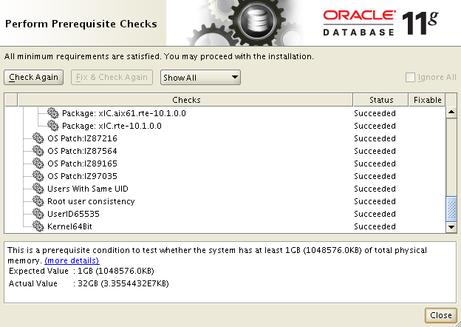

Close once all checked or fixed if any warning.

5.2. Create clone tar file and extract file over to new Oracle Home

. ~/.profile

ORA11204_1

cd $ORACLE_HOME

nohup tar cvf /opt/u10/oraback/tar/tar_11204_db1_any_`date '+%Y%m%d'`_4clone.tar . |tee /opt/u10/oraback/tar/tar_11204_db1_any_`date '+%Y%m%d'`_4clone_tar.out

egrep –i “permission|denied” /backup/oraback/tar/tar_11204_db1_any_`date '+%Y%m%d'`_4clone_tar.out

a ./bin/hsots tar: ./bin/nmb: The file access permissions do not allow the speci
fied action.
tar: ./bin/nmhs: The file access permissions do not allow the specified action.
tar: ./bin/nmo: The file access permissions do not allow the specified action.
55 blocks.

Request Unix admin do change permissions.

chmod 4750 /u01/app/oracle/product/11.2.0.4/db_1/bin/nmb
chmod 4750 /u01/app/oracle/product/11.2.0.4/db_1/bin/nmhs
chmod 4750 /u01/app/oracle/product/11.2.0.4/db_1/bin/nmo

Rerun tar command after that.

Also add following to root.sh

cd $ORACLE_HOME
vi root.sh

## EB 02/01/2015
#
# To address issue backing up Oracle Home in doc ID 1050290.1
#
#

chmod 4750 /u01/app/oracle/product/11.2.0.4/db_1/bin/nmb
chmod 4750 /u01/app/oracle/product/11.2.0.4/db_1/bin/nmhs
chmod 4750 /u01/app/oracle/product/11.2.0.4/db_1/bin/nmo

cd /u01/app/oracle/product/11.2.0.4/db_2

tar -xvf /opt/u10/oraback/tar/tar_11204_db1_any_20150202_4clone.tar

5.3. Confirm ORACLE_HOME_NAME to be used below is not currently being used

cat $HOME/oraInventory/ContentsXML/inventory.xml

5.4. Take Inventory backup first

cd $ORACLE_BASE
cp -rp oraInventory oraInventory_` date '+%Y%m%d'`_bclone_db2

5.5. Clone db_2

. ~/.profile

ORA11204_2

Note: the following command is wrapped. It should be entered as one line.
$ORACLE_HOME/oui/bin/runInstaller -clone -silent -waitForCompletion ORACLE_HOME=/u01/app/oracle/product/11.2.0.4/db_2 ORACLE_HOME_NAME=OraDb_11204_Home2 ORACLE_BASE=/u01/app/oracle

This will take about 5 minutes. Check the output and review log (log name in shown in the output) to make sure there are no problematic errors
You should see:
Install successful
and
The cloning of OraDb_11204_Home2 was successful.

Confirm Home added to Inventory
cat $HOME/oraInventory/ContentsXML/inventory.xml

5.6. Update network config files if needed

cd $ORACLE_HOME/network/admin

cp –p /u01/app/oracle/product/11.2.0/db_2/network/admin/*ora .

5.7. Run root.sh

Add following to db_2 root.sh

cd $ORACLE_HOME
vi root.sh

## EB 02/01/2015
#
# To address issue backing up Oracle Home in doc ID 1050290.1
#
#

chmod 4750 /u01/app/oracle/product/11.2.0.4/db_1/bin/nmb
chmod 4750 /u01/app/oracle/product/11.2.0.4/db_1/bin/nmhs
chmod 4750 /u01/app/oracle/product/11.2.0.4/db_1/bin/nmo

Have root user do the following:
cd /u01/app/oracle/product/11.2.0.4/db_2
./root.sh
Answer y when prompted to overwrites

$ORACLE_HOME/OPatch/opatch lsinventory -patch | grep "applied on" | sort
Patch 16188701 : applied on Thu Dec 18 11:17:43 EST 2014
Patch 17551261 : applied on Thu Dec 18 11:20:31 EST 2014
Patch 18255105 : applied on Thu Jan 22 10:25:59 EST 2015
Patch 19769489 : applied on Thu Jan 22 10:23:19 EST 2015

export PATH=$PATH:$ORACLE_HOME/OPatch

opatch lsinventory

Patch 19769489 : applied on Thu Jan 22 10:23:19 EST 2015
Unique Patch ID: 18280822
Patch description: "Database Patch Set Update : 11.2.0.4.5 (19769489)"
Created on 30 Dec 2014, 03:35:13 hrs PST8PDT
Sub-patch 19121551; "Database Patch Set Update : 11.2.0.4.4 (19121551)"
Sub-patch 18522509; "Database Patch Set Update : 11.2.0.4.3 (18522509)"
Sub-patch 18031668; "Database Patch Set Update : 11.2.0.4.2 (18031668)"
Sub-patch 17478514; "Database Patch Set Update : 11.2.0.4.1 (17478514)"
….

--only after clone completed. To be used for other servers.

cd /opt/u10/oraback/tar/
nohup gzip tar_11204_db1_any_20150202_4clone.tar

• 11.2.0.4 Patch Set - Availability and Known Issues (Doc ID 1562139.1) – Particularly the section entitled “Issues introduced in 11.2.0.4”. These are new bugs that are introduced by 11.2.0.4.

Download and ftp following patches:
Patch 20040179 - MERGE REQUEST ON TOP OF 11.2.0.4.0 FOR BUGS 14033503 14772891 - p20040179_112040_AIX64-5L.zip
Patch 19978292 - DUMP UNDER KAUXALO() WHEN RUNNING MERGE USING TABLE/VIEW WITH XMLTYPE COLUMN - p19978292_112040_AIX64-5L.zip
Patch 19576559 - _OPTIMIZER_FILTER_PUSHDOWN = FALSE CAUSES WRONG RESULT ON 11.2.0.4 - p19576559_112040_AIX64-5L.zip
Patch 19523291 - Subquery unnesting does not happen or ORA-1790 is signaled during subquery unnesting - p19523291_112040_AIX64-5L.zip
Patch 18384537 - OPIPLS TAKES TOO MANY RETRIES TO LOAD CURSOR - p18384537_112044_AIX64-5L.zip
Patch 17956707 - ORA-904 EXECUTING SQL WITH DBLINK - p17956707_112042_AIX64-5L.zip
Patch 17852660 - ORA-907 USING INDICATOR VARIABLES WITH CURSOR_SHARING=FORCE AND PATCH 14053457 - p17852660_112045_AIX64-5L.zip
Patch 19877440 - ORACLE JAVAVM COMPONENT 11.2.0.4.2 DATABASE PSU - p20406239_112040_AIX64-5L.zip

--Unzip files
cd /u11/Ora11204_stage
unzip p20040179_112040_AIX64-5L.zip
unzip p19978292_112040_AIX64-5L.zip
unzip p19576559_112040_AIX64-5L.zip
unzip p19523291_112040_AIX64-5L.zip
unzip p18384537_112044_AIX64-5L.zip
unzip p17956707_112042_AIX64-5L.zip
unzip p17852660_112045_AIX64-5L.zip
unzip p20406239_112040_AIX64-5L.zip

!! Apply manually to db_2 first

. ~/.profile
DPDEVUG

Blackout OEM for DPDEVUG

sqlplus / as sysdba
shutdown immediate;

lsnrctl stop DPDEVUG

export PATH=$PATH:$ORACLE_HOME/OPatch

opatch lsinventory

cd /u11/Ora11204_stage/20040179

opatch prereq CheckConflictAgainstOHWithDetail -ph ./

opatch apply

cd /u11/Ora11204_stage/19978292

opatch prereq CheckConflictAgainstOHWithDetail -ph ./

opatch apply

cd /u11/Ora11204_stage/19576559

opatch prereq CheckConflictAgainstOHWithDetail -ph ./

opatch apply

cd /u11/Ora11204_stage/19523291

opatch prereq CheckConflictAgainstOHWithDetail -ph ./

opatch apply

cd /u11/Ora11204_stage/18384537

opatch prereq CheckConflictAgainstOHWithDetail -ph ./

opatch apply

cd /u11/Ora11204_stage/17956707

opatch prereq CheckConflictAgainstOHWithDetail -ph ./

opatch apply

cd /u11/Ora11204_stage/17852660

opatch prereq CheckConflictAgainstOHWithDetail -ph ./

opatch apply

cd /u11/Ora11204_stage/20406239

opatch prereq CheckConflictAgainstOHWithDetail -ph ./

opatch apply

cd $ORACLE_HOME/sqlpatch/20406239
sqlplus / as sysdba
startup upgrade
@postinstall.sql
shutdown
startup

@?/rdbms/admin/utlrp

lsnrctl start DPDEVUG

!! Re clone back to db_1

. ~/.profile

ORA11204_2

cd $ORACLE_HOME

nohup tar cvf /opt/u10/oraback/tar/tar_11204_db2_any_`date '+%Y%m%d'`_4clone.tar . |tee /opt/u10/oraback/tar/tar_11204_db2_any_`date '+%Y%m%d'`_4clone_tar.out

egrep –i “permission|denied” /backup/oraback/tar/tar_11204_db2_any_`date '+%Y%m%d'`_4clone_tar.out

!! Remove db_1 first

cd /u01/app/oracle/product/11.2.0.4
rm -rf ./db_1

cd /u01/app/oracle/product/11.2.0.4/db_1

tar -xvf /opt/u10/oraback/tar/tar_11204_db2_any_20150505_4clone.tar

5.3. Confirm ORACLE_HOME_NAME to be used below is not currently being used if yes deattach

cat $HOME/oraInventory/ContentsXML/inventory.xml

. ~/.profile
ORA11204_1

cd $ORACLE_HOME/oui/bin
./runInstaller -detachHome -silent ORACLE_HOME="/u01/app/oracle/product/11.2.0.4/db_1" ORACLE_HOME_NAME="OraDb11g_home1"

cat $HOME/oraInventory/ContentsXML/inventory.xml

5.4. Take Inventory backup first

cd $ORACLE_BASE
cp -rp oraInventory oraInventory_` date '+%Y%m%d'`_bclone_db1

5.5. Clone db_1

. ~/.profile

ORA11204_1

Note: the following command is wrapped. It should be entered as one line.
$ORACLE_HOME/oui/bin/runInstaller -clone -silent -waitForCompletion ORACLE_HOME=/u01/app/oracle/product/11.2.0.4/db_1 ORACLE_HOME_NAME=OraDb_11204_Home1 ORACLE_BASE=/u01/app/oracle

$ORACLE_HOME/oui/bin/runInstaller -clone -silent -waitForCompletion ORACLE_HOME=/u01/app/oracle/product/11.2.0.4/db_1 ORACLE_HOME_NAME=OraDb_11204_Home1 ORACLE_BASE=/u01/app/oracle

This will take about 5 minutes. Check the output and review log (log name in shown in the output) to make sure there are no problematic errors
You should see:
Install successful
and
The cloning of OraDb_11204_Home1 was successful.

Confirm Home added to Inventory
cat $HOME/oraInventory/ContentsXML/inventory.xml

5.6. Update network config files if needed

cd $ORACLE_HOME/network/admin

cp –p /u01/app/oracle/product/11.2.0/db_1/network/admin/*ora .

5.7. Run root.sh

The following configuration scripts need to be executed as the "root" user.
/u01/app/oracle/product/11.2.0.4/db_1/root.sh
To execute the configuration scripts:
1. Open a terminal window
2. Log in as "root"
3. Run the scripts

oracle:ORA11204_1:>inventory -patch | grep "applied on" | sort
Patch 16188701 : applied on Thu Dec 18 11:17:43 EST 2014
Patch 17551261 : applied on Thu Dec 18 11:20:31 EST 2014
Patch 17852660 : applied on Mon May 04 10:45:40 EDT 2015
Patch 17956707 : applied on Mon May 04 10:42:55 EDT 2015
Patch 18255105 : applied on Thu Jan 22 10:25:59 EST 2015
Patch 18384537 : applied on Mon May 04 10:40:35 EDT 2015
Patch 19523291 : applied on Mon May 04 10:38:03 EDT 2015
Patch 19576559 : applied on Mon May 04 10:35:25 EDT 2015
Patch 19769489 : applied on Thu Jan 22 10:23:19 EST 2015
Patch 19978292 : applied on Mon May 04 10:32:25 EDT 2015
Patch 20040179 : applied on Mon May 04 10:26:09 EDT 2015
Patch 20406239 : applied on Mon May 04 10:49:18 EDT 2015

--only after clone completed. To be used for other servers.

cd /opt/u10/oraback/tar/
nohup gzip tar_11204_db2_any_20150505_4clone.tar

