DPP PeopleSoft Database Upgrade from 11.2.0.4 to 12.1.0.2

This document includes only Software Installation and Cloning procedures.

Fresh Software Install – db_1

- Download/Stage 12.1.0.2 Software on database server

- 12.1.0.2 Oracle DB Software
p21419221_121020_AIX64-5L_1of10.zip
p21419221_121020_AIX64-5L_2of10.zip

- Download/Stage Latest PSU (Oct 2015 and Jan 2016)
#Patch 21359755: DATABASE PATCH SET UPDATE 12.1.0.2.5 – Oct 2015
p21359755_121020_AIX64-5L.zip

- Download/Stage Recommended Patches
Things to Consider Before Upgrading to 12.1.0.2 to Avoid Poor Performance or Wrong Results (Doc ID 2034610.1)

##Document 20807398.8 ORA-600 [kgl-hash-collision] with fix to bug 20465582 installed
#on top of 12.1.0.2.0
p21800251_121020_AIX64-5L.zip

#on top of 12.1.0.2.5
p20807398_121025_AIX64-5L.zip

##Document 21091518.8 Extend fix of bug 18304693 to Partition Views
p21091518_121020_AIX64-5L.zip

##Document 13542050.8 A mutex related hang with holder around 65534 (0xfffe)
#on top of 12.1.0.2
p13542050_121020_AIX64-5L.zip

#on top of 12.1.0.2.4
p13542050_121024_AIX64-5L.zip

##Document 20879889.8 Open cursor leak from DML on table with a materialized view log
p20879889_121020_AIX64-5L.zip

##Document 19855835.8 Upgrade slow when reorganizing large stats history tables
NB: Only applicable for upgrades from 11.2.0.3 or below. Apply before running the 12.1.0.2 upgrade script. There is no benefit to applying it later on.
p19855835_121020_Generic.zip

Required Interim Patches for the Oracle Database with PeopleSoft (Doc ID 1100831.1)

##MATERIALIZED VIEW DEFERRED MODE ORA-00918: COLUMN AMBIGUOUSLY DEFINED
p20228093_121020_AIX64-5L.zip

##ORA-7445 [QERTBSTART()+3105] CRASHES QUERY WITH DISTINCT AND PJE TRANSFORMATION
p18201352_121020_AIX64-5L.zip

- Latest OPatch Utility version (if required..)
p6880880_121010_AIX64-5L.zip

--DPPDEV
cd /orastage/u177
mkdir Ora12102_stage

FTP zip files over….

--Unzip files
cd /orastage/u177/Ora12102_stage

unzip p21419221_121020_AIX64-5L_1of10.zip
unzip p21419221_121020_AIX64-5L_2of10.zip

unzip p21359755_121020_AIX64-5L.zip
unzip p21800251_121020_AIX64-5L.zip
unzip p21091518_121020_AIX64-5L.zip
unzip p13542050_121020_AIX64-5L.zip
unzip p20228093_121020_AIX64-5L.zip

unzip p18201352_121020_AIX64-5L.zip
unzip p20879889_121020_AIX64-5L.zip

unzip p19855835_121020_Generic.zip
unzip p6880880_121010_AIX64-5L.zip

unzip p20807398_121025_AIX64-5L.zip
unzip p13542050_121024_AIX64-5L.zip

## Just to remember that during Upgrade….
alter system set "_optimizer_aggr_groupby_elim"=false scope=both;
alter system set "_optimizer_reduce_groupby_key"=false scope=both;
if 21555660 applied it may require postinstall DB part see Read Me

cd $ORACLE_HOME
cp -r OPatch Opatch_20151204
cd /orastage/u177/Ora12102_stage

cp -rp OPatch $ORACLE_HOME

- Install Software

##Create dummy Database Entry in oratab file to start 12.1.0.2 environment

##Pre create directory (if not already there):

cd /orahome/u01
mkdir app
cd app
mkdir oracle
cd oracle
mkdir product
cd product
mkdir 12.1.0.2
cd 12.1.0.2
mkdir db_1

cd /etc
vi oratab

ORA12102_1:/orahome/u01/app/oracle/product/12.1.0.2/db_1:N
ORA12102_2:/orahome/u01/app/oracle/product/12.1.0.2/db_2:N

cd $HOME/aetna/scripts

cp -p oraprof oraprof_20151202

---Add following entries to oraprof

vi oraprof

"ORA12102_1")
NLS_LANG=AMERICAN_AMERICA.WE8ISO8859P15; export NLS_LANG
;;

"ORA12102_2")
NLS_LANG=AMERICAN_AMERICA.WE8ISO8859P15; export NLS_LANG
;;

. ~/.profile

ORA12102_1

--If needed
export ORACLE_HOME=/orahome/u01/app/oracle/product/12.1.0.2/db_1
export ORACLE_BASE=/orahome/u01/app/oracle
--Get Your local IP address. :

ipconfig
172.21.181.252

--Start Exceed
Start-> Programs -> Aetna Applications -> Open Text Exceed 14 -> Exceed

-- Go back to ssh window
cd /usr/bin/X11

xterm -display 172.21.181.252:0 &

-- This should bring up new xWindow

-- Go to xwindow

cd /orastage/u177/Ora12102_stage/database

export DISPLAY=172.21.181.252:0

./runInstaller

It should ask about rootpre.sh. Respond (y)
No need to run since server has existing 11.2.0.3 Software

Your platform requires the root user to perform certain pre-installation
OS preparation. The root user should run the shell script 'rootpre.sh' before
you proceed with Oracle installation. rootpre.sh can be found at the top level
of the CD or the stage area.

Answer 'y' if root has run 'rootpre.sh' so you can proceed with Oracle
installation.
Answer 'n' to abort installation and then ask root to run 'rootpre.sh'.

********************************************************************************

Has 'rootpre.sh' been run by root? [y/n] (n)

Ask Unix Admin to run this script. Note all databases needs to be shutdown prior to that.

(Use Copy All to Clipboard option and paste to this document to capture screens)

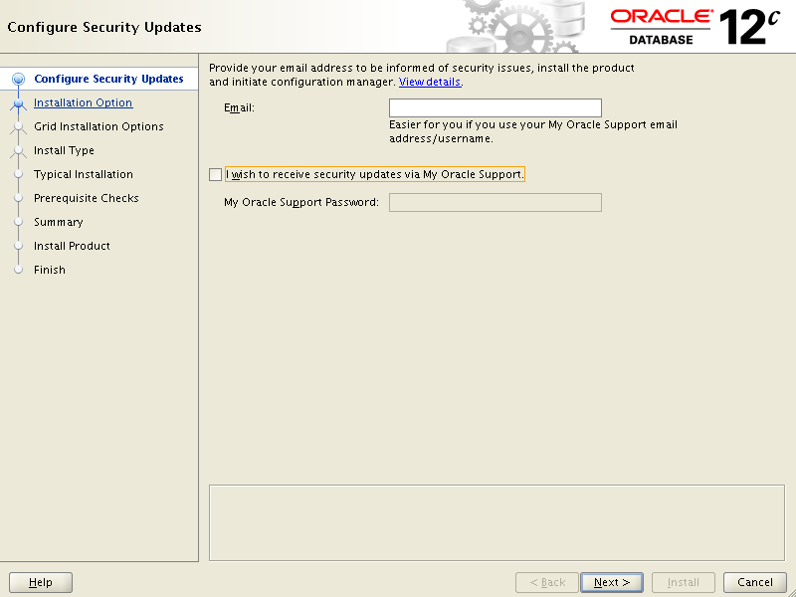

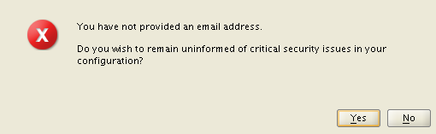

Say Yes

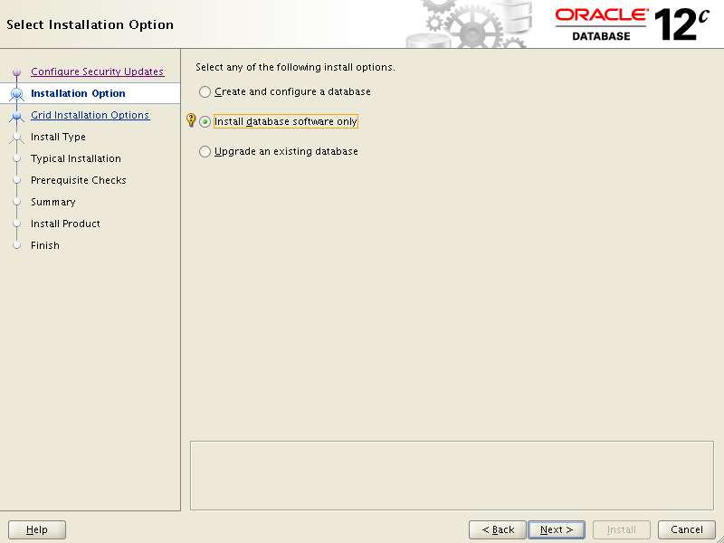

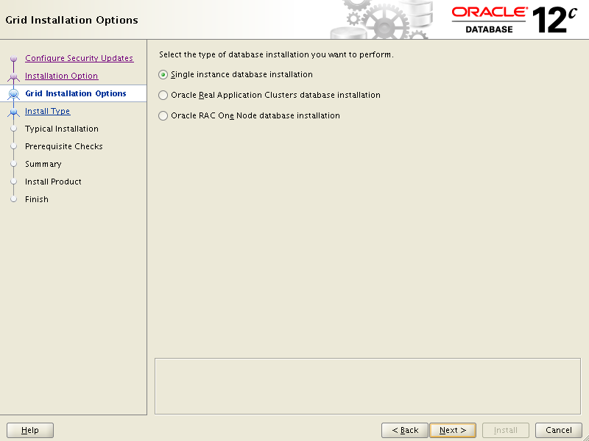

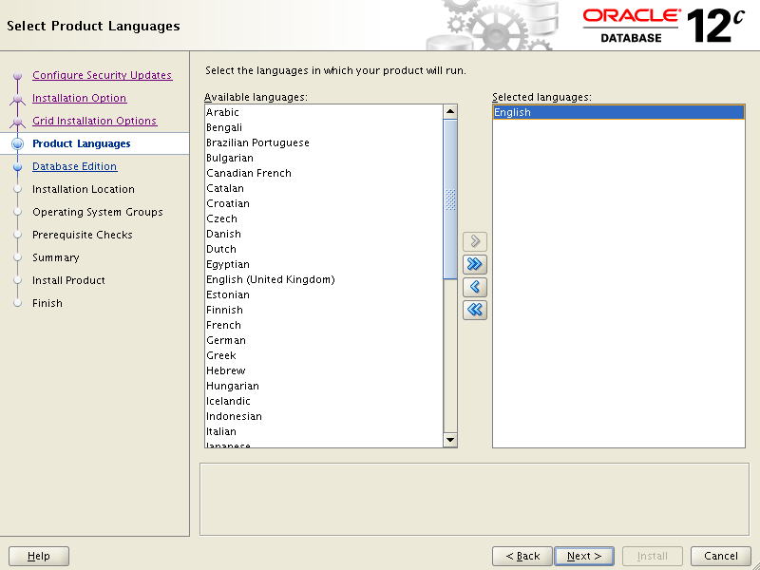

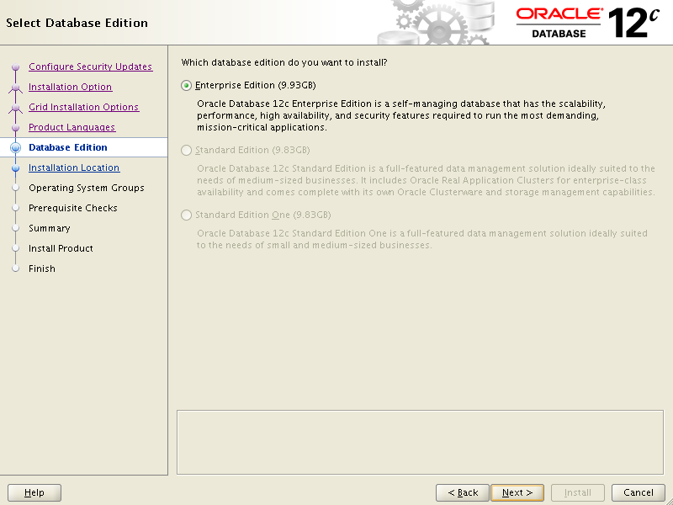

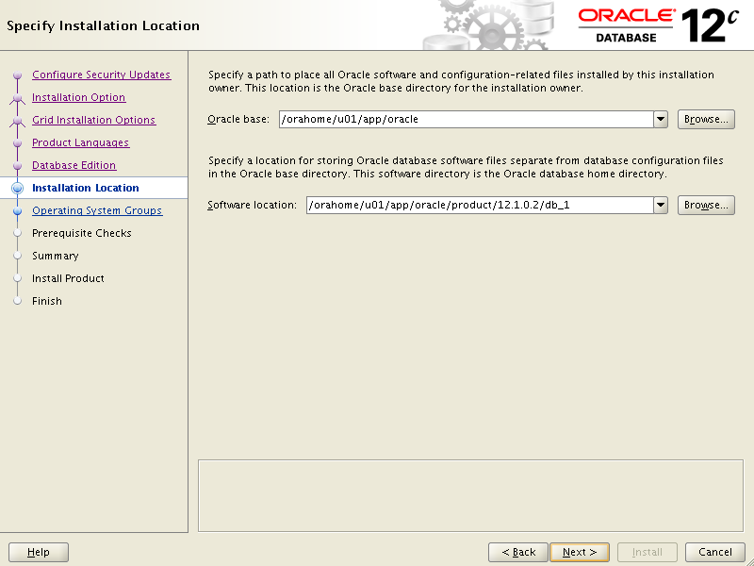

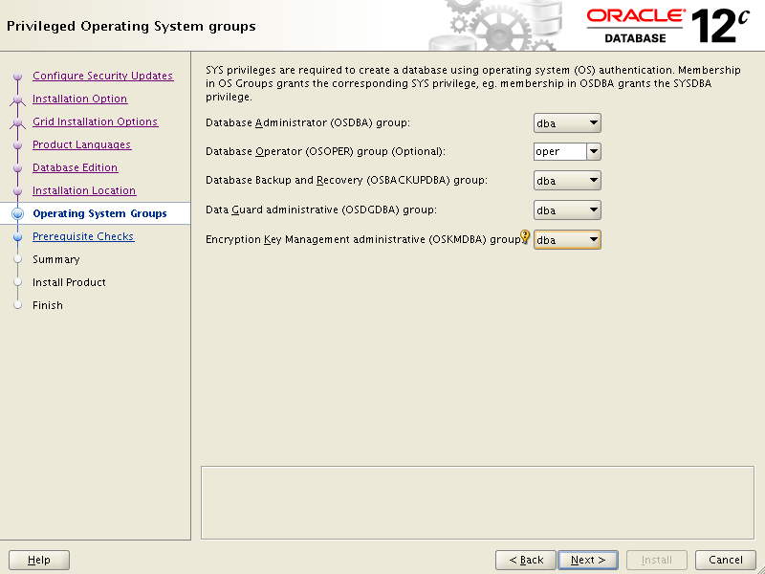

First time got Prerequisite warning see below. Aborted Installation .Contacted Storeman/unix Admin to correct. Then started over.

--dppdev

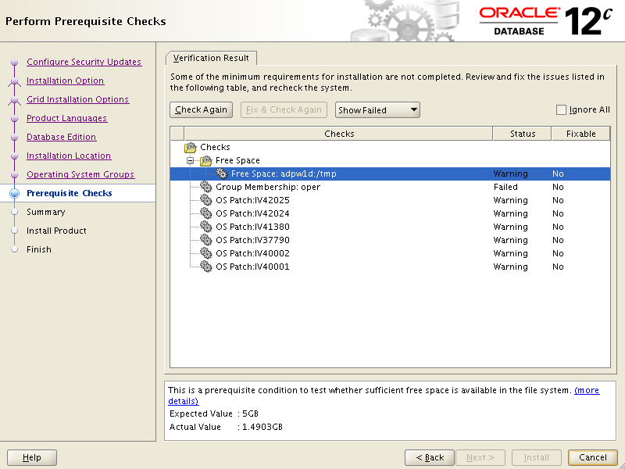

Unix Admin response blow with suggestion to proceede forward.

Seems like Oracle check script is still not up to date and always showing items missing when they are not.
See list as they are all included.
dppdev:/:# oslevel -s
7100-03-04-1441
IV42024 applies only to 7100-00
IV42025 applies only to 7100-00
included in 7100-03-01-1341:
IV16737
IV21116
IV21235
IV28925
IV34869
IV35057
IV37790
IV39136
IV41380
IV41415
IV40001 applies only to 7100-02
IV40002 applies only to 7100-02

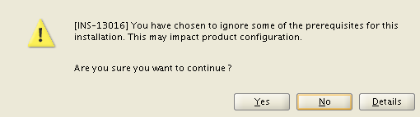

Click Yes

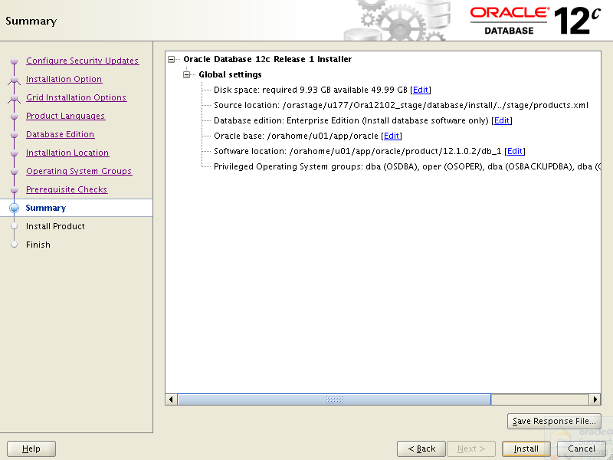

Click Install

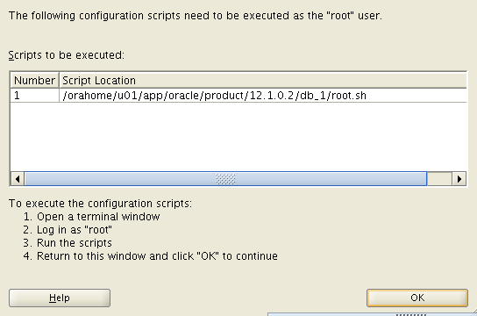

Contact Unix Admin to execute script above.

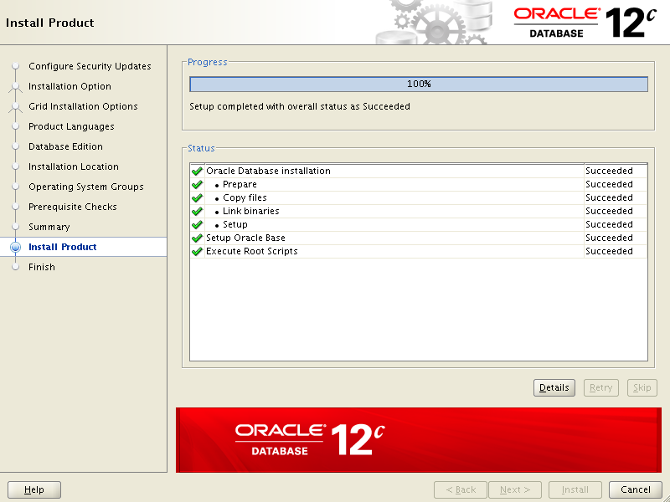

- Install Recommended Patches
Confirm inventory
Put opatch into path:
Ensure $ORACLE_HOME set to home being patched

export PATH=$PATH:$ORACLE_HOME/OPatch

opatch version
OPatch Version: 12.1.0.1.3
OPatch succeeded.

opatch lsinventory
oracle:ORA12102_1:>opatch lsinventory
Oracle Interim Patch Installer version 12.1.0.1.3
Copyright (c) 2015, Oracle Corporation. All rights reserved.

Oracle Home : /orahome/u01/app/oracle/product/12.1.0.2/db_1
Central Inventory : /u01/app/oracle/oraInventory
from : /orahome/u01/app/oracle/product/12.1.0.2/db_1/oraInst.loc
OPatch version : 12.1.0.1.3
OUI version : 12.1.0.2.0
Log file location : /orahome/u01/app/oracle/product/12.1.0.2/db_1/cfgtoollogs/op
atch/opatch2015-12-03_14-01-06PM_1.log

Lsinventory Output file location : /orahome/u01/app/oracle/product/12.1.0.2/db_1
/cfgtoollogs/opatch/lsinv/lsinventory2015-12-03_14-01-06PM.txt

--------------------------------------------------------------------------------
Installed Top-level Products (1):

Oracle Database 12c 12.1.0.2.0
There are 1 products installed in this Oracle Home.

There are no Interim patches installed in this Oracle Home.

--------------------------------------------------------------------------------

OPatch succeeded.

--Take Inventory backup first
cd $HOME
cp -rp oraInventory oraInventory_` date '+%Y%m%d'`_b4RecomPatches_12102_db1

##Apply latest Oct 2015 PSU

cd /orastage/u177/Ora12102_stage/21359755

export PATH=$PATH:$ORACLE_HOME/OPatch

opatch prereq CheckConflictAgainstOHWithDetail -ph ./

PREREQ session

Oracle Home : /orahome/u01/app/oracle/product/12.1.0.2/db_1
Central Inventory : /u01/app/oracle/oraInventory
from : /orahome/u01/app/oracle/product/12.1.0.2/db_1/oraInst.loc
OPatch version : 12.1.0.1.10
OUI version : 12.1.0.2.0
Log file location : /orahome/u01/app/oracle/product/12.1.0.2/db_1/cfgtoollogs/op
atch/opatch2015-12-04_08-45-28AM_1.log

Invoking prereq "checkconflictagainstohwithdetail"

Prereq "checkConflictAgainstOHWithDetail" passed.

OPatch succeeded.

opatch apply

$ORACLE_HOME/OPatch/opatch lsinventory -patch | grep "applied on" | sort

Patch 21359755 : applied on Fri Dec 04 08:49:59 EST 2015

##Apply Document 20807398.8 ORA-600 [kgl-hash-collision] with fix to bug 20465582 installed

cd /orastage/u177/Ora12102_stage/20807398

opatch prereq CheckConflictAgainstOHWithDetail -ph ./

opatch apply

$ORACLE_HOME/OPatch/opatch lsinventory -patch | grep "applied on" | sort

##Apply Document 21091518.8 Extend fix of bug 18304693 to Partition Views

cd /orastage/u177/Ora12102_stage/21091518

opatch prereq CheckConflictAgainstOHWithDetail -ph ./

opatch apply

$ORACLE_HOME/OPatch/opatch lsinventory -patch | grep "applied on" | sort

Patch 21091518 : applied on Fri Dec 04 09:19:59 EST 2015
Patch 21359755 : applied on Fri Dec 04 08:49:59 EST 2015

##Apply Document 13542050.8 A mutex related hang with holder around 65534 (0xfffe)
cd /orastage/u177/Ora12102_stage/13542050

p13542050_121024_AIX64-5L.zip
opatch prereq CheckConflictAgainstOHWithDetail -ph ./

opatch apply

$ORACLE_HOME/OPatch/opatch lsinventory -patch | grep "applied on" | sort

##Document 20879889.8 Open cursor leak from DML on table with a materialized view log

cd /orastage/u177/Ora12102_stage/20879889

opatch prereq CheckConflictAgainstOHWithDetail -ph ./

opatch apply

$ORACLE_HOME/OPatch/opatch lsinventory -patch | grep "applied on" | sort

Patch 20879889 : applied on Fri Dec 04 09:25:53 EST 2015
Patch 21091518 : applied on Fri Dec 04 09:19:59 EST 2015
Patch 21359755 : applied on Fri Dec 04 08:49:59 EST 2015

## Apply Document 19855835.8 Upgrade slow when reorganizing large stats history tables
NB: Only applicable for upgrades from 11.2.0.3 or below. Apply before running the 12.1.0.2 upgrade script. There is no benefit to applying it later on.
cd /orastage/u177/Ora12102_stage/19855835

opatch prereq CheckConflictAgainstOHWithDetail -ph ./

opatch apply

$ORACLE_HOME/OPatch/opatch lsinventory -patch | grep "applied on" | sort

Patch 19855835 : applied on Fri Dec 04 09:28:40 EST 2015
Patch 20879889 : applied on Fri Dec 04 09:25:53 EST 2015
Patch 21091518 : applied on Fri Dec 04 09:19:59 EST 2015
Patch 21359755 : applied on Fri Dec 04 08:49:59 EST 2015

##Apply MATERIALIZED VIEW DEFERRED MODE ORA-00918: COLUMN AMBIGUOUSLY DEFINED

cd /orastage/u177/Ora12102_stage/20228093

opatch prereq CheckConflictAgainstOHWithDetail -ph ./

opatch apply

$ORACLE_HOME/OPatch/opatch lsinventory -patch | grep "applied on" | sort
Patch 19855835 : applied on Fri Dec 04 09:28:40 EST 2015
Patch 20228093 : applied on Fri Dec 04 09:31:16 EST 2015
Patch 20879889 : applied on Fri Dec 04 09:25:53 EST 2015
Patch 21091518 : applied on Fri Dec 04 09:19:59 EST 2015
Patch 21359755 : applied on Fri Dec 04 08:49:59 EST 2015

##Apply ORA-7445 [QERTBSTART()+3105] CRASHES QUERY WITH DISTINCT AND PJE TRANSFORMATION

cd /orastage/u177/Ora12102_stage/18201352

opatch prereq CheckConflictAgainstOHWithDetail -ph ./

opatch apply

$ORACLE_HOME/OPatch/opatch lsinventory -patch | grep "applied on" | sort

Patch 13542050 : applied on Fri Dec 04 14:54:47 EST 2015
Patch 18201352 : applied on Fri Dec 04 09:34:34 EST 2015
Patch 19855835 : applied on Fri Dec 04 09:28:40 EST 2015
Patch 20228093 : applied on Fri Dec 04 09:31:16 EST 2015
Patch 20807398 : applied on Fri Dec 04 14:52:46 EST 2015
Patch 20879889 : applied on Fri Dec 04 09:25:53 EST 2015
Patch 21091518 : applied on Fri Dec 04 09:19:59 EST 2015
Patch 21359755 : applied on Fri Dec 04 08:49:59 EST 2015

Configure TSM/TDP stuff

. ~/.profile

ORA12102_1

cd $ORACLE_HOME/lib
ln -s /usr/tivoli/tsm/client/oracle/bin64/libobk64.a libobk.a
ls -l libobk.a

##The output should read:
lrwxrwxrwx 1 oracle dba 46 Dec 04 10:47 libobk.a -> /usr/tivol
i/tsm/client/oracle/bin64/libobk64.a

cd $ORACLE_HOME/lib
sbttest test

##The output should read:
The sbt function pointers are loaded from libobk.a(shr.o) library.
-- sbtinit succeeded
Return code -1 from sbtinit, bsercoer = 0, bsercerrno = 0
Message 0 not found; product=RDBMS; facility=SBT

Clone Software from Rich Ryan Gold copy – db_2

- Copy tar file, stage and clone

Login to xoracldw2d Server

scp -p dbms_home_121025_aix.tar dppdev:/backup/oraback/dbms_home_121025_aix.tar

Login back to dppdev

cd /orahome/u01/app/oracle/product/12.1.0.2
mkdir clone

cd /orahome/u01/app/oracle/product/12.1.0.2/clone
tar -xvf /backup/oraback/dbms_home_121025_aix.tar

cd /orahome/u01/app/oracle/product/12.1.0.2/clone/12.1.0.2.5

cp -rp db_1 /orahome/u01/app/oracle/product/12.1.0.2/db_2

cd /orahome/u01/app/oracle/product/12.1.0.2

rm -rf ./clone

. ~/.profile

ORA12102_2

--If needed
export ORACLE_HOME=/orahome/u01/app/oracle/product/12.1.0.2/db_2
export ORACLE_BASE=/orahome/u01/app/oracle

Note: the following command is wrapped. It should be entered as one line.
$ORACLE_HOME/oui/bin/runInstaller -clone -silent -waitForCompletion ORACLE_HOME=/orahome/u01/app/oracle/product/12.1.0.2/db_2 ORACLE_HOME_NAME=OraDB12Home2 ORACLE_BASE=/orahome/u01/app/oracle

This will take about 5 minutes. Check the output and review log (log name in shown in the output) to make sure there are no problematic errors
You should see:
End of install phases.(Friday, December 4, 2015 12:43:53 PM EST)
WARNING:
The following configuration scripts need to be executed as the "root" user.
/orahome/u01/app/oracle/product/12.1.0.2/db_2/root.sh
To execute the configuration scripts:
1. Open a terminal window
2. Log in as "root"
3. Run the scripts
Send above to Unix Admin
Confirm Home added to Inventory
cat $HOME/oraInventory/ContentsXML/inventory.xml

$ORACLE_HOME/OPatch/opatch lsinventory -patch | grep "applied on" | sort
Patch 21359755 : applied on Fri Oct 30 14:01:43 EDT 2015
Patch 21555660 : applied on Fri Oct 30 14:03:54 EDT 2015

- Apply necessary patches

export PATH=$PATH:$ORACLE_HOME/OPatch

cd $ORACLE_HOME
cp -r OPatch Opatch_20151204
or

mv OPatch Opatch_20151204

cd /orastage/u177/Ora12102_stage

cp -rp OPatch $ORACLE_HOME

##Apply Document 20807398.8 ORA-600 [kgl-hash-collision] with fix to bug 20465582 installed

cd /orastage/u177/Ora12102_stage/20807398

opatch prereq CheckConflictAgainstOHWithDetail -ph ./

opatch apply

$ORACLE_HOME/OPatch/opatch lsinventory -patch | grep "applied on" | sort

Patch 20807398 : applied on Fri Dec 04 15:13:20 EST 2015
Patch 21359755 : applied on Fri Oct 30 14:01:43 EDT 2015
Patch 21555660 : applied on Fri Oct 30 14:03:54 EDT 2015

##Apply Document 21091518.8 Extend fix of bug 18304693 to Partition Views

cd /orastage/u177/Ora12102_stage/21091518

opatch prereq CheckConflictAgainstOHWithDetail -ph ./

opatch apply

$ORACLE_HOME/OPatch/opatch lsinventory -patch | grep "applied on" | sort

Patch 20807398 : applied on Fri Dec 04 15:13:20 EST 2015
Patch 21091518 : applied on Fri Dec 04 15:15:03 EST 2015
Patch 21359755 : applied on Fri Oct 30 14:01:43 EDT 2015
Patch 21555660 : applied on Fri Oct 30 14:03:54 EDT 2015

##Apply Document 13542050.8 A mutex related hang with holder around 65534 (0xfffe)
cd /orastage/u177/Ora12102_stage/13542050

opatch prereq CheckConflictAgainstOHWithDetail -ph ./

opatch apply

$ORACLE_HOME/OPatch/opatch lsinventory -patch | grep "applied on" | sort

Patch 13542050 : applied on Fri Dec 04 15:16:29 EST 2015
Patch 20807398 : applied on Fri Dec 04 15:13:20 EST 2015
Patch 21091518 : applied on Fri Dec 04 15:15:03 EST 2015
Patch 21359755 : applied on Fri Oct 30 14:01:43 EDT 2015
Patch 21555660 : applied on Fri Oct 30 14:03:54 EDT 2015

##Document 20879889.8 Open cursor leak from DML on table with a materialized view log

cd /orastage/u177/Ora12102_stage/20879889

opatch prereq CheckConflictAgainstOHWithDetail -ph ./

opatch apply

$ORACLE_HOME/OPatch/opatch lsinventory -patch | grep "applied on" | sort

Patch 13542050 : applied on Fri Dec 04 15:16:29 EST 2015
Patch 20807398 : applied on Fri Dec 04 15:13:20 EST 2015
Patch 20879889 : applied on Fri Dec 04 15:19:14 EST 2015
Patch 21091518 : applied on Fri Dec 04 15:15:03 EST 2015
Patch 21359755 : applied on Fri Oct 30 14:01:43 EDT 2015
Patch 21555660 : applied on Fri Oct 30 14:03:54 EDT 2015

## Apply Document 19855835.8 Upgrade slow when reorganizing large stats history tables
NB: Only applicable for upgrades from 11.2.0.3 or below. Apply before running the 12.1.0.2 upgrade script. There is no benefit to applying it later on.
cd /orastage/u177/Ora12102_stage/19855835

opatch prereq CheckConflictAgainstOHWithDetail -ph ./

opatch apply

$ORACLE_HOME/OPatch/opatch lsinventory -patch | grep "applied on" | sort

Patch 13542050 : applied on Fri Dec 04 15:16:29 EST 2015
Patch 19855835 : applied on Fri Dec 04 15:20:40 EST 2015
Patch 20807398 : applied on Fri Dec 04 15:13:20 EST 2015
Patch 20879889 : applied on Fri Dec 04 15:19:14 EST 2015
Patch 21091518 : applied on Fri Dec 04 15:15:03 EST 2015
Patch 21359755 : applied on Fri Oct 30 14:01:43 EDT 2015
Patch 21555660 : applied on Fri Oct 30 14:03:54 EDT 2015

##Apply MATERIALIZED VIEW DEFERRED MODE ORA-00918: COLUMN AMBIGUOUSLY DEFINED

cd /orastage/u177/Ora12102_stage/20228093

opatch prereq CheckConflictAgainstOHWithDetail -ph ./

opatch apply

$ORACLE_HOME/OPatch/opatch lsinventory -patch | grep "applied on" | sort
Patch 13542050 : applied on Fri Dec 04 15:16:29 EST 2015
Patch 19855835 : applied on Fri Dec 04 15:20:40 EST 2015
Patch 20228093 : applied on Fri Dec 04 15:21:55 EST 2015
Patch 20807398 : applied on Fri Dec 04 15:13:20 EST 2015
Patch 20879889 : applied on Fri Dec 04 15:19:14 EST 2015
Patch 21091518 : applied on Fri Dec 04 15:15:03 EST 2015
Patch 21359755 : applied on Fri Oct 30 14:01:43 EDT 2015
Patch 21555660 : applied on Fri Oct 30 14:03:54 EDT 2015

##Apply ORA-7445 [QERTBSTART()+3105] CRASHES QUERY WITH DISTINCT AND PJE TRANSFORMATION

cd /orastage/u177/Ora12102_stage/18201352

opatch prereq CheckConflictAgainstOHWithDetail -ph ./

opatch apply

$ORACLE_HOME/OPatch/opatch lsinventory -patch | grep "applied on" | sort
Patch 13542050 : applied on Fri Dec 04 15:16:29 EST 2015
Patch 18201352 : applied on Fri Dec 04 15:23:20 EST 2015
Patch 19855835 : applied on Fri Dec 04 15:20:40 EST 2015
Patch 20228093 : applied on Fri Dec 04 15:21:55 EST 2015
Patch 20807398 : applied on Fri Dec 04 15:13:20 EST 2015
Patch 20879889 : applied on Fri Dec 04 15:19:14 EST 2015
Patch 21091518 : applied on Fri Dec 04 15:15:03 EST 2015
Patch 21359755 : applied on Fri Oct 30 14:01:43 EDT 2015
Patch 21555660 : applied on Fri Oct 30 14:03:54 EDT 2015

Configure TSM/TDP stuff

. ~/.profile

ORA12102_2

cd $ORACLE_HOME/lib
ln -s /usr/tivoli/tsm/client/oracle/bin64/libobk64.a libobk.a
ls -l libobk.a

##The output should read:
lrwxrwxrwx 1 oracle dba 46 Dec 04 10:47 libobk.a -> /usr/tivol
i/tsm/client/oracle/bin64/libobk64.a

cd $ORACLE_HOME/lib
sbttest test

##The output should read:
The sbt function pointers are loaded from libobk.a(shr.o) library.
-- sbtinit succeeded

Return code -1 from sbtinit, bsercoer = 0, bsercerrno = 0
Message 0 not found; product=RDBMS; facility=SBT

Clone db_2 back to db_1

- Remove original db_1 Oracle Home first

##Take Inventory backup first
cd $HOME
cp -rp oraInventory oraInventory_` date '+%Y%m%d'`_b4Remove_12102_db1

##Remove original db_1 Oracle Home first that was created from Fresh Install erlier.
cd $ORACLE_HOME/oui/bin/
./runInstaller -detachHome -silent ORACLE_HOME="/orahome/u01/app/oracle/product/12.1.0.2/db_1" ORACLE_HOME_NAME="OraDB12Home1"

cd /orahome/u01/app/oracle/product/12.1.0.2

rm -rf ./db_1

cd $HOME/oraInventory/ContentsXML

# To make sure OraDB12Home1 marked as REMOVED
view inventory.xml

- Clone db_2 to db_1

## Create GOLD copy db_2
. ~/.profile

ORA12102_2

cd $ORACLE_HOME

nohup tar cvf /opt/u10/oraback/tar/12102_GOLD_`date '+%Y%m%d'`_4clone.tar . |tee /opt/u10/oraback/tar/12102_GOLD_`date '+%Y%m%d'`_4clone_tar.out

egrep –i “permission|denied” /backup/oraback/tar/12102_GOLD_`date '+%Y%m%d'`_4clone_tar.out

cd /orahome/u01/app/oracle/product/12.1.0.2
mkdir db_1

cd /orahome/u01/app/oracle/product/12.1.0.2/db_1

tar -xvf /opt/u10/oraback/tar/12102_GOLD_20151207_4clone.tar

. ~/.profile

ORA12102_1

--If needed
export ORACLE_HOME=/orahome/u01/app/oracle/product/12.1.0.2/db_1
export ORACLE_BASE=/orahome/u01/app/oracle

Note: the following command is wrapped. It should be entered as one line.
$ORACLE_HOME/oui/bin/runInstaller -clone -silent -waitForCompletion ORACLE_HOME=/orahome/u01/app/oracle/product/12.1.0.2/db_1 ORACLE_HOME_NAME=OraDB12Home1 ORACLE_BASE=/orahome/u01/app/oracle

This will take about 5 minutes. Check the output and review log (log name in shown in the output) to make sure there are no problematic errors
You should see:
End of install phases.(Friday, December 4, 2015 12:43:53 PM EST)
WARNING:
The following configuration scripts need to be executed as the "root" user.
/orahome/u01/app/oracle/product/12.1.0.2/db_1/root.sh
To execute the configuration scripts:
1. Open a terminal window
2. Log in as "root"
3. Run the scripts
Send above to Unix Admin
Confirm Home added to Inventory
cat $HOME/oraInventory/ContentsXML/inventory.xml

$ORACLE_HOME/OPatch/opatch lsinventory -patch | grep "applied on" | sort
Patch 13542050 : applied on Fri Dec 04 15:16:29 EST 2015
Patch 18201352 : applied on Fri Dec 04 15:23:20 EST 2015
Patch 19855835 : applied on Fri Dec 04 15:20:40 EST 2015
Patch 20228093 : applied on Fri Dec 04 15:21:55 EST 2015
Patch 20807398 : applied on Fri Dec 04 15:13:20 EST 2015
Patch 20879889 : applied on Fri Dec 04 15:19:14 EST 2015
Patch 21091518 : applied on Fri Dec 04 15:15:03 EST 2015
Patch 21359755 : applied on Fri Oct 30 14:01:43 EDT 2015
Patch 21555660 : applied on Fri Oct 30 14:03:54 EDT 2015

- Copy sqlnet.ora and tnsnames.ora and listener.ora to new Oracle Homes.

cp -p /u01/app/oracle/product/11.2.0.4/db_1/network/admin/sqlnet.ora /orahome/u01/app/oracle/product/12.1.0.2/db_1/network/admin/sqlnet.ora
cp -p /u01/app/oracle/product/11.2.0.4/db_1/network/admin/tnsnames.ora /orahome/u01/app/oracle/product/12.1.0.2/db_1/network/admin/tnsnames.ora
cp -p /u01/app/oracle/product/11.2.0.4/db_1/network/admin/listener.ora /orahome/u01/app/oracle/product/12.1.0.2/db_1/network/admin/listener.ora

cp -p /u01/app/oracle/product/11.2.0.4/db_2/network/admin/sqlnet.ora /orahome/u01/app/oracle/product/12.1.0.2/db_2/network/admin/sqlnet.ora
cp -p /u01/app/oracle/product/11.2.0.4/db_2/network/admin/tnsnames.ora /orahome/u01/app/oracle/product/12.1.0.2/db_2/network/admin/tnsnames.ora
cp -p /u01/app/oracle/product/11.2.0.4/db_2/network/admin/listener.ora /orahome/u01/app/oracle/product/12.1.0.2/db_2/network/admin/listener.ora

--only after clone completed. To be used for other servers.

cd /opt/u10/oraback/tar/
nohup gzip 12102_GOLD_20151207_4clone.tar

- Modify backup script

cd /u01/app/oracle/relink

cp save_OH_b4patch.ksh save_OH_b4patch.ksh.20151208

vi save_OH_b4patch.ksh

Misc: Apply Datapump export bug fix patch 21554480

cd /orastage/u177/Ora12102_stage/

unzip p21554480_121020_Generic.zip

cd 21554480
export PATH=$PATH:$ORACLE_HOME/OPatch

opatch prereq CheckConflictAgainstOHWithDetail -ph ./

...
Invoking prereq "checkconflictagainstohwithdetail"

Prereq "checkConflictAgainstOHWithDetail" passed.

. ~/.profile

DPDEVUG

sqlplus / as sysdba

shutdown immeidate

exit

opatch apply

$ORACLE_HOME/OPatch/opatch lsinventory -patch | grep "applied on" | sort

Patch 13542050 : applied on Fri Dec 04 15:16:29 EST 2015
Patch 18201352 : applied on Fri Dec 04 15:23:20 EST 2015
Patch 19855835 : applied on Fri Dec 04 15:20:40 EST 2015
Patch 20228093 : applied on Fri Dec 04 15:21:55 EST 2015
Patch 20807398 : applied on Fri Dec 04 15:13:20 EST 2015
Patch 20879889 : applied on Fri Dec 04 15:19:14 EST 2015
Patch 21091518 : applied on Fri Dec 04 15:15:03 EST 2015
Patch 21359755 : applied on Fri Oct 30 14:01:43 EDT 2015
Patch 21554480 : applied on Tue Dec 29 11:08:13 EST 2015
Patch 21555660 : applied on Fri Oct 30 14:03:54 EDT 2015

sqlplus / as sysdba

startup

exit

cd /orastage/u177/Ora12102_stage/21554480

datapatch
...
SQL Patching tool version 12.1.0.2.0 on Tue Dec 29 11:16:15 2015
Copyright (c) 2015, Oracle. All rights reserved.

Connecting to database...OK
Determining current state...done
Adding patches to installation queue and performing prereq checks...done
Installation queue:
Nothing to roll back
The following patches will be applied:
21554480 ()

Installing patches...
Patch installation complete. Total patches installed: 1

Validating logfiles...done
SQL Patching tool complete on Tue Dec 29 11:17:10 2015

******* JAN 2016 PSU and other remaining steps

1. Upon receiving JAN 2016 PSU from Oracle apply it over to dppdev /orahome/u01/app/oracle/product/12.1.0.2/db_2
Check following Recommended patches (2034610.1) and PeopleSoft (Doc ID 1100831.1)

■ Download/Stage Latest PSU (Jan 2016)
p21948354_121020_AIX64-5L.zip

--Unzip files
cd /orastage/u177/Ora12102_stage

unzip p21948354_121020_AIX64-5L.zip

cd /orastage/u177/Ora12102_stage/21948354

export PATH=$PATH:$ORACLE_HOME/OPatch

opatch prereq CheckConflictAgainstOHWithDetail -ph ./

...
Invoking prereq "checkconflictagainstohwithdetail"

Prereq "checkConflictAgainstOHWithDetail" passed.

. ~/.profile

DPDEVUG

sqlplus / as sysdba

shutdown immeidate

exit

opatch apply

$ORACLE_HOME/OPatch/opatch lsinventory -patch | grep "applied on" | sort

Patch 13542050 : applied on Fri Dec 04 15:16:29 EST 2015
Patch 18201352 : applied on Fri Dec 04 15:23:20 EST 2015
Patch 19855835 : applied on Fri Dec 04 15:20:40 EST 2015
Patch 20228093 : applied on Fri Dec 04 15:21:55 EST 2015
Patch 20807398 : applied on Fri Dec 04 15:13:20 EST 2015
Patch 20879889 : applied on Fri Dec 04 15:19:14 EST 2015
Patch 21091518 : applied on Fri Dec 04 15:15:03 EST 2015
Patch 21554480 : applied on Tue Dec 29 11:08:13 EST 2015
Patch 21555660 : applied on Fri Oct 30 14:03:54 EDT 2015
Patch 21948354 : applied on Wed Jan 20 12:37:49 EST 2016

- Apply post installation part to DPDEVUG
sqlplus / as sysdba

startup

exit

cd $ORACLE_HOME/OPatch

./datapatch –verbose

#Check to makes sure it registered
select * from dba_registry_sqlpatch

rman
connect target /
connect catalog DPDEVUG/ DPDEVUG namr@RCATDEV
UPGRADE CATALOG;

- Clone db_2 back to db_1

- Remove original db_1 Oracle Home first

. ~/.profile

ORA12102_1

##Take Inventory backup first
cd $HOME
cp -rp oraInventory oraInventory_` date '+%Y%m%d'`_b4Remove_12102_db1

##Remove original db_1 Oracle Home first that was created from Fresh Install earlier.
cd $ORACLE_HOME/oui/bin/
./runInstaller -detachHome -silent ORACLE_HOME="/orahome/u01/app/oracle/product/12.1.0.2/db_1" ORACLE_HOME_NAME="OraDB12Home1"

cd /orahome/u01/app/oracle/product/12.1.0.2

rm -rf ./db_1

cd $HOME/oraInventory/ContentsXML

# To make sure OraDB12Home1 marked as REMOVED
view inventory.xml

- Clone db_2 to db_1

## Create New GOLD copy db_2
. ~/.profile

ORA12102_2

cd $ORACLE_HOME

nohup tar cvf /opt/u10/oraback/tar/12102_GOLD_`date '+%Y%m%d'`_4clone.tar . |tee /opt/u10/oraback/tar/12102_GOLD_`date '+%Y%m%d'`_4clone_tar.out

egrep –i “permission|denied” /backup/oraback/tar/12102_GOLD_`date '+%Y%m%d'`_4clone_tar.out

cd /orahome/u01/app/oracle/product/12.1.0.2
mkdir db_1

cd /orahome/u01/app/oracle/product/12.1.0.2/db_1

tar -xvf /opt/u10/oraback/tar/12102_GOLD_20160121_4clone.tar

. ~/.profile

ORA12102_1

--If needed
export ORACLE_HOME=/orahome/u01/app/oracle/product/12.1.0.2/db_1
export ORACLE_BASE=/orahome/u01/app/oracle

Note: the following command is wrapped. It should be entered as one line.
$ORACLE_HOME/oui/bin/runInstaller -clone -silent -waitForCompletion ORACLE_HOME=/orahome/u01/app/oracle/product/12.1.0.2/db_1 ORACLE_HOME_NAME=OraDB12Home1 ORACLE_BASE=/orahome/u01/app/oracle

This will take about 5 minutes. Check the output and review log (log name in shown in the output) to make sure there are no problematic errors
You should see:
End of install phases.(Friday, December 4, 2015 12:43:53 PM EST)
WARNING:
The following configuration scripts need to be executed as the "root" user.
/orahome/u01/app/oracle/product/12.1.0.2/db_1/root.sh
To execute the configuration scripts:
1. Open a terminal window
2. Log in as "root"
3. Run the scripts
Send above to Unix Admin
Confirm Home added to Inventory
cat $HOME/oraInventory/ContentsXML/inventory.xml

$ORACLE_HOME/OPatch/opatch lsinventory -patch | grep "applied on" | sort
Patch 13542050 : applied on Fri Dec 04 15:16:29 EST 2015
Patch 18201352 : applied on Fri Dec 04 15:23:20 EST 2015
Patch 19855835 : applied on Fri Dec 04 15:20:40 EST 2015
Patch 20228093 : applied on Fri Dec 04 15:21:55 EST 2015
Patch 20807398 : applied on Fri Dec 04 15:13:20 EST 2015
Patch 20879889 : applied on Fri Dec 04 15:19:14 EST 2015
Patch 21091518 : applied on Fri Dec 04 15:15:03 EST 2015
Patch 21554480 : applied on Tue Dec 29 11:08:13 EST 2015
Patch 21555660 : applied on Fri Oct 30 14:03:54 EDT 2015
Patch 21948354 : applied on Wed Jan 20 12:37:49 EST 2016

cp -p /u01/app/oracle/product/11.2.0.4/db_1/network/admin/sqlnet.ora /orahome/u01/app/oracle/product/12.1.0.2/db_1/network/admin/sqlnet.ora
cp -p /u01/app/oracle/product/11.2.0.4/db_1/network/admin/tnsnames.ora /orahome/u01/app/oracle/product/12.1.0.2/db_1/network/admin/tnsnames.ora
cp -p /u01/app/oracle/product/11.2.0.4/db_1/network/admin/listener.ora /orahome/u01/app/oracle/product/12.1.0.2/db_1/network/admin/listener.ora

Misc: Apply bug fix patch 21915719

. ~/.profile

DPDEVUG

cd /orastage/u177/Ora12102_stage/

unzip p21915719_121025_AIX64-5L.zip

cd 21915719
export PATH=$PATH:$ORACLE_HOME/OPatch

opatch prereq CheckConflictAgainstOHWithDetail -ph ./

...
Invoking prereq "checkconflictagainstohwithdetail"

Prereq "checkConflictAgainstOHWithDetail" passed.

cd $HOME
cp -rp oraInventory oraInventory_` date '+%Y%m%d'`_b421915719_12102_db2

. ~/.profile

DPDEVUG

sqlplus / as sysdba

shutdown immeidate

exit

cd /orastage/u177/Ora12102_stage/

cd 21915719

export PATH=$PATH:$ORACLE_HOME/OPatch

opatch apply

$ORACLE_HOME/OPatch/opatch lsinventory -patch | grep "applied on" | sort

Patch 13542050 : applied on Fri Dec 04 15:16:29 EST 2015
Patch 18201352 : applied on Fri Dec 04 15:23:20 EST 2015
Patch 19855835 : applied on Fri Dec 04 15:20:40 EST 2015
Patch 20228093 : applied on Fri Dec 04 15:21:55 EST 2015
Patch 20807398 : applied on Fri Dec 04 15:13:20 EST 2015
Patch 20879889 : applied on Fri Dec 04 15:19:14 EST 2015
Patch 21091518 : applied on Fri Dec 04 15:15:03 EST 2015
Patch 21554480 : applied on Tue Dec 29 11:08:13 EST 2015
Patch 21555660 : applied on Fri Oct 30 14:03:54 EDT 2015
Patch 21915719 : applied on Tue Feb 02 10:49:06 EST 2016
Patch 21948354 : applied on Wed Jan 20 12:37:49 EST 2016

sqlplus / as sysdba

startup

exit

Apply over other Oracle Home to ORA12102_1

. ~/.profile

ORA12102_1

Misc: Apply bug fix patch 21915719

cd /orastage/u177/Ora12102_stage/

cd 21915719
export PATH=$PATH:$ORACLE_HOME/OPatch

opatch prereq CheckConflictAgainstOHWithDetail -ph ./

...
Invoking prereq "checkconflictagainstohwithdetail"

Prereq "checkConflictAgainstOHWithDetail" passed.

cd /orastage/u177/Ora12102_stage/

cd 21915719

export PATH=$PATH:$ORACLE_HOME/OPatch

opatch apply

$ORACLE_HOME/OPatch/opatch lsinventory -patch | grep "applied on" | sort

Patch 13542050 : applied on Fri Dec 04 15:16:29 EST 2015
Patch 18201352 : applied on Fri Dec 04 15:23:20 EST 2015
Patch 19855835 : applied on Fri Dec 04 15:20:40 EST 2015
Patch 20228093 : applied on Fri Dec 04 15:21:55 EST 2015
Patch 20807398 : applied on Fri Dec 04 15:13:20 EST 2015
Patch 20879889 : applied on Fri Dec 04 15:19:14 EST 2015
Patch 21091518 : applied on Fri Dec 04 15:15:03 EST 2015
Patch 21554480 : applied on Tue Dec 29 11:08:13 EST 2015
Patch 21555660 : applied on Fri Oct 30 14:03:54 EDT 2015
Patch 21915719 : applied on Tue Feb 02 10:49:06 EST 2016
Patch 21948354 : applied on Wed Jan 20 12:37:49 EST 2016

## Create New GOLD copy db_2
. ~/.profile

ORA12102_2

cd $ORACLE_HOME

nohup tar cvf /opt/u10/oraback/tar/12102_GOLD_`date '+%Y%m%d'`_4clone.tar . |tee /opt/u10/oraback/tar/12102_GOLD_`date '+%Y%m%d'`_4clone_tar.out

egrep –i “permission|denied” /backup/oraback/tar/12102_GOLD_`date '+%Y%m%d'`_4clone_tar.out

select * from DBA_REGISTRY_SQLPATCH;

Do the same on DPPQA server

Apply Jan 2016 JVM p22139226_121020_AIX64-5L.zip

##Download/Stage Latest JVM patch (Jan 2016)
p22139226_121020_AIX64-5L.zip

--Unzip files
cd /orastage/u177/Ora12102_stage

unzip p22139226_121020_AIX64-5L.zip

cd /orastage/u177/Ora12102_stage/22139226

export PATH=$PATH:$ORACLE_HOME/OPatch

opatch prereq CheckConflictAgainstOHWithDetail -ph ./

PREREQ session

Oracle Home : /orahome/u01/app/oracle/product/12.1.0.2/db_2
Central Inventory : /u01/app/oracle/oraInventory
from : /orahome/u01/app/oracle/product/12.1.0.2/db_2/oraInst.loc
OPatch version : 12.1.0.1.10
OUI version : 12.1.0.2.0
Log file location : /orahome/u01/app/oracle/product/12.1.0.2/db_2/cfgtoollogs/og

Invoking prereq "checkconflictagainstohwithdetail"

Prereq "checkConflictAgainstOHWithDetail" passed.

OPatch succeeded.

. ~/.profile

DPDEVUG

sqlplus / as sysdba

shutdown immeidate

exit

lsnrctl stop DPDEVUG

cd /orastage/u177/Ora12102_stage/22139226

export PATH=$PATH:$ORACLE_HOME/OPatch

opatch apply

$ORACLE_HOME/OPatch/opatch lsinventory -patch | grep "applied on" | sort

Patch 13542050 : applied on Fri Dec 04 15:16:29 EST 2015
Patch 18201352 : applied on Fri Dec 04 15:23:20 EST 2015
Patch 19855835 : applied on Fri Dec 04 15:20:40 EST 2015
Patch 20228093 : applied on Fri Dec 04 15:21:55 EST 2015
Patch 20807398 : applied on Fri Dec 04 15:13:20 EST 2015
Patch 20879889 : applied on Fri Dec 04 15:19:14 EST 2015
Patch 21091518 : applied on Fri Dec 04 15:15:03 EST 2015
Patch 21554480 : applied on Tue Dec 29 11:08:13 EST 2015
Patch 21915719 : applied on Tue Feb 02 10:49:06 EST 2016
Patch 21948354 : applied on Wed Jan 20 12:37:49 EST 2016
Patch 22139226 : applied on Mon Feb 29 09:46:27 EST 2016

## Apply post installation part to DPDEVUG

sqlplus / as sysdba

startup upgrade

exit

cd $ORACLE_HOME/OPatch

./datapatch -verbose

sqlplus / as sysdba
shutdown immediate
startup
exit

lsnrctl start DPDEVUG
#Check to makes sure it registered
select * from dba_registry_sqlpatch

### Apply over other Oracle Home to ORA12102_1

. ~/.profile

ORA12102_1

cd /orastage/u177/Ora12102_stage/22139226

export PATH=$PATH:$ORACLE_HOME/OPatch

opatch prereq CheckConflictAgainstOHWithDetail -ph ./

Invoking prereq "checkconflictagainstohwithdetail"

Prereq "checkConflictAgainstOHWithDetail" passed.

OPatch succeeded.

opatch apply

$ORACLE_HOME/OPatch/opatch lsinventory -patch | grep "applied on" | sort

Patch 13542050 : applied on Fri Dec 04 15:16:29 EST 2015
Patch 18201352 : applied on Fri Dec 04 15:23:20 EST 2015
Patch 19855835 : applied on Fri Dec 04 15:20:40 EST 2015
Patch 20228093 : applied on Fri Dec 04 15:21:55 EST 2015
Patch 20807398 : applied on Fri Dec 04 15:13:20 EST 2015
Patch 20879889 : applied on Fri Dec 04 15:19:14 EST 2015
Patch 21091518 : applied on Fri Dec 04 15:15:03 EST 2015
Patch 21554480 : applied on Tue Dec 29 11:08:13 EST 2015
Patch 21915719 : applied on Tue Feb 02 10:56:11 EST 2016
Patch 21948354 : applied on Wed Jan 20 12:37:49 EST 2016
Patch 22139226 : applied on Mon Feb 29 09:56:56 EST 2016

## Create New GOLD copy db_2

. ~/.profile

ORA12102_2

cd $ORACLE_HOME

nohup tar cvf /opt/u10/oraback/tar/12102_GOLD_`date '+%Y%m%d'`_4clone.tar . |tee /opt/u10/oraback/tar/12102_GOLD_`date '+%Y%m%d'`_4clone_tar.out

egrep –i “permission|denied” /backup/oraback/tar/12102_GOLD_`date '+%Y%m%d'`_4clone_tar.out

******* Apr 2016 PSU ******

1.

■ Download/Stage Latest PSU (APR 2016)
p22291127_121020_AIX64-5L.zip
--Unzip files
cd /orastage/u177/Ora12102_stage

unzip p22291127_121020_AIX64-5L.zip

. ~/.profile

DPDEVUG

echo $ORACLE_HOME
/orahome/u01/app/oracle/product/12.1.0.2/db_2

cd /orastage/u177/Ora12102_stage/22291127

export PATH=$PATH:$ORACLE_HOME/OPatch

opatch prereq CheckConflictAgainstOHWithDetail -ph ./

...
There are no patches that can be applied now.

Following patches have conflicts. Please contact Oracle Support and get the merg
ed patch of the patches :
20807398, 22291127

Following patches will be rolled back from Oracle Home on application of the pat
ches in the given list :
21915719, 20879889, 13542050

Whole composite patch Conflicts/Supersets are:

Composite Patch : 22291127

Bug Superset of 21915719

Bug Superset of 20879889

Bug Superset of 13542050

Conflict with 20807398

Detail Conflicts/Supersets for each patch are:

Sub-Patch : 22291127

Bug Superset of 21915719
Super set bugs are:
21915719

Bug Superset of 20879889
Super set bugs are:
20879889

Bug Superset of 13542050
Super set bugs are:
13542050

Conflict with 20807398
Conflict details:
/orahome/u01/app/oracle/product/12.1.0.2/db_2/lib/libserver12.a:qkscr.o
/orahome/u01/app/oracle/product/12.1.0.2/db_2/lib/libserver12.a:qksbg.o
/orahome/u01/app/oracle/product/12.1.0.2/db_2/lib/libserver12.a:qksfm.o

OPatch succeeded.

Use OPATCH checker to locate merge patch and download

p20807398_12102160419_AIX64-5L.zip

. ~/.profile

DPDEVUG

sqlplus / as sysdba

shutdown immeidate

exit

cd /orastage/u177/Ora12102_stage/22291127

export PATH=$PATH:$ORACLE_HOME/OPatch

opatch apply

$ORACLE_HOME/OPatch/opatch lsinventory -patch | grep "applied on" | sort

Patch 13542050 : applied on Fri Dec 04 15:16:29 EST 2015
Patch 18201352 : applied on Fri Dec 04 15:23:20 EST 2015
Patch 19855835 : applied on Fri Dec 04 15:20:40 EST 2015
Patch 20228093 : applied on Fri Dec 04 15:21:55 EST 2015
Patch 20807398 : applied on Fri Dec 04 15:13:20 EST 2015
Patch 20879889 : applied on Fri Dec 04 15:19:14 EST 2015
Patch 21091518 : applied on Fri Dec 04 15:15:03 EST 2015
Patch 21554480 : applied on Tue Dec 29 11:08:13 EST 2015
Patch 21555660 : applied on Fri Oct 30 14:03:54 EDT 2015
Patch 21948354 : applied on Wed Jan 20 12:37:49 EST 2016

Apply merge patch

cd /orastage/u177/Ora12102_stage

unzip p20807398_12102160419_AIX64-5L.zip

cd /orastage/u177/Ora12102_stage/20807398

opatch apply

$ORACLE_HOME/OPatch/opatch lsinventory -patch | grep "applied on" | sort

- Apply post installation part to DPDEVUG
sqlplus / as sysdba

startup

exit

cd $ORACLE_HOME/OPatch

./datapatch –verbose

#Check to makes sure it registered
select * from dba_registry_sqlpatch

rman
connect target /
connect catalog DPDEVUG/ DPDEVUG namr@RCATDEV
UPGRADE CATALOG;

******* JVM Apr 2016 PSU ******

Download/Stage Latest PSU (APR 2016)
p22674709_121020_AIX64-5L.zip

--Unzip files
cd /orastage/u177/Ora12102_stage

unzip p22674709_121020_AIX64-5L.zip

export PATH=$PATH:$ORACLE_HOME/OPatch

opatch prereq CheckConflictAgainstOHWithDetail -ph ./

. ~/.profile

DPDEVUG

sqlplus / as sysdba

shutdown immeidate

exit

lsnrctl stop DPDEVUG

cd /orastage/u177/Ora12102_stage/22674709

export PATH=$PATH:$ORACLE_HOME/OPatch

opatch apply

$ORACLE_HOME/OPatch/opatch lsinventory -patch | grep "applied on" | sort

## Apply post installation part to DPDEVUG

sqlplus / as sysdba

startup upgrade

exit

cd $ORACLE_HOME/OPatch

./datapatch -verbose

sqlplus / as sysdba
shutdown immediate
startup
exit

lsnrctl start DPDEVUG

- cd $ORACLE_HOME/rdbms/admin
- sqlplus /nolog
- SQL> CONNECT / AS SYSDBA
SQL> @utlrp.sql

4. On dppdev Copy and Clone over to new 12.1.0.2.6/db_1 and 12.1.0.2.6/db_2
5. On dppdev repoint DPDEVUG over to new 12.1.0.2.6/db_2
6. On dppdev detach and remove both 12.1.0.2/db_1 and 12.1.0.2/db_2
7. Submit new DASD request to add more space to /orahome/u01
8. Stage Software on dppqa and app servers
9. Stage Software on spnode45 and app servers
10. dppqa - During next AIX OS upgrade run rootpre.sh
11. spnode45 -During next AIX OS upgrade run rootpre.sh
12. dppqa - Copy/Clone 12.1.0.2.6/db_1 from db_2 tar + app servers
13. spnode45 - Copy/Clone 12.1.0.2.6/db_1 from db_2 tar + app servers
14. Secure dates for upgrade DPDEV91 and DPDEMO91
15. Secure dates for DPUAT91 upgrade
16. Secure dates for PROD upgrade - Target April 2016

