Procedures on how to create new ClearCase View

- Start Clear Case Remote Client
- Make sure ClearCase Navigator Tab is open
- Select My Views See picture below

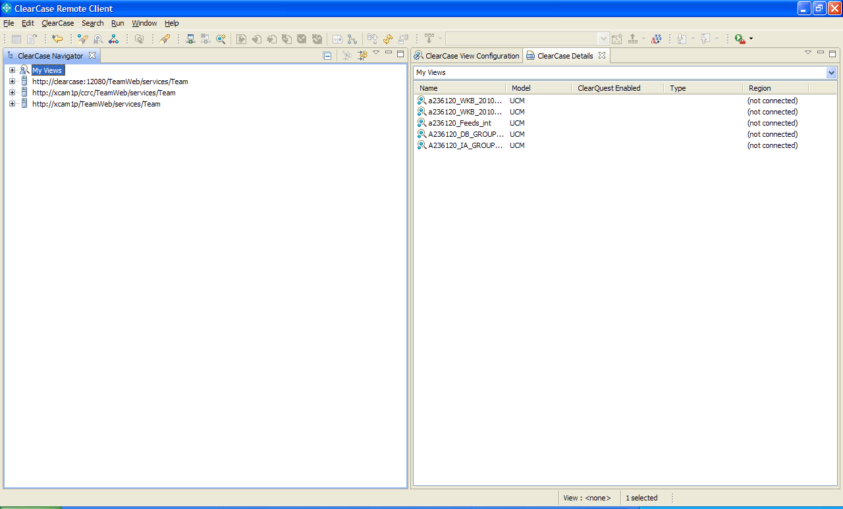

- Right mouse click on My Views and select Create View. See below

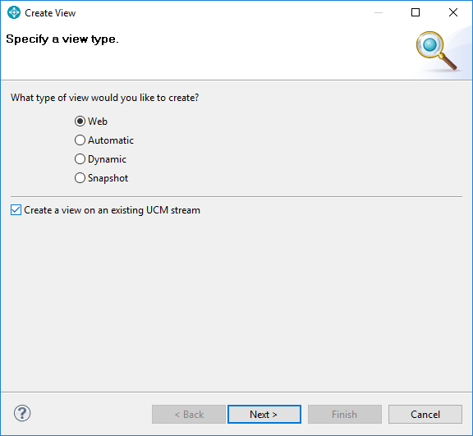

- If you not connected it will popup Login Dialog box. Enter Your Aetna ID/ZOPA. Make sure you have selected correct URL for server:
https://ccrc8/ccrc (new)

See below

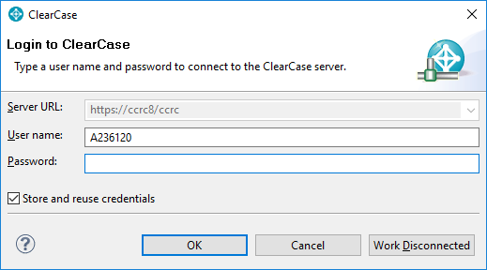

- Select under http://clearcase/TeamWeb/services/Team --> ClearCase --> Projects VOBs
It will expand in several seconds showing all projects. Select /v/P_WKB → WKAB→WKAB_2011Jan→WKB_2011Jan_rel. See below

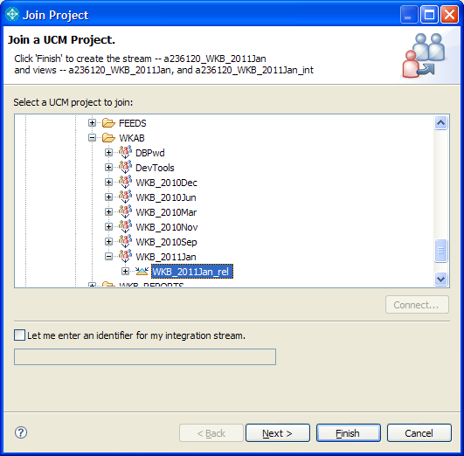

- Click Next. It will bring screen below

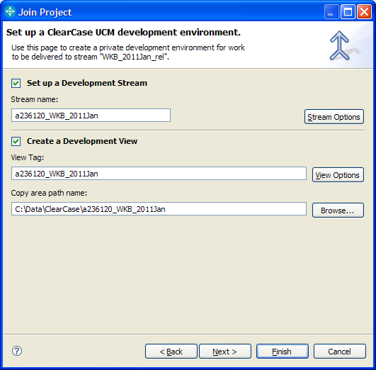

- Make sure you have directory that you want under Copy area path name. Also uncheck Set up a Development Stream check box. See below

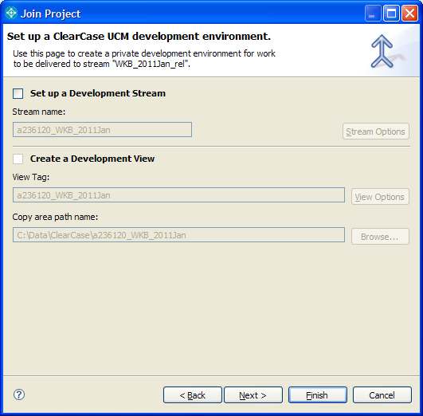

- Click Next. It will bring to screen below

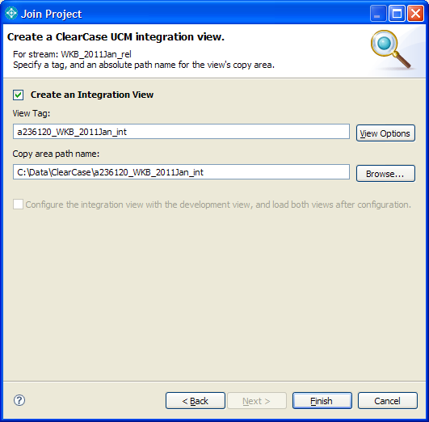

- Click Finish. It will bring screen below

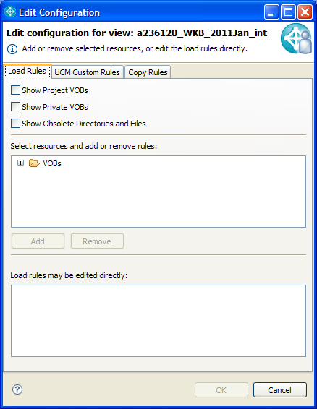

- Expand VOBs. It will take some time…Scroll down to v/wkb_Workability →ReleaseDBItems→Pick release folder. See screens below

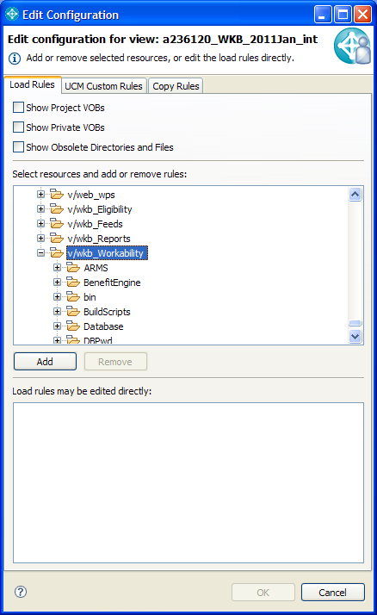

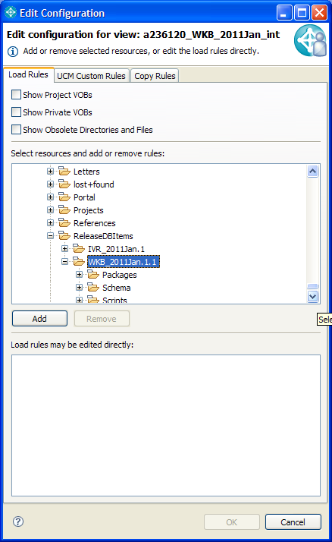

- Click Add Selected Folder and Click OK. See screen below

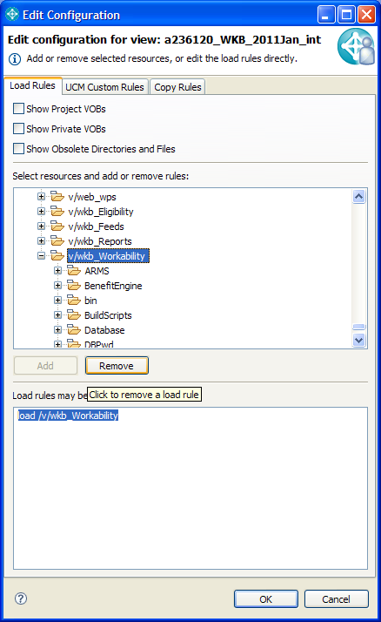

- When it completed. Start Windows Explorer and navigate to directory where you selected in step 8 (Copy area path name). And you should be able to see folders and files under. See screen below as example

