- Create new directory for example: C:\oracle_tns
- Copy 2 files from existing directory where current tnsnames.ora and sqlnet.ora files reside to new directory.
For example my existing directory: C:\Oracle\ora92\network\ADMIN,

- Right Mouse click on My Computer shortcut and click on Properties
- Click on Advanced Tab
- Click on Environmental Variables Button. See picture below

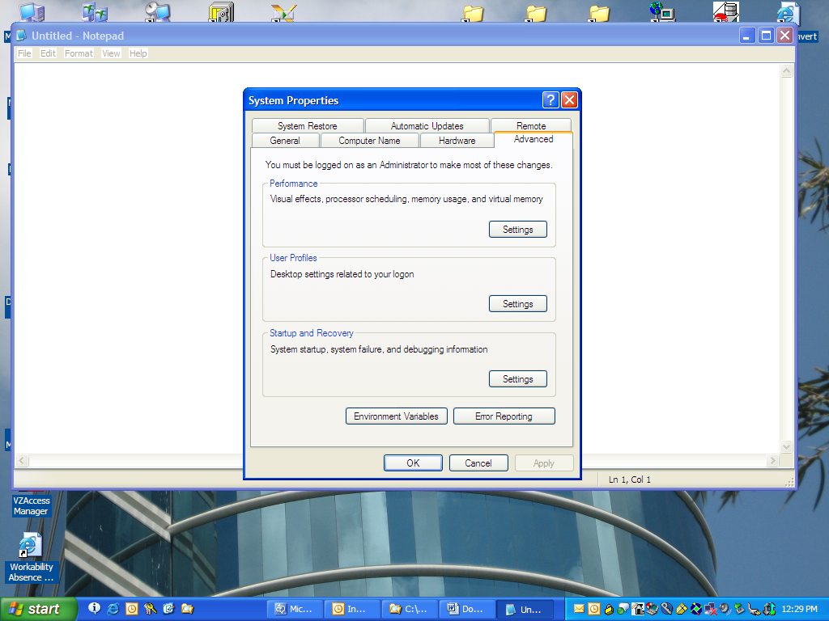

- Click on New button under System Variables Sections. This option could be disabled due to Admin rights, so use User Variable Section. See picture below

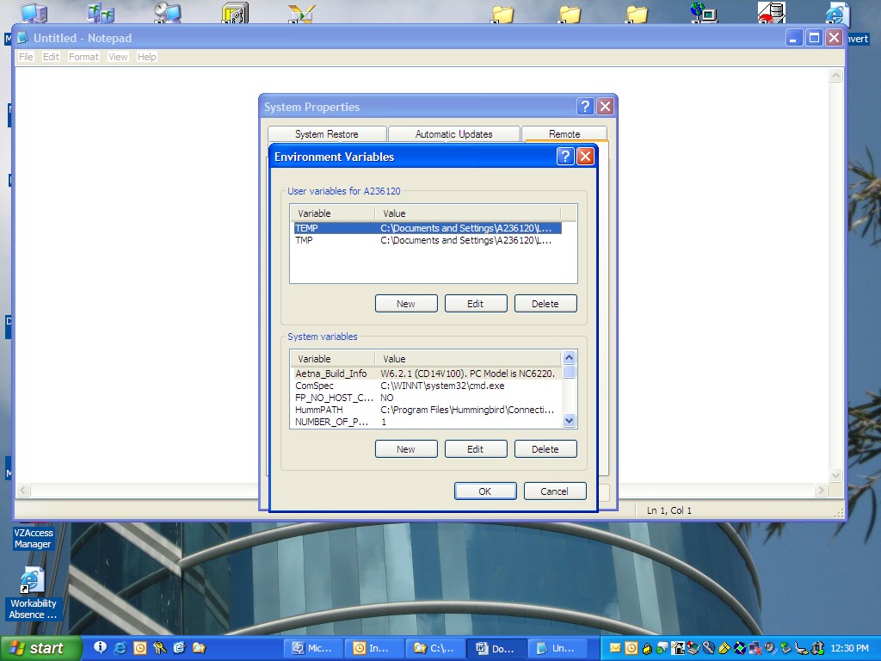

- Create new variable TNS_ADMIN and use New Directory path under value section. See picture below

