To Export via PL/SQL Developer

Do Nor run the query via the top tool bar



On the right side of the SQL window, there is a active button, Export Query Results, click it to run the query to a file

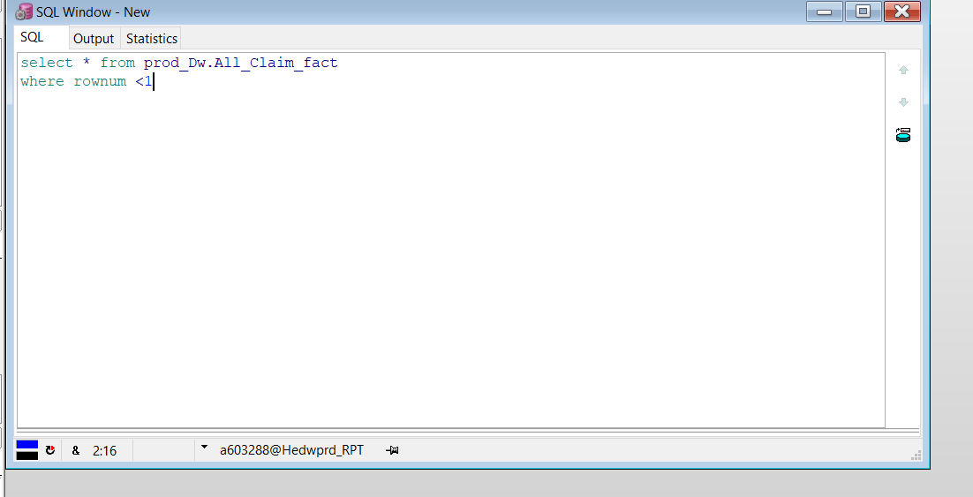

You will get a pop up asking for file time, CSV or TSV are recommended. Going straight to an Excel file is not. It added overhead.

Then you get the standard Windows Directory screen to select where to save the file and filename.

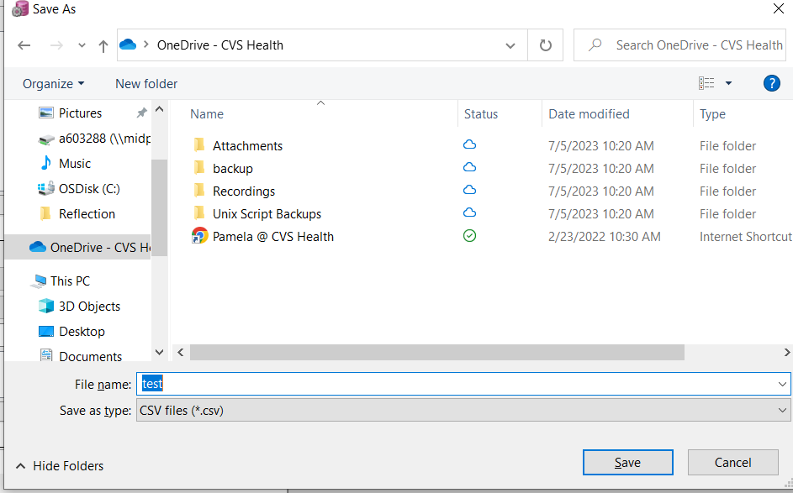

Once you hir save, the query will be started.

The states bar of the query window will tell you if the query is executing or if the data is being exported

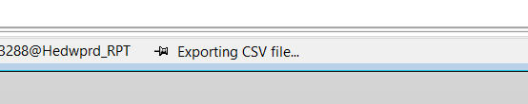

If you find the EXPORT step is taking a long time or hung, try changing there you are writing the file. Network drives tend to be better then your local C: Drive