**If you are getting following error while getting into Availability à Backup & Recoveryà Schedule backup**

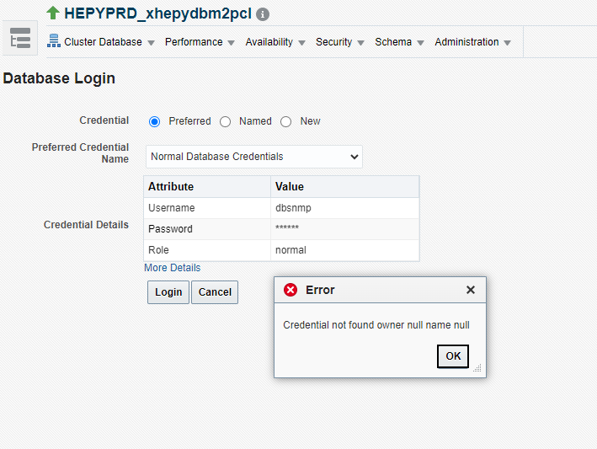

As a work around,  chose named credentials instead of preferred credentials, then choose dbsnmp  from the credential pull down.

