**Part 1: Access and App Setup**

**Step1 – Request Access**

Email Pamela Bolkovac to request access to the HEDW Repository. Do not simply asked for “GitHub” You must specify the repertory.

**Step 2 – Log into GITHUB**

Once you receive the email that you have been added to the AD group (HEDW_GIT_DEVELOPER), Log into the Web version:

<https://github.aetna.com/>

Use SAMI authentication

You will not see any repositories at this point. The security permissions are not pushed to GITHUB until after a user’s first login. At this point, **log off**. Wait at least 3 hours, but it can take as much as 24 for access to trickle down.

**Step 2 - Confirm access to repository**

After 24 hours, log back in and confirm you see the repository HEDW. If you don’t, email Pam Bolkovac to confirm your access.

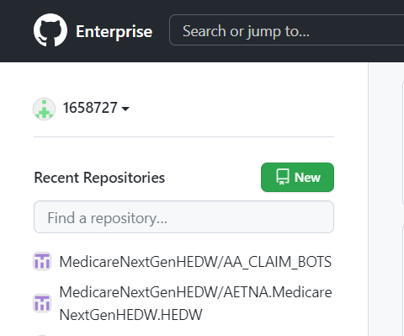

**Step 3 Setup Personal Access Key**

1. On Right hand side, under your id#, open the drop down menu and select settings

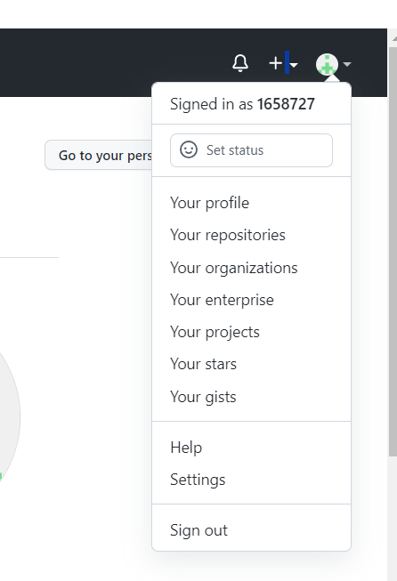

b)On the left side of the SETTING page, at the very end of the list, select Developer Settings

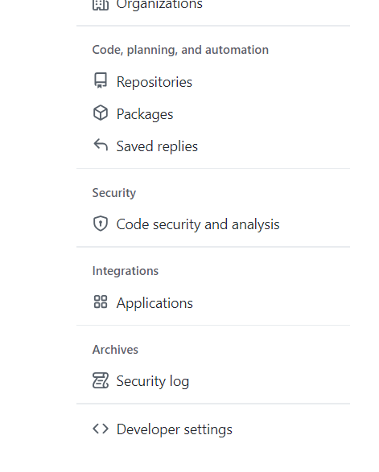

1. Select Personal Access Token

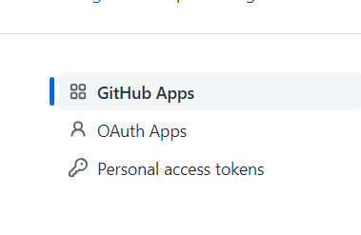

1. Click Generate Personal Access Token

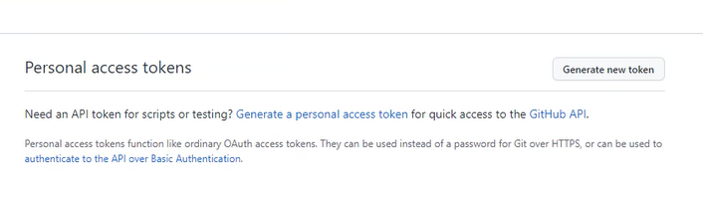

e)Name and Set properites

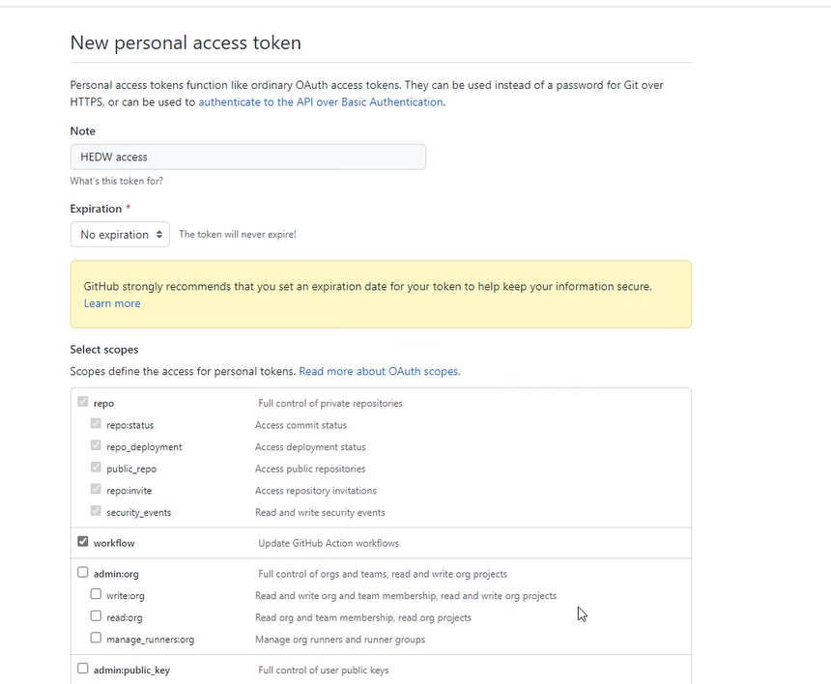

1)Name it something like HEDW Access

2)Select No Expiration

3)Select Repo

And Workflow

f)Go to the bottom of the screen and select Generate Token

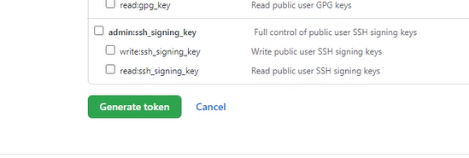

**Step 5 Configure Desktop App and Clone Repository**

a)Open the Desktop App

b)Log into the Enterprise URL (This will take you back to website for now to log in)

c)On Left panel, select CLONE ReposiroyEnterprise and go to URL tab

URL: https://github.aetna.com/MedicareNextGenHEDW/AETNA.MedicareNextGenHEDW.HEDW

Local Path MUST be on your C drive Recommendation, create a subfolder

Github to put it in.

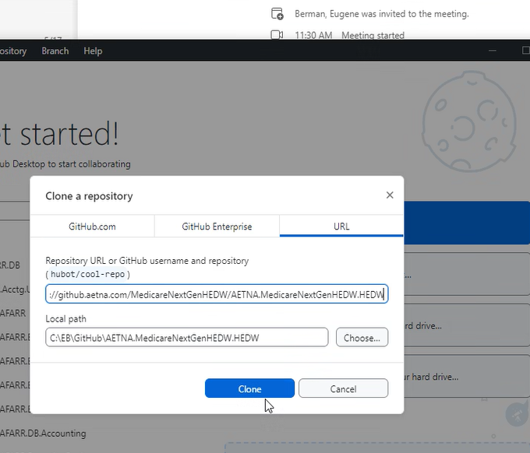

**Part 2: Using the Desktop App**

**Refreshing your local copy**

Your local copy does not refresh automatically. When every you need to do a deployment, in the APP, you must “Fetch origin”

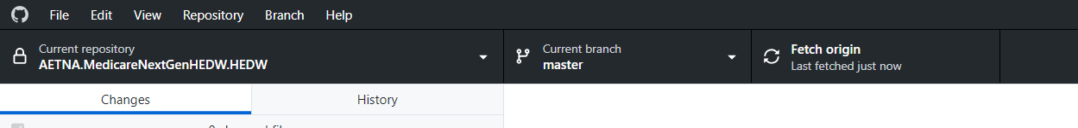

Then open File Explore and navigate to your local copy on your C Drive and the list of Deployments will be there. Find the CHG folder for the deployment and the files will be under it. **DO NOT EDIT THESE FILES.** If you need changed made, contact the CHG owner

