Database –> Monitoring-> Metrics and Collection Settings

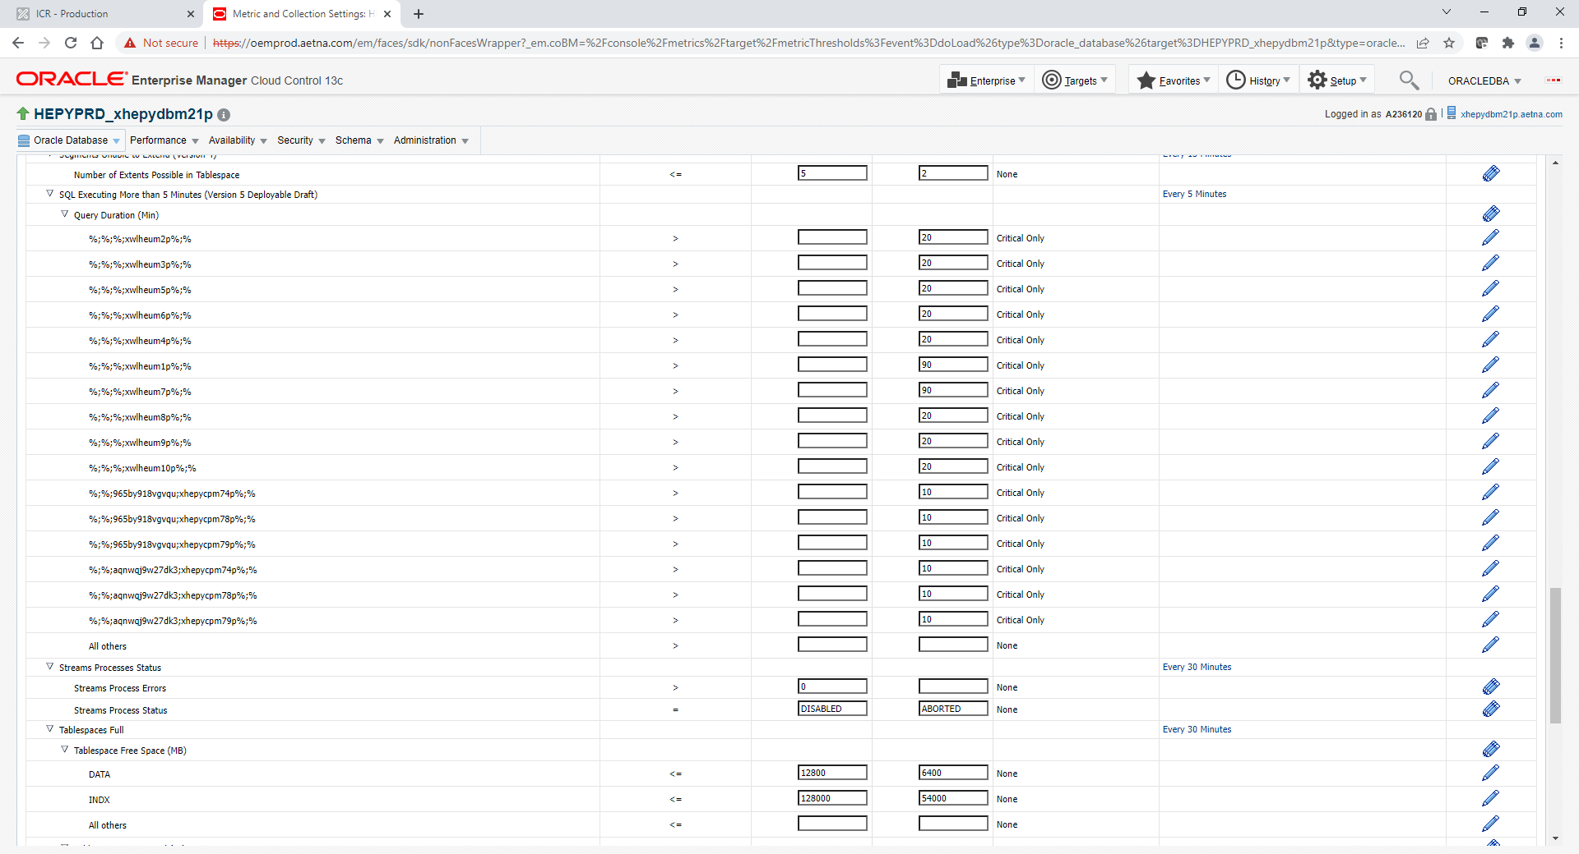

SQL Executing More than 5 Minutes (Version 5 Deployable Draft)

Query Duration (Min) - Click Edit-key based Metric blue wide button on right side

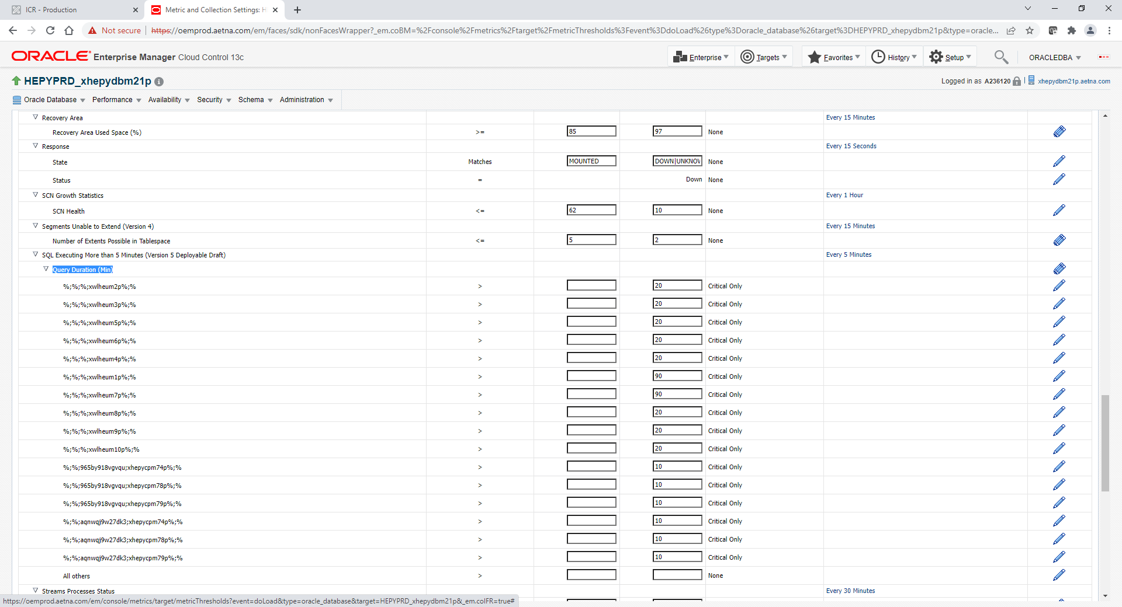

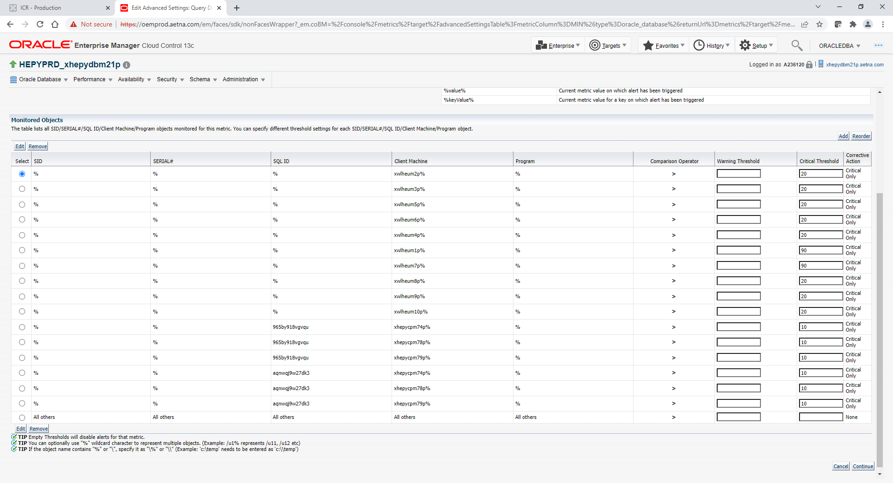

Click **Add** button

Fill out all boxes. Populate % to the first one. It’s defaults empty for some reason. Populate SQL ID and Populate MachineName including % at the end. Populate number of minutes in under Critical Only box. See example below.

Click **Add** button again if you need to add new row or click Continue button if you done. Both Add or Continue will save.

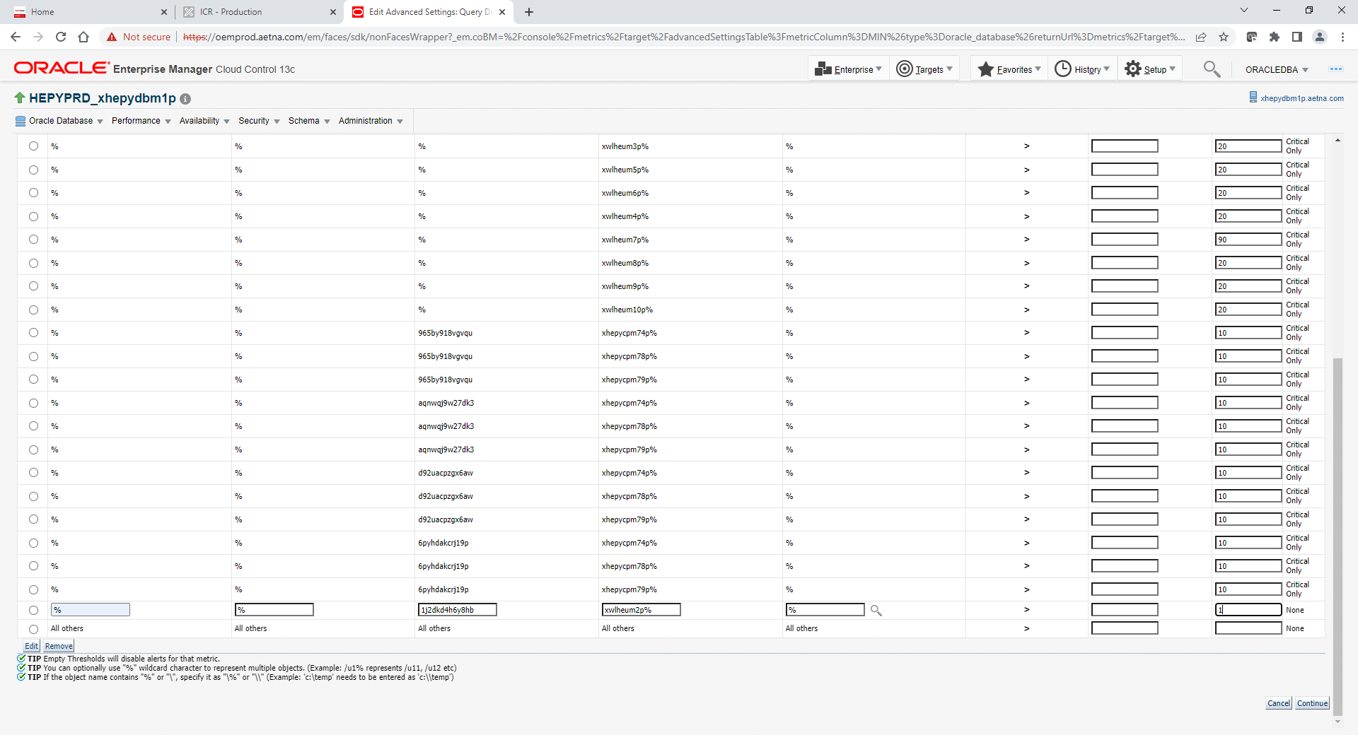

Click small ok button on top right corner

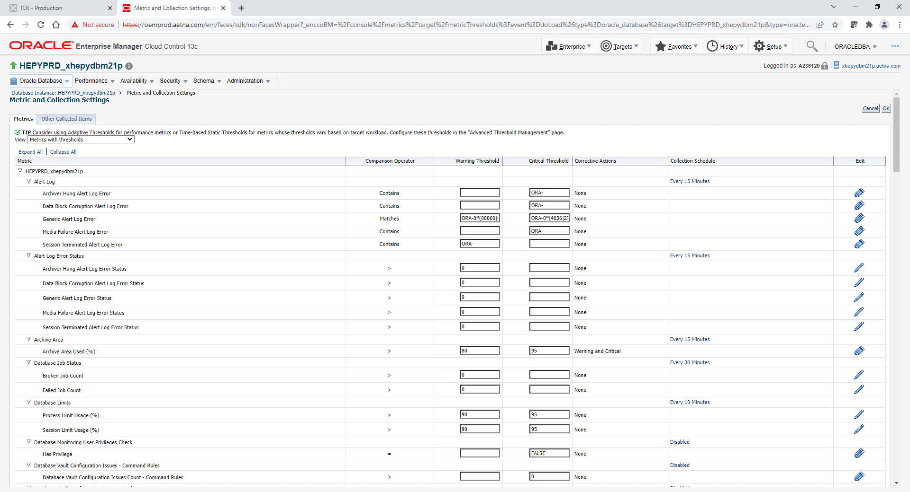

Next step to populate Corrective Actions column with Critical Only

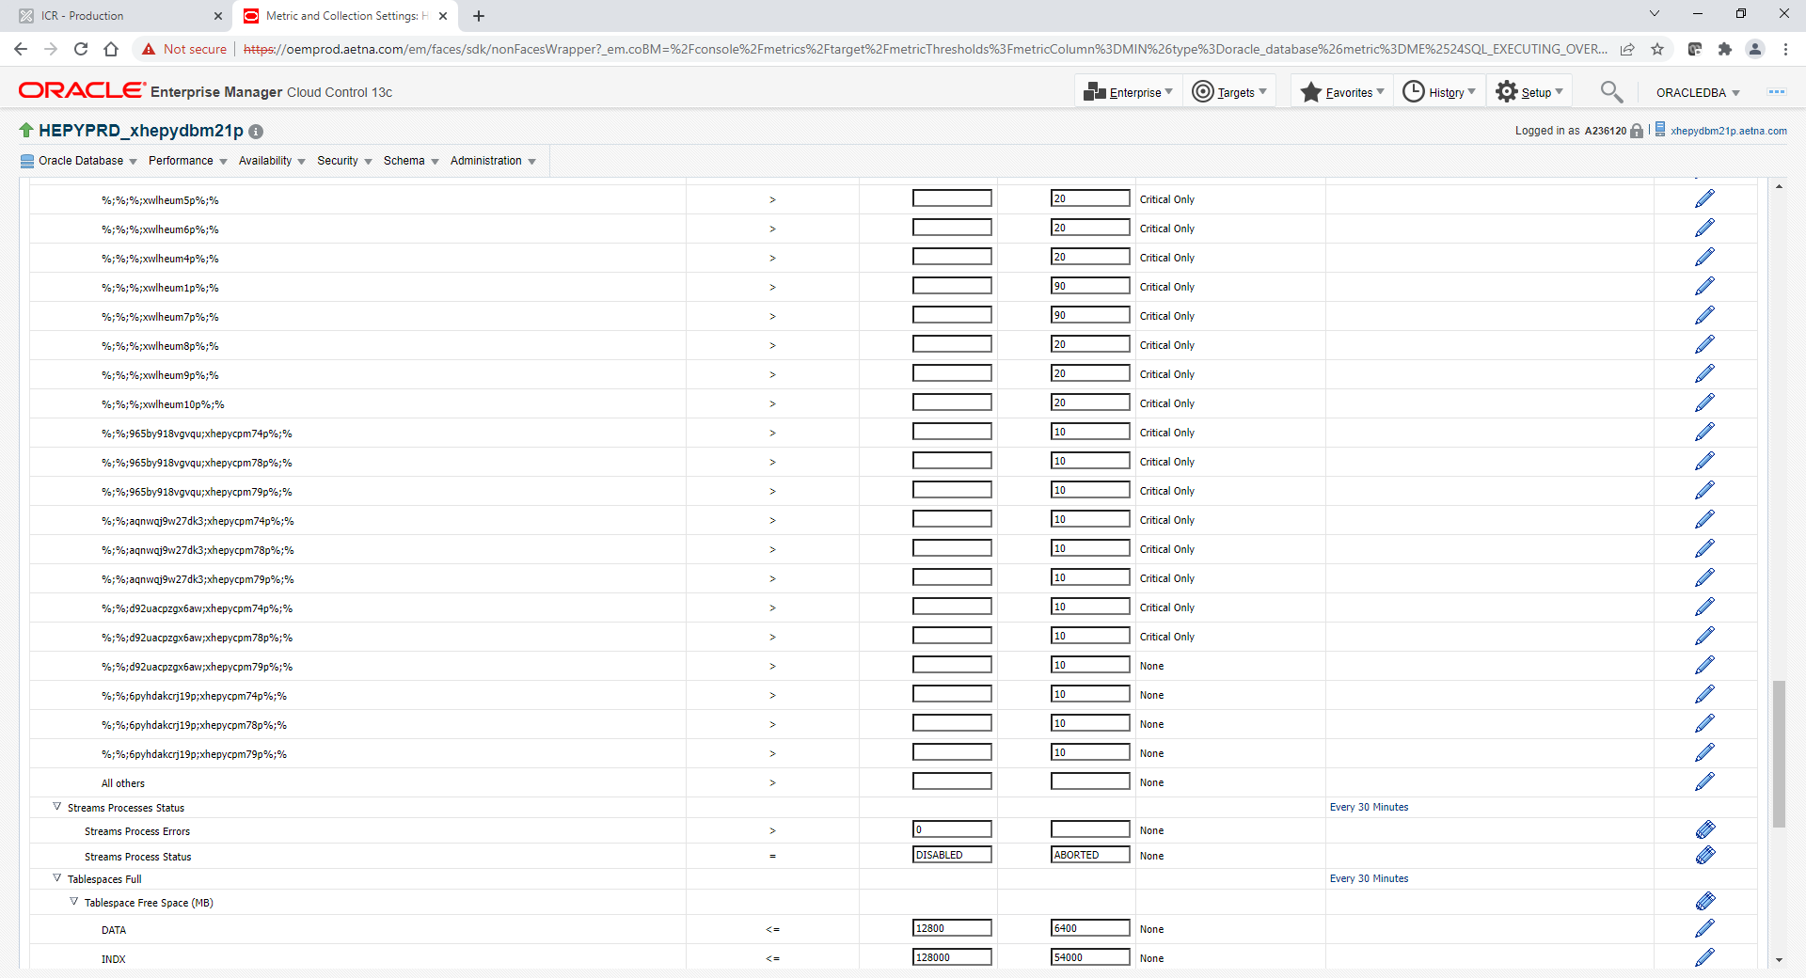

To do for each row click on blue pencil on right

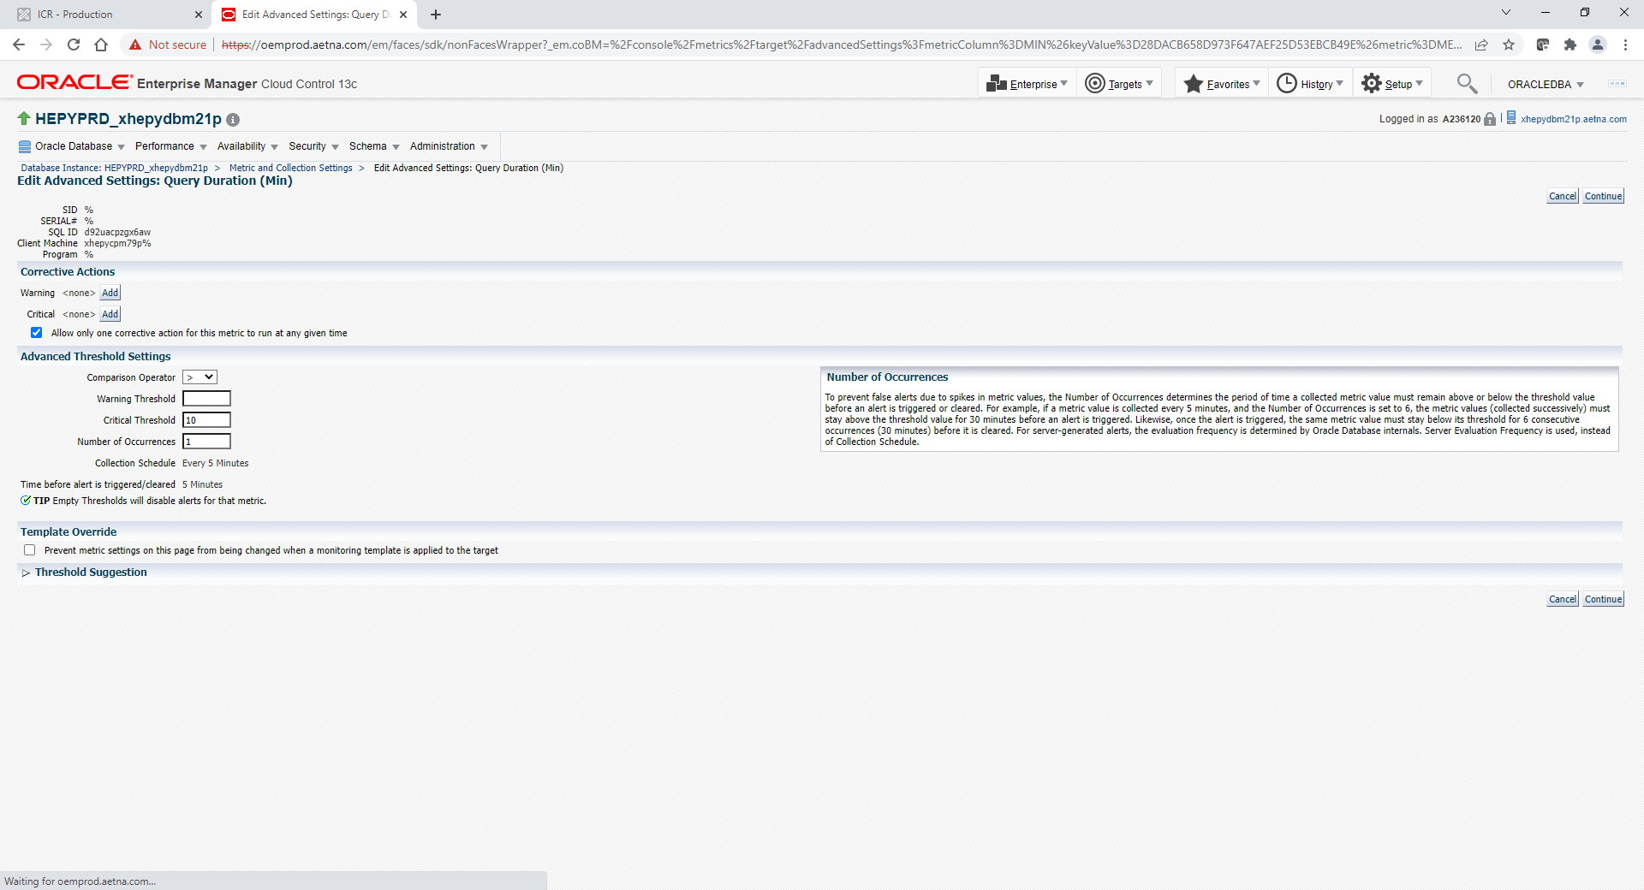

Populate how many minutes in example above is 10. Click Add Next to Critical on left side

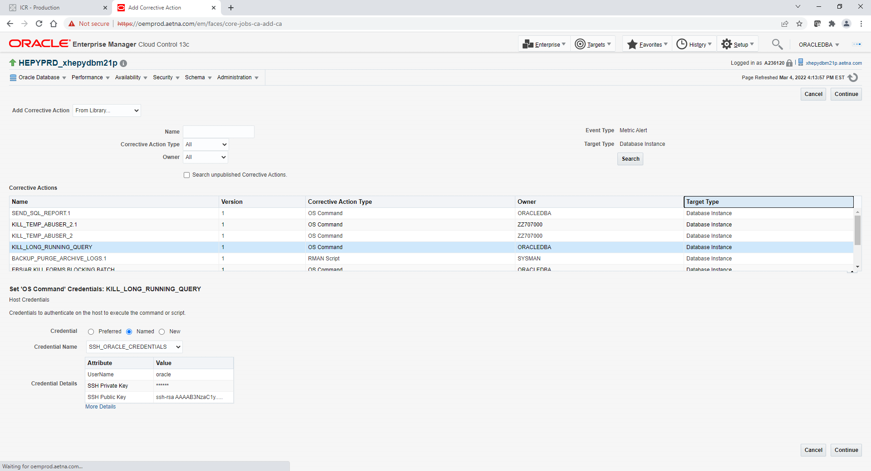

Click on KILL_LONG_RUNNING_QUERY row and click Continue button

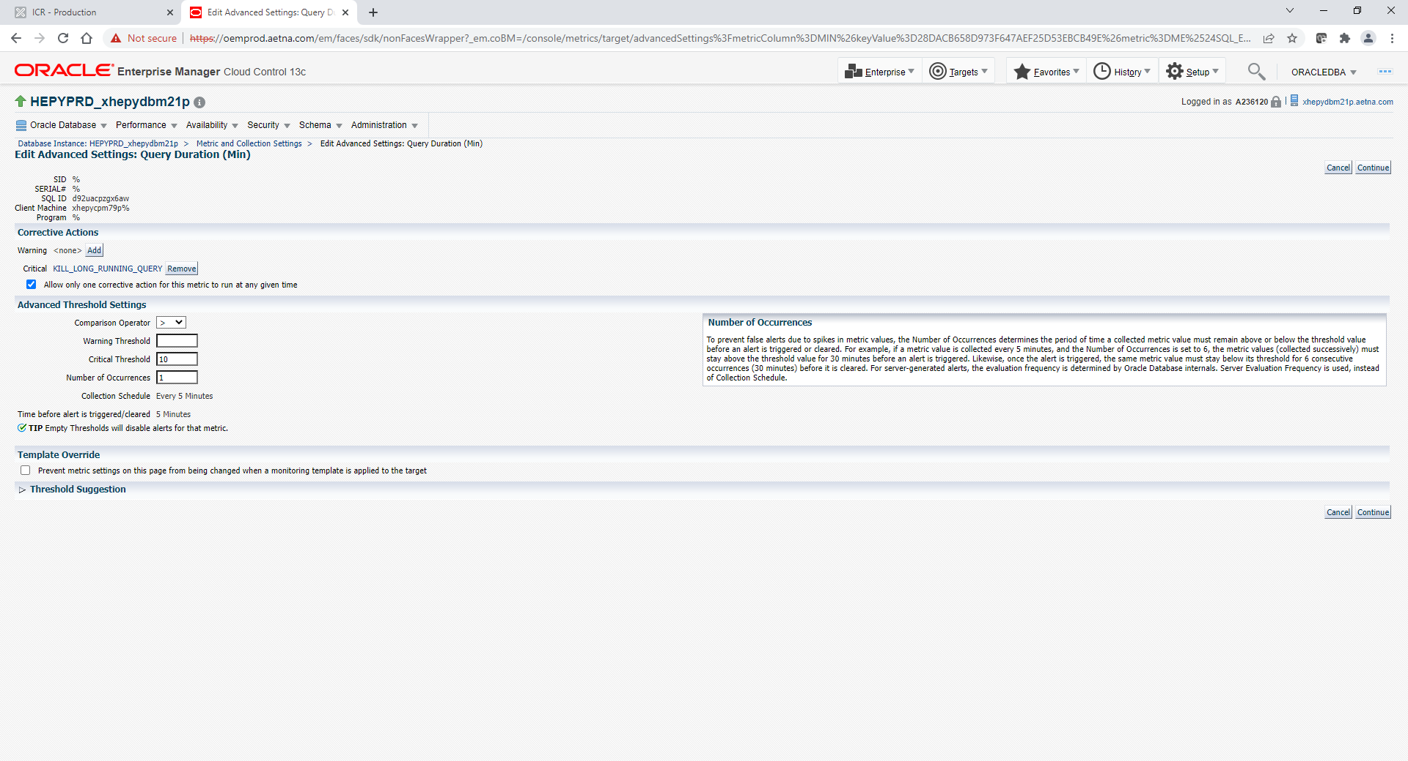

Click continue again

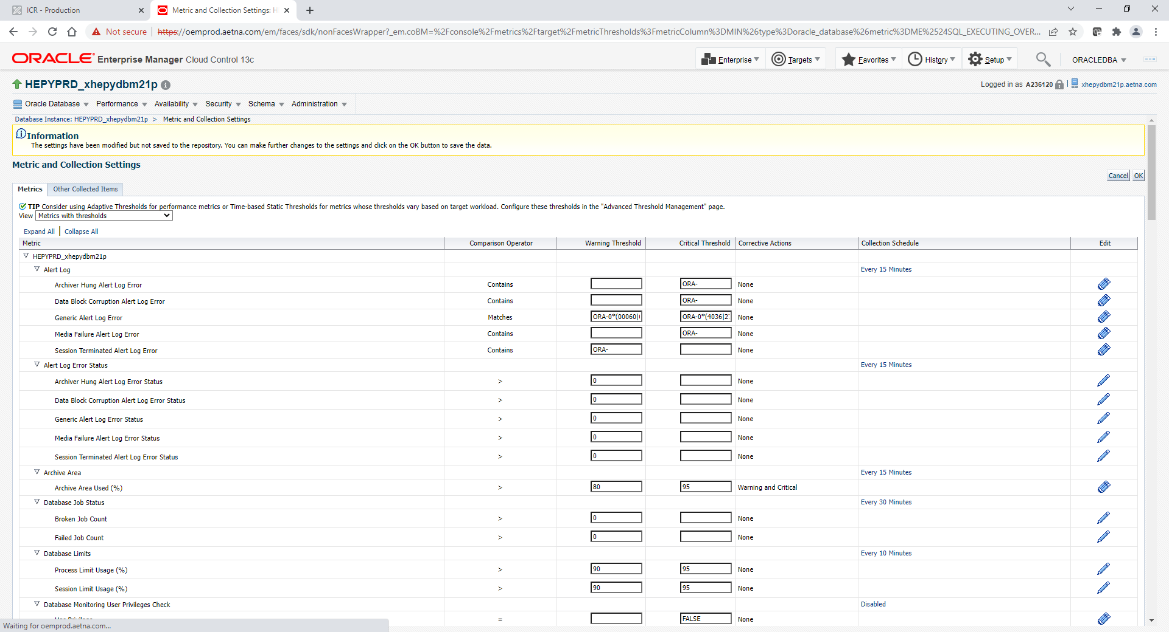

Click ok when all done

