Select DB Target: HEPYPRD

Monitoring --> Metric and Collection Settings

Scroll down to SQL Executing More than 5 Minutes (Version 5)

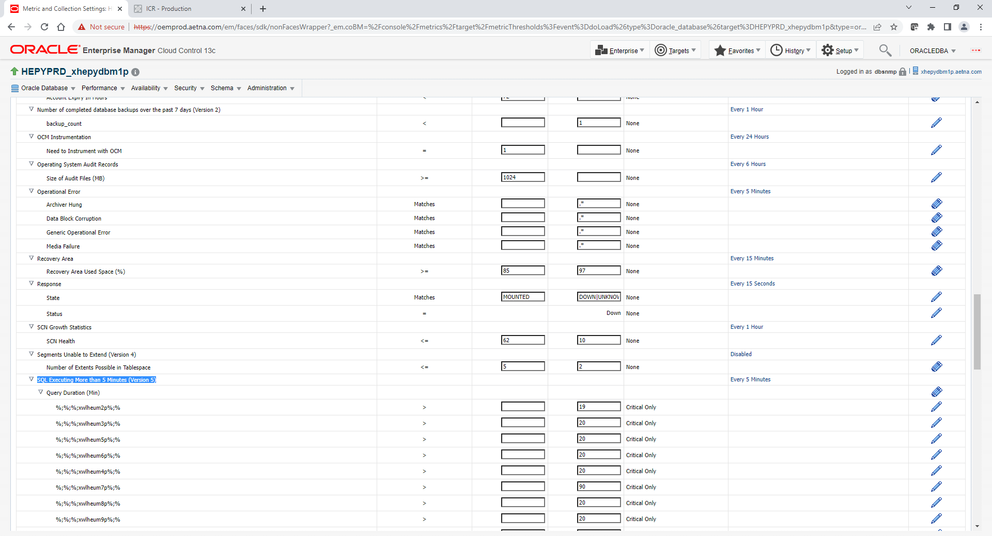

Click on Every 5 Minutes link

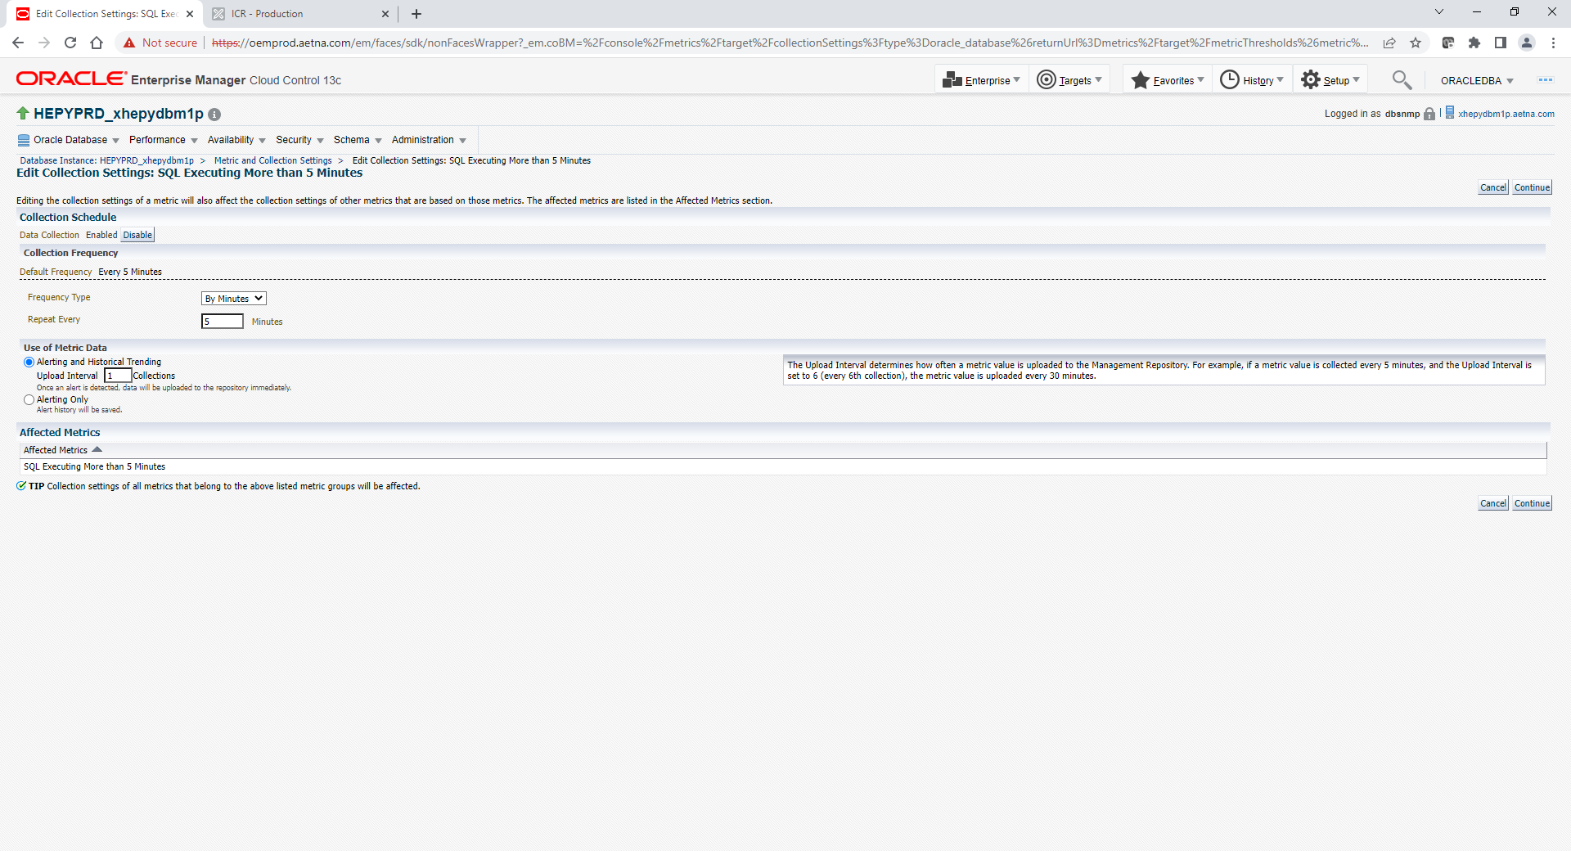

Click Data Collection Enable or Disable button on top Left corner

Click Continue

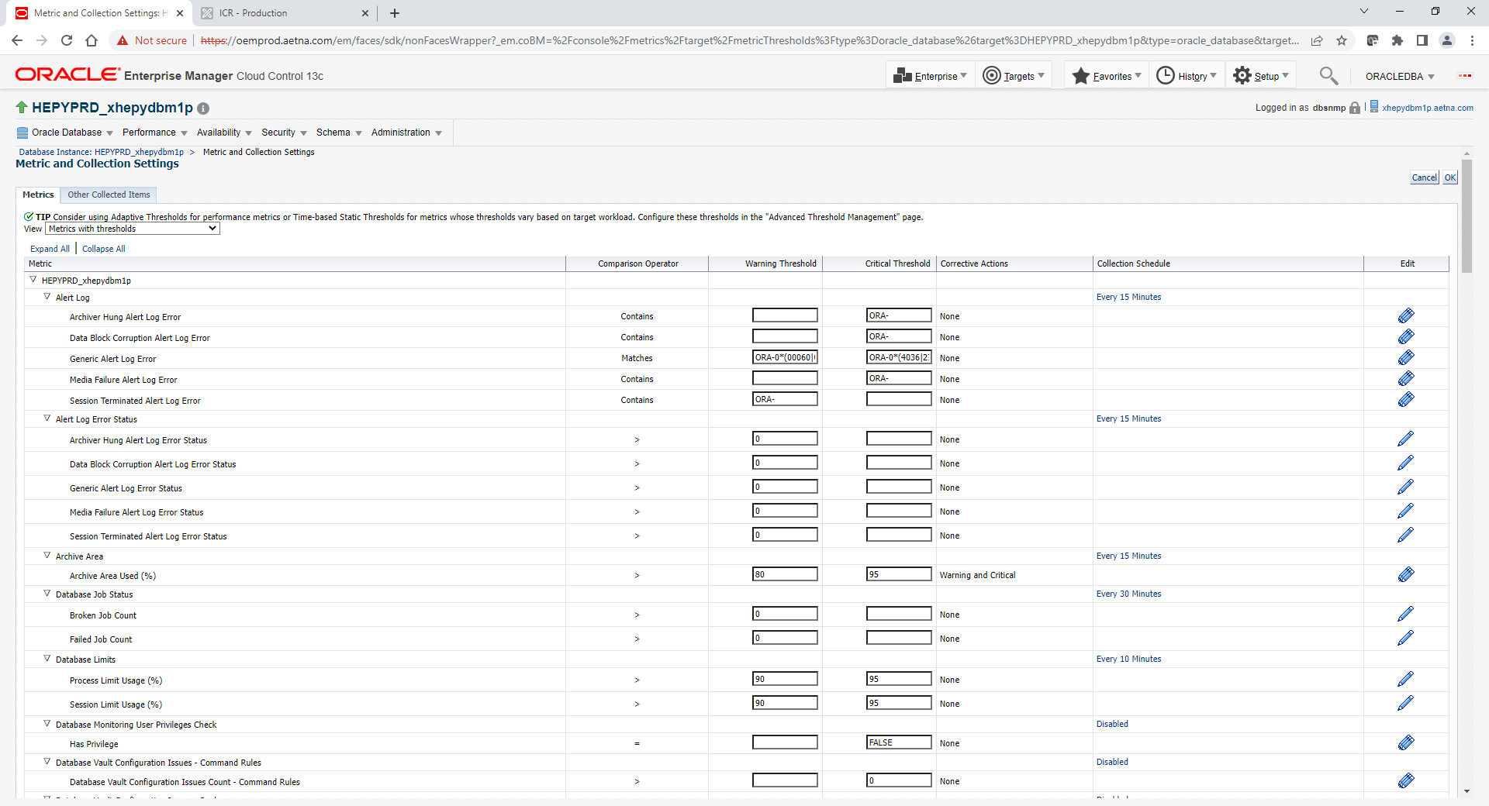

Clock OK top right corner of Metric and Collection Settings Screen to SAVE