First thing you need to check to ensure no collections are suspended

1. navigate to the agent home page in the oem console
2. under monitoring details, select the metric issues tab, **select historical and real time** in the view data pull down
3. if any are suspended,  highlight the metric and click on Un-suspend Metric

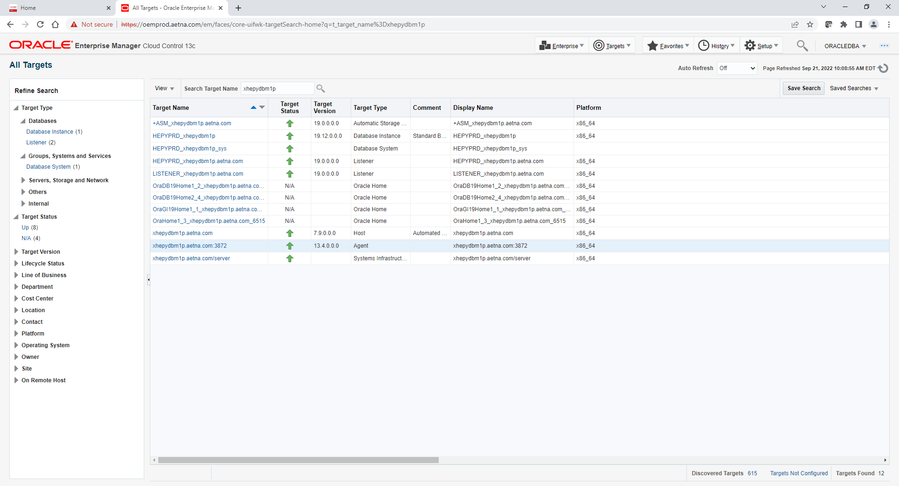

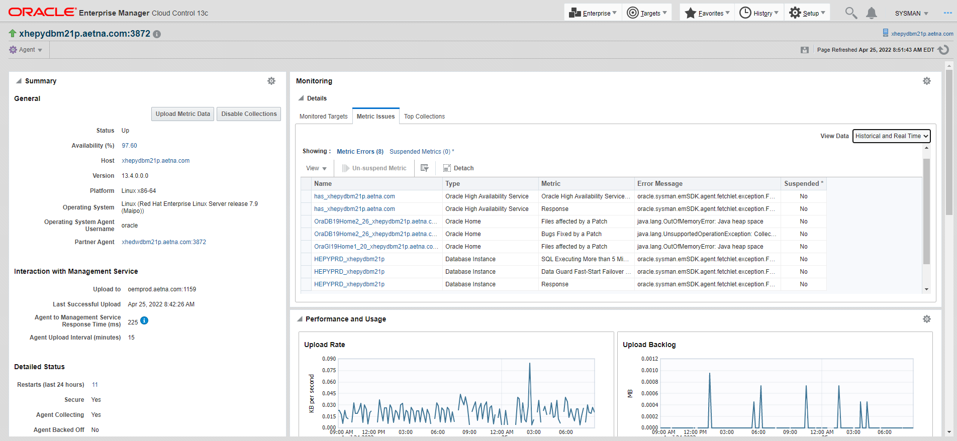

hopefully we will avoid this with the user **block chain metric disabled**

if above did not help. Try following

Navigate to **Metric and Collection Settings** under HEPYPRD target. Scroll down till you see SQL Executing More than 5 Minutes Thresholds

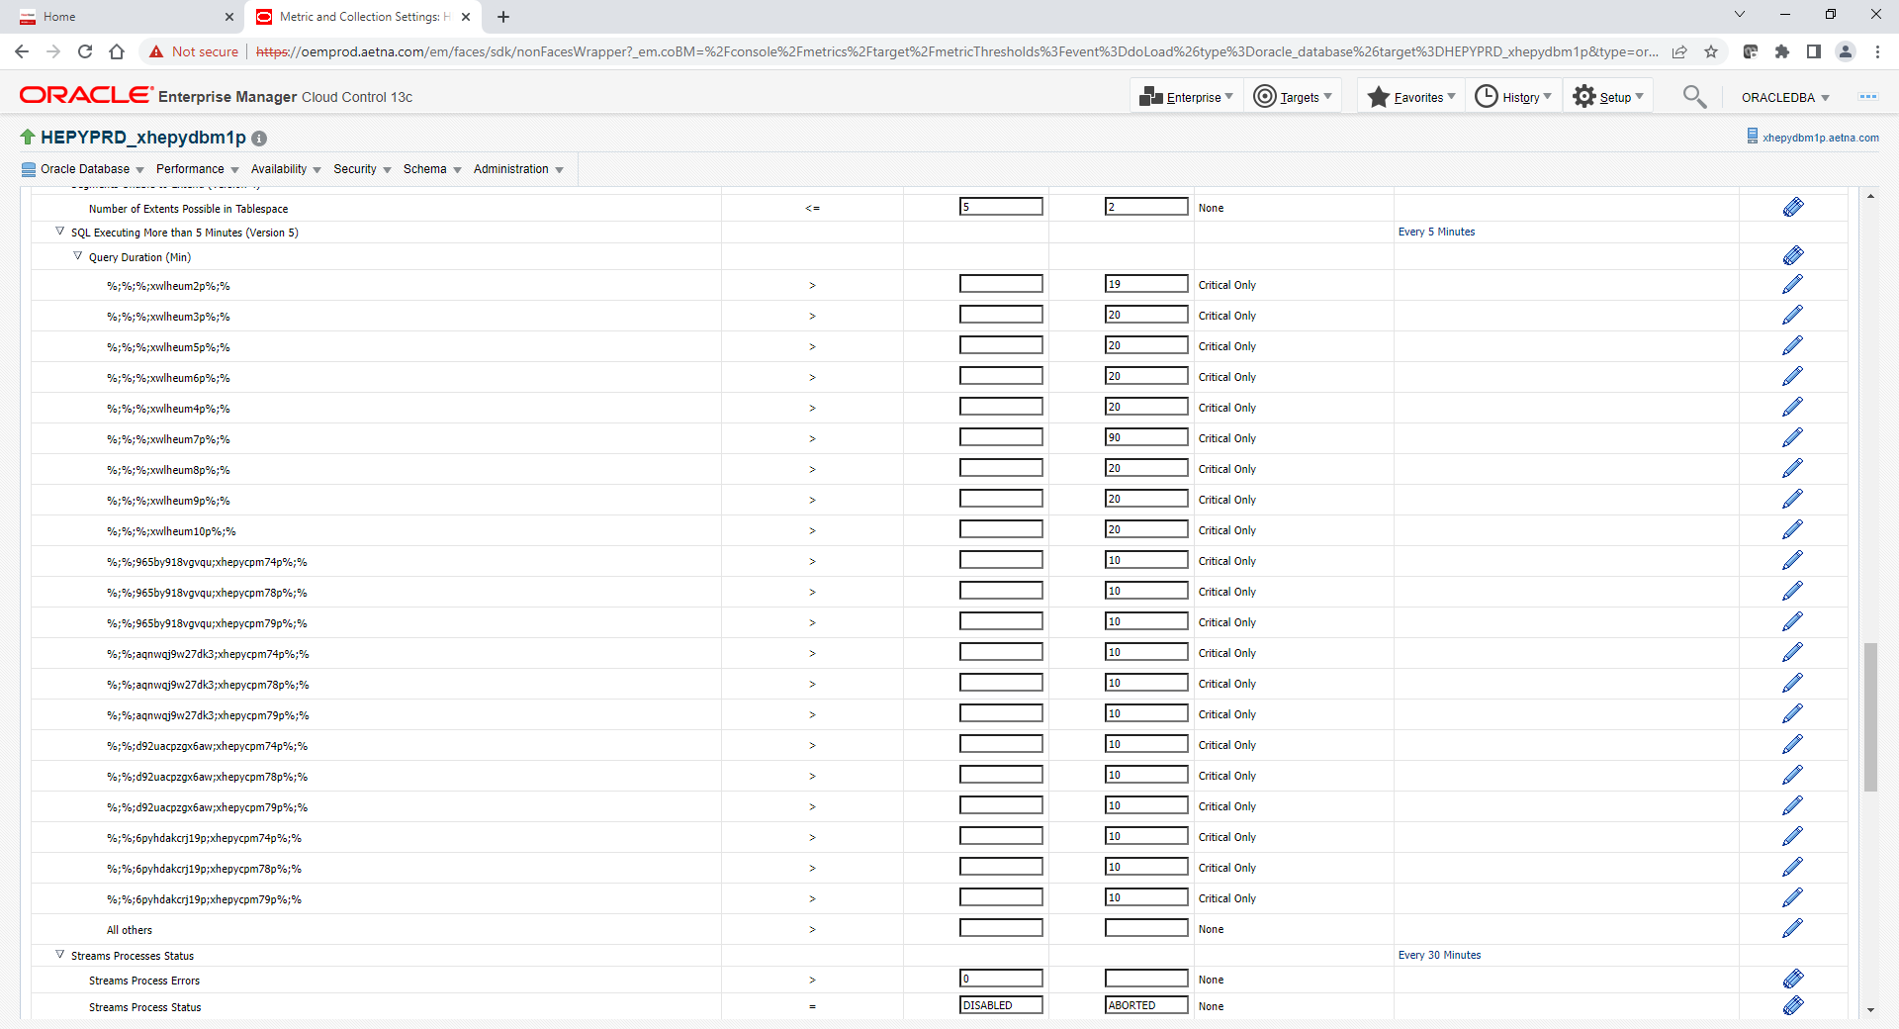

Change one of these settings. For example put 19 instead of 20 and click ok on top right corner to save. This may help to kick start killing. (Be aware this is not very affective fix but worked several times)

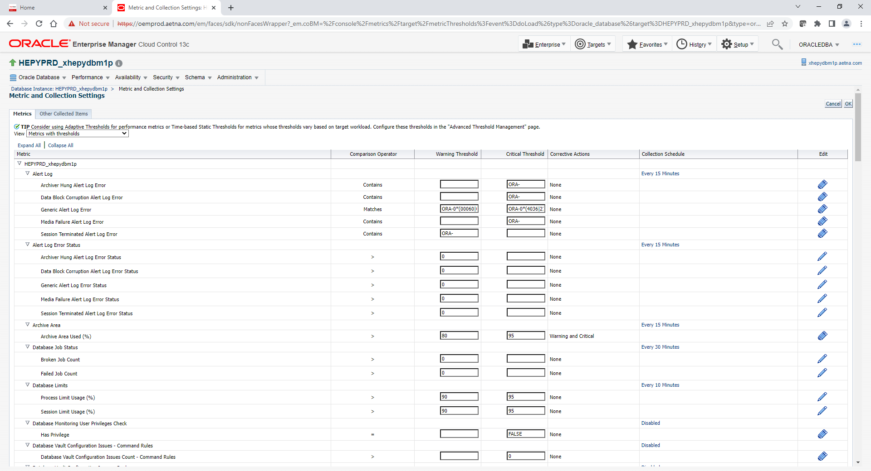

if above did not help. Try following

Login to xhepydbm1p

. oraenv

GCAGENT

emctl status agent

if agent is up try clearstate

emctl clearstate agent

if agent is down bounce agent

emctl stop agent

emctl start agent

if not helped try clearstate again

emctl clearstate agent

if above did not help. Try following. After that you may need to perform clearstate steps again.

You can check to see of the issue is persisting by manually executing the collection as indicated in the Guided Resolution.

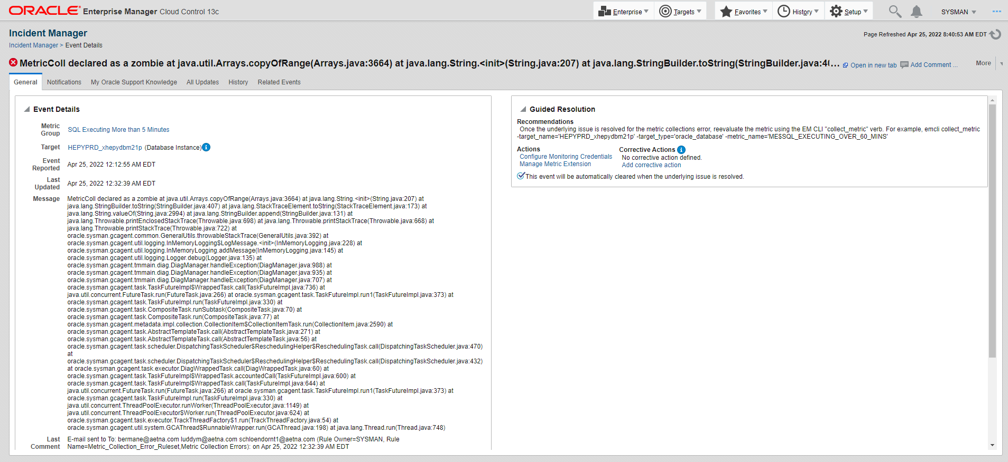

To execute the collection,   Login to **xoracldm2p** as oracle.      Log into the oms with

emcli login -username=sysman

The sysman password for prod is Autumn#20

Then execute the collection as provided

oms13c> emcli collect_metric -target_name='HEPYPRD_xhepydbm1p' -target_type='oracle_database' -metric_name='ME$SQL_EXECUTING_OVER_60_MINS';

Metric ME$SQL_EXECUTING_OVER_60_MINS was collected at repository successfully.

emcli logout

if above did not help.

Follow action plan b in note  2502487.1   plan to resolve the errors reported in the agent log and the reason the metric was suspended.

2022-09-21 10:15:19,253 [15086:GC.Executor.3971 (oracle_database:HEPYPRD_xhepydbm1p:UserBlock_10i) (oracle_database:HEPYPRD_xhepydbm1p:UserBlock_10i:UserBlock)] ERROR - Timestamp of first severity dropped: 1663769081000

2022-09-21 10:15:19,253 [15086:GC.Executor.3971 (oracle_database:HEPYPRD_xhepydbm1p:UserBlock_10i) (oracle_database:HEPYPRD_xhepydbm1p:UserBlock_10i:UserBlock)] ERROR - Timestamp of last severity dropped: 1663769141000

2022-09-21 10:15:19,362 [15086:GC.Executor.3971 (oracle_database:HEPYPRD_xhepydbm1p:UserBlock_10i) (oracle_database:HEPYPRD_xhepydbm1p:UserBlock_10i:UserBlock)] ERROR - Dropped 52 number of severity records from the severity logger queue as  the queue size had grown to 2 times the bound limit of 50 set for the queue.

2022-09-21 10:25:15,486 [15226:GC.Executor.4012 (oracle_database:HEPYPRD_xhepydbm1p:ME$SQL_EXECUTING_OVER_60_MINS) (oracle_database:HEPYPRD_xhepydbm1p:ME$SQL_EXECUTING_OVER_60_MINS:ME$SQL_EXECUTING_OVER_60_MINS)] ERROR - Dropped 52 number of severity records from the severity logger queue as  the queue size had grown to 2 times the bound limit of 50 set for the queue.

2022-09-21 10:25:15,487 [15226:GC.Executor.4012 (oracle_database:HEPYPRD_xhepydbm1p:ME$SQL_EXECUTING_OVER_60_MINS) (oracle_database:HEPYPRD_xhepydbm1p:ME$SQL_EXECUTING_OVER_60_MINS:ME$SQL_EXECUTING_OVER_60_MINS)] ERROR - Timestamp of first severity dropped: 1663769681000

2022-09-21 10:25:15,487 [15226:GC.Executor.4012 (oracle_database:HEPYPRD_xhepydbm1p:ME$SQL_EXECUTING_OVER_60_MINS) (oracle_database:HEPYPRD_xhepydbm1p:ME$SQL_EXECUTING_OVER_60_MINS:ME$SQL_EXECUTING_OVER_60_MINS)] ERROR - Timestamp of last severity dropped: 1663770015421