**HEDWPRD/HEDWPRD_RPT PASSWORD CHANGE Options**

**Option 1 – Alter Command**

This is the preferred method because it gives feedback on success and failure.

**Step 1:**

Log into the HEDWPRD (not HEDWPRD_RPT) using your preferred SQL Tool

**Step 2:**

Run this command with the appropriate values:

alter user USERID IDENTIFIED BY "NEWPASSWORD” replace "OLDPASSWORD"

Example:

alter user a123456 IDENTIFIED BY "Nwpss12#” replace "Oldword34$"

Please pay attention to the DOUBLE quotes around the old and new passwords. These are required because of the special character requirement in HEDW passwords.

**Option 2 – Use Reset Password Option in SQL Developer**

The downside to using this option is that it does not provide any feedback. You don’t know if the change was successful or not or why it was not until you try to log in again. In addition, it is very easy to type in the wrong new password twice and not know it. If you use this method, it is recommended to type the new password in to NOTEPAD and then copy it into the popup box so that you are sure you know what it is.

**Step 1**

Open Connections View and Right click on Database you want to change and select Reset Password – 4th option on the list

NOTE: You must use HEDWPRD not HEDWPRD_RPT to change your password

You will get the following popup screen:

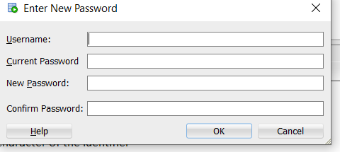

**Step2**

Fill in the appropriate boxes and hit OK

**Step 3**

Log into the database to confirm Password change

**Option 3 – Open a Ticket to the DBAs**

If you need to have a password reset and do not remember your old password or neither of the above methods work for you, you will need to call SPOC and have a ticket opened to **DBA Oracle HCB**