**PY and DW Friday pre steps**

**Adjust schedule for both HEPYPRD and HEDWPRD Level 0 jobs to start earlier on Saturday**. Based on latest average completion time figure out best time to start with goal to finish at least 1 hour prior to start of HRP upgrade.

**Adjust schedule for both HEPYPRD and HEDWPRD Archivelog jobs schedule** so they can finish right before HRP Upgrade start time. This will ensure FLASH_01 Disk space freed up.

**Adjust schedule for both HEPYRD (StandBy) and HEDWRPD (StandBy) archive purge jobs** **schedule** so they can finish right before HRP Upgrade start time. This will ensure FLASH_01 Disk space freed up.

**Disable OEM Saturday and Sunday and Automated Maintenance Tasks for both HEPYPRD and HEDWPRD.** See example below

These jobs occasionally run longer into HRP upgrade start time and we want to keep them down during HRP upgrade.

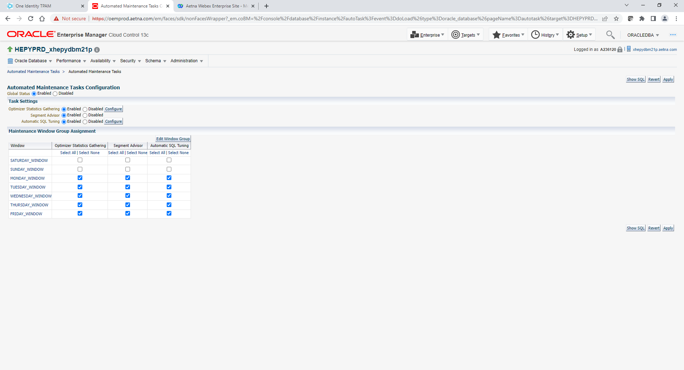

**PY and DW Saturday pre upgrade steps (you can do this while HRP bringing apps down or earlier during the day)**

-- Comment out PY crontab stats jobs. **If you see stats job running prior to Upgrade start time kill it.**

-- Check make sure PY Level 0 and DW Level 0 completed (should start earlier on Saturday and should be completed before HRP upgrade start). **If backup still running prior to Upgrade start time kill it**

-- Disable PY OEM Kill Job (comment out crontab job below)

#KILL JOB

*/5 * * * * /home/oracle/eb/kill_job/kill_jobs.sh HEPYPRD > /dev/null 2>/dev/null

-- Check make sure FLASH_01 space freed up on both PY Primary, PY Standby and DW Primary, DW Standby servers.

--Example below. Look for FLASH_01 DISK space.

+ASM> asmcmd lsdg

**** HEPYPRD ******

PLACE HOLDER FOR EXTRA DBA TASKS THAT NEEDS TO BE DONE PRIOR TO UPGRADE. Like changing DB parameters, bounce DB, index related work A lot of times DBA’s assigned extra tasks during HRP upgrade window to make changes not related to HRP upgrade…

**~~Deploy PY Upgrade Automation (only add crontab entries all other completed)~~**

**Process parameter changes Primary and Standby, bounce database. Follow srvctl_serverControl_bounce_DB.txt**

In Both Primary and Standby

alter system set db_recovery_file_dest_size = 1000G scope=both;

**** HEDWPRD ******

PLACE HOLDER FOR EXTRA DBA TASKS THAT NEEDS TO BE DONE PRIOR TO UPGRADE. Like changing DB parameters, bounce DB, index related work A lot of times DBA’s assigned extra tasks during HRP upgrade window to make changes not related to HRP upgrade…

**~~Deploy DW Upgrade Automation (only add crontab entries all other completed)~~**

In Both Primary and Standby

alter system set db_recovery_file_dest_size = 800G scope=both;

**PY Saturday upgrade steps (after apps down)**

Primary Server : xhepydbm1p (HEPYPRD)

StandBy Server: xhepydbw21p (HEPYPRD)

--Comment heartbeat in cron on **Primary** server

#*/5 * * * * /home/oracle/tls/rman/heartbeat.ksh HEPYPRD AEDBA > /dev/null 2>&1

--Manually update RMAN HeartBeat Table in **Primary** Database. Document outputs for reference.

/home/oracle/tls/rman/heartbeat.ksh HEPYPRD AEDBA

DBNAME Start Time

--------------------------- ----------------------------------------------

HEPYPRD 10-08-2022 06:48:53 PM

Previous TimeStamp

------------------------------------------------------------------

10-08-2022 06:45:01 PM

Current TimeStamp

------------------------------------------------------------------

10-08-2022 06:48:53 PM

End Time

------------------------------------------------------------------

10-08-2022 06:48:53 PM

--Get Flashback Database status in **Primary** database (Should return NO)

sql => select flashback_on from v$database;

FLASHBACK_ON

------------------

NO

--Get Flashback Database status in **Standby** database (Should return NO)

sql => select flashback_on from v$database;

FLASHBACK_ON

------------------

NO

From **Primary** database

alter system set db_recovery_file_dest_size = 1000G scope=both;

SQL> show parameter db_recovery_file_dest

From **Standby** database

alter system set db_recovery_file_dest_size = 1000G scope=both;

SQL> show parameter db_recovery_file_dest

**--Create the Guaranteed Restore Point**

**--To be run on the Primary database server - Script will also configure the standby database**

cd $SCRIPTS

create_guaranteed_restore_point.sh HEPYPRD b4_app_upgrade

NAME INCARNATION SCN TIME GUAR

------------------------------------ ------------ ---------------- ------------------------------- ----

B4_APP_UPGRADE 2 13624228151450 10-JUL-22 12.05.14.000000000 AM YES

Uncomment the heartbeat script in cron on primary server

*/5 * * * * /home/oracle/tls/rman/heartbeat.ksh HEPYPRD AEDBA > /dev/null 2>&1

**Confirm flashback_database configured in standby database**

Run below select in standby database

select flashback_on from v$database;

**DW Saturday upgrade steps**

Primary Server: xhedwdbm21p (HEDWPRD)

Standby Server: xhedwdbw21p (HEDWPRD)

--Run **AEDBA.LOCKUSER** procedure in HEDWPRD.

sqlplus / as sysdba

EXECUTE aedba.LOCKUSER;

--Manually kill N and A ID connections if you see any. Should not be any active at this point.

--Comment heartbeat in cron on **Primary** server

#* /home/oracle/tls/rman/heartbeat.ksh HEDWPRD AEDBA

--Manually update RMAN HeartBeat Table in **Primary** Database. Document for reference.

/home/oracle/tls/rman/heartbeat.ksh HEDWPRD AEDBA

DBNAME Start Time

--------------------------- --------------------------------------------------------

HEDWPRD 10-08-2022 06:59:13 PM

Previous TimeStamp

------------------------------------------------------------------

10-08-2022 06:55:01 PM

Current TimeStamp

------------------------------------------------------------------

10-08-2022 06:59:13 PM

End Time

------------------------------------------------------------------

10-08-2022 06:59:13 PM

-- Get Flashback Database status in **Primary** database (Should return NO)

sql => select flashback_on from v$database;

FLASHBACK_ON

------------------

NO

--Get Flashback Database status in **Standby** database (Should return NO)

sql => select flashback_on from v$database;

FLASHBACK_ON

------------------

NO

From **Primary** database

alter system set db_recovery_file_dest_size = 800G scope=both;

SQL> show parameter db_recovery_file_dest

From **Standby** database

alter system set db_recovery_file_dest_size = 800G scope=both;

SQL> show parameter db_recovery_file_dest

**--Create the Guaranteed Restore Point**

**--To be run on the Primary database server - Script will also configure the standby database**

cd $SCRIPTS

create_guaranteed_restore_point.sh HEDWPRD b4_app_upgrade

NAME INCARNATION SCN TIME GUAR

------------------------------------ ------------ ---------------- ------------------------------- ----

B4_APP_UPGRADE 2 13633812145040 10-JUL-22 12.10.11.000000000 AM YES

Uncomment the heartbeat script in cron on primary server

*/5 * * * * /home/oracle/tls/rman/heartbeat.ksh HEDWPRD AEDBA > /dev/null 2>&1

**Confirm flashback_database configured in standby database**

Run below select in Standby database

select flashback_on from v$database;

**-----------------------------> Sunday morning steps (whenever time you get green light after checkout).**

**PY Sunday steps**

--To Check flashback logs size that being generated during upgrade

. oraenv

HEPYPRD

sqlplus / as sysdba

SELECT

SUM(bytes/1024/1024/1024) as "Size(GB)"

FROM

v$flashback_database_logfile;

**Get total from Size(GB) column and note size here for reference: 264 GB**

**Drop restore points**

**Drop Guaranteed Restore Point and turn off flashback_database in the standby database**

**To be run on the primary database server - Script will also configure the standby database**

**Primary**:

cd $SCRIPTS

drop_guaranteed_restore_point.sh HEPYPRD b4_app_upgrade

Confirm restore point dropped

sqlplus / as sysdba

select name from v$restore_point where guarantee_flashback_database='YES';

**Confirm flashback_database not configured in standby database**

Run below select in standby database

select flashback_on from v$database;

Resize the FRA in the primary database and the standby database

Primary DataBase:

sqlplus / as sysdba

alter system set db_recovery_file_dest_size = 7G scope=both;

show parameter db_recovery_file_dest_size;

Standby DataBase:

sqlplus / as sysdba

alter system set db_recovery_file_dest_size = 7G scope=both;

show parameter db_recovery_file_dest_size;

**Uncomment stats jobs (reschedule to start Sunday jobs that supposed to start earlier. Remember to put old schedule back after that.)**

PLACE HOLDER FOR EXTRA DBA TASKS. Like changing DB parameters, bounce DB, index related work, BLOB table migration to Big File Tablespaces etc. A lot of times DBA’s assigned extra tasks during HRP upgrade window to make changes not related to HRP upgrade…

***** HEPYPRD*****

select INDEX_NAME

from dba_indexes

where owner = 'PROD'

and VISIBILITY = 'INVISIBLE';

ALTER INDEX PROD.SPPLR_LATEST VISIBLE;

ALTER INDEX PROD.FK_SUPPLIER_PRVDRIDCD_DATES VISIBLE;

ALTER INDEX PROD.VIDDATES_PRACT_LATEST VISIBLE;

ALTER INDEX PROD.PKDATES_PRACT_LATEST VISIBLE;

ALTER INDEX PROD.ALIAS_PRACT_LATEST VISIBLE;

ALTER INDEX PROD.V_PRACT_HCCID_INDX VISIBLE;

ALTER INDEX PROD.PRACT_LATEST_IDENT_NBR VISIBLE;

ALTER INDEX PROD.FK_PRACT_L_DENT_NBR_PRACT_EST VISIBLE;

ALTER INDEX PROD.FK_PRACT_LAT_IDENT_NBR_CD_E_RY VISIBLE;

ALTER INDEX PROD.PRACT_LATEST_LICENSE_NBR VISIBLE;

ALTER INDEX PROD.FK_PRACT_LA_ENSE_NBR_PRAC_EST VISIBLE;

ALTER INDEX PROD.V_PRACT_NPI_INDX VISIBLE;

ALTER INDEX PROD.V_PRACT_NPI_UPPER_IX VISIBLE;

ALTER INDEX PROD.PRACT_LATEST_IDENT_NBR_TXT VISIBLE;

ALTER INDEX PROD.PRACT_LATEST_LICENSE_NBR_TXT VISIBLE;

ALTER INDEX PROD.VIDDATES_SPPLR_LATEST VISIBLE;

ALTER INDEX PROD.PKDATES_SPPLR_LATEST VISIBLE;

ALTER INDEX PROD.ALIAS_SPPLR_LATEST VISIBLE;

ALTER INDEX PROD.SPPLR_LATEST_IDENT_NBR VISIBLE;

ALTER INDEX PROD.FK_SPPLR_L_DENT_NBR_SPPLR_EST VISIBLE;

ALTER INDEX PROD.FK_SPPLR_LAT_IDENT_NBR_CD_E_RY VISIBLE;

ALTER INDEX PROD.UP_PRIMARY_NAME_SPPLR_LATEST VISIBLE;

ALTER INDEX PROD.FK_SUPPLIER_LATEST_TAX_ENTITY VISIBLE;

ALTER INDEX PROD.SPPLR_LATEST_IDENT_NBR_TXT VISIBLE;

ALTER INDEX PROD.PRACT_LATEST VISIBLE;

ALTER INDEX PROD.FK_SUPPLIER_HCCID_ENDORDT VISIBLE;

ALTER INDEX PROD.V_SUPPLIER_LATEST_PCP VISIBLE;

CREATE INDEX PROD.PAYABLE_AEDBA_3

ON PROD.PAYABLE("TENANT_ID", "SPPLR_ID", "PAYABLE_ID")

TABLESPACE INDX4 ONLINE PARALLEL 6 ;

ALTER INDEX PROD.PAYABLE_AEDBA_3 NOPARALLEL;

~~ALTER INDEX PROD.FK_PAYABLE_SUPPLIER INVISIBLE~~

~~/~~

DROP INDEX PROD.FK_PAYABLE_SUPPLIER

/

CREATE INDEX PROD.PAYABLE_AEDBA_2

ON PROD.PAYABLE("SPPLR_ID", "SUBTYPE_NM", "CYCLE_ID", "BANK_ACCT_ID", "TENANT_ID", "RELEASE_DT")

TABLESPACE INDX4 ONLINE PARALLEL 6;

ALTER INDEX PROD.PAYABLE_AEDBA_2 NOPARALLEL;

CREATE INDEX PROD.ADJUSTMENT_PAYABLE_AEDBA_1

ON PROD.ADJUSTMENT_PAYABLE("TENANT_ID", "PAYABLE_ID")

TABLESPACE INDX4 ONLINE PARALLEL 6;

ALTER INDEX PROD.ADJUSTMENT_PAYABLE_AEDBA_1 NOPARALLEL;

!!!

**Deploy latest kill script changes**

**DW Sunday steps**

-- To Check flashback logs size that being generated during upgrade

. oraenv

HEDWPRD

sqlplus / as sysdba

SELECT

SUM(bytes/1024/1024/1024) as "Size(GB)"

FROM

v$flashback_database_logfile;

**Get total from Size(GB) column and note size here for reference: 24 GB**

**Drop restore points**

cd $SCRIPTS

drop_guaranteed_restore_point.sh HEDWPRD b4_app_upgrade

**Confirm restore point dropped**

sqlplus / as sysdba

select name from v$restore_point where guarantee_flashback_database='YES';

**Confirm flashback_database not configured in standby database**

Run below select in standby database

select flashback_on from v$database;

Resize the FRA in the primary database and the standby database

Primary DataBase:

sqlplus / as sysdba

alter system set db_recovery_file_dest_size = 7G scope=both;

show parameter db_recovery_file_dest_size;

Standby DataBase:

sqlplus / as sysdba

alter system set db_recovery_file_dest_size = 7G scope=both;

show parameter db_recovery_file_dest_size;

--Following script will add appropriate grants to newly created tables during upgrade. It will ask for **database name** and **number of days or hours** to check for new objects back. Just put 12 hours like this 12/24 or query database for last PROD_DW table create date to get an idea how many hours new tables were added.

cd /home/oracle/tls/security

grant_permissions.ksh

-- Run **AEDBA.UNLOCKUSER** procedure in HEDWPRD

sqlplus / as sysdba

EXECUTE aedba.UNLOCKUSER;

--Deploy DSR to update views. Pam should submit DSR with bunch of scripts mostly views to redeploy.

--Enable OEM Saturday and Sunday Automated Maintenance Tasks for both PY and DW

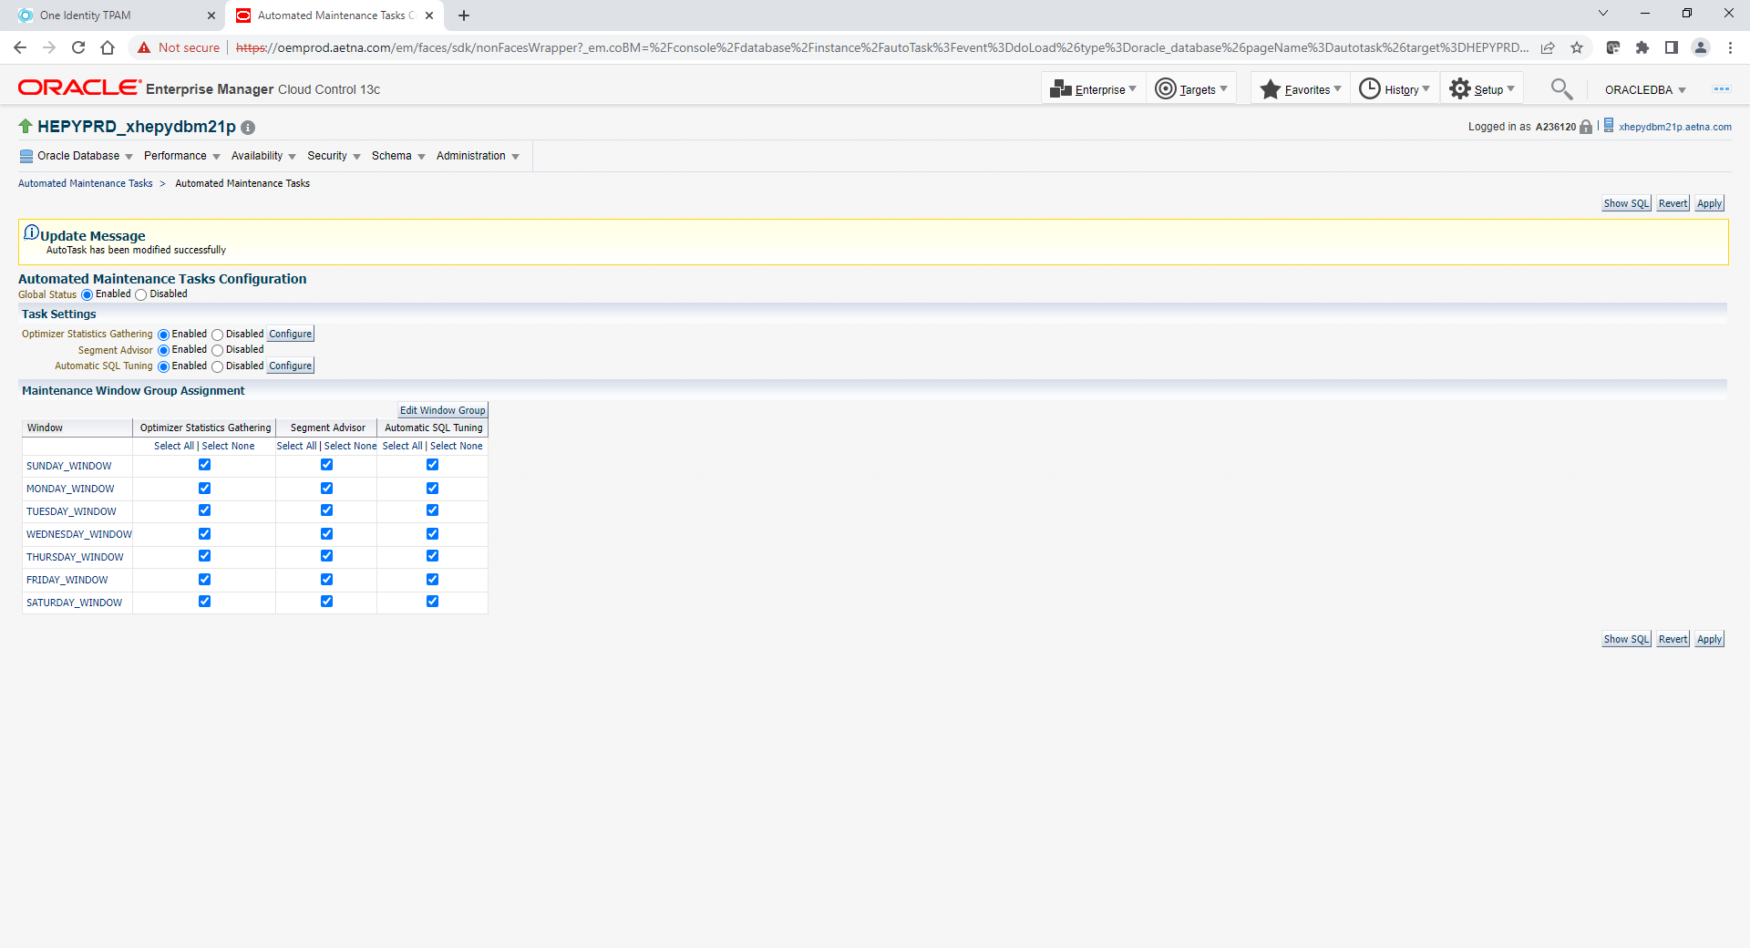

--Uncomment PY crontab stats job that were commented out night before. If it already not completed. If it past Sunday’s job start time just adjust start time based on current time.

-- Enable PY OEM Kill Job (Uncomment job below)

#KILL JOB

*/5 * * * * /home/oracle/eb/kill_job/kill_jobs.sh HEPYPRD > /dev/null 2>/dev/null