**Rollback databases during the HRP Application Upgrade**

PY backout

Comment the heartbeat script in cron on primary server

#*/5 * * * * /oradb/app/oracle/local/scripts/monitor/rman/heartbeat.ksh **DbNameTobeRollBack** AEDBA > /dev/null 2>&1

To be performed in the primary database

Flashback the database

sqlplus / as sysdba

shutdown immediate;

startup mount;

## if flashback was created in Jenkins use double quates per example below

**flashback database to restore point "b4_app_upgrade";**

shutdown immediate;

startup mount;

--if you want to confirm the flashback by querying the heartbeat table then you open the database read only.  Otherwise, not needed.

alter database open read only;

select * from aedba.rman_heartbeat;

--Confirm output to output above before restore point was set

shutdown immediate;

startup mount;

alter database open resetlogs;

To be performed in the Standby database

**To be performed in an Active DataGuard Standby Database ONLY!**

Note: The below is not required for a normal mounted standby database (Not an ADG db opened read only with apply)

Below is run on the standby server

sqlplus / as sysdba

shutdown immediate;

startup mount;

exit;

sqlplus / as sysdba

alter database open read only;

select * from aedba.rman_heartbeat;

Confirm output to output above before restore point was set

exit;

sqlplus / as sysdba

select open_mode from v$database; --Confirm open_mode is READ ONLY WITH APPLY

To be performed in the primary database

**Drop restore points**

. oraenv

**DbNameTobeRollBack**

cd $SCRIPTS/HRP_upgrade

sqlplus / as sysdba

@DROP_GRP.sql

exit

# In new incognito window open below link

<https://ci-autoeng.cvshealth.com/jenkins/>

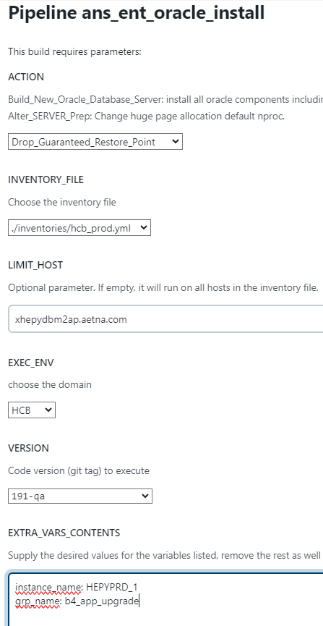

UnComment the heartbeat script in cron on primary server

*/5 * * * * /oradb/app/oracle/local/scripts/monitor/rman/heartbeat.ksh **DbNameTobeRollBack** AEDBA > /dev/null 2>&1

DW rollback

Comment the heartbeat script in cron on primary server

#*/5 * * * * /oradb/app/oracle/local/scripts/monitor/rman/heartbeat.ksh **DbNameTobeRollBack** AEDBA > /dev/null 2>&1

To be performed in the primary database

Flashback the database

sqlplus / as sysdba

shutdown immediate;

startup mount;

## if flashback was created in Jenkins use double quates per example below

**flashback database to restore point "b4_app_upgrade";**

shutdown immediate;

startup mount;

--if you want to confirm the flashback by querying the heartbeat table then you open the database read only.  Otherwise, not needed.

alter database open read only;

select * from aedba.rman_heartbeat;

--Confirm output to output above before restore point was set

shutdown immediate;

startup mount;

alter database open resetlogs;

**To be performed in an Active DataGuard Standby Database ONLY!**

Note: The below is not required for a normal mounted standby database (Not an ADG db opened read only with apply)

Below is run on the standby server

sqlplus / as sysdba

shutdown immediate;

startup mount;

exit;

sqlplus / as sysdba

alter database open read only;

select * from aedba.rman_heartbeat;

Confirm output to output above before restore point was set

exit;

sqlplus / as sysdba

select open_mode from v$database; --Confirm open_mode is READ ONLY WITH APPLY

To be performed in the primary database

**Drop restore points**

. oraenv

**DbNameTobeRollBack**

cd $SCRIPTS/HRP_upgrade

sqlplus / as sysdba

@DROP_GRP.sql

Exit

# In new incognito window open below link

<https://ci-autoeng.cvshealth.com/jenkins/>

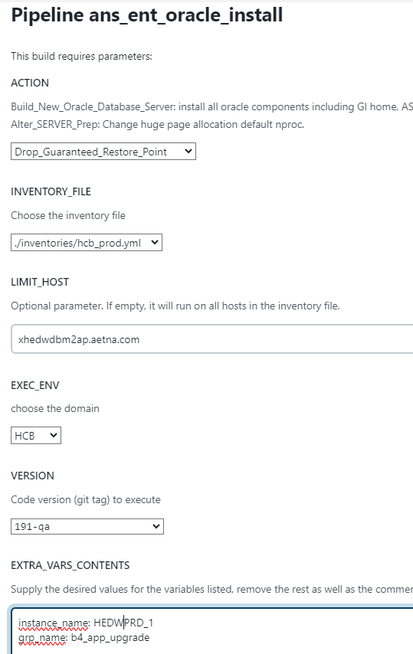

Uncomment the heartbeat script in cron on primary server

*/5 * * * * /oradb/app/oracle/local/scripts/monitor/rman/heartbeat.ksh **DbNameTobeRollBack** AEDBA > /dev/null 2>&1