* ~~Move DB to norachivelog if not already~~

~~alter system set "_use_realfree_heap"=false scope=spfile;~~

~~alter system set "_dbwr_stall_write_detection_interval" = 0;~~

~~alter system set audit_trail=NONE scope=spfile;~~

~~shutdown immediate;~~

~~startup mount;~~

~~alter database flashback off;~~

~~ALTER DATABASE NO FORCE LOGGING;~~

~~alter database noarchivelog;~~

~~alter database open;~~

~~archive log list;~~

* Add quota to new TBS and change defaults

~~ALTER SYSTEM SET UNDO_RETENTION = 28800;~~

~~ALTER USER HE_CUSTOM QUOTA UNLIMITED ON INDX5;~~

~~ALTER USER HE_CUSTOM QUOTA UNLIMITED ON DATA5~~

~~ALTER USER HE_CUSTOM QUOTA UNLIMITED ON INDX4;~~

~~ALTER USER HE_CUSTOM QUOTA UNLIMITED ON DATA4;~~

~~ALTER USER HE_CUSTOM QUOTA UNLIMITED ON INDX3;~~

~~ALTER USER HE_CUSTOM QUOTA UNLIMITED ON DATA3;~~

~~ALTER USER HE_CUSTOM QUOTA UNLIMITED ON INDX2;~~

~~ALTER USER HE_CUSTOM QUOTA UNLIMITED ON DATA2;~~

~~ALTER USER AEDBA~~

~~DEFAULT TABLESPACE DATA5~~

~~/~~

~~ALTER USER HEDBA~~

~~DEFAULT TABLESPACE DATA5~~

~~/~~

~~ALTER USER HE_CUSTOM~~

~~DEFAULT TABLESPACE DATA5~~

~~/~~

~~ALTER USER PROD~~

~~DEFAULT TABLESPACE DATA5~~

~~/~~

* Resize Tablespaces overall targets. Do incremental resize at the beginning.

Resize DATA4 to 11 TB (add ~ 2 TB)

Resize INDX4 to 10 TB (add ~ 2 TB)

Resize DATA5 to 10 TB (add 10 TB)

Resize INDX5 to 10 TB (add ~ 9 TB)

Add datafiles to DATA and INDX if needed.

Add datafiles to TEMP if needed

**!! Table Move and LOB Move it using Source Tablespace space to temporary hold table. Make sure you have appropriate size in Source Table Tablespace to hold Data size and at least half table indexes size and in Target Tablespace of course. Also, during Table move it rebuilds their indexes in place so you need to have temp space in appropriate Index tablespace during table move. Space will be reclaimed.**

**Support query for references**

SELECT SUM(bytes)/1024/1024/1024 gb

FROM dba_segments

WHERE (owner ='PROD' and

segment_name IN

(

'BL_CONSLTD_CLM_U_ED_SERV_DEF'

)

)

OR (owner, segment_name) IN (

SELECT owner, segment_name

FROM dba_lobs

WHERE owner = 'PROD'

AND table_name IN

(

'BL_CONSLTD_CLM_U_ED_SERV_DEF'

)

)

select segment_name Name, segment_type Type, s.bytes/1024/1024/1024 GB, s.tablespace_name TS

from dba_segments s

where s.segment_name IN

(

‘TRANSFOR_RD_SERV_X_SEARCH_OSES’

)

and s.segment_type = 'TABLE'

and s.owner = 'PROD'

union all

select segment_name, segment_type, s.bytes/1024/1024/1024 GB, s.tablespace_name TS

from dba_segments s,

dba_indexes i

where s.segment_name = i.index_name

and s.owner = i.owner

and i.TABLESPACE_NAME ='INDX'

and i.table_name IN

(

‘TRANSFOR_RD_SERV_X_SEARCH_OSES’

)

and s.segment_type = 'INDEX'

and s.owner = 'PROD'

order by 3 desc;

-- FUNCTION BASED

select count(*) from dba_indexes where index_type = 'FUNCTION-BASED NORMAL' and owner = 'PROD' and tablespace_name = 'INDX';

-- Total TEMP free now

SELECT A.tablespace_name tablespace, D.mb_total,

SUM (A.used_blocks * D.block_size) / 1024 / 1024 mb_used,

D.mb_total - SUM (A.used_blocks * D.block_size) / 1024 / 1024 mb_free

FROM v$sort_segment A,

(

SELECT B.name, C.block_size, SUM (C.bytes) / 1024 / 1024 mb_total

FROM v$tablespace B, v$tempfile C

WHERE B.ts#= C.ts#

GROUP BY B.name, C.block_size

) D

WHERE A.tablespace_name = D.name

GROUP by A.tablespace_name, D.mb_total;

select SID,

SERIAL#,

OPNAME,

START_TIME,

TOTALWORK,

sofar,

ROUND((sofar/totalwork) * 100,2) pct_done,

sysdate + TIME_REMAINING/3600/24 end_time, MESSAGE

from v$session_longops

where

TOTALWORK != 0

AND SOFAR != TOTALWORK

;

select SID from v$session where username = 'SYS' and program like '%sqlplus%'

select count(*) from dba_segments where TABLESPACE_NAME IN ('DATA','INDX');

select count(*) from dba_tables where TABLESPACE_NAME IN ('DATA','INDX');

select count(*) from dba_indexes where TABLESPACE_NAME IN ('DATA','INDX');

select count(*) from dba_segments where TABLESPACE_NAME IN ('DATA');

select count(*) from dba_segments where TABLESPACE_NAME IN ('INDX');

select table_name, degree from dba_tables where owner IN ('PROD','HE_CUSTOM') and degree > 1

select index_name, degree from dba_indexes where owner IN ('PROD','HE_CUSTOM') and degree > 1

~~cd $HOME/eb/tblmove~~

* ~~Open with 0_index_1_rebuild to move indexes from DATA to INDX4. To free up DATA 1 TB (30 min/2 hours/45 min)~~

~~nohup 0_index_1_rebuild.sh HEPYPRD > 0_index_1_rebuild.stdout 2>&1 &~~

* ~~0_index_2_rebuild to move large indexes from INDX to INDX4. To free up INDX 1300 GB (50 min/2 Hours 15 min/50 min)~~

~~nohup 0_index_2_rebuild.sh HEPYPRD > 0_index_2_rebuild.stdout 2>&1 &~~

* ~~0_TELEPHONE (115 DATA and 155 INDX) (30 min/30 min with parallel 28/30 min)~~

~~nohup 0_TELEPHONE_move_rebuild.sh HEPYPRD > 0_TELEPHONE_move_rebuild.stdout 2>&1 &~~

* ~~UDT_VALUE (227 DATA and 136 INDX) to DATA4/INDX4 (25 min/45 with 28/25 min)~~

~~nohup 0_UDT_VALUE_move_rebuild.sh HEPYPRD > 0_UDT_VALUE_move_rebuild.stdout 2>&1 &~~

* ~~OTHER_ORGANIZATION_NAME_USED (136 DATA and 500 INDX) to DATA4/INDX4 (15 min table + 15 min indexes – 1 hour table with 12 side by side/ 35 min tables + indexes )~~

~~nohup 0_OTHER_ORGANIZATION_NAME_USED_move_rebuild.sh HEPYPRD > 0_OTHER_ORGANIZATION_NAME_USED_move_rebuild.stdout 2>&1 &~~

* *~~MBRSHP_X_OTHR_ID_NBR_LST (110 DATA and 420 INDX) to DATA4/INDX4 (15 min table + 10 min indexes – 1 hour table with 12 side by side/ 30 min tables + indexes)~~*

~~nohup 0_MBRSHP_X_OTHR_ID_NBR_LST_move_rebuild.sh HEPYPRD > 0_MBRSHP_X_OTHR_ID_NBR_LST_move_rebuild.stdout 2>&1 &~~

* ~~POSTAL_ADDRESS (230 DATA and 1250 INDX) ( 1 hour 45 min/4 hours with 28/1 hour 45 min)~~

~~nohup 0_POSTAL_ADDRESS_move_rebuild.sh HEPYPRD > 0_POSTAL_ADDRESS_move_rebuild.stdout 2>&1 &~~

* ~~SUPPLIER_X_SUPPLIER_CLASS_TYPE (209 DATA and 2000 INDX) (7 min/ 2 hours 30 min with 28/ 1 hour)~~

~~nohup 0_SUPPLIER_X_SUPPLIER_CLASS_TYPE_move_rebuild.sh HEPYPRD > 0_SUPPLIER_X_SUPPLIER_CLASS_TYPE_move_rebuild.stdout 2>&1 &~~

* ~~MESSAGE_CODE (383 DATA and 101 INDX) to DATA4/INDX4 or DATA5/INDX5 (25 min/45 min with 28/25 min)~~

~~nohup 0_MESSAGE_CODE_move_rebuild.sh HEPYPRD > 0_MESSAGE_CODE_move_rebuild.stdout 2>&1 &~~

* *~~FEE_DETAIL (370 DATA and 2000 INDX) (1 hour 30 min table + 1:30 Indexes/ 2 hours table with 28/ 3 hours tables + indexes)~~*

~~nohup 0_FEE_DETAIL_move_rebuild.sh HEPYPRD > 0_FEE_DETAIL_move_rebuild.stdout 2>&1 &~~

* ~~9_move_rebuild (small) (25 min with parallel 2 running side by side with some long batch/30 min with 28 stand alone)~~

~~nohup 9_move_rebuild.sh HEPYPRD > 9_move_rebuild.stdout 2>&1 &~~

* ~~8_move_rebuild (small) (30 min with parallel 4 running side by side with some long batch/ 30 min with 28 stand alone/30 min)~~

~~nohup 8_move_rebuild.sh HEPYPRD > 8_move_rebuild.stdout 2>&1 &~~

* ~~7_move_rebuild (small) (35 min with parallel 4 running side by side with some long batch/ 30 min with 28 stand alone/30 min)~~

~~nohup 7_move_rebuild.sh HEPYPRD > 7_move_rebuild.stdout 2>&1 &~~

* ~~6_move_rebuild (small) (30 min with parallel 4 running side by side with some long batch/30 min with 28 stand alone/30 min)~~

~~nohup 6_move_rebuild.sh HEPYPRD > 6_move_rebuild.stdout 2>&1 &~~

* ~~5_move_rebuild (small) –142 G / 329 G (50 min with parallel 4 running side by side with some long batch/30 min with 28 stand alone)~~

~~nohup 5_move_rebuild.sh HEPYPRD > 5_move_rebuild.stdout 2>&1 &~~

* ~~4_move_rebuild (mid) (2 hours with parallel 4 running side by side with some long batch/45 min with 28 stand alone/40 min)~~

~~nohup 4_move_rebuild.sh HEPYPRD > 4_move_rebuild.stdout 2>&1 &~~

* ***~~3_move_rebuild (mid) – 880 G tbl/2.1 TB (1.5 Hours only tables + 1 hour index/ 3 hours tables/1.5 hours only tables)~~***

~~!! Do tables first if need to move Data first. Comment out INDEX portion~~

~~!! First run move only tables. Comment out file. Move indexes after DATA drop~~

~~!! Once Data Tbls dropped and IndxXX increased. Comment out TABLE portion and uncomment INDEX.~~

~~nohup 3_move_rebuild.sh HEPYPRD > 3_move_rebuild..stdout 2>&1 &~~

* ~~2_move_rebuild (large) – 1 TB tbl/2.8 TB indx (4 Hours/10 hours 40 min with 28/5 hours)~~

~~nohup 2_move_rebuild.sh HEPYPRD > 2_move_rebuild.stdout 2>&1 &~~

* ~~1_move_rebuild (large) – 1.4 TB tbl/4 TB indx (5 Hours/15 Hours with 24/6 hours 30 min)~~

~~nohup 1_move_rebuild.sh HEPYPRD > 1_move_rebuild.stdout 2>&1 &~~

* ~~0_move_rebuild (large) – 624 G tbl/600 G Indx ( 5 hours 30 min/5 hours 45 min)~~

~~nohup 0_move_rebuild.sh HEPYPRD > 0_move_rebuild.stdout 2>&1 &~~

* ~~IDENTIFICATION_NUMBER (HUGE) – 433 G/ 500 G (1 hour 20 min/ 5 hours with 24/1 hour 45 min)~~

~~!! Make sure have a least 1.5 TB free space in INDX5 because some existing index in that table rebuild.~~

~~nohup 12_IDENTIFICATION_NUMBER_move_rebuild.sh HEPYPRD > 12_IDENTIFICATION_NUMBER_move_rebuild.stdout 2>&1 &~~

* ~~OPS_VALUE_REFERENCE (HUGE) – 635 G/234 g (40 min/ 2 hours with 28/1 hour)~~

~~nohup 11_OPS_VALUE_REFERENCE_move_rebuild.sh HEPYPRD > 11_OPS_VALUE_REFERENCE_move_rebuild.stdout 2>&1 &~~

* ~~PRACTITIONER_MEMBER (HUGE) – 660G/270 g ( 2 hours/5 hours with 30 / 2 hours 30 min)~~

~~nohup 10_PRACTITIONER_MEMBER_move_rebuild.sh HEPYPRD > 10_PRACTITIONER_MEMBER_move_rebuild.stdout 2>&1 &~~

* ~~HE_CUSTOM tables (mid) (15 min/ 45 min with 28/30 min)~~

~~nohup 13_HE_CUSTOM_move.sh HEPYPRD > 13_HE_CUSTOM_move.stdout 2>&1 &~~

* BLOB Tables

~~nohup 14_BLOB_move_rebuild.sh HEPYPRD > 14_BLOB_move_rebuild.stdout 2>&1 & (10 min/10 min with 28/10min)~~

~~nohup 15_BLOB_BIG_move_rebuild.sh HEPYPRD > 15_BLOB_BIG_move_rebuild.stdout 2>&1 & (1 hour/ 1 .5 hour with 28/ 1 hour 20 min)~~

~~nohup 17_BLOB_BIG_move_rebuild.sh HEPYPRD > 17_BLOB_BIG_move_rebuild.stdout 2>&1 & (5 hours/12 hours with 28/6 hours)~~

**-- Empty PROD tables move**

~~@21_move.sql~~

**--Empty PROD and HE_CUSTOM tables move**

~~@22_rebuild.sql~~

* Talk to Rach he may need to suspend GG replication
* **\*\*\* Scripts and steps that need to be executed while GG replication is off \*\*\***

~~@table_move_offline.sql~~

**!! for 16 First run move only LOB and indexes - make sure you have at least 2 TB free space in target BIG TBLS (3 hours)**

**!! Wait a bit until space reclaimed in target BIG TBLS before running next table Move or use different TBS**

**!! for 16 Second run move only Table - make sure you have at least 2 TB free space in target BIG TBLS (3 hours)**

**!! Monitor progress LOB progress by checking Free space on Target TBS.**

~~nohup 16_BLOB_BIG_move_rebuild.sh HEPYPRD > 16_BLOB_BIG_move_rebuild.stdout 2>&1 & ( 3 hours 15 min LOB + indexes)~~

~~nohup 16_BLOB_BIG_move_rebuild.sh HEPYPRD > 16_BLOB_BIG_move_rebuild.stdout 2>&1 & ( 1 min for table or combine with LOB)~~

~~nohup 18_PERSON_IND_OFFLINE.sh HEPYPRD > 18_PERSON_IND_OFFLINE.stdout 2>&1 & (25 min)~~

select trim(count(*))

from dba_indexes

where owner = 'PROD'

and STATUS <> 'VALID';

!! if needed

rebuild_invalids.sql (45 min)

~~execute dbms_stats.gather_schema_stats('SYS',degree=>24); (5 min)~~

~~nohup drop_DATA_tbls.sh HEPYPRD > drop_DATA_tbls.stdout 2>&1 & (25 min)~~

**~~*** Run following scripts only comment out Table Move portion and uncomment Index ***~~**

~~!!Resize INDxx if needed~~

~~nohup 3_move_rebuild.sh HEPYPRD > 3_move_rebuild.stdout 2>&1 &~~ **~~(2.1 TB)~~**~~/ 2 hours with 28/ 1 hour 10 min~~

**\*\*\*\* Finish up Remaining Index rebuilds. Left overs from dba_segments and dba_indexes \*\*\*\***

~~@19_HE_CUSTOM_rebuild.sql~~ (10 min)

~~nohup 20_PROD_rebuild.sh HEPYPRD > 20_PROD_rebuild.stdout 2>&1 & (should be quick without FEE_DETAIL indexes that were in dryrun run in this script)~~

~~@21_rebuild.sql~~

~~execute dbms_stats.gather_schema_stats('SYS',degree=>24);~~

~~nohup drop_INDX_tbls.sh HEPYPRD > drop_INDX_tbls.stdout 2>&1 & (30 min)~~

**\*\*\*\*\*\*\*\*\*\*\*\*\*\*\*\* Schema stats \*\*\*\*\*\*\*\*\*\*\*\*\*\*\*\*\*\*\*\*\*\*\*\*\*\*\*\*\*\*\*\*\*\*\*\*\*\*\***

nohup gather_PROD_stats.sh HEPYPRD > gather_PROD_stats.stdout 2>&1 & (9 hours)

**\*\*\*\*\*\*\*\*\*\*\*\*\*\*\*\*\*\*\*\*\*\*\*\*\* DONE \*\*\*\*\*\*\*\*\*\*\*\*\*\*\*\*\*\*\*\*\*\*\*\*\*\*\*\*\*\*\*\*\*\*\*\*\*\***

HEPYPRD_REORG right after first attempt

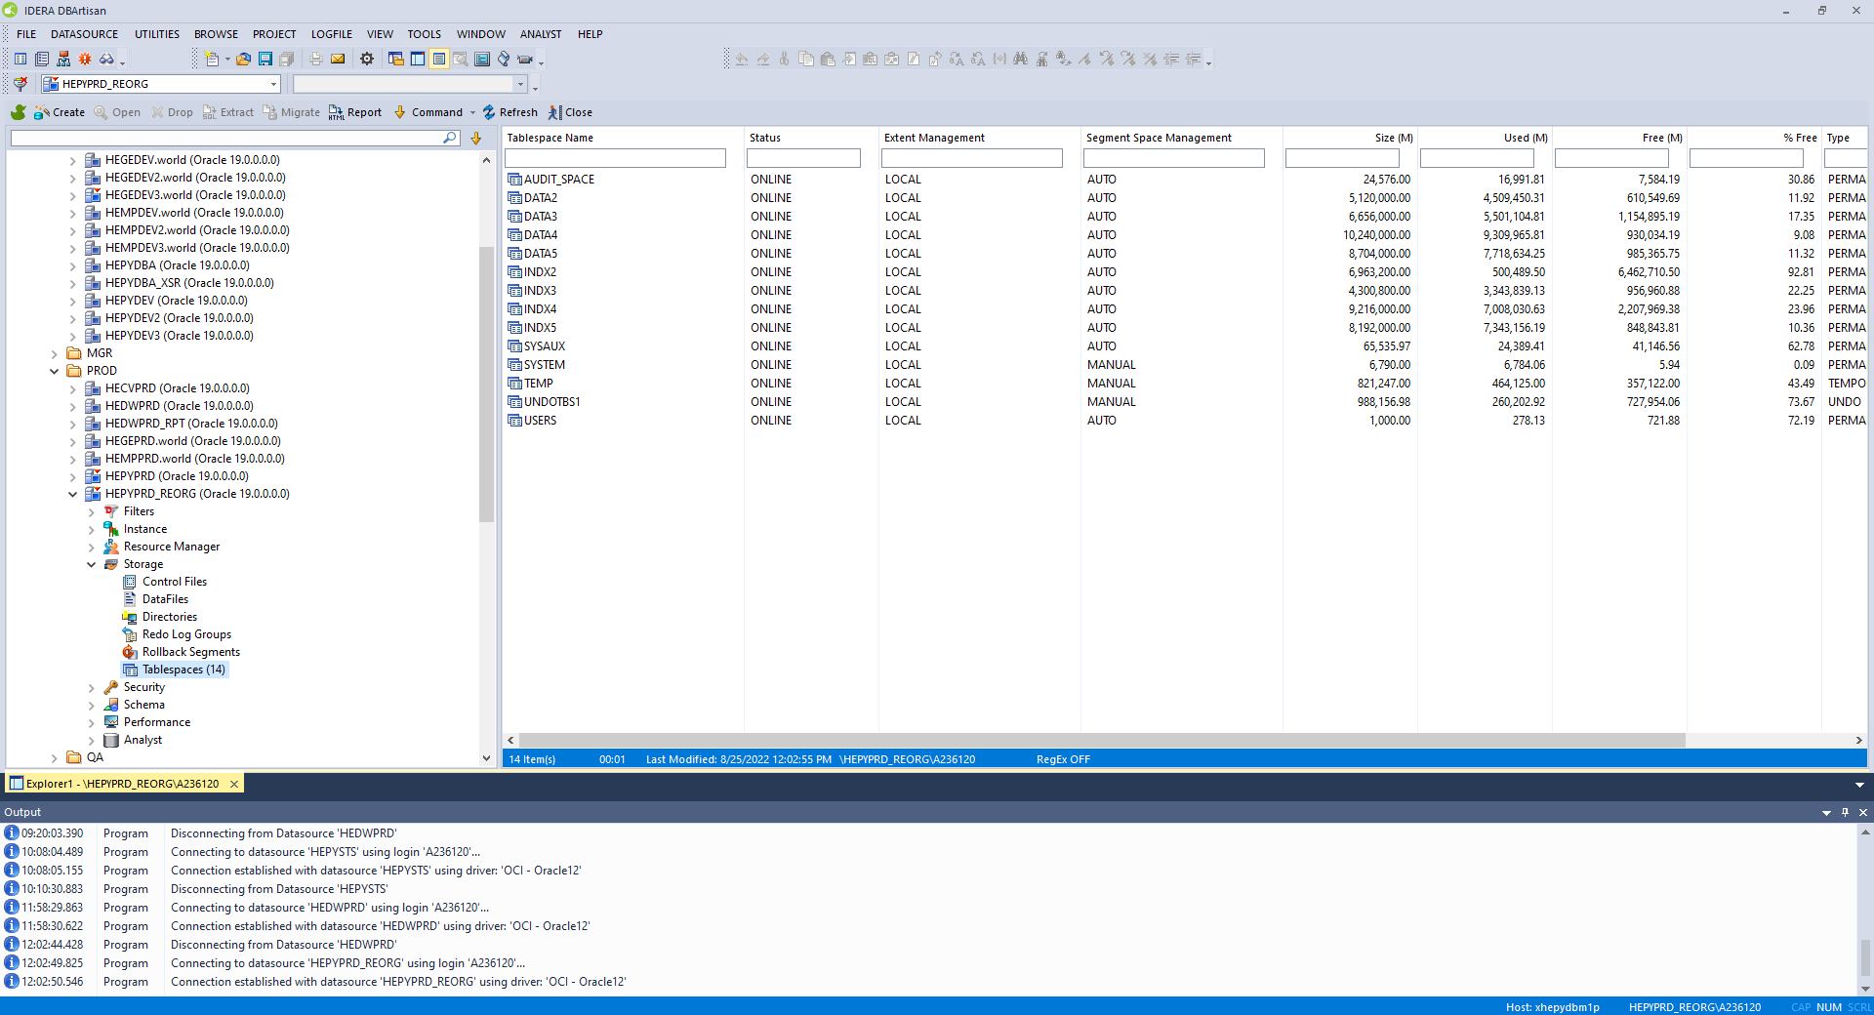

HEPYPRD_REORG right after second attempt

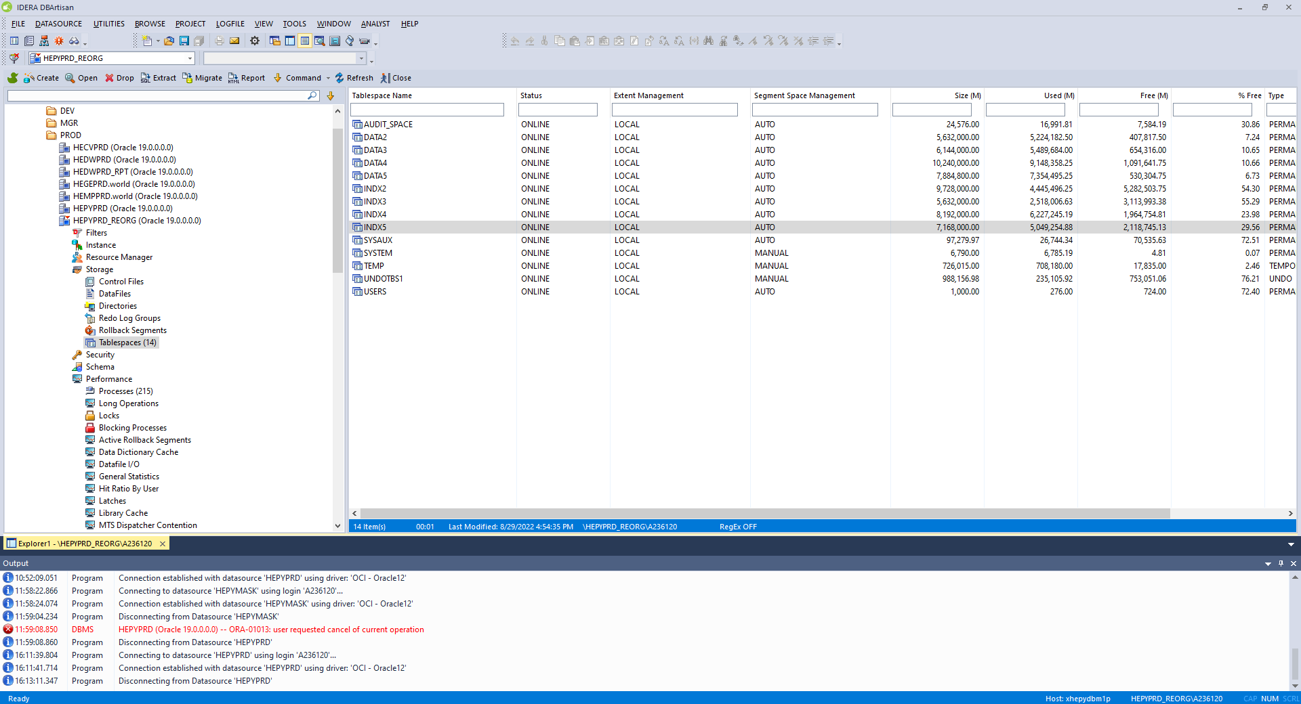

HEPYPRD REORG after clone before second attempt reorg activity

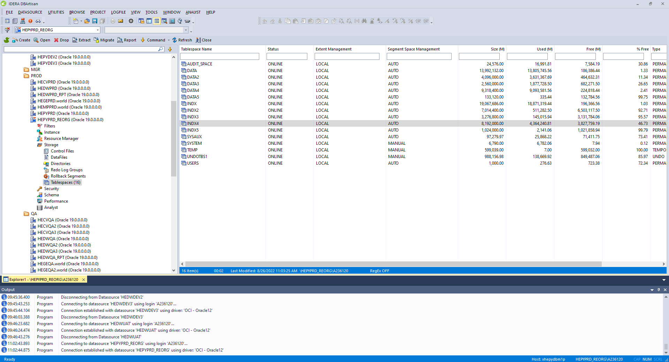

HEPYPRD on m21p after first attempt clone

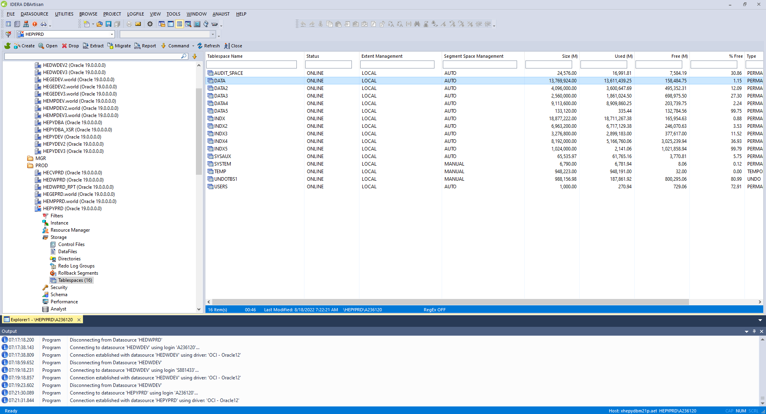

HEPYPRD on m1p after clone before reorg

**M1p ASM before reorg**