**Install Oracle Client on xppmw3p**

1. Make sure Unix Admin

Add oradbaix to /etc/opt/quest/vas/users.allow (Submit eService Request for that.)

Add following filesystem - /orahome/u01 - 100 GB

Add account (oracle) and group (dba) just like we have on **xppmw3d** box. (Submit eService Request for that.). Make $HOME /orahome/u01/oracle

Make /orahome owned by oracle

#PpMApp#12

1. Create and copy all necessary folders and scripts from xpsapm2d to setup oracle environment.

Login to **xppmw3p**

cd /orahome/u01/

mkdir oracle

cd oracle

mkdir product

cd /orahome/u01/oracle/product

mkdir oracle_12102_stage

mkdir tar

mkdir 12.1.0.2

cd 12.1.0.2

mkdir client_64bit_ppm1

mkdir client_64bit_ppm2

chmod 755 /orahome/u01/oracle

Login to **xppmw3d**

scp -rp /orahome/u01/oracle/aetna **xppmw3p**:/orahome/u01/oracle/aetna

scp -rp /orahome/u01/oracle/scripts **xppmw3p**:/orahome/u01/oracle/scripts

scp -rp /orahome/u01/oracle/tls **xppmw3p**:/orahome/u01/oracle/tls

scp -rp /orahome/u01/oracle/relink **xppmw3p**:/orahome/u01/oracle/relink

scp -rp /orahome/u01/oracle/monitor **xppmw3p**:/orahome/u01/oracle/monitor

scp -p /orahome/u01/oracle/.profile **xppmw3p**:/orahome/u01/oracle/.profile

Login back to **xppmw3p**

~~#Do following only if needed.~~

~~cd /orahome/psu01/oracle~~

~~cp .kshrc /orahome/u01/oracle/.kshrc~~

~~cp .gnome2 /orahome/u01/oracle/.gnome2~~

~~cp .bashrc /orahome/u01/oracle/.bashrc~~

~~cp .bash_profile /orahome/u01/oracle/.bash_profile~~

~~cp .bash_logout /orahome/u01/oracle/.bash_logout~~

~~cp .zshrc /orahome/u01/oracle/.zshrc~~

~~cp .viminfo /orahome/u01/oracle/.viminfo~~

~~cp .sh_history /orahome/u01/oracle/.sh_history~~

Modify some scripts

## Remove none PPM entries

cd /orahome/u01/oracle/scripts

cp oraprof oraprof_20160204

vi oraprof

## Ask Unix Admin to create oratab and oraInst.loc

vi /etc/oratab

ORA12102_1:/orahome/u01/oracle/product/12.1.0.2/client_64bit_ppm1:N

ORA12102_2:/orahome/u01/oracle/product/12.1.0.2/client_64bit_ppm2:N

vi oraInst.loc

inventory_loc=/orahome/u01/oracle/oraInventory

inst_group=dba

## Ask Unix Admin to copy oraenv and dbhome file over to new server

Login to **xppmw3d**

scp -p /usr/local/bin/oraenv **xppmw3p**:/usr/local/bin/oraenv

scp -p /usr/local/bin/dbhome **xppmw3p**:/usr/local/bin/dbhome

#Confirm oracle environment.

. ~/.profile

ORA12102_1

##Confirm Settings - Otherwise Set

export ORACLE_BASE=/orahome/u01/oracle

export ORACLE_HOME=/orahome/u01/oracle/product/12.1.0.2/client_64bit_ppm1

export ORACLE_SID= ORA12102_1

1. SFTP or SCP necessary oracle client Install downloads over to /orahome/u01/oracle/product/ oracle_12102_stage folder..
2. #12.1.0.2 Oracle DB Software

unzip p21419221_121020_Linux-x86-64_7of10.zip

1. Install Oracle Client for First home.

##Get Your local IP address.

##run ipconfig from MS-DOS (cmd) window on your local laptop.

#Below example with IP that I had during that time… Yours will be different…

10.184.74.130

##Start Exceed

Start-> Programs -> Aetna Applications -> Open Text Exceed 14 -> Exceed

-- Go back to ssh window

cd /usr/bin

xterm -display 10.184.74.130:0 &

-- This should bring up new xWindow

-- Go back to xwindow

cd /orahome/u01/oracle/product/oracle_12102_stage/client

export DISPLAY=10.184.74.130:0

./runInstaller

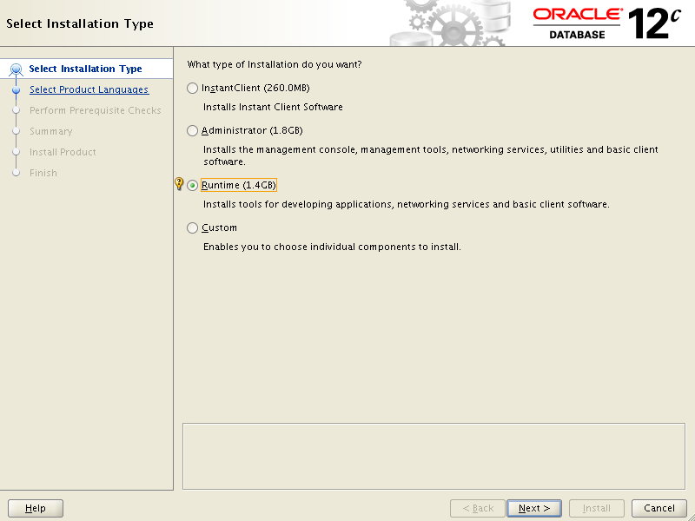

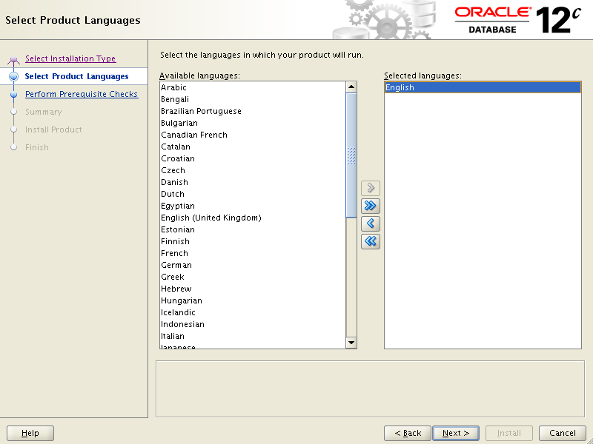

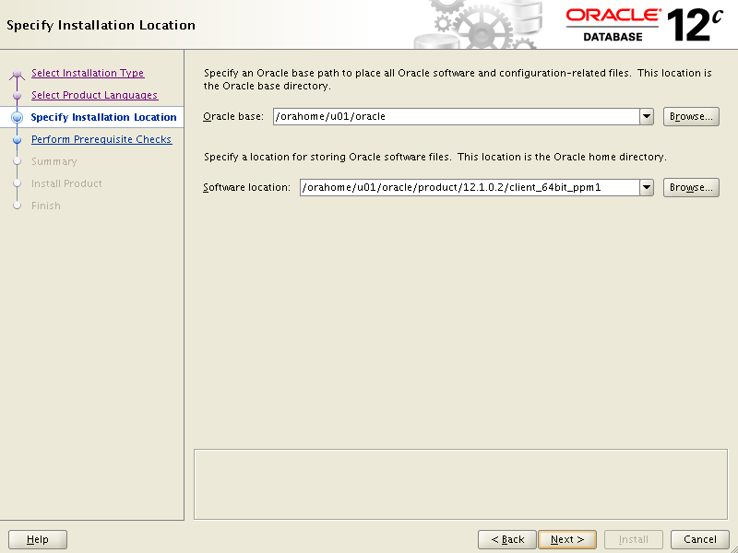

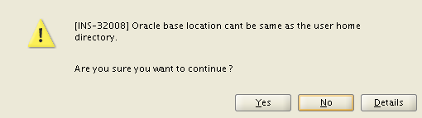

Click Yes

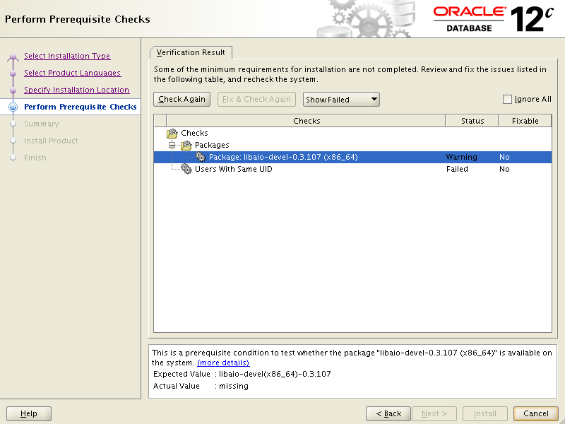

Send request to this mail box (Requests, Unix Software & Virtualization Serv) to take care pre Requests.

E.B.

Here is Unix Admin response:

Click Check Again button

Select Ignore All check box and click Next

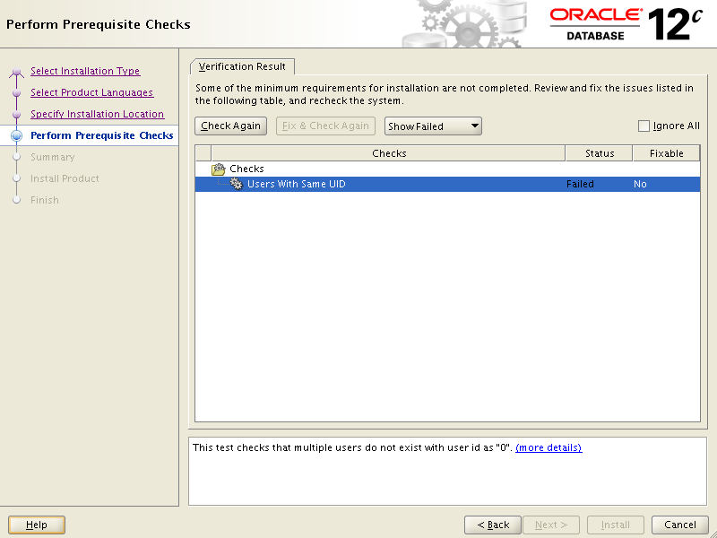

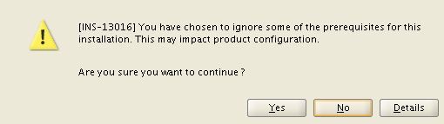

Click Yes

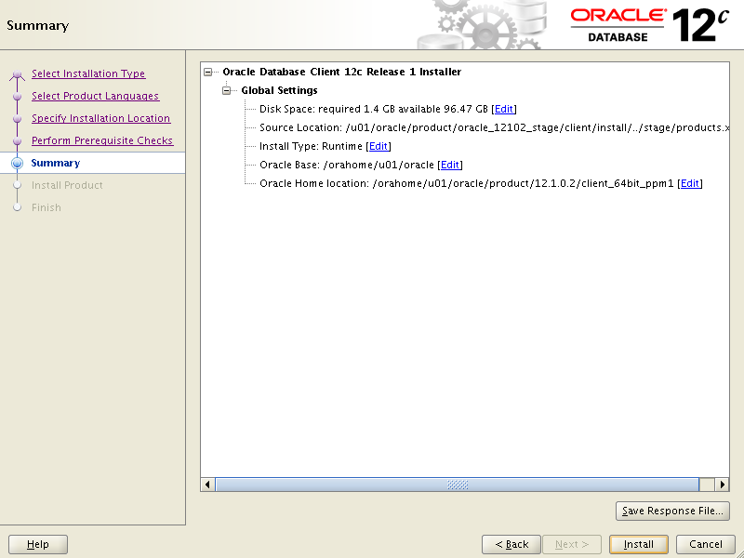

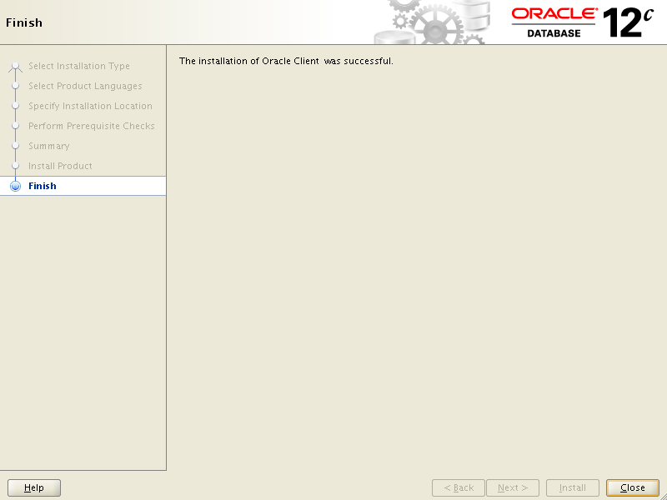

##Copy sqlnet.ora and tnsnames.ora to new Oracle Home

~~##Login to xpsapm2d~~

~~scp -p /orahome/psu01/oracle/product/11.2.0.4/client_64bit_dp1/network/admin/tnsnames.ora xpsdppw2d:/orahome/psu01/oracle/product/11.2.0.4/client_64bit_dp1/network/admin/tnsnames.ora~~

~~scp -p /orahome/psu01/oracle/product/11.2.0.4/client_64bit_dp1/network/admin/sqlnet.ora xpsdppw2d:/orahome/psu01/oracle/product/11.2.0.4/client_64bit_dp1/network/admin/sqlnet.ora~~

~~. ~/.profile~~

~~PPMTEST~~

~~#Test Connection~~

~~tnsping PPMTEST~~

~~Used parameter files:~~

~~/orahome/u01/oracle/product/12.1.0.2/client_64bit_ppm1/network/admin/sqlnet.ora~~

~~Used TNSNAMES adapter to resolve the alias~~

~~Attempting to contact (DESCRIPTION = (ADDRESS = (PROTOCOL = tcp)(HOST = aorinfw)~~

~~OK (0 msec)sqlplus~~

~~system/xxx@PPMTEST~~

1. Install Oracle Home Client for Second home.

#Confirm oracle environment.

. ~/.profile

ORA11204_2

----Confirm Settings - Otherwise Set

export ORACLE_BASE=/orahome/u01/oracle

export ORACLE_HOME=/orahome/u01/oracle/product/12.1.0.2/client_64bit_ppm2

export ORACLE_SID= ORA12102_2

Start xWindows env.

Follow same Screens as for First Home.

##After Install completed copy sqlnet.ora and tnsnames.ora to new Oracle Home

~~##Login to xpsapm2d~~

~~scp -p /orahome/psu01/oracle/product/11.2.0.4/client_64bit_dp2/network/admin/tnsnames.ora xpsdppw2d:/orahome/psu01/oracle/product/11.2.0.4/client_64bit_dp2/network/admin/tnsnames.ora~~

~~scp -p /orahome/psu01/oracle/product/11.2.0.4/client_64bit_dp2/network/admin/sqlnet.ora xpsdppw2d:/orahome/psu01/oracle/product/11.2.0.4/client_64bit_dp2/network/admin/sqlnet.ora~~

1. ~~Crontab entries~~

~~crontab -e~~

~~# Create Backup Copy of Cron Table~~

~~00 05 * * * crontab -l > ${HOME}/crontab.lst~~

~~#############################################################################~~

~~# Verify TSM Backup Was Run Recently~~

~~00 08 * * * ${HOME}/tls/get_tsm_backup_info.ksh~~

~~#############################################################################~~

#Oracle Homes backups once a month

05 00 1 * * /orahome/u01/oracle/relink/save_OH_b4patch.ksh