**Install 12c Oracle Client on xpsdppw1q**

1. Stage Software.

Login to **xpsdppw1q**

cd /orahome/psu01/oracle

!! If not already there

mkdir product

cd /orahome/psu01/oracle/product

mkdir oracle_12102_stage

mkdir 12.1.0.2

cd 12.1.0.2

mkdir client_64bit_dp1

mkdir client_64bit_dp2

Modify some scripts

cd /orahome/psu01/oracle/scripts

cp oraprof oraprof_20160126

vi oraprof

"ORA12102_1")

NLS_LANG=AMERICAN_AMERICA.WE8ISO8859P15; export NLS_LANG

;;

"ORA12102_2")

NLS_LANG=AMERICAN_AMERICA.WE8ISO8859P15; export NLS_LANG

;;

vi /etc/oratab

ORA12102_1:/orahome/psu01/oracle/product/12.1.0.2/client_64bit_dp1:N

ORA12102_2:/orahome/psu01/oracle/product/12.1.0.2/client_64bit_dp2:N

#Confirm oracle environment.

. ~/.profile

ORA12102_1

##Confirm Settings - Otherwise Set

export ORACLE_BASE=/orahome/psu01/oracle

export ORACLE_HOME=/orahome/psu01/oracle/product/12.1.0.2/client_64bit_dp1

export ORACLE_SID= ORA12102_1

1. SFTP or SCP necessary oracle client Install downloads over to /orahome/psu01/oracle/product/ oracle_12102_stage folder.

Login to xpsdppw2d

scp -p /orahome/psu01/oracle/product/oracle_12102_stage/p21419221_121020_Linux-x86-64_7of10.zip xpsdppw1q:/orahome/psu01/oracle/product/oracle_12102_stage/p21419221_121020_Linux-x86-64_7of10.zip

login to xpsdppw1q

cd /orahome/psu01/oracle/product/oracle_12102_stage

unzip p21419221_121020_Linux-x86-64_7of10.zip

1. Install Oracle Client for First home.

##Get Your local IP address.

##run ipconfig from MS-DOS (cmd) window on your local laptop.

172.21.114.216

##Start Exceed

Start-> Programs -> Aetna Applications -> Open Text Exceed 14 -> Exceed

-- Go back to ssh window

cd /usr/bin

xterm -display 172.21.114.216:0 &

-- This should bring up new xWindow

-- Go back to xwindow

cd /orahome/psu01/oracle/product/oracle_12102_stage/client

export DISPLAY=172.21.114.216:0

./runInstaller

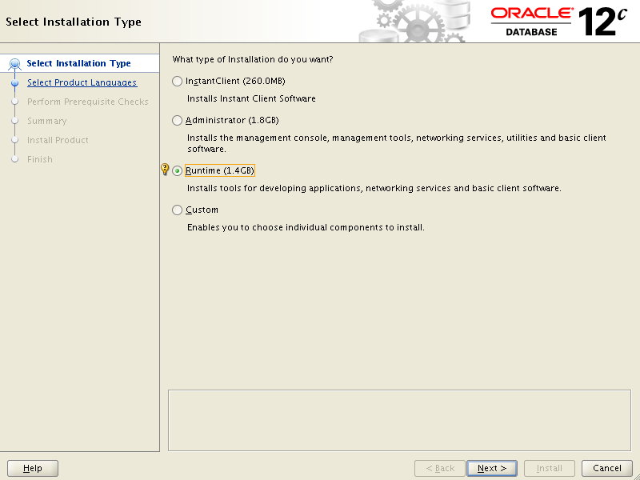

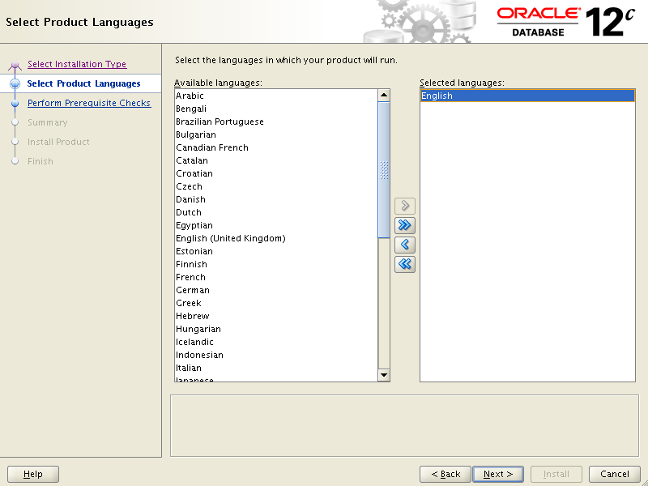

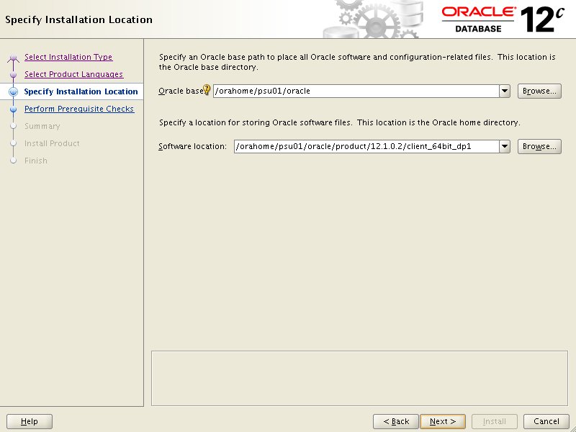

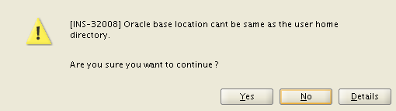

Click Yes

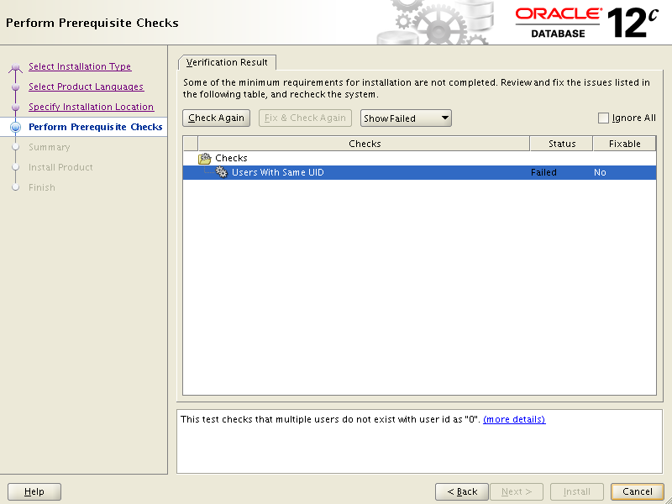

Select Ignore All check box and click Next

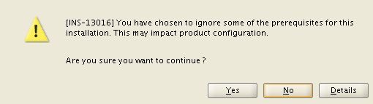

Click yes.

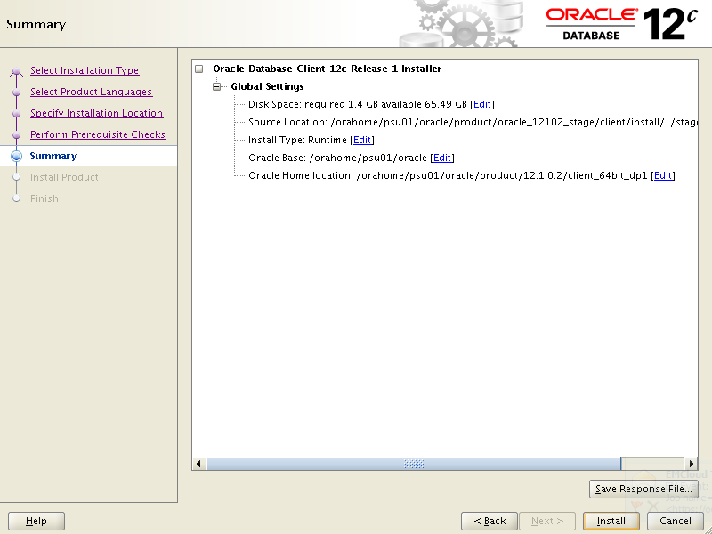

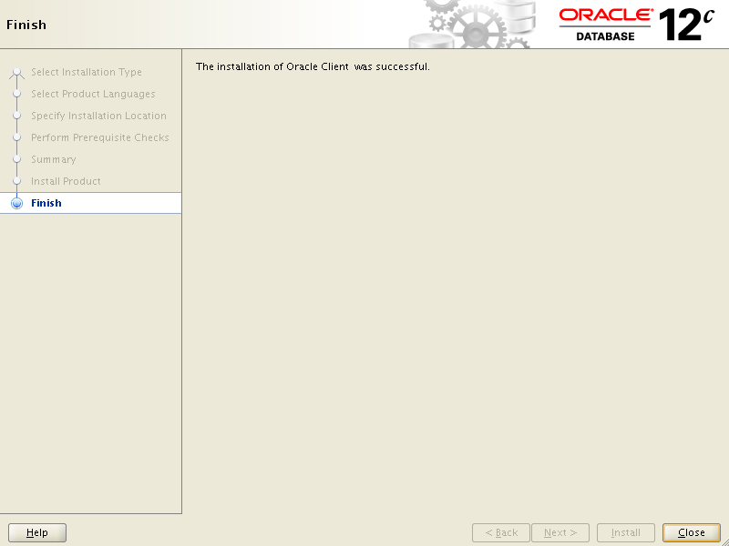

##Copy sqlnet.ora and tnsnames.ora to new Oracle Home

cp -p /orahome/psu01/oracle/product/11.2.0.4/client_64bit_dp1/network/admin/tnsnames.ora /orahome/psu01/oracle/product/12.1.0.2/client_64bit_dp1/network/admin/tnsnames.ora

cp -p /orahome/psu01/oracle/product/11.2.0.4/client_64bit_dp1/network/admin/sqlnet.ora /orahome/psu01/oracle/product/12.1.0.2/client_64bit_dp1/network/admin/sqlnet.ora

1. Install Oracle Home Client for Second home.

#Confirm oracle environment.

. ~/.profile

ORA11204_2

----Confirm Settings - Otherwise Set

export ORACLE_BASE=/orahome/psu01/oracle

export ORACLE_HOME=/orahome/psu01/oracle/product/12.1.0.2/client_64bit_dp2

export ORACLE_SID= ORA11204_2

Start xWindows env.

Follow same Screens as for First Home.

##After Install completed copy sqlnet.ora and tnsnames.ora to new Oracle Home

cp /orahome/psu01/oracle/product/11.2.0.4/client_64bit_dp2/network/admin/tnsnames.ora /orahome/psu01/oracle/product/12.1.0.2/client_64bit_dp2/network/admin/tnsnames.ora

cp /orahome/psu01/oracle/product/11.2.0.4/client_64bit_dp2/network/admin/sqlnet.ora /orahome/psu01/oracle/product/12.1.0.2/client_64bit_dp2/network/admin/sqlnet.ora

# Add new Oracle Homes backups once a month

05 00 1 * * /orahome/psu01/oracle/relink/save_OH_b4patch.ksh