**Install Oracle Client on xpsdppw2d**

1. Make sure Unix Admin Add oradbaix to /etc/opt/quest/vas/users.allow

Add following filesystem - /orahome/psu01 - 80 GB

Add account (oracle) and group (dba) just like we have on xpsapm2d box. (Submit eService Request for that.)

Make /orahome owned by oracle

1. Create and copy all necessary folders and scripts from xpsapm2d to setup oracle environment.

Login to xpsdppw2d

cd /orahome/psu01/oracle

mkdir product

cd /orahome/psu01/oracle/product

mkdir oracle_11204_cd_images

mkdir tar

mkdir 11.2.0.4

cd 11.2.0.4

mkdir client_64bit_dp1

mkdir client_64bit_dp2

chmod 755 /orahome/psu01/oracle

Login to xpsapm2d

scp -rp /orahome/psu01/oracle/aetna xpsdppw2d:/orahome/psu01/oracle/aetna

scp -rp /orahome/psu01/oracle/scripts xpsdppw2d:/orahome/psu01/oracle/scripts

scp -rp /orahome/psu01/oracle/tls xpsdppw2d:/orahome/psu01/oracle/tls

scp -rp /orahome/psu01/oracle/relink xpsdppw2d:/orahome/psu01/oracle/relink

scp -rp /orahome/psu01/oracle/monitor xpsdppw2d:/orahome/psu01/oracle/monitor

scp -p /orahome/psu01/oracle/.profile xpsdppw2d:/orahome/psu01/oracle/.profile

Modify some scripts

## Remove none DPP entries

cd /orahome/psu01/oracle/scripts

cp oraprof oraprof_20150827

vi oraprof

## Ask Unix Admin to create oratab and oraInst.loc

vi /etc/oratab

DPDEVUG:/orahome/psu01/oracle/product/11.2.0.4/client_64bit_dp2:N

DPDEMO91:/orahome/psu01/oracle/product/11.2.0.4/client_64bit_dp1:N

DPDEV91:/orahome/psu01/oracle/product/11.2.0.4/client_64bit_dp1:N

ORA11204_1:/orahome/psu01/oracle/product/11.2.0.4/client_64bit_dp1:N

ORA11204_2:/orahome/psu01/oracle/product/11.2.0.4/client_64bit_dp2:N

vi oraInst.loc

inventory_loc=/orahome/psu01/oracle/oraInventory

inst_group=dba

## Ask Unix Admin to copy oraenv and dbhome file over to new server

scp -p /usr/local/bin/oraenv xpsdppw2d:/usr/local/bin/oraenv

scp -p /usr/local/bin/dbhome xpsdppw2d:/usr/local/bin/dbhome

#Confirm oracle environment.

. ~/.profile

ORA11204_1

##Confirm Settings - Otherwise Set

export ORACLE_BASE=/orahome/psu01/oracle

export ORACLE_HOME=/orahome/psu01/oracle/product/11.2.0.4/client_64bit_dp1

export ORACLE_SID=ORA11204_1

1. SFTP or SCP necessary oracle client Install downloads over to /orahome/psu01/oracle/product/ oracle_11204_cd_images folder.

#11.2.0.4 Oracle DB Software

unzip p13390677_112040_Linux-x86-64_4of7.zip

#Latest OPatch

unzip p6880880_112000_Linux-x86-64.zip

1. Install Oracle Client for First home.

##Get Your local IP address.

##run ipconfig from MS-DOS (cmd) window on your local laptop.

172.21.118.110

##Start Exceed

Start-> Programs -> Aetna Applications -> Open Text Exceed 14 -> Exceed

-- Go back to ssh window

cd /usr/bin

xterm -display 172.21.118.110:0 &

-- This should bring up new xWindow

-- Go back to xwindow

cd /orahome/psu01/oracle/product/oracle_11204_cd_images/client

export DISPLAY=172.21.118.110:0

./runInstaller

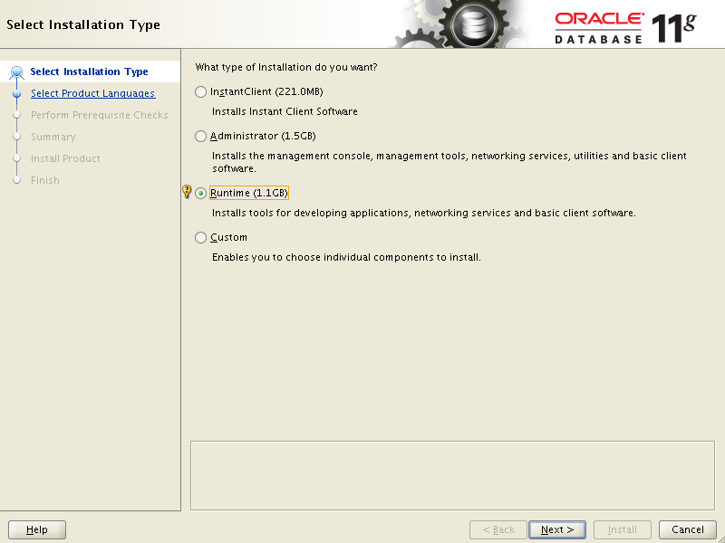

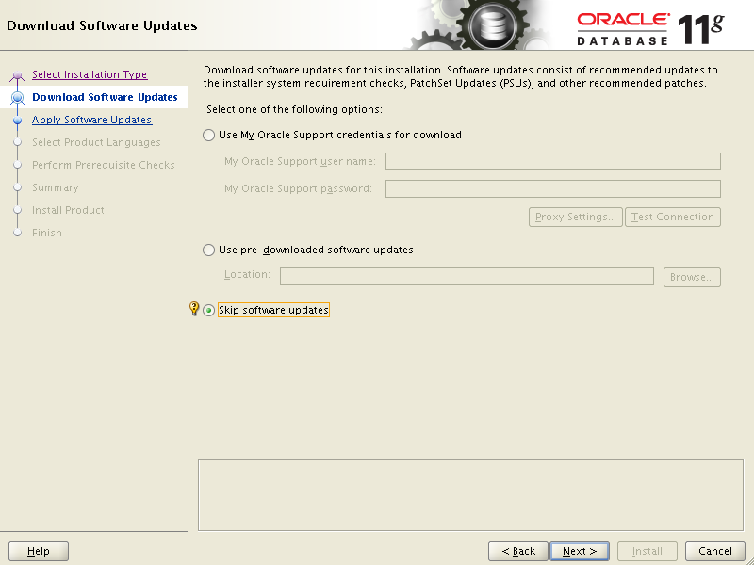

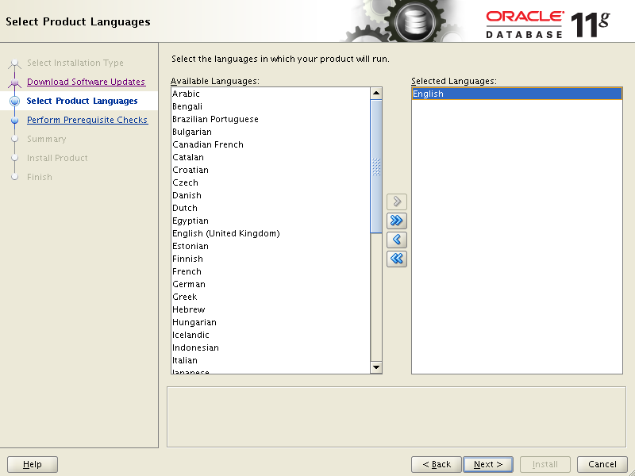

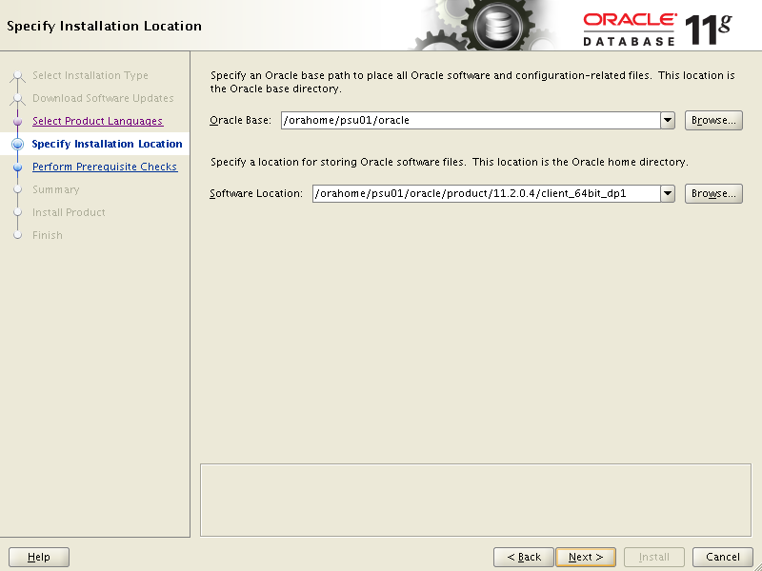

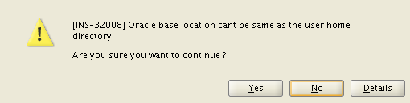

Click Yes

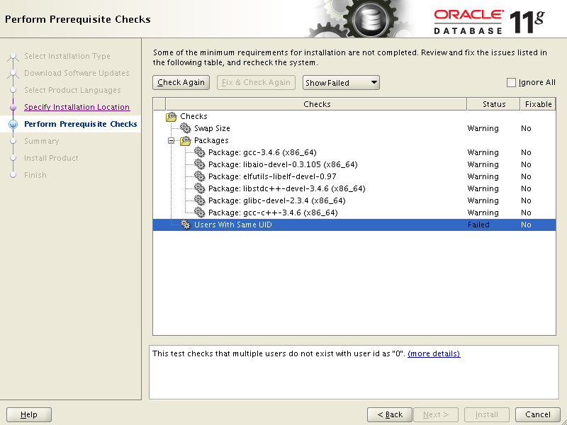

Send request to this mail box (Requests, Unix Software & Virtualization Serv) to take care pre Requests.

This is a prerequisite condition to test whether sufficient total swap space is available on the system. (more details)

Expected Value

 : 11.6259GB (1.2190636E7KB)

Actual Value

 : 8GB (8388604.0KB)

Users With Same UID - This test checks that multiple users do not exist with user id as "0".

 Details:

 -

PRVF-4132 : Multiple users "root,stmnroot,patmroot" with UID "0" exist on "xpsdppw2d".  - Cause:  More than one user is found to have the same user ID as specified in the message.  - Action:  Ensure that no two users share the same UID.

This is a prerequisite condition to test whether the package "gcc-3.4.6 (x86_64)" is available on the system. (more details)

Expected Value

 : gcc(x86_64)-3.4.6

Actual Value

 : missing

This is a prerequisite condition to test whether the package "libaio-devel-0.3.105 (x86_64)" is available on the system. (more details)

Expected Value

 : libaio-devel(x86_64)-0.3.105

Actual Value

 : missing

This is a prerequisite condition to test whether the package "elfutils-libelf-devel-0.97" is available on the system. (more details)

Expected Value

 : elfutils-libelf-devel-0.97

Actual Value

 : missing

This is a prerequisite condition to test whether sufficient total swap space is available on the system. (more details)

Expected Value

: 11.6259GB (1.2190636E7KB)

Actual Value

: 8GB (8388604.0KB)

Users With Same UID - This test checks that multiple users do not exist with user id as "0".

Details:

-

PRVF-4132 : Multiple users "root,stmnroot,patmroot" with UID "0" exist on "xpsdppw2d". - Cause: More than one user is found to have the same user ID as specified in the message. - Action: Ensure that no two users share the same UID.

This is a prerequisite condition to test whether the package "gcc-3.4.6 (x86_64)" is available on the system. (more details)

Expected Value

: gcc(x86_64)-3.4.6

Actual Value

: missing

This is a prerequisite condition to test whether the package "libaio-devel-0.3.105 (x86_64)" is available on the system. (more details)

Expected Value

: libaio-devel(x86_64)-0.3.105

Actual Value

: missing

This is a prerequisite condition to test whether the package "elfutils-libelf-devel-0.97" is available on the system. (more details)

Expected Value

: elfutils-libelf-devel-0.97

Actual Value

: missing

This is a prerequisite condition to test whether the package "libstdc++-devel-3.4.6 (x86_64)" is available on the system. (more details)

Expected Value

: libstdc++-devel(x86_64)-3.4.6

Actual Value

This is a prerequisite condition to test whether the package "glibc-devel-2.3.4 (x86_64)" is available on the system. (more details)

Expected Value

 : glibc-devel(x86_64)-2.3.4

Actual Value

 : missing

This is a prerequisite condition to test whether the package "gcc-c++-3.4.6 (x86_64)" is available on the system. (more details)

Expected Value

: gcc-c++(x86_64)-3.4.6

Actual Value

: missing

This is a prerequisite condition to test whether the package "gcc-c++-3.4.6 (x86_64)" is available on the system. (more details)

Expected Value

 : gcc-c++(x86_64)-3.4.6

Actual Value

 : missing

Here is Unix Admin response:

These have been installed  
gcc-3.4.6 (x86_64)  
libaio-devel-0.3.105 (x86_64)  
elfutils-libelf-devel-0.97  
libstdc++-devel-3.4.6 (x86_64)  
glibc-devel-2.3.4 (x86_64)  
gcc-c++-3.4.6 (x86_64)

Swap is now 12GB

This error is not going to change - it's our standard setup. You should be able to get past it. If not, let me know.

Click Check Again button

Select Ignore All check box and click Next

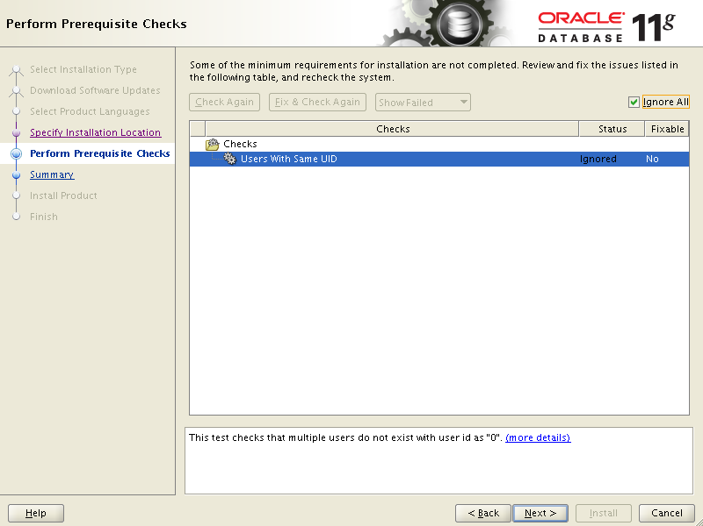

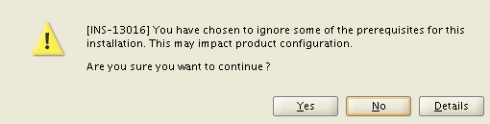

Click Yes

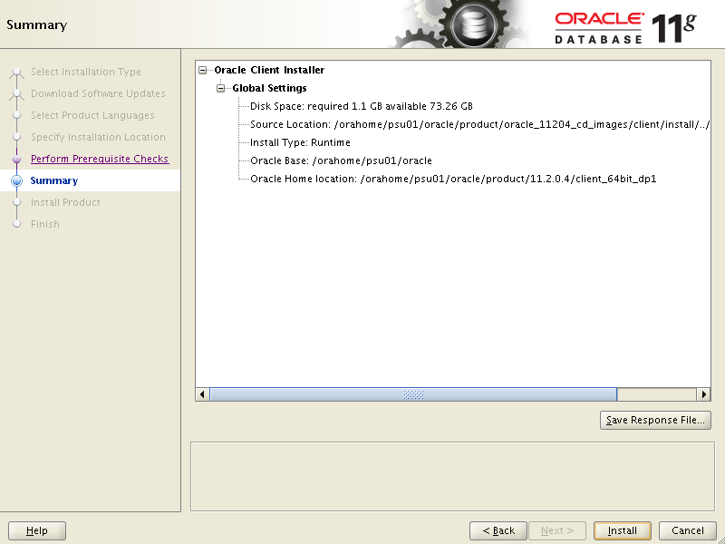

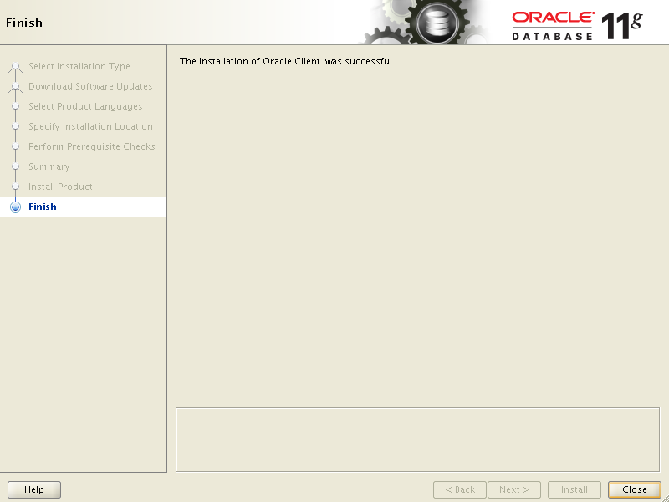

##Copy sqlnet.ora and tnsnames.ora to new Oracle Home

##Login to xpsapm2d

scp -p /orahome/psu01/oracle/product/11.2.0.4/client_64bit_dp1/network/admin/tnsnames.ora xpsdppw2d:/orahome/psu01/oracle/product/11.2.0.4/client_64bit_dp1/network/admin/tnsnames.ora

scp -p /orahome/psu01/oracle/product/11.2.0.4/client_64bit_dp1/network/admin/sqlnet.ora xpsdppw2d:/orahome/psu01/oracle/product/11.2.0.4/client_64bit_dp1/network/admin/sqlnet.ora

. ~/.profile

DPDEV91

#Test Connection

tnsping DPDEV91

TNS Ping Utility for Linux: Version 11.2.0.4.0 - Production on 18-DEC-2014 10:56

Copyright (c) 1997, 2013, Oracle. All rights reserved.

Used parameter files:

/orahome/psu01/oracle/product/11.2.0.4/client_64bit_dp1/network/admin/sqlnet.ora

Used TNSNAMES adapter to resolve the alias

Attempting to contact (DESCRIPTION = (ADDRESS_LIST = (ADDRESS = (COMMUNITY = tc)

OK (10 msec)

sqlplus

system/xxx@DPDEV91

1. Install Oracle Home Client for Second home.

#Confirm oracle environment.

. ~/.profile

ORA11204_2

----Confirm Settings - Otherwise Set

export ORACLE_BASE=/orahome/psu01/oracle

export ORACLE_HOME=/orahome/psu01/oracle/product/11.2.0.4/client_64bit_dp2

export ORACLE_SID=ORA11204_2

Start xWindows env.

Follow same Screens as for First Home.

##After Install completed copy sqlnet.ora and tnsnames.ora to new Oracle Home

##Login to xpsapm2d

scp -p /orahome/psu01/oracle/product/11.2.0.4/client_64bit_dp2/network/admin/tnsnames.ora xpsdppw2d:/orahome/psu01/oracle/product/11.2.0.4/client_64bit_dp2/network/admin/tnsnames.ora

scp -p /orahome/psu01/oracle/product/11.2.0.4/client_64bit_dp2/network/admin/sqlnet.ora xpsdppw2d:/orahome/psu01/oracle/product/11.2.0.4/client_64bit_dp2/network/admin/sqlnet.ora

. ~/.profile

DPDEVUG

#Test Connection

tnsping DPDEVUG

1. Copy latest OPath into both Oracle Homes.

cd /orahome/psu01/oracle/product/11.2.0.4/client_64bit_dp1

mv OPatch OPatch_ori

cd /orahome/psu01/oracle/product/11.2.0.4/client_64bit_dp2

mv OPatch OPatch_ori

cd /orahome/psu01/oracle/product/oracle_11204_cd_images

cp -r OPatch /orahome/psu01/oracle/product/11.2.0.4/client_64bit_dp1

cp -r OPatch /orahome/psu01/oracle/product/11.2.0.4/client_64bit_dp2

1. Crontab entries

crontab -e

# Create Backup Copy of Cron Table

00 05 * * * crontab -l > ${HOME}/crontab.lst

#############################################################################

# Verify TSM Backup Was Run Recently

00 08 * * * ${HOME}/tls/get_tsm_backup_info.ksh

#############################################################################

#Oracle Homes backups once a month

05 00 1 * * /orahome/psu01/oracle/relink/save_OH_b4patch.ksh