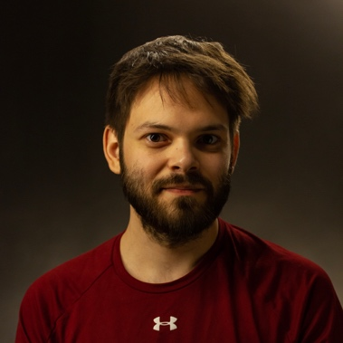**Résumé**

# Personal details

Name: David Ebert  
Place and date of birth: Pécs, 3/14/1990  
Address: 1083 Budapest, Práter utca 39., 2. em. 29. a.  
Cellphone: +36 (30) 275 0065  
Email: [cv@ebertek.com](mailto:cv@ebertek.com?subject=Re:%20CV)

# Experience

## October 2010- Systems Administrator

* Digibooks Ltd. (formerly X-Admin Ltd.)  
  2097 Pilisborosjenő, Ady Endre utca 10.
* macOS and Windows (client and server) administration
* Remote (Apple Remote Desktop and TeamViewer) and local support
* Direct contact with our clients
* Managing support tickets through ServiceNow
* Writing reports and creating documentations for my manager
* Network administration (Ubiquiti, Cisco)
* NAS administration (Synology)
* G Suite and Office 365 administration (incl. CoreView, Crossware)
* Building iPad management systems (Profile Manager + Apple Configurator), mass deployment
* Smaller repairs on Apple computers
* Web development and administration (cPanel, WordPress, HTML/CSS/JavaScript/PHP, Git)
* Some of our clients include mateco-Hungary, Gépbér-Színpad, SKY Marketing, Bástya-Őr, Daylight Média, government agencies (KEK KH, NISZ, KSH, Fővárosi Törvényszék), educational institutions (Kisképző, Károly Róbert Campus, University of Debrecen)

# College societies

## August 2009 - June 2014 BME-KTK IT Club

### 2010-2014 Interface team

* As leader of the new team of 10 people between 2010 and 2012: organizing meetings, holding Apache and ProFTPD classes, assigning and tracking projects, performance rating of my team members towards management
* Web development (HTML, CSS, JavaScript, PHP, MySQL, LDAP, regex)
* Administration of FTPS (ProFTPD), web (LAMP and SAMP; CMS: Drupal and Joomla!), and mailing lists (Mailman, Sympa)
* Configuration of Subversion and WebSVN
* Working in a project management system (Trac)
* Creating screencasts and how-tos for fellow team members and our end-users

### 2010-2014 User Support Band

* In charge of my floor in the dorm: network troubleshooting; management of tickets (osTicket); administration of Cisco, HP and 3Com switches; setting up a new rack

# Education

## 2018- OE-NIK BSc in CompSci & Engineering

* Óbuda University, John von Neumann Faculty of Informatics  
  1034 Budapest, Bécsi út 96/b.
* Natural sciences (discrete mathematics, linear algebra, electrical engineering)
* Software Design and Development, Computer Architectures

## 2008-2015, 2016-2018 BME-GPK BSc in Mechatronics Engineering

* Budapest University of Technology and Economics, Faculty of Mechanical Engineering  
  1111 Budapest, Műegyetem rakpart 3.
* Natural sciences (mathematics, mechanics)
* Mechanical engineering (technical drawing, CAD: AutoCAD, SolidWorks, machine elements, material sciences, heat transfer, fluid mechanics)
* Informatics, software engineering
* Electronics, measurement technology
* Opto-Mechatronics specialization: Color Theory, Image Processing, Optical System Design, Measurement Technology in Optics, Optomechatronical Instruments, Applied Laser Technology, Light Technology

## 2004-2008 ANK Hungarian-English bilingual class

* Apáczai Nevelési és Általános Művelődési Központ Gimnázium és Szakközépiskola  
  7632 Pécs, Apáczai Csere János körtér 1.
* English Civilisation, Mathematics, History, Biology, and Geography classes were in English
* Multicultural class
* All As on the matura (*érettségi*)

# Languages

* English C1 (bilingual high school diploma)
* French B2 (A-level matura), not active
* German B2 (TELC Zertifikat Deutsch), not active

# Driving experience

* Driver's license since 2007 (Hungarian, category B); driven tens of thousands of kilometers

# Soft skills

* Helpfulness, patience
* Working in smaller teams or independently

# Things I love

* Photography (both analog and digital)
* Travel
* Giant pandas
* Doctor Who
* Lego
* Haribo Goldbären