

**times.up**

Waste less, Effortless

times.up is a food inventory smartphone application designed to reduce downstream food waste in the household. Expiration date reminders and recipe suggestions encourage full utilization of fresh, available groceries. times.up improves upon existing alternatives by automating data input using QR codes, optical character recognition, and digital receipts.

**Needs Statement**

*Overview*

The United Nation’s Food and Agricultural Organization[1] estimates that approximately one-third of all food produced for human consumption is lost or wasted each year. Food wastage generates a substantial impact on the environment in terms of land use, water consumption and carbon emissions. It also represents a missed opportunity to improve global food security.

Downstream wastage occurring at the consumption level is very important in middle and high-income regions where it accounts for 31–39 percent of total food wastage (FAO 2013). A 2013 study by LEI Wageningen UR, a Hague-based research institute, found that a 40% reduction in food waste by 2020 in private households and the retail sector would result in annual savings of 123 euro per capita. This aggregates to annual savings of 75.5 billion euro for the EU in total and a 7% reduction in the average EU-household budget spent on food. The report also found overall savings in land use of 28,940 km2- equivalent to 1.6% of EU agricultural lands in 2020.[2]

How often do we find spoiled food in the fridge or pantry? Losing track of the food we buy is one of the main causes of food waste at the consumer level. Many neglect good practices such as looking in the fridge and checking expiration dates. A striking report made by the French Environmental Agency (ADEME) found that 35% of food waste collected by public utilities is composed of products that are still packed.[3]

times.up addresses these problems by helping households keep track of the food in their kitchens in a simple, efficient way.

*Existing Solutions*

There are currently applications in the market that help users organize food purchases, but all require manual data input. The apps NoWastes[4], CheckFood[5], Green Egg Shopper[6], The Fridge[7], Freedge[8],Fridge[9], Fridge Pal[10] and Freezer-Mate are all restricted by requiring the user to input purchases and expiration dates by scanning the products one by one. This imposes large time and effort costs on the user and discourages consistent use of the system. Many user reviews indicate dissatisfaction with this aspect. times.up improves upon these existing alternatives by automating data input using QR codes, optical character recognition, and digital receipts.

*User reviews for existing apps:*

“Takes more time to add/edit the stuff on the phone than to look through the fridge.” (Fridge)

“Keeping track of what's in my fridge in my phone is more time consuming than simply opening the fridge and looking.” (Fridge)

“If you have the time and desire to scan and manually enter everything in your pantry then this may be your app, but it's not mine.” (Fridge Pal)

“Items are exceptionally hard to edit.” (Fridge Pal)

“No barcode database, have to type name in yourself.” (Fridge Pal)

“It is tedious to enter dates one by one.” (CheckFood)

*Our Solution*

With times.up,[11] customers will no longer need to scan or manually enter their purchases into a database. They will be automatically notified of upcoming expiration dates of perishable foods at user-defined intervals. The purchase information will come from the food retailers’ databases or from scanned receipts. An approximate expiration date will be relayed to the user based on the purchase date or on estimates coming from retailers. This feature greatly lowers adoption barriers and will encourage regular and consistent use of the system.

**Practical Considerations**

*Best-by, use-by, sell-by, what are we talking about?*

The FDA does not require food firms to label “sell by”, “use by” or “best before” dates on food products. This information is entirely at the discretion of the manufacturer[12].

Given the large variety of terms currently used to designate optimal consumption dates, many consumers get confused. The NRDC (Natural Resources Defense Council) has found that such dates are misleading and actually contribute to food waste[13]. We can separate these dates in two categories: quality-based (best-before and use-by[14]) or safety-based (expiration date).

times.up will provide estimations of expiration dates to its users (safety-based). Those estimates will be based on databases from websites like [eatbydate.com](http://eatbydate.com) , [stilltasty.com](http://stilltasty.com) and the USDA. These databases provide estimations of how long after the use-by date an item is still safely consumable.

We also plan to incorporate an education tool in the app that tells users about the different kinds of optimal consumption dates and provides basic rules of tolerance regarding the information contained on food packages.

*Calculating Expiration Dates*

In an ideal world, we would expect all barcodes to contain expiration dates or batch numbers so that information could be read by scanners at the time of purchase and automatically be sent to consumers (see “*in the future”* section below). Because this system generally does not exist, the expiration dates given to users will be estimated using two difference methods depending on data availability.

Option 1: Based on retailers databases

Food retailers typically use inventory management systems like DateCheck-Pro[15] or eXpireTrack[16] that allow them to track product expiration dates for each batch number. Transmitting these expiration dates to consumers is tricky since batch numbers are not linked to the information read by scanners at the time of purchase. In this case the expiration date displayed to the consumer via the app can be estimated based on the average of existing batches of a given barcode. The user can then choose between a more conservative or generous estimate and also edit the date provided. More conservative estimates will use dates from batches that will expire soon whereas more generous estimates will use dates of batches expiring later.

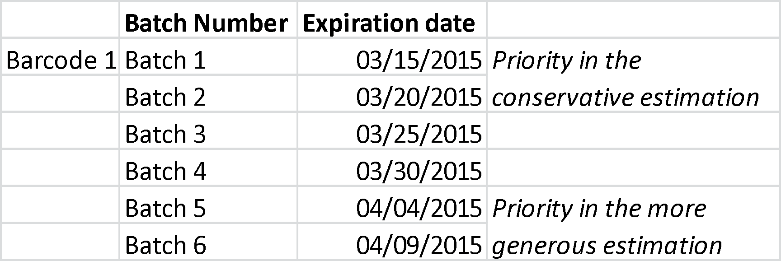

Option 2: Based on the purchase date

Another option is to estimate the expiration date based on purchase date. Such estimates can be made using existing online databases (e.g. Eat-by-date[17]) and by physically collecting data in supermarkets (manufacture & expiration dates for a range of popular products). In this scenario users will be able to edit the date provided and contribute to the improvement of future estimations (if they opt in to give user feedback). This method will be the best solution when retailers’ expiration date databases are not accessible, as is the case for the input by OCR. It will be necessary for fresh vegetables, which don’t have formal expiration dates. In this case users will also be able to choose between a more conservative or tolerant estimate.

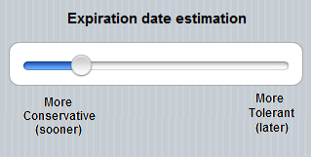

*Delivering the information to the user*

times.up will use three types of input methods: memberships and online platforms, QR Codes printed on sales receipts and Optical Character recognition (OCR) of sales receipts

1. Our initial target users will be customers with memberships since their purchase data is already available from food retailers and could be easily integrated by the app. Some supermarkets (e.g. Safeway in the US and Pão-de-Açucar in Brazil) already offer some kind of online purchase inventories to its consumers.
2. The app will also be able to read information directly from QR codes printed on purchase receipts. In this case the customer does not need to have an online account or a loyalty card, but we will depend on partner food retailers to print QR codes on its receipts. Our initial prototype is already capable of obtaining information from such QR codes ([see video](http://youtu.be/B0c8cQtU4YY)), although they are not printed by any major retailer for now. We chose to start the first phase with this feature because of its simplicity and low cost.
3. When QR codes are not available the user can take a picture of the receipt and the app will recognize the purchase receipt by OCR (optical character recognition). An initial test using a 5 megapixel smartphone camera and an online OCR tool yielded a 70% match rate between the receipt and our default expiration date database ([see video](http://www.youtube.com/watch?v=9lqU4FV0EqQ)). This procedure will be improved with a database that can account for the abbreviations commonly found in purchase receipts. User corrections will allow for continuous improvement in the matching algorithm. We are currently requesting the abbreviations database from a few retailers around Davis, CA in order to make this process faster.

**Initial prototype**

The current version of times.up provides an inventory of purchased items and an estimated expiration date for each of them, based on this default database: <http://bit.ly/1GnbvF7>

The only input method available for now is the QR code (pictured below). Users can input items manually and edit existing items.

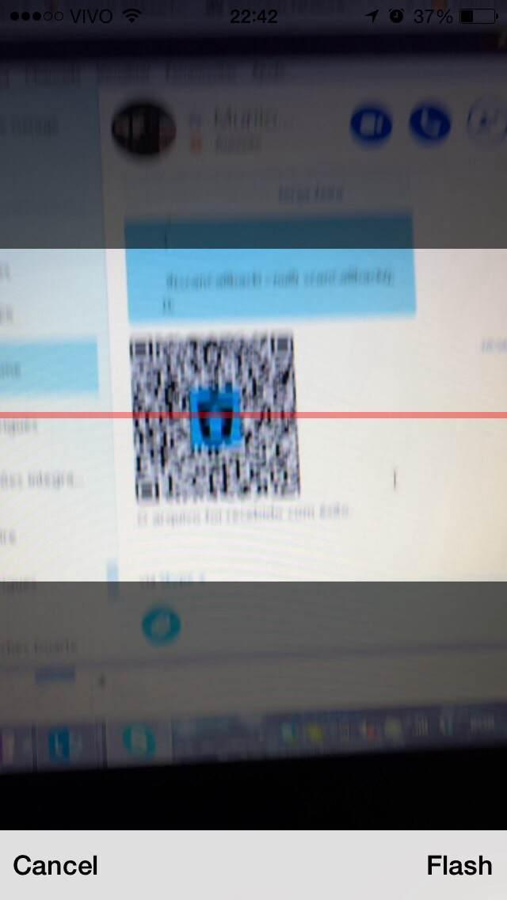

The products are ordered by expiration date (the closest to expire at the top). Users can choose a different storage mode if they desire to and the expiration date will then change depending on the storage place. The storage options available are: fridge, freezer and pantry. After consumption the products can be easily archived with one click.

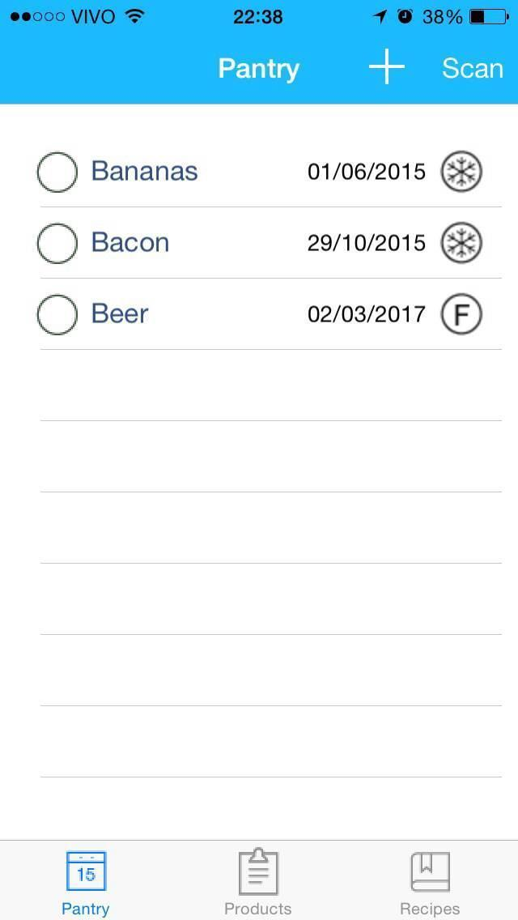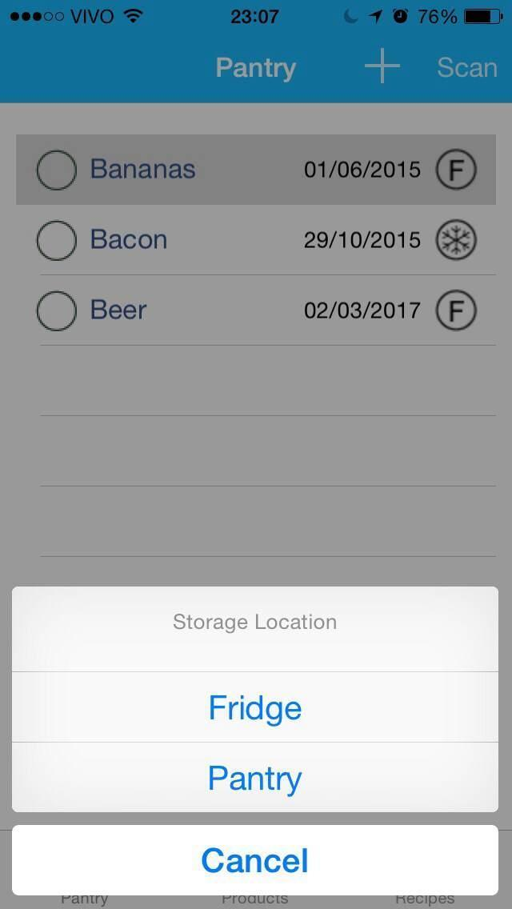

The user can also use the app to ask for recipe ideas. She or he can select all the items wanted in the recipe and then click “recipe”. The app will then open a default recipe website and show all the recipes containing the items selected by the user.

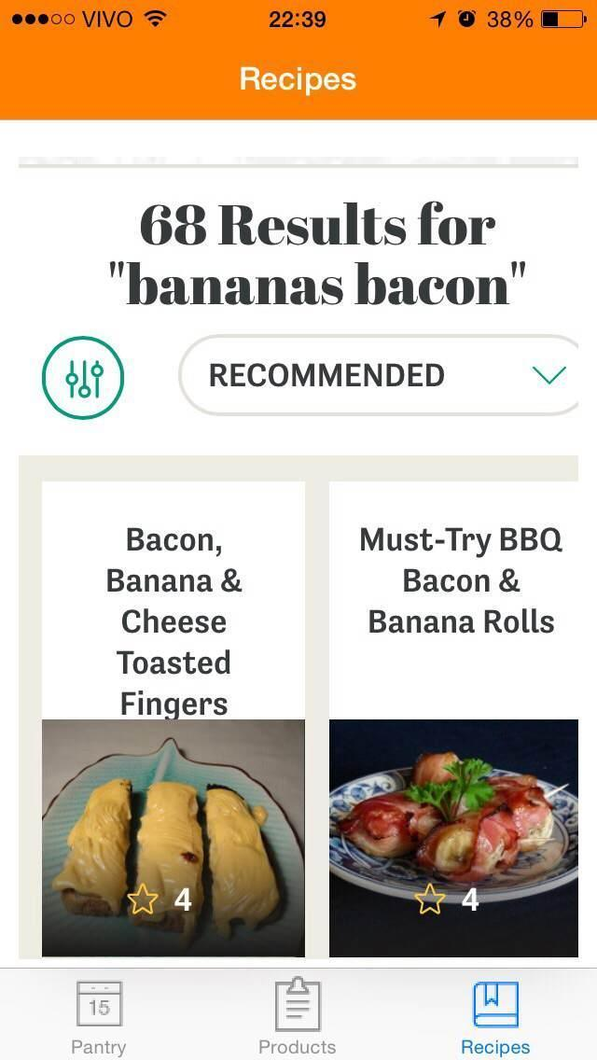

**What’s next?**

Products that pass the expiration date will be automatically deleted from the “consume soon” list and move to the “purge” list for a few days before finally being archived.

*New input methods*

In the next phase the app will be able to obtain food inventories from online databases (linked to loyalty cards), digital receipts and sales receipts (this time using Optical Character Recognition - OCR).

*New features:*

* A button for opened cans
* An adjustment bar for how tolerant the estimation of the expiration date should be.
* An education tool that tells users about the different kinds of optimal consumption date (best before, use-by, etc.)
* Expiration alerts: users will be notified when items in the inventory are approaching the expiration date.

Continuous feedback about the user’s activity will be sent to the developers allowing then to improve the calculation of the expiration dates informed to users.

*In the future (after the app is launched)*

We will allow users to adopt stricter rules about recipes search, such as vegetarian, allergic to peanuts, etc.

In addition to the alert function, times.up will integrate other existing ideas such as environmental indicators of food items (virtual water, CO2), nutritional information, storage tips for different kinds of products and a “donation” option.

The donation option

Users will be able to give their products directly from the app. times.up could be linked to food donation platforms such as Facebook “food trading” groups. We are also studying an option in which users can choose to be geolocalized and donate items to others users who are near them.

The app could allow for synchronization among members of a same household. A web-platform will also be built for users who don’t have smartphones or prefer using the online tool.

We are also studying a gamification option in which users earn “points” for not wasting food.

**Development objectives and strategies**

*Starting the project*

We are currently in contact with grocery stores around Davis, CA and trying to establish partnerships (Davis Food Co-op, Whole Foods, Nugget). Specifically, we are discussing the possibility of working with local groceries stores to:

1) email transaction receipts to customers after each purchase.

2) print QR codes on the receipts that can be scanned by the consumers. (The codes would contain the purchase inventory).

3) compile a list of abbreviations that are used in the sales receipts, so that customers can scan the receipt and the app can recognize the characters in the picture and link them to products' names.

(see “Potential Obstacles” for more details about our partnership perspectives)

*Growth perspectives and revenue model*

Based on our estimates from Google Play and the App Store, the apps currently offered were downloaded between 70000 and 300000 times[18]. We expect that the automatic features of times.up to greatly lower adoption barriers and encourage regular and consistent use of the system, thus increasing the number of users. times.up could also be used by schools, NGOs, CBOs and restaurants with large inventories to manage.

We recently conducted a survey (see Appendix II) asking potential users for their perspectives about times.up. Here are some results from our 75 respondents:

* 60% of the respondents often forget to eat some products but when they remember it is already too late.
* 67% of them waste 1 to 2 food items per week.
* 62% of them would be interested in an app that helps them track their food purchases and gives them automatic alerts about expiration dates.
* Only 10% of them think that scanning a QR code in order to import information to the app would be too much work.
* 38% of them think that taking a picture of the whole receipt (or a few pictures for a big receipt) in order to import information to the app would be too much work
* Only 16% think that having only an approximate expiration date provided by the app (not the one on the package) is a big problem

We are currently studying two potential business models: non-profit and B-Corp (Benefit Corporation). In both cases our app will be free (can be downloaded with no costs to the user) and our database will be public available (see “Ethical, cultural, and legal considerations” for more details).

Non-profit model

In this case our revenues will be guaranteed by user donations, grants and partnerships with retailers. We could also seek revenues from food websites that will be featured in our recipe search.

B-Corp (Benefit Corporation) model

As a benefit corporation, our main objective will be the reduction of food wastage at the consumer level. We expect to begin generating revenues in the second year of operations. Possible revenue sources include retailers who provide targeted coupons and also food websites that will be featured in our recipe search.

In the first option users will be able to opt in to receive targeted coupons from retailers nearby them. We expect this feature to eventually increase adoption of the app. Given that our primary goal is the reduction of food waste, we are concerned that targeting ads or coupons to consumers could possibly increase consumption and food waste. We are considering limiting this option to coupons for products that are going to expire soon (at the store).

Users’ data will only be available to partners (for targeted expire soon coupons) if the users change their privacy settings and opt in to this feature (default choice will be “no”). Consumers who do not opt in to receive targeted coupons will not receive any kind of advertisement.

*In the future*

Expiration dates could also be sent by SMS or be printed directly on sale tickets, in the same way we already do with prices- even frugal consumers who do not have smartphones could benefit from it.

Instead of an approximate expiration dates, the app could provide precise dates if the batch numbers were linked to the information read by scanners at the time of purchase. This kind of link is possible for some types of barcode (e.g. EAN 128[19]) but most food retailers and producers do not currently use them. Their adoption could bring not only improvements in terms of food waste reduction, but also of internal logistics and product traceability. Such systems are slowly being adopted by retailers, such as Biedronka in Poland, which is using barcodes containing expiration date and batch number for meats, poultry, fresh salads, bread, dairy and fish[20].

Please visit our webpage for more information: [wastemore.org/times-up/](http://wastemore.org/times-up/)

**Potential Obstacles**

1. Partnering with retailers in order to get access to their databases or print QR codes in sales receipts is our primary challenge. Since our first app prototype was completed we have been contacting a retailers around the Davis, CA (Food Co-op, Whole Foods, Nugget) in order to propose a partnership with them. Our biggest difficulty is getting access to decision markers. Smaller stores (such as the Co-op) are more accessible but have less power to act. Changes in their system are costly and they hesitate to make changes unless there is enough proven demand from customers.

*Possible solution*

We will continue to contact different players until we can start a pilot in one store, subsequently expanding to a bigger group or network. We will also use existing “loyalty card” databases that already provide purchase inventory to its users in order to begin our first tests (some databases only require the user authorization and therefore no partnership is needed (e.g. online shopping with *Pão de Açucar* in Brazil).

1. Uncertainty about OCR recognition: Optimal character recognition is currently not 100% precise and retailers’ abbreviation databases are still not available to us.

*Possible solution*

This input method does not require any partnership with supermarkets and we could use it as our strength. OCR will probably not be very precise in the beginning but with enough user feedback we will be able to build a reliable database. We believe that obtaining an abbreviations database from a supermarket is easier than establishing a partnership.

**Ethical, cultural, and legal considerations**

*Data privacy*

times.up is an independent project and all collected data will be treated with strict confidentiality and security. times.up will also allow for data input by QR codes and OCR which don’t require any data to be stored on times.up servers (data only stored on user’s phone).

*Reduction of food waste as the primary goal*

Reduction of food waste is the primary goal of our project. Any decision regarding our revenue model will have to satisfy this criterion and any revenue source that may lead to increases in food wastage (such as targeted ads) will not be used.

*Public database of barcodes and estimated expiration dates*

One of our main objectives is building a public database of food barcodes and estimated expiration dates. The data availability will depend on its source. If the data is provided by user feedback (users that choose to help improve the OCR database and expiration estimates) or by physical data collection in supermarkets, then this data will publicly available. If a partner retailer provides the data and doesn’t allow for the public distribution of the data, we will keep it private.

|  |  |  |  |  |
| --- | --- | --- | --- | --- |
| **DATA TYPE:** | **Abbreviation in sales receipt (used in the OCR method)** | **Barcode number** | **Item name** | **Expiration date estimate, based on purchase date (min, max)** |
| **PUBLIC AVAILABILITY:** | If obtained from user feedback: Public  If provided by retailer: Public if allowed by retailer | If obtained from physical data collection in supermarkets or user feedback: Public  If provided by retailer: Public if allowed by retailer | | |

**Impact Evaluation**

Benefits for Consumers: time and money saving, awareness about food waste.

Benefits for food retailers and food producers: increase of market share, CSR strategy. If retailers and producers chose to adopt barcodes that contain batch numbers and consequently expiration dates (in the future) they could greatly improve their internal logistics and the traceability of products.

Benefits for society: Reducing pressure on the natural resources linked to food production; promoting food sharing, fight against poverty.

*A Randomized control trial (RCT) to test the efficiency of times.up (described in the Jastro Award proposal used to finance the Phase I of this project)*

We will implement a RCT to verify whether or not expiration date reminders sent by times.up can decrease food waste and/or food expenditures at the consumer level.

A treatment group will be randomly assigned among consumers who choose to participate in the project. We will evaluate the food expenditures and food wastage of the assigned, treated and comply groups before and after the app (for more information refer to Appendix III - Procedures of RCT).

**Current Achievements and Timeline**

Phase 1 of the project began in October 2014 and was completed in February 2015 thanks to funding from the Henry Jastro Award at UC Davis. The Jastro research grant was based on times.up and aimed to verify whether expiration date reminders sent by the app could decrease food waste and/or food expenditures at consumer’s level.

The funding from this award (1500 USD) was used to hire Murilo Beltrame,[21] a programmer based in Brazil and co-worker of team member Paulo Gerage. On February 2015 we completed a prototype that is capable of reading QR codes containing food inventories and provides an estimated expiration date for each scanned item (see “Initial prototype for more information”),

In March 2015 we launched Phase 2, which involves using the functional prototype to look for potential partners for our system. These may include:

* retailers who want to promote the app among their consumers through QR Codes and online databases
* inventory management companies who want to promote our software among their clients (food retailers)

Our programmer Murilo Beltrame already started working on Phase 2 of the app development.

|  |  |  |
| --- | --- | --- |
| Programing Phase 2 to be completed by July 2015 | | Days (part-time) |
|  | Importing Purchase List via e-mail or web-based platform | 9 |
| OCR reading | 9 |
| Alert service (iOS) | 9 |
| Alert service (Android) | 9 |
| Alert service (WinPhone) | 9 |
|  | Online DB | 9 |
|  | Web-Service Database (WS DB) | 9 |
| Changing Recipe inquiries to WS | 6 |
| Changing Expiration date inquiries to WS | 6 |

Additionally, we will launch a crowd-funding campaign to help finance Phase 2 in May 2015. The end of Phase 2 will involve physically collecting data in supermarkets in order to build our expiration date database, (manufacture & expiration dates for a range of popular products).

We plan to launch times.up in summer 2015 and spend the following months collecting user feedback to resolve issues that will certainly arise.

**Team Bios**

Ernst Bertone worked in environmental auditing for three years prior to arriving in Davis. He has extensive experience in large-scale databases management. He has worked on issues related to sustainable food consumption for the past four years, more recently with a focus on projects aiming to reduce food waste at the consumer level. One of them is free.go[22], a food-sharing mechanism with public refrigerators that aims to reduce food waste and build a stronger community (free.go is currently shut down for legal reasons[23]). Please see attached CV for more information.

Paulo Gerage[24] has over 7 years as a Web Developer and will be responsible for our activities in Brazil and other Latin American markets. He is currently our primary contact with our programmer Murilo Beltrame.

Eric Yen is a student in Agricultural and Resource Economics at UC Davis. He has strong interests in international development and energy. He was included in our team after suggesting the OCR solution for the cases in which we lack access to retailers’ databases.

Charles Pozzo di Borgo is an Energy Networks Expert and has worked for 2 years as a Utilities Analyst for Accenture. He has solid background in databases management and is one of the co-founders of the project.

**Budget**

|  |  |  |
| --- | --- | --- |
| SECTION 1. PROJECTED EXPENSES |  |  |
| **II. Travel & Transportation Costs** | **Travel Cost Details** | **Total** |
| Meeting with potential partners | Bus travel in Brazil (average 70 USD per trip x 3) and car travel in the US (average 150 USD per trip x 2) | $510.00 |
| **Subtotal Travel** |  | **$510.00** |
| **III. Personnel Costs** | **Personnel Cost Details** | **Total** |
| Programming Phase 1 | Price agreed with the programmer for 63 days of work (part-time) | $1,315.00 |
| Programming Phase 2 | Price agreed with the programmer for 75 days of work (part-time) | $2,150.00 |
| Physical collection of data in supermarkets (barcodes and expiration dates) | Estimate of 15 man-days in each country (US and Brazil). Average daily wage: 50 USD/day in Brazil and 150 USD/day in the US. Average: 100 USD 30 x 100 = 3000 | $3,000.00 |
| **Subtotal Personnel** |  | **$6,465.00** |
| **IV. Other Project Costs** | **Other Cost Details** | **Total** |
| Maintenance costs post-launch | Version updates and bug fixes | $1,500.00 |
| Database systems - Hosting and Management |  | $500.00 |
| **Subtotal Other Costs** |  | **$2,000.00** |
| **TOTAL PROJECTED EXPENSES** |  | $8,975.00 |
| SECTION 2. PROJECTED REVENUE |  |  |
| **Revenue and In-kind Contribution Sources** | **Revenue/ In-kind Contribution Details** | **Total** |
| We expect to begin generating revenues in the second year of operations. Possible revenue sources include retailers who provide targeted coupons and food websites that will be featured in our recipe search. |  |  |
| **Subtotal revenue/ In-kind Contribution Details** |  | **$0.00** |
| **Additional Grant or Prize Money** | **Additional Grant or Prize Money Details** | **Total** |
| Jastro Award | Awarded | $1,500.00 |
| Crowdfunding | Expected | $2,000.00 |
| **Subtotal additional grant or prize money** |  | **$3,500.00** |
| **TOTAL PROJECTED REVENUE** |  | **$3,500.00** |
| SECTION 3.FUNDING GAP |  |  |
| **PROJECTED FUNDING GAP** |  | $5,475.00 |

**APPENDIX**

***Appendix I. Estimation of Market size for currently available apps:***

|  |  |  |  |
| --- | --- | --- | --- |
| ANDROID | Downloads | |  |
|  | Min | Max | Number of ratings |
| Fridge | 10000 | 50000 | 91 |
| Easy Fridge | 500 | 1000 | 16 |
| What's in the Fridge? - Recipes only | 5000 | 10000 | 40 |
| Keep Fridge | 1000 | 5000 | 8 |
| Fridge Check - Recipes only | 10000 | 50000 | 245 |
| TOTAL ANDROID | 26500 | 116000 | 400 |
|  |  |  |  |
| Downloads per rating - Android | 66,25 | 290 |  |
|  |  |  |  |
| IPHONE |  |  | Number of ratings |
| Fridge Pal |  |  | 155 |
| Fresh Box |  |  | 445 |
| Checkfood |  |  | 58 |
| TOTAL IPHONE |  |  | 658 |
|  |  |  |  |
|  | Min | Max |  |
| Estimated downloads Iphone | 43592,5 | 190820 |  |
|  |  |  |  |
| Total Downloads (Assuming the same rating ratio between android and iOS) | 70092,5 | 306820 |  |

***Appendix II. Survey results***

|  |  |  |
| --- | --- | --- |
| Do you think food waste is a problem that affects your household? |  |  |
|  |  |  |
|  | Responses | Percentage |
| Yes | | |
|  | 55 | 74.3% |
| No | | |
|  | 19 | 25.7% |
| Do you often forget to eat some products but when you remember it's already too late (the expiration date is already passed)? |  |  |
|  |  |  |
|  | Responses | Percentage |
| Yes | | |
|  | 45 | 60.8% |
| No | | |
|  | 29 | 39.2% |
| Approximatelly how many food items do you waste per week? |  |  |
|  |  |  |
|  | Responses | Percentage |
| None | | |
|  | 12 | 16.0% |
| 1 or 2 | | |
|  | 50 | 66.7% |
| 3 to 5 | | |
|  | 12 | 16.0% |
| 6 t o10 | | |
|  | 1 | 1.3% |
| More than 10 | | |
|  | 0 | 0.0% |
| Would you be interested in an app that helps you track your food purchases and gives you automatic alerts about expiration dates? |  |  |
|  |  |  |
|  | Responses | Percentage |
| Yes | | |
|  | 47 | 62.7% |
| No | | |
|  | 28 | 37.3% |
| Do you have a loyalty card from any major grocery retailer (Safeway, Costco, etc...)? |  |  |
|  |  |  |
|  | Responses | Percentage |
| Yes | | |
|  | 53 | 70.7% |
| No | | |
|  | 22 | 29.3% |
| If you had to scan a QR Code printed on the sales receipt in order to import information to the app (like this one on the right), would you think that this is : |  |  |
|  |  |  |
|  | Responses | Percentage |
| Too much work | | |
|  | 8 | 10.7% |
| It's OK | | |
|  | 44 | 58.7% |
| Totally fine | | |
|  | 23 | 30.7% |
| If you had to take a picture of the whole receipt (or a few pictures for a big receipt) in order to import information to the app, would you think that this is: |  |  |
|  |  |  |
|  | Responses | Percentage |
| Too much work | | |
|  | 29 | 38.7% |
| It's OK | | |
|  | 36 | 48.0% |
| Totally fine | | |
|  | 10 | 13.3% |
| If the expiration dates provided by the app are only approximate (not the ones on the package), do you think this is: |  |  |
|  |  |  |
|  | Responses | Percentage |
| A big problem | | |
|  | 12 | 16.0% |
| A small problem | | |
|  | 35 | 46.7% |
| It's ok | | |
|  | 20 | 26.7% |
| Totally fine | | |
|  | 8 | 10.7% |
| How often do you buy your groceries online? |  |  |
|  |  |  |
|  | Responses | Percentage |
| Never | | |
|  | 70 | 93.3% |
| Sometimes | | |
|  | 5 | 6.7% |
| Always | | |
|  | 0 | 0.0% |
| Do you use any app to order your groceries (like instacart)? |  |  |
|  |  |  |
|  | Responses | Percentage |
| Never | | |
|  | 73 | 97.3% |
| Sometimes | | |
|  | 1 | 1.3% |
| Always | | |
|  | 1 | 1.3% |

***Appendix III. Procedures of RCT***

**Procedures**

i. In order to carry out this research we will need to have access to the consumers’ database of any food retailer that offers special deals for members or loyal clients (Costco, Safeway, etc.) and keeps historical data of its clients’ purchases.

ii. We then randomly select a large number of customers that will receive an online food-wastage survey in one of the formats designed by the EPA**[25]**. One of the question in the survey will be: Would you like to receive an app that helps you organize your purchases and reduce food waste? The respondents that want to receive the app are our “comply” group.

iii. We randomly assign the treatment sending a download link to 50% of the compliers (this will be our “assign” group). The ones who choose to download the app (the treated) will immediately start receiving information from the food retailer and have access to their food inventory with respective expiry dates.

iv. Some months after the app is distributed we send out a second food-wastage survey to all the participants.

v. We then observe the survey results and the food expenditures for three groups before and after the implementation of the app: comply, assigned and treated. We can also compare the food expenditures of these groups to other consumers that didn’t receive any survey or that received a survey without the option of complying. A similar data generation process was run in Nicaragua by Michal Carter, Patricia Toledo and Emilia Tjernström with positive results**[26]**.

vi. If the app has a significant impact we should observe a significant decrease in food wastage and/or food expenditures.

1. FAO, Food Wastage Footprint, Impacts on Natural Resources (2013), <http://www.fao.org/docrep/018/i3347e/i3347e.pdf>
2. LEI Wageningen UR, Reducing food waste by households and in retail in the EU: A prioritization using economic, land use and food security impacts (2013)
3. ADEME, <http://optigede.ademe.fr/gaspillage-alimentaire-0>
4. NoWastes, <https://itunes.apple.com/us/app/nowastes/id881480975?mt=8>
5. CheckFood, <https://itunes.apple.com/us/app/checkfood/id885516934?mt=8>
6. The Green Egg Shopper, <http://www.greeneggshopper.com/>
7. The Fridge, <https://itunes.apple.com/us/app/the-fridge/id459846036?mt=8>
8. Freedge, <http://www.freedge.co/>
9. Fridge, <https://play.google.com/store/apps/details?id=com.app.afridge&hl=en>
10. Fridge Pal, <https://itunes.apple.com/us/app/fridge-pal-shopping-lists/id496451091?mt=8>
11. times.up, our app: <http://wastemore.org/times-up/>
12. FDA: <http://www.fda.gov/AboutFDA/Transparency/Basics/ucm210073.htm>
13. NRDC Expiration dates: <http://www.nrdc.org/food/expiration-dates.asp>
14. USDA : <http://www.fsis.usda.gov/wps/portal/fsis/topics/food-safety-education/get-answers/food-safety-fact-sheets/food-labeling/food-product-dating/food-product-dating/!ut/p/a0/04_Sj9CPykssy0xPLMnMz0vMAfGjzOINAg3MDC2dDbz8LQ3dDDz9wgL9vZ2dDSyCTfULsh0VAdVfMYw!/#4>
15. DateCheck-Pro: <http://www.datecheckpro.com/>
16. eXpire Track: <http://www.expiretrack.com/about.php>
17. Eat-by-date website: <http://www.eatbydate.com/>
18. Please see our detailed estimation in Appendix II (Estimation of Market size for currently available apps)
19. EAN 128: <http://www.barcodeisland.com/uccean128.phtml>
20. The Biedronka case in Poland: <http://www.gs1.org/docs/barcodes/databar/1_4_GS1_Poland_Expiration_Date_Management_at_the_POS.pdf>
21. Murilo Beltrame Linked-In page <https://www.linkedin.com/in/murilobeltrame>
22. free.go: <http://wastemore.org/free-go/>
23. <http://sacramento.cbslocal.com/2015/01/20/unlawful-fridge-yolo-county-shuts-down-communal-refrigerator-in-davis-yard/>
24. Paulo Gerage Linked-In page: <https://www.linkedin.com/in/paulogerage>
25. [EPA Food Waste Assessment Tools: http://www.epa.gov/wastes/conserve/foodwaste/tools/](https://www.linkedin.com/in/paulogerage)
26. [The Impact of Rural Business Services on the Economic Well-being of Small Farmers in Nicaragua (Michael R. Carter, Patricia Toledo, Emilia Tjernström),](https://www.linkedin.com/in/paulogerage)<http://www.mcc.gov/documents/reports/report-102012-evaluation-nic-rural-business-development.pdf>