# Dynamic Sentiment Analysis for Real Time Social Media User Profile

**PROJECT REPORT**

**21AD1513- INNOVATION PRACTICIES LAB**

***Submitted by***

**SANTHOSH.M [REGISTER NO:21142243286]**

**JAI SURIYA.S [REGISTER NO:21142243109]**

**KARTHIK RAJA.K [REGISTER NO:21142243143]**

**DEPARTMENT OF**

***ARTIFICIAL INTELLIGENCE AND DATA SCIENCE***



**PANIMALAR ENGINEERING COLLEGE**

### (An Autonomous Institution, Affiliated to Anna University, Chennai)

**OCTOBER 2024**

# PANIMALAR ENGINEERING COLLEGE

**(An Autonomous Institution, Affiliated to Anna University, Chennai)**

**BONAFIDE CERTIFICATE**

Certified that this mini project report**“LEVERAGING NLTK FOR CONTENT OPTIMIZATION”** is the bonafide work of **“SANTHOSH M [21142243286],JAI SURIYA S [21142243109],KARTHIK RAJA K [21142243143]”** who carried out the project work under my supervision.

|  |  |
| --- | --- |
| **SIGNATURE**  **Ms.P.SHYAMALA.,B.Tech., M.E ASSISTANT PROFESSOR**  **DEPARTMENT OF AI&DS, PANIMALAR ENGINEERING**  **COLLEGE, NAZARATHPETTAI,**  **POONAMALLEE, CHENNAI-600 123.** | **SIGNATURE**  **Dr.S.MALATHI.,M.E.,Phd.,**  **PROFESSOR**  **HEAD OF THE DEPARTMENT**  **DEPARTMENT OF AI&DS, PANIMALAR ENGINEERING**  **COLLEGE, NAZARATHPETTAI,**  **POONAMALLEE, CHENNAI-600 123.** |

Certified that the candidates was examined in the viva-voce examination on INNOVATION **PRACTICIES LAB(21AD1513**) held on

**INTERNAL EXAMINER EXTERNAL EXAMINER**

# DECLARATION BY THE STUDENTS

We SANTHOSH M [21142243286], JAI SURIYA S[21142243109],

KARTHIK RAJA K [21142243143] hereby declare that this project report titled **“DYNAMIC SENTIMENT ANALYSIS FOR REAL TIME SOCIAL MEDIA USER PROFILE”**, under the

guidance of **Ms.P.SHYAMALA.,** is the original work done by us and we have not plagiarized or submitted to any other degree in any university by us.

# ACKNOWLEDGEMENT

We would like to express our deep gratitude to our respected Secretary and

Correspondent **Dr. P. CHINNADURAI, M.A., Ph.D.,** for his kind words and enthusiastic motivation, which inspired us a lot in completing this project.

We express our sincere thanks to our Directors **Tmt. C. VIJAYARAJESWARI**, **Dr. C. SAKTHI KUMAR, M.E., Ph.D.** and **Dr. SARANYASREE SAKTHI**

**KUMAR B.E., M.B.A., Ph.D.,** for providing us with the necessary facilities to undertake this project.

We also express our gratitude to our Principal **Dr. K. MANI, M.E., Ph.D.** who facilitated us in completing the project.

We thank the Head of the AI&DS Department, **Dr. S. MALATHI, M.E., Ph.D.,** for the support extended throughout the project.

We would like to thank our supervisor **Ms.P.SHYAMALA., .**coordinator & **Ms.K.CHARULATHA M.E .. Asst Prof ,DR.S.RENUGA M.E..,Ph.D.. Asst Prof** and all the faculty members of the Department of AI&DS for their advice and

encouragement for the successful completion of the project.

**SANTHOSH M JAI SURIYA S**

**KARTHIK RAJA K**

# ABSTRACT

This project, "Dynamic Sentiment Analysis for Real-Time Social Media User Profiles," is designed to capture, analyze, and visualize user emotions in real-time, utilizing data from text, emojis, and voice inputs. By integrating multiple data types, it provides a nuanced understanding of user sentiment, enabling dynamic emotional profiling that goes beyond traditional text-only analysis. This approach creates a more accurate and holistic view of user states as they evolve.

The system architecture includes real-time data pipelines and advanced sentiment analysis algorithms, such as BERT or LSTM models for text analysis, combined with emoji sentiment mapping and speech-to-text emotion detection. Data from these sources is continually processed and updated in a user profile dashboard, presenting dynamic sentiment scores, emotional trends, and an adaptive emotional profile.

Applications of this project range from business intelligence and consumer insights to mental health monitoring and social sentiment tracking, offering stakeholders the ability to observe and understand real-time emotional trends. The framework enables valuable insights across various fields, providing a foundation for responsive user engagement and actionable insights that reflect the emotional pulse of social media users.

**TABLE OF CONTENTS**

**CHAPTER TITLE PAGE NO. NO.**

**ABSTRACT** v

LIST OF FIGURES viii

LIST OF ABBREVIATIONS ix

1. INTRODUCTION 1
2. LITERATURE SURVEY 2
3. METHODOLOGY 9
   1. Data Collection and Preprocessing 9
   2. Sentiment Analysis Techniques
   3. - Text Sentiment Analysis
   4. - Emoji Sentiment Mapping
   5. - Voice-Based Emotion Detection 10
      1. Multimodal Emotion Recognition 10
   6. 2. Real-Time Data Pipeline 10
4. SYSTEM ARCHITECTURE 13
   1. Overview of System Components 13
   2. Backend Design and Implementation 13
   3. Frontend Dashboard Design
   4. Database and storage Solution
5. IMPLEMENTATION 14
   1. Text Sentiment Analysis Model 14

|  |  |
| --- | --- |
| **CHAPTER TITLE**  **NO.** | **PAGE**  **NO.** |
| 5.2 Emoji Sentiment Mapping | 15 |
| 5.3 Speech-to-Text and Emotion Detection | 15 |
| 5.4 Integration of Real-Time Data | 15 |
| **6 CONCLUSION**  **7 REFERENCE** | 19  21 |
|  |  |
|  |  |
|  |  |
|  |  |
|  |  |
|  |  |
|  |  |

# LIST OF FIGURES

**FIGURE FIGURE PAGE NO. NO. DESCRIPTION**

* 1. System Modules 14
  2. Home Page 1 17
  3. Home Page 2 17
  4. Summarizer Page 18
  5. Sentiment Analyzer Page 1 18
  6. Sentiment Analyzer Page 2 19
  7. Keyword Extractor Page 1 19
  8. Keyword Extractor Page 2 20
  9. Paraphrazer Page 20

# LIST OF ABBREVIATION

|  |  |  |  |
| --- | --- | --- | --- |
| **SERIAL NO.** | **ABBREVIATION** | **EXPANSION** |  |
| 1 | AI | Artificial Intelligence |  |
| 2 | ML | Machine Learning |  |
| 3 | NLP | Natural Language Processing |  |
| 4 | NLTK | Natural Language ToolKit |  |
| 5 | NER | Named Entity Recognition |  |
| 6 | VADER | Valence Aware Dictionary | and |

sEntiment Reasoner

7 BERT Bidirectional Encoder Representations from Transformers

8 LSTM Long Short-Term Memory

## CHAPTER 1 INTRODUCTION

This project, titled "Dynamic Sentiment Analysis for Real-Time Social Media User Profiles," seeks to address this limitation by developing a multimodal sentiment analysis system that integrates textual, emoji, and voice data to assess user emotions accurately and comprehensively. By combining these inputs, the system can better understand the nuances in user interactions, creating a more holistic emotional profile that reflects real-time sentiment changes.

The proposed solution utilizes advanced Natural Language Processing (NLP) techniques, including BERT (Bidirectional Encoder Representations from Transformers) and LSTM (Long Short-Term Memory) models, to perform sentiment classification on textual data. Emoji sentiment mapping and speech-to-text emotion detection further enhance the system, offering a more refined understanding of user emotions. Through a real-time processing pipeline, this project enables dynamic updates to user sentiment profiles, providing immediate, actionable insights into shifting emotional states.

This report explores the project’s methodology, technical architecture, and the ethical considerations involved in real-time sentiment analysis. It also highlights the broader implications of multimodal sentiment detection for improving our understanding of human emotions and behaviors in an increasingly digital world.

## CHAPTER 2 LITERATURE SURVEY

### Enhanced Audio-Based Open-Source Intelligence Insights using Machine Learning :

**Author Name:** Muhammad Ayub, Sidra Irum, Dr. Zunera Jalil

**Year:** 2024

Research on OSINT has expanded significantly with the integration of Machine Learning (ML), enabling more sophisticated analysis of diverse data types such as text, images, and audio. In military intelligence, audio data remains an underdeveloped area, despite its potential to yield valuable insights through Named Entity Recognition (NER) for identifying key entities (e.g., location, rank, and weapon). Studies on Natural Language Processing (NLP) have explored various models for NER, including Hugging Face’s Transformers, spaCy, NLTK, and Stanford CoreNLP, each offering unique advantages for real-time analysis. Existing literature highlights the challenges in processing audio data and adapting AI models to complex military lexicons, where accuracy and precision are critical. This project builds on prior studies by developing a customized, annotated dataset and evaluating diverse NLP models to enhance OSINT capabilities in audio data for military applications, particularly within the context of Pakistan’s defence sector.

### Advancing automatic text summarization Unleashing enhanced binary multi-objective grey wolf optimization with mutation:

**Author Name:** Muhammad Ayyaz SheikhID, Maryam BashirID, Mehtab Kiran SudddleID

**Year:** 2024

Automatic Text Summarization (ATS) research has evolved to address the challenge of condensing vast textual data into coherent, concise summaries.

Traditional methods, including statistical, graph-based, and

linguistic approaches, often lack robustness, particularly in handling redundancy, coverage, and coherence. With advancements in NLP, ATS

techniques shifted towards machine learning, where extractive and abstractive methods emerged. Extractive summarization focuses on selecting relevant text segments, while abstractive summarization aims to generate summaries with rephrased content for improved readability. Recent efforts include multi- objective optimization,

where algorithms such as Binary Multi-Objective Grey Wolf Optimizer (BMOGWO) are applied to ATS for improved performance across multiple

criteria, like coverage and redundancy. This study builds on these advancements by enhancing BMOGWO with mutation to optimize ATS performance,

leveraging multi-objective evolutionary algorithms to deliver higher- quality summaries that maintain coherence and reduce repetition.

### Content Analysis Using Specific Natural Language Processing Methods for Big Data:

**Author Name:** Mironela Pirnau , Mihai Alexandru Botezatu , Iustin Priescu , Alexandra Hosszu , Alexandru Tabusca ,Cristina Coculescu and Ionica Oncioiu

**Year:** 2024

The COVID-19 pandemic spurred a surge in research across various disciplines, leading to a vast volume of published work. Studies on pandemic-related topics were widely disseminated in peer-reviewed journals indexed in databases like Web of Science (WoS), Scopus, and PubMed, with high visibility and

accessibility, particularly through open access publications. Bibliometric and scientometric analyses frequently appeared to track these studies’ impact, aiming to quickly convey findings on prevention, treatment, and social impacts to decision-makers and the public. Natural Language Processing (NLP) has proven valuable for processing this expansive literature, enabling sentiment analysis,

similarity analysis, and content analysis, which together reveal research priorities, the tone of author perspectives, and the recurring themes. The current study builds on this approach, leveraging NLP tools such as NLTK, TextBlob, VADER, and Azure Machine Learning to process and visualize content from top- cited papers. This methodology has potential applications for any research topic, helping generate concise dictionaries and word clouds for rapid theme identification and sentiment insights.

1. **Defining content marketing and its influence on online user behavior: Author Name:** Belém Barbosa, José Ramón Saura, Senka Borovac Zekan, Domingo Ribeiro-Soriano

**Year:** 2023

A data-driven prescriptive analytics method Content marketing has emerged as a critical strategy in digital marketing, focusing on creating and distributing

relevant content to engage users across digital channels. With the rise of social networks, companies have increasingly tailored their content marketing strategies to align with user interests and behaviors, especially through

AI-driven personalization methods. Studies indicate that user-generated content (UGC) on platforms like Twitter can offer valuable insights into user sentiment and preferences, thus informing more targeted content strategies. Recent research incorporates machine learning and Natural Language Processing (NLP) techniques, including sentiment analysis and topic modeling, to evaluate UGC, revealing key themes and attitudes toward various content types. This study builds on these findings by applying sentiment analysis and topic modeling to Twitter UGC, identifying techniques and themes in content marketing, and examining their impact on online user behavior.

1. **Twitter Sentiment Analysis and Emotion Detection using NLTK and TextBlob: Author Name:** Nehal,Sushruta Mishra,Divyank Jeet,Celestine Iwendi,Vandana

Sharma,Jude Osamor

**Year:** 2024

The proliferation of social media, particularly Twitter, has made it an invaluable platform for sentiment analysis, allowing businesses to gauge public opinion on products, services, or events. Users express their opinions and behaviors in real time, generating vast quantities of data that are ideal for text-based analysis. Sentiment analysis, often conducted through Natural Language Processing (NLP), categorizes user sentiment as positive, neutral, or negative, which provides insights into consumer attitudes. However, the informal language, slang, and brevity used in tweets present challenges for accurate classification, especially when sarcasm or irony is involved. Tokenization, part-of-speech tagging, and sentiment libraries like TextBlob, which analyze polarity and subjectivity, provide foundational tools for sentiment analysis. Advanced techniques such as Support Vector Machines (SVM), Naive Bayes, and Random Forest classifiers further enhance classification accuracy. Additionally, models like VADER, tailored for social media sentiment, and Transformer models like BERT, which capture complex language interactions, are increasingly utilized to improve analysis precision. Together, these approaches allow for a nuanced understanding of public sentiment, driving informed business and strategic decisions.

### Arabic Sentiment Analysis of YouTube Comments:

**Author Name:** Dhiaa A. Musleh, Ibrahim Alkhwaja , Ali Alkhwaja , Mohammed Alghamdi Hussam Abahussain ,Faisal Alfawaz, Nasro Min-Allah and Mamoun Masoud Abdulqader

**Year:** 2023

NLP-Based Machine Learning Approaches for Content Evaluation YouTube comments can provide a valuable source of sentiment information regarding video quality and viewer engagement, but analyzing them manually is

time-intensive. Past research highlights the effectiveness of machine learning (ML) and natural language processing (NLP) techniques in English-language sentiment analysis across various domains. However, studies focused on Arabic sentiment analysis remain limited. Challenges unique to Arabic, such as dialect variations, connected script, and the lack of capitalization, complicate automated sentiment analysis. This study contributes to filling this gap by proposing a supervised ML approach, using six classifiers and leveraging a new dataset of Arabic YouTube comments to classify sentiments accurately and support Arabic sentiment analysis advancements.

### Text keyword research with python implementation:

**Author Name:** Mrs. Mukkala Sruthi, Battula Sai Teja, K. Nikheel Kumar Goud,

P. Manjula Reddy,B. Rahul

**Year:** 2023

The process of keyword assignment and extraction has been widely researched to improve content visibility and optimize search engine relevance. Traditional methods in keyword research for digital content focus on understanding user intent and aligning with search engine algorithms to enhance reach and engagement. Automated keyword extraction systems, particularly in scientific publications, face challenges such as data scarcity, missing keywords, and label imbalance. Techniques using multi-label classification algorithms, such as binary relevance transformation combined with classifiers like LightGBM, have proven effective, with data sampling methods (e.g., random oversampling) shown to improve classification accuracy. Python’s NLP libraries, like NLTK, facilitate this process by enabling tokenization, stemming, and pattern recognition, thus enhancing the precision of keyword extraction. This project builds on these approaches by integrating Python-based tools to systematically analyze and assign relevant keywords to scientific abstracts, ultimately refining content targeting and aiding in recommendation systems.

1. **An Empirical Comparison of Web Content Extraction Algorithms: Author Name:** Janek Bevendorff,Sanket Gupta,Johannes Kiesel,Benno Stein **Year:** 2023

Web content extraction, or boilerplate removal, has been a focus of research for over two decades due to the web’s vast amount of unstructured data and the need for precise content retrieval. Despite advancements in HTML standards, challenges persist in isolating primary content from secondary elements such as headers, ads, and navigation links, especially due to inconsistent usage of

semantic markup. Existing content extraction tools have varied definitions of boilerplate content and often lack large, consistently annotated datasets for rigorous evaluation. Current approaches have improved with ensemble models

and multi-dataset benchmarking, yet system performance remains genre- dependent, revealing the need for more refined extraction techniques. This project builds on these findings by employing a combined dataset and ensemble methodologies to enhance extraction precision and adaptability across content types.

### The Application of NLTK Library for Python NaturalLanguage Processing in Corpus Research:

**Author Name:** Meng Wang,Fanghui Hu

**Year:** 2021

The use of corpora has become essential in linguistic research and foreign language education, providing a wealth of authentic language data for analysis.

Traditional corpus tools like WordSmith and AntConc are widely utilized in

corpus linguistics for basic retrieval and analysis. However, these tools often lack advanced capabilities in syntax analysis, visualization, and flexible data processing. Python’s Natural Language Toolkit (NLTK) offers a versatile

alternative, supporting comprehensive tasks in corpus linguistics, such as text

cleaning, part-of-speech tagging, and syntactic parsing, while accommodating various data formats. Studies have highlighted NLTK’s effectiveness in

enhancing linguistic research through its powerful functionalities and Python’s extensive libraries for handling complex language data.

### Solving General Natural-Language-Description Optimization Problems with Large Language Models:

**Author Name:** Jihai Zhang, Wei Wang, Siyan Guo, Li Wang, Fangquan Lin, Cheng Yang and Wotao Yin

**Year:** 2024

Optimization problems are central in domains like finance, logistics, and strategy, yet traditional methods for solving these challenges require extensive domain knowledge, mathematical skill, and programming expertise.

Traditionally, the modelling process involves translating real-world scenarios into problem descriptions, encoding these with languages like Python or AMPL, and applying solvers to arrive at decision-making outcomes. However, this approach can be inaccessible to non-experts and time-consuming even for professionals. Recently, large language models (LLMs) have shown promise in simplifying complex tasks through natural language processing. Nevertheless, LLMs alone struggle with precise mathematical reasoning and face privacy concerns for sensitive applications. To bridge these gaps, OptLLM, a novel framework, has been developed to augment LLMs with external solvers, streamlining the optimization process. OptLLM supports multi-round dialogues, transforming user input into refined mathematical models and coded solutions, which it sends to solvers for results. This interactive and iterative design simplifies optimization problem-solving for both non-experts and professionals by automating key stages, significantly improving accessibility and efficiency.

## CHAPTER 3 METHODOLOGY

### DATA COLLECTION AND PREPROCESSING

NLP is a branch of AI that deals with the interaction between computers and human language. The main objective of NLP is to enable machines to understand, interpret, and generate human language in a way that is both meaningful and practical. NLP allows computers to perform various

language-related tasks, making it possible for machines to process language at scale and recognize nuances such as context, sentiment, and structure.

NLP has become essential in a wide range of applications due to its ability to automate language-driven processes and enhance user experiences. For instance, NLP is widely used in text summarization, sentiment analysis and automatic language translation in various applications. Additionally, NLP supports chatbots and virtual assistants in customer service, enabling them to understand user queries and provide relevant responses.

Recent advancements in NLP have also improved tasks like named entity recognition where specific entities such as names, dates, and locations are identified within text and topic modelling which classifies content into specific themes or topics. These capabilities make NLP indispensable for analyzing and organizing massive datasets enabling smarter data-driven decisions in fields like healthcare, finance, e-commerce, and social media analysis.

NLP continues to evolve with ongoing research expanding its applications and enhancing its accuracy. By allowing machines to handle language in a way that was previously only possible for humans, NLP is transforming industries and driving innovation in AI. Its impact on modern applications highlights the importance of continued development in this field, as NLP technologies become more refined, context-aware and integral to AI-powered solutions.

### SENTIMENT ANALYSIS TECHNIQUES

NLTK is a widely used and powerful Python library designed to simplify natural language processing (NLP) tasks. It provides developers and researchers with a comprehensive suite of tools for handling and analyzing human language data, making it an ideal framework for a wide range of text-processing applications. With an extensive array of functions, NLTK enables efficient execution of various NLP tasks, such as named entity recognition, tokenization,

stemming, lemmatization, and part-of-speech tagging, making text analysis easier and more accessible.

### Essential Features of NLTK

### Text Sentiment Analysis:

NLTK provides robust text manipulation capabilities, including tokenization (breaking text into words or sentences), lemmatization, and stemming, which simplifies words to their root forms. These tools are essential for processing text at a granular level, supporting applications in text normalization and simplifying further analysis.

### Emoji Sentiment Analysis:

One of NLTK’s strengths lies in its access to over 50 corpora and lexical resources, such as WordNet, a semantic database that helps identify synonyms, relationships, and word meanings. These resources are valuable for tasks requiring linguistic knowledge, like keyword extraction, sentiment analysis, and text summarization, as they allow for in-depth exploration of language and meaning.

### Voice Sentiment Analysis :

NLTK includes pre-trained models that developers can use out-of-the-box for tasks like text categorization and sentiment analysis. This functionality enables

quick prototyping and analysis on real-world text data without extensive training, making NLTK ideal for rapid development and research applications.

### MultiModel Emotion Recognation:

Tokenization is the process of dividing text into manageable pieces, such as sentences or words. NLTK offers multiple tokenization methods, including sentence and lexical tokenization, which form the foundation for many NLP tasks by enabling systems to analyze text at a more granular level.

### Real-Time Data Pipeline:

Stemming reduces words to their base or root form by removing suffixes, while lemmatization uses linguistic rules to return words to their original dictionary form based on context. These processes are crucial for normalizing text, reducing word variations, and improving the accuracy of models by creating uniform data.

## CHAPTER 4 SYSTEM REQUIREMENTS

### Hardware Requirements:

* + - A PC with Windows/Linux operating system
    - Minimum of 4 GB RAM
    - Minimum of 5 GB free disk space
    - x86 64-bit CPU (Intel / AMD architecture) with 1.7-2.4gHz speed
    - Stable web connection
    - A Graphical Processing unit(GPU)
    - High end computational machine required for Web Scraping and ML Model training if required.
    - Used PEC’s DGX GPU using docker and Team viewer for training ML Models.

### Software Requirements:

* + - Google Colab
    - Anaconda Navigator
    - Jupyter Notebook
    - Python libraries(NLTK)

## CHAPTER 5 MODULES

The Content Optimization Tool is a comprehensive solution that utilizes various NLP techniques to streamline and improve textual content. By leveraging the power of NLTK, this tool enables efficient text summarization, sentiment analysis, keyword extraction, and paraphrasing, each serving a unique role in refining and enhancing the readability and relevance of content. Below is a detailed look at each module within the tool.

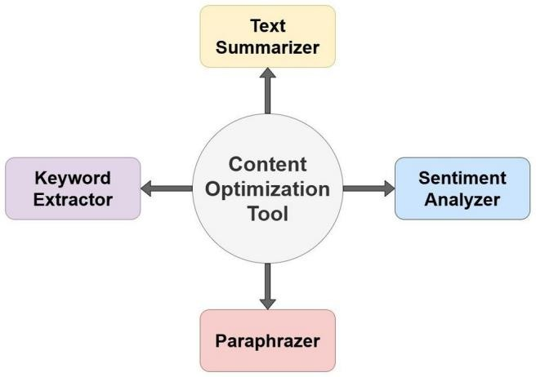

FIGURE 5.1. System Modules

### Text Summarizer:

Text summarization allows for the creation of concise and coherent summaries by extracting critical sentences from a text. Initially, the content is tokenized into sentences and words, breaking down the text into manageable segments for further analysis. A frequency table is then created using NLTK’s frequency distribution methods, which helps identify significant terms by removing common stop words such as "the" and "and." Once this frequency table is established, each sentence is scored based on the recurrence of important words, and the highest- scoring sentences are selected to form the summary. These sentences are combined to ensure coherence and preserve the original message, with additional grouping techniques used to improve fluency and continuity in more complex texts.

### Sentiment Analyzer:

Sentiment analysis in the tool leverages NLTK’s integration with the VADER (Valence Aware Dictionary and sEntiment Reasoner) model, which is highly effective for short, informal content, such as social media posts. The process begins by tokenizing and preparing the text for analysis, after which the VADER model calculates sentiment scores using NLTK's SentimentIntensityAnalyzer class. VADER assigns four scores to each text segment: positive, negative, neutral, and a composite score that categorizes the text as positive, negative, or neutral based on a weighted average. This scoring system is particularly useful for understanding audience reactions and gauging sentiment in customer feedback, social media analytics, and other forms of qualitative data.

### Keyword Extractor:

Keyword extraction is another vital function, aiding in the identification of main themes within the text. The process begins with tokenizing the text into individual words, followed by the removal of stop words to refine the set of tokens for more accurate keyword extraction. The frequency distribution of the words is then calculated, identifying terms that appear frequently and highlighting central themes. By selecting high-frequency terms as keywords, the tool offers insights into the core topics of a document, which can be valuable for search engine optimization and other content management purposes.

### Paraphrazer:

Paraphrasing enables the tool to rewrite content while maintaining the original meaning, facilitated by NLTK’s WordNet integration, which provides access to a

large lexical database of synonyms. This process involves retrieving synonyms for selected words within the text, considering each replacement's context to ensure appropriateness. A revised version of the text is created by substituting words with suitable synonyms and adjusting sentence structure.

## CHAPTER 6

***IMPLEMENTATION***

### 6.1 Home Page:

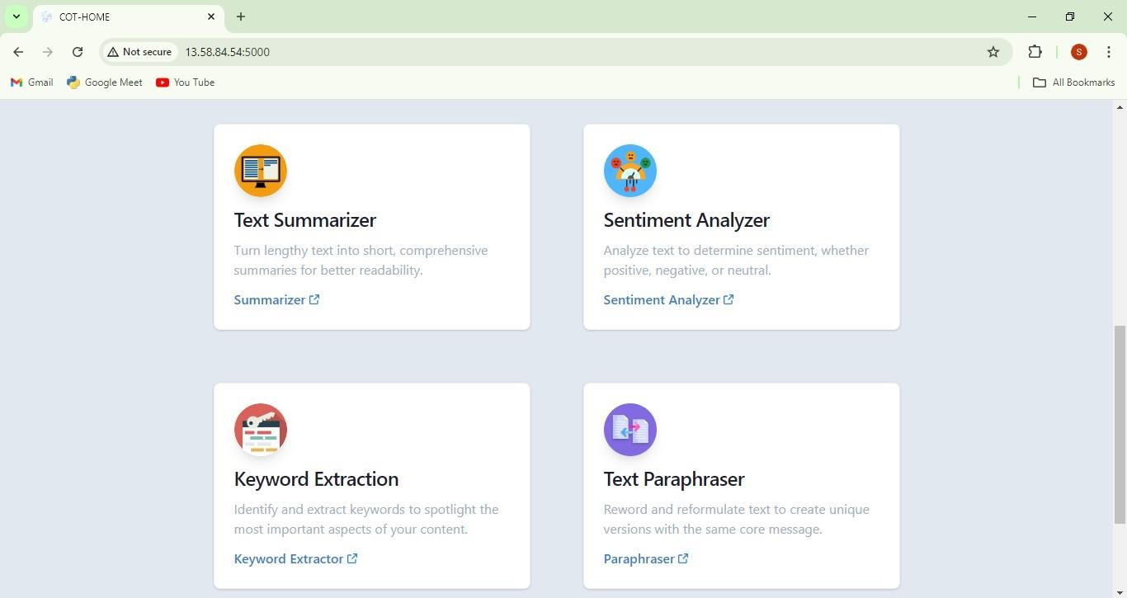FIGURE 6.1. Home Page 1

### 6.2. Summarizer Page:

FIGURE 6.2. Home Page 2

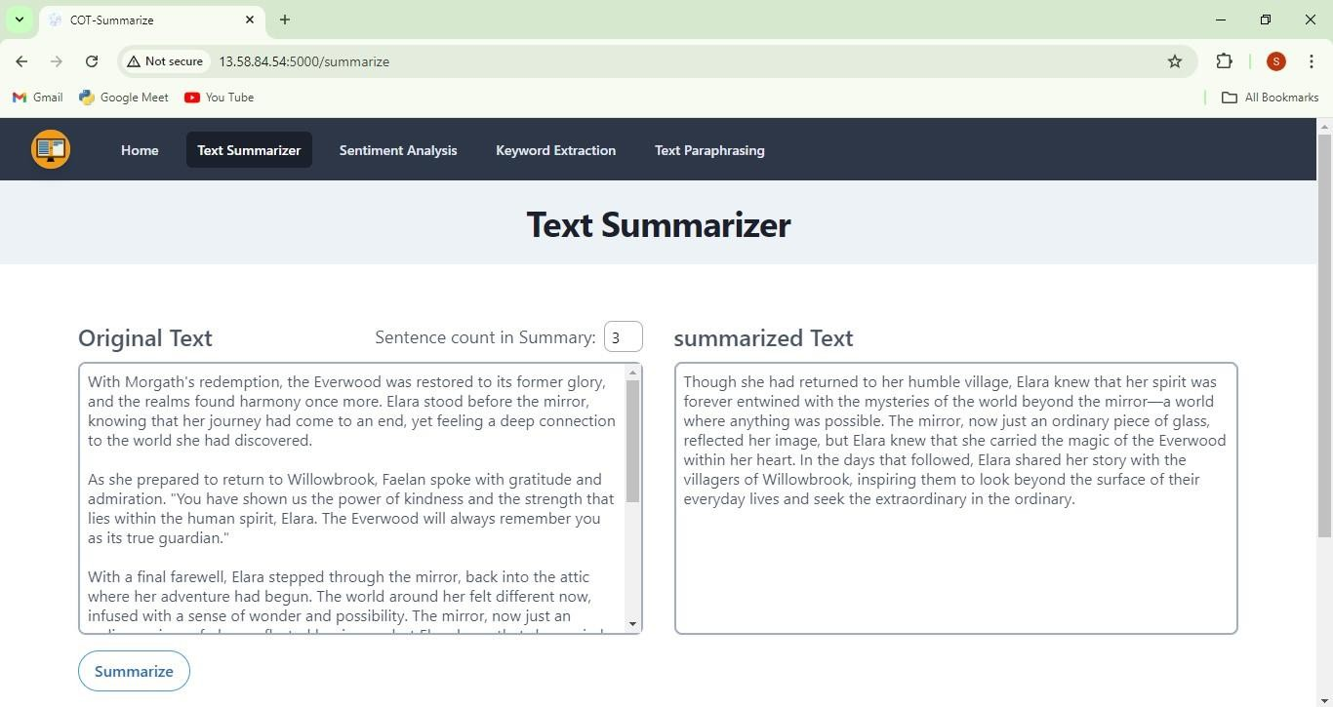

FIGURE 6.3. Summarizer Page **6.3.**

### Sentiment Analyzer Page:

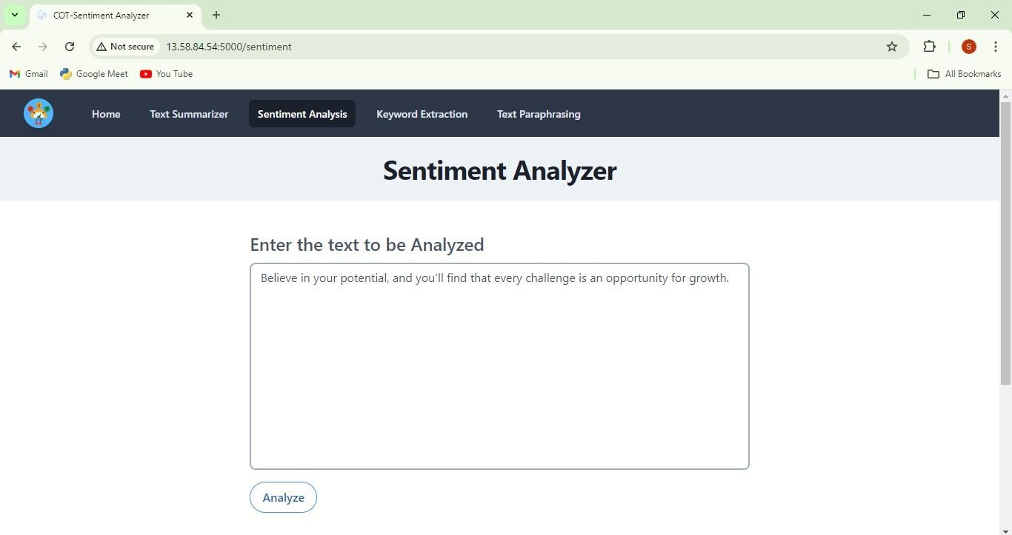

FIGURE 6.4. Sentiment Analyzer Page 1

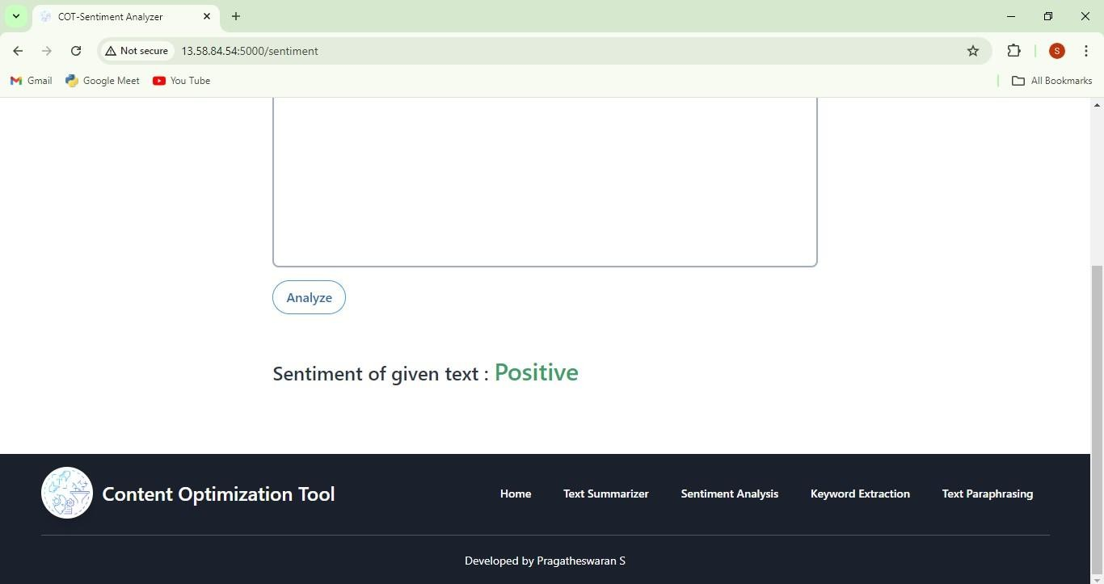

FIGURE 6.5. Sentiment Analyzer Page 2 **6.4.**

### Keyword Extractor Page:

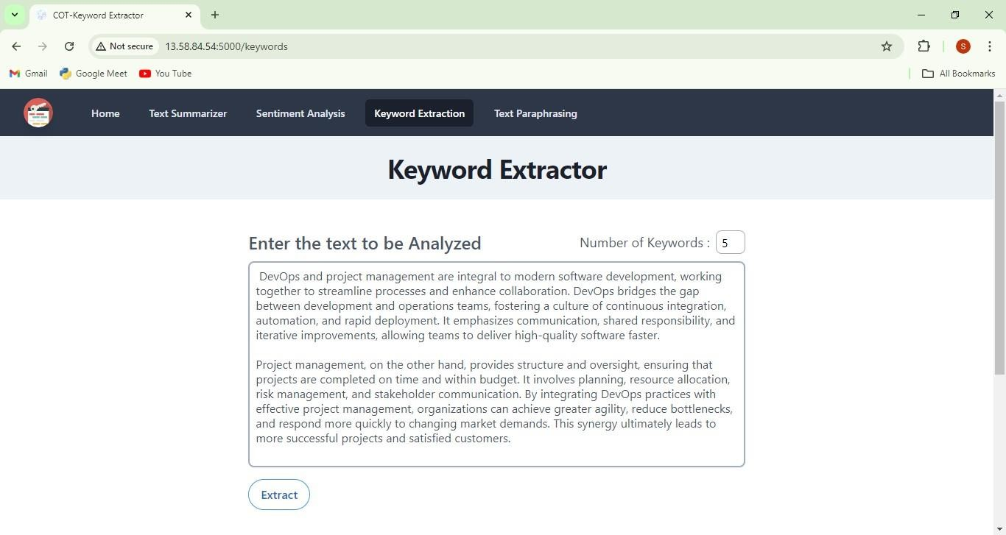

FIGURE 6.6. Keyword Extractor Page 1

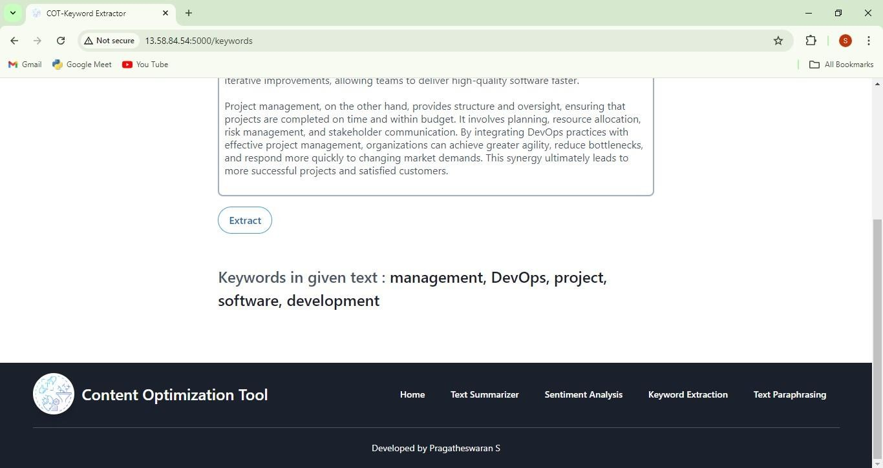

FIGURE 6.7. Keyword Extractor Page 2 **6.5.**

### Paraphrazer Page:

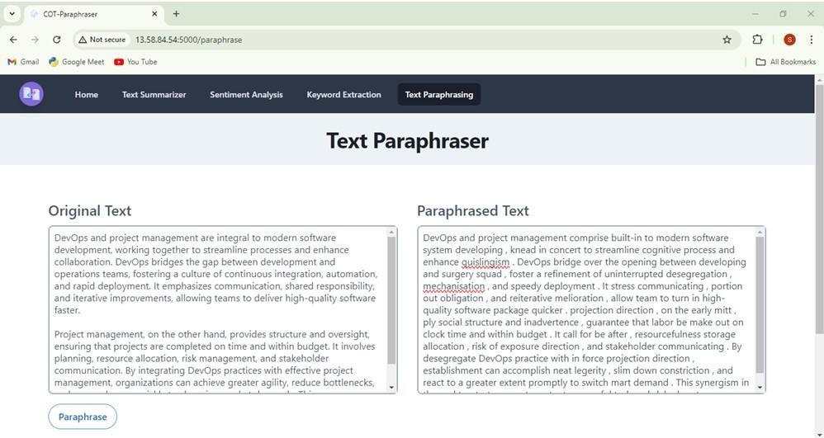

FIGURE 6.8. Paraphrazer Page

## CHAPTER 7 CONCLUSION

In conclusion, the Dynamic Sentiment Analysis for Real-Time Social Media User Profiles project represents a significant advancement in the way emotions are detected and understood across social media platforms. By leveraging multimodal data sources—text, emojis, and voice inputs—this system provides a comprehensive and dynamic analysis of user sentiment in real-time. The integration of state-of-the-art technologies like BERT and LSTM for text sentiment analysis, along with speech-to-text and emoji-based emotion detection, allows for a more accurate and nuanced interpretation of user emotional states, which is crucial in capturing the complexity of modern social interactions.

The real-time nature of the system ensures that emotional profiles are continuously updated, offering a responsive and evolving picture of user sentiment. This makes the system highly valuable for diverse applications such as business intelligence, mental health monitoring, and social sentiment analysis. By enabling stakeholders to observe and act on real-time emotional shifts, the system has the potential to drive more effective decision-making, personalized user experiences, and even early interventions in areas like mental health.

While the project demonstrates considerable promise, there are challenges and limitations to address, such as data privacy concerns, potential biases in sentiment models, and the need for further refinement in multimodal emotion recognition. Future improvements could focus on scaling the system for larger datasets, enhancing model accuracy, and expanding its application to other forms of digital communication.

Overall, this project underscores the importance of real-time sentiment analysis in understanding human emotions in a digital-first world. As social media continues to evolve, systems like this will play a crucial role in decoding the emotional landscape of online interactions, providing deeper insights into how users feel, what they care about, and how they engage with the digital world.

## CHAPTER 8 REFERENCES

1. Muhammad Ayub, Sidra Irum, Dr. Zunera Jalil. "Enhanced Audio-Based Open-Source Intelligence Insights using Machine Learning" (2024).
2. Muhammad Ayyaz SheikhID, Maryam BashirID, Mehtab Kiran SudddleID.

"Advancing automatic text summarization:Unleashing enhanced binary multi- objective grey wolf optimization with mutation" (2024).

1. Mironela Pirnau , Mihai Alexandru Botezatu , Iustin Priescu , Alexandra Hosszu , Alexandru Tabusca ,Cristina Coculescu and Ionica Oncioiu. "Content

Analysis Using Specific Natural Language Processing Methods for Big Data" (2024).

1. Belém Barbosa, José Ramón Saura, Senka Borovac Zekan, Domingo

Ribeiro-Soriano. "Defining content marketing and its influence on online user behavior: a data-driven prescriptive analytics method" (2023).

1. Nehal,Sushruta Mishra,Divyank Jeet,Celestine Iwendi,Vandana Sharma,Jude

Osamor. "Twitter Sentiment Analysis and Emotion Detection using NLTK and TextBlob" (2024).

1. Dhiaa A. Musleh, Ibrahim Alkhwaja , Ali Alkhwaja , Mohammed Alghamdi

Hussam Abahussain ,Faisal Alfawaz, Nasro Min-Allah and Mamoun Masoud Abdulqader. "Arabic Sentiment Analysis of YouTube Comments: NLP-Based Machine Learning Approaches for Content Evaluation" (2023).

1. Mrs. Mukkala Sruthi, Battula Sai Teja, K. Nikheel Kumar Goud, P. Manjula

Reddy,B. Rahul. "Text Keyword Research With Python Implementation" (2023). [8] Janek Bevendorff,Sanket Gupta,Johannes Kiesel,Benno Stein. "An Empirical Comparison of Web Content Extraction Algorithms" (2023).

1. Meng Wang,Fanghui Hu. "The Application of NLTK Library for Python Natural Language Processing in Corpus Research" (2021).
2. Jihai Zhang, Wei Wang, Siyan Guo, Li Wang, Fangquan Lin, Cheng Yang and Wotao Yin. "Solving General Natural-Language-Description Optimization Problems with Large Language Models" (2024).
3. Rupal Yadav, Madhuri Sharma. "NLTK-Powered Text Summarization: Streamlining Information Access" (2024).
4. Vinayak Pillai. "Enhanced Sentimental Analysis Through Decision SupportSystem Based On Learning Techniques Using NLTK Vinayak Pilla" (2024).
5. Mironela Pirnau, Mihai Alexandru Botezatu , Iustin Priescu, Alexandra Hosszu, Alexandru Tabusca, Cristina Coculescu and Ionica Oncioiu. "Content

Analysis Using Specific Natural Language Processing Methods for Big Data" (2024).

1. Mike Nkongolo Wa Nkongolo. "News Classification and Categorization with Smart Function Sentiment Analysis" (2023).
2. Clinton T. White , Neil P. Molino, Julia S. Yang and John M. Conroy. "A Text Summarization Package" (2023).
3. T.Ranjith Kumar, Anishka Akarapu, Sathwik Rao Allam,Naga Chandana

Gattepally, Pooja yashaswi Nellutla. "Chatbot Application Using NLTK And Keras" (2024).

1. Durga Sharma,Rahul Johari ,Kalpana Gupta. "Translation of Code-Mixed and Code-Switched Tweets Using LLMs for Enhanced Sentiment Analysis Outcomes" (2024).
2. Yaroslav Starukhin, Vladimir Diukarev. "Automation Of Text Data Processing Using NLP" (2024).
3. Divya Amade, Rashmi Chandra, Vivek Kumar Sinha, Divya Anand. "Automatic Text Summarization Using NLTK & Spacy" (2024).
4. Dr V Srilakshmi,Chitla Vinay SanthoshK Anusha, E Vivek,k, V Dhanya Sri, V Pardha Saradhi. "Text Summarization Using Natural Language

Processing" (2023).

**Dynamic Sentiment Analysis for Real Time Social Media User Profile**

|  |  |  |
| --- | --- | --- |
| Santhosh. M,  AI&DS  Panimalar Engineering College,  Chennai, India.  [ms1932641@gmail.com](mailto:vharishh.11@gmail.com) | Jai Suriya. S,  AI&DS  Panimalar Engineering College,  Chennai, India.  jaisuriya7119@gmail.com | Karthik Raja.K,  AI&DS  Panimalar Engineering College,  Chennai, India.  karthikraja6507531@gmail.com |

Ms.P.Shyamala…, AI&DS

Panimalar Engineering College, Chennai, India.

***ABSTRACT***

**The ability of machines to understand and interpret human language is made possible by Natural Language**

**Processing, which is now a crucial part**

**of many applications. With the advancement of current applications, NLP has become a key technology that allows machines to comprehend, analyze and interpret human language more accurately. Its uses span from sentiment analysis and text analysis to more sophisticated jobs like automated summarization and language translation. Among the different NLP tools available, the Natural Language Toolkit (NLTK) is one of the most complete and popular packages in the Python ecosystem. NLTK makes NLP tasks easier by providing tools like tokenization, stemming, lemmatizing, part-of-speech tagging, parsing and more. These parts help developers break down text into smaller parts, use linguistic rules and learn useful**

**information from text. Its features make it easy to use and benefits both new programmers and experienced NLP practitioners. The toolkit's modular design and pre-trained models make it**

**easy for developers to solve language processing problems. The implementation of Content Optimization Tool using NLTK’s capabilities to enhance content creation and analysis is explained. This tool uses several NLP features and NLTKs pre- trained models and modules to process text data. This practical application demonstrates NLTK’s potential to deliver high-quality**

**language processing solutions, making it an essential resource for developing intelligent content optimization tools and similar applications.**

**Keywords -** Natural Language Processing, NLTK, Content Optimization Tool.

**I.INTRODUCTION**

This project, titled **"Dynamic Sentiment Analysis for Real-Time Social Media User Profiles,"** seeks to address this limitation by developing a multimodal sentiment analysis system that integrates textual, emoji, and voice data to assess user emotions accurately and comprehensively. By combining these inputs, the system can better understand the nuances in user interactions, creating a more holistic emotional profile that reflects real-time sentiment changes.

The proposed solution utilizes advanced Natural Language Processing (NLP) techniques, including **BERT (Bidirectional Encoder Representations from Transformers)** and **LSTM (Long Short-Term Memory)** models, to perform sentiment classification on textual data. Emoji sentiment mapping and speech-to-text emotion detection further enhance the system, offering a more refined understanding of user emotions. Through a real-time processing pipeline, this project enables dynamic updates to user sentiment profiles, providing immediate, actionable insights into shifting emotional states.

Proposed system is a Content Optimization Tool that leverages NLTK’s capabilities to improve the quality and impact of textual data. The tool integrates several modules, including text summarization, keyword extraction, sentiment analysis, and paraphrasing, to streamline content creation and management processes. By demonstrating the application of NLTK within this tool, we also explore how NLP can be harnessed to address real-world needs in content management and

optimization, showcasing NLTK’s versatility and relevance in modern

NLP-driven initiatives.

**II. NATURAL LANGUAGE PROCESSING**

NLP is a branch of artificial intelligence (AI) that deals with the interaction between computers and human language. The main objective of NLP is to enable machines to understand, interpret, and generate human language in a way that is both meaningful and practical. NLP allows computers to perform various language- related tasks, making it possible for machines to process language at scale and recognize nuances such as context, sentiment, and structure.

NLP has become essential in a wide range of applications due to its ability to automate language-driven processes and enhance user experiences. For instance, NLP is widely used in text summarization, sentiment analysis and automatic language translation in various applications.

Additionally, NLP supports chatbots and virtual assistants in customer service, enabling them to understand user queries and provide relevant responses.

Recent advancements in NLP have also improved tasks like named entity recognition where specific entities such as names, dates, and locations are identified within text and topic modelling which classifies content into specific themes or topics. These capabilities make NLP indispensable for analyzing and organizing massive datasets enabling smarter data- driven decisions in fields like healthcare, finance, e-commerce, and social media analysis.

NLP continues to evolve with ongoing research expanding its applications and enhancing its accuracy. By allowing machines to handle language in a way that was previously only possible for humans, NLP is transforming industries and driving innovation in AI. Its impact on modern applications highlights the importance of continued development in this field, as NLP technologies become more refined, context-aware and integral to AI-powered solutions.

**III. NATURAL LANGUAGE TOOLKIT**

NLTK is a widely used and powerful

Python library designed to simplify natural language processing (NLP) tasks. It provides developers and researchers with a comprehensive suite of tools for handling and analyzing human language data, making it an ideal framework for a wide range of text-processing applications. With an extensive array of functions, NLTK enables efficient execution of various NLP tasks, such as named entity recognition, tokenization, stemming, lemmatization, and part-of-speech tagging, making text analysis easier and more accessible.

**Essential Features of NLTK**

* 1. **Text Processing Tools:** NLTK provides robust text manipulation capabilities, including tokenization (breaking text into words or sentences), lemmatization, and stemming, which simplifies words to their root forms. These tools are essential for processing text at a granular level, supporting applications in text normalization and simplifying further analysis.
  2. **Corpora and Lexical Resources:** One of NLTK’s strengths lies in its access to over 50 corpora and lexical resources, such as WordNet, a semantic database that helps identify synonyms, relationships, and word meanings. These resources are valuable for tasks requiring linguistic knowledge, like keyword extraction, sentiment analysis, and text

summarization, as they allow for in-depth exploration of language and meaning.

* 1. **Pre-Trained Models:**

NLTK includes pre-trained models that developers can use out-of-the-box for tasks like text categorization and sentiment analysis. This functionality enables quick prototyping and analysis on real-world text data without extensive training, making NLTK ideal for rapid development and research applications.

* 1. **Tokenization:**

Tokenization is the process of dividing text into manageable pieces, such as sentences or words. NLTK offers multiple

tokenization methods, including sentence and lexical tokenization, which form the foundation for many NLP tasks by

enabling systems to analyze text at a more granular level.

* 1. **Stemming and Lemmatization:**

Stemming reduces words to their base or root form by removing suffixes, while lemmatization uses linguistic rules to return words to their original dictionary form based on context. These processes are crucial for normalizing text, reducing word variations, and improving the accuracy of models by creating uniform data.

* 1. **Named Entity Recognition (NER):**

NLTK provides tools for named entity

recognition (NER), which identifies entities such as names, locations, and

organizations within text. NER is vital for extracting key entities from content, enabling more targeted content analysis and enhancing applications like text summarization and keyword extraction.

* 1. **Modular Design:**

NLTK’s modular architecture allows for the creation of customized NLP pipelines, making it adaptable to a wide variety of text processing and analysis projects. Developers can combine different components to build solutions that are specifically tailored to their requirements, enabling a high degree of flexibility.

NLTK is a valuable tool for performing complex language processing tasks, such as tokenization, stemming, parsing, and classification, and it offers extensive support for content analysis and optimization. Its broad collection of corpora and lexical resources, such as WordNet, supports nuanced text tasks like keyword extraction and synonym

generation, leading to richer and more accurate analysis. With pre-trained models for rapid deployment and a modular design for customization, NLTK promotes adaptability and efficiency, making it a prime choice for both educational and real- world NLP projects.

* + 1. **EXISTING SYSTEM** Existing

content processing and optimization solutions rely on

various approaches, such as machine learning algorithms, rule-based models, and

custom-built logic to perform text analysis and enhancement. While these systems

can achieve basic content manipulation and processing, they face significant

limitations. Many systems are

non-modular and use a combination of proprietary algorithms, making it

challenging to integrate them seamlessly with other tools or adapt them to new requirements. This lack of flexibility complicates customization, restricts

scalability, and limits the system's ability to handle dynamic content needs effectively.

Additionally, while NLP techniques have become more prevalent, many existing solutions either lack comprehensive NLP functionalities or use outdated,

lower-quality methods that struggle with nuances like context or sentiment. These limitations can lead to suboptimal results in tasks such as summarization, sentiment detection, and keyword extraction, which are essential for robust content optimization. Furthermore, existing systems often feature complex interfaces with limited documentation, creating a steep learning curve and reducing accessibility for non-expert users. These systems frequently require considerable effort to maintain and modify, creating challenges for users seeking intuitive, scalable, and high-performing solutions.

* + 1. **PROPOSED SYSTEM**

The proposed system aims to leverage Natural Language Processing (NLP) through the Natural Language Toolkit

(NLTK) to overcome the limitations seen in existing content processing solutions.

NLP has become indispensable in applications requiring text analysis, language understanding, and data-driven

insights, as it enables systems to interpret and process human language effectively.

However, implementing NLP can be challenging without the right tools. NLTK, a comprehensive Python library for NLP, simplifies this process by offering an extensive suite of modules and pre-built functionalities, making it easier for developers to integrate sophisticated NLP techniques into their applications.

NLTK's capabilities include tokenization, lemmatization, stemming, named entity recognition, parsing, and sentiment analysis—tools essential for accurate and efficient language processing. By using NLTK, developers can create applications that perform complex language tasks with minimal setup, supporting a variety of applications from text summarization to language translation. The toolkit also provides access to a large collection of lexical resources and pre-trained models, accelerating application development and ensuring reliable results in processing large-scale text data.

This proposed system takes full advantage of NLTK's modular design to enable the creation of targeted content optimization applications. With NLTK, users can

develop applications tailored to specific content processing tasks, including text summarization, keyword extraction, sentiment analysis, and paraphrasing. Each of these modules serves a unique role in transforming and optimizing text, allowing users to streamline workflows and enhance content readability, relevance, and engagement.

The proposed Content Optimization Tool is an implementation of NLTK designed to

provide a streamlined, user-friendly interface for handling and enhancing textual content. Through a combination of NLTK’s capabilities, this tool promises to improve content quality while minimizing manual effort, making it an effective solution for users looking to process and optimize language-driven data efficiently.

* + 1. **CONTENT OPTIMIZATION TOOL** The

Content Optimization Tool is a comprehensive solution that utilizes various NLP techniques to streamline and improve textual content. By leveraging the power of NLTK, this tool enables efficient text summarization, sentiment analysis, keyword extraction, and paraphrasing, each serving a unique role in refining and enhancing the readability and relevance of content. Below is a detailed look at each module within the tool.

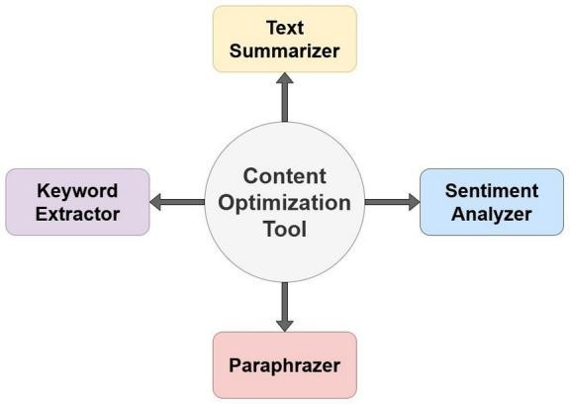

***FIGURE 1. System Modules***

* 1. **Text Summarizer:**

Text summarization allows for the creation of concise and coherent summaries by extracting critical sentences from a text. Initially, the content is tokenized into sentences and words, breaking down the text into manageable segments for further analysis. A frequency table is then created using NLTK’s frequency distribution methods, which helps identify significant

terms by removing common stop words such as "the" and "and." Once this frequency table is established, each sentence is scored based on the recurrence of important words, and the

highest-scoring sentences are selected to form the summary. These sentences are combined to ensure coherence and preserve the original message, with additional grouping techniques used to improve fluency and continuity in more complex texts.

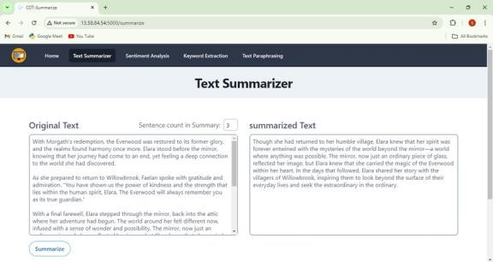

***FIGURE 2. Text Summarizer Model***

* 1. **Sentiment Analyzer:**

Sentiment analysis in the tool leverages NLTK’s integration with the VADER (Valence Aware Dictionary and sEntiment Reasoner) model, which is highly effective for short, informal content, such as social media posts. The process begins by tokenizing and preparing the text for analysis, after which the VADER model calculates sentiment scores using NLTK's SentimentIntensityAnalyzer class. VADER assigns four scores to each text segment: positive, negative, neutral, and a composite score that categorizes the text as positive, negative, or neutral based on a weighted average. This scoring system is particularly useful for understanding audience reactions and gauging sentiment in customer feedback, social media analytics, and other forms of qualitative data.

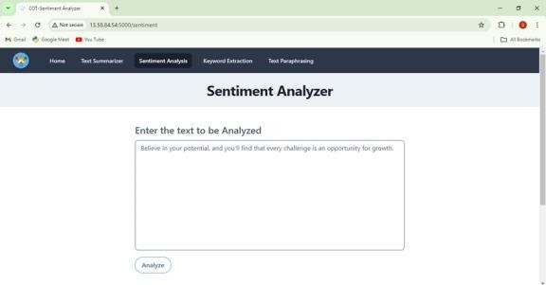

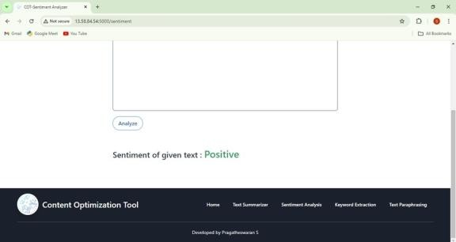

***FIGURE 3. Sentiment Analyzer Model***

* 1. **Keyword Extractor:**

Keyword extraction is another vital function, aiding in the identification of main themes within the text. The process begins with tokenizing the text into individual words, followed by the removal of stop words to refine the set of tokens for more accurate keyword extraction. The frequency distribution of the words is then calculated, identifying terms that appear frequently and highlighting central themes. By selecting high-frequency terms as keywords, the tool offers insights into the core topics of a document, which can be valuable for search engine optimization and other content management purposes.

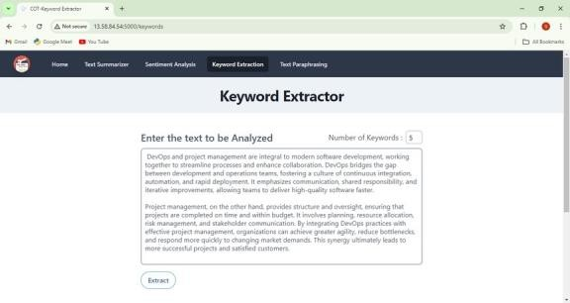

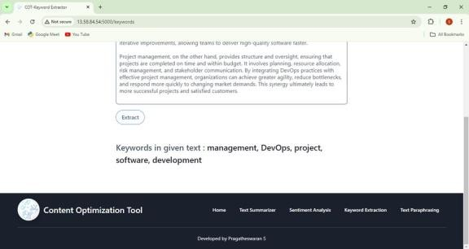

***FIGURE 4. Keyword Extractor Model***

* 1. **Paraphrazer:**

Paraphrasing enables the tool to rewrite content while maintaining the original meaning, facilitated by NLTK’s WordNet integration, which provides access to a large lexical database of synonyms. This process involves retrieving synonyms for

selected words within the text, considering each replacement's context to ensure appropriateness. A revised version of the text is created by substituting words with suitable synonyms and adjusting sentence structure, offering a diverse range of content while preserving the message’s essence. This approach is highly beneficial for content diversification in SEO and reducing redundancy.

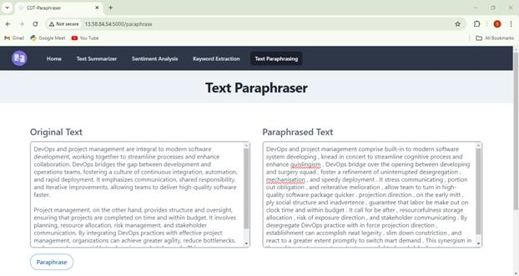

***FIGURE 5. Paraphrazer Model***

Through these modules, the Content Optimization Tool provides an efficient platform for enhancing, analyzing, and reformatting textual content. NLTK's extensive functionalities make each module effective, allowing users to

streamline various content processes with minimal manual effort, thus highlighting the practical applications of NLP in modern content processing systems.

* + 1. **CONCLUSION**

The development of the Content Optimization Tool demonstrates the significant impact of Natural Language Processing (NLP) and the Natural

Language Toolkit (NLTK) in enhancing text management and analysis. By incorporating advanced functionalities such as text summarization, sentiment analysis, keyword extraction, and paraphrasing, this tool effectively streamlines various content-related tasks, providing users with efficient and accurate solutions for handling textual data.

The ability to generate concise summaries allows for quicker comprehension of large volumes of information, making it invaluable in today’s fast-paced digital environment. Sentiment analysis offers insights into audience perceptions, enabling organizations to tailor their messaging and improve customer

engagement. Keyword extraction aids in identifying critical themes, enhancing search engine optimization strategies and content relevance. Finally, paraphrasing fosters creativity and reduces redundancy, ensuring that content remains fresh and engaging.

Overall, the integration of NLTK within the Content Optimization Tool exemplifies how modern NLP techniques can transform content processing workflows. The tool not only simplifies complex language tasks but also empowers users to

harness the full potential of their textual data, ultimately leading to improved productivity and enhanced user experiences. As NLP continues to evolve, tools like this will play a crucial role in driving innovation and efficiency across various sectors, underscoring the importance of adopting advanced linguistic technologies in content management practices.

* + 1. **REFERENCES** [1]

Muhammad Ayub, Sidra Irum, Dr.

Zunera Jalil. "Enhanced Audio-Based Open- Source Intelligence Insights using Machine Learning" (2024).

1. Muhammad Ayyaz SheikhID, Maryam

BashirID, Mehtab Kiran SudddleID. "Advancing automatic text summarization:Unleashing enhanced binary multi-objective grey wolf optimization with mutation" (2024).

1. Mironela Pirnau , Mihai Alexandru Botezatu , Iustin Priescu , Alexandra Hosszu , Alexandru Tabusca

,Cristina Coculescu and Ionica Oncioiu. "Content Analysis Using Specific Natural Language Processing Methods for Big Data" (2024).

1. Belém Barbosa, José Ramón Saura,

Senka Borovac Zekan, Domingo Ribeiro-Soriano. "Defining content marketing and its influence on online user behavior: a data-driven prescriptive analytics method" (2023).

1. Nehal,Sushruta

Mishra,Divyank

Jeet,Celestine Iwendi,Vandana Sharma,Jude Osamor. "Twitter Sentiment Analysis and Emotion Detection using NLTK and TextBlob" (2024).

1. Dhiaa A. Musleh, Ibrahim Alkhwaja

,

Ali Alkhwaja , Mohammed Alghamdi Hussam Abahussain ,Faisal Alfawaz, Nasro Min-Allah and Mamoun Masoud Abdulqader. "Arabic Sentiment Analysis of YouTube Comments: NLP-Based Machine Learning Approaches for Content Evaluation" (2023).

1. Mrs. Mukkala Sruthi, Battula Sai Teja,

K. Nikheel Kumar Goud, P. Manjula Reddy,B. Rahul. "Text Keyword Research With Python Implementation" (2023).

1. Janek Bevendorff,Sanket Gupta,Johannes Kiesel,Benno Stein. "An Empirical Comparison of Web Content Extraction Algorithms" (2023).
2. Meng Wang,Fanghui Hu.

"The

Application of NLTK Library for Python Natural Language Processing in Corpus Research" (2021).

1. Jihai Zhang, Wei Wang, Siyan Guo,

Li Wang, Fangquan Lin, Cheng Yang and Wotao Yin. "Solving General Natural-Language-Description Optimization Problems with Large Language Models" (2024).

1. Rupal Yadav, Madhuri Sharma. "NLTK-Powered Text Summarization:

Streamlining Information Access" (2024).

1. Vinayak Pillai. "Enhanced Sentimental Analysis Through Decision

Support System Based On Learning Techniques Using NLTK Vinayak Pilla" (2024).

1. Yaroslav Starukhin, Vladimir Diukarev. "Automation Of Text Data

Processing Using NLP" (2024).

1. Divya Amade, Rashmi Chandra, Vivek Kumar Sinha, Divya Anand. "Automatic Text Summarization Using NLTK & Spacy" (2024).

|  |  |  |  |  |  |  |
| --- | --- | --- | --- | --- | --- | --- |
| [13] | Mironela Pirnau, |  | Mihai | [20] | Dr V | Srilakshmi,Chitla |
|  | Alexandru Botezatu | , | Iustin |  | Vinay |  |

Priescu, Alexandra Hosszu, Alexandru Tabusca, Cristina Coculescu and Ionica Oncioiu. "Content Analysis Using Specific Natural Language Processing Methods for Big Data" (2024).

1. Mike Nkongolo Wa Nkongolo. "NewsClassification and Categorization with Smart Function Sentiment Analysis"

SanthoshK Anusha, E Vivek,k, V Dhanya

Sri, V Pardha Saradhi. "Text Summarization Using Natural Language Processing" (2023).

(2023).

1. Clinton T. White , Neil P. Molino, Julia S. Yang and John M. Conroy. "A Text Summarization Package" (2023).
2. T.Ranjith Kumar, Anishka Akarapu,

Sathwik Rao Allam,Naga Chandana Gattepally, Pooja yashaswi Nellutla. "Chatbot Application Using NLTK And Keras" (2024).

1. Durga Sharma,Rahul Johari

,Kalpana

Gupta. "Translation of Code-Mixed and Code-Switched Tweets Using LLMs for Enhanced Sentiment Analysis Outcomes" (2024).