**Batchevaluation wrapper: Short introduction**

Madhulika Mishra, Guillaume HEGER, Pablo Moreno, Irene Papatheodorou, Janet M Thronton

01/06/2020

Table of Contents

# Introduction

Over time, a vast amount of genomic information has been accumulated in the public repository mainly in GEO and ArrayExpress for the given phenotype. However, it is still challenging to integrate different high throughput experiments reflecting similar phenotype because of various other non-biological confounding factors such as type of array, date of experiment, a laboratory where data was generated, etc and, can be summarized as batch effects. In order to solve this issue, various batch-effect correction algorithms(BECAs) such as ComBat, SVA, and RUV have been developed to remove such batch effects from the integrated data and have shown promising results in mining biological signals. Evaluation of batch correction protocols involves mainly looking at the Principle component plots or RLE plot or sometimes by measuring batch entropy.

This project is to increase the reusability and reproducibility of these workflows in order- to facilitate batch correction, comparison, and benchmarking for ExpressionAtlas. Our strategy is to provide command-line access to individual library functions through simple wrapper scripts packaged in R wrapper. Batchevaluation R Wrapper contain implements of a variety of methods for batch correction of microarray as well as for bulk RNA-seq data.

# Project overview

Batchevaluation analyses include step such as:

* Fetching experiments from ExpressionAtlas based on a biological factor of interest, such as disease, species and tissue
* Removing isolated experiments
* Merging experiments in a single dataset
* Evaluation of batch effect in the merged dataset
* Correcting batch effects
* Evaluation of batch correction methods

These steps may be implemented in a variety of ways including stand-alone tools, scripts or R package functions. To compare equivalent logical steps between workflows, and to ‘mix and match’ those components for optimal workflows is, therefore a challenging exercise without having additional infrastructure. The current R package provides a flexible to perform batch correction and evaluate effect of the batch correction on the given dataset.

# Installation

Installation should take less than 5 min.

## Via Github and devtools

If you want to install the package directly from Github, I recommend using the devtools package.

library(devtools)  
install_github('XXXXXXXX') link is not up yet

## Manually

Please download the package as zip archive and install it via

install.packages('Batchevaluation.zip', repos = NULL, type = 'source')

## Installing the dependencies (first use)

To run the following functions, you will need some packages that can be installed using these commands in R :

install.packages(c('magrittr','stringr','purrr','dplyr','tibble','ggplot2','igraph','gtools','lme4','readr','rowr','statmod','RANN','cluster','WGCNA'))  
if (!requireNamespace("BiocManager", quietly = TRUE))  
 install.packages("BiocManager")  
BiocManager::install('preprocessCore')  
BiocManager::install('limma')  
BiocManager::install('sva')  
BiocManager::install('RUVSeq')  
BiocManager::install('RUVnormalize')  
BiocManager::install('SummarizedExperiment')  
BiocManager::install('batchelor')  
devtools::install_github('tengfei-emory/scBatch')

# Overview of steps available in Batchevaluation

Batchevaltaion package has several steps ranging from meta-experiment creation to batcheffect evaluation step (Figure1). In current wrapper, scripts are written in user-friendly way. Short description of each step and example is given below -

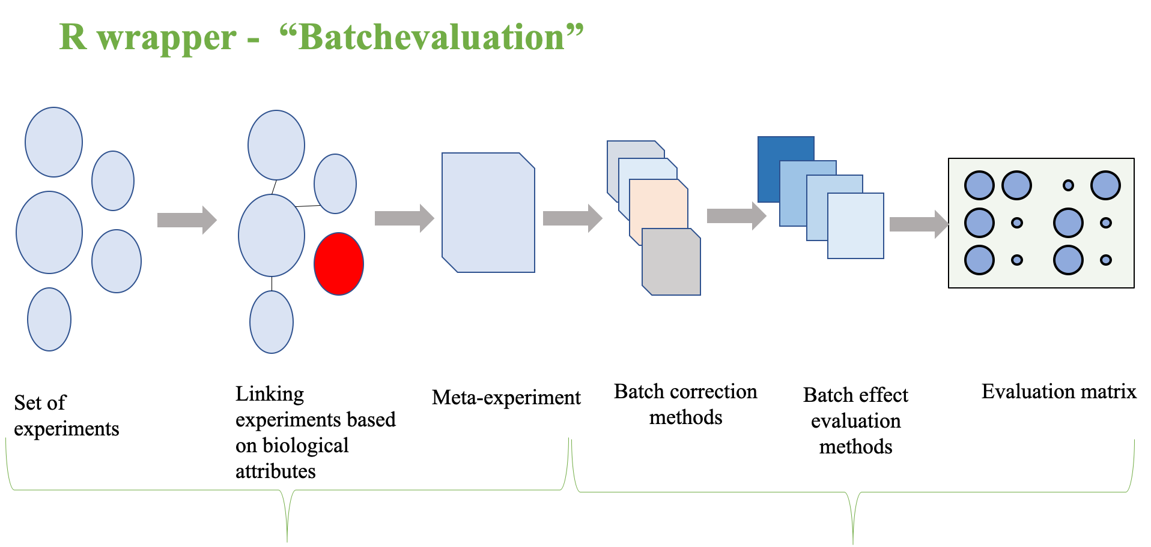

Workflow of the Batchevaluation package.

## Loading data in R

If the data files are already on your computer, you can use this step. If you want to download data from Expression Atlas, skip this part and go directly to “Downloading data from Expression Atlas”.

**Recommendation:** Microarray input data should be preprocessed- appropriately back-ground corrected without any normalization step, probe-to-gene level mapped and log-transformed. It is also recommended to remove low-expressed genes from data if possible. It should be count matrix for bulk-RNaseq.

**Steps:**

* Put the data files in .Rdata format in a directory containing only them. (The R objects contained in those files must be either SummarizedExperiment or ExpressionSet experiment.)
* Load all the experiments in a list using the function load_experiments

experiments <- load_experiments('directory_path')  
experiments<-load_experiments('./')

Example Microarray data is provided in **example1** folder of the package.

## Downloading data from Expression Atlas

If you want to use data from Expression Atlas that can be downloaded in .Rdata format, you can use the function download_experiments_from_ExpressionAtlas in this way :

experiments <- download_experiments_from_ExpressionAtlas('E-MTAB-3718','E-MTAB-3725','E-GEOD-44366','E-GEOD-74747')

This downloads the experiments in a new directory called **“experiments”** in your working directory and loads all the experiments in R within a list, using load_experiments function. After having loaded the experiments, you get a list of either SummarizedExperiment or list of ExpressionSet object.

**Caution**: Avoid mixing experiments of SummarizedExperiment with ExpressionSet. Experiment can only belong from any one of the class only.

Example of loaded data:

> experiments  
$GSE1297_rawdata.Rdata  
ExpressionSet (storageMode: lockedEnvironment)  
assayData: 8872 features, 29 samples   
 element names: exprs   
protocolData: none  
phenoData  
 rowNames: 1 2 ... 3 (29 total)  
 varLabels: ID Assay ... Batch (9 total)  
 varMetadata: labelDescription  
featureData: none  
experimentData: use 'experimentData(object)'  
Annotation:   
  
$GSE1711_rawdata.Rdata  
ExpressionSet (storageMode: lockedEnvironment)  
assayData: 12386 features, 24 samples   
 element names: exprs   
protocolData: none  
phenoData  
 sampleNames: SAMPLE212704SUB4576 SAMPLE212705SUB4576 ... SAMPLE212727SUB4576 (24 total)  
 varLabels: AtlasAssayGroup age ... biosource_type (9 total)  
 varMetadata: labelDescription  
featureData: none  
experimentData: use 'experimentData(object)'  
Annotation:

## Removing the isolated experiments

To correct the batch effect, one needs to take the biological characteristics of the samples into account (Tissue in our example). If no sample of an experiment shares biological characteristics with samples from other batches, it is not possible to correct batch effect with these batches because one cannot distinguish the biological difference from the artifact. The function remove_isolated_experiments removes the isolated experiments and plots graphs of intersections between the experiments before and after removal.

experiments %<>% remove_isolated_experiments('Tissue')

**WARNING:** this function only removes the isolated experiment. Although it is still possible that two or more unconnected groups of experiments remain, within which the experiments are connected. In this case, batch effect correction is not possible neither and one has to choose a group of experiments manually.

The two following plots are displayed by the function. The first one shows the graph of intersections of all the experiments before the removal of isolated ones. The second shows the same graph after their removal.

## Merging experiments in a single dataset

The function merge_experiments merges all the experiments in the list in a single SummarizedExperiment or ExpressionSet object and doesn’t perform any correction. This function has two additional arguments log and filter (respectively set to TRUE and FALSE by default).

* The log argument determines whether to perform log transformation on the data (recommended for bulk RNAseq).
* The filter argument determines whether to filter genes for which all the samples of a batch have zero-counts. Set it to TRUE if you have issues in running ComBat at the next step.

experiments %<>% merge_experiments  
#OR  
experiments %<>% merge_experiments(log=TRUE,filter=FALSE)

experiments is now an only ExpressionSet object containing the information about batches both in its @metadata and @colData slots :

ExpressionSet (storageMode: lockedEnvironment)  
assayData: 8872 features, 56 samples   
 element names: exprs   
protocolData: none  
phenoData  
 sampleNames: GSM21215.cel GSM21218.cel ... GSM697308.CEL (56 total)  
 varLabels: ID Assay ... batch (10 total)  
 varMetadata: labelDescription  
featureData: none  
experimentData: use 'experimentData(object)'  
Annotation:

**Caution:** Sometimes during merging experiment, phenodata (SDRF) file gets corrupted, hence, it is advised to always check meta-data before proceeding further.

## Correcting batch effect

The function batch_correction perform various type of batch-correction on given merged dataset and output batch-corrected data as a list.

Short detail of methods implemented in batch_correction function are given below-

* For Microarray, batch_correction function has following batch correction methods-
  + **limma**- default limma setting, more detail about method can be learnt from Limma [documentation](https://www.bioconductor.org/packages/release/bioc/manuals/limma/man/limma.pdf).
  + **GFS**- Gene Fuzzy Score, more detail about method can be learnt from [publication](https://bmcbioinformatics.biomedcentral.com/articles/10.1186/s12859-016-1327-8).
  + **Robust quantile normalization**- quantile normalisation method from PreprocessCore package. More information can be obtained from their [documentation](https://www.bioconductor.org/packages//2.7/bioc/html/preprocessCore.html).
  + **ComBat**- implemented from SVA package. More information can be obtained from their [documentation](https://bioconductor.riken.jp/packages/3.0/bioc/html/sva.html). In current batch_correction method, there are two versions of ComBat- 1) **ComBat1**- for parametric adjustment and, 2) **ComBat2** - for non-parametric adjustment, mean-only version.
  + **Q_ComBat** - is Quantile+ parametric adjustment of ComBat.
  + **MNN** - default mnnCorrect function from batchelor package. More information can be obtained from their [documentation](https://bioconductor.org/packages/release/bioc/html/batchelor.html).
  + **naiveRandRUV_HK** - default naiveRandRUV using Human HK genes from RUVnormalize package. More information can be obtained from their [documentation](https://bioconductor.org/packages/release/bioc/html/RUVnormalize.html). Human Housekeeping gene list is from this [publication](https://academic.oup.com/gigascience/article/8/9/giz106/5570567). No. of confounders were estimated using both “leek” and “be” method and then least no. of estimated confounders were used as input for all variants of **naiveRandRUV** method.
  + **Q_naiveRandRUV_HK** - is Qunatile+ naiveRandRUV_HK
  + **naiveRandRUV_empi.controls** - default naiveRandRUV using data-empirically derived HK genes from RUVnormalize package.
  + **Q_naiveRandRUV_empi.controls** -is Qunatile+ naiveRandRUV_empi.controls.
* For bulk-RNAseq, batch_correction function has the following batch correction methods-
  + **limma**- default limma setting, more detail about method can be learnt from Limma [documentation](https://www.bioconductor.org/packages/release/bioc/manuals/limma/man/limma.pdf).
  + **ComBat**- implemented from SVA package. More information can be obtained from their [documentation](https://bioconductor.riken.jp/packages/3.0/bioc/html/sva.html).
  + **ComBat_seq** - RNAseq version of ComBat, now implemented in SVA package. More information can be obtained from this [publication](https://www.biorxiv.org/content/10.1101/2020.01.13.904730v1).
  + **MNN** - default mnnCorrect function from batchelor package. More information can be obtained from their [documentation](https://bioconductor.org/packages/release/bioc/html/batchelor.html).
  + **RUVs** - default RUVs function from RUVSeq package.Here, k=1 is used. More information can be obtained from their [documentation](https://bioconductor.org/packages/release/bioc/html/RUVSeq.html).
  + **scBatch** - batch correction method implemented in scBatch package. More information can be obtained from their [publication](https://academic.oup.com/bioinformatics/article/34/15/2634/4916062).

This function has following arguments-

* The experiment argument is the input merged dataset.
* The model argument is a R formula mentioning the biological factor to take into account during correction.
* The batch argument is a meta-data column which has information about batch-label.
* The k argument is a no. of confounders for RUV methods and denotes the “number of factors of unwanted variation to remove”. If k is not provided it will then estimated from input data.
* The filter argument specify gene label for the given dataset. It Should be one of following string- ‘symbol’, ‘ensembl_gene_id’ or ‘entrezgene_id’ depending on gene label for the given dataset.

Since, this merged dataset had some issue while merging, phenodata was added separately. Phenodata is also available with the package in data folder and can be accessed like this:

load("~/Batchevaluation/data/pheno.example1.Rdata")  
experiments <- ExpressionSet(exprs(experiments), phenoData=pheno.experiment1)

After assigning phenodata, batch correction can be performed like this:

result <- batch_correction(experiment= experiments,model=~Disease, batch = "batch",'symbol')

Result is the list of batch-corrected data:

> summary(result)  
 Length Class Mode  
data.limma 1 ExpressionSet S4   
data.GFS 1 ExpressionSet S4   
data.quantile 1 ExpressionSet S4   
data.ComBat1 1 ExpressionSet S4   
data.ComBat2 1 ExpressionSet S4   
data.Q_ComBat 1 ExpressionSet S4   
data.mnncorrect 1 ExpressionSet S4   
data.Q_naiveRandRUV_HK 1 ExpressionSet S4   
data.naiveRandRUV_HK 1 ExpressionSet S4   
data.naiveRandRUV_empi.controls 1 ExpressionSet S4   
data.Q_naiveRandRUV_empi.controls 1 ExpressionSet S4

## Assessment of batch-correction methods

The function evalution_matrix performs various evaluation on batch-corrected data and output performance list of each individual method. Since, there are no. of ways batch-correction can be evaluated and each method has its own limitation, we have used cocktail of methods to perform analysis. This function has both PCA-inspired as well as biology inspired qualitative assessment protocol for batch-correction.

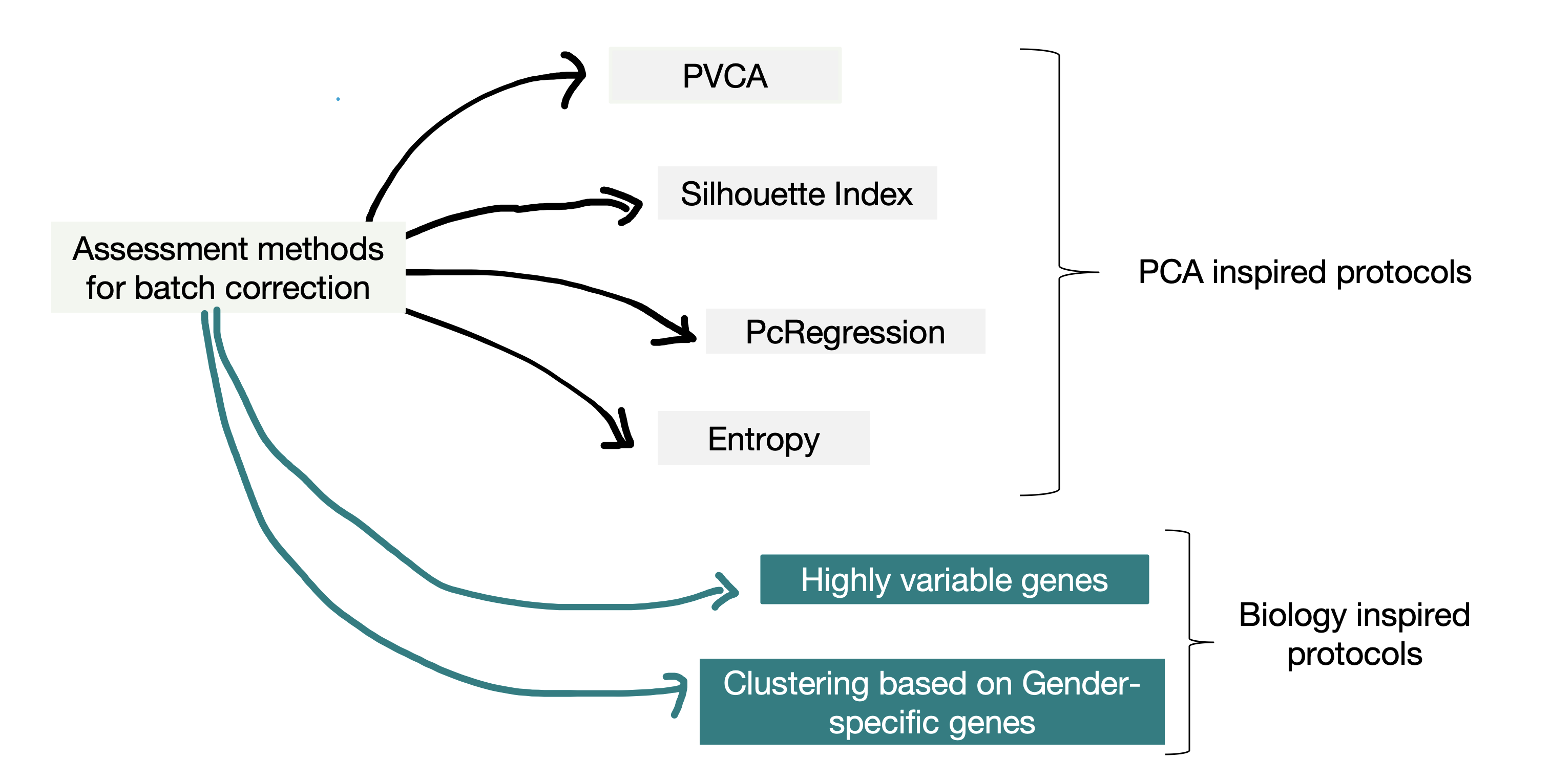

Overview of implemented assessment methods.

Short detail of methods implemented in evalution_matrix function is given below-

* **pvca**- A function for principal variance component analysis. The function is written based on the ‘pvcaBatchAssess’ function of the PVCA R package and slightly changed to make it more efficient and flexible for both microarray and bulk RNAseq gene-expression data. From <https://github.com/dleelab/pvca>.
* **silhouette**- Determine batch effect using the silhouette coefficient (adopted from scone) with default setting (nPcs=3). Taken from kBET [package](https://github.com/theislab/kBET).
* **pcRegression**- Determine batch effect by a linear model fit of principal components and a batch (categorical) variable with a default setting (n_top=20). Taken from kBET [package](https://github.com/theislab/kBET).
* **entropy**- Determine batch effect by computed the entropy of mixing to quantify the extent of intermingling of cells from different batches. Taken from MNN [package](https://github.com/MarioniLab/MNN2017).For calculation, first two Pcs are used as input. Since,depending on no. of samples in merged dataset, it is important to choose N1 and N2 for Batchentropy calculation, we have put both argument as variable here.
* **gender**- Determine overfitting issue using the silhouette coefficient with default setting (nPcs=3). Method computes silhouette coefficient using gender-specific genes and gender/sex meta-data column. Higher the silhouette coefficient, lesser overfitting will be expected because of batch-correction.**Warning**- If phenodata(SDRF) file doesn’t contain sex/Gender/Sex/gender column, than this analysis will be skipped.
* **HVG.intersection**- This analysis calculate fraction of conserved highly variable genes (HVG) according to Brennecke et al., 2013 [publication](https://www.nature.com/articles/nmeth.2645). This indirectly reflects whether biological heterogeneity is preserved or not during batch-correction. For this calculation, we consider ratio of HVG genes after correction/conserved HVG genes among different batches.
* **HVG.union**- This calculation also accounts for perseverance of biological heterogeneity by measuring ratio of conservation of HVG genes after batch correction. This function calculate ratio of no.of conserved HVG after batch correction/ Union of HVG genes among all the batches. Therefore, this function is less stringent compared to HVG.intersection function.

This function has following arguments-

* The result argument is a list of wrapped batch-corrected experiments obtained from last step (‘batch_correction’).
* The batch.factors is a list of factors to perform PVCA analysis. Along with batch as factor, one biological factor which can be used to assess over-fitting should be provided. Providing more than one biological factor here, will create issue while plotting the results.
* The experiment argument is the input merged dataset.
* The N1 is the number of randomly picked cells for BatchEntropy function.
* The N2 is the number of nearest neighbours of cell (from all batches) to check (for BatchEntropy function).
* The filter argument specify gene label for the given dataset. It Should be one of following string- ‘symbol’, ‘ensembl_gene_id’ or ‘entrezgene_id’ depending on gene label for the given dataset.

Assessment of batch-corrected data can be performed like this:

assessment <- evalution_matrix(result, batch.factors=c("batch","sex"), experiments,10,10,'symbol')

Result is the nested list of evalation scores for each of the evaluation protocol.

> assessment  
  
$pvca  
# A tibble: 2 x 11  
 data.limma data.GFS data.quantile data.ComBat1 data.ComBat2 data.Q_ComBat data.mnncorrect data.Q_naiveRan…  
* <dbl> <dbl> <dbl> <dbl> <dbl> <dbl> <dbl> <dbl>  
1 8.64e-10 0.0326 9.99e- 1 0.0000000153 0.0000000783 3.60e-12 0.0122 0.000000000313  
2 7.14e- 2 0.0261 4.75e-12 0.0708 0.0718 7.55e- 2 0.0700 0.0760   
# … with 3 more variables: data.naiveRandRUV_HK <dbl>, data.naiveRandRUV_empi.controls <dbl>,  
# data.Q_naiveRandRUV_empi.controls <dbl>  
  
$silhouette  
# A tibble: 1 x 11  
 data.limma data.GFS data.quantile data.ComBat1 data.ComBat2 data.Q_ComBat data.mnncorrect data.Q_naiveRan…  
* <dbl> <dbl> <dbl> <dbl> <dbl> <dbl> <dbl> <dbl>  
1 -0.00793 0.0853 0.744 -0.00849 -0.00743 -0.00498 0.0726 -0.00199  
# … with 3 more variables: data.naiveRandRUV_HK <dbl>, data.naiveRandRUV_empi.controls <dbl>,  
# data.Q_naiveRandRUV_empi.controls <dbl>  
  
$pcRegression  
# A tibble: 1 x 11  
 data.limma data.GFS data.quantile data.ComBat1 data.ComBat2 data.Q_ComBat data.mnncorrect data.Q_naiveRan…  
* <dbl> <dbl> <dbl> <dbl> <dbl> <dbl> <dbl> <dbl>  
1 0 0 0.872 0 0 0 0 0  
# … with 3 more variables: data.naiveRandRUV_HK <dbl>, data.naiveRandRUV_empi.controls <dbl>,  
# data.Q_naiveRandRUV_empi.controls <dbl>  
  
$entropy  
# A tibble: 1 x 11  
 data.limma data.GFS data.quantile data.ComBat1 data.ComBat2 data.Q_ComBat data.mnncorrect data.Q_naiveRan…  
* <dbl> <dbl> <dbl> <dbl> <dbl> <dbl> <dbl> <dbl>  
1 0 0 0 0 0 0 0 0  
# … with 3 more variables: data.naiveRandRUV_HK <dbl>, data.naiveRandRUV_empi.controls <dbl>,  
# data.Q_naiveRandRUV_empi.controls <dbl>  
  
$gender  
# A tibble: 1 x 11  
 data.limma data.GFS data.quantile data.ComBat1 data.ComBat2 data.Q_ComBat data.mnncorrect data.Q_naiveRan…  
* <dbl> <dbl> <dbl> <dbl> <dbl> <dbl> <dbl> <dbl>  
1 0.0549 -0.00168 0.0198 0.0502 0.0550 0.133 0.107 0.123  
# … with 3 more variables: data.naiveRandRUV_HK <dbl>, data.naiveRandRUV_empi.controls <dbl>,  
# data.Q_naiveRandRUV_empi.controls <dbl>  
  
$HVG.intersection  
# A tibble: 1 x 11  
 data.limma data.GFS data.quantile data.ComBat1 data.ComBat2 data.Q_ComBat data.mnncorrect data.Q_naiveRan…  
* <dbl> <dbl> <dbl> <dbl> <dbl> <dbl> <dbl> <dbl>  
1 1 0.0395 0.355 1 1 1 1 0  
# … with 3 more variables: data.naiveRandRUV_HK <dbl>, data.naiveRandRUV_empi.controls <dbl>,  
# data.Q_naiveRandRUV_empi.controls <dbl>  
  
$HVG.union  
# A tibble: 1 x 11  
 data.limma data.GFS data.quantile data.ComBat1 data.ComBat2 data.Q_ComBat data.mnncorrect data.Q_naiveRan…  
* <dbl> <dbl> <dbl> <dbl> <dbl> <dbl> <dbl> <dbl>  
1 0.716 0.0401 0.254 0.666 0.719 0.735 0.791 0.00118  
# … with 3 more variables: data.naiveRandRUV_HK <dbl>, data.naiveRandRUV_empi.controls <dbl>,  
# data.Q_naiveRandRUV_empi.controls <dbl>

### Interpretaion of result of evaluation protocols

Below is the table explaining how results from each evalaution protocol should be interpreted. PVCA, silhouette index and PcRegression measures residual batch-effect in corrected data, therefore for these measurements lower the score, better the performance will be. HVG (HVG.union & HVG.inersection) measures inherent biological heterogeneity, therefore higher the score, better will be method. Entropy measures entropy of batch-mixing, therefore, higher the score better the method is. Lastly, we also compute silhouette index using only gender-specific genes and gender meta-data. This gives us measurement of impact of batch-correction on gender-difference which is well-estabilshed biological phenotype. Ideally, any good batch-correction method should not decrease silhouette index of gender-based clustering after batch-correction.

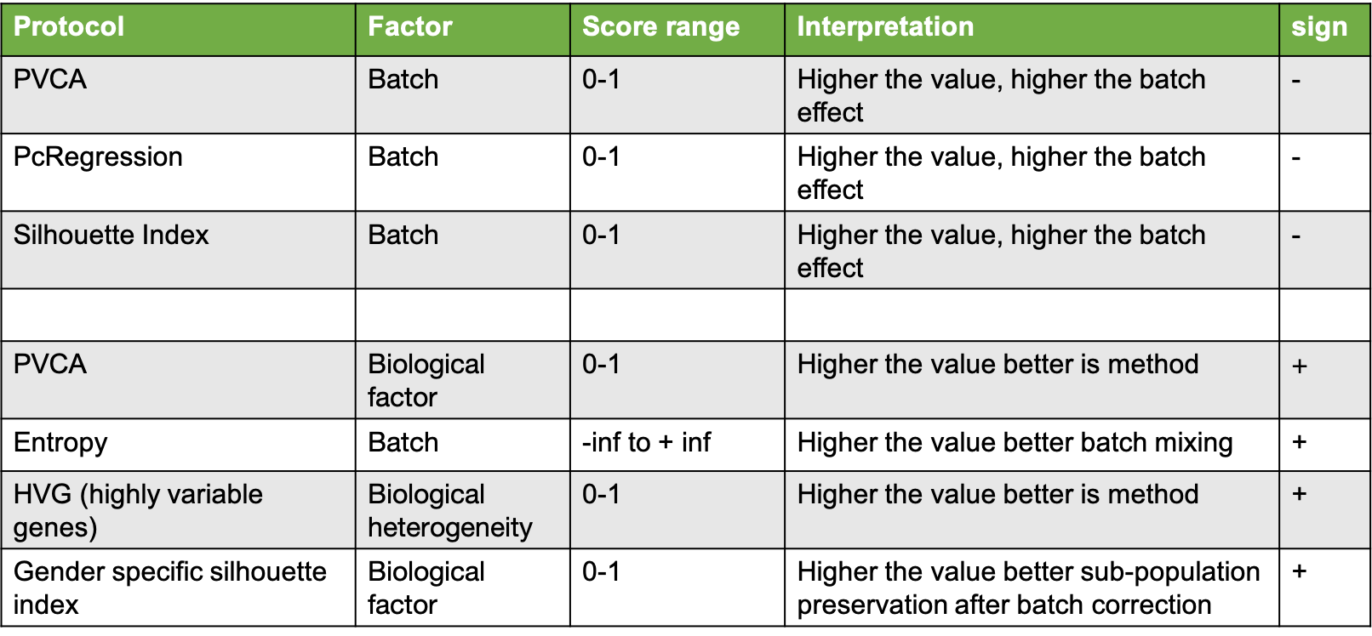

Result interpretation.

## Diagnostic plot

Once, assessment is done, in next step, results obtained from evaluation_matrix step can be further analyszed using Rank.plot function which performs ranking and plotting of evaluation matrix obtained at previous step. Here, methods are ranked on their individual performance and finally sumRank is final Rank of each method for the given input dataset. Rank 1 will be the best performer method.

This function has only one argument-

* evaluation is a evaluation list obtained from previous step evaluation_matrix.

final <- Rank.plot(assessment)

**final** is a list of two data-frame- (a) raw - simple data-frame output of evaluation matrix and, (b) ranked- Ranked data-frame of evaluation matrix which has additional column sumRank containing final Rank of each method. Ranks are in descending performance order, i.e. method having score 1 will be the best method. This function also output diagnostic plot, where x-axis is the evaluation methods and y-axis is the Rank of each normalization method.

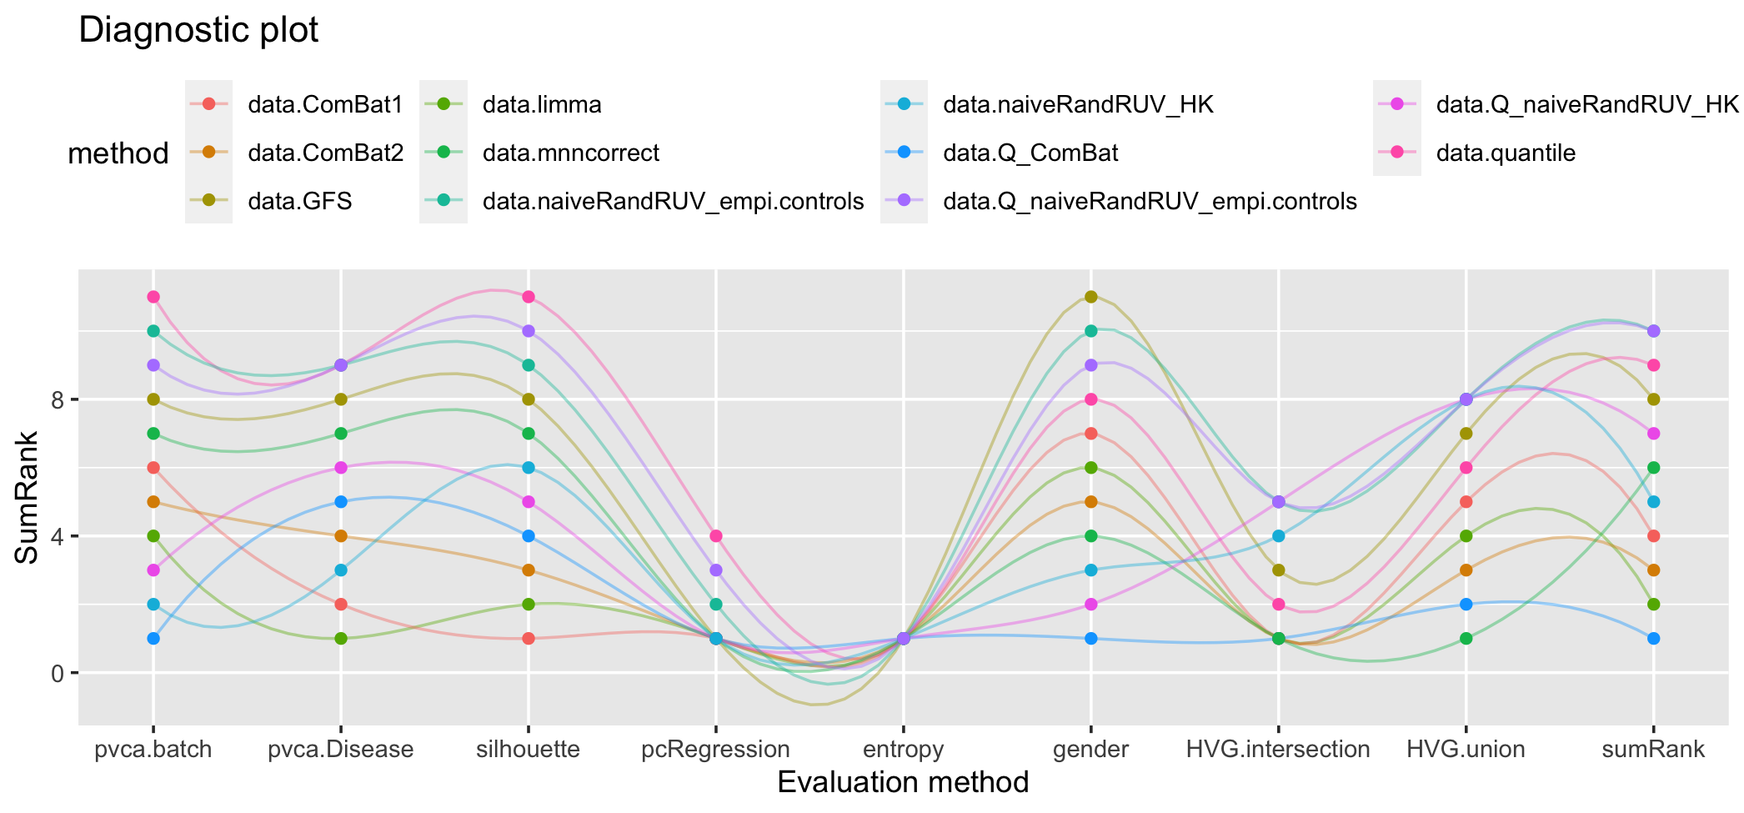

Diagnostic plot.

Result:

> final  
$raw  
 pvca.batch pvca.Disease silhouette pcRegression entropy gender HVG.intersection  
data.limma 3.182752e-10 0.09378949 -0.007928513 0.0000000 0 0.054923829 1.00000000  
data.GFS 2.847282e-02 0.03073336 0.085294013 0.0000000 0 -0.001681921 0.03947368  
data.quantile 9.994937e-01 0.00000000 0.743891878 0.8721174 0 0.019791930 0.35526316  
data.ComBat1 2.605892e-09 0.09262298 -0.008489088 0.0000000 0 0.050211019 1.00000000  
data.ComBat2 5.605465e-10 0.09087029 -0.007427614 0.0000000 0 0.054974163 1.00000000  
data.Q_ComBat 4.700739e-12 0.09074923 -0.004983807 0.0000000 0 0.132690922 1.00000000  
data.mnncorrect 1.490184e-02 0.08641440 0.072566372 0.0000000 0 0.106900826 1.00000000  
data.Q_naiveRandRUV_HK 2.636718e-10 0.08810802 -0.001986466 0.0000000 0 0.123477965 0.00000000  
data.naiveRandRUV_HK 5.259534e-11 0.09142561 0.003888988 0.0000000 0 0.113243768 0.01315789  
data.naiveRandRUV_empi.controls 9.994633e-01 0.00000000 0.680552340 0.8204334 0 0.018579751 0.00000000  
data.Q_naiveRandRUV_empi.controls 9.994511e-01 0.00000000 0.704169390 0.8687179 0 0.019300120 0.00000000  
 HVG.union  
data.limma 0.715801887  
data.GFS 0.040094340  
data.quantile 0.253537736  
data.ComBat1 0.666273585  
data.ComBat2 0.719339623  
data.Q_ComBat 0.734669811  
data.mnncorrect 0.791273585  
data.Q_naiveRandRUV_HK 0.001179245  
data.naiveRandRUV_HK 0.001179245  
data.naiveRandRUV_empi.controls 0.001179245  
data.Q_naiveRandRUV_empi.controls 0.001179245  
  
$ranked  
 pvca.batch pvca.Disease silhouette pcRegression entropy gender HVG.intersection HVG.union  
data.limma 4 1 2 1 1 6 1 4  
data.GFS 8 8 8 1 1 11 3 7  
data.quantile 11 9 11 4 1 8 2 6  
data.ComBat1 6 2 1 1 1 7 1 5  
data.ComBat2 5 4 3 1 1 5 1 3  
data.Q_ComBat 1 5 4 1 1 1 1 2  
data.mnncorrect 7 7 7 1 1 4 1 1  
data.Q_naiveRandRUV_HK 3 6 5 1 1 2 5 8  
data.naiveRandRUV_HK 2 3 6 1 1 3 4 8  
data.naiveRandRUV_empi.controls 10 9 9 2 1 10 5 8  
data.Q_naiveRandRUV_empi.controls 9 9 10 3 1 9 5 8  
 sumRank method  
data.limma 2 data.limma  
data.GFS 8 data.GFS  
data.quantile 9 data.quantile  
data.ComBat1 4 data.ComBat1  
data.ComBat2 3 data.ComBat2  
data.Q_ComBat 1 data.Q_ComBat  
data.mnncorrect 6 data.mnncorrect  
data.Q_naiveRandRUV_HK 7 data.Q_naiveRandRUV_HK  
data.naiveRandRUV_HK 5 data.naiveRandRUV_HK  
data.naiveRandRUV_empi.controls 10 data.naiveRandRUV_empi.controls  
data.Q_naiveRandRUV_empi.controls 10 data.Q_naiveRandRUV_empi.controls

# Accessory functions

## Detetction of batch-effects in raw merged dataset

This is a accessory function which perform subset of evaluation tests of evaluation_matrix function and provide estimates whether merged dataset obtained after ‘merge_experiments’ requires batch correction or not. Higher value of pvca.batch, silhouette, pcRegression and entropy is a direct indicative of batch-effects in raw merged dataset.

This function has following arguments-

* The result argument is a is the input merged dataset obtained from merge_experiments step.
* The batch.factors is a list of factors to perform PVCA analysis. Along with batch as factor, one biological factor which can be used to assess over-fitting should be provided. Providing more than one biological factor here, will create issue while plotting the results.
* The experiment argument is the again the same input merged dataset.
* The N1 is the number of randomly picked cells for BatchEntropy function.
* The N2 is the number of nearest neighbours of cell (from all batches) to check (for BatchEntropy function).
* The filter argument specify gene label for the given dataset. It Should be one of following string- ‘symbol’, ‘ensembl_gene_id’ or ‘entrezgene_id’ depending on gene label for the given dataset.

Assessment of batch-effect on raw merged data can be performed like this:

batch_effect.raw <- raw.evaluation(experiments,experiment = experiments, batch.factors=c("batch","Disease"),10,10,'symbol')  
Result <- do.call(rbind, lapply(batch_effect.raw, data.frame))

Result:

> Result  
 raw  
pvca.batch 0.9994122  
pvca.Disease 0.0000000  
silhouette 0.7406456  
pcRegression 0.9173469  
entropy 0.0000000