

\

# **“EBS”**

# **Ecommerce for Banking Sector Documentation**

# **Version: 0.1**

# **Date: 5/12/2024**

* **Prepared By:**

|  |  |
| --- | --- |
| **Names** | **Names** |
| **Ahmed Mohamed** | **Monica Atfy** |
| **Ahmed Mostafa** | **Nesma Gaber** |
| **Ahmed Sabry** | **Omnia Ahmed** |
| **Habiba Fouad** | **Pola George** |
| **Ibram Osama** | **Sara Ahmed** |
| **Mariam Bayoumy** | **Sherif Essam** |
| **Mariam Mahmoud** | **Shrouk Naser** |
| **Matthew Badry** | **Yahia Mohamed** |
| **Michael Ashraf** | **Yara Amr** |
| **Mohamed Hossam** |  |
| **Muharram Othman** |  |

Contents

**“EBS”** 1

**Ecommerce for Banking Sector Documentation** 1

**Version: 0.1** 1

**Date: 5/12/2024** 1

➢ Introduction 4

System Requirements 4

Architecture 4

**Modules Description** 4

Protoype 7

Use Cases 12

Development and Deployment 19

Security Considerations 19

Appendices 20

➢ **RESTful API** 20

➢ **MVC Architecture API** 20

# **Introduction**

* **E-Commerce for Banking Sector is a web application developed using Spring Boot for selling Dbanking products such as loans, cards, certifications and accounts for corporates and retails. The application is designed to provide a user-friendly platform for bank customers and supports various banking services. Designed to empower users with secure and convenient banking experiences, our application merges the reliability of traditional banking services with the accessibility and efficiency of e-commerce. This documentation covers a wide range of topics, including System Requirements, Architecture, Modules Description, Use Cases, Development and Deployment and Security Considerations.**

# **System Requirements**

* **The application requires a server with a minimum of 16 GB RAM and a quad-core CPU. The operating system should be Windows Server. We uses a MySQL database, Spring Security and Spring Boot.**

# **Architecture**

* **Bank e-commerce a commercial website that developed using Spring Boot 3.2.5. Its features several independent services such as User, Product and Category Management for serval customers (Retail or Corporate) for Admin and Serval Categories for Serval Product with Subscription system for every Customer , communicating via RESTful APIs and MVC Architecture.**

# **Modules Description**

* **The application is divided into several key modules:**

|  |  |
| --- | --- |
| **Modules** | **Description** |
| **User Management** | **Handles user registration, login, and profile management creation of serval account for every customer.** |
| **Product Management** | **Manages product listings, descriptions, categorizations, durations, and rate of benefit if it exists.** |
| **Category Management** | **Manages Category listings, descriptions, with different types of customers.** |
| **Subscription System** | **Subscription for some products for loan and certificates with choosing the account and amount of money.** |
| **Customer Management** | **Manages Customer with enabling to create customer and create account or several accounts for the same customer.** |

* **ERD diagram**

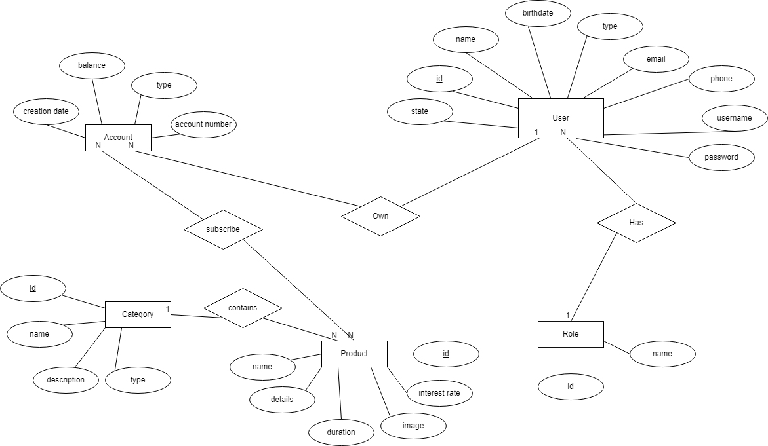

* **Schema Diagram**

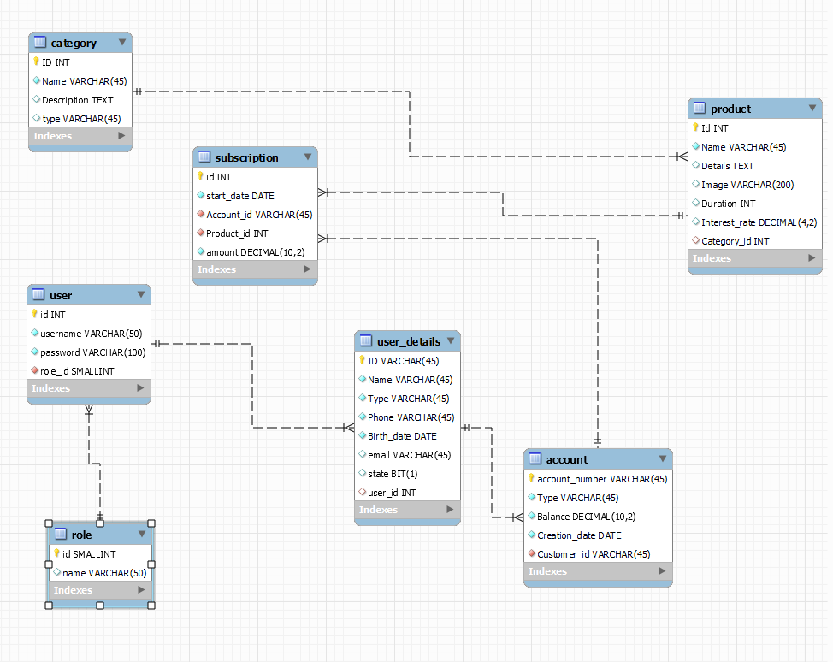

# **Protoype**

* **Admin (product management) :**

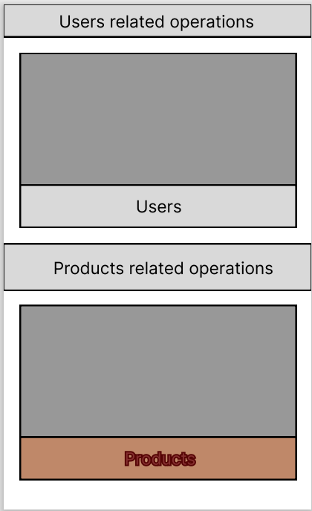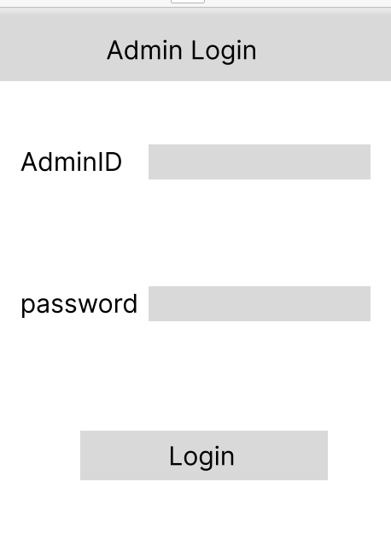

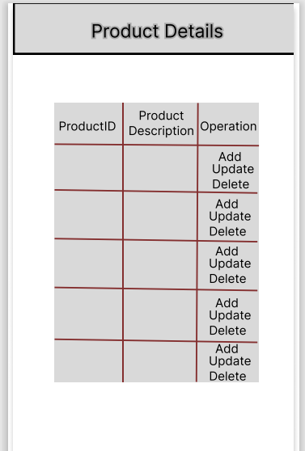

* **Admin (User management for existing customer) :**

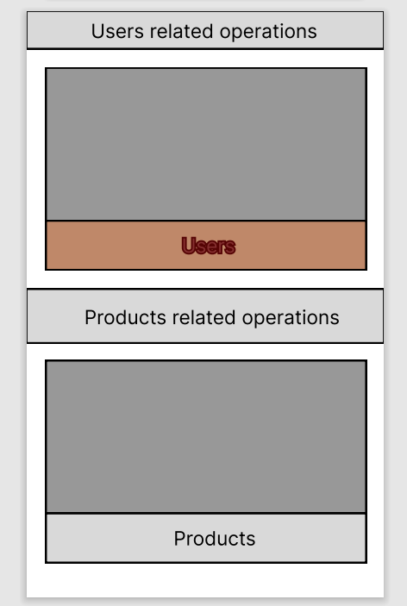

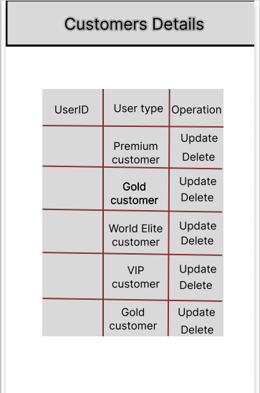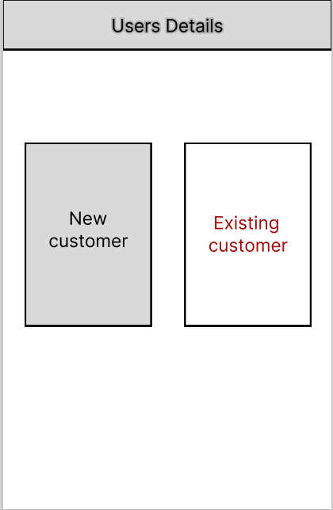

* **Admin (User management for new customer) :**



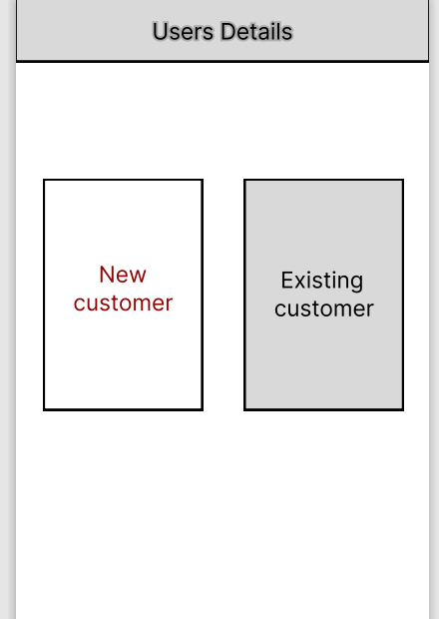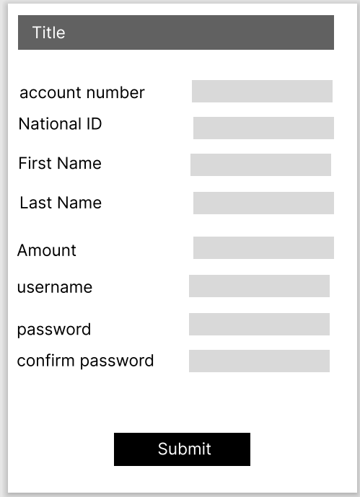

* **Customer (Login as Retail customer or Corporate) :**

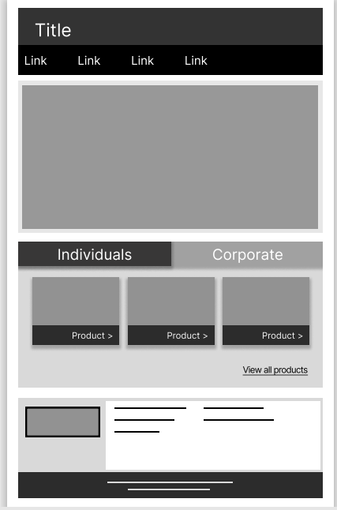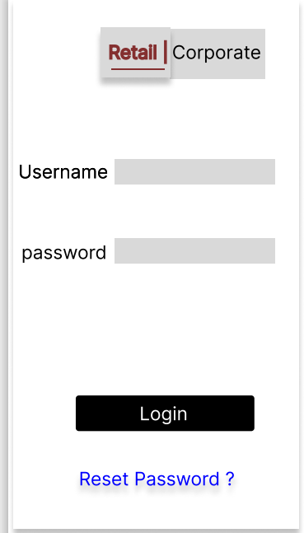

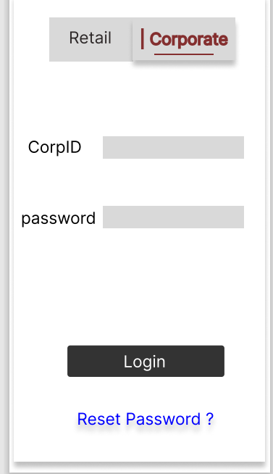

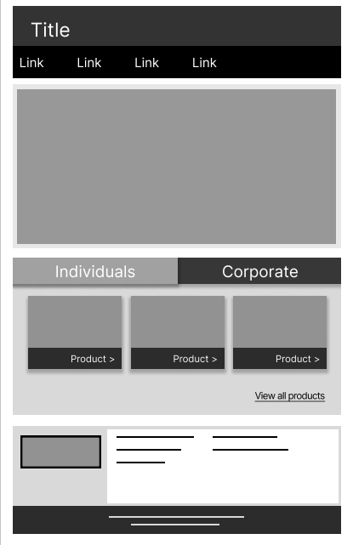

* **Customer (product showing) :**

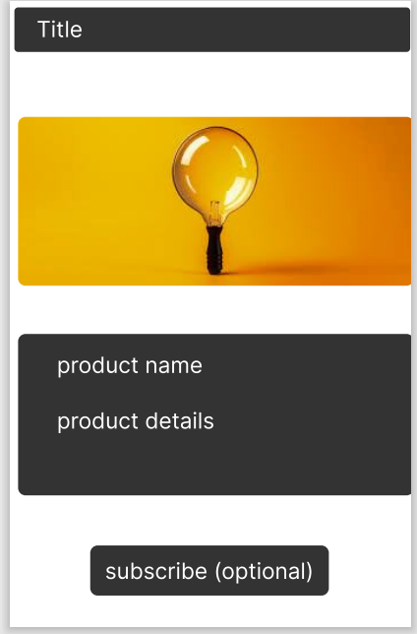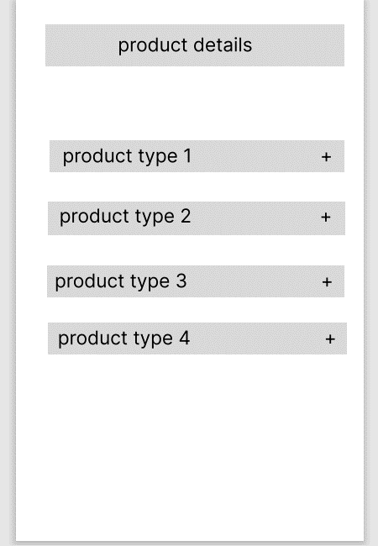

# **Use Cases**

* **Admin Diagram**

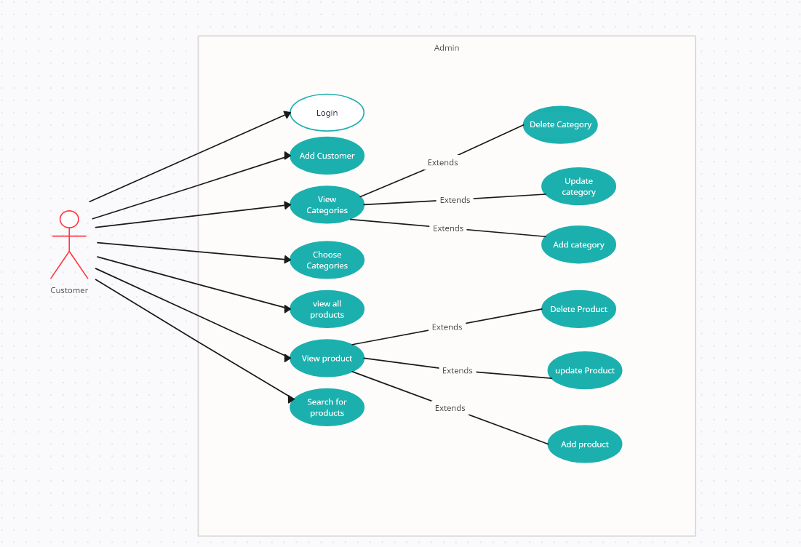

|  |  |
| --- | --- |
| **Title** | Login |
| **Primary Actor** | Admin |
| **Goal** | * The admin will log in to his account |
| **Preconditions** | -- |
| **Scenario** | |
| The admin will enter a valid username and password | |

|  |  |
| --- | --- |
| **Title** | Admin operations on categories |
| **Primary Actor** | Admin |
| **Goal** | Admin wants to add, update or delete category. |
| **Preconditions** | * The Admin must be logged in to their accounts * The Admin must be choose the categories section first. |
| **Scenario** | |
| The Admin after choosing categories section will see all categories and can do update, delete operations on each category or add a new one. | |

|  |  |
| --- | --- |
| **Title** | Operations on product |
| **Primary Actor** | Admin |
| **Goal** | Admin makes Crud operation on The Products. |
| **Preconditions** | * The Admin must be logged in to their accounts * The Admin must be choose the categories section first. |
| **Scenario** | |
| **1. Add product:**  - He will choose The Button "Add New Product" in the product list.  - Then, direct to the page "Add product" and then fill the forms with information.  - After that, click "add product".  2. **Update product:**  - He will choose The Button "update Product" in the product list (selected the product by id).  - Then, direct to the page "update product" that fills with product data selected and then update the data.  - After that, click "update product".  3. **Delete product:**  - He will choose The Button "delete Product" in the product list (selected the product by id).  - Then, he must confirm the delete operation.  - If yes, click "confirm delete".  - If want to take back on this step, click "cancel" | |

|  |  |
| --- | --- |
| **Title** | Add customer |
| **Primary Actor** | Admin |
| **Goal** | The admin create new account to customers |
| **Preconditions** | the customers must have bank account to have an account in the website |
| **Scenario** | |
| the admin create an account and assign username and password to the customer | |

* **User Diagram**

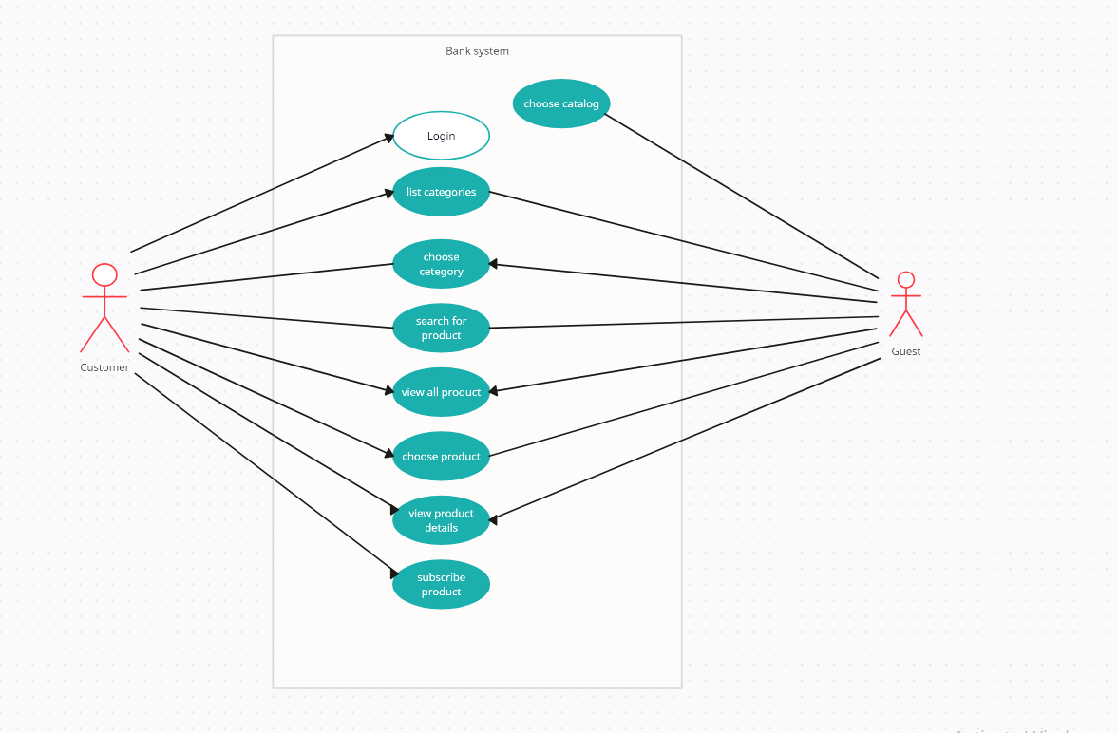

|  |  |
| --- | --- |
| **Title** | Open Homepage |
| **Primary Actor** | visitor |
| **Goal** | The visitor wants to browse the website |
| **Preconditions** | **--** |
| **Scenario** | |
| * The guest views the website. * The guest can choose either view the individual's product or the corporate products. * The guest can login. | |

|  |  |
| --- | --- |
| **Title** | Choose Category |
| **Primary Actor** | Guest |
| **Goal** | The guest wants to browse individual products or corporate products |
| **Preconditions** | the user must be open home page |
| **Scenario** | |
| * Users can choose between browsing as individuals or as companies. * Users can choose from three main categories: cards, accounts and certificates, and loans. * Each category contains specific types of products. * Users can explore the details of each product type within the selected category. | |

|  |  |
| --- | --- |
| **Title** | View the bank's list of products |
| **Primary Actor** | Individual or Corporate |
| **Goal** | As an individual or corporate you can view products like Cards, certificates & Accounts or loans |
| **Preconditions** | -- |
| **Scenario** | |
| * Individual or corporate navigates to the home page. * Depending on the type of user, the web site will display products like Cards, certificates & Accounts or loans. | |

|  |  |
| --- | --- |
| **Title** | The bank's products |
| **Primary Actor** | Individuals and Corporates |
| **Goal** | Individuals and Corporates would like to explore one of these banking products (cards, loans, accounts and certificates) |
| **Preconditions** | -- |
| **Scenario** | |
| - Individuals and Corporates navigates to home page.  -Depending on the type of user, the web site will display products (cards, loans, accounts and certificates)  - Individuals and companies can explore all products in detail | |

|  |  |
| --- | --- |
| **Title** | Login |
| **Primary Actor** | Customer |
| **Goal** | The customer wants to login to his account. |
| **Preconditions** | The user must open the home page first then choose to log in. |
| **Scenario** | |
| * The user must enter a valid username and correct password. * The password must has 8 characters contains letters and numbers and at least one uppercase and one special character. | |

|  |  |
| --- | --- |
| **Title** | Show product Details |
| **Primary Actor** | Individual or Corporate |
| **Goal** | As an individual or corporate he can view product details. |
| **Preconditions** | * User must have access to this product based on his category. * User can apply if only he is logged in. |
| **Scenario** | |
| * User must see what he is applying for, benefits and how to be qualified for it. * Apply button to apply for product. | |
| **Title** | Apply for Account products |
| **Primary Actor** | Individual or Corporate |
| **Goal** | * As an individual he can apply for Current, Saving or Pay-roll Account. * As a corporate he can apply for Current Account. |
| **Preconditions** | * User must see only suitable options listed according to his actor / Category. * User must log in to apply for product. * User can view product and navigate to product details screen without logging in. * User must be qualified to open desired account. |
| **Scenario** | |
| - User navigate to product form which contains product details and takes amount from user to open account. Then, show the yearly benefit rate for product and amount if exist.  - A confirmation page must appear with all details.  - After user confirms, pop up should appear with message: Account creation request has been sent for review you will receive SMS with confirmation in minutes on your phone. | |

|  |  |
| --- | --- |
| **Title** | Cards product |
| **Primary Actor** | Individual or Corporate |
| **Goal** | * As an individual he can apply for (Prepaid card, Debit card, or Credit Card). * As a corporate he can apply for (Prepaid card, Debit card, or Credit Card). |
| **Preconditions** | * User must see only suitable options listed according to his actor / Category. * User must log in to apply for product. * User must be qualified to open desired account. |
| **Scenario** | |
| - User navigate to product form which contains product details and takes amount from user to open account. Then, show the yearly benefit rate for product and amount if exist.  - A confirmation page must appear with all details.  - After user confirms, pop up should appear with message: Card request has been sent for review you will receive SMS with confirmation in minutes on your phone.  - Navigate user to category list page. | |

|  |  |
| --- | --- |
| **Title** | Certificate Product |
| **Primary Actor** | Individual or Corporate |
| **Goal** | * A customer as an individual wants to apply for a 1-, 3- or 5-years certificate. * A customer as a corporate wants to apply for a 3- or 5-years certificate. |
| **Preconditions** | * Customer must be logged in to their account. Customer must have a valid I-score. * Customer must select the desired type of certificate that he wants to apply. |
| **Scenario** | |
| The customer navigates to the certificate products page. The system displays the selected type of certificate and its details. The customer confirms his subscription for the suitable certificate by clicking on “apply” button. The system notifies the customer by sending him a confirmation message on phone or email. | |

# **Development and Deployment**

* **Development uses Git for version control and Intelij for coding and debugging. The application requires SpringBoot framework for building the backend services, MySQL for handling database and Spring Security for authentication and authorization.**

# **Security Considerations**

* **Authentication:**
* **This project employs a widely adopted industry standard for secure authorization.**
* **Ensure that handling authentication with username and password for any user (admin & customer) are securely transmitted over HTTPS to prevent interception by unauthorized parties.**
* **Implement proper token validation mechanisms to verify the authenticity and integrity of tokens received from clients.**
* **Token Handling:**
* **Using Cross-Site Request Forgery (CSRF) protection is implemented using CSRF tokens to prevent unauthorized actions initiated by malicious actors.**
* **Generate unique CSRF tokens for each user session and include them in forms or requests to validate the origin and integrity of incoming requests.**
* **Access Control: (Between: Admin & Customer)**
* **Enforce fine-grained access control policies based on user roles and permissions to restrict access to sensitive resources.**
* **Regularly audit and review access control configurations to identify and remediate any potential security vulnerabilities.**
* **Vulnerability Management:**
* **Stay informed about security validation for SQL injections.**
* **Promptly apply security patches and updates to mitigate the risk of known vulnerabilities.**

# **Appendices**

* + **RESTful API**
    - **Overview**
      * **This RESTful API provides endpoints for managing electronic items in an e-commerce platform. Developers can use this API to perform CRUD (Create, Read, Update, Delete) operations on electronic items.**
    - **Authentication**
      * **This API requires authentication using CSRF. Developers need to include the CSRF token in the Authorization header for protected endpoints.**

### **MVC Architecture API**

#### **Overview**

* + - * **This MVC architecture API provides endpoints for managing user accounts in an e-commerce platform. Developers can use this API to register new users, authenticate users, and manage user profiles and accounts, also managing products, and categories from creation, updating and deleting.**

#### **Dependencies**

* + - * **Spring Security**
      * **Spring Web**
      * **Lombok**
      * **Spring Data JPA**