Akili Risk
System Architecture Documentation
Executive overview for stakeholders
Prepared June 12, 2026
Version 1.0

Contents

1. Executive Summary
Akili Risk is a multi-tenant, white-label risk assessment platform that helps wealth advisors evaluate and report on the non-investment risks facing high-net-worth households. The platform serves three distinct audiences: end-clients who complete structured intake and assessments, advisors who review their clients’ results and deliver recommendations, and Akili platform staff who administer the service.
The defining architectural feature is the white-label tenant model. Each advisor firm operates from its own subdomain (for example, independent-wealth.akilirisk.com) with its own logo, brand colors, and firm name, while all tenants share a single application code base and database. This lets Akili roll out improvements once and have them available to every advisor immediately, without sacrificing each advisor’s ability to present an on-brand experience to their clients.
The system is built on Next.js 16 with TypeScript, deployed on Vercel, with a managed Neon Postgres database and a small set of best-in-class external services: Stripe for advisor billing, Resend for transactional email, AWS S3 for advisor branding assets, and OpenAI for AI-assisted scoring. This document describes how those pieces fit together at a level appropriate for executive and stakeholder review.

2. System Overview
At the highest level, every request from a client, advisor, or admin browser reaches Akili through Vercel’s edge network and is handled by the Next.js application. The application talks to a single Postgres database for all state, and to a handful of external services for specialized concerns (payments, email, file storage, AI). The diagram below shows the relationships.
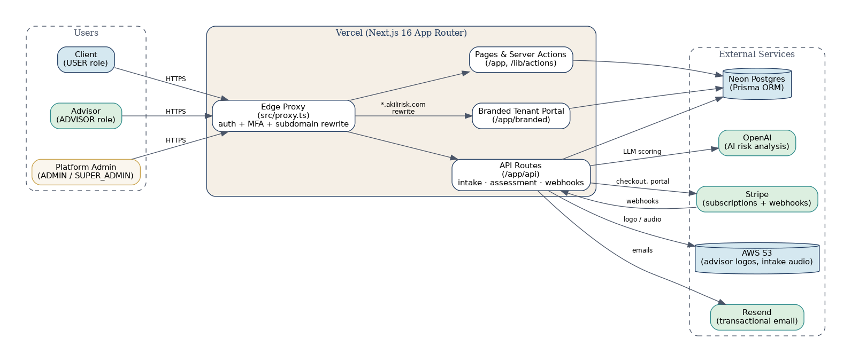
Figure 1: Akili Risk system overview — users, application, and external services.
The edge proxy (src/proxy.ts) is the first line of routing logic. It runs on every request, authenticates the session against the JSON Web Token issued by NextAuth, enforces the multi-factor authentication gate, and decides whether the request is for the main platform application or for an advisor-branded tenant portal. Server-rendered pages and server actions handle most user-facing interactions; a smaller set of REST-style API routes handle background tasks, webhooks from Stripe, and asynchronous jobs.

3. Technology Stack
Akili Risk is built on a modern, mainstream stack. Every component is either a hosted service (so Akili does not have to operate infrastructure) or a widely-used open-source library (so engineering talent is easy to hire). The table below summarizes the layers.
Layer | Technology
Frontend framework | Next.js 16 (App Router) with React 19
Language | TypeScript (strict mode)
Styling | Tailwind CSS 4 with shadcn/ui components
Server logic | Next.js Server Actions and route handlers
Database | PostgreSQL hosted on Neon, accessed via Prisma 7 ORM
Authentication | NextAuth (Auth.js v5) — credentials for staff, magic link for clients, optional TOTP MFA
Hosting | Vercel (single project, wildcard *.akilirisk.com)
Object storage | AWS S3 (advisor logos, intake audio)
Email | Resend (transactional notifications)
Payments | Stripe (advisor subscriptions, customer portal, webhooks)
AI services | OpenAI API (LLM-assisted scoring and analysis)
Testing | Vitest (unit) and Playwright (end-to-end against preview.akilirisk.com)

4. Multi-Tenant White-Label Architecture
Every advisor firm in Akili Risk is modeled as a tenant. In the data model, the tenant is represented by an AdvisorProfile record attached to the firm’s primary user account. The AdvisorProfile stores branding (firm name, brand name, tagline, logo URL, primary and secondary colors, support contact details) and a related AdvisorSubdomain record stores the firm’s unique subdomain label.
When an advisor signs up, claims a subdomain, and Akili verifies the DNS and SSL provisioning, the advisor’s clients can be invited to a tenant-branded URL such as independent-wealth.akilirisk.com. From that URL the platform feels like the advisor’s own product: the logo, colors, and firm name replace the default Akili lockup throughout the client experience.
Mechanically, the routing is handled at the edge. The diagram below shows the path a tenant-subdomain request takes from the browser to the rendered page.
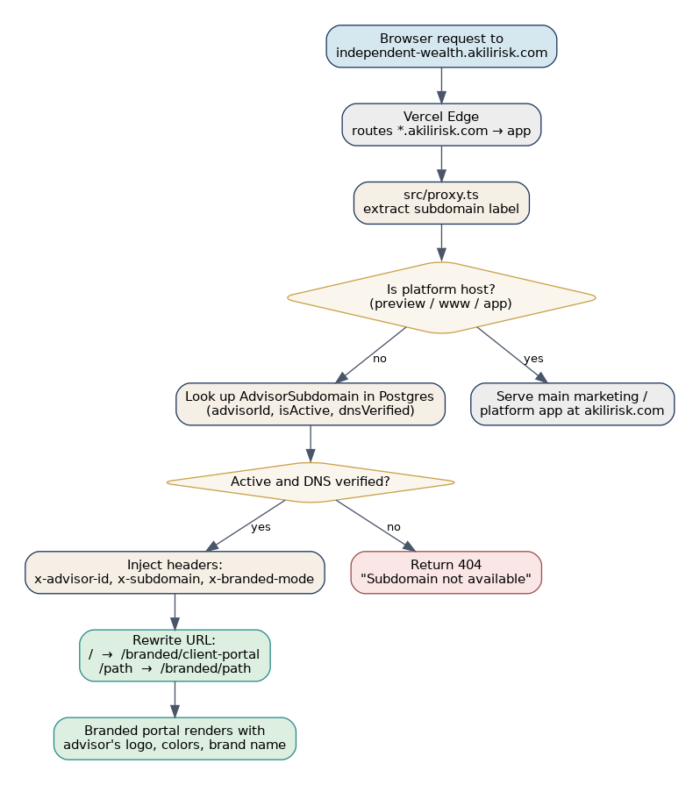
Figure 2: Subdomain routing flow — how tenant requests are resolved and branded.
Two safeguards are important to note. First, platform-reserved subdomains (preview, www, app, and a configurable list) are never treated as tenant requests, so internal hosts cannot be hijacked. Second, the proxy strips any incoming x-advisor-id, x-subdomain, and x-branded-mode headers before forwarding a non-subdomain request — those headers are only set by the proxy after a successful AdvisorSubdomain lookup, so a malicious caller cannot impersonate a tenant by sending them directly.

5. User Roles and Access Model
Akili Risk uses a small, explicit role enum that drives both UI and server-side authorization. The same auth helpers (requireAdminRole, requireSuperAdminRole, etc.) are used in server actions, API routes, and middleware, so authorization rules are not duplicated.
Role | Enum value | What they can do
Client | USER | Sign in with magic link, complete intake interview, take assessment, view personal results and recommendations, manage personal settings.
Advisor | ADVISOR | Sign in with credentials, manage clients in the Pipeline view, review intake transcripts, approve/return intake submissions, review scores and recommendations, configure firm branding and subdomain, manage their Stripe subscription.
Platform Admin | ADMIN | Manage advisors, clients, assessment content, and platform-wide settings via the /admin console; access audit logs.
Super Admin | SUPER_ADMIN | All Admin powers plus feature flags, risk thresholds, password policy, and other platform-wide controls (requireSuperAdminRole helper).
A client (USER role) is always associated with one or more advisors via a ClientAdvisorAssignment record. Tenant isolation is enforced in every advisor-facing query by joining through this assignment table — an advisor never sees a client that is not explicitly assigned to them. This rule is applied uniformly in server actions and API routes, not left to UI filtering.

6. Core Data Model
The Prisma schema defines more than fifty entities, but ten of them carry the conceptual weight of the system. The diagram below shows those entities and the relationships between them. Field lists are abbreviated to keep the picture readable.
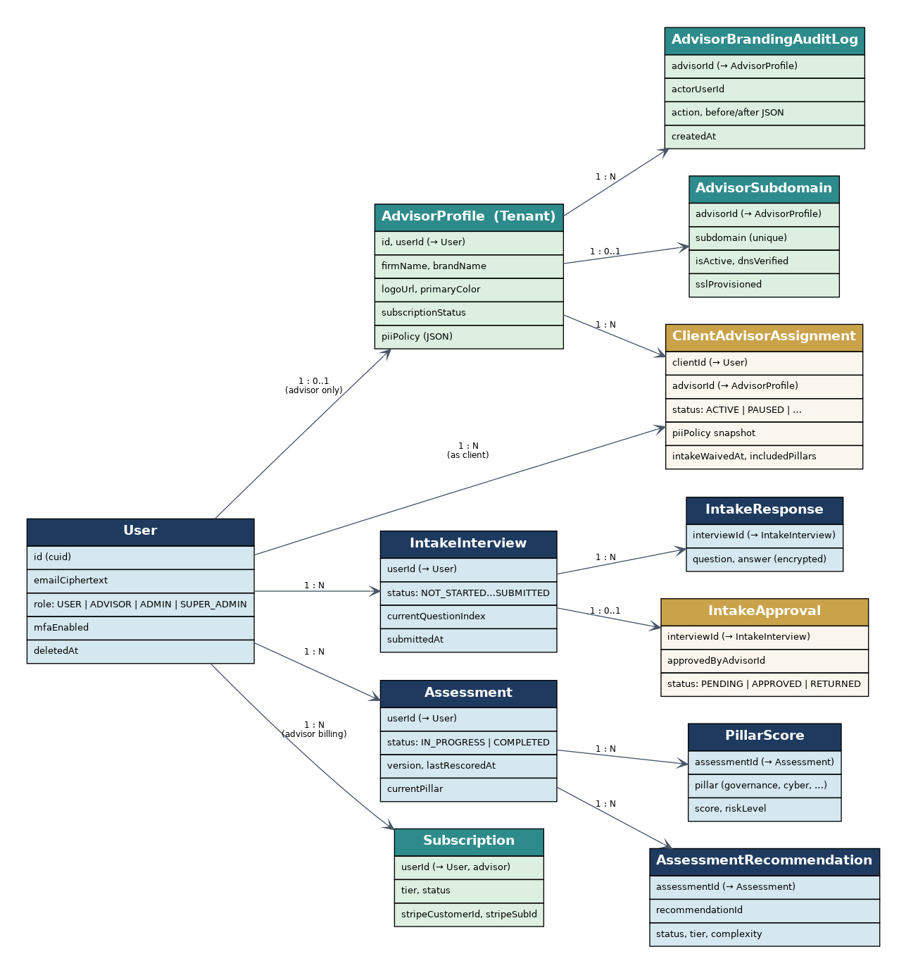
Figure 3: Core data model — abbreviated entity-relationship diagram.

Key entities at a glance
- User — every human in the system (client, advisor, or admin). The role enum determines what they can do. Email is stored as deterministic ciphertext for privacy-preserving lookup.
- AdvisorProfile — the tenant. One per advisor firm, holding branding, firm metadata, and the firm-level PII visibility policy.
- AdvisorSubdomain — the white-label DNS record for a tenant. Tracks isActive, dnsVerified, and sslProvisioned.
- ClientAdvisorAssignment — the link between a client and an advisor. Carries the per-assignment PII visibility snapshot, assessment scope, and any intake waiver.
- IntakeInterview / IntakeResponse / IntakeApproval — the client’s structured onboarding conversation and the advisor’s approval of it.
- Assessment / PillarScore / AssessmentRecommendation — the scored output. Pillars currently include Governance, Cyber, Physical, Reputational/Social, Family, and others defined in PillarCategory.
- AdvisorBrandingAuditLog and AuditLog — append-only records of who changed what and when, used for compliance review.
- Subscription — the advisor’s billing relationship with Stripe, reconciled by webhook.

7. Key User Flows
Three flows drive the bulk of activity in the system: client intake, advisor review, and (transparent to the user) the subdomain branded portal that wraps all client interactions for tenant firms.

7.1 Client intake and advisor review
The intake-to-recommendation cycle is the platform’s core value loop. The swimlane below shows the round-trip across the client, the platform, and the advisor.
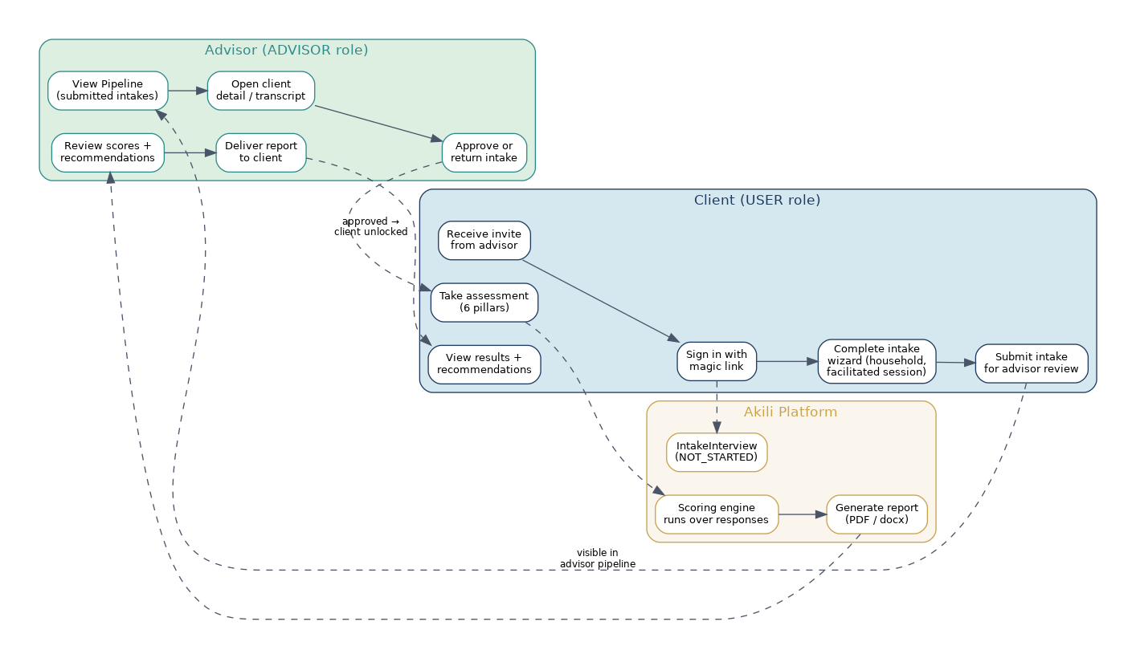
Figure 4: Client intake and advisor review swimlane.
The state of the IntakeInterview record moves through NOT_STARTED, IN_PROGRESS, and SUBMITTED. Only a SUBMITTED interview becomes visible in the advisor’s pipeline. Approval unlocks the Assessment for the client; the scoring engine then runs over the responses and produces PillarScore and AssessmentRecommendation rows, which the advisor reviews before delivering a final report.

7.2 Subdomain branded portal
When a client visits the tenant subdomain, the edge proxy resolves the AdvisorProfile and rewrites the request into the /branded/* tree. Layouts under /app/branded read the x-advisor-id header that the proxy injected and pull the correct logo, color palette, and brand name. This means the same client features (dashboard, intake, assessment, results) render with the advisor’s identity automatically — no per-tenant code paths.

7.3 Advisor onboarding and billing
A new advisor signs up with an invite code, completes profile and branding, claims a subdomain label, and selects a Stripe subscription tier. The Vercel deployment serves wildcard DNS, so once the AdvisorSubdomain is marked active and DNS-verified the tenant URL is immediately live. Stripe webhooks keep the local Subscription row in sync; advisors without an active subscription are routed to /advisor/billing rather than into the workspace.

8. External Integrations
Akili Risk relies on a deliberately small set of external services. Each is a market leader in its niche and exposes a well-documented API, which keeps integration code small and replaceable.
Service | Direction | Purpose in Akili Risk
Neon Postgres | Inbound | Primary data store — every entity in the schema. Accessed exclusively through the Prisma client (src/lib/db.ts).
AWS S3 | Outbound | Advisor logos and intake audio. Signed URLs are generated server-side; clients never get raw bucket access.
Stripe | Bidirectional | Advisor subscriptions, customer portal links, and webhook-driven reconciliation (StripeWebhookEvent table for idempotency).
Resend | Outbound | Magic-link sign-in emails, invitations, advisor notifications, report-ready emails.
OpenAI | Outbound | LLM calls for assisted scoring, intake transcription cleanup, and recommendation generation.
Vercel | Hosting / DNS | Application hosting and wildcard DNS for *.akilirisk.com. Preview branch is deployed at preview.akilirisk.com.

9. Security and Multi-Tenant Isolation
Because every tenant’s data lives in the same Postgres database, isolation is enforced in code rather than at the infrastructure layer. Several overlapping controls keep tenants separated and the platform auditable.

Authentication
Sessions are issued by NextAuth (Auth.js v5) and stored as JWTs with a 30-day lifetime. Clients sign in with single-use magic links delivered by Resend; advisors and admins sign in with email and password through the credentials provider. Two-factor authentication is supported via TOTP and can be required at the platform-policy level for any role.

Authorization
All workspace routes pass through an edge proxy that checks the session, the MFA state, and any pending password-change requirement before forwarding the request. Server actions and API handlers re-check the role against the operation — requireAdminRole and requireSuperAdminRole helpers raise on mismatch, so a missing check is loud rather than silent.

Tenant isolation
Every advisor-facing query that touches client data joins through ClientAdvisorAssignment. The ADVISOR role itself does not authorize access to any specific client; the assignment row does. The per-assignment piiPolicy snapshot additionally limits which PII fields a given advisor can see for a given client — two advisors assigned to the same client may have different visibility.

Audit trail
Sensitive actions are recorded in AuditLog and AdvisorBrandingAuditLog. Branding edits (logo, colors, brand name) carry before/after snapshots so that any visible change to a client-facing tenant can be traced to the actor and the time. The Stripe webhook log (StripeWebhookEvent) records every received event for idempotent reconciliation.

Data protection
User email addresses are stored as deterministic AES-256-GCM ciphertext, with helper functions encapsulating read and write. Passwords are bcrypt hashes. Logos and audio are stored in S3 and reached only through server-issued signed URLs.

10. Deployment and Environments
Akili Risk runs on Vercel as a single project. Two environments are configured today:
- Preview / staging — the staging Git branch deploys to preview.akilirisk.com. Tenant URLs in this environment use the suffix -staging (for example, independent-wealth-staging.akilirisk.com), driven by the TENANT_SUBDOMAIN_SUFFIX environment variable. Subdomains auto-activate to make end-to-end testing fast.
- Production — deploys to the apex domain akilirisk.com. Tenants live at {slug}.akilirisk.com with no suffix. Subdomain activation requires verified DNS and SSL.
Wildcard DNS for *.akilirisk.com is configured in Vercel and points at one environment at a time. Database migrations are managed by Prisma Migrate and applied during deploy via prisma migrate deploy. Seed scripts (npm run seed:pillar-ddl, scripts/seed-advisor-test-data.js, and others) populate test data in non-production environments.
End-to-end tests run via Playwright against the preview environment. Vitest unit tests run in CI on every pull request. ESLint and the TypeScript strict compiler are part of the same pipeline, so type or lint regressions cannot reach production.

Summary
Akili Risk is a focused, modern stack: a single Next.js application, a single managed Postgres database, a small set of best-in-class external services, and a multi-tenant model that lets every advisor present their own brand without operational overhead. The platform is designed for incremental change — every layer is replaceable independently, and every tenant-visible change is auditable.

