Akili Risk
Infrastructure Documentation
Operations & support runbook
Prepared June 12, 2026
Version 1.0
Audience: ops, support, and stakeholders

Contents

How to use this document
This runbook is for the people who keep Akili Risk running day to day: the operations and support team, the engineering on-call, and the stakeholders responsible for vendor relationships and budget. It is meant to be read end-to-end once, and then used as a reference.
The procedures below are grounded in the code and configuration that exist in the repository today. Where a procedure depends on a fact that cannot be derived from the code — for example the on-call rotation, the customer support email address, or the contractual SLA with a vendor — the document uses a placeholder so that the gap is visible rather than hidden.
Look for [TBD — …] markers throughout the document. Each one calls out a piece of information the team needs to decide on and fill in before this runbook can be used in earnest. The Vendor Contact Information and Customer Support sections in particular have several of these placeholders.
Production-environment notes deserve a particular call-out. At the time of writing, Akili Risk runs only the Preview environment on Vercel (the staging branch deployed to preview.akilirisk.com and tenant hosts at slug-staging.akilirisk.com). The wildcard *.akilirisk.com is attached to Preview. Procedures that would differ in a Production environment are labelled with a note describing what the team will need to add at launch.
This document is a companion to Akili_Risk_Architecture.docx, which describes the system as designed. Where the architecture document answers "how is it built," this one answers "how is it operated, restored, and supported."

1. Deployment Procedures
Akili Risk is deployed on Vercel as a single Next.js project. The repository's staging branch is the deploy-from branch for the Preview environment, and Vercel builds and publishes a new deployment every time staging is updated. There is currently no separate Production environment standing; this section describes the Preview-only workflow in use today, and the additional steps that will apply when a Production environment is added.

1.1 Environments
The platform recognizes three deployment scopes at the Vercel project level: Development (local), Preview, and Production. Only the Preview scope is live.
Scope | Vercel branch | Platform host | Tenant hosts | Status
Development | (local checkout) | http://localhost:3000 | n/a (suffix not applied) | In use for engineering
Preview | staging | preview.akilirisk.com | {slug}-staging.akilirisk.com | In use (current default)
Production | main (planned) | www.akilirisk.com (planned) | {slug}.akilirisk.com (planned) | Not yet stood up
The apex domain akilirisk.com sits on Vercel-managed nameservers. DNS records for the platform host (preview.akilirisk.com today, www.akilirisk.com at launch) and the tenant wildcard *.akilirisk.com are configured in the Vercel Domains panel. Per the team's white-label runbook, the wildcard is attached to one environment at a time — Preview today, to be moved to Production at launch — so that staging deployments do not accidentally serve production tenant traffic.

1.2 Deployment Flow
A normal feature deployment follows the path below.
- An engineer creates a feature branch off of staging and pushes it to GitHub.
- A pull request is opened against the staging branch. The PR is reviewed and CI is allowed to run.
- Once approved and green, the PR is merged into staging.
- Vercel detects the staging push and triggers a build. The build runs npm install (which fires the postinstall prisma generate hook), next build, and then injects environment variables scoped to the Preview environment.
- On a successful build, Vercel aliases the resulting deployment to preview.akilirisk.com. Tenant hosts under the wildcard see the same build immediately.
- If the deployment fails, Vercel leaves the previous deployment aliased and the operator is notified through the Vercel dashboard and the team's [TBD — Slack/email integration].
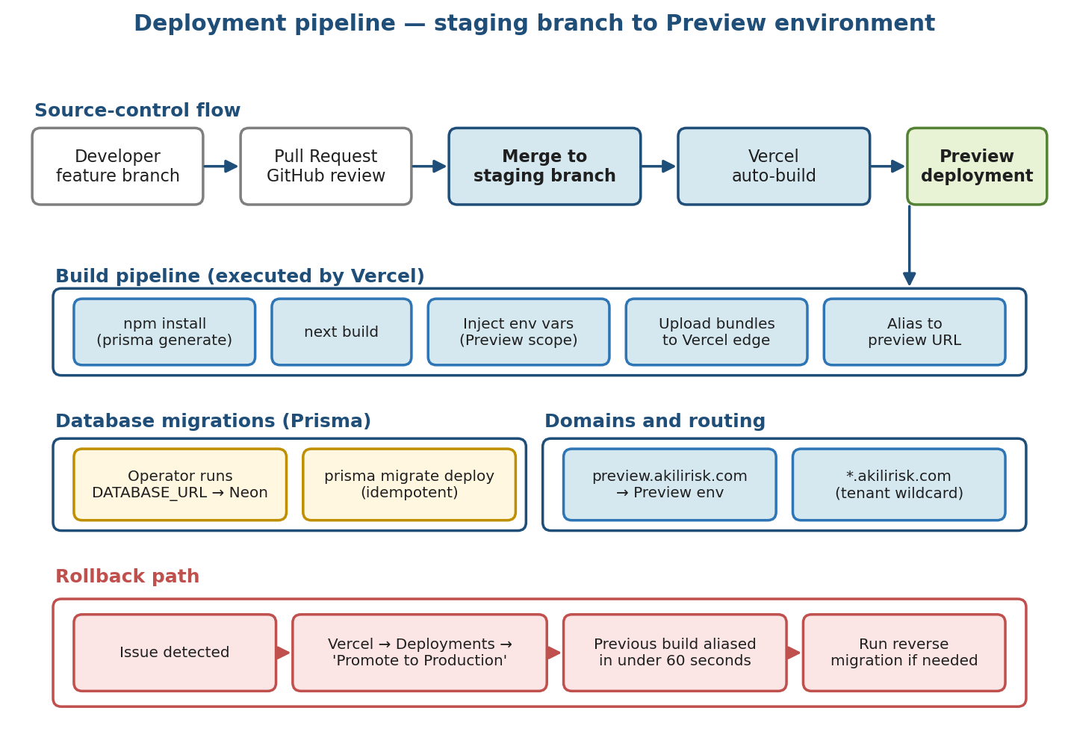
Figure 1: Deployment pipeline from a developer branch through Preview rollout, with the rollback path called out.

1.3 Manual Production Deploy
There is no Production environment configured at the moment, so there is no manual production deploy to run. The following procedure is what the team will adopt when Production is stood up.
- Open the Vercel project, switch to the Deployments tab, and filter to deployments built from the main branch (or whichever branch is designated as the Production source).
- Select the candidate deployment — the build that has been validated on Preview — and use the "Promote to Production" action.
- Confirm that the Production environment variables are present and correct. Stripe, Resend, and Auth secrets are scoped to Production separately from Preview.
- Watch the Vercel build and runtime logs for the first few minutes after the promote completes, and verify the platform host (www.akilirisk.com) and at least one tenant host with a hand-curated smoke test.
Until Production is configured, treat every staging push as the production change. Document the change with a short release note in [TBD — release notes location] so support knows what to expect.

1.4 Database Migrations
Schema changes are managed with Prisma migrations under /prisma/migrations. There are currently about thirty applied migrations covering the platform settings, the assessment question bank, the multi-tenant subdomain model, the Stripe billing tables, the audit log, and the magic-link tokens. Migration order matters; some replays are guarded with idempotent SQL because Neon's transactional DDL has historically failed mid-replay on a couple of the larger migrations.
Migrations do not run automatically during a Vercel build. The operator runs them from a workstation that has DATABASE_URL set to the target database. The standard sequence is:
- Pull the latest staging branch onto the workstation.
- Run prisma migrate deploy. This applies any new migration files in order, skipping ones already recorded in _prisma_migrations.
- If prisma migrate deploy fails with P3009 on 20260410000001_cybersecurity_assessment_bank, run npm run db:fix-cyber-migration to mark it rolled back and re-run.
- If it fails with P3018 on 20260410180000_enhanced_assessment_engine because a type already exists, run npm run db:fix-enhanced-migration — that migration is idempotent and safe to replay.
- Verify with a quick query against the _prisma_migrations table to confirm the new migration row landed.
After migrations, run npm run seed:pillar-ddl from the same workstation to refresh the categories / sections / questions tables from the Belvedere workbook. This is mandatory after any pillar-table migration; the assessment surface raises an error if the pillar bank is empty.

1.5 Environment Variables and Secret Management
All runtime secrets and configuration live in Vercel's Project Settings → Environment Variables panel, scoped by environment (Development, Preview, Production). The full inventory is documented in .env.example at the repository root; the table below lists the ones the operator should expect to see filled in for the Preview environment.
Category | Variable | Purpose
Database | DATABASE_URL | Postgres connection to the Neon-hosted database (sslmode=verify-full).
Authentication | AUTH_SECRET | NextAuth signing secret (32 bytes, base64).
Authentication | AUTH_URL, NEXT_PUBLIC_URL, NEXTAUTH_URL | Public origin used to build links in outbound email.
Encryption | ENCRYPTION_KEY | Application-level encryption for MFA secrets and PII columns.
Email | RESEND_API_KEY, FROM_EMAIL | Outbound transactional email via Resend.
Captcha | TURNSTILE_SECRET_KEY, NEXT_PUBLIC_TURNSTILE_SITE_KEY | Cloudflare Turnstile for the public contact form.
AI | OPENAI_API_KEY | OpenAI API key used for transcription, TTS, and AI-assisted scoring.
Object storage | AWS_ACCESS_KEY_ID, AWS_SECRET_ACCESS_KEY, AWS_REGION | IAM credentials for the Akili AWS account; region pinned to us-east-2.
Object storage | S3_BRANDING_BUCKET, S3_INTAKE_BUCKET, S3_BUCKET_NAME | Bucket names for advisor logos, intake audio, and client documents.
Billing | STRIPE_SECRET_KEY, NEXT_PUBLIC_STRIPE_PUBLISHABLE_KEY, STRIPE_WEBHOOK_SECRET | Stripe API keys and webhook signing secret.
Billing | STRIPE_PRICE_* (six recurring price IDs) | Stripe Price IDs for Starter, Growth, and Professional, monthly and annual.
White-label | PRODUCTION_DOMAIN, TENANT_SUBDOMAIN_SUFFIX, SUBDOMAIN_AUTO_ACTIVATE | Multi-tenant routing configuration.
Cron | CRON_SECRET | Bearer token for the five Vercel-scheduled cron routes.
Audit log | AUDIT_LOG_RETENTION_DAYS | Days of audit log history retained (default 365).
Two repo-local helper scripts pull these values back down for local development: npm run env:vercel:preview and npm run env:vercel:production. Use the helper that matches the environment the engineer is debugging. Both scripts write to .env.local and should never be committed.
Secret rotation is covered in section 6.5. As a general rule, never paste production secrets into chat tools, screenshots, or tickets — promote them to Vercel directly and let the rest of the team pull them down with the helpers.

1.6 Subdomain Provisioning
A new tenant (advisor firm) needs three things to be reachable at its branded host: a Vercel project domain binding, an AdvisorSubdomain row in the database, and DNS resolution through the wildcard.
- DNS resolution is already in place for any *.akilirisk.com host through the Vercel-managed wildcard, so there is no per-tenant DNS work to do.
- The advisor claims a slug from Settings → Custom Domain. The /api/advisor/subdomain/claim handler validates the label, writes an AdvisorSubdomain row with the requested slug, and (when SUBDOMAIN_AUTO_ACTIVATE is true, which is the default on Preview) sets isActive and dnsVerified to true. The row is audited in AdvisorBrandingAuditLog.
- If SUBDOMAIN_AUTO_ACTIVATE is false (which is the safer default to choose at production launch), an operator needs to set isActive and dnsVerified to true in the AdvisorSubdomain table after a manual smoke test confirms the host loads correctly.
- Verify by visiting https://{slug}-staging.akilirisk.com on Preview, or https://{slug}.akilirisk.com on Production once the wildcard is moved. A successful response carries the x-matched-path: /branded/client-portal header.
Reserved labels — preview, www, app, api, admin, and the configurable PLATFORM_SUBDOMAIN_LABELS list — cannot be claimed by an advisor. The seed script seed-platform-reserved-subdomains.js mirrors these into the ReservedSubdomains table as a belt-and-braces enforcement.

1.7 Rollback
Rollback on Vercel is a single action and is the first response to any deployment-introduced regression. The team uses the Vercel "Promote" action to alias a previous, known-good deployment back to the live host.
- Identify the regression and confirm it ships with the most recent deployment by comparing against the previous build's logs.
- In the Vercel dashboard, open Deployments, find the last known-good build (typically the one immediately preceding), and choose Promote → to the affected environment (Preview today).
- Watch the dashboard for the alias change to complete. This is normally under a minute.
- If the broken deployment ran a database migration, the rollback does not revert that migration. Determine whether the migration is forward-compatible with the prior application build. If it is not, prepare a reverse migration (typically a hand-authored SQL script) and apply it from the operator workstation before declaring the incident closed.
- Inform the team and customer-facing channels per section 3.5.
Vercel retains deployment artifacts indefinitely for the project, so older deployments remain promote-able. However, environment variable changes are not snapshotted with a deployment, so a rollback to a build that depended on a now-removed variable will fail to boot. When rotating secrets or removing variables, give a one-week soak window before pruning the old variable from Vercel.

2. Recovery Procedures
Recovery procedures describe how to restore the platform to a working state after an event has impaired it: a bad deployment, a database mishap, lost object storage, or a tenant-scoped data problem. Each scenario has its own playbook because the underlying mechanics — and the trade-offs involved — are different.
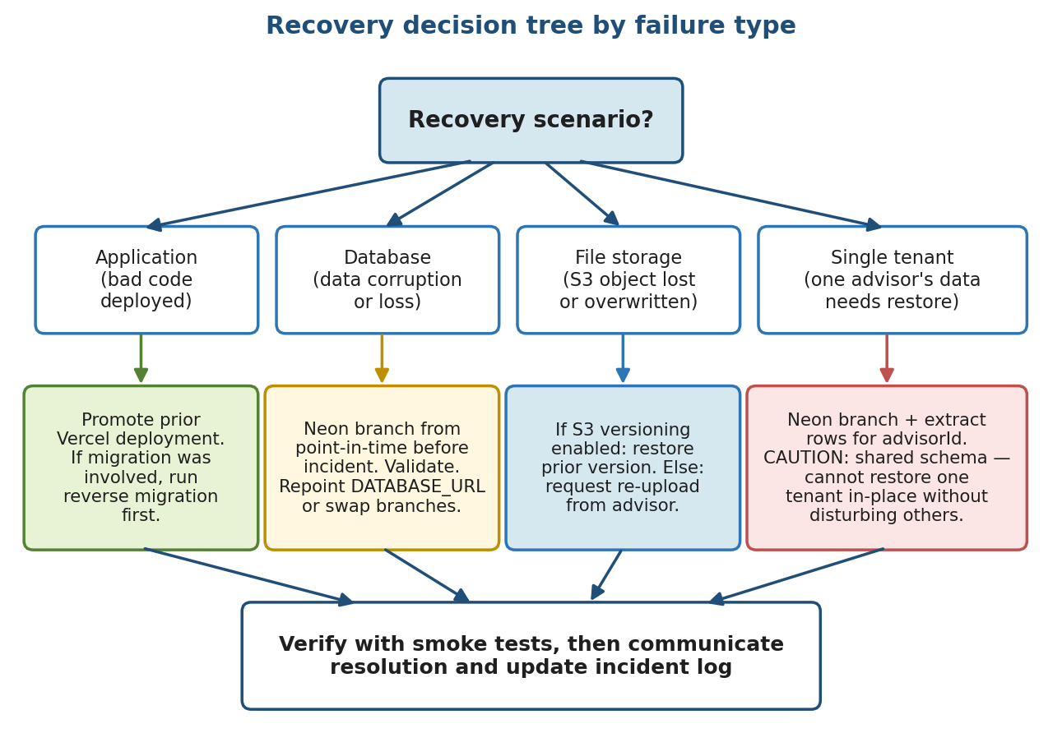
Figure 2: Recovery decision tree by failure type.

2.1 Database Recovery (Neon)
Akili Risk uses Neon as its hosted Postgres provider. Neon offers three complementary recovery mechanisms: branches, point-in-time restore, and snapshots. Each is appropriate for a different class of incident.
- Branching. Neon branches are copy-on-write clones of a database at a point in time. For investigation — "did this row exist yesterday afternoon?" — the operator creates a branch from the relevant timestamp, points a temporary DATABASE_URL at it, and queries without disturbing production.
- Point-in-time recovery (PITR). Neon retains write-ahead log history for the length of the project's plan-defined retention window. To roll the live database back to a specific moment, create a branch at that timestamp, validate the data, and then promote the branch (or repoint the application's DATABASE_URL at it).
- Snapshots. On Neon's paid plans, snapshots provide a longer-retention, manually triggered backup. Snapshots are appropriate before high-risk schema migrations and before bulk imports such as the Belvedere workbook seed.
The standing direction is to take a Neon snapshot immediately before any prisma migrate deploy that touches a table containing customer data, and to verify in the Neon console that the snapshot completed before proceeding. The retention window of write-ahead-log history is [TBD — confirm with current Neon plan]; until that is documented, treat PITR as available only for the last seven days.

2.2 File Storage Recovery (AWS S3)
Object storage lives in three S3 buckets in the us-east-2 region: S3_BRANDING_BUCKET (advisor logos and brand assets), S3_INTAKE_BUCKET (intake voice-response audio), and S3_BUCKET_NAME (client document collection; in the current Preview setup this overlaps with the branding bucket). All three are accessed with the IAM credentials configured under the Akili AWS account (profile ebilly / buddy@ebilly.com).
Recovery from a lost or overwritten S3 object depends on whether bucket versioning is enabled.
- If versioning is enabled, the prior version of the object is still in the bucket. Use the S3 console or aws s3api list-object-versions to find the version ID, then GET that version and write it back. No coordination with the advisor is required.
- If versioning is not enabled — or if the object predates versioning — the object cannot be recovered from S3 alone. Contact the advisor and request a re-upload. For intake audio specifically, the originating client may need to re-record.
[TBD — confirm versioning status on each bucket and turn it on where it is off.] The team should also confirm whether S3 server-side encryption is using SSE-S3 (the AWS default) or SSE-KMS with the customer-managed key documented in docs/operations/s3-sse-kms.md. Recovery procedure is the same either way, but a disabled KMS key fails-closed on all reads and is itself a recovery scenario.

2.3 Application Recovery
Application-level failures — wedged servers, a runtime error in a freshly deployed build, a configuration regression — are resolved by Vercel rollback as described in section 1.7. The key principle is to roll back first and investigate second: a known-good deployment is a single click away, and there is no benefit to debugging a broken build in production while users wait.
If the issue is not deployment-introduced (for example, a runtime dependency on a third party that has degraded), application rollback will not help. Skip to the incident-response procedures in section 3 and engage the upstream vendor.

2.4 Multi-Tenant Data Recovery
A recurring concern in a shared-schema multi-tenant system is restoring one tenant's data without disturbing the others. Akili Risk uses a single Postgres schema with advisorId scoping on tenant-owned rows, which makes per-tenant recovery operationally heavier than it would be in a per-tenant-database design.
To restore a single advisor's data to a prior state:
- Branch the production database in Neon to the point in time before the incident.
- Connect to the branch with read-only credentials and extract the affected rows for the relevant advisorId. The dominant tables are AdvisorProfile, AdvisorSubdomain, AdvisorBrandingAuditLog, the advisor's clients (User rows where advisorId matches), and the clients' IntakeInterview, IntakeResponse, Assessment, and Document rows.
- Apply the extracted data back to the live database in a transaction. Be deliberate about whether the operation is an UPSERT (to allow concurrent writes from other tenants to stand) or a hard overwrite of the affected rows.
- If the recovery requires reversing schema-level changes (a migration in the window that altered the affected tables), coordinate with engineering before proceeding; this is generally only feasible by restoring the whole database to a Neon branch and accepting that other tenants will lose any writes since that point.
In practice, a per-tenant restore is feasible for misclicks and accidental deletions but not for corruption affecting shared schema-level structures. Where the choice is between restoring everyone or restoring no one, restore the whole database during a brief maintenance window and accept the lost writes. Communicate clearly and proactively under the procedures in section 3.

2.5 RTO and RPO Targets
Recovery Time Objective (RTO) is the maximum acceptable time between an incident and full restoration; Recovery Point Objective (RPO) is the maximum acceptable data loss measured in time. These are business decisions, not engineering ones, and should be set with input from the advisor customers.
Scenario | Current capability (informal) | Documented target
Application rollback | Under 5 minutes (Vercel Promote) | [TBD — define with stakeholders]
Database PITR | Minutes to tens of minutes (Neon branch + cutover) | [TBD — define with stakeholders]
S3 object recovery (versioned) | Minutes (manual restore) | [TBD — define with stakeholders]
S3 object recovery (unversioned) | Best-effort; advisor re-upload required | [TBD — define with stakeholders]
Per-tenant data restore | Hours (extract + reapply) | [TBD — define with stakeholders]
Whole-platform outage | Depends on upstream Vercel/Neon | [TBD — define with stakeholders]

3. Incident Response Procedures
Incident response is the procedure the team follows when something that affects customers — or that is at risk of affecting customers — goes wrong. The goal is to bring the platform back to a healthy state quickly, keep customers informed honestly, and learn from each incident so the next one is shorter or avoided entirely.

3.1 Severity Classification
Every incident is classified into one of three severities. The classification drives the urgency of response, the people who are pulled in, and the level of customer communication.
Severity | Definition | Examples | Initial response
Sev 1 | Outage. Platform is unreachable or core flows are broken for all or a large portion of users. Data integrity may be at risk. | Vercel deployment fails open with 5xx errors; authentication is broken for all advisors; database is unreachable; sustained data corruption. | Page on-call immediately. Open an incident channel. Roll back the most recent deployment unless ruled out. Customer status update within 30 minutes.
Sev 2 | Partial degradation. A meaningful part of the platform is broken but most users are unaffected, or a single tenant is fully impaired. | Payments are failing; outbound email is blocked at Resend; one advisor subdomain is not loading; intake audio uploads are failing. | Notify on-call within 30 minutes. Engage the relevant vendor if the cause is external. Status update to affected customers.
Sev 3 | Cosmetic or single-user. The platform is fully functional; a non-blocking bug, a branding issue, or a one-off user issue exists. | A tenant's logo renders too small; a button is misaligned on one page; a single advisor reports a bug that has not affected others. | File a ticket and resolve in the next normal deploy cycle. No paging.

3.2 Detection Sources
Incidents reach the team through three channels today:
- Vercel deploy and build failures. The Vercel dashboard reports build errors and runtime crashes. Email and [TBD — Slack] notifications are configured under the Vercel project settings.
- Application logs. Vercel surfaces runtime logs and serverless function logs in the dashboard. There is no dedicated error-monitoring vendor integrated yet (Sentry, Datadog, etc.) — adding one is a known follow-up; until then, the operator monitors the Vercel logs manually.
- User reports. Advisors and clients report issues through the support channels described in section 4. Treat any pattern of more than one user reporting the same issue within a short window as a likely Sev 2.
Beyond the basics above, cron job failures show up in Vercel's Cron Jobs panel. The five scheduled routes — document-reminders, workflow-reminders, audit-log-retention, magic-link-prune, and advisory-outreach-reminder — run daily or weekly; an extended run of failures on the retention or prune jobs is a Sev 3, but on the reminder jobs it is a Sev 2 because it directly affects customer-facing email.

3.3 Triage Flow
Triage is the work of deciding what to do next. The diagram below summarizes the flow. The work happens in the incident channel where everyone responding is gathered; the on-call engineer drives it.
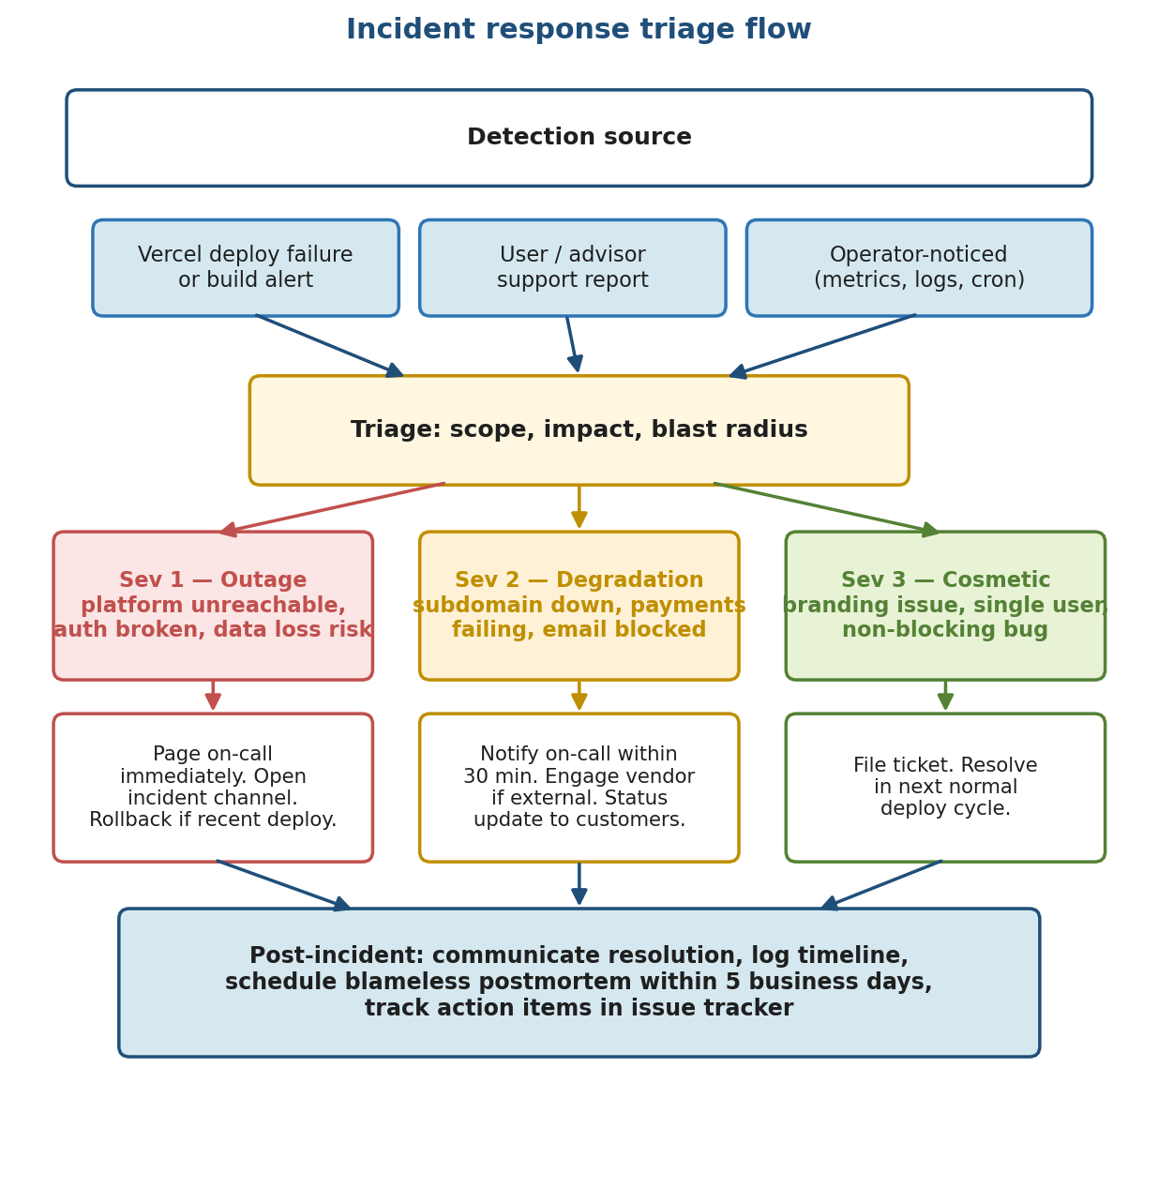
Figure 3: Incident response triage flow.
The triage step itself is short — typically under ten minutes. It exists to make sure the response is proportional and that no one is paged unnecessarily. Three questions are asked and answered: what is broken, who is affected, and is the cause clearly the most recent deployment.

3.4 On-Call and Escalation
The on-call chain is the ordered list of people the operator contacts when an incident is declared. Order matters: the first person is paged immediately, the second is engaged if the first is unreachable or if the incident escalates beyond their scope, and so on.
Tier | Role | Person | Contact
1 | Primary on-call engineer | [TBD — name] | [TBD — phone/PagerDuty]
2 | Secondary on-call engineer | [TBD — name] | [TBD — phone/PagerDuty]
3 | Engineering lead | [TBD — name] | [TBD — phone/email]
4 | Product / executive escalation | [TBD — name] | [TBD — phone/email]
The team should choose a paging tool (PagerDuty, Opsgenie, or a Slack-based rotation) and document the rotation policy here. [TBD — paging tool, rotation cadence, handoff procedure]

3.5 Communication Plan
Customers tolerate outages; they do not tolerate silence. The team's communication discipline during an incident is at least as important as the technical fix.
- Internal. An incident channel is opened in [TBD — Slack/Teams workspace]. Updates land there every fifteen minutes during a Sev 1, every thirty minutes during a Sev 2, until resolution.
- Customer-facing status page. The team does not yet have a published status page. [TBD — choose a status page provider (statuspage.io, Better Stack, Cachet) and publish the URL.] For now, customer updates go out by email through Resend.
- Direct advisor outreach. If a single tenant is impaired and other tenants are unaffected, contact that advisor directly rather than broadcasting.

3.6 Post-Incident
Every Sev 1 and every Sev 2 results in a written postmortem within five business days of resolution. The postmortem is blameless: it describes what happened, the timeline, the contributing causes, and the action items. The intent is to improve the system, not to assign fault.
Action items from postmortems are tracked in [TBD — issue tracker / project board] with owners and target dates. They are reviewed at a weekly cadence until they are either completed or explicitly retired.
A template for the postmortem document — sections for summary, timeline, contributing causes, what went well, what to improve, and action items — should live alongside this runbook. Until that template is checked in, use the format described in this paragraph.

4. Customer Support Procedures
Customer support for Akili Risk has two distinct audiences: advisors (the team's direct customers, who pay for the platform) and the clients those advisors invite to use it. Both audiences route to the same support function, but advisors get faster response times and a higher level of attention.

4.1 Support Channels
Support arrives through the channels below.
Channel | Audience | Where it lands | Notes
Support email | Advisors and clients | [TBD — support@akilirisk.com or similar] | Primary channel. Auto-acknowledgement should fire on receipt.
Contact form (/contact) | Anyone | Resend → CONTACT_FORM_TO_EMAIL (defaults to buddy@ebilly.com) | Protected by Cloudflare Turnstile.
In-app messaging | Advisors | [TBD — not yet implemented] | Future direction.
Ticketing system | Internal | [TBD — Zendesk, Linear, GitHub Issues, etc.] | Used to track work past the first response.

4.2 Tiered Response
Support requests are handled in three tiers. Most issues are resolved at Tier 1 without engineering involvement.
- Tier 1 — Account and access. Password resets, MFA help, magic-link delivery, login confusion. These are handled by the support agent directly using the self-service flows in the application.
- Tier 2 — Account and data. Subscription questions, branding configuration, subdomain provisioning, intake or assessment data the advisor needs help interpreting. Handled by support with operator-level read access to the admin tools.
- Tier 3 — Engineering escalation. Suspected bugs, data integrity concerns, anything that requires a code or schema change. Escalated to engineering through the ticketing system; routed to the on-call engineer if the impact is at Sev 2 or above.

4.3 SLA Targets
Tier | First response | Resolution
Tier 1 (advisor) | [TBD — e.g. 2 business hours] | [TBD — e.g. same business day]
Tier 1 (client) | [TBD — e.g. 1 business day] | [TBD — e.g. 2 business days]
Tier 2 | [TBD — e.g. 1 business day] | [TBD — e.g. 3 business days]
Tier 3 | [TBD — depends on severity] | [TBD — depends on severity]
SLA targets should be agreed with the executive team before being published to advisors. The placeholders above are reasonable starting points but should not be treated as commitments.

4.4 Common Scenarios

Password reset
The application supports two ways for a user to recover access: a magic link sent on demand to the user's email, and a self-serve forgot-password flow. Both are wired up in the codebase; support's role is to walk the user through the flow rather than reset the password directly.
- Confirm the email on file matches the user's expectation. If it does not, escalate to Tier 2 to investigate.
- Direct the user to the sign-in page, choose Forgot password, enter their email, and follow the link in the email Resend delivers.
- If the email does not arrive within ten minutes, check the Resend dashboard for delivery status, then check the user's spam folder.

MFA lockout
If a user has lost access to their TOTP device, support cannot reset MFA directly through the UI; the operation requires admin-tool access. The procedure is to verify the user's identity, then have an admin clear the MFA secret in the database (the user re-enrolls on next sign-in). The application encrypts MFA secrets at rest with ENCRYPTION_KEY, so a stale secret cannot be recovered.

Advisor branding
Advisors occasionally report that their logo is the wrong size, the colors are off, or the white-label experience is partially showing the default Akili lockup. The common causes are: brandingEnabled is set to false on the AdvisorProfile (intentional for some accounts; check first), the logo upload did not complete because of an S3 CORS misconfiguration, or the subdomain is not isActive && dnsVerified. Walk the advisor through Settings → Branding and confirm the AdvisorProfile state.

Subscription and billing
Billing is handled by Stripe. Most billing questions — invoice access, payment-method updates, plan changes — are resolved by sending the advisor to the Stripe customer portal, which is exposed in-app at /advisor/billing. For genuinely unusual cases (failed renewals after the BILLING_GRACE_PERIOD_DAYS window, contested charges, mid-cycle proration), escalate to Tier 2; the operator can use the Stripe dashboard to inspect the customer record and adjust if needed. Do not move money or issue refunds without explicit advisor sign-off.

4.5 Escalation to Engineering
When support determines an issue is Tier 3, the procedure is:
- Write up the issue with reproduction steps, the advisor's account identifier, the impacted clients, and any relevant log lines from the Vercel dashboard.
- File a ticket in [TBD — issue tracker]. Tag with the severity assessment from section 3.1.
- If Sev 1 or Sev 2, page the on-call engineer per section 3.4.
- Stay in the loop on the engineering response and keep the customer informed at the cadence set by the severity.

5. Vendor Contact Information
Akili Risk depends on a small set of external services. This section records the operational contact information for each one. The vendors listed are those identified from the codebase and environment configuration; the account holder, billing contact, and SLA tier fields are placeholders that the team should fill in from the actual account records.
API keys are documented by the environment variable name they live under in Vercel, not by their value. To inspect or rotate a key, open the Vercel project's Environment Variables panel and edit the corresponding variable; do not copy values into this document.

Vercel
Service | Vercel
Purpose | Hosting, DNS, edge proxy, scheduled cron
Account holder | [TBD]
Support URL | https://vercel.com/help
Status page | https://www.vercel-status.com
Billing contact | [TBD]
Credential location | (Vercel account; not stored as env var)

Neon
Service | Neon
Purpose | Postgres database hosting
Account holder | [TBD]
Support URL | https://neon.tech/docs/introduction/support
Status page | https://neonstatus.com
Billing contact | [TBD]
Credential location | DATABASE_URL

AWS S3 (us-east-2)
Service | AWS S3 (us-east-2)
Purpose | Object storage: advisor logos, intake audio, client documents
Account holder | [TBD — Akili org under buddy@ebilly.com]
Support URL | https://aws.amazon.com/contact-us/
Status page | https://health.aws.amazon.com/health/status
Billing contact | [TBD]
Credential location | AWS_ACCESS_KEY_ID / AWS_SECRET_ACCESS_KEY

Resend
Service | Resend
Purpose | Transactional email (invitations, notifications, magic links, password resets)
Account holder | [TBD]
Support URL | https://resend.com/support
Status page | https://resend-status.com
Billing contact | [TBD]
Credential location | RESEND_API_KEY

Stripe
Service | Stripe
Purpose | Advisor subscription billing, customer portal, webhooks
Account holder | [TBD]
Support URL | https://support.stripe.com
Status page | https://status.stripe.com
Billing contact | [TBD]
Credential location | STRIPE_SECRET_KEY / STRIPE_WEBHOOK_SECRET

OpenAI
Service | OpenAI
Purpose | AI-assisted scoring, intake transcription, text-to-speech
Account holder | [TBD]
Support URL | https://help.openai.com
Status page | https://status.openai.com
Billing contact | [TBD]
Credential location | OPENAI_API_KEY

Cloudflare (Turnstile)
Service | Cloudflare (Turnstile)
Purpose | Bot protection on the public contact form
Account holder | [TBD]
Support URL | https://support.cloudflare.com
Status page | https://www.cloudflarestatus.com
Billing contact | [TBD]
Credential location | TURNSTILE_SECRET_KEY / NEXT_PUBLIC_TURNSTILE_SITE_KEY

GitHub
Service | GitHub
Purpose | Source code hosting, pull-request review, CI triggers
Account holder | [TBD]
Support URL | https://support.github.com
Status page | https://www.githubstatus.com
Billing contact | [TBD]
Credential location | (GitHub account; no API key)

Anthropic
Service | Anthropic
Purpose | Not currently integrated. Listed here for awareness if the team adds Claude to the scoring or chat features later.
Account holder | n/a
Support URL | https://support.anthropic.com
Status page | https://status.anthropic.com
Billing contact | n/a
Credential location | n/a

5.10 Vendor Summary
At a glance, the vendor landscape today is: Vercel for hosting and DNS, Neon for the database, AWS for object storage, Resend for email, Stripe for billing, OpenAI for AI features, and Cloudflare Turnstile for bot protection on the contact form. There is no dedicated error-monitoring vendor yet, no SMS provider, and Anthropic is listed only as a forward-looking possibility.

6. Credential Recovery Procedures
This section describes how to regain access to each system and how to rotate the secrets the application depends on. Credential recovery is one of the highest-stakes operations the team performs; the steps below assume the operator has already confirmed they are dealing with a legitimate lockout, not a social-engineering attempt.

6.1 Vercel Account Recovery
The Vercel project owns the application's hosting, the Vercel-managed DNS for akilirisk.com, the environment variables, and the wildcard tenant routing. Loss of Vercel access is therefore one of the most consequential failures the team can experience.
- Account recovery for an individual operator starts at the Vercel sign-in page using the email-based recovery flow. If the operator's email is intact, this is enough.
- If the team-owner account is unreachable (separated employee, lost device, missing MFA), open a support ticket with Vercel and follow their documented account-recovery process, which requires proof of ownership of the registered email domain.
- Team ownership transfer — needed when the current owner is leaving the team — is performed by the current owner from the Team Settings page. Do not delay this when an owner is transitioning out; recovery without the leaving owner is significantly slower.
- Deploy hook secrets (used by external systems to trigger Vercel builds) are rotatable from the Vercel project's Git integration panel. Rotate any deploy hook a former operator has had access to as part of offboarding.

6.2 Neon Account Recovery
- Individual Neon accounts recover through the standard email-based flow at neon.tech.
- Database password rotation is performed in the Neon console: open the project, choose the database role (typically the primary owner role), generate a new password, and update DATABASE_URL in Vercel.
- Plan for a brief connection storm when the password rotates: the application reconnects automatically, but in-flight queries on the old credential will fail. Schedule rotations during low-traffic windows.
- If the Neon project owner is unreachable, contact Neon support; they will require proof of ownership of the registered email and may require billing verification.

6.3 Domain and DNS Access
DNS for akilirisk.com sits on Vercel-managed nameservers, which means DNS access recovery is the same problem as Vercel access recovery — see section 6.1. There is currently no registrar-level recovery to perform separately, but the team should record the registrar account (likely [TBD — registrar name] under [TBD — billing email]) so that nameserver changes can still be made if Vercel ever needs to be replaced.

6.4 SSL Certificates
Vercel auto-provisions and auto-renews SSL certificates for every domain attached to the project, including the platform host (preview.akilirisk.com today, www.akilirisk.com at launch) and the *.akilirisk.com tenant wildcard. The team does not manage certificate material directly and there is no certificate to rotate manually.
If certificate provisioning fails for a newly attached domain, the failure mode is visible in the Vercel Domains panel as a red status badge and a specific error message. Most failures are DNS-related (the domain points somewhere other than Vercel) and resolve automatically once DNS is corrected.

6.5 Application Secrets Rotation
The application's runtime secrets are rotated in Vercel's Environment Variables panel for the relevant environment. The rotation procedure below applies to each secret in turn.
- Generate the new secret in the vendor's dashboard (Stripe, Resend, AWS IAM, etc.). Most vendors support having two active credentials at once during a rotation window.
- Add the new value to Vercel as the new environment variable value. Trigger a redeploy so the running application picks up the change.
- Verify the application is healthy on the new credential. For Stripe webhook secret rotations, send a test webhook from the Stripe dashboard and confirm it lands successfully.
- Revoke the old credential in the vendor's dashboard once verification is complete.
Secret | Where it lives | Rotation guidance
AUTH_SECRET | Vercel env (all envs) | Rotate every 12 months or after a suspected compromise. Rotation invalidates existing sessions, so schedule outside business hours.
ENCRYPTION_KEY | Vercel env (all envs) | Used to encrypt MFA secrets and PII at rest. A rotation requires re-encrypting affected rows; do not rotate without a planned migration script.
STRIPE_SECRET_KEY | Vercel env (Preview, Production) | Rotate from Stripe dashboard → Developers → API keys. Stripe supports overlapping keys during rotation.
STRIPE_WEBHOOK_SECRET | Vercel env (Preview, Production) | Rotate when the webhook endpoint changes or after a suspected compromise. Use Stripe → Developers → Webhooks.
RESEND_API_KEY | Vercel env (all envs) | Rotate from Resend dashboard → API Keys. Create new, deploy, then delete old.
OPENAI_API_KEY | Vercel env (all envs) | Rotate from OpenAI platform → API Keys. No overlap support; expect a brief gap on cutover.
AWS_ACCESS_KEY_ID / AWS_SECRET_ACCESS_KEY | Vercel env (all envs) | Create new IAM access key alongside the old, deploy, verify, then deactivate and delete the old.
CRON_SECRET | Vercel env (all envs) | Rotate by generating a new openssl rand -hex 32 value. Update Vercel; no external system needs to be informed.
TURNSTILE_SECRET_KEY | Vercel env (Preview, Production) | Rotate from Cloudflare dashboard. Update site key in lockstep.

6.6 Test Account Credentials
Local test accounts are documented in the project's CLAUDE.md file at the repository root. They are not reproduced here on purpose: the canonical list lives in one place, and CLAUDE.md is the source of truth. If a test account password drifts, run the seed scripts (scripts/seed-advisor-test-data.js, scripts/set-admin-role.js, and the rest) to restore the documented values.
The seeded test users are intended for local development and Preview-environment smoke tests only. They should never be created in a Production database.

6.7 Admin User Lockout Recovery
The platform's super-admin account (buddy@ebilly.com) is privileged in both the application logic (it is the only account that can edit platform settings and risk thresholds) and the operations process (it is typically the account that owns the Vercel and Neon access).
If the super-admin account is locked out at the application level:
- Confirm whether the lockout is at the auth layer (forgot password, lost MFA) or the role layer (the user exists but no longer has SUPER_ADMIN). Inspect the User row in the database.
- If it is an auth issue, use the password reset and MFA-clearing procedures in sections 4.4 and the database column updates described there.
- If it is a role issue, run scripts/set-admin-role.js from a workstation with DATABASE_URL set to the target database. The script idempotently sets the documented admin account to SUPER_ADMIN.
- If even the script approach is not available — for example, because no engineer with database access is reachable — the absolute last-resort recovery is a direct SQL update against the User table. Document the use of last-resort recovery in the incident log.
To avoid the bus-factor risk of a single SUPER_ADMIN, the team should designate at least one secondary super-admin and add the account here as a documented backup. [TBD — secondary super-admin]

