Akili Risk
Mobile App Development Plan
Intake and assessment on iOS and Android
Prepared June 13, 2026
Version 1.0
Audience: stakeholders and engineering

Contents

1. Executive Summary
Akili Risk is launching native iOS and Android applications in Q3 2026 to bring the platform’s intake and assessment experience to mobile devices. The mobile app does not replace the existing web platform; it is a focused companion that lets clients complete their household risk intake wherever they are, and lets advisors review submitted intake responses on the go. All reporting, scoring presentation, recommendation delivery, and administrative work remain on the web.
The app is built with React Native and Expo, which lets a single TypeScript codebase ship to both app stores. It reuses the existing Next.js API surface and the same authentication, encryption, and tenant-isolation guarantees that the web platform already enforces. A local-first architecture — Expo SQLite for drafts, an outbox queue for writes, and a file cache for audio recordings — keeps the intake usable in spotty connectivity and on planes, syncing safely when the device comes back online.
The plan below outlines the functional scope, the technology stack, the architecture, the authentication and offline-sync strategies, low-fidelity wireframes for every key screen, and a phased twelve-week delivery plan that targets a Q3 2026 public release in both stores. A Phase 2 roadmap captures the work explicitly out of scope for launch: push notifications, per-advisor white-labeled apps, a dedicated mobile API surface, and a mobile reporting view.

2. Goals and Non-Goals

Goals
- Ship a single Akili-branded iOS and Android app to the App Store and Play Store in Q3 2026.
- Let clients complete the household risk intake on a phone, in both Type and Voice modes, online or offline.
- Let advisors sign in, see their assigned clients, and read submitted intake responses from their phone.
- Reuse the existing Next.js auth, intake endpoints, and S3 audio pipeline — no parallel backend in Phase 1.
- Match the web platform’s security guarantees: encrypted-at-rest secrets on device, JWT auth, biometric unlock.
- Cross-platform from one TypeScript codebase via React Native + Expo, with EAS Build for releases.

Non-goals (Phase 1)
- Reporting, score views, recommendations, and PDF delivery remain web-only.
- Per-advisor white-labeled apps (each firm gets its own App Store listing) are deferred to Phase 2.
- Push notifications are not in Phase 1 — including intake reminders and approval notifications.
- Admin and Super-Admin roles are out of scope on mobile. Admin work continues on the web /admin console.
- Stripe purchases inside the app. Paid features remain web-only to avoid the App Store IAP requirement at launch.
- A separately deployed mobile API. Phase 1 reuses Next.js routes; a dedicated surface is a Phase 2 roadmap item.
- Tablet-optimized layouts. The app targets phone form factors first; tablets get the phone layout.

3. User Personas

Client — completing intake
The client is the head of a high-net-worth household who has just been invited by their advisor to complete an Akili intake. They are typically time-pressed, used to consumer apps, and prefer to handle paperwork on their phone rather than at a desktop. They may start the intake in a back-of-taxi moment with intermittent connectivity, pause for several days, and finish from a quiet living room. They appreciate the option to speak rather than type for longer free-form answers. They want reassurance that nothing is lost when the network drops, and they want to know that their answers are private. The mobile app exists primarily for them.

Advisor — reviewing intake
The advisor is a wealth advisor who manages between twenty and a hundred client households across several firms. On mobile they want a quick read on which of their clients have submitted intake, the ability to skim transcripts on the way to a meeting, and the assurance that any consequential action — approving an intake, returning it for revision, sending the report — is performed on the web where the full context is available. The mobile app is an inbox and a reader for them, not a workspace.

4. Functional Scope
The app contains two role-aware experiences behind a single sign-in screen. The role of the user (USER for clients, ADVISOR for advisors) is determined server-side after authentication, and the app routes to the appropriate stack.

4.1 Sign-in and session
- Email entry → magic-link email via Resend, identical to web.
- Deep link from the email returns the user to the app and exchanges the token for a session JWT.
- Paste-code fallback for users whose mail app does not honor the universal/app link.
- JWT stored in the OS keychain via Expo SecureStore.
- Biometric (Face ID / Touch ID / Android fingerprint) gates re-entry after the app is backgrounded or relaunched.
- Lock-screen fallback: passcode entry through OS biometric prompt; “Use email instead” to start over.

4.2 Client intake
- Home screen with a Begin / Resume / Submitted status and the assigned advisor’s firm name.
- Intake landing with question count, time estimate, and a brief privacy reminder.
- Per-question screen with two modes in a tab strip: Type and Voice — same model as the web intake wizard.
- Type mode: multi-line input, autosave, character counter, Save / Next / Previous controls.
- Voice mode: native record button with idle, recording, playback, re-record, and save states; uses Expo AV for capture.
- Per-answer save status (Saved on device · Synced · Queued) so the user always knows where their answer lives.
- Offline banner whenever NetInfo reports no connectivity, with a summary of pending writes.
- Submission confirmation summarizing answered count, voice vs. typed breakdown, and a reference ID.

4.3 Advisor review
- Clients list with search and a small set of status filters (All, In review, Submitted, Approved).
- Per-client detail with read-only transcripts of intake responses; voice answers play back inline using a server-issued signed URL.
- Per-question pillar tag (Governance, Cyber, Physical, …) preserved from the web intake script.
- A single “Approve & continue on web” call-to-action — consequential approval lives on the web console.

4.4 What the app does not do
- No score view, no recommendations, no PDF report, no document generation.
- No billing, no Stripe customer portal, no subscription management.
- No admin or super-admin surfaces — those remain web-only.
- No advisor-side configuration (branding, subdomain, firm settings) — web-only.

5. Technology Stack
The mobile stack mirrors the conservatism of the web stack: every component is either a managed service or a widely-used open-source library, and the surface area is intentionally small.
Layer | Technology | Why
App framework | React Native via Expo (SDK 53+, managed workflow) | Single TypeScript codebase for iOS and Android; OTA updates via EAS.
Language | TypeScript strict | Same standard as the web codebase; shared types where pragmatic.
Navigation | Expo Router (file-based) | Familiar to Next.js developers; deep-link friendly.
Auth storage | Expo SecureStore (Keychain / Keystore) | JWT stored in hardware-backed secure storage.
Biometric | Expo LocalAuthentication | Face ID / Touch ID / Android biometric prompt.
Audio | Expo AV | Native record + playback; .m4a output on both platforms.
Offline DB | Expo SQLite | Reliable embedded store for drafts and queue.
Data fetching | TanStack Query (React Query) | Cache, retry, background refresh, offline cache.
Connectivity | @react-native-community/netinfo | Online/offline events to drive the sync worker.
Forms | React Hook Form + Zod | Same validation primitives as the web app.
UI primitives | Tamagui or React Native Paper (selection TBD) | Theming, accessibility, dark-mode support.
Releases | EAS Build + EAS Submit | Reproducible builds; App Store and Play Store submission.
OTA updates | EAS Update | Patch JavaScript without a binary release for non-native fixes.
Observability | Sentry React Native | Crash + error reporting, parity with web.
Testing | Jest + React Native Testing Library; Detox (post-launch) | Unit + integration; end-to-end deferred.

6. Architecture
At the highest level, the mobile app is a thin client over the existing Akili web backend. The device holds a small local database for drafts and an outbox for writes; the network is treated as unreliable by default, and every server interaction goes through a sync worker that knows how to queue, retry, and de-duplicate. The diagram below shows the major components on the device and their relationships to the existing Vercel-hosted Next.js application.
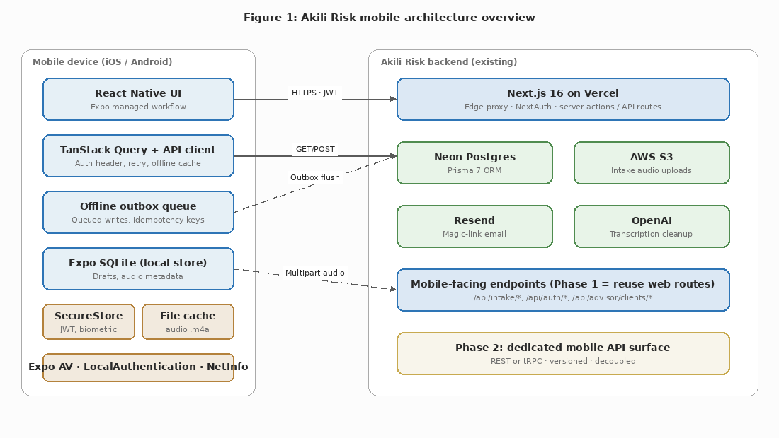
Figure 1: Mobile architecture overview — device-side stack on the left, existing Akili backend on the right.
In Phase 1 the mobile app calls the same Next.js routes that the web app uses today: /api/auth/magic-link for sign-in, /api/intake/* for intake reads and writes, /api/advisor/clients/* for the advisor view, and a presign endpoint for audio upload. Authentication is by JWT bearer header issued by NextAuth, which the proxy already understands. This preserves the existing tenant- isolation rules: every advisor-facing query joins through ClientAdvisorAssignment, and the proxy continues to be the single place that maps subdomain or auth claim to tenant.
Phase 2 introduces a dedicated mobile API surface (REST or tRPC) so the web and mobile clients can evolve independently. The Phase 2 surface is a versioned, mobile-optimized shape over the same Prisma layer; it is a roadmap item, not a launch dependency.

7. Authentication Flow
First-time sign-in uses a magic link, the same primitive the web platform uses today. The user enters their email, the app posts to the existing /api/auth/magic-link endpoint, and Resend delivers a one-time link. Tapping the link in the mail app returns to Akili via a universal link on iOS or an app link on Android. If the OS does not honor the link (some corporate mail clients strip them, or the user opens it on a different device), a six-digit code in the same email gives them a paste-code fallback inside the app. The session JWT returned by /api/auth/verify is written to Expo SecureStore, which uses Keychain on iOS and Keystore on Android — hardware-backed where the device supports it.
On subsequent launches the JWT is held in SecureStore and a biometric prompt gates access to it. The app does not store the magic link itself, and it never displays the JWT in any UI. Logout simply deletes the SecureStore entry, which forces the next launch back through the magic-link flow. If the JWT has expired server-side, any 401 from the API triggers a soft re-authentication: the app prompts for biometric, and if the refresh path fails, returns the user to the email screen.
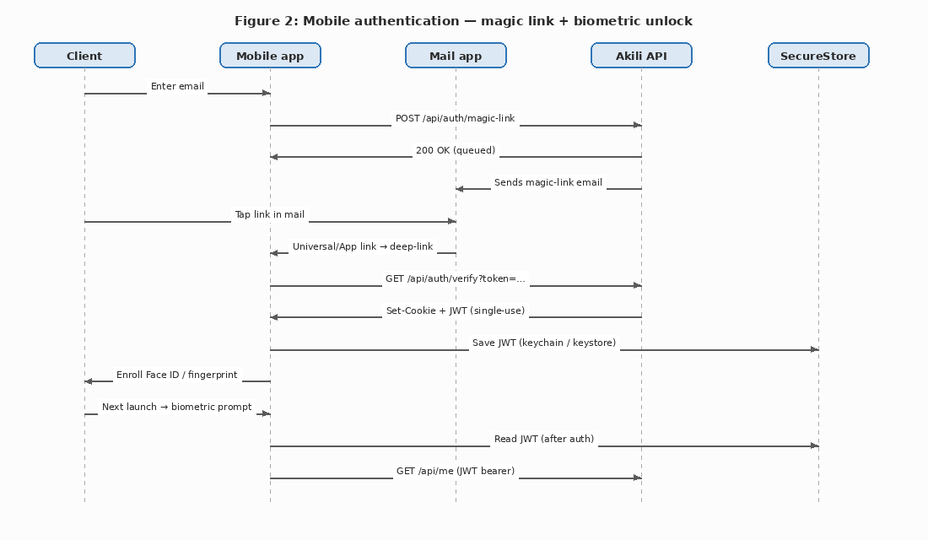
Figure 2: Magic-link first auth and biometric unlock on subsequent launches.

8. Offline Sync Strategy
Intake is the dominant use case on mobile, and the intake user is the one most likely to be on spotty connectivity — a back of a car, an airport, a vacation home. The app is local-first: every answer the user types or records is committed to Expo SQLite on the device first, and the user is told immediately that the answer is saved. A sync worker takes responsibility for moving those writes to the server when the device is online.

8.1 Local-first writes
The app uses an outbox queue pattern. Each save (typed answer, audio recording, status change) becomes a row in an outbox table with a client-generated UUID idempotency key. The UI reads from the local database; it does not wait on the network. Audio files are written to the app sandbox and referenced by path from the outbox row. The diagram below shows the flow.
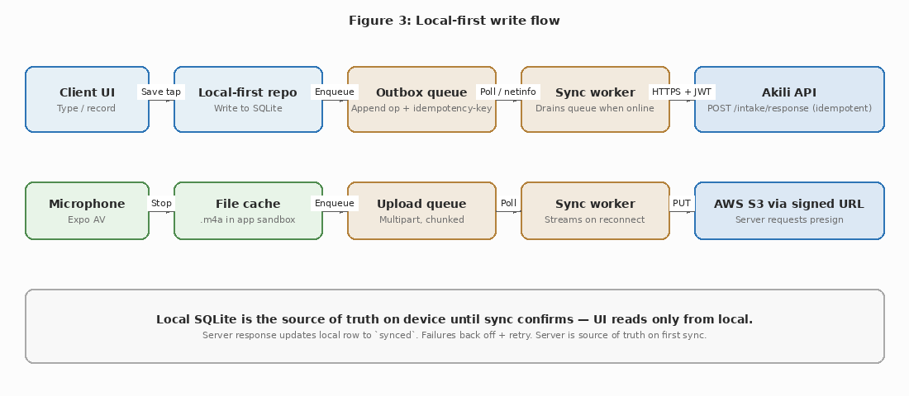
Figure 3: Local-first write flow — UI commits to SQLite first; sync worker drains outbox.

8.2 Sync and conflict resolution
When NetInfo reports the device is online, the sync worker drains the outbox in insertion order. Each write carries an Idempotency-Key header so retries cannot duplicate. The IntakeResponse table already has a unique constraint on (interviewId, questionId) and an updatedAt timestamp, which the server uses as the merge axis: if the server already holds a response with a newer updatedAt (the user typed on the web in the interim), the mobile draft is discarded and the local row is overwritten with the server value. Because responses are append-only per question — the user revises a single answer in place — conflicts are rare in practice.
Audio recordings follow the same queue but stream out as multipart uploads against a presigned S3 URL the server issues on demand. Once the server confirms the audio is durable, the local file is evicted from the cache. A failed upload backs off exponentially; a hard failure (a 4xx response, e.g. an expired session) moves the row to a dead-letter table the user can see in the offline banner. Submission of the intake is blocked until the outbox is empty and every response is reported synced by the server. The conflict-handling rules are summarized in the diagram below.
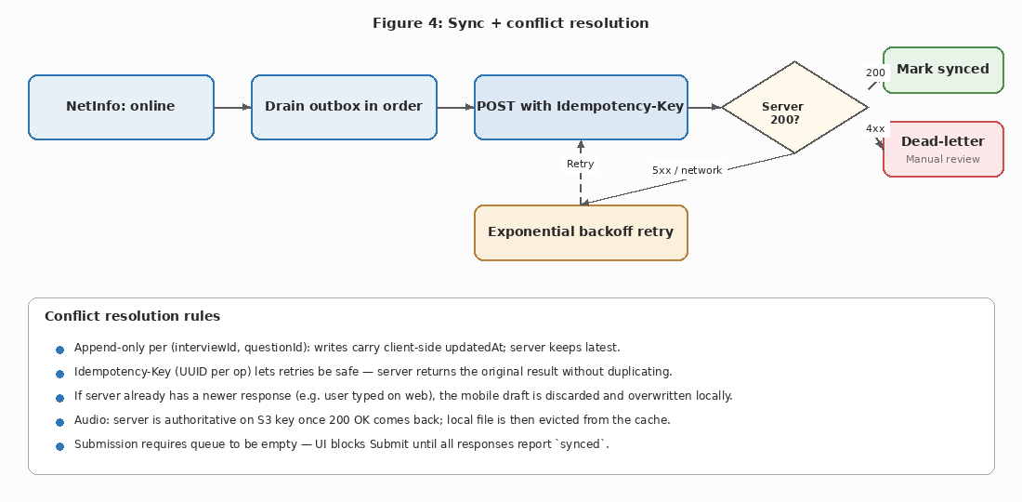
Figure 4: Sync worker control flow and the rules that govern conflicts.

9. Wireframes
The wireframes below are deliberately low-fidelity. They communicate layout, hierarchy, and the major affordances — not visual design. Final visual treatment will be produced by the design team against the firm’s existing brand guidelines and applied uniformly across the screens shown here.
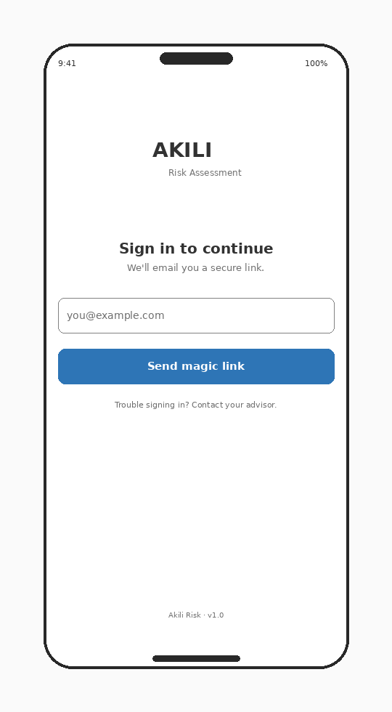
Figure 5: Splash and sign-in — email entry kicks off the magic-link flow.
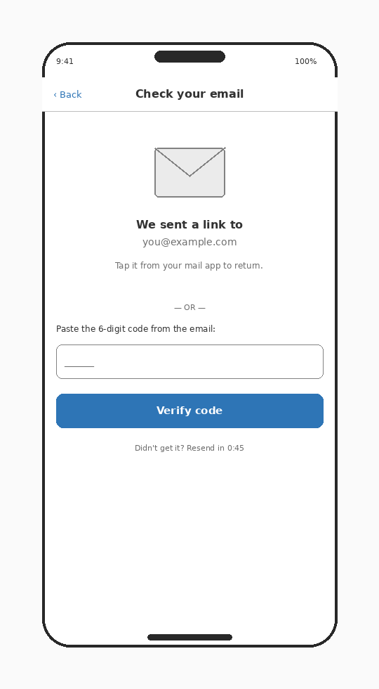
Figure 6: Magic-link sent confirmation with paste-code fallback for mail clients that strip the deep link.
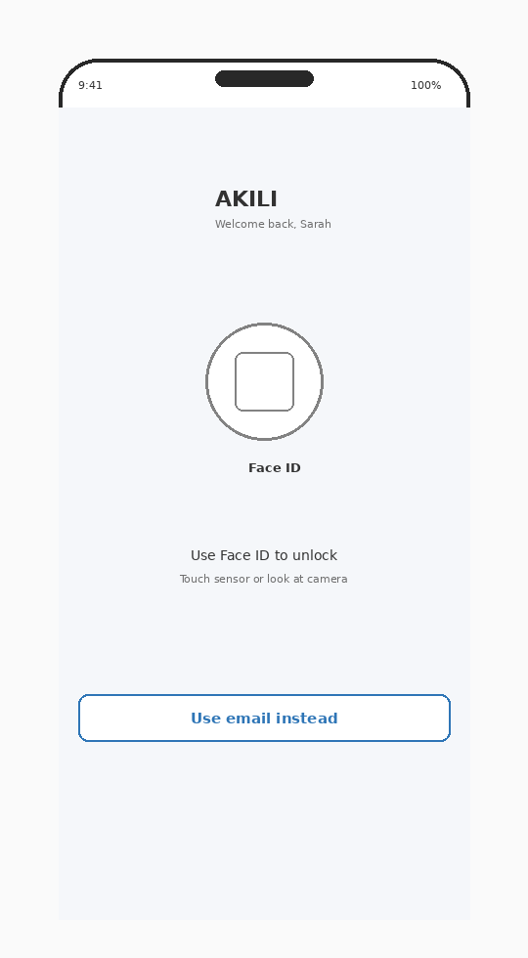
Figure 7: Biometric unlock on subsequent launches; falls back to email if biometric is unavailable.
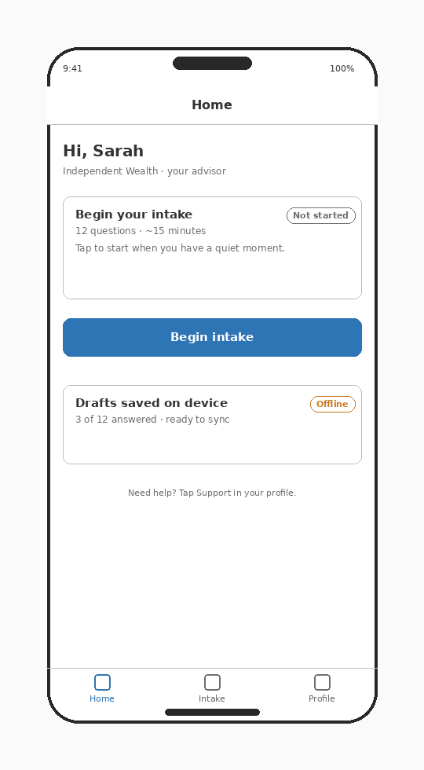
Figure 8: Client home — Begin / Resume CTA and a status pill for current intake state.
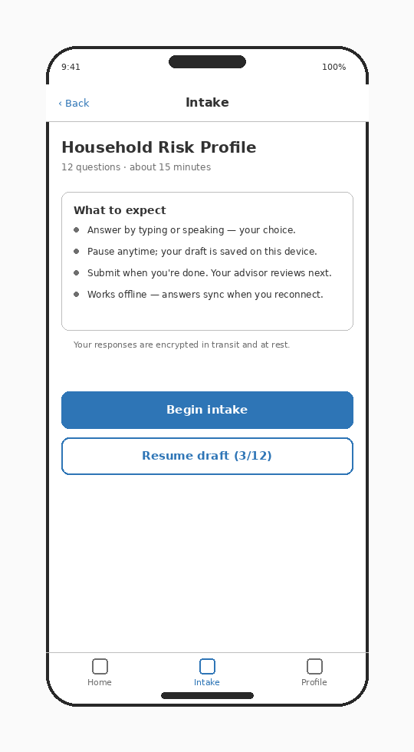
Figure 9: Intake landing with question count, time estimate, and offline guarantee.
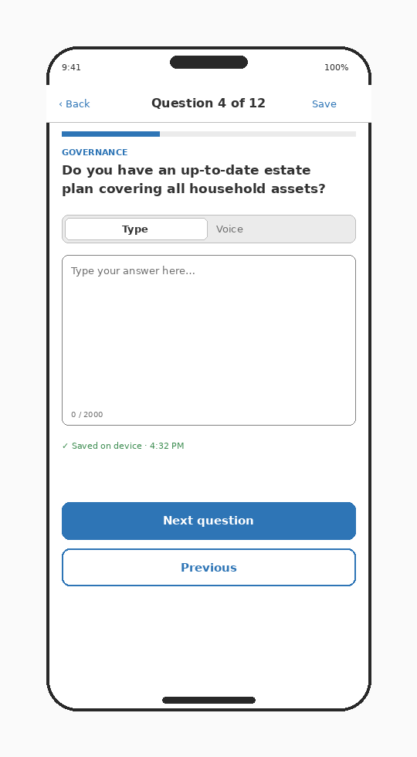
Figure 10: Intake question — Type mode with autosave indicator and Next / Previous controls.
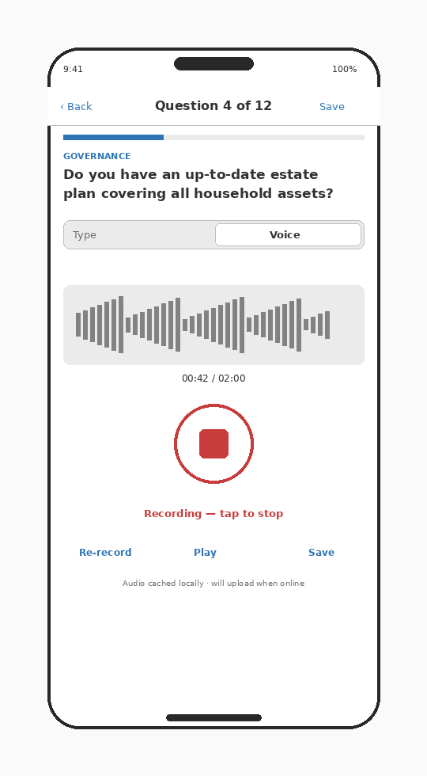
Figure 11: Intake question — Voice mode showing the record / playback / save lifecycle.
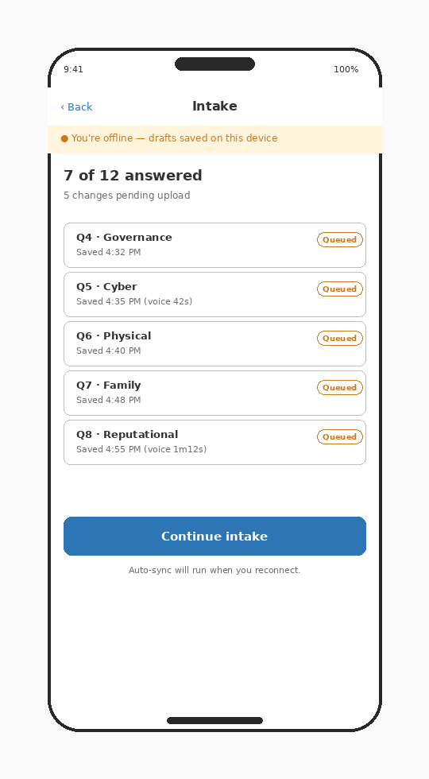
Figure 12: Offline indicator and a queue of locally-saved drafts waiting to upload.
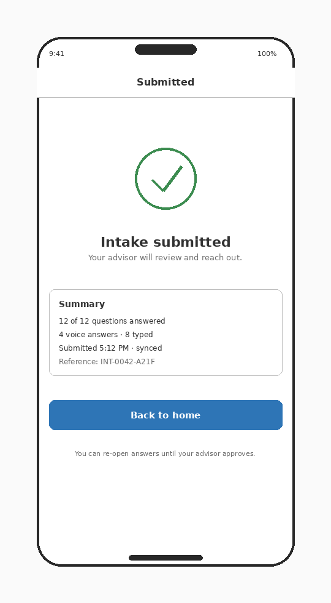
Figure 13: Submission confirmation with a summary and a reference ID.
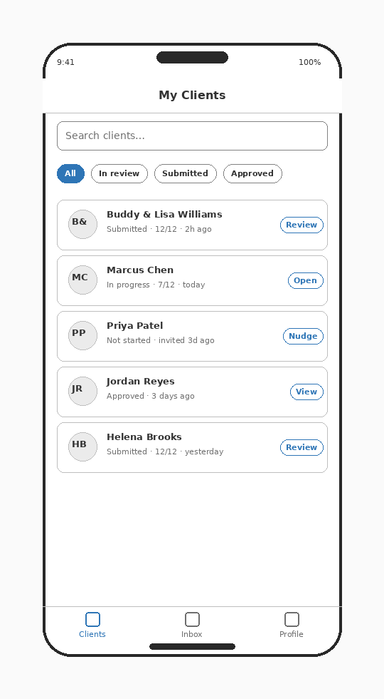
Figure 14: Advisor home — assigned clients with status pills and quick actions.
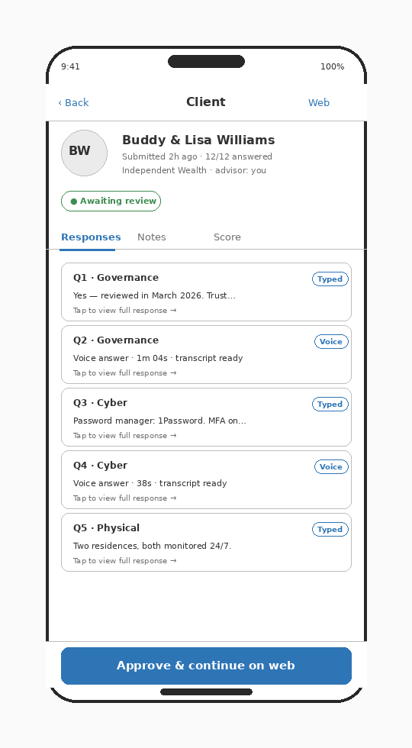
Figure 15: Advisor client detail — read-only responses with “continue on web” for approval.

10. Phased Delivery Plan
The plan targets twelve calendar weeks from project start to a public release in both stores. Week numbering below assumes a kickoff in the third week of June 2026.
Week | Milestone | Deliverable
1–2 | Project scaffold and auth | Expo project, EAS Build pipeline, magic-link sign-in, SecureStore-backed JWT, biometric unlock, navigation skeleton.
3–5 | Intake wizard — Type mode | Per-question Type mode, autosave, question script ingestion from /api/intake/script, online-first writes against /api/intake/response.
6–7 | Voice mode | Expo AV recorder UI, playback, audio upload via presigned S3 URLs, transcription status display.
8–9 | Offline mode | Expo SQLite store, outbox queue, sync worker, conflict resolution rules, offline banner, dead-letter view.
10 | Advisor surface | Advisor sign-in, clients list, client detail with read-only responses and audio playback. “Continue on web” deep link.
11 | Internal testing | TestFlight + Play Console Internal Testing builds, bug bash, accessibility pass (VoiceOver / TalkBack).
12 | Release prep | App Store + Play Store metadata, privacy disclosures, screenshots, support page, submission for review.

10.1 Engineering staffing
- 1 senior React Native engineer (lead, full-time, weeks 1–12).
- 1 backend engineer (50%, weeks 3–10) for any web API adjustments and the presign endpoint.
- 1 designer (50%, weeks 1–8) — wireframes → final visual design and asset production.
- 1 QA / release manager (50%, weeks 9–12) — store metadata, internal testing, accessibility, submission.

10.2 Risks to the schedule
- App Store review can take 24–72 hours. We submit by end of week 11 to allow for one rejection-and-resubmit cycle.
- Universal/App link configuration requires DNS and signing setup on both platforms; this is scheduled in week 1 to surface issues early.
- Audio file sizes on slow connections drive multipart upload tuning; this is the riskiest piece of the offline work and gets the most testing time.

11. Risks and Mitigations
Risk | Likelihood | Impact | Mitigation
Magic-link UX friction on mobile (link does not open the app) | Medium | Medium | Paste-code fallback in every magic-link email. Universal/App link verification monitored in Sentry.
App Store / Play Store rejection delays release | Medium | High | Submit by week 11. Pre-submission review of privacy disclosures and microphone usage strings. Avoid Apple IAP triggers in Phase 1.
Offline sync edge cases (duplicate writes, lost audio) | Medium | High | Idempotency keys on every write. Server is source of truth on first sync. Submission blocks until queue is empty.
Audio uploads fail on slow or metered connections | High | Medium | Chunked multipart upload, exponential backoff, retry on reconnect. Local file retained until 200 OK from server.
Apple in-app-purchase requirements if Akili tries to charge in-app | Low | High | Phase 1 keeps all paid features web-only. No purchase surface in the app.
Coupling to the web backend slows future changes | Medium | Medium | Define a stable v1 API contract before launch. Schedule the dedicated mobile API as a Phase 2 deliverable.
Biometric unavailable on older devices | Low | Low | “Use email instead” fallback returns the user to the magic-link flow at any time.
Mic permission denied on Voice mode | Medium | Low | Inline empty-state with deep link to system settings; Type mode is always available.
Crash or regression introduced by OTA update | Low | High | EAS Update with a staged rollout (10% → 50% → 100%). Sentry crash-free-session monitoring per release.

12. Post-Launch Roadmap (Phase 2)
Phase 2 captures the work that is explicitly out of scope for the Q3 2026 launch but expected to follow within the subsequent two quarters. Each item below is sized and scoped at a high level; detailed planning will follow once Phase 1 is in production.

12.1 Push notifications
- Intake reminders to clients (configurable cadence; default at 3 and 7 days after invite).
- Advisor notifications when a client submits intake or when an intake is returned for revision.
- Expo Push + APNs / FCM. User-level opt-in stored on the User record alongside MFA preferences.

12.2 Per-advisor white-labeled apps
- A separate App Store and Play Store listing per advisor firm, built from the same codebase via EAS Build profiles.
- Per-profile signing identities and app metadata; bundle identifier and display name driven by profile.
- Per-tenant Apple Developer account ownership and review handled by each advisor firm (with Akili support).

12.3 Dedicated mobile API surface
- Versioned REST or tRPC surface under /api/mobile/v1/ separate from the web routes.
- Lets the mobile and web clients evolve independently; reduces breakage risk during web refactors.
- Same Prisma layer, same tenant isolation rules; the surface change is in routing, validation, and contract.

12.4 Reporting and score view
- Read-only assessment summary on mobile: pillar scores, recommendations, and the same PDF link the web exposes.
- Charting via Victory Native or react-native-svg-charts.

12.5 Admin role on mobile
- Deferred indefinitely unless platform staff request it. Admin work is well-suited to the web /admin console.

13. Open Questions / TBD
The following decisions are not yet made and will gate specific deliverables. Each is flagged with the team or stakeholder accountable for resolution.
Item | Owner | Needed by
Apple Developer Program account ownership (corporate vs. individual) | Operations | Week 1
Google Play Console account ownership and signing key custody | Operations | Week 1
App icon, splash, and store screenshot assets | Design | Week 8
Final UI primitives selection (Tamagui vs. React Native Paper) | Engineering | Week 2
Terms of service URL for store metadata | Legal | Week 10
Privacy policy URL (mobile-specific disclosures: microphone, secure storage) | Legal | Week 10
Support email surfaced inside the app | Customer Success | Week 10
In-app feedback channel (e.g. Sentry user-feedback, Intercom) | Product | Week 11
Universal/App link host and apple-app-site-association file location | Engineering + Web ops | Week 1
OTA update gating policy (staged rollout thresholds, kill-switch ownership) | Engineering | Week 11

Summary
Akili Risk is bringing intake and assessment to iOS and Android in Q3 2026. The mobile app is a focused companion to the web platform: it lets clients fill out their household risk intake on a phone — in Type or Voice mode, online or offline — and lets advisors read submitted intake on the go. Everything consequential (reporting, approval, configuration, billing) stays on the web.
The technology stack is React Native + Expo on the device and the existing Next.js backend on the server. A local-first architecture with an outbox queue, idempotent writes, and a hardware-backed keystore for tokens lets the app behave well in poor connectivity without surrendering security guarantees. The twelve-week delivery plan ends with App Store and Play Store submissions; Phase 2 roadmap items — push notifications, white-labeled per-advisor apps, a dedicated mobile API, and a mobile reporting view — are scoped but explicitly deferred.

