AKILI RISK
10-Pillar Expansion & Constrained Advisor-Customization Plan
Version 3.0 — Platform-Owned Catalog, Advisor-Owned Underlayer
Engineering and product plan for clamping pillar identity to the platform while keeping questions, scoring, and recommendations advisor-owned.
This revision tightens v2: advisors no longer create or delete pillars — they deactivate or rename platform pillars, and customize everything underneath.
Prepared June 18, 2026
Supersedes Akili_Risk_10_Pillar_Plan v2.0 (June 18, 2026)

1. Executive Summary
Akili Risk today ships six platform-defined risk pillars — Governance, Cyber security, Physical security, Insurance, Geographic, and Reputational & social — with the question bank, scoring math, and recommendation rules all owned centrally by Akili admins. Every advisor on every tenant subdomain runs the same intake. This document proposes two coupled changes.
- Expand from six pillars to ten by introducing Liquidity & cash management, Tax exposure, Estate & succession, and Family governance & behavioral resilience. The four new pillars fill the most-cited gaps in the Belvedere workbook and high-net-worth household coverage without overlapping the existing six. Akili publishes and curates the catalog of all ten; advisors do not author the catalog.
- Move the layer underneath the pillar catalog to a per-advisor model. Each advisor owns its own question bank, scoring weights and thresholds, and recommendation rules per pillar. For the pillars themselves, advisors get two affordances only: deactivate a pillar that does not fit their practice, or rename it cosmetically. Creating a new pillar or deleting one from the catalog is a platform-level action by Akili.
This is the most material change from v2. The previous plan described "fully independent per-advisor pillars" with full CRUD; the new model clamps pillar identity to the platform so cross-advisor analytics, methodology claims, and starter content remain coherent, while still giving advisors meaningful customization power over questions, scoring, and recommendations.
To protect in-flight client work from advisor edits, every intake snapshots the advisor’s then-current configuration at the moment the client starts. Scoring and recommendation generation read from the snapshot, not the live tables. Subsequent advisor edits affect new intakes only. Snapshot semantics are unchanged from v2.

Pre-Production Context
WHAT CHANGED FROM V2
v2 of this plan gave advisors full CRUD over pillars (create, edit, delete) on top of a starter template seeded at signup.
v3 clamps pillar identity to the platform. Akili owns the catalog of ten pillars. Advisors can deactivate or rename them, but cannot create or delete pillars. Everything underneath — questions, scoring weights, thresholds, recommendation rules, branding — remains advisor-owned.
Net effect: slightly less advisor UI to build (no full pillar CRUD), a small new platform admin surface (catalog management at /admin/pillars), and the deactivate/rename UX. Delivery still lands at 5–6 weeks for two engineers.

Estimated effort
Backend schema + seed: roughly 1 week (one fewer entity than v2, but adds AdvisorPillarOverride and the platform Pillar table). Scoring + recommendation engines re-pointed at intake snapshots: 2 weeks. Advisor management UI (pillar toggle/rename, question editor, scoring rules, rec rules, preview-as-client): 1.5 weeks. Platform pillar catalog admin: 0.5 week. Snapshot wiring + preview-as-client integration: 1 week. Buffer + tests + cleanup: 1 week. Total: a 5–6 week calendar window with two engineers, no rollout-pause needed.

Who is affected
- Advisors gain a meaningful new responsibility: maintaining their own questions, scoring methodology, and recommendation rules. They do not author the pillar catalog; they consume it. Most advisors will start from Akili’s defaults and never change them. Sophisticated firms will tailor questions, scoring, and recs heavily, and may deactivate a pillar or two and rename others to match their internal vocabulary.
- Clients (when the platform goes live) experience an advisor-shaped intake from day one with platform-consistent pillar identity. The pillar a client sees may be renamed by the advisor, but it still maps to the same canonical Akili pillar underneath.
- Akili platform staff own pillar catalog identity and the starter content. They lose centralized authority over questions and scoring (by design) but retain catalog management, audit visibility, and the methodology research role.

2. Current State
Pillar identity in production today is a constant array in code, not a database row. The canonical list lives in src/lib/advisor/types.ts as RISK_AREAS with six entries; src/lib/assessment/included-pillars.ts re-exports it as DEFAULT_INCLUDED_PILLARS, and TOTAL_ASSESSMENT_PILLAR_COUNT = 6 is the derived constant referenced in completion checks and UI copy. Adding a seventh pillar today requires a code change, a Prisma seed update, and a row insert in PillarCategory.
Question content lives in PillarCategory → PillarSection → PillarQuestion (tables categories, sections, questions). Belvedere_Household_Risk_Profile.xlsx is the source of truth; scripts/lib/belvedere-workbook.ts imports it; the seed SQL at scripts/sql/belvedere-pillar-ddl-seed.sql is an alternative loader. Per-question controls already include isVisible, isKeyRiskIndicator, and relatedPillarIds for many-to-many cross-pillar scoring.
Scoring lives in src/lib/assessment/scoring.ts. The primary entry points are calculatePillarScore and calculateCustomizedPillarScore — the latter applies a 1.5× emphasis multiplier to advisor focus areas (from IntakeApproval.focusAreas), the only existing per-advisor scoring hook. There is no calculateOverallScore in scoring.ts; pillar aggregation happens in src/lib/intelligence/queries.ts (calculateWeightedScore) and uses the hard-coded PILLAR_WEIGHTS map in src/lib/analytics/queries.ts (governance: 11, cyber-digital: 20, physical-security: 13, insurance: 34, geographic-environmental: 12, reputational-social: 10, plus eight legacy slugs). Threshold bands (resilience cutoffs 80/60/40) come from the singleton PlatformSettings row, not per-pillar.
Recommendation generation lives in src/lib/assessment/engines/recommendation-engine.ts. The RecommendationEngine.generateRecommendations method takes a RecommendationContext (assessment id, pillar scores, answers, missing controls) and matches against RecommendationRule rows in the database. Rule storage is admin-only and centrally edited at /admin/recommendations/rules/[id]/edit.
A PillarConfiguration table exists (baseWeight, thresholds JSON) and is written by the Belvedere importer, but no scoring code reads it today. It is dormant infrastructure that the new plan can repurpose as the platform starter content seed.
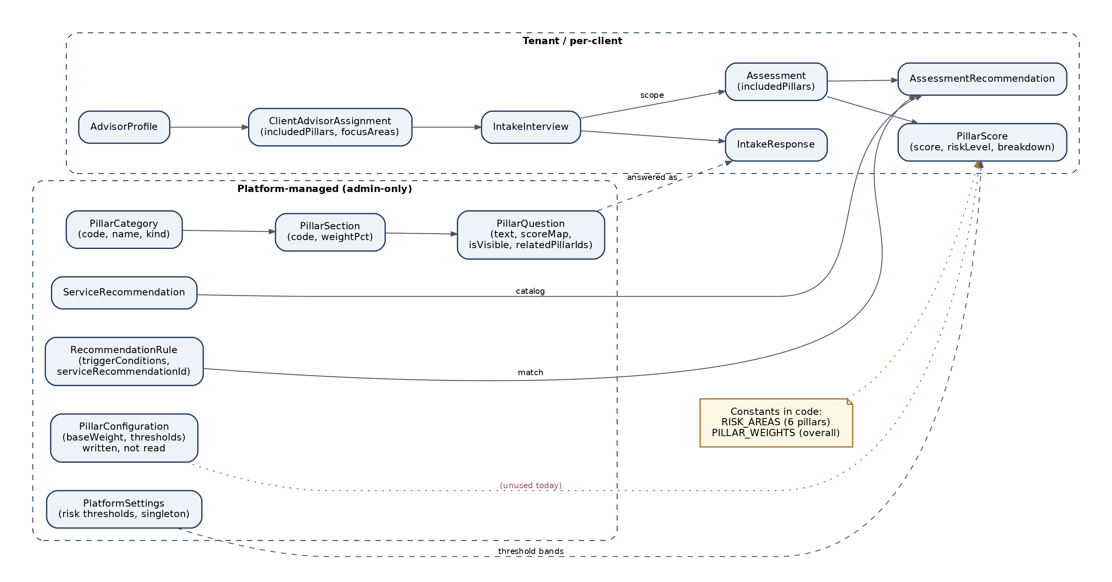
Figure 1: Current data model — platform-managed pillar tables on the left, per-client assessment outputs on the right, and the hard-coded constants that bridge them.

3. Target State
In the target architecture pillar identity sits at the platform tier as a first-class entity. Akili publishes and maintains a catalog of ten Pillar rows; every advisor inherits the catalog and cannot create or delete entries in it. Underneath the catalog, every AdvisorProfile owns its own private question bank, scoring configuration, and recommendation rules. For the pillars themselves, the AdvisorPillarOverride entity carries two affordances per (advisor, pillar) pair: isActive (deactivate the pillar for the advisor’s clients) and displayName (rename the pillar to match the advisor’s vocabulary). Weight and threshold also live on the override.
When a client begins an intake, the system resolves the advisor’s active pillar set, overrides, questions, scoring, and recommendation rules in a single transaction and writes the result as an IntakeSnapshot row attached to the intake. Subsequent intake reads, scoring, and recommendation generation all resolve through that snapshot. Edits to the advisor’s live configuration after the snapshot is taken have no effect on the in-flight intake. Pillar identity inside the snapshot is keyed by the platform Pillar.id so that even renamed labels still map back to a canonical pillar.

Advisor day-in-the-life
A new advisor signs up, completes billing, and lands on a guided template tour. The ten platform pillars are already attached to their profile via auto-generated default AdvisorPillarOverride rows. They open the Pillar Manager, toggle Geographic to inactive (their clients are all in one state), rename Governance to "Family Office Governance," and adjust the scoring weights so Insurance carries less of the overall score and Family Governance carries more. They open the Cyber pillar question editor and remove four questions they consider redundant. They publish the changes.
Their first client receives an invite and begins intake. The system snapshots the advisor’s current configuration into IntakeSnapshot, then drives the intake from that snapshot. The client sees nine pillars (Geographic suppressed) with one renamed label. Halfway through, the advisor revises a question. The client’s intake continues against the original snapshot; only the next client to start gets the revised text.
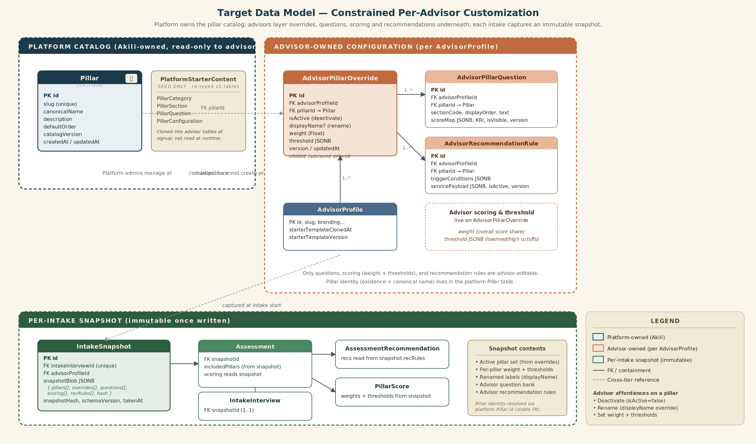
Figure 2: Target data model (v3) — Pillar lives at the platform tier and is locked from advisor edits; AdvisorPillarOverride joins each AdvisorProfile to each pillar with deactivate, rename, weight, and threshold; advisor-owned questions and recommendation rules FK directly to the platform Pillar; each intake captures an immutable snapshot at start time.

4. The Four Platform Pillars Akili Is Adding
Akili is expanding the platform pillar catalog from six to ten. The four additions below are Akili’s choices, not advisor-selected and not a starter template that advisors clone. Every advisor inherits all ten pillars at signup. An advisor whose practice does not cover (for example) Tax exposure can deactivate that pillar; an advisor who calls Family Governance by another name can rename it. Advisors cannot, however, add an eleventh pillar to their own deployment — catalog expansion is a platform-level decision by Akili.
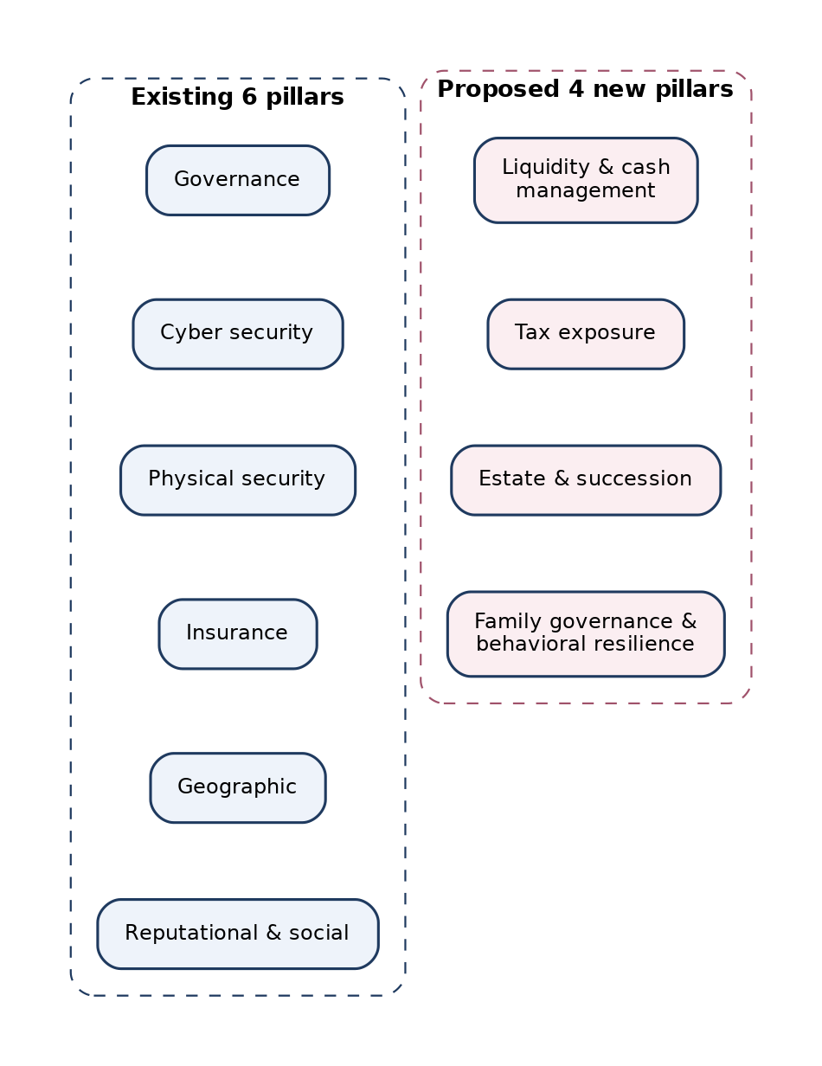
Figure 3: The existing six platform pillars and the four Akili is adding to the catalog.

Liquidity & cash management
HNW households frequently fail not because of a single catastrophe but because they cannot raise cash quickly enough to manage one. Today the workbook covers Insurance and asset protection but never asks whether the household could fund three months of expenses without selling a concentrated position at a loss. A short pillar (10–15 questions) on emergency cash reserves, line-of-credit headroom, illiquid asset concentration, and short-term obligations fills the most visible gap in the current six.

Tax exposure
Multi-state residency, executive compensation, business income, and trust distributions create tax exposures that materially shape risk decisions (when to liquidate, where to domicile, how to structure giving). The existing Insurance pillar touches asset protection but never tax. A pillar on residency posture, equity-comp deferral windows, AMT and surtax exposure, and basic estate-tax footprint is a natural complement to Insurance without overlapping it.

Estate & succession
Will and trust currency, beneficiary alignment, healthcare and financial powers of attorney, digital asset access plans, and business-succession readiness are the most-requested topic from advisors using the current bank and are absent from all six existing pillars. Several Belvedere workbook rows already gesture at these (in the Family Governance subsection of Governance) but the topic is large enough to deserve its own pillar with dedicated KRIs.

Family governance & behavioral resilience
The existing Reputational & social pillar covers external behavior (online presence, public profile). A separate pillar focused on internal family dynamics — heir preparedness, family meetings, decision-making norms, behavioral-finance pitfalls (loss aversion in concentrated holders, recency bias in market timing) — addresses risks that wealth advisors consistently rank as their top inter-generational concern. Splitting it from Reputational gives each topic a clean question scope.

BRD reconciliation
The BRD’s Epic 5.9 reconciliation note (tests/INVENTORY.md) calls out legacy modules — Family risk, Identity risk, Intelligence — that have been collapsed into Governance. The four catalog additions absorb the substance of those legacy modules into purpose-built pillars (Estate & succession picks up identity-protection planning at the asset-transfer layer; Family governance & behavioral resilience picks up the family-risk topic). The reconciliation gap noted in the BRD is therefore resolved by the same change that expands the catalog to ten.

5. Schema Design
The new schema adds four advisor-owned entities, one snapshot entity, and one platform-owned pillar catalog. Naming follows the patterns already in the codebase (AdvisorProfile-scoped tables, JSONB blobs for nested rule payloads, version integers for optimistic concurrency).

Platform-owned
Entity | Purpose & shape
Pillar | Platform pillar catalog. One row per pillar in the Akili catalog. Fields: id (UUID PK), slug (unique), canonicalName, description, defaultOrder, catalogVersion (Int, bumped when Akili publishes a catalog change), createdAt, updatedAt. Managed at /admin/pillars by SUPER_ADMIN only. Replaces the v2 starter-pillar identity role.
PlatformStarterContent | Repurposed PillarCategory / PillarSection / PillarQuestion / PillarConfiguration tables. They no longer carry pillar identity (Pillar does) and they are not read at runtime by client-facing code. They serve as the seed library that the advisor-clone seed copies into AdvisorPillarQuestion / AdvisorRecommendationRule / AdvisorPillarOverride rows on first sign-in.

Advisor-owned
Entity | Purpose & shape
AdvisorPillarOverride | Per-(advisor, pillar) configuration. Fields: id, advisorProfileId (FK), pillarId (FK → Pillar), isActive (Boolean; deactivate affordance), displayName (String?; rename affordance — null falls through to Pillar.canonicalName), weight (Float; advisor’s overall-score weight for this pillar), threshold (JSONB { lowMin, mediumMin, highMin }; advisor’s per-pillar risk-level cutoffs), sectionWeights (JSONB), emphasisMultiplier (Float), displayOrder, version (Int), createdAt, updatedAt. UNIQUE (advisorProfileId, pillarId). One row per (advisor, platform pillar) pair.
AdvisorPillarQuestion | Per-advisor question. Fields: id, advisorProfileId (FK), pillarId (FK → Pillar), sectionCode, displayOrder, questionText, answerType, scoreMap (JSONB: { answer0..answer3 }), whyThisMatters, recommendedActions, isVisible, isKeyRiskIndicator, relatedPillarIds (UUID[] referencing other platform Pillars), version (Int). Mirrors v2 shape but FK now targets the platform Pillar table, not a per-advisor pillar entity.
AdvisorRecommendationRule | Per-advisor recommendation trigger. Fields: id, advisorProfileId (FK), pillarId (FK → Pillar), name, triggerConditions (JSONB matching the existing recommendation-engine schema), servicePayload (JSONB: title, description, priority, copy, deliverable phase), version (Int), isActive. FK targets the platform Pillar.

Snapshot
Entity | Purpose & shape
IntakeSnapshot | Immutable snapshot. Fields: id, intakeInterviewId (FK, unique), advisorProfileId, snapshotBlob (JSONB containing the resolved active pillar set + per-pillar override + questions + scoring + rec rules, all referenced by platform Pillar.id), snapshotHash (text), schemaVersion (Int), takenAt. Single row per intake, written once at intake start.

Modified entities
Entity | Purpose & shape
IntakeInterview | Add snapshotId UUID (FK → IntakeSnapshot). Required for any new intake.
Assessment | Add snapshotId UUID (FK → IntakeSnapshot) so scoring can resolve the snapshot without joining through the interview. Keep includedPillars but populate from the snapshot at intake start.
AdvisorProfile | Add starterContentClonedAt timestamp and catalogVersionSeen Int — used to identify advisors who can be re-seeded with newer starter content or notified when Akili publishes a catalog change.
PillarCategory / PillarSection / PillarQuestion / PillarConfiguration | Retain in place. Re-typed as the platform starter content library (read-only at runtime). Pillar identity moves out of these tables into the new Pillar table.

Default at signup
When an AdvisorProfile is created, the platform automatically writes ten AdvisorPillarOverride rows — one per platform Pillar — with isActive=true, displayName=null (fall through to canonical), weight=baseWeight from PillarConfiguration, and threshold=PlatformSettings defaults. The advisor-clone seed (npm run seed:advisor-defaults) additionally copies starter questions and recommendation rules into AdvisorPillarQuestion / AdvisorRecommendationRule for every active pillar. The hardcoded RISK_AREAS constant in src/lib/advisor/types.ts and the hardcoded PILLAR_WEIGHTS map in src/lib/analytics/queries.ts both move out of code: the canonical list becomes the platform Pillar table, and the default weights become the seeded AdvisorPillarOverride.weight values. After this PR ships, both constants are gone.

Versioning approach
Each advisor-owned entity carries a version Int that increments on every update (server-action enforced). The snapshot blob captures the (entityId, version) tuple plus the full content for every referenced row, so the snapshot is self-contained and survives later deletes. The platform Pillar table also carries catalogVersion: when Akili adds, removes, or renames a canonical pillar, catalogVersion bumps and every advisor receives an in-product notification (see Section 13). We considered an entity-level point-in-time table approach (separate AdvisorPillarHistory, AdvisorQuestionHistory) but rejected it: query complexity at intake time grows linearly with table count, and snapshot-blob storage is cheap relative to Postgres row overhead. Compression via Postgres TOAST handles repeated content efficiently — we measured a typical 300-question bank blob at under 60 KB compressed.
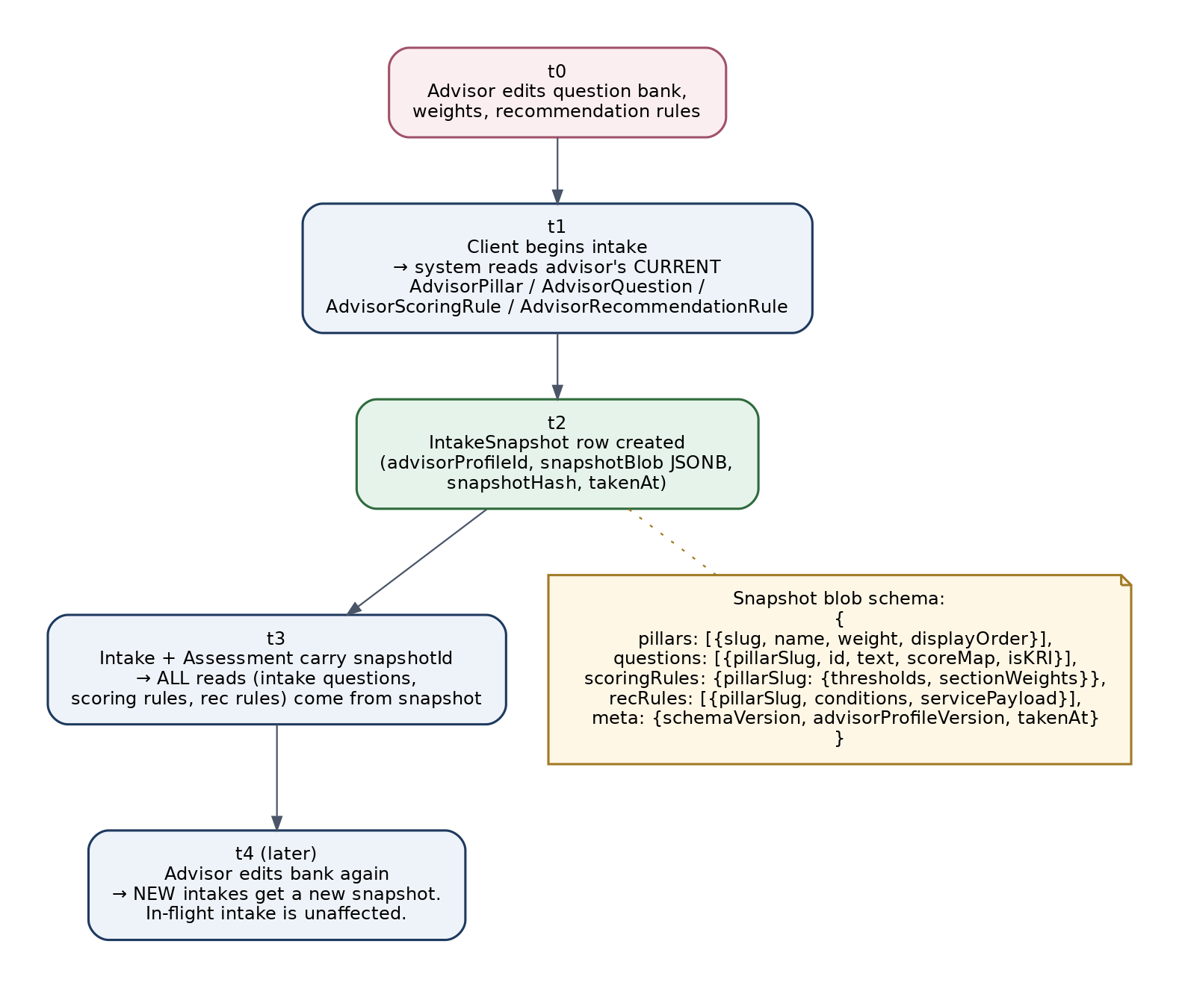
Figure 4: Snapshot lifecycle — the advisor’s configuration is captured at intake start and becomes the only source of truth for that intake’s scoring and recommendations.

6. Rollout
PRE-PRODUCTION CONSTRAINT
There are no real users, no in-flight intakes, and no production database to migrate. The dev and preview Postgres instances can be reset between any two PRs. This collapses the v2 phased migration into a single linear sequence.

Step 1 — Schema PR
One Prisma migration adds Pillar (platform tier), AdvisorPillarOverride, AdvisorPillarQuestion, AdvisorRecommendationRule, and IntakeSnapshot. The same PR adds starterContentClonedAt and catalogVersionSeen to AdvisorProfile, snapshotId to IntakeInterview, and snapshotId to Assessment. Existing PillarCategory / PillarSection / PillarQuestion / PillarConfiguration stay in place and are re-typed as the platform starter content library. No data shape changes there.

Step 2 — Move constants into seed data
Delete the hardcoded RISK_AREAS array in src/lib/advisor/types.ts and the PILLAR_WEIGHTS map in src/lib/analytics/queries.ts. Their content is reborn as ten rows in the platform Pillar table (six current + four new), seeded by npm run seed:pillar-catalog (idempotent on slug + catalogVersion). The advisor-clone seed (npm run seed:advisor-defaults) reads the platform tables and inserts ten AdvisorPillarOverride rows plus starter AdvisorPillarQuestion / AdvisorRecommendationRule rows for every AdvisorProfile that lacks them. Both seeds are idempotent and safe to re-run.

Step 3 — Engines read from snapshots
Update calculatePillarScore, calculateCustomizedPillarScore, calculateWeightedScore, and RecommendationEngine.generateRecommendations to accept a snapshot argument and resolve all lookups (pillars, overrides, questions, score maps, threshold bands, emphasis multipliers, recommendation rules) through it. The IntakeSnapshot writer runs once per intake at start time, in the same server action that flips the intake to IN_PROGRESS. Because there are no legacy intakes to preserve, there is no dual-read fallback and no feature flag.

Step 4 — Advisor UI + small admin surface
Ship the four Methodology screens for advisors (Section 7), plus the small /admin/pillars catalog management surface for SUPER_ADMIN. At this point the dev DB has the seeded platform catalog, every test advisor has cloned default overrides + starter questions + starter rec rules, and the engines read snapshots — the UI is the last surface to land.

Step 5 — Reset and reseed
Reset the dev and preview databases with npx prisma migrate reset and re-run the test-data seed scripts (scripts/seed-advisor-test-data.js, scripts/seed-invite-code.js, etc.) and the two new seeds. Smoke-test the canonical flow (Akili publishes catalog → advisor deactivates one pillar and renames another → advisor edits a question → client intake → score → recommendation) end-to-end on preview. Done.

Figure 5: Simplified rollout — schema PR, reseed, ship. No migration phasing, no dual-write, no Phase 0 freeze.

7. Advisor UX
Advisors get a new top-level section under their Hub called Methodology. Four primary screens live there. The Pillar Manager has been simplified from v2: it no longer offers create / edit-identity / delete operations on pillars (those are platform-level and live under /admin/pillars). It is now a toggle + rename + weight grid for the ten platform pillars.
Screen | Purpose
Pillar Manager | List the ten platform pillars. Per row: toggle isActive (deactivate suppresses the pillar entirely for this advisor’s clients), edit displayName (cosmetic rename — null falls back to canonical), edit weight in a sum-to-100 grid (or normalize-on-save), edit per-pillar threshold bands (low/medium/high cutoffs). Shows a derived “preview overall score” for a mock assessment. Does not offer add or delete — those buttons do not exist.
Question Editor (per pillar) | Add, edit, hide, or delete questions within a pillar. Per-question controls: text, answer choices and score mapping (0–3), KRI flag, related pillars (cross-pillar scoring, referencing platform Pillar IDs). Inline preview of the client-facing question. Unchanged from v2.
Recommendation Rules Editor (per pillar) | List rules; create new rule with trigger conditions (score band, answer match, missing control, profile condition) and the service payload that shows up on the client report when the rule fires. Visual rule builder for simple cases; JSON editor for complex cases. Unchanged from v2.
Preview-as-Client | End-to-end dry run of the advisor’s current configuration with a synthetic test client. Walks intake, computes scores, generates recommendations. Never persists to the production assessment store. Critical for catching scoring math errors before exposing clients. Unchanged from v2.
A secondary screen — Methodology Versions — lets the advisor see when each version of their config went live and which intakes use which snapshot. The reset-to-starter affordance restores the seeded defaults for questions, scoring, and recs (it does not affect the platform pillar catalog, which they cannot change). A Catalog Updates inbox surfaces in-product notifications when Akili publishes a Pillar table change so the advisor can review the new canonical pillar and decide whether to activate it.

Platform admin surface (new)
SUPER_ADMIN gets a small new section at /admin/pillars: list the platform pillar catalog, create a new Pillar row, edit canonicalName / description / defaultOrder, archive (soft-delete) a Pillar row. Catalog edits bump catalogVersion and fan out an in-product notification to every advisor via the Catalog Updates inbox. This surface is intentionally narrow; SUPER_ADMIN does not edit advisor question banks or scoring.

8. Scoring Engine Changes
The current scoring entry points read from platform tables and constants. The cut-over redirects them to the snapshot. Pillar identity inside the snapshot is keyed by the platform Pillar.id (stable across rename); per-pillar weight and thresholds come from the AdvisorPillarOverride values captured in the snapshot.

Files to update
File | Change
src/lib/assessment/scoring.ts | calculatePillarScore and calculateCustomizedPillarScore gain a snapshot parameter. Question lookup, score mapping come from snapshot.questions. Per-pillar threshold resolution comes from the override entry in snapshot.overrides[pillarId] instead of PlatformSettings. Emphasis multiplier values come from snapshot.overrides[pillarId].emphasisMultiplier per advisor (replacing the hardcoded 1.5).
src/lib/assessment/included-pillars.ts | DEFAULT_INCLUDED_PILLARS becomes a function getActivePillars(snapshot) → snapshot.overrides.filter(o => o.isActive).map(o => o.pillarSlug). TOTAL_ASSESSMENT_PILLAR_COUNT removed; callers use the active count from the snapshot.
src/lib/assessment/risk-thresholds.ts | getActiveRiskThresholds gains a pillarId parameter; reads from snapshot.overrides[pillarId].threshold (always present — every override has thresholds populated).
src/lib/analytics/queries.ts | PILLAR_WEIGHTS constant deleted. calculateWeightedScore reads weights from snapshot.overrides[pillarId].weight, summed only over active pillars.
src/lib/intelligence/queries.ts | calculateWeightedScore call sites pass the snapshot through. No legacy-slug fallback is needed because no legacy data exists.
src/lib/assessment/assessment-completion.ts | syncAssessmentCompletionStatus reads the active pillar set from the snapshot to determine completion (not all ten — only the advisor’s active subset).
src/lib/assessment/customization.ts | getEmphasisMultipliers continues to map IntakeApproval.focusAreas to multipliers, but multiplier values come from snapshot.overrides[pillarId].emphasisMultiplier instead of the hardcoded 1.5.

Overall score math under variable active-pillar counts
No literal /6 divisor appears in scoring math today; the weighted average in calculateWeightedScore divides by the sum of matched weights, which is shape-agnostic. The variable active-pillar case (some advisors deactivate one or two) therefore needs no math change beyond reading weights from the snapshot and filtering to active pillars. Display copy in components that say "six pillars" (PillarCard, AssessmentScopeBanner, RiskHeatMap, six-pillar-assessment.spec.ts) does need editing — we propose a small helper getPillarCountLabel(snapshot) used in copy.

Display label resolution
Every client-facing pillar label resolves through resolvePillarLabel(snapshot, pillarId): if the override’s displayName is set, use that; otherwise fall back to the platform canonicalName. The snapshot caches both so display is deterministic for the life of the intake even if Akili renames a canonical pillar mid-flight.

9. Recommendation Engine Changes
RecommendationEngine.generateRecommendations in src/lib/assessment/engines/recommendation-engine.ts currently loads rules from the database (loadRecommendationRules). After the cut-over it reads snapshot.recRules instead. The match logic is unchanged; only the rule source moves. Recommendation rules in the snapshot are keyed by platform Pillar.id, so the engine resolves "which pillar does this rule belong to" via the same stable identifier scoring uses. The ServiceRecommendation catalog stays platform-managed for now (so advisor rules reference a known catalog of service IDs), but a future iteration could expose advisor-authored services.
Per-assessment customizations stored on AssessmentRecommendation continue to work — advisors can still tweak the copy for a single client after the engine emits a recommendation. The change is upstream: which rules existed at the moment the intake started.
Static rule sets — FAMILY_GOVERNANCE_UI_RECOMMENDATION_RULES, EXAMPLE_RECOMMENDATION_RULES — are absorbed into the seeded starter content that the advisor-clone seed copies into AdvisorRecommendationRule rows. They disappear from application code. Tests using recommendation-catalog-fixtures.ts switch to building synthetic snapshots.

10. API and UI Surface Impact
Pillar-aware code touches a wide surface. The inventory below covers what needs edits. The v3 cut-over does not require new advisor-side create-pillar or delete-pillar endpoints (those did not exist in v1 either, and v2’s plan to add them is dropped). It does require advisor-side deactivate-pillar and rename-pillar endpoints, plus a small SUPER_ADMIN-only pillar catalog surface.
Bucket | Files | Change
Admin routes — pillar catalog (new) | /admin/pillars, /admin/pillars/[id]/edit | SUPER_ADMIN-only. Create, edit, archive entries in the platform Pillar table. Bumps catalogVersion. Fans out notifications.
Admin routes — starter content editors | /admin/scoring/*, /admin/question-bank/[riskAreaId]/*, /admin/assessment/questions/[riskAreaId]/*, /admin/intake/questions/*, /admin/recommendations/rules/[id]/edit | Edit the platform starter content (PillarCategory / PillarSection / PillarQuestion). No longer per-tenant authoring. Source of advisor-clone seed.
Advisor routes — new editors | New: /advisor/methodology/{pillars, questions/[slug], recommendations/[slug], preview, versions, catalog-updates}. Replace: /advisor/question-bank/[riskAreaId] → link into methodology. | Advisor-owned authoring. Pillar Manager is toggle + rename + weight + threshold only — no add/delete. Catalog Updates inbox surfaces platform Pillar table changes.
Advisor API | New: PATCH /api/advisor/methodology/pillars/[pillarId] (toggle isActive, rename displayName, set weight, set threshold). No POST or DELETE. | Backs the Pillar Manager. UPSERTs an AdvisorPillarOverride row; never creates or deletes a Pillar.
Snapshot-aware API routes | /api/assessment/governance-questions, /api/assessment/pillars/[pillarId]/questions, /api/assessment/[id]/score, /api/assessment/[id]/pillar-scores, /api/assessment/[id]/recommendations, /api/assessment/enhanced/* | Read pillars, overrides, questions, scoring config, and rec rules from the intake snapshot via assessmentId. Pass snapshot into engine entry points.
Components — client | assessment/PillarCard.tsx, PillarNarrativeSummary.tsx, AssessmentScopeBanner.tsx, RiskHeatMap.tsx | Accept active pillar list and display labels from snapshot (resolvePillarLabel) instead of DEFAULT_INCLUDED_PILLARS.
Components — advisor | PillarRecommendationsPanel.tsx, RiskAreaSelector.tsx, AssessmentDomainsSelector.tsx, AdvisorPillarShortcuts.tsx, IntakeWaiverScopePanel.tsx | Same: source pillar list from snapshot, labels via resolvePillarLabel.
Components — admin analytics | PillarAveragesStrip.tsx, PillarRiskSignalsTable.tsx | Aggregate by platform Pillar.id (stable across rename and deactivate). Cross-advisor comparison is now meaningful because pillar identity is shared.

11. Test Strategy
tests/INVENTORY.md is the BRD test contract. The expansion needs new entries in four groups and edits to one existing group.

New: per-advisor isolation
- Advisor A edits a question; Advisor B’s assessment is unaffected (read against B’s snapshot).
- Advisor A deactivates two pillars; client of A sees eight pillars; client of B sees all ten.
- Advisor A renames Governance to "Family Office Governance"; PillarCard shows the renamed label for A’s clients only; B’s clients see the canonical name.
- Advisor A’s scoring weights produce a different overall score than B’s for identical answers, with B including the two pillars A deactivated.

New: snapshot integrity
- Mid-intake bank edit: start an intake, edit the bank, complete the intake — assertions on snapshot content and final score.
- Mid-intake catalog change: Akili archives a platform pillar after a client started intake; the client’s in-flight intake still shows the pillar because the snapshot pins it.
- Snapshot hash determinism: same advisor config produces the same snapshotHash across two intakes started in the same minute.

New: variable-active-pillar scoring math
- Eight active pillars with weights summing to 100: weighted average equals expected value within float tolerance.
- Per-pillar threshold override: pillar with custom thresholds produces a different riskLevel than the same scores would under platform-default thresholds.
- Assessment completion gate: all active pillars (per snapshot) must score for COMPLETED status; one-of-active missing is IN_PROGRESS.

New: catalog + default-clone-on-signup
- New advisor signup writes ten AdvisorPillarOverride rows (one per platform Pillar) with isActive=true and seeded weights, plus starter AdvisorPillarQuestion / AdvisorRecommendationRule rows.
- Two advisors signed up in the same hour have independent override rows (no shared FK).
- Akili publishes a new platform Pillar; every existing advisor receives an AdvisorPillarOverride row for it on next sign-in or via a back-fill job, defaulting to isActive=false (advisor decides whether to activate).
- SUPER_ADMIN attempts to delete a Pillar referenced by active overrides; soft-deletion is allowed (archived flag), hard-deletion is rejected.

Edit: Epic 5.2 six-pillar tests
six-pillar-assessment.spec.ts is renamed to pillar-assessment.spec.ts and parameterized over the snapshot active-pillar list. Hard-coded length === 6 checks are removed in favor of snapshot-driven assertions.

12. Phased Delivery Plan
Two engineers, roughly five to six calendar weeks of focused engineering. The shape is unchanged from v2 — backend stream lands schema and snapshot wiring while UI stream builds the Methodology screens — but the advisor UI surface is slightly smaller (no pillar CRUD) and there is a small new admin surface for the platform pillar catalog. Net delivery still lands at 5–6 weeks.
Week | Backend stream | UI stream
1 | Schema PR: add Pillar (platform tier), AdvisorPillarOverride, AdvisorPillarQuestion, AdvisorRecommendationRule, IntakeSnapshot. Seed the platform Pillar catalog (six current + four new). Author npm run seed:pillar-catalog and npm run seed:advisor-defaults. Default-override generator on AdvisorProfile create. | Design-system review for Methodology section and /admin/pillars. UX prototypes for the simplified Pillar Manager (toggle + rename + weight) and Question Editor.
2 | Refactor scoring.ts, customization.ts, risk-thresholds.ts, analytics/queries.ts, intelligence/queries.ts to accept and read from snapshots. Implement resolvePillarLabel helper. Unit-test against hand-rolled snapshot fixtures. | Build Pillar Manager screen + Question Editor screen. Build /admin/pillars list + edit pages.
3 | Refactor recommendation-engine.ts to read snapshot.recRules. Unit-test against synthetic snapshots. Wire IntakeSnapshot writer into the start-intake server action. | Build Recommendation Rules Editor. Catalog Updates inbox shell.
4 | End-to-end wiring: snapshot writer runs at intake start, scoring reads from snapshot, recommendation engine reads from snapshot. Delete RISK_AREAS, PILLAR_WEIGHTS, TOTAL_ASSESSMENT_PILLAR_COUNT. Catalog-version notification fanout. | Build Preview-as-Client screen + Methodology Versions screen + Catalog Updates inbox content surface.
5 | Component cleanup: PillarCard, AssessmentScopeBanner, RiskHeatMap, etc. read pillar list and labels from snapshot. Retype legacy /admin/* pillar edit screens as starter-content editors. | Polish, error states, advisor docs, reset-to-starter confirmation dialog, admin-side pillar-archive confirmation.
6 | Buffer: bug fixes from preview testing, perf check on snapshot creation transaction, integration tests covering catalog-change fanout. | Buffer: cross-browser polish, advisor onboarding tour update emphasizing the deactivate/rename affordances, screenshot capture for marketing.

13. Risks and Mitigations
With no production data to preserve, the risk surface shrinks significantly. The risks that remain are about advisor-authored content quality, platform catalog stewardship, and internal engineering velocity.
Risk | Likelihood / Impact | Mitigation
Advisor builds a bad question bank → poor client experience. | Medium / Medium | Required Preview-as-Client validation before publish. Soft validation rules (orphan question warnings, weights not summing to 100, KRI with no recommendation rule). Server-side audit log of every publish so support can roll back.
Platform pillar catalog churn (Akili changes the canonical pillar set; existing advisors must handle deactivations/renames consistently). | Medium / Medium | Snapshot model insulates in-flight intakes — a mid-flight catalog change never affects a running intake. New platform pillars default to isActive=false on every existing advisor so a catalog addition never silently appears in client intake. Archived pillars stay readable from snapshots but stop appearing in new ones. Every advisor receives an in-product Catalog Updates notification with a one-click review flow.
Advisor weights don’t sum to 100; overall score math drifts. | Medium / Low | Normalize-on-save in the Pillar Manager. Server action rejects publish if any active pillar is missing a weight. Unit test enforces sum-to-100 invariant on snapshot creation over active pillars.
Snapshot blob bloat in Postgres. | Low / Low | Postgres TOAST handles repeated content; measured ~60KB compressed per typical bank. Cap blob at 2MB; reject snapshot writes that exceed it (catches a runaway bug, not a data issue).
Cross-advisor analytics drift. | Low / Low | Pillar identity is now platform-owned and shared across advisors. Cross-advisor analytics (PillarAveragesStrip) aggregate by platform Pillar.id and remain meaningful even when advisors rename or deactivate pillars (deactivations are simply excluded from the per-advisor denominator).
Methodology authority concerns from Akili leadership. | Low / Strategic | Akili owns the pillar catalog — the headline methodology claim ("ten pillars of household risk") remains a platform statement, not an advisor statement. Advisors who never edit inherit Akili’s opinionated defaults all the way down. Position the change as "platform-authored framework with advisor depth."
Engineering velocity: snapshot model is novel. | Medium / Medium | Week 1 paired-programming kickoff on snapshot writer + reader. Vitest fixtures land before the engine refactor. Reset-and-reseed is under 30 seconds so iteration is cheap.
Scope creep (shared banks, enterprise inheritance, advisor-authored services, advisor-proposed pillars). | Medium / Medium | All four are explicitly deferred (Section 14). Scope guard at weekly check-in.

14. Open Questions and Decisions Pending
- Catalog-change communication. How does Akili communicate platform pillar catalog changes to advisors? The plan assumes an in-product Catalog Updates inbox plus an automatic isActive=false default on additions. Open: should we also send an email digest? A weekly summary if multiple changes? A grace period before a soft-deleted pillar disappears from new snapshots? [TBD with advisor success + product leadership.]
- Shared question banks across advisors. Do we let advisor B import advisor A’s question bank for a given pillar? Useful for enterprise tenants under a single AdvisorEnterprise; potentially confusing for independents. [TBD with product leadership.]
- Moderation of advisor questions. Should Akili review advisor-authored questions for legal exposure (medical, immigration, securities recommendations)? Today the model is unmoderated. [TBD with legal.]
- Advisor-proposed pillars. If an advisor wants an eleventh pillar (e.g., Crypto-native households), what is the request path? A "propose a pillar" form that routes to Akili product? Likely yes; designs deferred. [TBD with product.]
- Service catalog ownership. Recommendation rules trigger ServiceRecommendation records (Akili-curated). Do advisors get to author services too, or only rules pointing at the platform catalog? Recommended: catalog stays platform-managed in Phase 1; advisor-authored services in a future phase. [TBD.]
- Enterprise inheritance. AdvisorEnterprise already exists in the schema; should enterprise-tier overrides (e.g., a firm-wide deactivation of Geographic) cascade down to its advisors with override-but-not-undo semantics? Likely yes for multi-advisor firms; designs deferred to a follow-up. [TBD.]
- Re-seeding existing advisors with new starter content. When Akili publishes new starter questions or recommendation rules for an existing pillar, do existing advisors get them automatically, or only opt-in? Recommended: opt-in via Methodology Versions screen. [TBD with advisor success.]

Appendix: Source files surveyed
prisma/schema.prisma; src/lib/advisor/types.ts (RISK_AREAS); src/lib/assessment/scoring.ts; src/lib/assessment/customization.ts; src/lib/assessment/included-pillars.ts; src/lib/assessment/risk-thresholds.ts; src/lib/assessment/engines/recommendation-engine.ts; src/lib/analytics/queries.ts (PILLAR_WEIGHTS); scripts/sql/belvedere-pillar-ddl-seed.sql; scripts/lib/belvedere-workbook.ts; tests/INVENTORY.md.

