Output of description.py

Data shape:

(9314, 8)

Data types:

Year int64

Month int64

Day int64

MaxTemp float64

MinTemp float64

MeanTemp float64

HeatDegDays float64

Total_Precip_mm float64

dtype: object

Data description:

Year Month Day MaxTemp MinTemp MeanTemp HeatDegDays Total_Precip_mm

count 9314.000 9314.000 9314.000 9314.000 9314.000 9314.000 9314.000 9314.000

mean 2002.338 7.106 15.955 16.426 8.499 12.481 6.641 30.492

std 8.669 2.863 8.809 9.165 8.604 8.645 7.452 11.753

min 1987.000 1.000 1.000 -16.400 -29.000 -22.300 0.000 20.100

25% 1995.000 5.000 9.000 9.500 2.500 6.300 0.000 23.000

50% 2002.000 7.000 16.000 17.500 10.000 14.000 4.000 26.600

75% 2010.000 9.000 24.000 24.000 15.500 19.500 11.700 34.000

max 2017.000 12.000 31.000 38.500 26.000 30.500 40.300 175.800

Correlations:

Year Month Day MaxTemp MinTemp MeanTemp HeatDegDays \

Year 1.000e+00 -0.055 0.022 0.003 -0.003 2.602e-04 -1.519e-04

Month -5.460e-02 1.000 0.008 0.141 0.176 1.624e-01 -1.791e-01

Day 2.160e-02 0.008 1.000 0.028 0.019 2.402e-02 -2.851e-02

MaxTemp 3.174e-03 0.141 0.028 1.000 0.890 9.739e-01 -9.475e-01

MinTemp -2.843e-03 0.176 0.019 0.890 1.000 9.704e-01 -9.537e-01

MeanTemp 2.602e-04 0.162 0.024 0.974 0.970 1.000e+00 -9.777e-01

HeatDegDays -1.519e-04 -0.179 -0.029 -0.947 -0.954 -9.777e-01 1.000e+00

Total_Precip_mm 2.703e-02 0.055 -0.006 0.135 0.162 1.525e-01 -1.530e-01

Total_Precip_mm

Year 0.027

Month 0.055

Day -0.006

MaxTemp 0.135

MinTemp 0.162

MeanTemp 0.153

HeatDegDays -0.153

Total_Precip_mm 1.000

Covariance:

Year Month Day MaxTemp MinTemp MeanTemp HeatDegDays Total_Precip_mm

Year 75.144 -1.355 1.649 0.252 -0.212 0.019 -0.010 2.754

Month -1.355 8.195 0.203 3.696 4.330 4.019 -3.821 1.857

Day 1.649 0.203 77.601 2.221 1.423 1.829 -1.872 -0.574

MaxTemp 0.252 3.696 2.221 83.988 70.192 77.156 -64.710 14.563

MinTemp -0.212 4.330 1.423 70.192 74.029 72.178 -61.150 16.397

MeanTemp 0.019 4.019 1.829 77.156 72.178 74.734 -62.992 15.497

HeatDegDays -0.010 -3.821 -1.872 -64.710 -61.150 -62.992 55.539 -13.398

Total_Precip_mm 2.754 1.857 -0.574 14.563 16.397 15.497 -13.398 138.133

Data skew:

Year 0.005

Month -0.257

Day 0.012

MaxTemp -0.483

MinTemp -0.749

MeanTemp -0.623

HeatDegDays 1.068

Total_Precip_mm 2.872

dtype: float64

output of seasonPlot.py

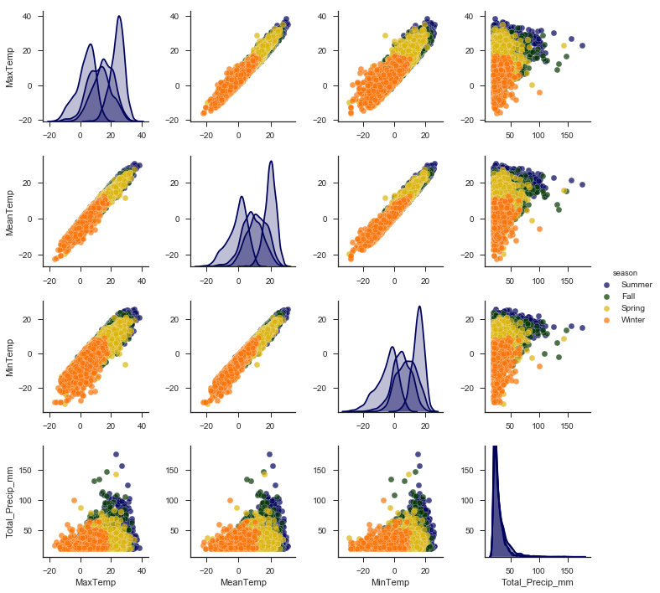

Output of Linear_Reg_Coeff.py

The coefficient for Year is -1.8667517826067876e-05

The coefficient for Month is 0.0001639392009616094

The coefficient for Day is 7.751674125048345e-05

The coefficient for MaxTemp is 0.49926820675709654

The coefficient for MinTemp is 0.49978313007715003

The coefficient for HeatDegDays is -0.0021614603228394206

The coefficient for Total_Precip_mm is 1.4014519516446411e-05

The intercept is 0.08169032180993518

Score: 0.99999082337

MSE: 0.000697663808955

MSE sqrt: 0.026413326351574735

The predicted Mean Temp is: [[ 2.03857878]]

Output of Lin_Reg_Plot.py

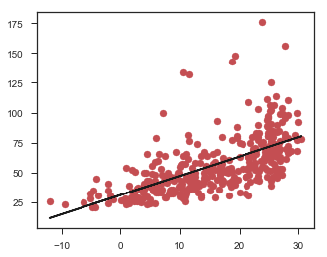

Output of randomForest.py:

Accuracy: 74.66 %.

Variable: MinTemp Importance: 0.19

Variable: Day Importance: 0.18

Variable: MaxTemp Importance: 0.18

Variable: Year Importance: 0.17

Variable: MeanTemp Importance: 0.14

Variable: Month Importance: 0.09

Variable: HeatDegDays Importance: 0.06