Employee Turnover Data
Data Profiling and Cleaning Report
Earl Birdsong | Python 3.12, pandas, NumPy, Matplotlib, seaborn

Executive Summary
A technology firm wants to understand which employees are at greater risk of leaving so it can design better retention strategies. Before any modeling, the raw HR dataset had to be profiled and cleaned. This report documents the dataset’s structure, the quality issues found, how each was corrected in Python, and the trade-offs of that approach.
Result: the raw file of 10,199 records was reduced to 10,100 unique records with all 16 variables retained, no missing values, consistent category labels, numeric fields stored as numbers, and implausible values corrected.

1. Data Profile
The raw dataset contains 10,199 records (rows) and 16 variables (columns). Table 1 lists each variable with its data type, subtype, and a sample of observed raw values.
Table 1. Variable profile
Variable | Data type | Subtype | Sample values (raw)
EmployeeNumber | Qualitative | Nominal | 1, 2, 3, 4
Age | Quantitative | Discrete | 28, 33, 22, 23
Tenure | Quantitative | Discrete | 6, 2, 1, 16
Turnover | Qualitative | Nominal | Yes, No
HourlyRate | Quantitative | Continuous | $24.37, $22.52, $88.77
HoursWeekly | Quantitative | Discrete | 40
CompensationType | Qualitative | Nominal | Salary
AnnualSalary | Quantitative | Continuous | 50689.6, 46841.6, 284641.6
DrivingCommuterDistance | Quantitative | Continuous | 89, 35, 12, 0
JobRoleArea | Qualitative | Nominal | Research, Sales, Information_Technology
Gender | Qualitative | Nominal | Female, Male, Prefer Not to Answer
MaritalStatus | Qualitative | Nominal | Married, Single, Divorced
NumCompaniesPreviouslyWorked | Quantitative | Discrete | 3, 6, 1, 7
AnnualProfessionalDevHrs | Quantitative | Discrete | 7, 8, 19, 23
PaycheckMethod | Qualitative | Nominal | Mail Check, Mailed Check, DirectDeposit
TextMessageOptIn | Qualitative | Nominal | Yes, No

EmployeeNumber is stored as an integer but is classified as nominal because it is an identifier with no numeric meaning. HoursWeekly and CompensationType each hold a single value for every employee; they were kept to preserve the complete variable list.

2. Data Quality Inspection and Findings
Each issue was checked in a single reproducible Python script using pandas and NumPy, with boxplots drawn in Matplotlib and seaborn. Table 2 summarizes the inspection method and what it found.
Table 2. Quality issues: detection and findings
Issue | How it was inspected | Findings
Duplicate entries | df.duplicated().sum() on full rows; EmployeeNumber checked separately for repeated IDs | 99 exact duplicate rows, each repeating an existing EmployeeNumber
Missing values | df.isna().sum() with percentage of rows per column | NumCompaniesPreviouslyWorked: 665 (6.5%); AnnualProfessionalDevHrs: 1,969 (19.3%); TextMessageOptIn: 2,266 (22.2%)
Inconsistent entries | value_counts() on each categorical column; AnnualSalary compared with HourlyRate × HoursWeekly × 52 | JobRoleArea: 228 rows with variant spellings (e.g., Human_Resources). PaycheckMethod: 7 labels for 2 methods. AnnualSalary: 2,149 rows disagree with the hourly rate, including 57 negative salaries
Formatting errors | repr() on column names; dtypes and head() to confirm storage types | HourlyRate header has a trailing space; values are text with a $ sign and trailing space; count columns stored as decimals
Outliers | describe() summary statistics, IQR fences (Q1 − 1.5×IQR, Q3 + 1.5×IQR, and boxplots | DrivingCommuterDistance: 1,351 negative values and extreme values of 250–950 miles. Age, Tenure, and the count columns had no outliers

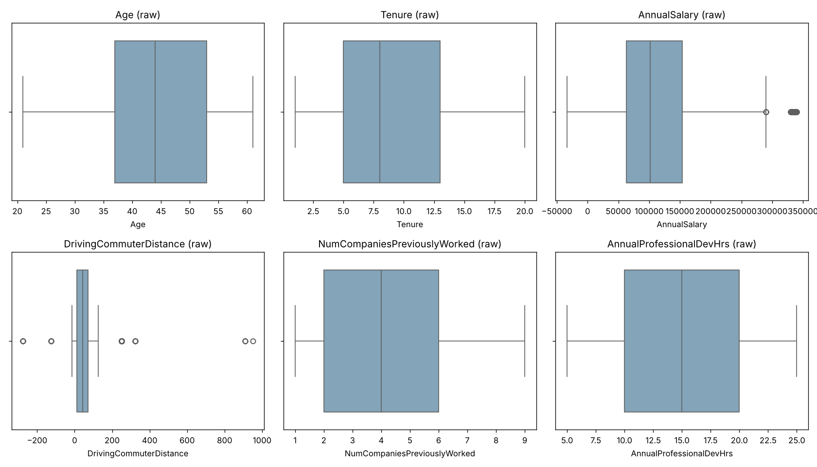
Figure 1. Boxplots of the raw numeric variables. AnnualSalary shows negative and inflated values; DrivingCommuterDistance shows negative and extreme values.

3. Data Cleaning

Modifications and Rationale
Table 3 describes how the dataset was modified for each issue and why that technique was chosen.
Table 3. Cleaning techniques applied
Issue | Modification in Python | Why this technique
Duplicates | drop_duplicates(keep="first") | Rows were exact copies, so removing them loses no information and prevents double-counting employees
Missing values | Median imputation for the two numeric counts; "Unknown" for TextMessageOptIn | The median resists skew and keeps whole-number counts. Labeling opt-in as Unknown avoids inventing a Yes/No answer
Inconsistent entries | Mapping dictionaries for JobRoleArea and PaycheckMethod; AnnualSalary recalculated as HourlyRate × 40 × 52 | Mapping merges variants into one category per value. HoursWeekly is constant, so the hourly rate is the reliable source for salary
Formatting errors | str.strip() on headers and text; regex removal of $ and spaces; to_numeric() and astype(int) | Numeric columns must be numeric for calculation and modeling; whole-number counts are stored as integers
Outliers | abs() on negative commutes; values beyond the IQR fence set to NaN and replaced with the median (41 miles) | Small negatives are sign-entry errors. Commutes of 250+ miles are not plausible daily trips, and median replacement keeps the records

After cleaning, the script verifies zero missing values, zero duplicates, and no negative salaries or commutes, then exports the result to employee_turnover_cleaned.csv.

Advantages
- Every employee is retained. Imputing and replacing values instead of deleting rows keeps all 10,100 unique records, which preserves statistical power for later turnover modeling.
- Reproducible and auditable. All changes run from one annotated script against an untouched raw file, so the same cleaned output can be regenerated and every rule reviewed.

Limitations
- Imputation reduces variability. Filling 19% of AnnualProfessionalDevHrs and the replaced commute outliers with medians concentrates values at the center, which can weaken relationships a model might detect.
- Some corrections rely on assumptions. Treating negative commutes as sign errors and recalculating salary from the hourly rate assume the hourly rate is correct. TextMessageOptIn also now carries an Unknown category that later analysis must handle.

