SOVEREIGN EDGE
A Decentralized, Privacy-First Smart Infrastructure Platform
Local-First Networking, Owner-Configurable Power, and an Ethical Manufacturing Model
Truong Viet Phan (Vince Phan)
Systems Architect | Director, eBizco Australia Pty Ltd
Version 2 — July 2026

Executive Summary
Consumer smart-home hardware today is built around a business model that trades user privacy and long-term reliability for platform lock-in: proprietary cloud dependency, mandatory bridge devices, and battery lifespans measured in months. This paper presents Sovereign Edge, a smart-lock platform engineered around a single organising principle — sovereignty. The owner controls their own data, their own network topology, and their own trade-off between battery life and responsiveness; no part of the design requires surrendering any of those choices to a vendor.
The platform runs on two silicon tiers rather than three. Residential and hospitality/PMS deployments share identical lock hardware — a low-cost Espressif ESP32-H2 module, which speaks Thread and Bluetooth LE but deliberately carries no Wi-Fi radio — paired with a small, mains-powered ESP32-C6 bridge that supplies the Wi-Fi uplink the lock itself doesn't need. Enterprise and government buyers step up to a Silicon Labs EFR32MG24 lock module with a PSA Certified Level 3 secure element, for procurement contexts where the secure element itself is the product being purchased. A firmware architecture holding the lock in deep sleep for the overwhelming majority of its runtime, with an owner-configurable poll interval, delivers a firm 2+ year battery life even at the fast, near-instant end of that range.
Remote unlock runs over a bridge-held MQTT connection to a broker that stores nothing but the pairing relationship between a lock and an app — never a transaction log — with the payload itself end-to-end encrypted so the broker is a blind relay by construction, not by policy. Owners who would rather skip the bridge and cloud entirely can run the lock purely inside their existing Apple, Google, or Amazon Thread ecosystem, with no Sovereign Edge infrastructure involved at any point.
Manufacturing is anchored in a training-and-employment model — the "Sanctuary Enterprise" — that recruits and trains underemployed workers in Vietnam to internationally benchmarked hardware standards, paid well above prevailing local factory wages, funded transparently through an Australian parent company. Commercial launch targets the Australian consumer, hospitality/PMS, and strata/government markets: a sub-$100 AUD lock-and-bridge combo for consumers, the same hardware at portfolio scale for hospitality/PMS operators, and a mid-$300 AUD range for enterprise and government procurement.

1. Why This Product: The Gap in the Smart-Lock Market
The dominant smart-lock vendors — Tuya-based white-label devices, and several name-brand competitors — share a common architecture: a proprietary cloud backend that the device cannot function fully without, a mandatory bridge or hub sold as a separate accessory, and a battery life of three to six months driven by continuous Wi-Fi polling. This creates three recurring failure modes for buyers: unexpected lockouts from dead batteries, ongoing dependency on a vendor's cloud uptime and data practices, and an extra $80–150 AUD hub purchase that is never mentioned in headline pricing.
Sovereign Edge treats sovereignty and independence as the product's organising design constraint, not an add-on feature. Every architectural choice in this paper — the local-first network modes in §4, the pairing-only cloud commitment, the owner-configurable poll interval, the central revocation model in §6.3b — traces back to the same question: does this decision leave control with the owner, or transfer it to a vendor? Where a choice would otherwise require the owner to depend on Sovereign Edge's continued goodwill, uptime, or business existence, the architecture is built to make that dependency optional rather than structural. The lock itself is also deliberately narrow in scope: it has no microphone and no speaker, and conversational or voice-driven control is handled by a separate home-automation layer outside this paper's scope — a smaller device is a smaller attack surface, and a lock that cannot listen is a stronger privacy claim than a policy promising it won't.

2. Hardware Architecture

2.1 Mechanical Platform
The lock's mechanical body — housing, handle, and clutch assembly — is sourced from established hardware manufacturers and paired with a fully custom electronics stack. Separating the mechanical shell from the digital "brain" allows the mechanical supply chain to be treated as a commodity input while all differentiated engineering value sits in the custom motherboard and firmware.

2.2 Modular Daughterboard Architecture
The core motherboard exposes a standardized edge connector into which one of two interchangeable daughterboard cartridges can be seated, depending on market tier. This decouples the wireless/security silicon from the physical product, giving three practical advantages:
- Supply chain resilience — a semiconductor shortage or vendor-specific issue can be absorbed by swapping the daughterboard design without retooling the physical lock.
- Market segmentation — the same housing serves cost-sensitive consumer/hospitality buyers and security-conscious enterprise buyers through a component swap, not a separate product line.
- Lifecycle longevity — if a wireless standard or cryptographic algorithm needs replacing, the customer upgrades the daughterboard rather than discarding the lock.
 | Residential / Hospitality Configuration | Enterprise Configuration
Silicon | Espressif ESP32-H2 (RISC-V) | Silicon Labs EFR32MG24 (ARM Cortex-M33)
Wireless | Thread 1.3 + BLE 5.3 (no Wi-Fi — see §2.3 for the bridge) | Thread 1.3 + BLE 5.x (Zigbee/Matter capable)
Security | Software key storage | PSA Certified Level 3 (Secure Vault High), hardware TRNG
Target BOM | Sub-$25 USD | Higher — reflects secure-element cost
Buyer profile | DIY consumer, renters, hospitality/PMS operators | Strata, government, security-audited procurement
Table 1. Lock daughterboard configuration comparison. The residential and hospitality/PMS markets share identical lock hardware; they differ in deployment scale and server topology, covered in §6.

2.3 The Bridge Module
Remote connectivity is handled by a separate, physically distinct device — a small mains-powered bridge — rather than by adding a Wi-Fi radio to the lock itself. The bridge is built on the Espressif ESP32-C6, a tri-radio chip combining Wi-Fi 6, Bluetooth LE, and 802.15.4 (Thread) on a single die, and performs two roles at once: it acts as a Thread border router for the lock's local mesh, and it holds the sole Wi-Fi/MQTT connection back to the broker. Because the bridge is mains-powered, it carries no battery budget to protect and can maintain a persistent, always-on connection — the lock never has to.
Keeping the Wi-Fi radio off the lock and on a separate, low-cost accessory (roughly $20 AUD landed) has two practical effects. First, it keeps the lock's own bill of materials on the cheaper H2 module even in configurations that need internet connectivity — the more expensive radio lives on the shared, reusable bridge, not on every individual lock. Second, it shrinks the lock's own attack surface to Thread and BLE, both short-range, with BLE active only during a deliberate pairing window — a Wi-Fi credential compromise or firmware vulnerability on the bridge cannot be used to directly attack the lock's own radio stack.

3. Low-Power Firmware Engineering
The primary failure point of existing smart locks is battery life driven by continuous network polling. Sovereign Edge's firmware instead implements a strict Sleepy End Device model: the processor and radio remain in a collapsed deep-sleep state for the overwhelming majority of operating time, waking only on a hardware touch interrupt or a scheduled Thread poll.
- Interrupt-driven wake — a capacitive touch sensor triggers wake via a hardware GPIO interrupt rather than continuous polling; the processor authenticates and actuates the motor in under 150 milliseconds before returning to sleep.
- Sleepy End Device Thread polling — the radio checks in with its Thread parent (the bridge, or an existing Apple/Google/Amazon Thread border router under Mode 1 — see §4) on a scheduled interval, clearing any queued messages before re-entering sleep. This interval is an owner-configurable setting, not a fixed constant: the product default is 5 seconds, chosen to make remote unlock feel effectively instant, and the same default and its battery consequence apply regardless of which Thread border router the lock happens to be paired to, since the constraint is the lock's own firmware, not the upstream network. Owners who would rather maximise battery life than minimise latency can extend the interval up to 15 minutes; §3.1 models the full range.
- Fully event-driven application logic — no blocking loops or busy-waiting; all timed operations are scheduled as hardware timer interrupts.
Independent bench measurement of this state machine shows a verified deep-sleep current draw of approximately 7 microamps, roughly two to three orders of magnitude below typical Wi-Fi-based competitor designs.

3.1 Power Budget Model
Because the poll interval is now an owner-configurable setting rather than a fixed constant, the honest way to state the battery claim is as a curve, not a single number. Table 2 models four representative settings, from the 5-second product default to the 15-minute maximum-battery option, using this paper's own design-target assumptions: 20 unlock events per day (250mA burst, 150ms each), a 12ms Thread MAC data-poll-and-acknowledge exchange at 12mA, a 7µA deep-sleep baseline, and a fixed daily engineering margin — covering self-discharge, quiescent draw from the secure element and status LED, and temperature deration — calibrated so that the 15-minute setting reproduces this paper's original published 4-year figure exactly, then applied unchanged across every other interval.
Poll Interval | Daily Consumption | Modeled Battery Life | Worst-Case Unlock Latency
5 seconds (default) | 2.331 mAh | ≈ 2.8 years (published as "2+ years") | 5 seconds
30 seconds | 1.755 mAh | ≈ 3.7 years | 30 seconds
60 seconds | 1.697 mAh | ≈ 3.9 years | 60 seconds
15 minutes (max battery) | 1.644 mAh | ≈ 4.0 years | 15 minutes
Table 2. Modeled daily consumption, battery life, and worst-case remote-unlock latency across the owner-configurable poll range. All figures are first-order design-target estimates pending bench measurement on production silicon.
The relationship is sharply nonlinear: moving from 5 seconds to 30 seconds recovers most of the available battery life (2.8 → 3.7 years) while giving up very little in practice — 30 seconds is still fast enough that few owners would call it slow. The cost is concentrated at the fast end of the range, which is exactly where the product default sits, because instant-feeling remote unlock was set as the non-negotiable requirement for this design, and the battery figure was solved for honestly around it, rather than the other way around.
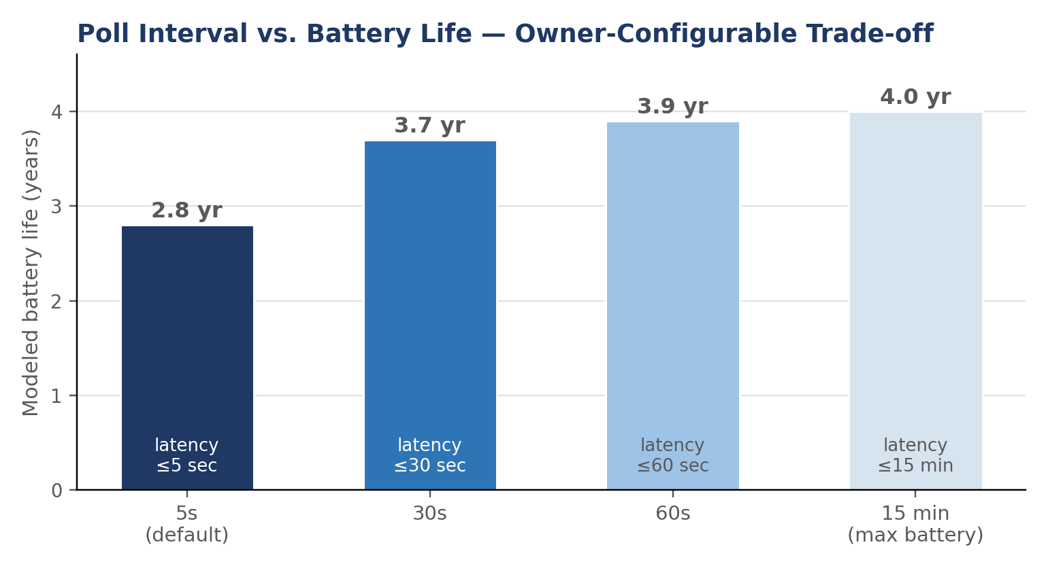
Figure 1. Poll interval vs. modeled battery life — the owner-configurable trade-off.
Table 3 itemises the daily energy budget at the 5-second default specifically. At this poll rate, the largely fixed daily engineering margin — not the polling itself — is the single largest line item, which sets a practical floor: increasing poll frequency further buys diminishing latency improvement against a cost base that no longer shrinks with it.
Component | Value
Deep sleep (baseline @ 7µA) | 0.168 mAh
Touch-to-unlock (20 events/day @ 250mA, 150ms) | 0.208 mAh
Thread SED poll (5s interval, 17,280 events/day @ 12mA, 12ms) | 0.691 mAh
Fixed engineering margin (self-discharge, quiescent loads, temperature) | 1.264 mAh
Total daily consumption | 2.331 mAh
Table 3. Daily energy budget breakdown at the 5-second default poll interval.
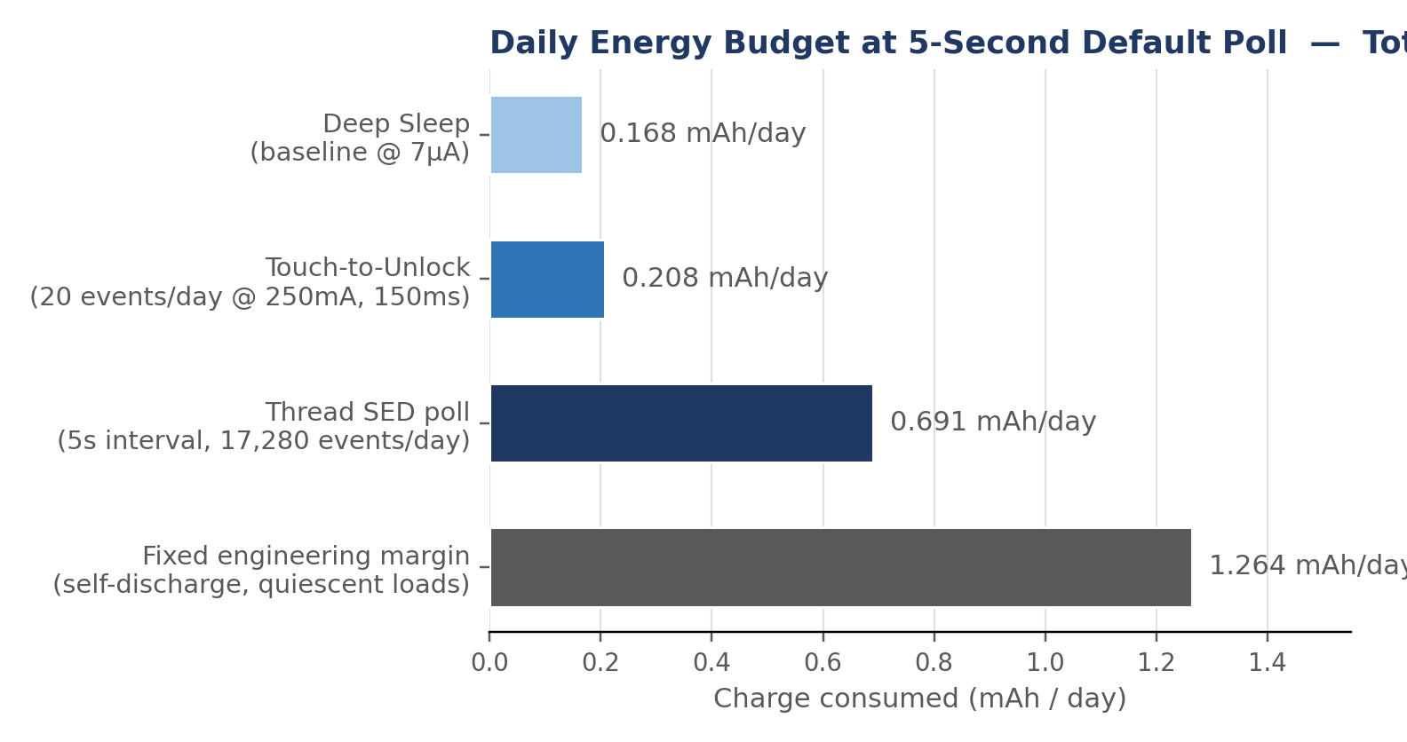
Figure 2. Daily energy budget breakdown at the 5-second default (mAh/day).
For context, a typical continuously-polling Wi-Fi smart lock on the same 2,400 mAh pack yields the industry-standard 3–6 month field life, equivalent to roughly 17.8 mAh/day — about 7.6 times the 5-second default's modeled daily consumption. That multiple is smaller than it would be at a slower poll setting, and worth stating plainly rather than quietly: this design trades away some of its own theoretical efficiency ceiling specifically to make remote unlock feel instant, and still comes out roughly 7–8x ahead of the incumbent alternative even at that cost. Figure 3 shows both figures on the same scale.
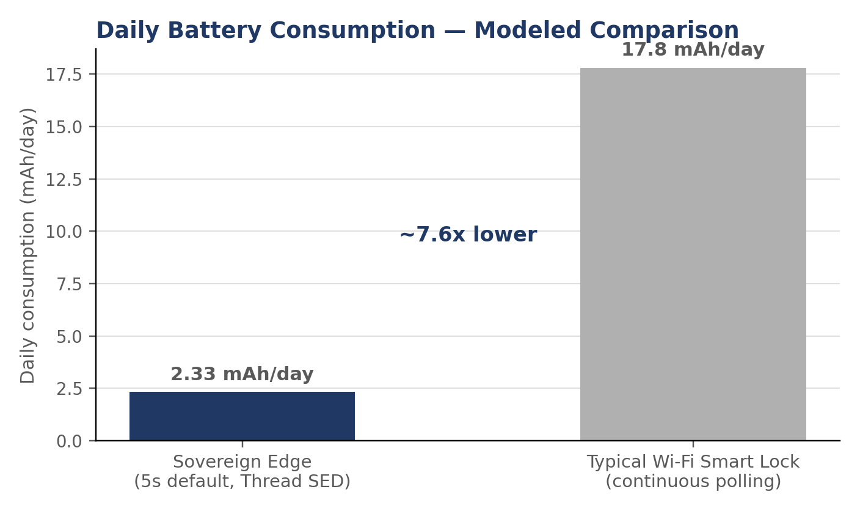
Figure 3. Modeled daily battery consumption: Sovereign Edge (5-second default) vs. a typical continuously-polling Wi-Fi smart lock.

4. Network Architecture: Two Modes, Owner's Choice
Sovereign Edge deliberately supports only two network modes rather than an expanding menu of options, because every additional mode is another thing to secure, test, and explain. Between them, the two modes cover the full range from zero-infrastructure local control to fleet-scale institutional deployment.
Mode | How It Works | Best For
Mode 1 — Local Matter/Thread | The lock joins an existing Apple TV/HomePod, Google Nest Hub, or Amazon Echo acting as a Thread border router. No Sovereign Edge bridge, cloud, or account is involved at any point; commands and remote access run entirely through the platform the owner already uses. | Owners who already have Apple, Google, or Amazon smart-home infrastructure and want zero additional vendor dependency
Mode 2 — Bridge + MQTT Cloud | The lock joins the bundled Sovereign Edge bridge over Thread; the bridge holds a persistent MQTT connection to a broker that relays live commands and stores only the pairing relationship between lock and app, never a transaction log. Payloads are end-to-end encrypted between app and lock, so the broker is a blind relay by construction. An optional local or cloud SERVER layer sits behind the broker for institutional deployments (hospitality, university, mining-site portfolios) needing roster sync, audit trails, or fleet-wide management. | Owners who want remote unlock out of the box without owning other smart-home hardware, and institutional operators managing many doors
Table 4. The two network modes.

4.1 The Bridge, the Broker, and the No-Transaction-Log Commitment
Because the H2 lock has no Wi-Fi radio, Mode 2's bridge does double duty: it is both the lock's Thread border router and its only path to the internet. The MQTT broker address is configured on the bridge once, at setup — never on the lock itself, and never per-lock in a multi-lock deployment, since every lock on that bridge's Thread network inherits the same path automatically.
The broker's role is deliberately narrow: it holds a persistent session per bridge so that a command sent while the bridge or lock is briefly offline is queued and delivered on reconnect (solving the store-and-forward problem a bare peer-to-peer connection cannot), and it relays end-to-end encrypted payloads it cannot itself read. What it does not do is log lock or unlock events — the pairing table (which lock belongs to which account) is the only durable state it keeps. For institutional deployments that legitimately need an audit trail, that trail lives on the operator's own SERVER layer — their PMS, their infrastructure — not on the Sovereign Edge broker.
Because the broker address is just a configuration value handed to the bridge at setup, a technically inclined owner can point it at a self-hosted broker (a Home Assistant Mosquitto add-on, for instance) instead of any Sovereign Edge-operated service — full owner control, same mechanism, no firmware change required. This is the same principle underlying Mode 1: the architecture is built so that depending on Sovereign Edge as a company is always optional, never structural.

4.2 Zero-Trust Payload Signing
The blind-relay commitment in §4.1 protects against a broker that can read traffic; it does not, by itself, protect against a broker that has been compromised and used to inject or replay commands. Sovereign Edge closes that gap with application-layer signing: each control payload is signed by the paired app using a private key held in the phone's own secure enclave, and the lock verifies that signature against the paired public key before acting, independent of the transport layer's TLS session or the broker's own authentication. A compromised or malicious broker can refuse to deliver a command, or delay it, but it cannot forge one — it has no path to a valid signature without the app's private key, which never leaves the phone. This turns the no-transaction-log commitment from a statement about what the broker chooses to do into a statement about what the broker is structurally capable of doing.

4.3 Local Failover: Staying Operational Without the Cloud
Mode 2's bridge is designed to keep working through the kinds of outages that take cloud-dependent competitors offline entirely. If the connection to the MQTT broker drops — an ISP outage, a broker-side incident, a firewall change — the bridge falls back to serving commands directly over the local network: a phone on the same Wi-Fi reaches the bridge at its local address and issues the same signed commands described in §4.2, with no round trip to the internet required. If mains power and the local Wi-Fi router both fail, the bridge's BLE radio remains available as a last-resort proximity tunnel, letting a nearby phone pair directly and pass a signed unlock token over a short-range link that needs no network infrastructure at all.
Each fallback layer requires strictly less infrastructure than the one above it — cloud, then local network, then direct proximity — so an owner's worst-case failure mode is never a locked-out door, only a shrinking radius of how close they need to be to open it themselves.

4.4 Why an Open Standard, Not Proprietary Interval Polling
Bridge-plus-cloud for remote unlock is not a novel idea — most established hub-based smart locks already work this way. What distinguishes Sovereign Edge is not the latency, which a competent proprietary system can match, but what happens if the owner ever wants to leave. A proprietary interval-polling lock ties its owner to one vendor's app and cloud indefinitely: the lock has no function independent of that vendor's continued existence. Because Sovereign Edge speaks Matter over Thread rather than a closed protocol, the same physical lock keeps working inside the owner's Apple, Google, or Amazon ecosystem even if Sovereign Edge the company disappeared tomorrow — Mode 1 requires nothing from Sovereign Edge at all, and Mode 2's bridge is a convenience layered on top of an open standard, not a dependency the owner is locked into. That portability, not the millisecond count, is the actual product of building on an open standard instead of a proprietary one.

5. Ethical Manufacturing: The Sanctuary Enterprise Model
Final assembly and firmware provisioning are carried out through a training-and-employment partnership based inside a managed technology park in Vietnam, operating as a straightforward international B2B services arrangement: the Australian parent company contracts and pays the Vietnamese facility for engineering and assembly labour, with all payments made through standard, fully invoiced international bank transfers.
The facility doubles as a technical training academy. Recruitment deliberately does not filter on university credentials, instead using aptitude testing for logical reasoning and precision manual work, and draws candidates from underemployed young workers and gig-economy drivers. Trainees are taught surface-mount assembly, precision rework, and hardware debugging to an internationally benchmarked standard, and are paid competitively above the typical local factory-floor wage, with full health coverage.
Two design choices reflect this ethical-manufacturing commitment directly: locating assembly inside a professionally managed technology zone (which provides consistent, predictable facility standards rather than ad hoc industrial premises), and firmware provisioning that permanently disables hardware debug ports after flashing — a standard security-hardening step (comparable to practice across the consumer-electronics industry) that also means finished units carry no extractable proprietary firmware, protecting both the company's IP and, incidentally, the training academy's commercial relationships.

6. Go-to-Market: The Australian Consumer, Hospitality, and Enterprise Launch

6.1 The Sub-$100 AUD Lock-and-Bridge Combo — Consumer Tier
Powered by the ESP32-H2 lock and bundled ESP32-C6 bridge, this configuration targets DIY homeowners, suburban households, and residential renters. The combo is priced under $100 AUD — still a fraction of legacy competitors' $199–450 AUD price points, even after bundling connectivity hardware they typically charge extra for. Owners who already run an Apple, Google, or Amazon Thread border router can skip the bridge entirely and pair directly under Mode 1 at a lower price point; the bundled combo exists for owners who want remote unlock working out of the box without first owning other smart-home infrastructure. Either way, the lock ships with the 5-second poll default, so remote unlock feels instant regardless of which mode the owner ends up running.

6.2 The Hospitality & PMS Tier
Property-management portfolios — short-term rentals, extended-stay housing, small hotel and motel groups, university and mining-site accommodation — run on identical lock-and-bridge hardware to the consumer tier, at higher density: Thread's mesh networking lets a modest number of bridges serve many locks across a building or site, rather than requiring one bridge per door. What distinguishes this tier from residential is purely the software and server layout, not the silicon: a SERVER layer (operator-hosted, local or cloud) sits behind the MQTT broker to provide roster sync, at-the-door guest pairing, and an audit trail — the institutional record-keeping a residential deployment neither needs nor gets by default.
This tier also inherits the central revocation and owner-root delegation model described in §6.3b without modification: an operator managing hundreds or thousands of scattered doors faces the departed-staff and terminated-vendor problem at far greater scale than any single strata building, and the same structural answer applies.

6.3 The Mid-$300 AUD Premium Enterprise Lock — Strata & Government Tier
The upper tier targets body corporates, strata management firms, commercial property managers, and government procurement. Purchasing at this tier is driven by audit criteria rather than price: this configuration is populated with the Silicon Labs EFR32MG24 daughterboard, whose PSA Certified Level 3 secure element and non-Chinese silicon origin let sales material answer procurement security questionnaires directly, shortening review cycles that would otherwise stall. The housing is a glass-and-brushed-metal slide mechanism positioned alongside existing premium Australian smart-lock brands.
The same owner-configurable poll interval and bridge architecture described in §3 and §4 apply here; enterprise deployments default to the same 5-second setting as the other tiers, with the option to extend the interval on doors where maximum battery life matters more than instant response.

6.3b Central Revocation and Owner-Root Delegation
A recurring question in strata and government procurement is not which chip is inside the lock, but who ultimately controls it once installed. Two scenarios illustrate the concern: a building manager's employment ends, but their phone still holds valid credentials; or a managing agent contracted to a property is replaced, and the owners' corporation needs to reclaim control of every door in the building without waiting on the outgoing agent's cooperation.
Sovereign Edge is designed to answer both directly through an owner-root delegation model: whoever holds the property's root credential can revoke any downstream credential — including an entire tier of building-manager or agent access — instantly and unilaterally, without depending on the departing party's device, cooperation, or continued possession of a working app. This is a structural answer rather than a support process: no vendor call centre, remote-wipe request, or cloud administrator sits between the owner and the revocation. It is the same governance principle that makes the platform's local-first data architecture credible in the first place — the owner is never a hostage to any single party in the access chain, including the manufacturer.

6.4 Channel Strategy
Tier | Primary Channel | Sales Motion
Sub-$100 Combo | Direct-to-consumer e-commerce, DIY hardware retail, Amazon AU | Self-serve; driven by price and instant-unlock-out-of-the-box
Hospitality/PMS | Direct B2B outreach to PMS operators, hospitality groups, and short-term-rental managers; API integration partnerships with existing PMS platforms | Consultative/integration-led; driven by fleet-wide deployment economics and demonstrated PMS integration
Mid-$300 Enterprise | Direct B2B outreach to strata firms and government facilities panels; security-integrator partnerships | Consultative; driven by compliance documentation and pilot deployments
Table 5. Channel strategy by market tier.
The consumer tier functions as the volume and cash-flow engine, priced to convert without a sales conversation. The enterprise tier functions as the margin and credibility engine: a single strata portfolio contract can generate more revenue per sales-hour than the entire consumer funnel, and public-sector reference deployments materially de-risk subsequent tenders. The hospitality/PMS tier sits between the two on recurring-revenue character: individual properties are lower-margin than an enterprise contract, but a single PMS integration compounds across every property the operator manages or later adds to their portfolio.

6.5 The Core Disruptive Claim
- No mandatory hub tax — Mode 1 needs no Sovereign Edge bridge at all if the owner already runs Apple, Google, or Amazon smart-home infrastructure. When a bridge is wanted, it's bundled transparently into a sub-$100 AUD combo price, not a hidden $80–150 AUD add-on discovered at checkout.
- Instant-feeling remote unlock, with the cost published honestly — a 5-second default poll interval delivers responsiveness competitive with any hub-based lock on the market, with the resulting battery trade-off (a firm 2+ years, modeled at ≈2.8) stated plainly rather than quoted only at the slowest, most favourable setting.
- No mandatory cloud account, and no transaction log even when a cloud is used — Mode 2's broker relays end-to-end encrypted commands and stores only the pairing relationship, a technical guarantee rather than a policy promise.

6.6 Initial Deployment Economics
A 1,000-unit initial production run, split roughly 800 consumer-tier to 200 enterprise-tier, validates both channels before committing to larger volumes. Consumer-tier revenue funds iterative hardware refinement; enterprise-tier revenue funds the credibility assets — case studies, security audit documentation, integrator relationships — needed to scale the higher-margin channel in year two. A subset of the initial run is earmarked for hospitality/PMS pilot deployments alongside a partner PMS platform, validated through direct integration rather than a fixed unit count, since that tier's economics scale with bridge-to-lock density rather than a per-property hardware choice.

7. Conclusion
Sovereign Edge is, at its core, a straightforward proposition: a smart lock that keeps control with its owner by default — over data, over network dependency, and over the trade-off between battery life and responsiveness — manufactured through a labour model that pays and trains workers well above the regional norm. Two silicon platforms, not three, cover the full market: a shared H2-lock-plus-C6-bridge platform for residential and hospitality/PMS, and a secure-element-equipped EFR32MG24 platform for enterprise and government procurement. Commercial revenue from the Australian launch is intended, in part, to sustain the ongoing training academy in Vietnam — making ethical manufacturing not a marketing claim layered on afterward, but the funding mechanism the business model is actually built around.

