T3 Customer Integration Document

1. Basic Functions and Performance
The T3 module is available in T3‑U and T3‑U‑IPEX versions. It integrates a 32‑bit MCU running at up to 320 MHz, with 4 MB Flash and 640 KB SRAM. It supports Wi‑Fi 6/4 and Bluetooth 5.4 Low Energy. The module connects to the Tuya Cloud, supports Bluetooth provisioning and real‑time Wi‑Fi control, and allows local lock control through Bluetooth when the network is unavailable.

1.1 Features
- Wi‑Fi keep‑alive mechanism: maintains a low‑power connection with the router and supports real‑time remote control.
- Configurable Wi‑Fi sleep mode: users can configure deep sleep periods to further optimize power consumption.
- Automatic Bluetooth control when Wi‑Fi is disconnected: the device uses Wi‑Fi by default. If Wi‑Fi is unavailable, Bluetooth local control is automatically enabled. Bluetooth provisioning can be completed first, and Wi‑Fi can be added later to achieve dual‑link control.
- OTA supported: firmware upgrades can be performed via Wi‑Fi for the module, lock board, and other components.

1.2 Power Consumption and RF Performance
- Keep‑alive current: typical 150–200 μA @ DTIM10.
- Average current during Bluetooth provisioning: 75 mA @ 3.3V.
- Average current during Wi‑Fi connection: 45 mA @ 3.3V.
- Peak current: < 400 mA.
- Wi‑Fi receive sensitivity: –89 dB (802.11b).
- Bluetooth receive sensitivity: –96 dBm.
Note: Actual values may vary depending on the test environment and router model.
- Communication range:
Scenario | Maximum Distance | Typical Distance
Through wall (35 cm brick wall) | 35 m | 10 m
Open environment | 200 m | 150 m

1.3 Key Differences Compared with WXU
1) Supports Bluetooth control.
2) Supports UART wake‑up and IO wake‑up.
3) Pin compatible with WXU.
4) Supports repeater and doorbell functions.
5) Lower power consumption.
6) More cost‑effective.

2. Hardware Integration
Please refer to the following module specifications for hardware design:
T3‑U Module Datasheet – Tuya Developer Platform
T3‑U‑IPEX Module Datasheet – Tuya Developer Platform
T3 supports both IO wake‑up and UART wake‑up. Unlike WXU, no additional hardware adaptation is required.
Design guide file:
T3‑U Design Guide.zip

2.1 UART Connection
Use User UART0 to communicate with the lock board MCU.
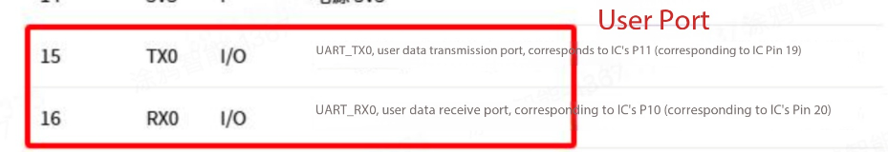

2.2 Wake‑Up Interface

2.2.1 Module Wakes MCU
The module wakes the lock board MCU by sending a 300 ms high‑level pulse on P32.

2.2.2 MCU Wakes Module
- IO Wake‑Up:
The lock board MCU wakes the module with a high‑level pulse of at least 1 ms on P13 (rising edge triggered).
- UART Wake‑Up:
The module can be awakened by MCU TX data.

2.3 Log Port
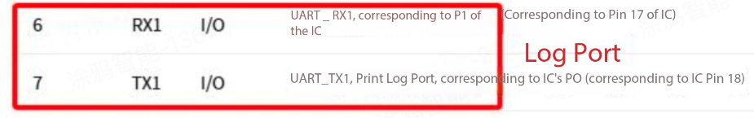

3. Software Integration

3.1 PID Creation
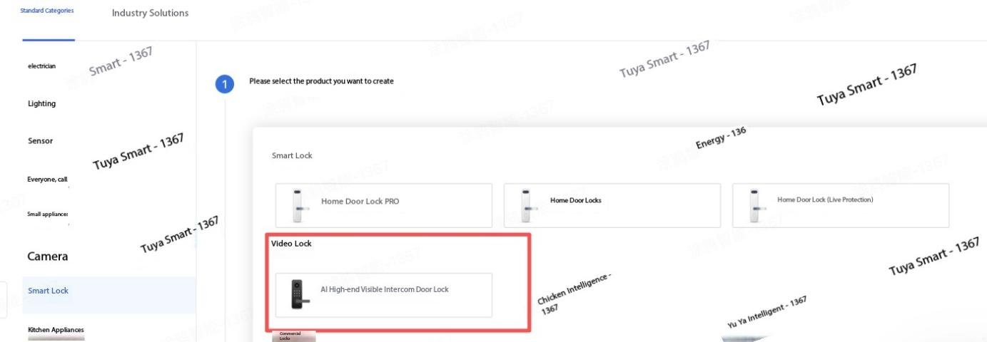
Select communication protocol: Wi‑Fi + Bluetooth.
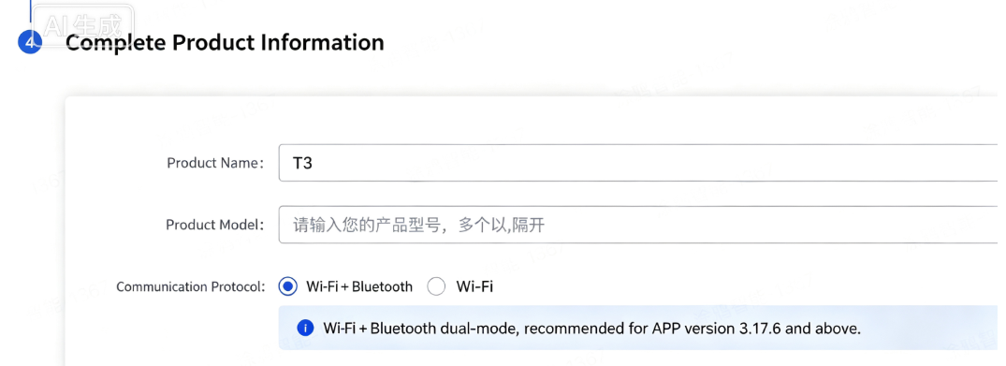
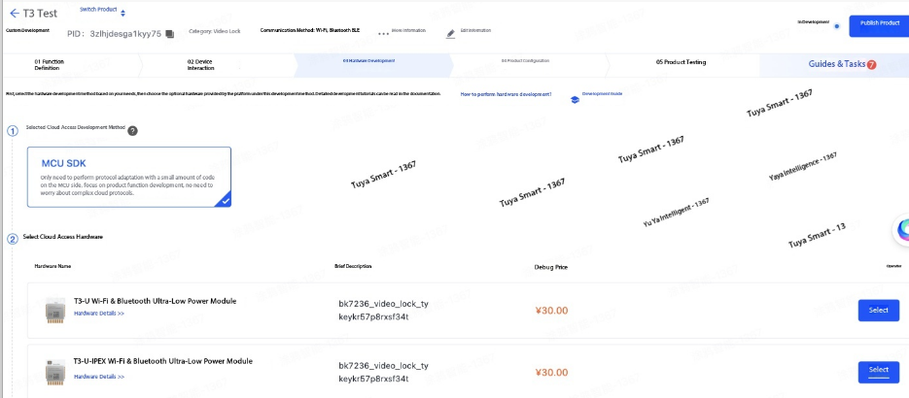
Notes:
- For video intercom smart locks, do not select DP212 if audio/video entries should be hidden.
- To enable Bluetooth lock control when the device is offline, select DP76 – unlock_ble.
- Do not select DP149.
- DP42 controls whether Bluetooth transmission is enabled when Wi‑Fi is disconnected in dual‑mode operation.
- When creating the product solution, select Wi‑Fi + Bluetooth and choose Tuya Mini Program for the panel configuration.
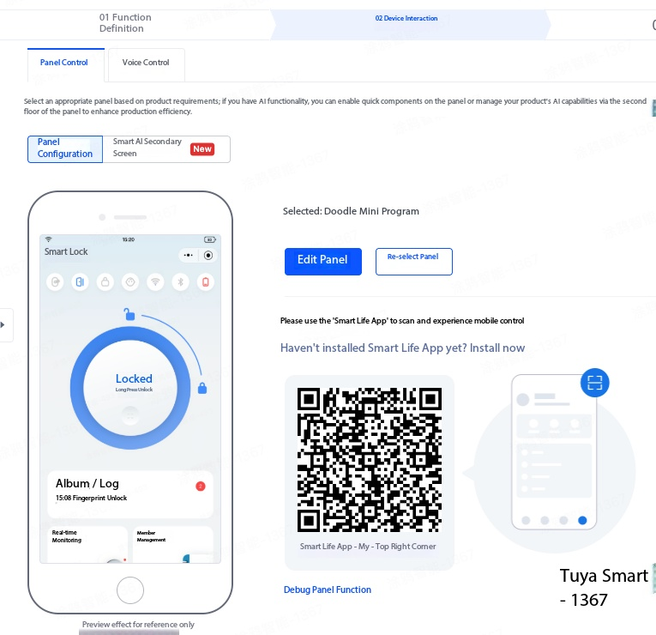

3.2 Wake‑Up Logic
- MCU Wakes the T3 Module
The following flowchart shows the wake‑up and sleep process initiated from the lock side:
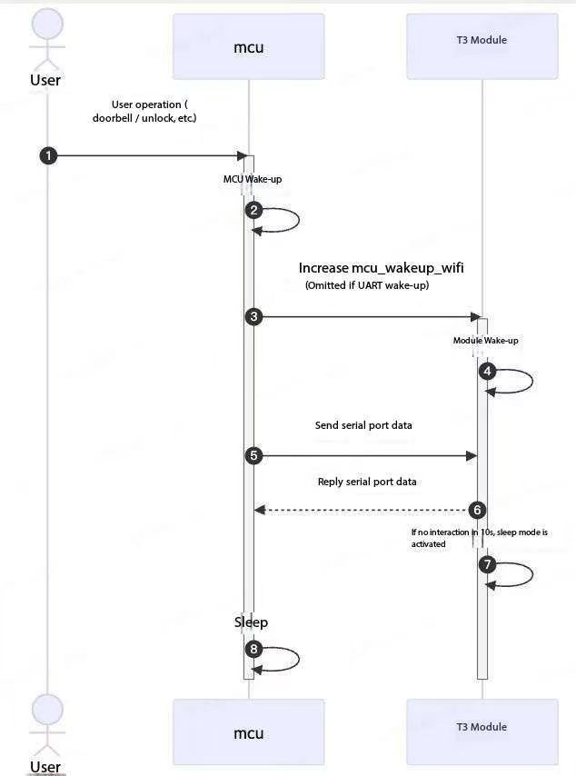

- APP Command Issued – T3 Wakes MCU
The following flowchart shows the wake‑up and sleep process initiated from the APP side:

3.3 Protocol Integration
Protocol integration references:

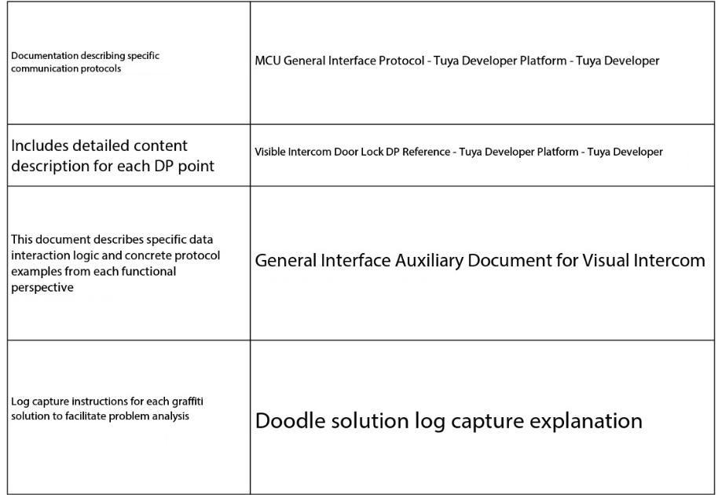Protocol Difference:
Command 0x84 is not supported.

4. Ordering Information
Please contact your Tuya account manager to enable the purchasing whitelist.
Create the order using PID‑B as shown below (the actual product uses PID‑A).
