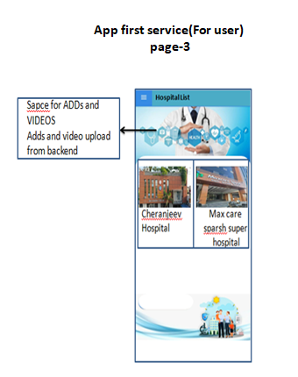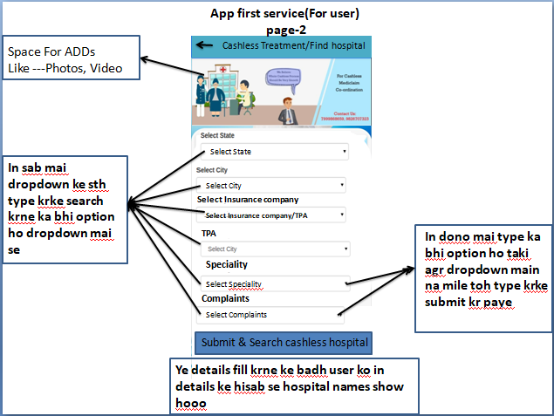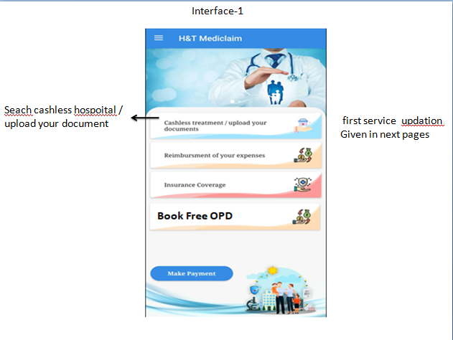

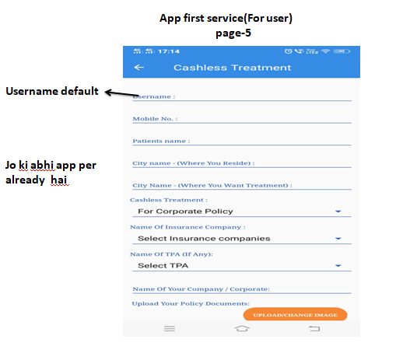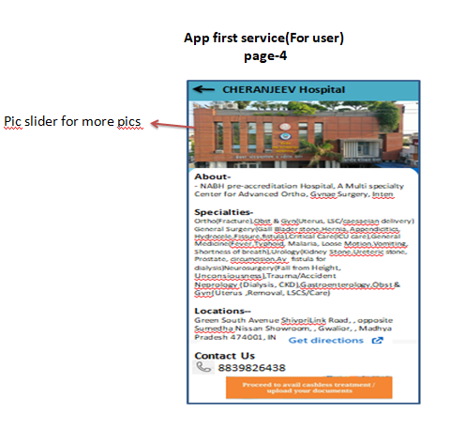

After upload document  
show in hospital login active case list

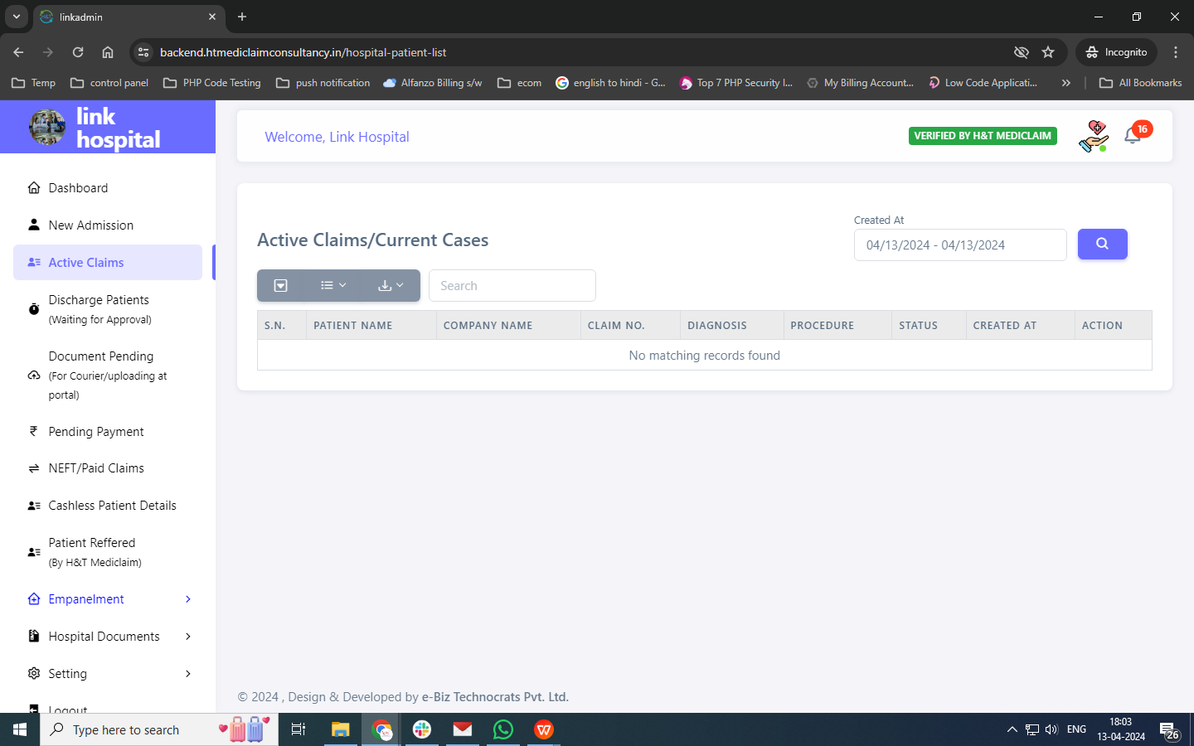  
  
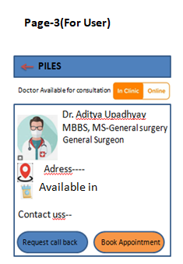

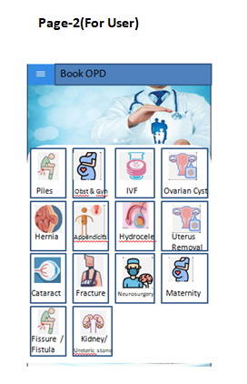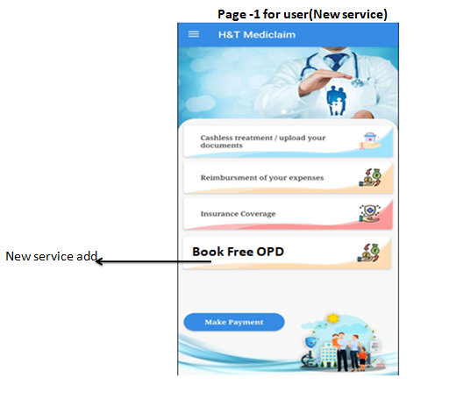

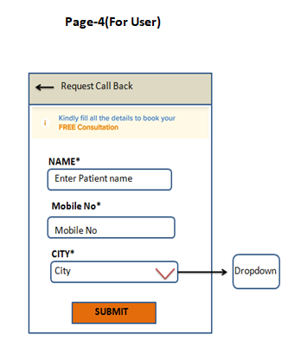

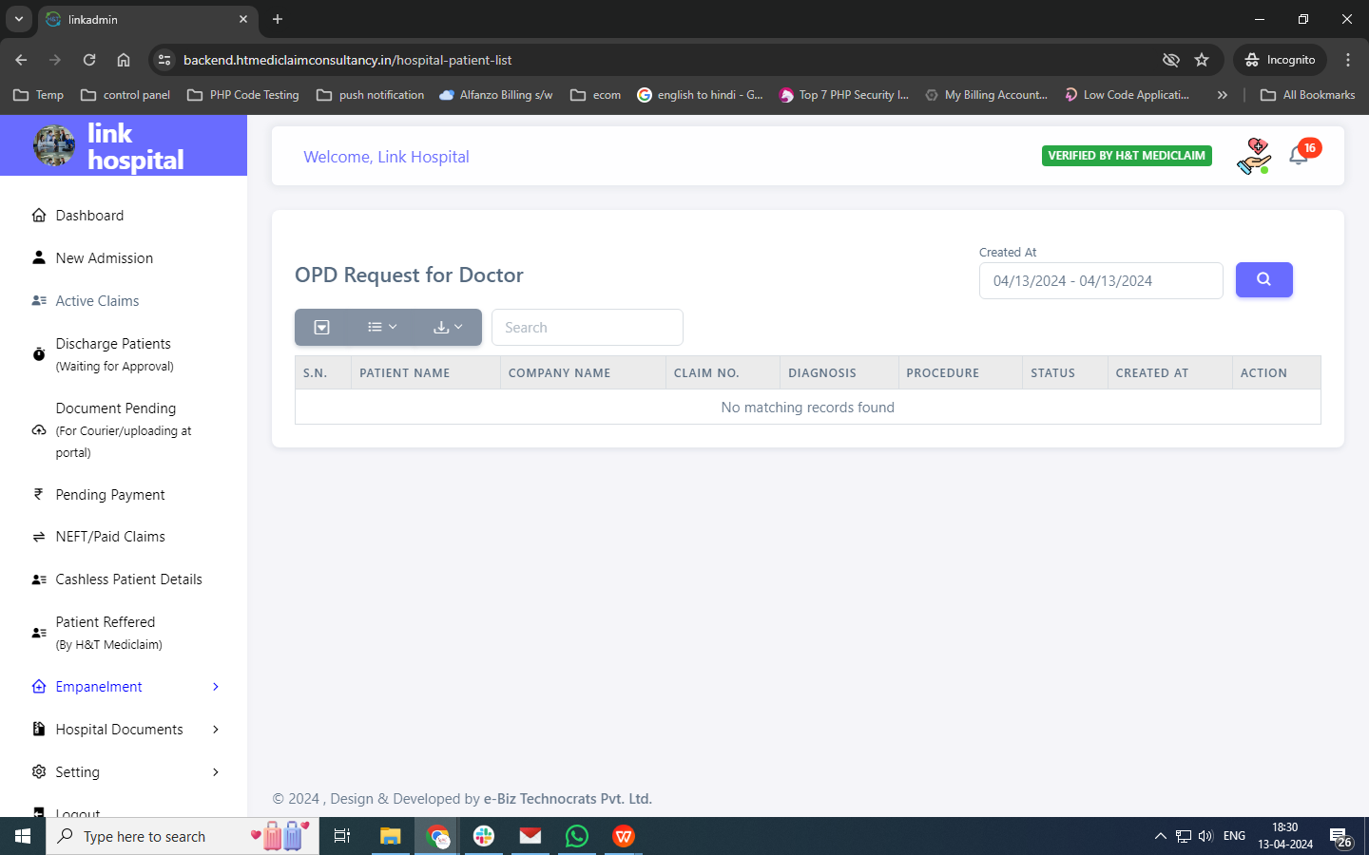

**Need to create these functionality in admin and hospital module**

* Registration Module
* Hospital Add form - Add about hospital
* Advertisement Module for app placement
* User notification - if admin and hospital change status for his/her case
* OPD services module create
* My medical record module
* Appointment module created
* Refer now
* Rate on google play store

Dashboard

1. Total App Download
2. Patient search hospital - doctor
3. No. Of cashless processed/ upload document
4. No of reimbursement
5. No of insurance lead
6. Reffered
7. Request call back
8. Rate us
9. Appointment