Practical 3: Fermentation of yoghurt

By: Edward Blake

ID Card Number: 171098M

University of Malta

**Aim:**

To detect the presence of yoghurt forming bacteria and to ferment milk into yoghurt.

## Introduction:

The concept of fermentation dates back to the ancient era of human history. Furthermore, the process of fermenting milk to yoghurt dates to the earliest known types of fermentations, where milk was held in young calve stomachs which contained rennin. Rennin acts as a coagulate to the soluble proteins, by converting the proteins to insoluble casein. Currently, the yoghurt is formed using a selectively bred culture of *Lactobacillus* and *Streptococcus*, which will excrete lactase, there by breaking down lactate into favorable molecules, such as, acetaldehyde. These bacteria will also change properties of the milk resulting in the coagulation of the milk’s fat and proteins to produce a high viscous texture (Kaur et al., 2017). The yoghurt is sometimes heated so as to kill off all the added and (possible) foreign microbes, but will not be heated too high, since high enough heat can result in the yoghurt proteins’ denaturing. As such, a hypothesis within this practical is that if the bacteria are detected in the yoghurt sample using gram staining, then it is the selectively bred *Lactobacillus* and *Streptococcus* which are within the yoghurt source and are alive. Furthermore, within the practical, the observation of fermenting sterile milk into yoghurt shall be performed using the starting bacteria culture from a yoghurt source. Hence another hypothesis can be made, that being if the bacterial colony is recorded to increase their number in a small period of time, then the initiation of the conversion of milk to yoghurt has commenced. This method of creating yoghurt from pre-existing yoghurt cultures is used within industrial size factories for mass production of yoghurt at a cost-effective way. It should also be noted that within some yoghurt brands, the usage of starch instead of milk coagulation is performed to allow for the high viscous texture. As such, an iodine test shall be performed to detect if the yoghurt contains starch. Therefore, a hypothesis shall be stated that if the yoghurt obtained has a high viscous consistency and has no starch present, then the high viscosity is due to the fermentation process.

## Procedure:

The protocol used within this practical is by Buhagiar. (2021), and can be found in the link below:

[https://www.um.edu.mt/vle/pluginfile.php/1116168/mod_resource/content/0/Schedule%20Practical%203%20-%20Monitoring%20Growth%20of%20Bacteria%20Yoghurt%20Fermentation%20-%20Modified.pdf](https://www.um.edu.mt/vle/pluginfile.php/1116168/mod_resource/content/0/Schedule%20Practical%203%20-%20Monitoring%20Growth%20of%20Bacteria%20Yogurt%20Fermentation%20-%20Modified.pdf)

Modifications:

* In page 1, under procedure, of yoghurt culture was added to of boiled milk
* In page 1, under procedure, only three growth points were observed via gram staining. These being at , and
* The serial dilution found in page 2 was not performed.
* The serial dilution used in the spectrophotometer is the following:
* of sterile milk mixed with of fresh yoghurt with of phosphate buffer solution.
* of sterile milk mixed with of fresh yoghurt with of phosphate buffer solution

## Sources of Errors:

* Foreign microbes might infiltrate the milk or yoghurt there by ruining the experiment.
* The bacteria genus present in the yoghurt sample is only assumed to be *Lactobacillus* and *Streptococcus*, due to it being common in finding them in the fermentation of yoghurt. But it may be another genus of bacteria.
* The temperature of the milk may go below due to human error.

## Precautions:

* Wear disposable gloves when performing gram staining so as to avoid staining one’s hands.
* Do not dispose of the gram staining solutions in the sink, but instead in a large beaker for later disposal.
* Use a small drop of yoghurt on the glass slide before heat fixing.
* When heat fixing does not leave it in the flame too long since it will destroy the bacteria structure.
* If debris is found in the thermos clean it with detergent.
* When boiling the milk do not exceed a temperature of to , so to avoid curdling of the milk.
* The temperature of the boiled milk should not reduce past .
* Do not put in too much yoghurt into the boiled milk, since if the bacteria concentration is too high, a large quantity of them will perform aerobic respiration, which will produce large quantities of nasty tasting lactic acid.
* Mix the yoghurt thoroughly in the milk before the milk’s temperature falls below .

## Results:

*Table 1*:

|  |  |  |  |  |
| --- | --- | --- | --- | --- |
| Samples | Iodine Test | | Fehling’s Test | |
| Before Adding Sample | After Adding Sample | Before Adding Sample | After Adding Sample |
| Yoghurt | Yellow | Yellow | Blue | Yellow |
| Milk | Yellow | Yellow | Blue | Yellow/Red |

*Note:* This is showing the results of the iodine and Fehling test on the fresh yoghurt and milk sample to detect the presence of starch and simple sugars.

*Table 2*:

|  |  |
| --- | --- |
| Time after adding yoghurt sample to sterile mile / min | Optical density |
| 0 | 2.755 |
| 15 | 2.653 |
| 30 | 2.801 |
| 45 | 2.724 |

*Note:* This is the optical density taken using the spectrophotometer. Furthermore, the sample is at a dilution factor of , hence, of sterile milk mixed with of fresh yoghurt with of phosphate buffer solution.

*Table 3*:

|  |  |
| --- | --- |
| Time after adding yoghurt sample to sterile mile / min | Optical density |
| 45 | 1.084 |
| 60 | 0.796 |
| 75 | 1.181 |

*Note:* This is the optical density taken using the spectrophotometer. Furthermore, the sample is at a dilution factor of , hence, of sterile milk mixed with of fresh yoghurt with of phosphate buffer solution.

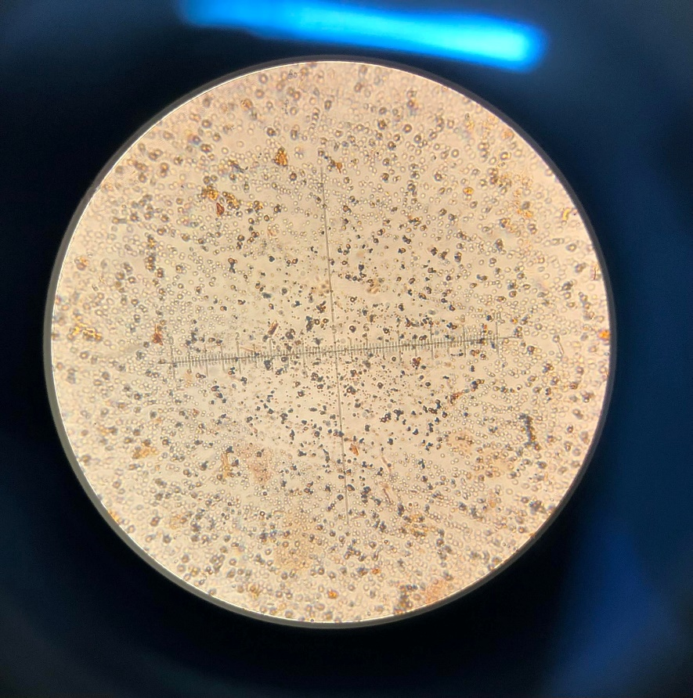*Figure 1*:

*Note:* This is the gram staining of milk straight out of the milk carton, at magnification.

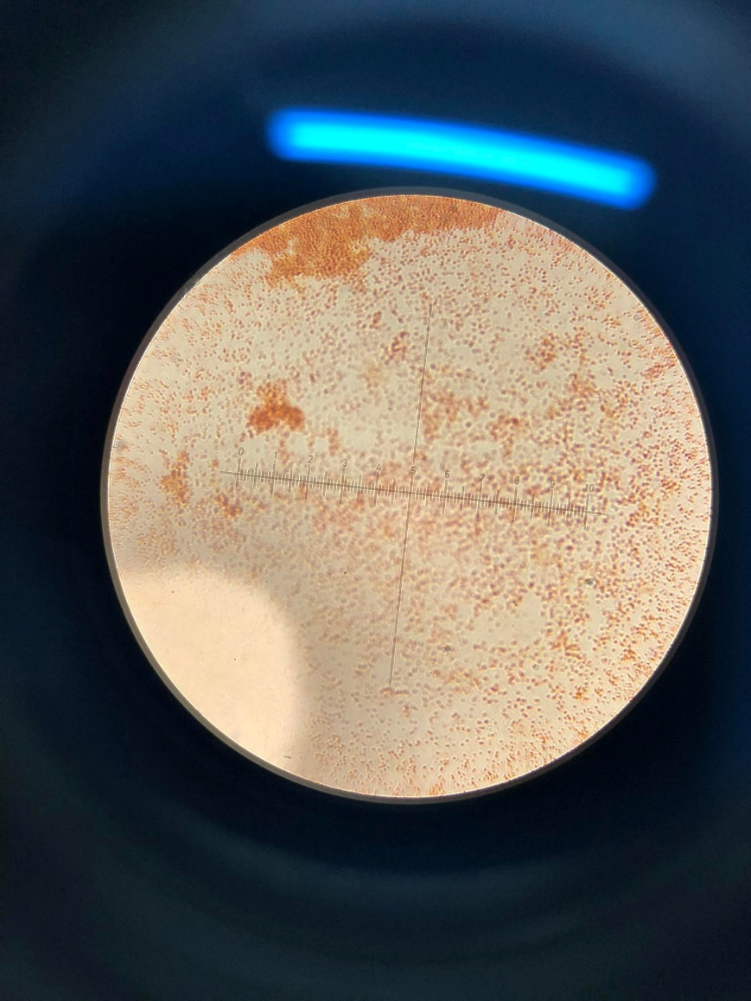*Figure 2*:

*Note:* This is the gram staining of milk straight out of the milk carton, at magnification.

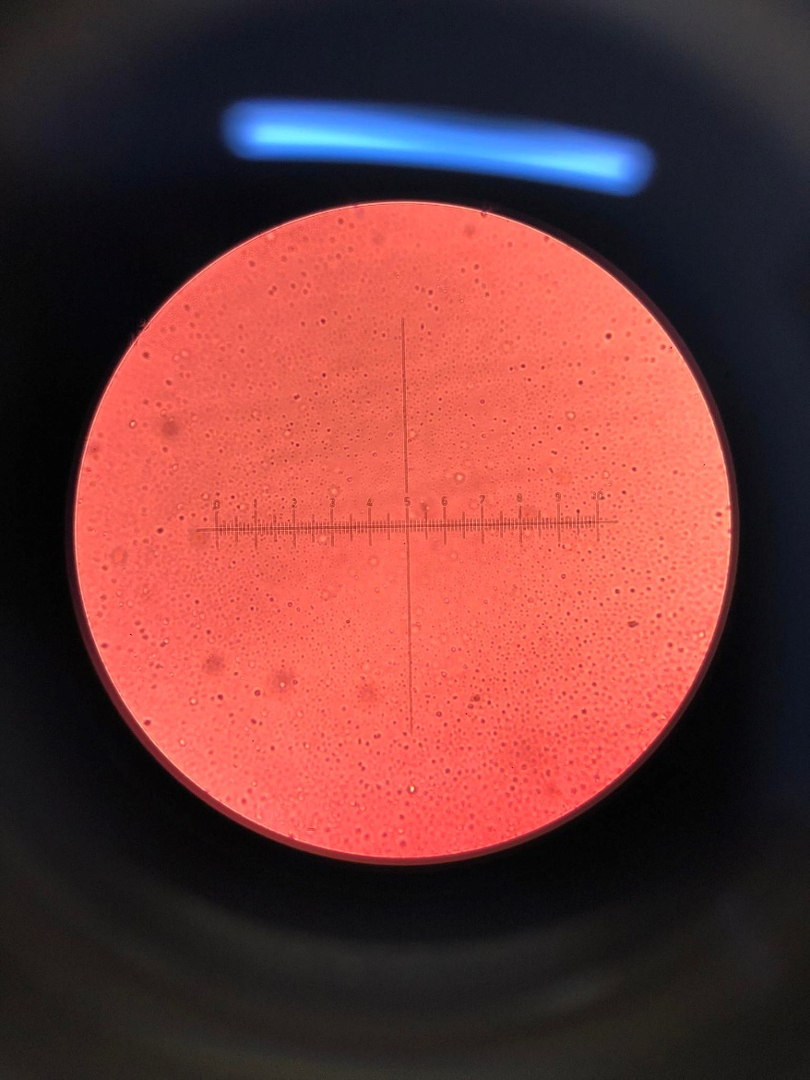*Figure 3*:

*Note:* This is the gram staining of of sterile milk after incorporating of yoghurt after , at magnification.

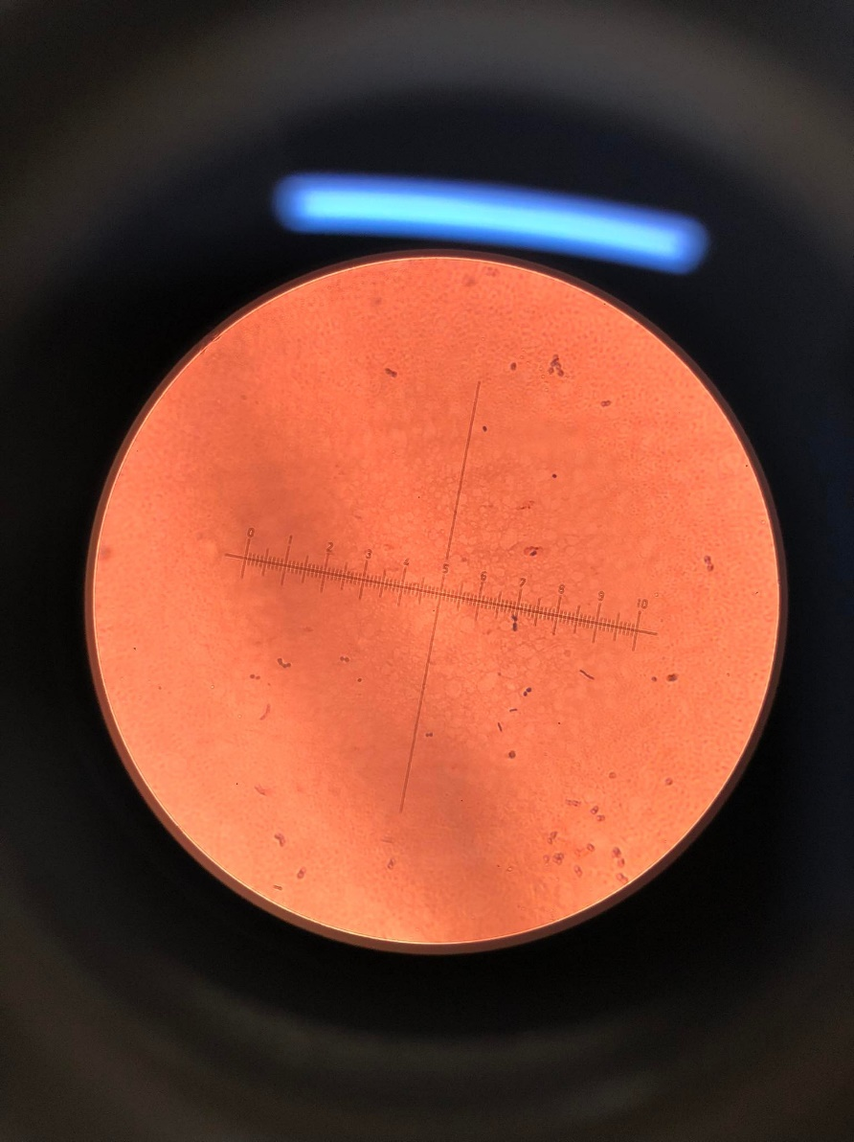*Figure 4*:

*Note:* This is the gram staining of of sterile milk after incorporating of yoghurt after , at magnification.

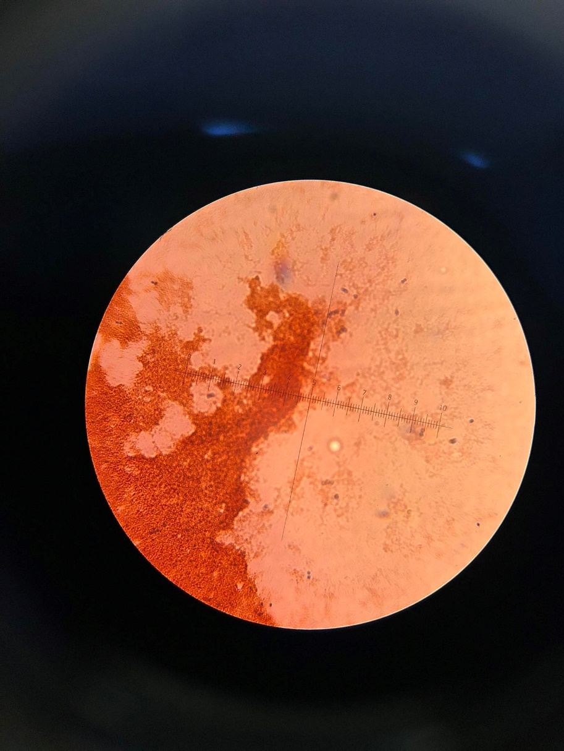*Figure 5*:

*Note:* This is the gram staining of of sterile milk after incorporating of yoghurt after , at magnification.

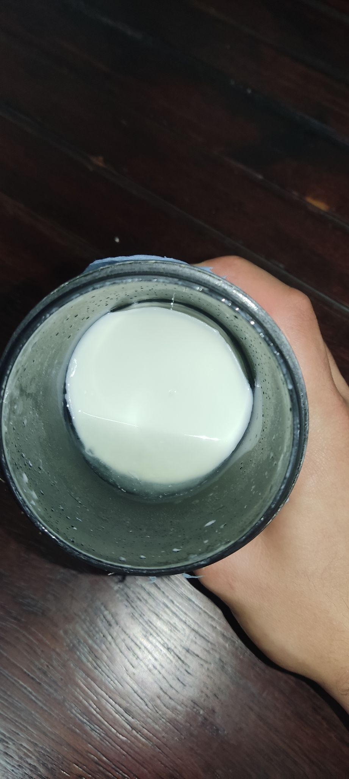*Figure 6*:

*Note:* The solidified gelatin mass of of sterile milk after incorporating of yoghurt after .

## Discussion:

Within this practical, the temperature of the sterile incubator was left at to so as to increase the efficiency of fermentation while also not being too hot which would kill the bacteria. Furthermore, the thermos housing the fermenting milk possessed two container walls with a gab in between filter with air or a vacuum. This gab prevented the escape of heat via conduction.

As seen in *Table 1*, it was found via the iodine test that there was no change in colour, hence stayed a yellow colour and did not turn blue. As such, no starch was present in both the milk and the yoghurt. Hence proving the hypothesis that the yoghurt obtained is of a high viscous consistency via the fermentation presence alone. It was also found that simple sugars are in fact present in the milk and yoghurt since the Fehling’s test when from a blue colour to a yellow to yellow/red colour. It is likely that the simple sugar present is lactose. Furthermore, as seen in *Figure 1, Figure 2, Figure 3, Figure 4* and *Figure 5*, one can observe small purple and pink spherical and rod like cells, thus, indicating the presence of healthy living bacteria cells. Hence proving the hypothesis that the yoghurt does in fact contain a healthy source of *Lactobacillus* and *Streptococcus* species, for fermenting more milk into yoghurt. Furthering this, since *Lactobacillus* is a gram-positive bacterium, (Kim et al., 2020), then it will stain purple (retains the crystal violate), as such it can be noted that the *Lactobacillus* can be seen in *Figure 1, Figure 4* and *Figure 5*. Furthermore, *Streptococcus* is a gram-negative bacterium, (Patterson., 1996), thus, it can be seen stained pink in *Figure 1, Figure 2, Figure 3,* and *Figure 5*. As such, this further supports the hypothesis that the yoghurt bacteria source does in fact contain a healthy population of *Lactobacillus* and *Streptococcus*. Additionally, observing *Table 3*, it can be seen that this optical density value increased by after , as such, this supports the hypothesis that this bacterial culture is reproducing, thereby consuming the milk, thus, are in fact fermenting the milk into yoghurt. Note, due to *Table 2* having too high of an optical density value, it was omitted since it is out of the accurate detection range.

As seen in *Figure 6*, the milk has coagulated into a large gelatin mass. This further supports the hypothesis that the *Lactobacillus* and *Streptococcus* bacteria from the yoghurt source fermented the milk into yoghurt. This coagulation is due to the bacteria excreting lactic acid into the milk. This lactic acid will result in a lowering of the pH of the milk thereby causing casein to form micelle, hence stated by, Aryana & Olson. (2017). This emulsification of casein results in the soluble casein to become insoluble, thereby resulting in a high viscosity, this is known as acid coagulation of milk.

In conclusion, the absence and presence of starch and simple sugars were found, respectively. The yoghurt was proven to be a good source of *Lactobacillus* and *Streptococcus*. Finally, the *Lactobacillus* and *Streptococcus* were shown to be responsible for the successful coagulation of milk to form yoghurt.

## References:

Buhagiar, J. (2021). Fermentation of Yoghurt. <https://www.um.edu.mt/vle/pluginfile.php/1116168/mod_resource/content/0/Schedule%20Practical%203%20-%20Monitoring%20Growth%20of%20Bacteria%20Yogurt%20Fermentation%20-%20Modified.pdf>

Kaur, Ramandeep, Gurpreet Kaur, Santosh Kumar Mishra, Harsh Panwar, K. K. Mishra, and Gurvir Singh Brar. "Yogurt: A nature's wonder for mankind." *International Journal of Fermented Foods* 6, no. 1 (2017): 57-69.

Kim, H., Kim, T., Kang, J., Kim, Y., & Kim, H. (2020). Is Lactobacillus gram-positive? A case study of Lactobacillus iners. *Microorganisms*, *8*(7), 969.

Patterson, M. J. (1996). Streptococcus. *Medical Microbiology. 4th edition*.