RAG-Powered Pandas Chatbot
with Hybrid Q&A Retrieval
Retrieval-Augmented Generation · AGAI-03 Assignment 1 · Agentic AI Bootcamp
Field | Detail
Course / Batch | Agentic AI Bootcamp – AGAI-03
Project | Website-Specific RAG Chatbot using Scraping + Hybrid  Retrieval
Target Website | pandas.pydata.org/docs/user_guide
LLM (Q&A gen & chatbot) | Ollama · llama3.1:8b (local, offline)
Embeddings | multi-qa-MiniLM-L6-cos-v1 (sentence-transformers)
Framework | LangChain · ChromaDB · Streamlit
Date | 29 May 2026

Table of Contents
- Introduction & Website Choice
- Scraping Methodology & Challenges
- Q&A Generation Prompt Strategy
- System Architecture
- Hybrid Retrieval Explanation
- Chatbot Interface & Screenshots
- Limitations & Future Improvements
- Learnings
Appendix – Sample Data

Introduction & Website Choice

Project Overview
This project implements a Retrieval-Augmented Generation (RAG) chatbot that answers questions about the pandas Python library by retrieving relevant documentation passages and generating accurate, grounded responses via a locally running large language model. The system combines two retrieval strategies, direct Q&A matching and semantic document search, with a conversational LLM to deliver precise answers with source citations. The entire pipeline runs offline using Ollama; no cloud API keys are required.

Chosen Website
Target: https://pandas.pydata.org/docs/user_guide/ · Pages scraped: 23 pages across the full User Guide · Content type: Official Python library documentation (HTML, Sphinx-based).

The following User Guide sections were scraped:
# | Section | Slug / Filename
1 | 10 Minutes to pandas | 10min.html
2 | Intro to Data Structures | dsintro.html
3 | Essential Basic Functionality | basics.html
4 | IO Tools (read_csv, to_excel …) | io.html
5 | Indexing & Selecting Data | indexing.html
6 | MultiIndex / Advanced Indexing | advanced.html
7 | Merge, Join, Concatenate | merging.html
8 | Reshaping & Pivot Tables | reshaping.html
9 | Working with Text Data | text.html
10 | Working with Missing Data | missing_data.html
11 | Duplicate Labels | duplicates.html
12 | Categorical Data | categorical.html
13 | Chart Visualisation | visualization.html
14 | Group By: Split-Apply-Combine | groupby.html
15 | Windowing Operations | window.html
16 | Time Series / Date Functionality | timeseries.html
17 | Time Deltas | timedeltas.html
18 | Options & Settings | options.html
19 | Enhancing Performance | enhancingperf.html
20 | Scaling to Large Datasets | scale.html
21 | Sparse Data Structures | sparse.html
22 | Frequently Asked Questions (Gotchas) | gotchas.html
23 | Cookbook | cookbook.html

Justification for Choosing pandas Documentation
- High query frequency: pandas is among the most-used Python packages; developers constantly look up API usage, making a domain-specific Q&A chatbot immediately useful.
- Structured content: Sphinx-generated HTML has a consistent layout (headings, code blocks, parameter tables), which simplifies extraction of clean, coherent text chunks.
- Rich knowledge density: Each page contains numerous functions, parameters, and code examples – ideal for generating diverse, specific Q&A pairs.
- Publicly & legally scrape-able: The pandas documentation is published under the BSD 3-Clause licence and permits educational use and reproduction.
- Factual grounding requirement: Library documentation demands precise, factual answers (parameter names, return types), making it a good application of RAG over hallucination-prone free-form generation.

Scraping Methodology & Challenges

Tools & Libraries
The scraper (src/scraper.py) uses requests for HTTP fetching and BeautifulSoup 4 with the lxml parser for HTML parsing. The pipeline is:
- Iterate over a predefined list of 23 target URLs from config.py
- Fetch each page with a polite User-Agent header identifying the bot.
- Parse the page and remove non-content elements (navigation, footer, sidebar, search box).
- Extract the main article content using PyData Sphinx Theme selectors with a fallback chain.
- Unwrap inline formatting, convert code blocks to readable lines, and render tables as pipe-separatedtext.
- Clean and normalise whitespace, then save as a plain .txt file with a metadata header.
- Wait SCRAPE_DELAY = 2 seconds between requests to respect the server.

HTML Cleaning Strategy
The pandas documentation uses the PyData Sphinx Theme. Content is located via a cascading selector chain: div.bd-content → article.bd-article → div#main-content → div.body → main. Before text extraction the scraper decomposes these non-content elements:
- nav, footer, script, style – structural chrome
- .headerlink – permalink anchors (¶ symbols)
- .toctree-wrapper, #searchbox, .sphinxsidebar – navigation panels
- .bd-sidebar, .bd-toc, .prev-next-area – theme UI elements
Inline tags (em, strong, a, span, inline code) are unwrapped so text flows naturally; <pre> code blocks are converted to single 'Code: …' lines; headings h2–h6 are prefixed with '## ' so the Q&A generator can later split on section boundaries. Excessive blank lines are collapsed to at most one. Each saved file begins with a metadata header:
URL: https://pandas.pydata.org/docs/user_guide/groupby.html
TITLE: Group by: split-apply-combine
SCRAPED_AT: 2026-05-21T10:34:12
------------------------------------------------------------
(content follows)

Challenges Faced
Challenge | Description | Resolution
PyData Sphinx Theme selectors | The modern PyData theme nests content differently from classic Sphinx; a single CSS selector did not cover all pages. | Implemented a cascading selector chain (bd-content → bd-article → main → body) with fallback.
Challenge | Description | Resolution
Navigation / sidebar noise | Without removing sidebar elements, extracted text contained irrelevant menu items, increasing Q&A noise. | Explicit tag.decompose() calls for all non-content elements before text extraction.
Header-link artefacts | Sphinx inserts ¶ permalink symbols after every heading via .headerlink tags. | Removed via CSS selector before text extraction.
Rate limiting / politeness | Scraping 23 pages too quickly risks IP blocks and loads the server. | Added a 2-second delay between requests and a descriptive User-Agent string.
Large pages (e.g. io.html) | Some pages are very long (~60,000 characters), producing too many chunks for fast Q&A generation. | Chunking is done at Q&A-generation time (max 1,500 chars per chunk) rather than at scrape time.

Q&A Generation Prompt Strategy

Overview
The Q&A generator (src/qa_generator.py) converts raw scraped text into structured question-answer pairs using a locally running LLM. It operates in a fully offline, rate-limit-free manner using Ollama with the llama3.1:8b model. The final dataset contains over 1,800 Q&A pairs saved to data/processed/qa_dataset_ollama.csv.

Model Choice
Model: llama3.1:8b via Ollama (local inference). The model runs entirely offline – no API keys, no rate limits, no cost per token. llama3.1:8b was chosen because it produces coherent JSON-structured Q&A pairs with sufficient instruction-following for structured output.

Prompt Design
The prompt instructs the model to act as a practical dataset generator for data-science practitioners, to write general and standalone questions (not tied to example variables), and to return strict JSON. The exact prompt used in code is:
You are building a Q&A dataset for a RAG chatbot that helps coders, data scientists, data analysts, and data engineers use the pandas library effectively. Your goal is to generate question-answer pairs that teach users HOW to use pandas in real data workflows — not just what a function is called. Given the pandas documentation below, generate exactly {n} question-answer pairs.
RULES: - Questions must be general and standalone — a user must be able to ask them WITHOUT having read the docs - NEVER reference "the example", "the code", or example variable names (df, df2, s, ...) - Questions must be practical: purpose, how to use it, key parameters, return value, or common use cases - Answers must be explanatory and include a short code example when relevant
Return ONLY a valid JSON object with a "pairs" key: {"pairs": [{"question": "...", "answer": "..."}, ...]}
TEXT:
{chunk}

Chunking Strategy
Before passing content to the LLM, each page is split into chunks of max 1,500 characters. The algorithm:
- Splits first on section headings (the '## ' markers added by the scraper), keeping related contenttogether.
- Sections that still exceed 1,500 chars are split further on paragraph boundaries, then by sentence if asingle paragraph is still too long.
- Chunks shorter than 100 characters are filtered out (too short to generate meaningful pairs).
Each chunk requests a variable number of pairs – n = max(2, min(5, len(chunk) // 300)) – so longer chunks yield up to 5 pairs and short chunks yield at least 2. This balances diversity with speed on CPU inference.

JSON Robustness
- Markdown fence stripping: Removes ```json / ``` wrappers if the model adds them.
- Retry logic (max 2 retries): On a JSON parse failure the same chunk is retried up to 2 more times.
- Graceful skip: After 3 failed attempts the chunk is skipped with a log message.
- Cleanup before parsing: trailing commas removed, smart quotes normalised, unescaped newlines collapsed.
- Field validation: only pairs containing both a 'question' and an 'answer' key are kept.

Incremental & Resumable Writing
Generated pairs are flushed to the CSV every few pairs (streaming append), so progress is never lost if generation is interrupted. On restart the generator reads the existing CSV and skips any source page that has already been processed (resume-by-source_page), avoiding duplicate work across runs.

Pipeline Summary
Step | Action | Config
1 | Load 23 .txt files from data/raw/ | –
2 | Split each page into chunks | max_chars = 1,500
3 | POST each chunk to Ollama /api/chat | model = llama3.1:8b, temperature = 0.4
4 | Parse JSON response, validate fields | max_retries = 2
5 | Collect valid pairs per chunk | n = max(2, min(5, len//300))
6 | Append to CSV (resumable) | flush every few pairs
7 | Output dataset | data/processed/qa_dataset_ollama.csv

System Architecture

Full Pipeline Diagram
OFFLINE PHASE ONLINE PHASE
■■■■■■■■■■■■■■ ■■■■■■■■■■■■
pandas docs (23 pages) Streamlit UI (app.py) | HTTP GET | user question v v scraper.py (BS4 + lxml) OllamaChatbot (chatbot.py) | data/raw/*.txt - conversation memory v - builds LLM messages qa_generator.py (llama3.1:8b) | retrieve(query) | data/processed/qa_*.csv v v HybridRetriever (retriever.py)
vector_store.py (ChromaDB) + query expansion (2 variants)
| pandas_qa (Q&A pairs) ■■■■■■■■■■■■■■■■■■■■■■■■■■■■■■■■■■■■
| pandas_docs (doc chunks) | QA store search | Doc store search | v multi-qa-MiniLM-L6-cos-v1 | score >= 0.6 ? | top-k = 5 chunks | chroma_db/ ■■■■■■■■■■■■■■■■■■■■■■■■■■■■■■■■■■■■■
YES | NO | v v
matched Q&A pairs doc chunks -> -> Ollama answer Ollama answer
(qa_match mode) (doc_search mode)

Component Summary
Component | File | Technology | Role
Web Scraper | src/scraper.py | requests, BeautifulSoup4, lxml | Downloads & cleans pandas docs
Q&A Generator | src/qa_generator.py | Ollama REST API, llama3.1:8b | Creates structured Q&A dataset
Vector Store | src/vector_store.py | ChromaDB,  sentence-transformers | Embeds & indexes docs and  Q&A pairs
Hybrid Retriever | src/retriever.py | LangChain, ChromaDB,  Ollama | Decides retrieval strategy per query
Chatbot | src/chatbot.py | Ollama, llama3.1:8b | Generates answers with context & memory
UI | app.py | Streamlit | Web interface for user interaction
Config | config.py | python-dotenv | Central configuration

Hybrid Retrieval Explanation

Motivation
A RAG system must balance precision (returning the exact right answer) and coverage (handling questions not in the Q&A dataset). Pure Q&A matching is fast and precise but fails on novel phrasing. Pure document search is flexible but forces the LLM to synthesise answers from long contexts, risking hallucination. The hybrid approach uses a threshold-based decision gate: if the user's question closely matches known Q&A pairs, those pairs are used as high-confidence context; otherwise the system falls back to semantic document retrieval.

Two-Store Architecture
Store | Collection | Content | Embedding
Q&A Store | pandas_qa | Questions embedded; answer + source URL stored as metadata | multi-qa-MiniLM-L6-cos-v1
Doc Store | pandas_docs | Raw documentation chunks  (1,000 chars, 200 overlap) | multi-qa-MiniLM-L6-cos-v1
Document chunks are produced with LangChain's RecursiveCharacterTextSplitter (separators: paragraph, line, sentence, word). Embeddings are L2-normalised and indexed with ChromaDB's default L2 distance metric.

Retrieval Decision Logic
User Query | v Query expansion: Ollama rephrases into 2 documentation-style variants | (improves recall for colloquial phrasing) v QA store search over [original + variants], keep best relevance score (top-3)
|
+-- best score >= 0.6 --> qa_match mode
| matched Q&A pairs -> Ollama synthesises answer | (stored answer used as fallback if LLM down)
|
+-- best score < 0.6 --> doc_search mode doc store search (top-k = 5) -> build context -> Ollama generates a grounded answer (out-of-scope guard: best doc score < 0.20 and not a follow-up -> polite refusal)

Threshold Choice (0.6)
The threshold of 0.6 was set empirically with multi-qa-MiniLM-L6-cos-v1 embeddings. A score at or above
0.6 reliably indicates the user's phrasing matches a known question closely enough to trust the stored Q&A pairs as context. Below 0.6 the LLM answers from fresh document context instead. The threshold is configurable via HYBRID_THRESHOLD in config.py.
Note on the score: the value is LangChain's relevance score (1 − L2_distance / √2) over L2-normalised embeddings, bounded to [0, 1]. It behaves like a semantic-similarity score but is not raw cosine similarity.

Multi-Query Expansion
Before searching the Q&A store, the retriever asks Ollama to rephrase the user's question into two documentation-style variants (temperature 0, capped at 80 tokens). The original query and both variants are searched, and the best relevance score across all three is used for the threshold decision. This improves recall when a user's colloquial phrasing ("how do I read a csv") differs from the formally-worded stored question. If Ollama is unavailable the expansion is skipped silently and only the original query is used.

Embedding Model
- Optimised specifically for semantic similarity / question-answer retrieval tasks.
- Compact (~80 MB) – fast to load and run on CPU.
- 384-dimensional dense vectors – good quality for technical-domain search.
- Runs fully locally – no external API calls for embeddings.

Conversation Memory
The chatbot maintains a rolling window of the last 6 conversation turns (MAX_HISTORY_TURNS).
Previous turns are included in the LLM message list to resolve follow-up references such as "it" or "that". Short follow-up queries without pandas keywords trigger a retrieval rewrite that prepends the previous user topic. Memory is held in-process and can be reset via the 'Clear Chat' button.

Chatbot Interface & Screenshots

Interface Overview
The chatbot is served as a Streamlit web app (app.py), accessible at http://localhost:8501 after running 'streamlit run app.py'. The layout consists of a sidebar with metadata and a main chat area. The app checks that Ollama is running before allowing any queries.

Sidebar Features
- Ollama status: live connection indicator showing the connected model (llama3.1:8b).
- Statistics: pages scraped, Q&A pairs, doc chunks, and current memory turns.
- Sample questions: one-click example queries to demonstrate chatbot capabilities.
- Q&A preview: expandable random sample of Q&A pairs from the dataset.
- About panel: hybrid retrieval strategy, model info, and vector-DB details.
- Clear Chat: resets conversation memory.

Chat Interface Features
- Standard chat-bubble layout (user on the right, assistant on the left).
- Retrieval-mode badge: 'Q&A Match (xx%)' in green or 'Doc Search (xx%)' in blue.
- Source URL citation at the bottom of each response.
- Out-of-scope handling: questions unrelated to pandas receive a polite refusal.
- Matched Q&A expander: shows the matched question from the dataset in qa_match mode.
- Streaming responses: the answer is rendered token-by-token as the LLM generates it.

Screenshots
The following screenshots demonstrate the chatbot in operation. All were captured from the running Streamlit application (app.py) connected to Ollama llama3.1:8b.

Screenshot 1 and 2 – Full chatbot UI
The main interface showing the sidebar with Ollama connected status (llama3.1:8b), statistics, sample-question buttons, and the welcome message in the main chat area.
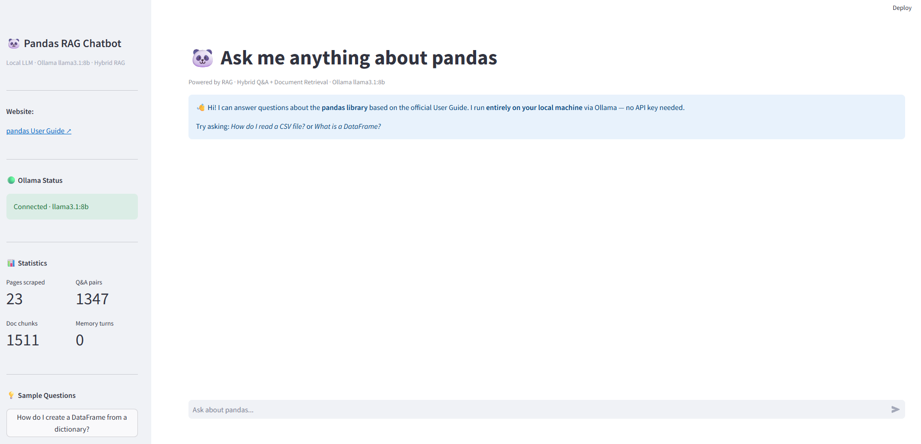

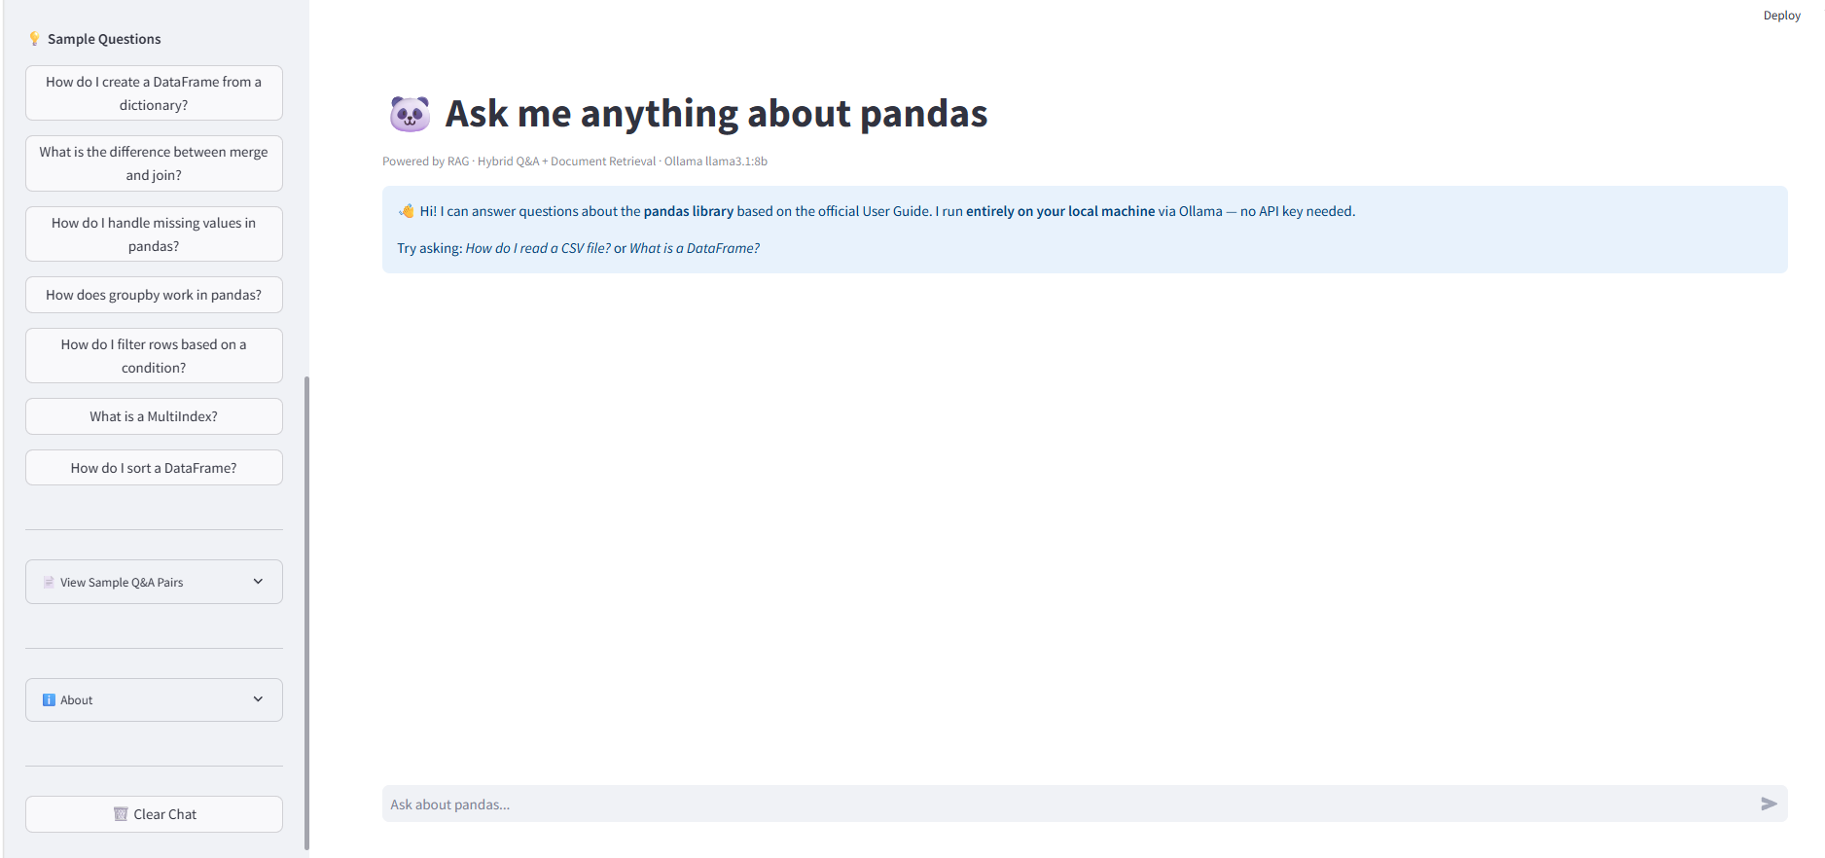

Screenshot 3- QA Mode
Question: 'How do I read a CSV file?' Retrieval mode: Q&A Match (68%). The chatbot finds high confidence matches in the Q&A store and synthesises a polished answer from them, with a 'Matched Q&A' expander showing the matched question.

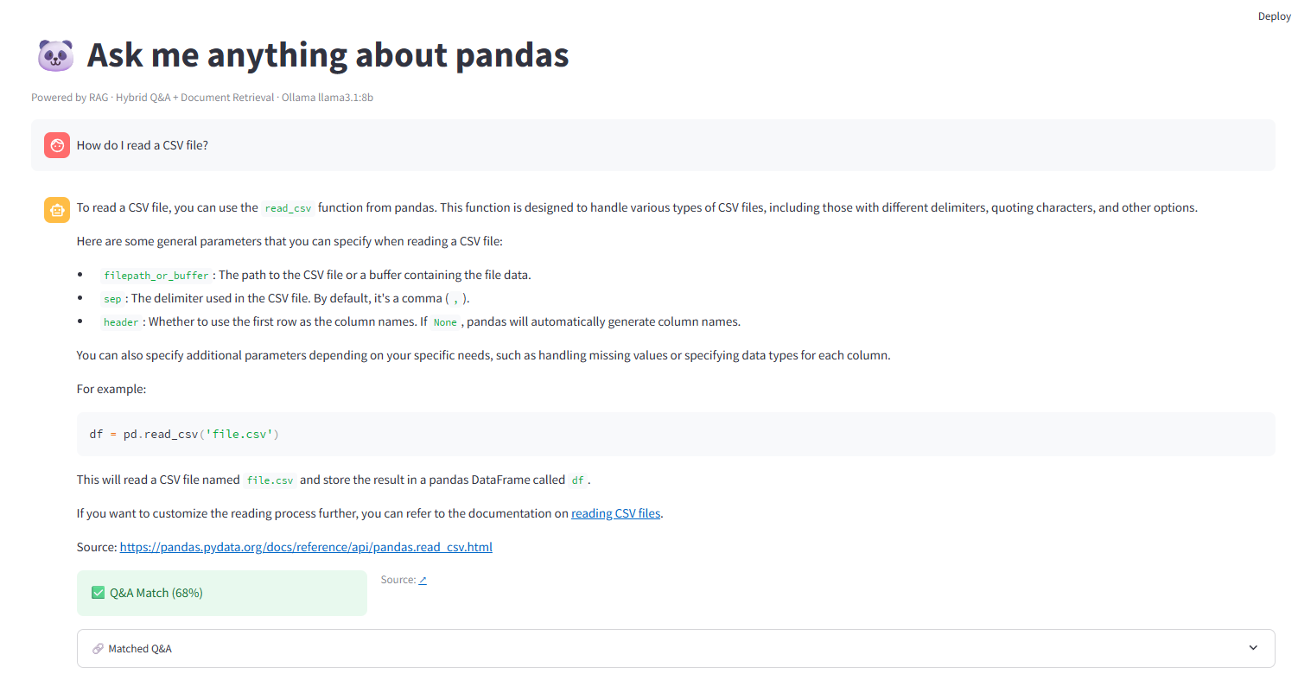

Screenshot 4 – Doc Search mode
Question: 'How do I see the first rows of a DataFrame?' Retrieval mode: Doc Search (35%). The chatbot retrieves relevant chunks from the documentation and generates a grounded answer with code examples (df.head(), df.head(3)) and a source citation to 10min.html.
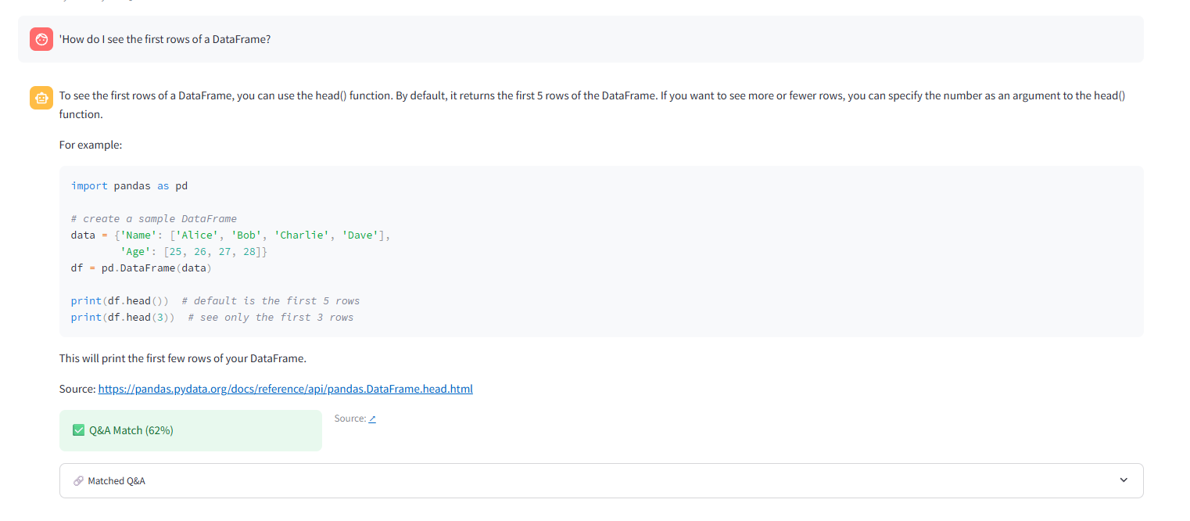

Screenshot 5 – Q&A Match with detail

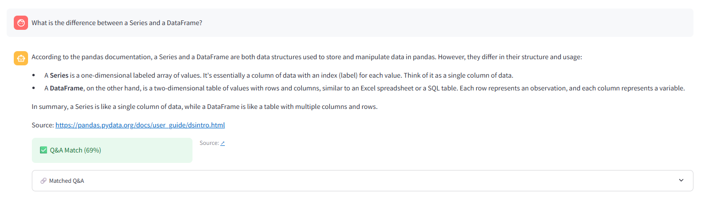

Question: 'What is the difference between a Series and a DataFrame?' Retrieval mode: Q&A Match (69%).
Demonstrates the green badge and a detailed explanation grounded on the indexed Q&A pairs.

Screenshot 6 – Out-of-scope refusal
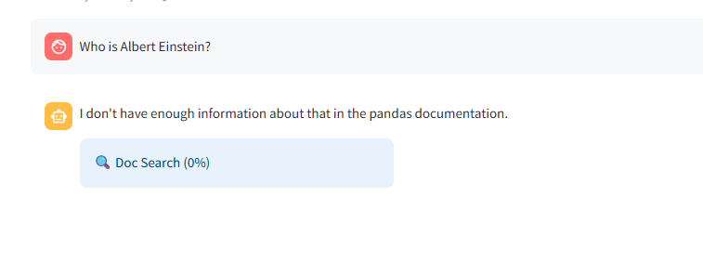

Question: 'Who is Albert Einstein?' Retrieval mode: Doc Search (0%). The chatbot correctly identifies the question as out of scope and responds: 'I don't have enough information about that in the pandas documentation.' This shows the system does not hallucinate.

Screenshot 7 – Doc Search with full answer
Question: 'What is a DataFrame?' Retrieval mode: Doc Search (36%). The chatbot retrieves the relevant passage from dsintro.html and generates a comprehensive answer explaining DataFrames as two-dimensional labelled tables, with a source citation.

Limitations & Future Improvements

Current Limitations
Limitation | Impact | Severity
Static dataset | Knowledge does not update automatically when pandas releases a new version. | Medium
CPU-only inference | Local Ollama inference is slower than GPU or cloud APIs (~5–15 s per response). | Medium
Limitation | Impact | Severity
Fixed threshold (0.6) | Set empirically; a different threshold may be optimal for code-heavy questions. | Low
No reranking | The doc store returns top-5 chunks by relevance with no further reranking. | Low–Medium
In-memory history | Chat history is lost on page refresh; no persistent sessions. | Low
Scope: User Guide only | API Reference, Release Notes and Changelog are not included. | Medium

Future Improvements
- Automated re-scraping to keep the dataset current with new pandas releases.
- RAGAS evaluation framework to measure answer faithfulness, relevance and context precision.
- Cross-encoder reranking for better doc-store precision.
- BM25 + vector fusion (Reciprocal Rank Fusion) for improved hybrid retrieval.
- Persistent chat sessions using SQLite.
- Expanded coverage to include pandas API Reference pages.

Learnings

Technical Learnings

Data quality is the dominant factor
The scraping and Q&A-generation pipeline consumed more time and effort than the chatbot logic itself.
Clean, well-structured documents produce better embeddings and more relevant retrievals.

Hybrid retrieval value
The two-store hybrid approach proved its value in testing. For frequent, textbook questions the Q&A store provides polished, pre-validated context; for complex or novel questions the doc store + LLM path provides flexible, context-grounded answers. Neither approach alone would have been as effective.

LLM quirks with JSON output
Small local models are inconsistent at producing valid JSON, especially when context chunks contain code blocks or special characters. Key lessons: always implement retry logic; strip markdown fences; and reducing the pairs-per-chunk count and chunk size (3,000 → 1,500 chars) significantly improved JSON reliability.

Multi-query expansion improves recall
Asking the LLM to rephrase the user query into documentation-style variants before searching the Q&A store noticeably increased the qa_match hit rate for colloquial phrasings, at the cost of one short extra LLM call per query.

Embedding model selection matters
multi-qa-MiniLM-L6-cos-v1 outperformed the general-purpose all-MiniLM-L6-v2 for this task because it is specifically optimised for question-answer semantic search, leading to higher Q&A-match precision.

Process Learnings
- Start with a working scraper before designing the LLM pipeline – data-quality issues compoundthrough every downstream step.
- Test each pipeline stage independently (scraper → Q&A gen → vector store → retriever → chatbot) before integrating end-to-end.
- Use version control from the start: pushing to GitHub immediately ensured no work was lost duringdebugging.
- Centralise configuration: a single config.py makes switching models, paths and hyperparameterstrivial.

Appendix – Sample Data

A.1 Raw Page Sample – 10 Minutes to pandas
File: data/raw/docs__user_guide__10min.txt
URL: https://pandas.pydata.org/docs/user_guide/10min.html
TITLE: 10 minutes to pandas SCRAPED_AT: 2026-05-21T...
------------------------------------------------------------
10 minutes to pandas This is a short introduction overview of pandas objects ...
By convention, we import as follows:
Code: import numpy as np import pandas as pd
Object creation Creating a Series by passing a list of values ...
Code: s = pd.Series([1, 3, 5, np.nan, 6, 8])

A.2 Sample Q&A Pairs
Question | Answer | Source
How do you create a DataFrame from a dictionary? | Pass a dictionary of lists to pd.DataFrame(). Each key becomes a column name and the corresponding list becomes the column values. | 10min.html
What is the purpose of the loc accessor? | loc is used for label-based indexing, selecting rows and columns by their index labels. It is inclusive on both ends of a slice. | indexing.html
How does groupby work in pandas? | groupby splits a DataFrame into groups based on one or more columns, applies a function to each group, and combines the results. | groupby.html
What is the difference between merge and concat? | merge combines DataFrames on shared column values (SQL join); concat stacks DataFrames along an axis without matching on values. | merging.html
How do you handle missing values in pandas? | dropna() removes rows with NaN; fillna(value) replaces NaN; isna() detects missing values as a boolean mask. | missing_data.html

A.3 Data Files Location
Artifact | Path | Description
Raw pages | data/raw/*.txt | 23 cleaned text files, one per scraped page
Q&A dataset | data/processed/qa_dataset_ollama.csv | Over 1,800 Q&A pairs (question, answer, source_page)
Vector store | chroma_db/ | ChromaDB persistent storage  (pandas_qa + pandas_docs)

A.4 Technology Stack
Python 3.10+ · LangChain · ChromaDB · Streamlit · Ollama llama3.1:8b · multi-qa-MiniLM-L6-cos-v1 · BeautifulSoup4 · sentence-transformers · python-dotenv · pandas · tqdm · requests · lxml
RAG Pandas Chatbot – Project Report | AGAI-03 Assignment 1 | May 2026

