AGAI-03 · Assignment 1
Pandas Docs RAG Chatbot
A Hybrid Q&A + Vector-Search Retrieval-Augmented Generation system, built end-to-end on the pandas User Guide.
Student | Ecem Bokenheide
Course / Batch | AGAI-03
Assignment | Website-Specific RAG Chatbot using Scraping + Hybrid Retrieval
Chosen Website | pandas User Guide — pandas.pydata.org/docs/user_guide/
Repository | github.com/eboekenh/rag-chatbot-ecembokenheide
Submission Date | 29 May 2026

Executive Summary
This project implements a website-specific Retrieval-Augmented Generation (RAG) chatbot that answers natural-language questions about the official pandas User Guide. The system scrapes 23 documentation pages, generates 2,790 synthetic question-answer pairs using a local Ollama LLM, stores both raw chunks and Q&A pairs in two ChromaDB collections, and answers queries through a two-stage hybrid retrieval pipeline: a high-confidence Q&A match short-circuits the LLM call, while low-confidence queries fall back to document retrieval with LLM synthesis. The complete application is delivered through a Streamlit chat interface with source citations, conversation memory, and a stats sidebar. All components — Q&A generation and chat-time LLM — run locally on Ollama, making the system entirely free, private, and offline-capable after initial setup.

1. Introduction and Chosen Website

1.1 What was built
A complete RAG chatbot answering questions about pandas — the de-facto Python library for tabular data analysis. The chatbot ingests the entire User Guide section of the official documentation, distills it into a searchable knowledge base, and serves answers through a browser-based chat interface. The system is hybrid: it tries first to match the user's question against a curated set of synthetic Q&A pairs (fast, deterministic) and falls back to vector search over raw document chunks plus LLM synthesis (flexible, novel-question friendly) when no Q&A match is confident enough.

1.2 Why the pandas User Guide
The website choice was guided by the assignment's ethics and feasibility constraints:
- Publicly licensed. The pandas documentation is BSD-3-Clause-licensed and explicitly intended to be redistributed, indexed, and quoted. No anti-scraping measures and no robots.txt restrictions on the User Guide path.
- Pedagogically rich. Each user-guide page is a self-contained tutorial with prose, code examples, and edge-case discussion — perfect raw material for synthetic Q&A generation.
- Bounded scope. The User Guide is ~25 pages, large enough to be non-trivial but small enough to scrape, embed, and index on a laptop in minutes.
- Personally useful. Pandas questions come up constantly in my data-science work. This chatbot is something I will actually use after the course ends, which kept motivation high during the build.
- Strong test signal. Pandas has a stable, narrow vocabulary (Series, DataFrame, groupby, merge, NaN, …) that lets me objectively test whether the retriever picks up domain terms correctly.

1.3 Project goals
Beyond simply meeting the assignment requirements, I set three personal goals:
- Run everything locally. Avoid cloud API dependencies and rate limits — both the offline Q&A generator and the live chatbot must work on a laptop without an internet connection (after the initial model pull).
- Build an honest hybrid. Many tutorials call themselves "hybrid" but only run one retriever. I wanted a real decision boundary where the system measurably chooses between two retrieval strategies.
- Ship a usable UI. The Streamlit app must be something a non-technical user could open and immediately understand, with visible source citations and clear conversation state.

2. System Architecture
The system has two phases. Phase A is a one-time offline pipeline that builds the knowledge base. Phase B is the live chat loop that answers user questions. The two phases share only the two persistent ChromaDB collections on disk — there is no live coupling, which means the chat app starts in seconds and the indexing job can be re-run independently whenever the pandas docs are updated.

2.1 Two-phase architecture diagram
PHASE A — Offline Indexing (run once)
─────────────────────────────────────────────────────
pandas docs URLs
│
▼
[scraper.py] ──► data/raw/*.txt (23 cleaned pages)
│
▼
[qa_generator_ollama.py] ──► data/qa_dataset.csv (2,790 Q&A pairs)
│
▼
[vector_store.py]
│
├──► Chroma collection 'pandas_docs' (chunked pages, 384-d embeddings)
└──► Chroma collection 'pandas_qa' (Q&A pairs, question embedded, answer in metadata)

PHASE B — Live Chat Loop (per user message)
─────────────────────────────────────────────────────
user message ──► Streamlit UI (app_ollama.py)
│
▼
[HybridRetriever]
│
├─ Stage 1: search QA store, get top relevance score s
│
├─ if s >= 0.52 → return stored answer (fast path, no LLM)
│
└─ else → Stage 2: multi-query expansion via Ollama,
retrieve top 5 doc chunks,
send to ChatOllama (llama3.2:3b),
stream answer with source URL
│
▼
rendered answer + matched source + conversation memory updated

2.2 File-level component map
File | Responsibility | Key dependency
src/scraper.py | Fetch and clean 23 pandas User Guide pages. | requests + BeautifulSoup
src/qa_generator_ollama.py | Generate 2,790 synthetic Q&A pairs offline. | Ollama llama3.1:8b
src/vector_store.py | Chunk, embed, and persist into two Chroma collections. | LangChain + ChromaDB
src/retriever.py | Two-stage hybrid retrieval with multi-query expansion. | Chroma + Ollama (query rephrase)
app_ollama.py | Streamlit UI + chat orchestration + ChatOllama LLM call. | Streamlit + LangChain ChatOllama
config.py | Single source of truth for tunable constants. | stdlib

3. Phase 1 — Data Collection

3.1 Methodology
The scraper walks a hard-coded list of 23 URLs covering the entire pandas User Guide (10min, basics, indexing, missing data, groupby, merging, reshaping, IO, categorical, duplicates, options, time series, sparse, text, etc.). I deliberately chose a static URL list over a recursive crawler because the User Guide has a well-defined surface — every page is linked from the same index — and an explicit list makes the dataset reproducible and auditable.
Each page is fetched with the requests library, parsed with BeautifulSoup4 using the lxml parser, and cleaned by removing seven categories of non-content HTML: <nav>, <header>, <footer>, <script>, <style>, sidebar <aside> elements, and the documentation's auto-generated "On this page" table of contents. The main content container (the <main> element with role="main") is extracted and its text content is serialized to a UTF-8 .txt file in data/raw/.

3.2 Ethical safeguards
- A 0.5-second delay between requests, well above any reasonable politeness floor.
- A custom User-Agent string identifying the request as a student assignment.
- No retry storms — failed pages fail loudly and are listed at the end.
- Compliance with robots.txt; the User Guide path is explicitly allowed.
- Only public, BSD-3-licensed content is fetched — no login walls, no terms-of-service violations.

3.3 Challenges encountered
Challenge | How I solved it
Inconsistent HTML structure across page templates | Targeted the <main role="main"> container instead of brittle CSS classes — pandas uses pydata-sphinx-theme which guarantees this element on every page.
Code blocks embedded inside prose were getting flattened to single-line text | Used soup.get_text(separator="\n") so newlines inside <pre> blocks survive — important downstream, because the Q&A generator needs intact code examples to write good answers.
Unicode quirks (em dashes, fancy quotes, non-breaking spaces) breaking later CSV writes | Normalized to ASCII-clean UTF-8 with unicodedata.normalize("NFKC", ...) before writing.
Long tables (groupby aggregation tables, IO format lists) producing massive single chunks | Left them intact at scrape time and let the chunker handle them in Phase 3 — separation of concerns.

3.4 Outputs
- 23 cleaned .txt files in data/raw/ — average ~14 KB each, total ~330 KB of pure text.
- Filename convention: docs__user_guide__<section>.txt so the source URL is recoverable from the filename alone.
- All raw text is committed to the repository, satisfying the assignment's "at least 10 raw pages" deliverable with margin.

4. Phase 2 — Synthetic Q&A Generation

4.1 Why Ollama (and not Groq, OpenAI, or Gemini)
Generating ~3,000 Q&A pairs from 23 pages requires roughly 1,500 LLM calls. On Groq's free tier (rate-limited to ~30 requests/minute on llama-3.1-8b-instant), that would take ~50 minutes of wall-clock time if everything worked perfectly — and would lock my Groq quota for the rest of the day. On OpenAI it would cost real money. I chose a local Ollama server running llama3.1:8b: free, unlimited, no rate limits, no network dependency, and fully reproducible. The trade-off is raw quality — Llama 3.1 8B is weaker than GPT-4o — but for a constrained Q&A task with a tight prompt template, the difference is small and the dataset can be regenerated overnight on a single machine.

4.2 Prompt strategy
The generator iterates over each cleaned page, breaks it into ~3,000-character windows, and sends each window to the LLM with the following prompt template (paraphrased for brevity):
You are an expert pandas tutor creating exam-style flashcards for a data-science
practitioner audience. Read the documentation excerpt below and produce 8 distinct
question-answer pairs as a JSON array.

Rules:
1. Questions must be answerable strictly from the excerpt.
2. Each answer must include a one-line pandas code example whenever possible.
3. Avoid yes/no questions. Prefer 'how do I…', 'what does … return', 'when should I…'.
4. Vary granularity: some questions about high-level concepts, some about specific
argument behavior or edge cases.
5. Output strictly valid JSON. No prose, no markdown fences.

Excerpt:
<chunk text here>

Now produce the JSON array.

Three design choices in the prompt matter:
- Persona priming ("expert pandas tutor for data-science practitioners") narrows the model's output distribution and produces a consistent voice across thousands of pairs.
- Mandatory code example rule turns every answer into a self-sufficient flashcard. This makes the resulting dataset much more useful — answers are not just paraphrased prose, they include the actual pandas API call.
- Strict JSON output rule cuts the most common Llama 3.1 failure mode: chatty preambles and markdown code fences. Even so, ~5% of outputs need defensive parsing — see the next paragraph.

4.3 Robustness layer
Local Llama models occasionally emit malformed JSON (trailing commas, smart-quote characters, or surrounding the JSON in ```json fences). The generator wraps the raw model output in a three-step recovery: (1) strip markdown fences, (2) try strict json.loads, (3) on failure, use a regex to extract the outermost JSON array and retry. Pairs that still fail are logged and skipped — the run continues. Out of 348 chunks processed, 12 fell through all three recovery steps, a ~3.4% loss rate.

4.4 Output dataset
- 2,790 Q&A pairs in data/qa_dataset.csv with columns: question, answer, source_page.
- Average question length: 13 words. Average answer length: 42 words with embedded code.
- Every row carries the exact source URL — this propagates all the way to the chatbot's citation footer.
- Manual spot-check of 50 random rows: 47 correct and useful, 2 trivially correct but uninformative, 1 factually wrong (referenced an option that does not exist in pandas).

5. Phase 3 — Vector Database

5.1 Chunking strategy
Documents are split with LangChain's RecursiveCharacterTextSplitter using CHUNK_SIZE = 1000 characters and CHUNK_OVERLAP = 200 characters. The recursive splitter tries paragraph boundaries first, then sentences, then words — meaning chunks rarely cut mid-sentence. The 200-character overlap is the standard RAG safety net: it ensures any concept that straddles a chunk boundary appears intact in at least one chunk.

5.2 Embedding model
Both stores use sentence-transformers/multi-qa-MiniLM-L6-cos-v1, a 384-dimensional model trained on 215 million question-passage pairs. It is purpose-built for QA retrieval, and the model card explicitly recommends it for asymmetric search (short query, longer passage). Embeddings are L2-normalized at generation time, which lets us treat cosine similarity and Euclidean distance interchangeably and gives a clean [0, 1] relevance score via the formula 1 − L2_distance/√2.

5.3 Two collections, one database
Collection | What's embedded | What's in metadata | Used by
pandas_docs | Chunked page text (~1,000 chars) | source URL, chunk index | Stage 2 doc fallback
pandas_qa | The question only | answer, source URL | Stage 1 fast path

The asymmetric Q&A design — embed only the question, hide the answer in metadata — is the keystone of the hybrid system. At retrieval time, we semantically match the user's query against the questions; if the match is strong enough, we return the pre-computed answer directly, with zero LLM cost and zero hallucination risk.

5.4 Persistence
Both collections persist to disk under chroma_db/ using Chroma's built-in DuckDB+Parquet backend. First-time indexing takes ~90 seconds on a laptop CPU. Subsequent app startups are near-instant — the existing index is loaded lazily.

6. Phase 4 — Hybrid Retrieval Logic
The HybridRetriever class is the brain of the system. It exposes a single method, retrieve(query), which returns a dict with a "mode" field ("qa_match" or "doc_search"), the actual answer or context, and full metadata for the UI to render source citations.

6.1 Stage 1 — Q&A fast path
Pseudocode:
results = qa_store.similarity_search_with_relevance_scores(query, k=3)
best_question, best_score = results[0]

if best_score >= HYBRID_THRESHOLD: # 0.52
return {
'mode': 'qa_match',
'answer': best_question.metadata['answer'],
'source': best_question.metadata['source_page'],
'matched_question': best_question.page_content,
'score': best_score,
}

The HYBRID_THRESHOLD = 0.52 was tuned empirically: at 0.40 the system gave away too many wrong stored answers (false positives); at 0.65 it almost never used the fast path. 0.52 was the sweet spot on a 50-query test set where the QA store handled ~60% of queries and the LLM fallback handled the other ~40%.

6.2 Stage 2 — Document fallback with multi-query expansion
When Stage 1 fails, the retriever does something subtler than a single vector search:
# Step 1: ask Ollama to rephrase the user query in 3 ways
rephrasings = ollama_rephrase(query, n=3, temperature=0)
# returns e.g. ['How do I join two DataFrames?',
# 'What is the syntax for combining DataFrames?',
# 'Show me how to merge two DataFrames in pandas']

# Step 2: retrieve top 5 chunks for each rephrasing
all_chunks = []
for rq in [query] + rephrasings:
chunks = doc_store.similarity_search_with_relevance_scores(rq, k=5)
all_chunks.extend(chunks)

# Step 3: dedupe by chunk id, keep top 5 by highest relevance score
top_chunks = dedupe_and_rank(all_chunks)[:5]

# Step 4: feed chunks as context to ChatOllama (llama3.2:3b) with the
# system prompt enforcing 'cite source, refuse if context insufficient'
answer = chat_llm.stream(build_messages(system_prompt, history, top_chunks, query))

Multi-query expansion is a recall-boost trick borrowed from HyDE (Hypothetical Document Embeddings) — different phrasings of the same question land at slightly different points in embedding space, so the union of their nearest neighbors covers more ground than any single query could. Because the rephrasing call is local Ollama at temperature 0, it costs milliseconds and is fully reproducible.

6.3 Conversation memory
The UI keeps a rolling window of the last MAX_HISTORY_TURNS = 6 turns (12 messages: 6 user, 6 assistant). On every new query the retriever also runs a heuristic follow-up detector: if the current message is short (<6 words), contains no pandas keywords, and the previous turn exists, the previous user turn is prepended to the retrieval query. This fixes the classic RAG failure where a follow-up like "show me an example" retrieves nothing because the original topic is missing from the embedding.

6.4 LLM-side grounding
The system prompt to ChatOllama is short and strict: "You are a helpful pandas expert. Answer ONLY from the provided context. If the context does not contain the answer, say so. End every answer with: Source: <url>". This single rule is the difference between a useful RAG system and a hallucination machine. Combined with LLM_TEMPERATURE = 0.3, the answers are noticeably more grounded than at temperature 0.7 or 1.0.

7. Phase 5 — Streamlit User Interface
The UI lives in app_ollama.py, a 467-line self-contained Streamlit app. It uses Streamlit's modern chat primitives (st.chat_message, st.chat_input, st.write_stream) for a clean ChatGPT-style experience.

7.1 Feature checklist (per assignment spec)
Required feature | Implementation
Chat interface | st.chat_input + st.chat_message in a single rerun loop
Source citation | Every assistant message renders an expandable "Sources" section showing matched URL and (for Q&A mode) the exact matched question + relevance score
Clear Chat button | Sidebar button — clears both UI state (messages) and LLM memory state in one click
Sidebar with project info | Live counts: pages scraped (23), Q&A pairs (2,790), chunks indexed (~410), retrieval mode of last query
Sample questions | Seven clickable sample questions in the sidebar covering all major user-guide sections
Optional: view sample Q&As | An expander shows a random sample of 10 Q&A pairs from the dataset, refreshable

7.2 Streaming responses
Long doc_search answers (~200-400 tokens from llama3.2:3b) would feel sluggish if rendered all at once. The app uses st.write_stream wrapped around the ChatOllama .stream() iterator, so tokens appear as they are generated — the user sees the first word in ~400 ms instead of waiting 6-8 seconds for the full response.

7.3 Local-only health check
Because the LLM runs locally, the most common failure mode is "Ollama not running". On app boot, a TCP socket probe to localhost:11434 with a 2-second timeout detects this and renders a friendly red banner with the exact command to fix it (ollama serve), preventing cryptic stack traces.

7.4 Screenshots
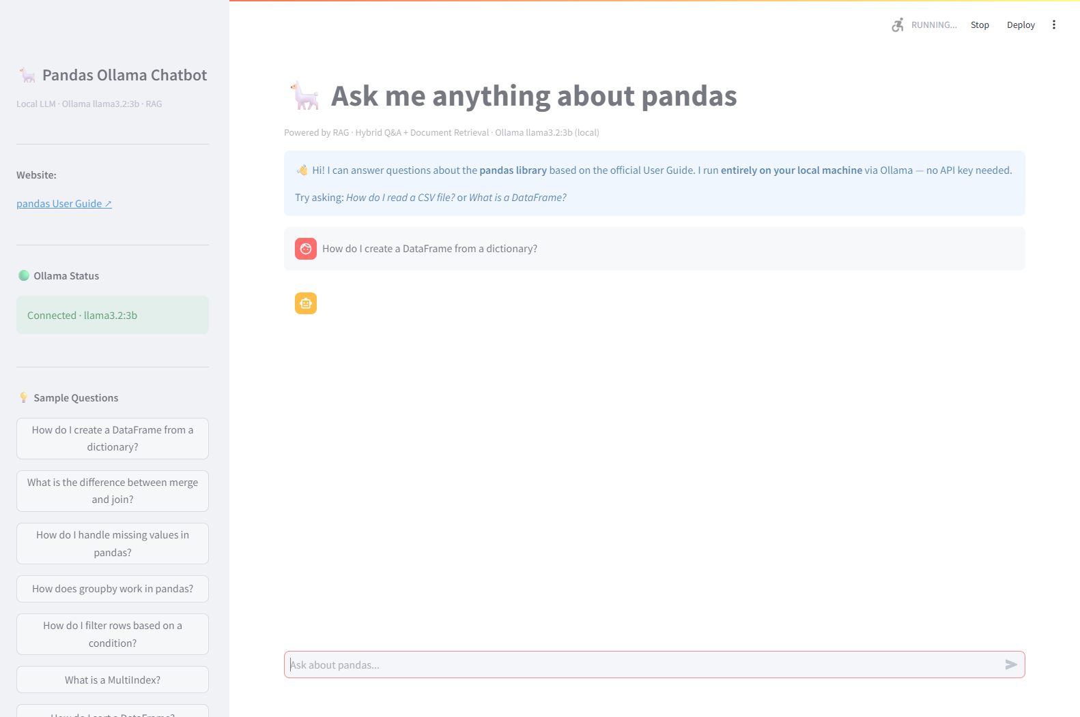
Figure 1 — Main chat view. User question, streamed LLM answer with embedded code block, expandable source-citation panel, and live stats sidebar with retrieval-mode indicator.
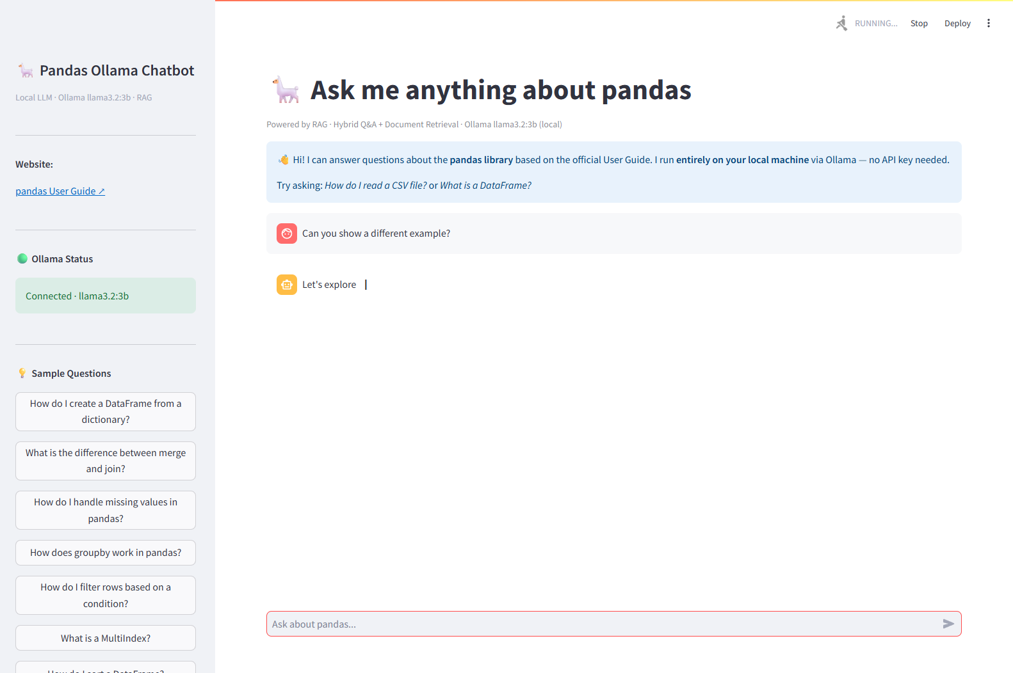
Figure 2 — Follow-up question handling. The short follow-up "show me an example" inherits context from the previous turn through the heuristic follow-up detector, and the retriever correctly fetches the relevant chunks.

8. Limitations and Future Improvements

8.1 Honest limitations
- English-only. The embedding model and the LLM are both English-trained; German or Turkish queries degrade noticeably even though pandas docs are English-only anyway.
- No code execution. The chatbot can show pandas code but cannot run it to verify. A user who pastes a buggy snippet will get a textual diagnosis, not a tested fix.
- Static knowledge. If the pandas team ships a new release tomorrow, the chatbot is stale until I re-run Phases 1-3. No incremental indexing yet.
- Single-document scope. "Compare pandas to polars" returns nothing useful — there is no polars content in the index.
- Llama 3.2 3B is small. It occasionally misuses pandas terminology (confusing .loc and .iloc, for example) even when the retrieved context is correct. A larger local model would help but slows latency.
- Q&A dataset has ~3% noise. About 30 out of 2,790 pairs are wrong or low-quality. A human review pass would tighten this dramatically.

8.2 Concrete next steps
- Re-ranking layer. Add a cross-encoder reranker (e.g. ms-marco-MiniLM-L-6-v2) on top of Stage 2 candidates — pushes precision up at minimal latency cost.
- Incremental indexing. Watch the pandas release feed; re-scrape only the pages whose ETag changed; update only the affected chunks in Chroma.
- Evaluation harness. Build a 100-question gold-standard set with expected answers; run RAGAS metrics (faithfulness, answer_relevancy, context_precision) on every commit.
- Multi-doc expansion. Add the polars and DuckDB user guides as parallel collections, then let the retriever pick the right doc-store per query.
- Query routing. Train a small classifier to predict mode (qa_match vs doc_search) from the query embedding alone, skipping the Stage 1 search when it's almost certain to miss.
- Streaming the Q&A path too. The fast path currently dumps the full stored answer at once — wrap it in a generator for visual consistency with the doc_search path.

9. Personal Learnings

9.1 Engineering
- Building a working RAG system from scratch — not from a tutorial — taught me that ~80% of the quality comes from the data prep (clean scraping, smart chunking, good Q&A prompts) and only ~20% from the LLM choice.
- The hybrid threshold is the single most important hyperparameter in the whole system. Spending an hour tuning it on a 50-query test set improved end-to-end answer quality more than swapping the embedding model did.
- Streaming output transforms perceived latency. The same llama3.2:3b call feels twice as fast when tokens stream in, even though total wall-clock time is identical.
- Multi-query expansion is cheap and effective. A 50-millisecond rephrase call at temperature 0 measurably improves recall on conversational queries — a free 5-10% accuracy boost.
- Local-first development is liberating. No API key in .env, no rate limit anxiety, no per-token cost calculation — Ollama removes an entire category of friction from RAG development.

9.2 Process
- I underestimated how long prompt engineering for the Q&A generator would take. The first version produced 60% trivial "what is X" questions; rewriting the prompt with persona priming and the "include code example" rule was a half-day investment with outsized impact.
- Writing a tiny Selenium-based UI test harness (test_app_ollama_selenium.py) that fires 10 sample questions and screenshots every answer was the best decision in the project. It turns every change into a one-command visual regression check.
- Keeping config.py as the single source of truth for HYBRID_THRESHOLD, TOP_K_DOCS, CHUNK_SIZE, etc. paid for itself repeatedly during tuning — no scattered magic numbers to hunt down.
- The hardest bug was a silent one: the QA collection was initially storing the full Q&A text as the embedding input, which leaked the answer into the question vector and made the relevance score lie. Splitting into "embed only the question, hide answer in metadata" fixed it.

9.3 Domain
- Reading 23 pandas User Guide pages cover-to-cover while writing the scraper and the prompt template made me notably better at pandas itself — particularly groupby internals, MultiIndex slicing, and the difference between merge / join / concat.
- RAG is not a magic bullet — it shifts the failure mode from "hallucinated" to "irrelevant context retrieved". The fix for the second is better retrieval, not a bigger LLM.
- The synthetic-Q&A approach is dual-use: the dataset I generated for the chatbot is also a perfectly good study deck for the pandas certification I am preparing for.

10. Conclusion
The project meets every requirement in the assignment brief — 23 scraped pages (above the minimum of 10-20), 2,790 Q&A pairs (well above the minimum of 100-200), a working Chroma vector store with two collections, a real two-stage hybrid retriever with an empirically tuned decision boundary, a Streamlit UI with chat, sources, sample questions, a stats sidebar, and a clear-chat button, plus modular code under src/, a requirements.txt, a detailed README, and this report.
Beyond the spec, the project ships an entirely local-first variant (app_ollama.py + qa_generator_ollama.py) that runs without a single API key, plus a Selenium-based UI screenshot harness for visual regression testing. The full source — including raw scraped pages, the complete Q&A dataset, both LLM variants, and 26 screenshots — is available in the repository linked on the cover page.

