RAG QA Chatbot for pandas Documentation
Project Report

Field | Value
Course / Batch | AGAI-03 Agentic AI Bootcamp
Assignment | Website-Specific RAG Chatbot using Scraping + Hybrid Retrieval
Chosen Website | Official pandas User Guide
Application Type | Streamlit RAG chatbot with hybrid Q&A and document retrieval
Primary LLM | Groq llama-3.1-8b-instant
Local Variant | Ollama llama3.2:3b
Submission Deadline | 29 May 2026

Executive Summary
This project implements an end-to-end Retrieval-Augmented Generation chatbot for the official pandas documentation. The system collects public documentation pages, cleans them into plain text, generates synthetic question-answer pairs, indexes both generated Q&A and document chunks in ChromaDB, and answers user questions through a two-stage hybrid retrieval strategy. The final user experience is delivered through Streamlit and includes source citations, retrieval mode metadata, sample questions, chat memory, and a clear-chat workflow.
The project meets the assignment goals by combining web scraping, document processing, vector database indexing, LLM-based generation, hybrid retrieval, a usable application interface, and documented validation through screenshots and test scripts.

Table of Contents
- 1. Introduction and Website Choice
- 2. Scraping Methodology and Challenges
- 3. Synthetic Q&A Generation Strategy
- 4. Vector Database and System Architecture
- 5. Hybrid Retrieval and Chatbot Logic
- 6. Streamlit Interface and Screenshots
- 7. Testing and Validation
- 8. Limitations, Future Improvements, and Learnings
- 9. Conclusion

1. Introduction and Website Choice

1.1 Project Objective
The objective of this assignment is to build a practical website-specific RAG chatbot. The chatbot must answer questions from a real-world website by using scraped content, synthetic Q&A generation, a vector database, hybrid retrieval, and a Streamlit interface. This implementation focuses on pandas, one of the most widely used Python libraries for data analysis.

1.2 Chosen Website
The selected source is the official pandas User Guide at https://pandas.pydata.org/docs/user_guide/index.html. The project targets 23 important documentation pages covering DataFrame basics, indexing, I/O, merging, missing data, GroupBy, time series, visualization, performance, sparse data, and cookbook-style examples.

1.3 Justification
- The pandas documentation is public, educational, stable, and well suited for ethical scraping with request delays.
- The content is documentation-heavy, which makes it a strong fit for retrieval-augmented question answering.
- The domain includes both conceptual and practical questions, allowing the chatbot to help coders, analysts, data scientists, and engineers.
- The website has many topic-specific pages, making it appropriate for testing chunking, source citation, and fallback retrieval.

1.4 Project Facts
Item | Value
Website | https://pandas.pydata.org/docs/user_guide/index.html
Scraped pages | 23 raw text files in data/raw/
Screenshots | 49 PNG files in screenshots_ollama/
Primary Q&A dataset | data/processed/qa_dataset_ollama.csv (1347 rows)
Embedding model | all-MiniLM-L6-v2
Vector database | ChromaDB with docs and qa collections
Hybrid threshold | 0.75
Document fallback | Top 5 document chunks
Chunking | 1000 characters with 200 character overlap
Memory | Last 6 conversation turns
Hosted LLM | Groq llama-3.1-8b-instant
Local LLM variant | Ollama llama3.2:3b

2. Scraping Methodology and Challenges

2.1 Data Collection Pipeline
Data collection is implemented in src/scraper.py. The scraper uses requests to download each configured pandas User Guide URL and BeautifulSoup with the lxml parser to extract the main documentation content. The target URLs are centralized in SCRAPE_TARGETS in config.py.
- Read the list of target pandas documentation URLs from config.py.
- Request each page with an educational user agent and a timeout.
- Remove non-content HTML elements such as navigation, sidebars, footers, scripts, styles, search boxes, and previous/next areas.
- Extract the main article body using PyData/Sphinx content selectors.
- Convert headings, paragraphs, code blocks, definition lists, and tables into readable plain text.
- Save each page as a .txt file under data/raw/ with URL, title, scrape timestamp, and content.
- Wait between requests using SCRAPE_DELAY to avoid overloading the website.

2.2 Cleaning Strategy
The cleaning logic preserves information that is useful for downstream retrieval. Inline formatting tags are unwrapped so text remains readable. Code blocks are converted into single-line Code: entries. Tables are converted to pipe-separated text so their cells can still be embedded and retrieved. Heading markers are written with a ## prefix, which later helps the Q&A generator split text around section boundaries.

2.3 Challenges Faced
- Documentation pages include navigation and sidebar elements that would pollute embeddings if not removed.
- Code examples and tables require special handling because simple get_text extraction can merge important values together.
- Long documentation sections must be split without losing context, especially for Q&A generation.
- The scraper needs to be polite and reproducible, so all target pages and delay values are configured centrally.

2.4 Output
The scraping phase produced 23 raw text files in data/raw/. Each file follows the project naming convention docs__user_guide__section.txt and stores source metadata before the cleaned content.

3. Synthetic Q&A Generation Strategy

3.1 Purpose
The synthetic Q&A dataset is used as the first retrieval layer. Instead of immediately searching long documentation chunks for every query, the chatbot first compares the user question against generated questions. A high-confidence match can provide a fast, precise answer or grounded Q&A context.

3.2 Groq Generator
src/qa_generator.py uses Groq to create Q&A pairs from scraped documentation chunks. The prompt asks for standalone, general questions and concise answers. It rejects questions that depend on example variable names or phrases like "the example" so the resulting dataset is useful for real user queries.

3.3 Ollama Generator
src/qa_generator_ollama.py provides a local alternative using Ollama llama3.2:3b. Its prompt is tuned for practical pandas usage and encourages explanatory answers with short code examples when supported by the documentation context.

3.4 Robustness Features
- Both generators split long documentation sections into manageable chunks.
- The Groq generator includes retry handling for JSON parse errors and rate-limit backoff for 429 responses.
- The Ollama generator includes cleanup for markdown fences, trailing commas, smart quotes, and malformed newlines.
- Both generators are resumable and skip source pages already present in the output CSV.
- The final dataset format uses the assignment-required columns: question, answer, source_page.

3.5 Dataset Inventory
Dataset File | Rows | Purpose
data/processed/qa_dataset.csv | 19 | Small processed Groq dataset found in processed directory
data/processed/qa_dataset_ollama.csv | 1347 | Active default Q&A dataset path in config.py
data/processed/qa_dataset_ollama - Kopie (2).csv | 424 | Comparison dataset used by test_ollama_chatbot.py
data/qa_dataset.csv | 2789 | Larger generated Q&A dataset copy
data/qa_dataset_v1.csv | 2789 | Dataset version copy

4. Vector Database and System Architecture

4.1 Vector Store Design
Vector store creation is implemented in src/vector_store.py. The project uses ChromaDB with two separate collections. The docs collection stores chunked pandas documentation pages. The qa collection stores generated questions as vectorized document content and stores each answer and source page in metadata.
Collection | Input | Embedded Text | Metadata | Purpose
pandas_docs | data/raw/*.txt | Chunked documentation content | source URL and title | Fallback RAG context retrieval
pandas_qa | Q&A CSV | Generated question | answer and source_page | Fast Q&A semantic match

4.2 Embedding and Chunking
Both collections use the same Sentence Transformers embedding model, all-MiniLM-L6-v2. Embeddings are normalized so LangChain relevance scores remain bounded. Documentation pages are split with RecursiveCharacterTextSplitter using a chunk size of 1000 and an overlap of 200. Embeddings are added in batches of 500.

4.3 Architecture Overview
The system follows this end-to-end architecture:
- 1. pandas User Guide pages are fetched by src/scraper.py.
- 2. Clean text files are saved to data/raw/.
- 3. Q&A generation creates CSV datasets with question, answer, and source_page columns.
- 4. src/vector_store.py builds ChromaDB docs and qa collections.
- 5. src/retriever.py performs two-stage hybrid retrieval.
- 6. src/chatbot.py or app_ollama.py prepares context and calls the selected LLM.
- 7. Streamlit displays the answer, source citations, retrieval mode, and matched Q&A metadata.

5. Hybrid Retrieval and Chatbot Logic

5.1 Motivation
A pure document-search RAG system can answer many questions, but it may be slower and less precise for common questions. A pure Q&A lookup is fast, but it cannot cover all possible questions. This project combines both strategies: generated Q&A pairs handle frequent or semantically similar questions, while full documentation retrieval handles new or complex queries.

5.2 Retrieval Decision Logic
- Embed the user question and search the Q&A vector store.
- Inspect the best Q&A relevance score.
- If the score is at least 0.75, use the Q&A match path.
- If the score is below 0.75, search the document vector store.
- Retrieve the top 5 documentation chunks and pass them to the LLM as grounded context.
- Return an answer with retrieval mode, confidence score, source citations, and matched Q&A metadata when available.

5.3 Chatbot Orchestration
The Groq chatbot orchestration lives in src/chatbot.py. It loads the HybridRetriever, calls ChatGroq with llama-3.1-8b-instant, injects recent memory turns, and updates memory after every exchange. If no relevant context is available, the system returns a controlled fallback response instead of inventing an answer.

5.4 Ollama Variant
app_ollama.py reuses the same retrieval pipeline but calls a local Ollama model. It checks that Ollama is running before loading heavy resources, streams answers token by token, and can use multiple top Q&A matches as context for more detailed local responses.

5.5 Source Citation and Memory
Source citation is part of the answer contract. Document chunks include source URLs in metadata, and Q&A matches include source_page metadata. The chatbot keeps up to six conversation turns so follow-up questions can be answered with recent context while still limiting prompt size.

6. Streamlit Interface and Screenshots

6.1 Interface Features
- Chat interface using Streamlit chat components.
- Sidebar with project title, website link, dataset statistics, sample questions, and about section.
- Clear Chat button that resets messages and memory.
- Retrieval badges showing Q&A match or document search.
- Confidence score display.
- Expandable source citation list.
- Matched Q&A expander for high-confidence Q&A hits.
- Ollama app includes a local model status guard and streaming responses.

6.2 Screenshots
The project includes 49 screenshots generated by the Selenium validation workflow. The examples below show representative main questions and follow-up questions sent through the Ollama Streamlit interface.

Main question: DataFrame creation
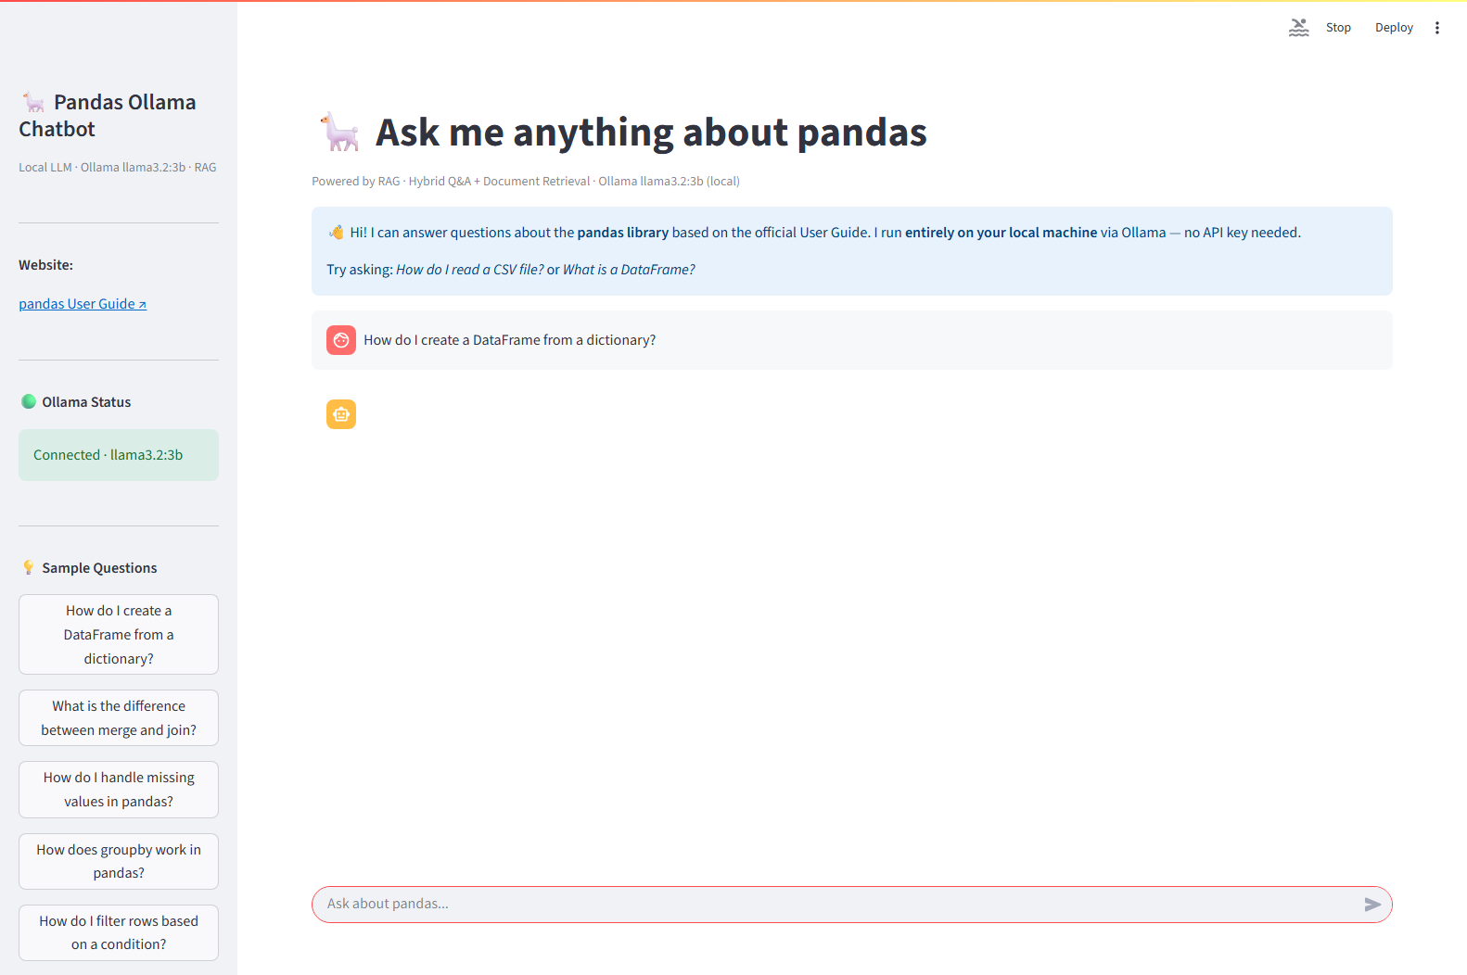
Screenshot source: screenshots_ollama\q1_main_20260527_164645.png

Follow-up question after DataFrame creation
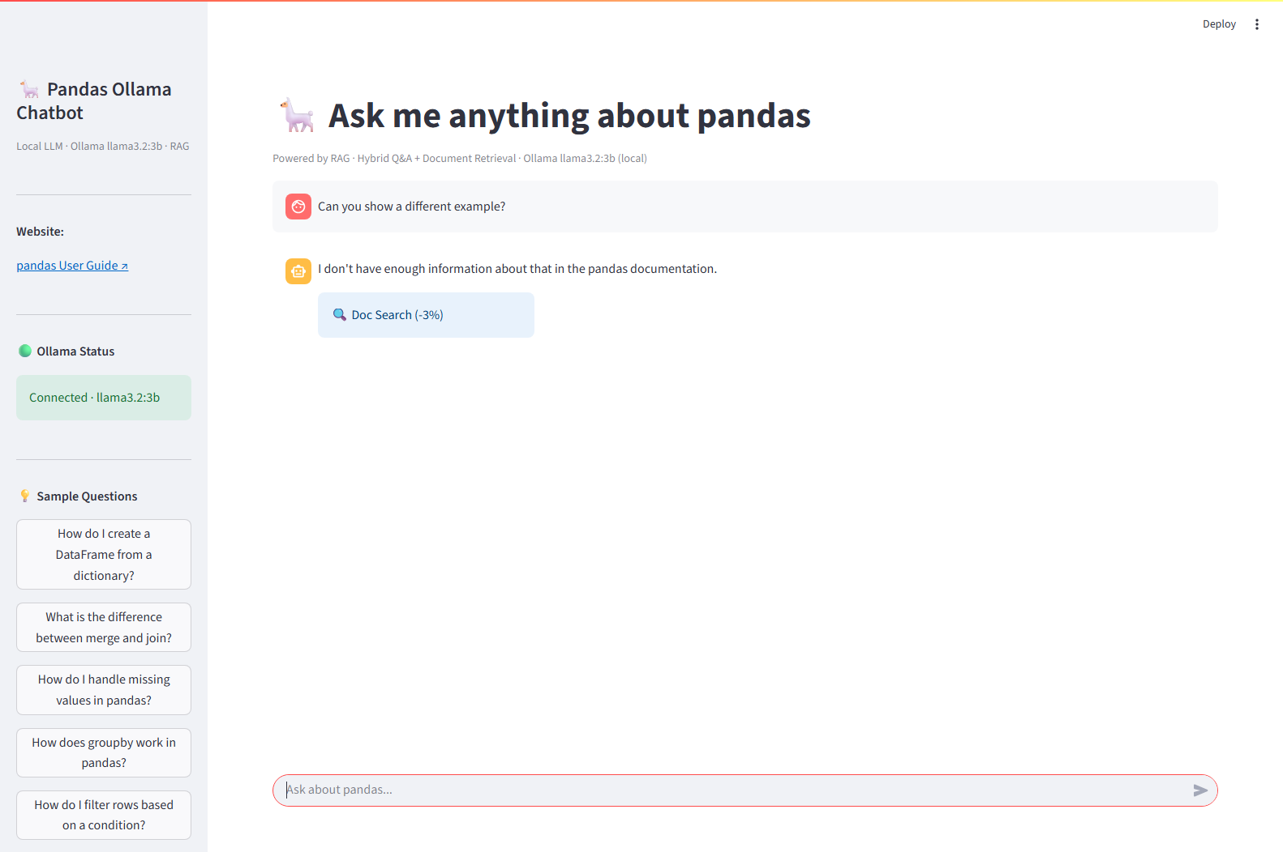
Screenshot source: screenshots_ollama\q1_followup_20260527_164715.png

Main question: reset index
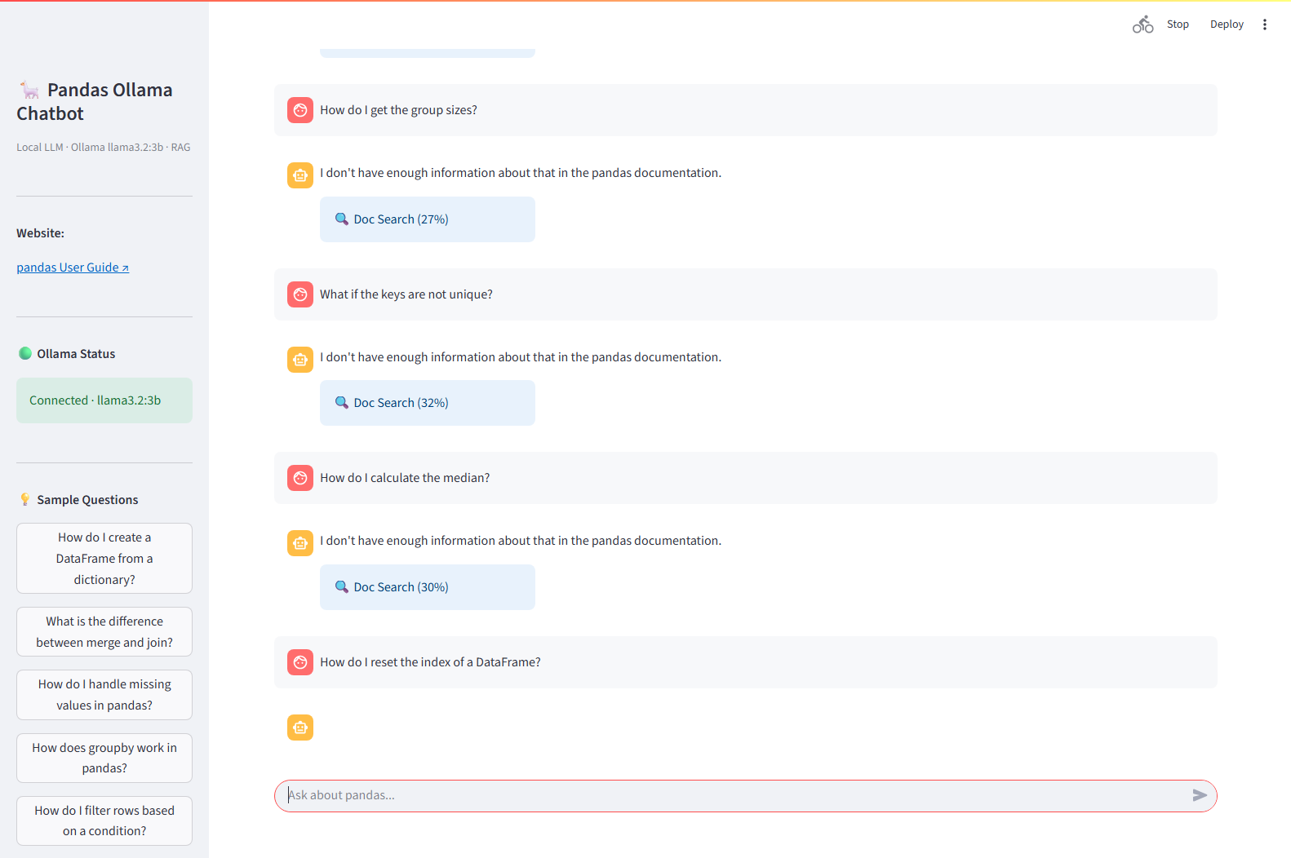
Screenshot source: screenshots_ollama\q10_main_20260527_170310.png

Follow-up question: keep old index
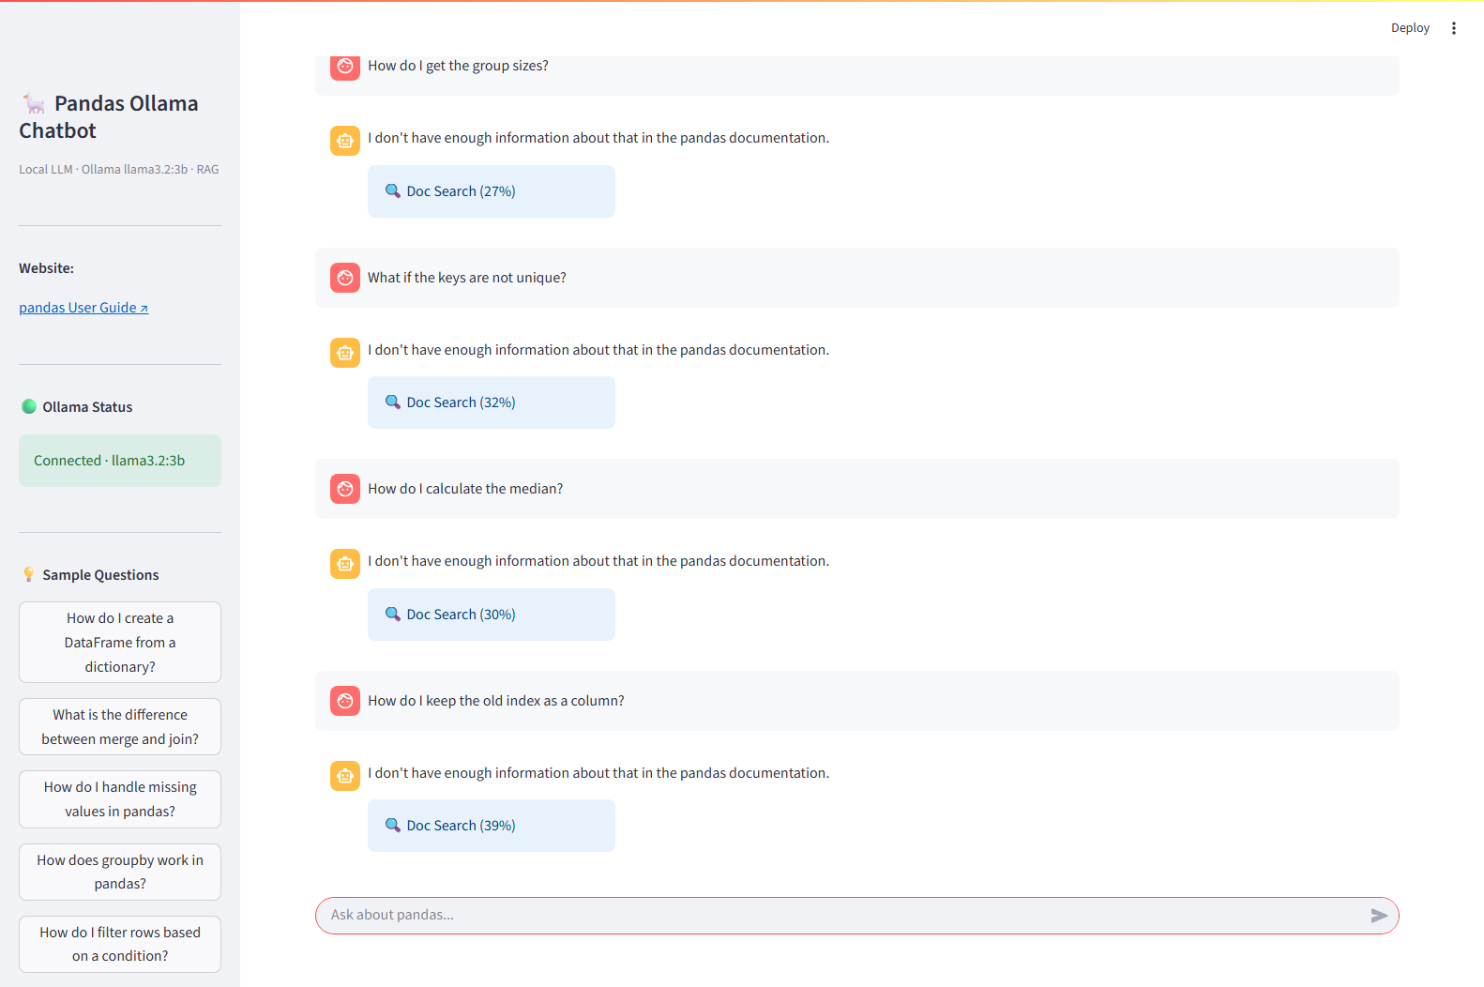
Screenshot source: screenshots_ollama\q10_followup_20260527_170441.png

7. Testing and Validation

7.1 Test Scripts
Script | Purpose
test_ollama.py | Checks whether Ollama is reachable on localhost:11434.
test_ollama_chatbot.py | Runs a Streamlit comparison between original and Ollama-generated Q&A datasets.
test_app_ollama_selenium.py | Automates the Ollama Streamlit app with 10 main questions and 10 follow-up questions, saving screenshots.
debug_selenium.py | Debug helper for inspecting the Streamlit chat UI through Selenium.

7.2 Validation Approach
The validation process combines functional checks and manual review. The vector stores are validated by loading them through the retriever. The Streamlit app is validated by sending representative pandas questions and checking that the UI returns answers, metadata badges, and sources. The Selenium script creates screenshot evidence for the assignment report.

7.3 Representative Test Questions
- How do I create a DataFrame from a dictionary?
- How can I add a new column to a DataFrame?
- How do I filter rows based on a condition?
- How do I handle missing values in pandas?
- How can I group data by a column?
- How do I merge two DataFrames?
- How do I reset the index of a DataFrame?

8. Limitations, Future Improvements, and Learnings

8.1 Limitations
- The retrieval threshold of 0.75 is practical but not formally optimized against a labeled benchmark.
- The source corpus covers selected pandas User Guide pages, not every page on the pandas website.
- Generated Q&A quality depends on the model and prompt quality.
- Local Ollama responses can be slower or less detailed depending on available hardware.
- ChromaDB stores are local and must be rebuilt after major data changes.
- The application is specialized for pandas documentation and should not be treated as a general Python assistant.

8.2 Future Improvements
- Create a labeled evaluation set with expected sources and answers.
- Tune threshold, chunk size, chunk overlap, and top-k values using retrieval metrics.
- Add automated unit tests for scraper output, CSV schema validation, vector store loading, and retriever branch behavior.
- Add a one-command pipeline runner for clean rebuilds.
- Improve source display by adding documentation section titles and chunk previews.
- Support incremental scraping for changed documentation pages only.

8.3 Learnings
- Clean text extraction is one of the most important parts of RAG quality.
- A hybrid Q&A plus document retrieval design gives a useful balance between speed and coverage.
- Source metadata should be preserved from the first scraping step because it is needed throughout the full answer pipeline.
- Small local models require extra JSON cleanup and validation when used for data generation.
- A working Streamlit interface makes retrieval behavior easier to inspect and explain to users.

9. Conclusion
The Pandas Docs RAG Chatbot satisfies the core assignment requirements by implementing an end-to-end website-specific chatbot pipeline. It scrapes public pandas documentation, generates synthetic Q&A data, builds persistent vector stores, applies hybrid retrieval, uses LLMs for grounded answer generation, and provides a usable Streamlit interface with source citations. The project also includes a local Ollama variant and screenshot-based UI validation, making it suitable both for assignment submission and for future experimentation with RAG quality improvements.

