NovaTech Revenue Intelligence: Quick Chat Q&A Log
Each question is labeled BEFORE. Where an after-fix answer has also been captured, it is stacked directly underneath. New questions asked only in the after (Topic-fixed) state appear at the end.
Q1: Which campaign channel drives the most revenue?
BEFORE
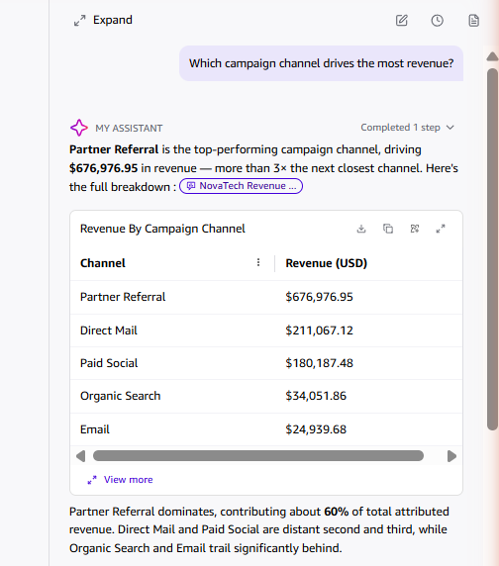
AFTER
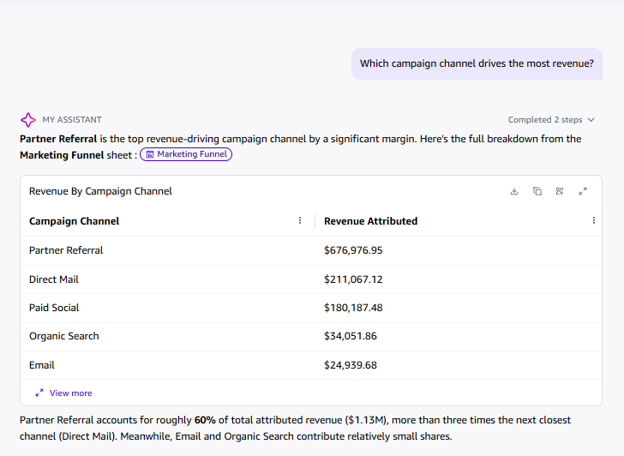
Q2: Which campaign channel has the highest average response rate?

BEFORE
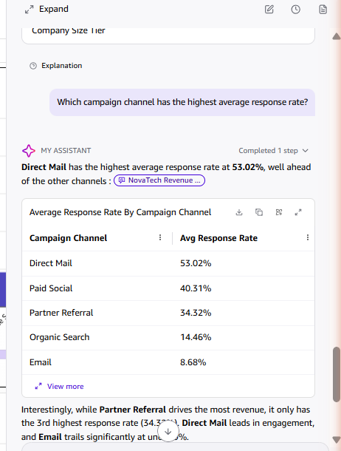
AFTER
