NovaTech Revenue Intelligence Dashboard
Student Name: Ecem Bökenheide
Course: Future AWS Agentic AI Business Professional → Business Intelligence and Knowlege Management Foundations with Amazon Quick → Project: Revenue Intelligence Dashboard for NovaTech Solutions
This document logs, in order, every step taken to prepare data which is the second step of the project, what was clicked, which option was chosen, and why. Screenshots are included where relevant. The full Verification Log table, also submitted in the Step 1 folder, appears at the end.

Step 0 - Read the reference materials
1. Opened the Instructions, Project Overview, Environment Setup, and Project Rubric pages in the Udacity classroom to understand the full task list, deliverables, and grading criteria.
2. Opened Lesson Resources → Download and download Project-Starter-Resources.zip. It contains the 3 starter CSVs, the data dictionary, Sarah Chen's dashboard requirements brief, the company background brief, and the two log templates. Based on the information from Sarah Chen, the datasets are the following:

Dataset | Business Context from Sarah Chen
CRM Deals | The CRM contains every deal the company has pursued, including the product purchased, the final outcome (won or lost), and the reason for the outcome.
Marketing Campaigns | The marketing platform tracks campaign performance, including channel investment, lead responses, and revenue attributed to each campaign.
Support Tickets | The support system records every customer ticket, including the issue, its severity, resolution time, and the customer’s reported experience.

3. Read the Data Dictionary (field definitions, expected row counts: CRM 499, Marketing 2,240, Support 3,000; shared join key account_id), Sarah Chen's brief (the 3 dashboard views and their required metrics and filters), and the Company Background (NovaTech Solutions context).
Known data quality issues documented in the dictionary:
- annual_income (Marketing): 24 rows missing (1.1%), flagged as intentional, realistic missing data
- ticket_resolved_date (Support): 59 rows missing (2.0%), blank for tickets still unresolved, not a data error
- account_id orphans: 150 rows in Marketing (6.7%) and 204 rows in Support (6.8%) use account IDs (ACCT 101 through ACCT 115) that don't exist in the CRM dataset; this is intentional, since not every marketing lead or support ticket is expected to trace back to a known CRM account
- loss_reason (CRM): blank in 315 rows, but only because it's populated exclusively for Lost deals, so this is expected structure rather than a quality gap
Key decisions this informed: the join key across all 3 datasets is account_id; the orphan ID pattern in Marketing and Support directly shapes the choice of join type later; calculated fields to build: days_to_close (CRM), campaign_roi (Marketing), resolution_time_hours (Support).

Step 1 - Open the AWS lab environment
1. In the Udacity lesson, clicked the Cloud Resources tab (bottom toolbar) → Open Cloud Console. This is the Vocareum-provided, pre-configured AWS account for the lab (no personal AWS account needed), it has a $25 budget cap and session time limits.
2. This opened a new browser tab/window that federates into Amazon Quick (QuickSight)

Step 2 - Finding the pre-indexed knowledge bases
1. Clicked New chat in the left nav of Amazon Quick.
2. Clicked the data-scope selector under the question box (default "All data") → opens an "Add Quick assets" picker with tabs: Recents, Favorites, Spaces, Topics, Dashboards, Knowledge Bases, Actions, Datasets.
3. The Knowledge Bases tab was empty. In this lab's Amazon Quick setup, the instructor's pre-indexed sources are exposed as regular Datasets, not separate "Knowledge Base" objects, this matches the Environment Setup page: "Locate the pre-indexed knowledge bases under Datasets and in Quick Chat."
4. On the Datasets tab the actual instructor-provided sources were found: novatech_crm_deals.csv, novatech_support_tickets.csv, novatech_marketing_campaigns.csv all owned by "Others", created 6 months ago. These are treated as the "pre-indexed knowledge bases , created by the instructor.
5. Checked the boxes for all three "Others" / 6-months-ago datasets at once, then clicked Save, scoping the chat to all three instructor knowledge bases together.
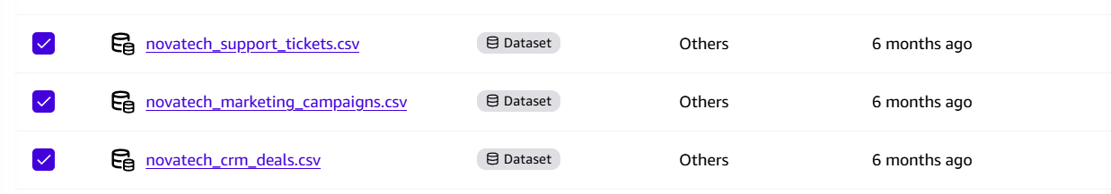
Fig. 1 — "Add Quick assets" picker, Datasets tab, page 2: all three instructor novatech_*.csv datasets (owned by "Others", 6 months old) checked before clicking Save.

Step 3 - Verify the knowledge bases (Verification Log)
Asked 6 questions, 2 per knowledge base, each chosen because the correct answer was already known from the data dictionary (cross-checked against the raw CSVs with pandas beforehand), so Q's answer could be objectively marked Match / No Match rather than just judged as "sounds plausible." Question mix was deliberately varied: row counts, category breakdowns, date ranges, null counts.

CRM Deals
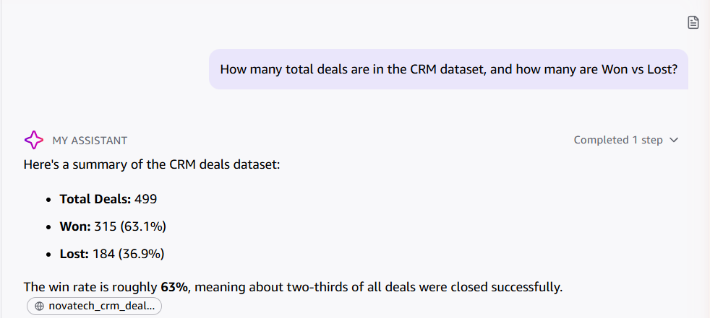
Fig. 2 — Q1: total deals + Won/Lost breakdown. Match: 499 total, 315 Won (63.1%), 184 Lost (36.9%).
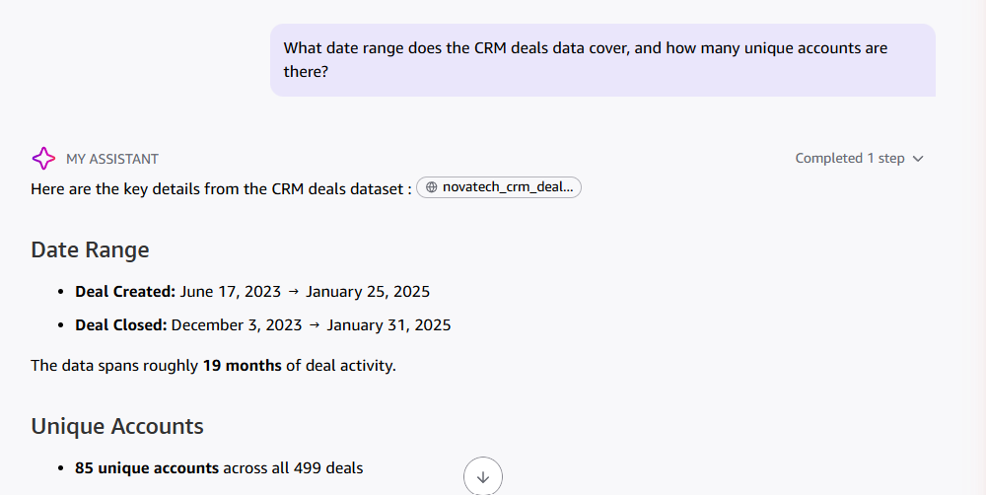
Fig. 3 — Q2: date range + unique accounts. Match: Jun 17 2023 → Jan 25 2025, 85 unique accounts and extra closed day information

Marketing Campaigns
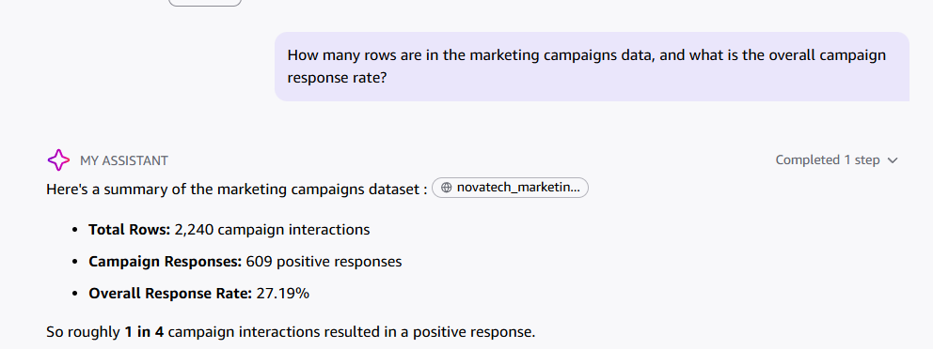
Fig. 4 — Q3: row count + response rate. Match: 2,240 rows, 27.19% response rate.
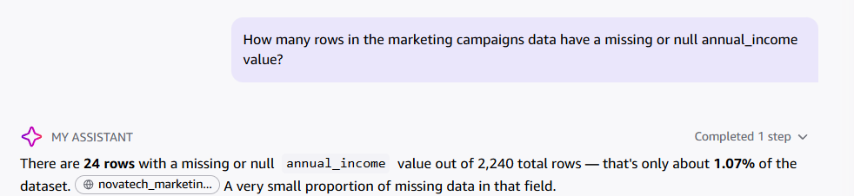
Fig. 5 — Q4: null count on annual_income. Match: 24 rows, 1.07%.

Support Tickets
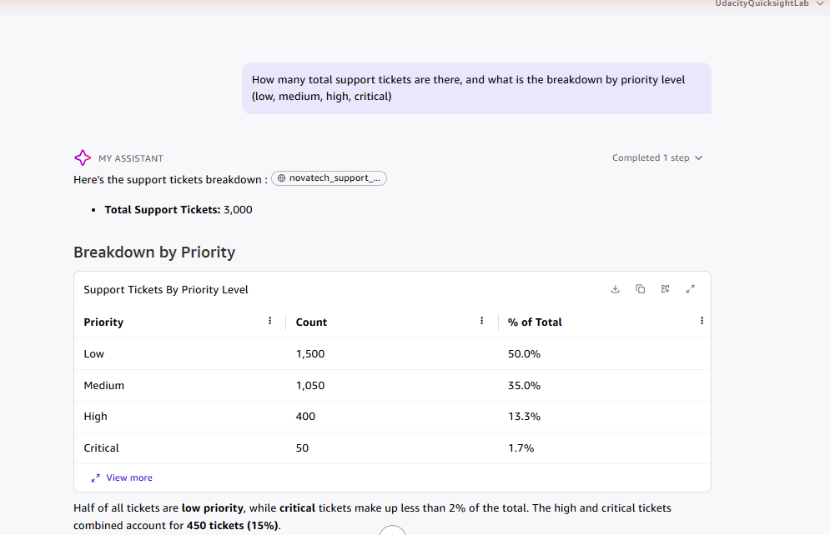
Fig. 6 — Q5: total tickets + priority breakdown. Match: 3,000 total; Low 1,500 / Medium 1,050 / High 400 / Critical 50.
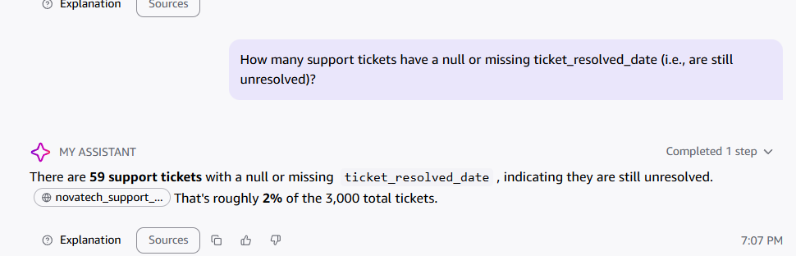
Fig. 7 — Q6: null count on ticket_resolved_date. Match: 59 rows, ~2%.
Result: 6 / 6 Match — Q answered every checkable fact correctly across all three knowledge bases, including one bonus detail on Q1 (deal_closed_date range) that wasn't asked for but was accurate.

Step 4 - Upload own CRM Deals dataset + fix data types
This is where my own submission begins: instead of reusing the instructor's 6-month-old "Others" datasets a fresh copy of each starter CSV is uploaded and prepared from scratch.
1. Went to Data → New dataset → Upload a file → selected novatech_crm_deals.csv.
2. On the "Confirm file upload settings" dialog, clicked "Edit settings and prepare data" (not the default "Next") to land in the full data-prep editor before importing to SPICE.
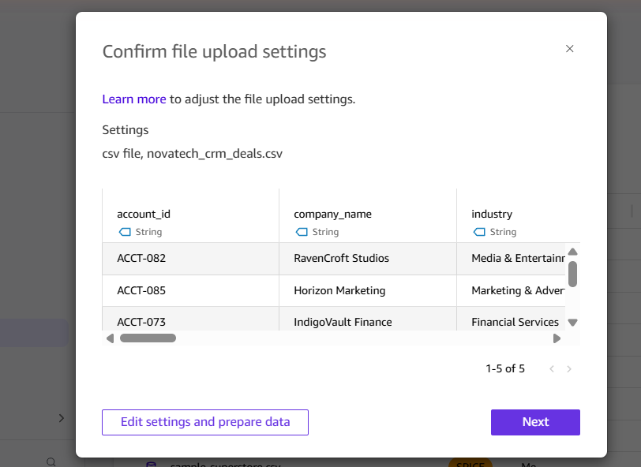
Fig. 8 — File-upload confirmation dialog, before entering the editor.
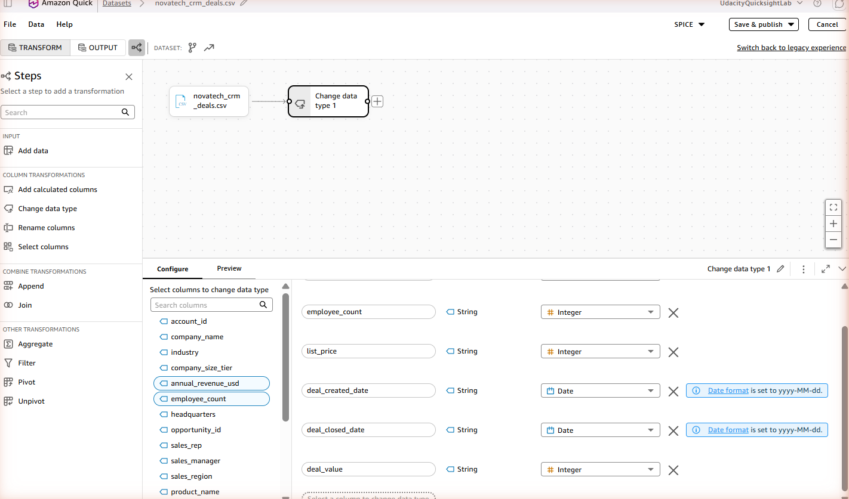
Fig. 9 — Data-prep editor just after entering, with QuickSight's initial auto-suggested type changes (employee_count, list_price, deal_created_date, deal_closed_date, deal_value).
3. Compared each suggested type against the data dictionary and corrected them:
- annual_revenue_usd: String → Decimal (dictionary: Float, currency in millions USD)
- employee_count: String → Integer — already correct
- list_price: String → Integer — already correct
- deal_created_date, deal_closed_date: String → Date, format yyyy-MM-dd — already correct
- deal_value: originally auto-suggested as Integer — corrected to Decimal. Every value in this CSV happens to be a whole number, so Integer wouldn't have caused an error, but the data dictionary formally types it as Float (a currency/revenue amount), so decimal matches the documented schema rather than this sample's coincidental shape.
- All other columns left as String — correct per data dictionary.
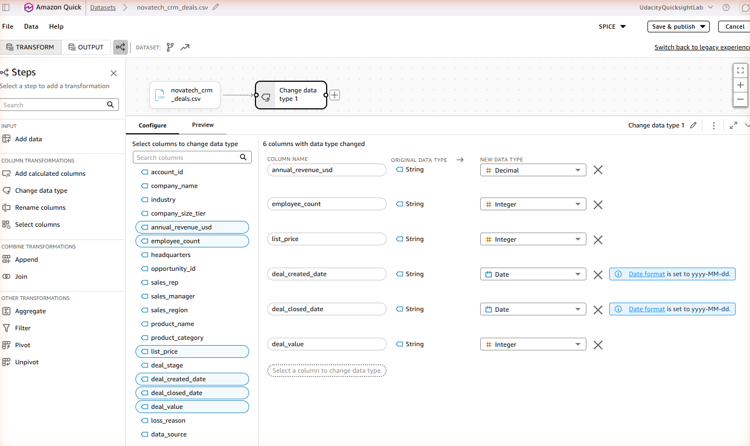
Fig. 10 — After fixing annual_revenue_usd to Decimal (deal_value still shows Integer at this point).
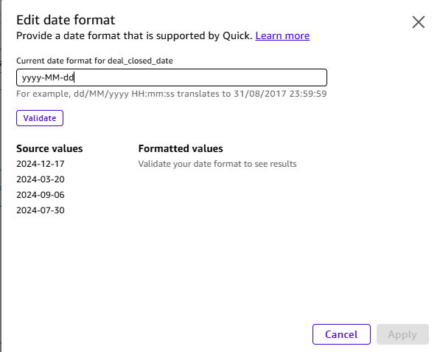
Fig. 11 — Checked the date-format dialog for deal_closed_date, confirmed yyyy-MM-dd was already correct, cancelled without changes.
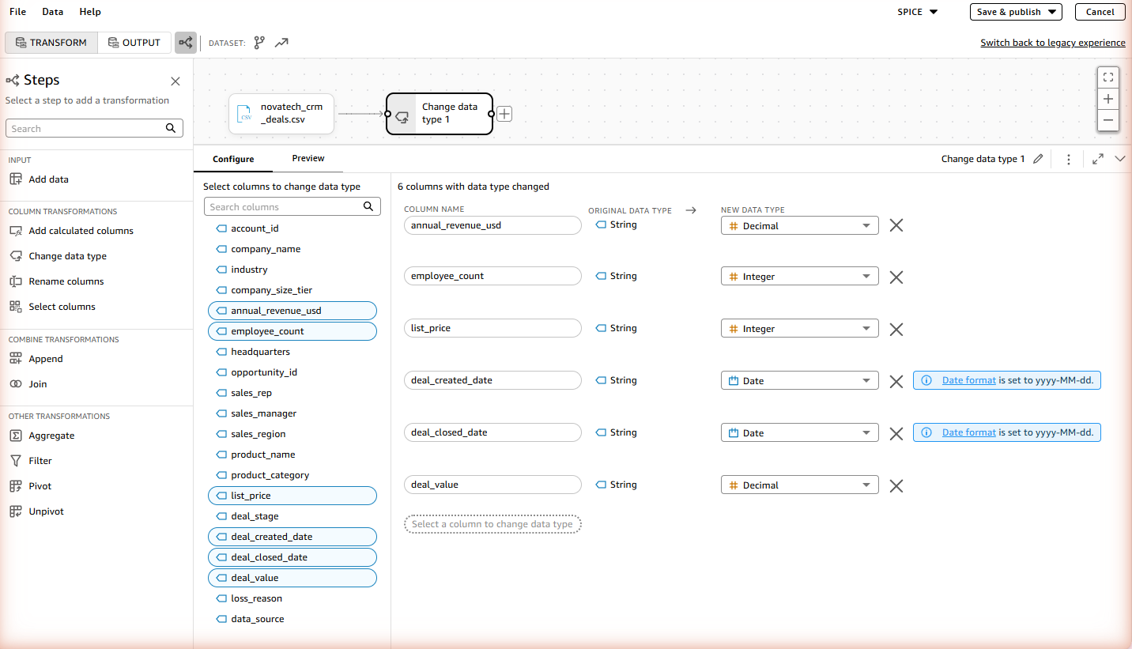
Fig. 12 — Final state: all 6 changed columns correct, including deal_value now as Decimal.
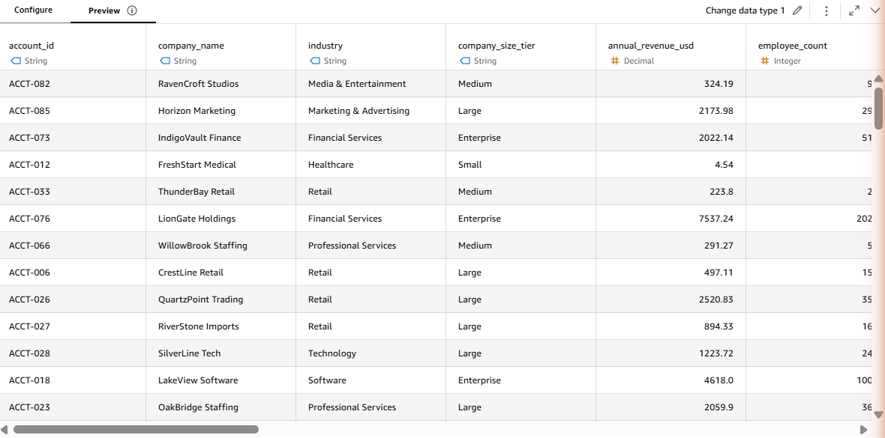
Fig. 13 — Preview tab confirming the corrected data renders sensibly.

Step 5 - Calculated field: days_to_close (CRM)
Why this metric, specifically:
- Sarah Chen's brief (Sales Pipeline view) asks for it: "Days to close - how long does it take us to close a deal from creation to close? Is that getting better or worse?"
- The data dictionary spells out the exact formula in its notes on deal_closed_date: "Students can compute days-to-close as deal_closed_date − deal_created_date."
- The rubric requires ≥2 calculated fields that derive a business metric the raw data doesn't already contain, and names days-to-close as the business metric example.

Steps:
1. Clicked "Add calculated columns" in the left panel.
2. Named the field days_to_close.
3. Formula: dateDiff({deal_created_date}, {deal_closed_date}, "DD")
4. Applied then preview was checked.
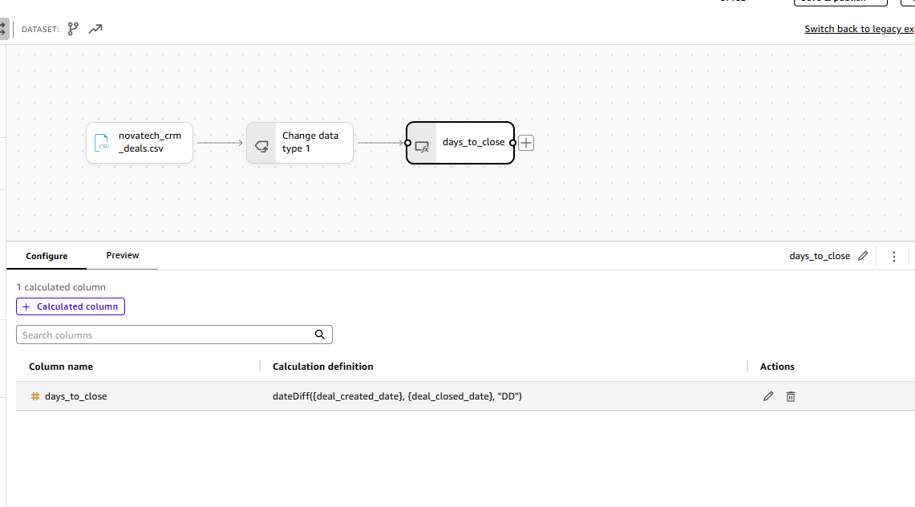
Fig. 14 — days_to_close calculated column configuration: dateDiff({deal_created_date}, {deal_closed_date}, "DD").
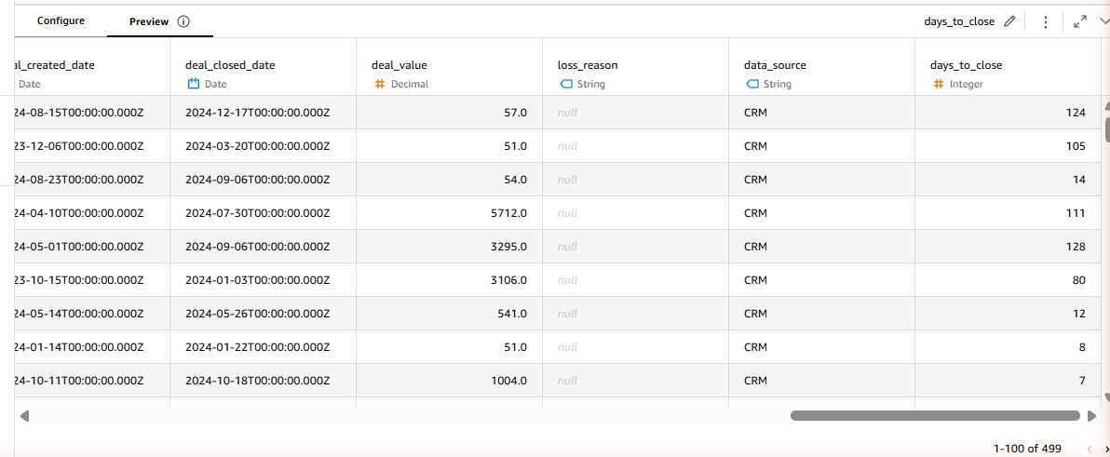
Fig. 15 — Preview showing realistic day counts (124, 105, 14, 111, 128, 80, 12, 8, 7…).

Step 6 - Publish CRM Deals dataset
1. Clicked Save & publish (top right) → Publish & visualize → Create.
2. Confirmation banner: "Saved and published successfully."
3. Navigated to Data → Datasets, opened the newly published novatech_crm_deals.csv (owner: Me).
4. Dataset detail page confirms: 21 columns (the 20 original + days_to_close), and under Refresh: "499 rows imported (100% success)" an exact match with both the data dictionary and Q's answer in Verification Log entry #1. This closes out the Verification Log's Cross-Check section.
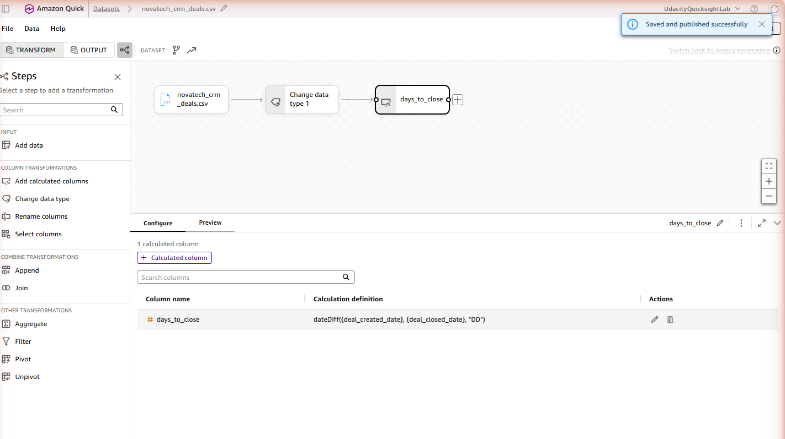
Fig. 16 — "Saved and published successfully" confirmation.
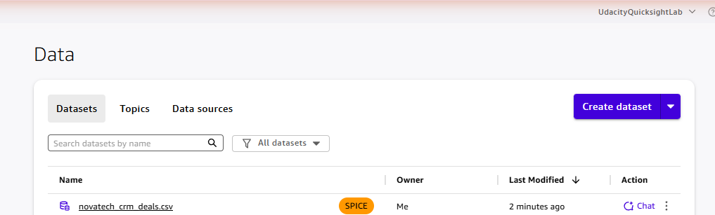
Fig. 17 — Dataset list showing the student's own novatech_crm_deals.csv (owner: Me, SPICE).
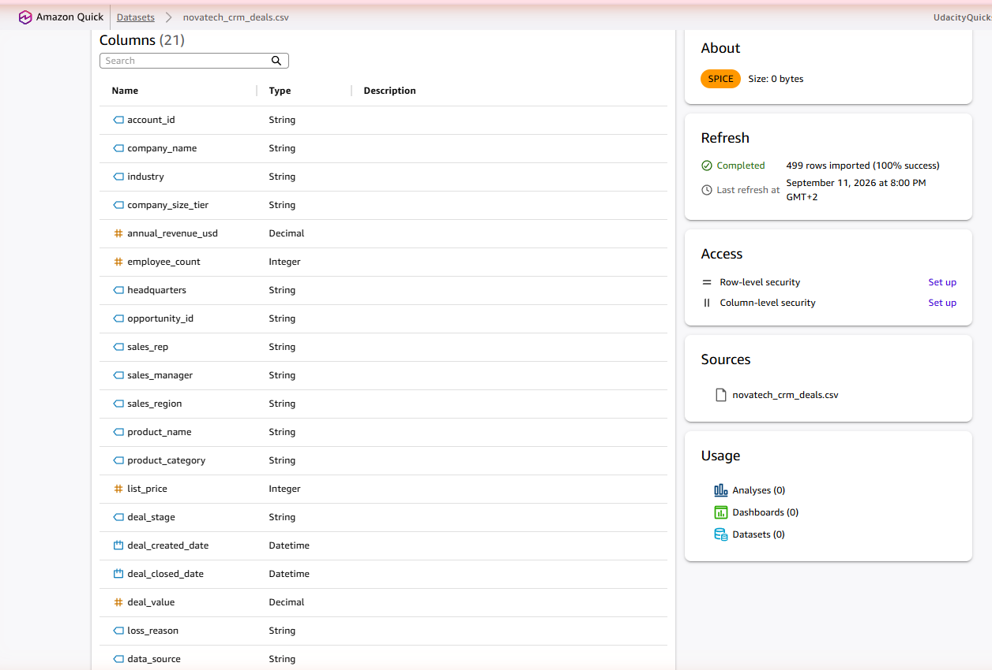
Fig. 18 — Dataset detail page: 21 columns, "499 rows imported (100% success)" — cross-check confirmed against Q's answer.

Step 7 - Upload own Marketing Campaigns dataset + fix data types
1. Went to Data → Create dataset → Upload a file → selected novatech_marketing_campaigns.csv → "Edit settings and prepare data".
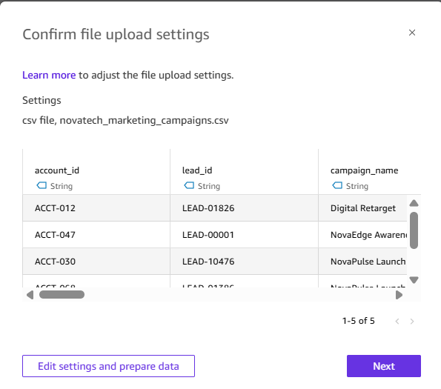
Fig. 19 — File-upload confirmation dialog for novatech_marketing_campaigns.csv, before entering the editor.
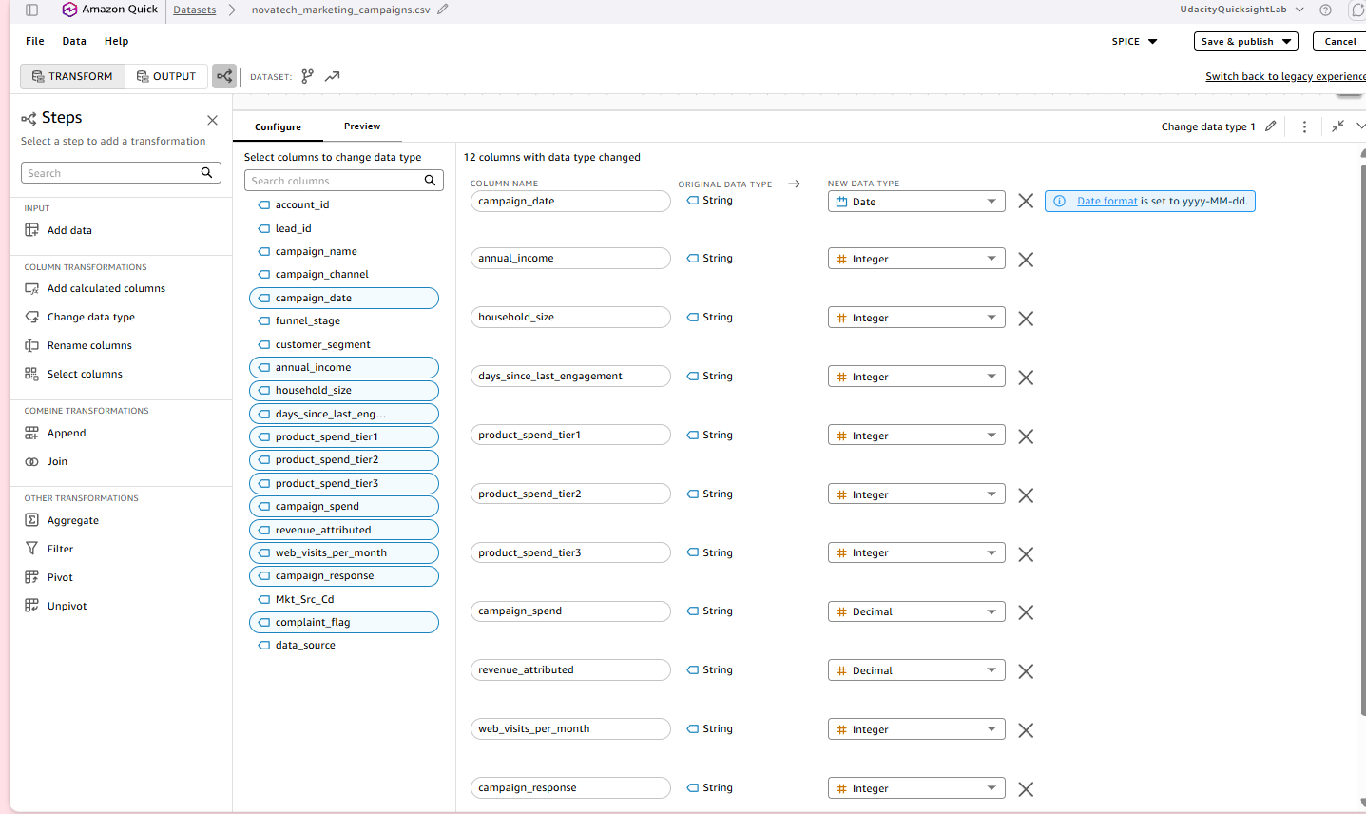
Fig. 20 — Data-prep editor just after entering, with QuickSight's initial auto-suggested type changes across 12 columns.
2. QuickSight auto-suggested type changes for 12 columns. Checked each against the data dictionary:
- campaign_date → Date (yyyy-MM-dd) — already correct
- household_size, days_since_last_engagement, product_spend_tier1/2/3, web_visits_per_month, campaign_response, complaint_flag → Integer — all correct per dictionary
- campaign_spend, revenue_attributed → Decimal — correct per dictionary (Float)
- annual_income → auto-suggested as Integer, corrected to Decimal (dictionary: Float — annual income can carry decimals in general).
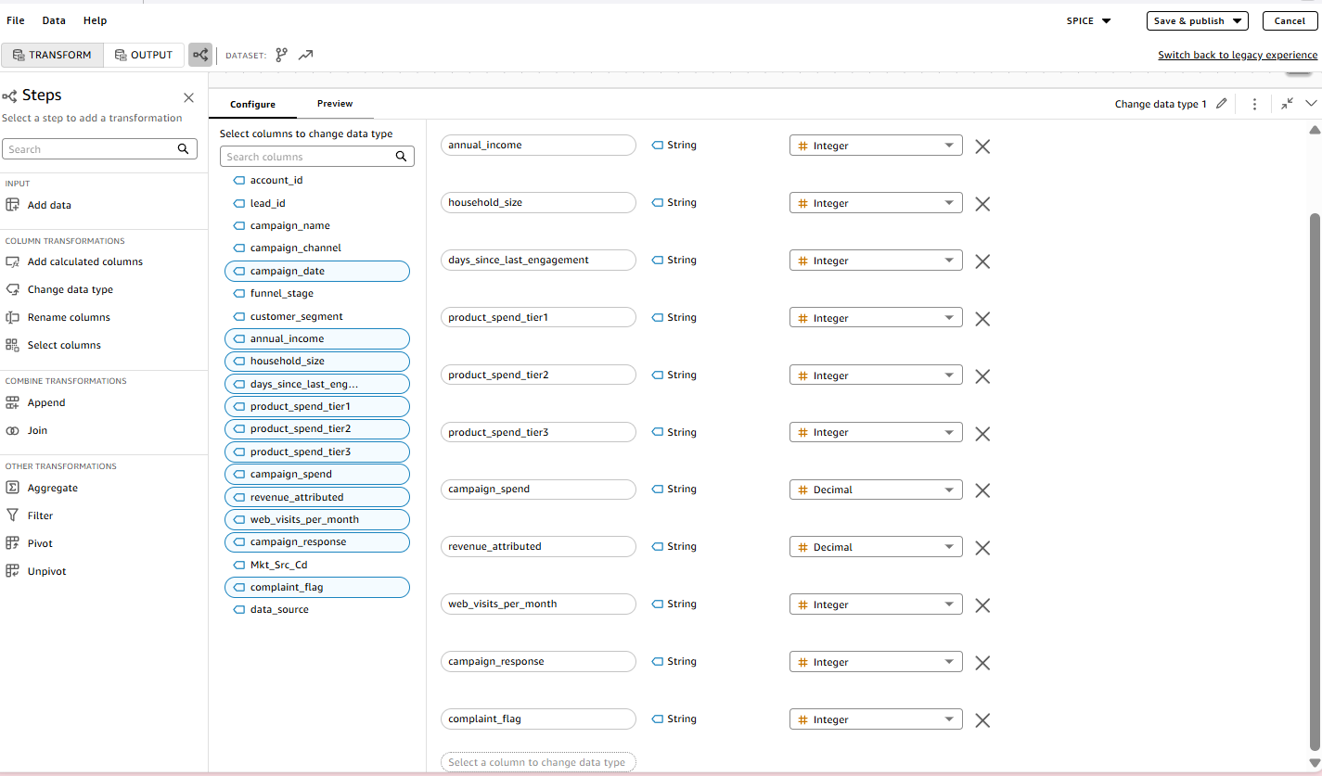
Fig. 21 — Scrolled through the type list, confirming complaint_flag and the other Integer columns were already correct.
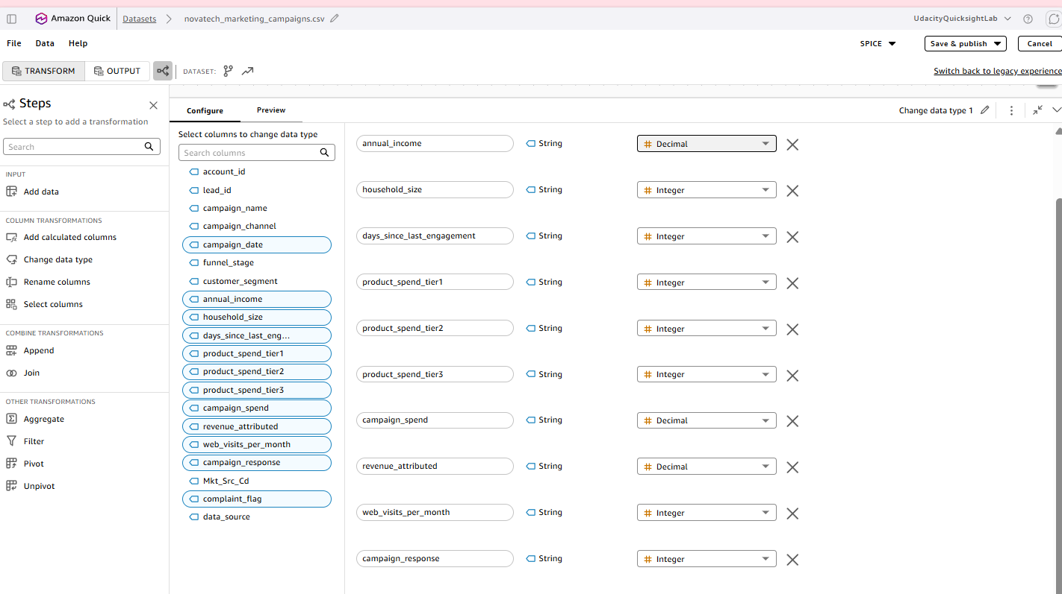
Fig. 22 — Final state: all 12 columns correct, including annual_income → Decimal.

Step 8 - Calculated field: campaign_roi (Marketing)
Why this metric, specifically:
- Sarah Chen's brief (Marketing Funnel view) explicitly asks: " we're spending money on six campaigns right now. Which ones are paying for themselves and which ones aren't?", a direct ask for a per-campaign ROI figure.
- The data dictionary lists campaign_spend and revenue_attributed as the two raw fields a return-on-spend metric should be derived from, ROI is not itself a raw column, it only exists once these two are combined.
- The rubric requires ≥2 calculated fields across the project that derive a business metric the raw data doesn't already contain; campaign_roi is the Marketing-side counterpart to CRM's days_to_close (Step 5).
Standard ROI formula used: (revenue − spend) / spend, i.e. net return as a fraction of what was spent. A value of 0 means break-even, 1.0 means the campaign returned double its spend, and a negative value means the campaign lost money (spent more than it earned back).
1. In the Marketing dataset's data-prep editor, clicked "Add calculated columns" in the left panel.
2. Named the field campaign_roi.
3. Formula: (revenue_attributed - campaign_spend) / campaign_spend
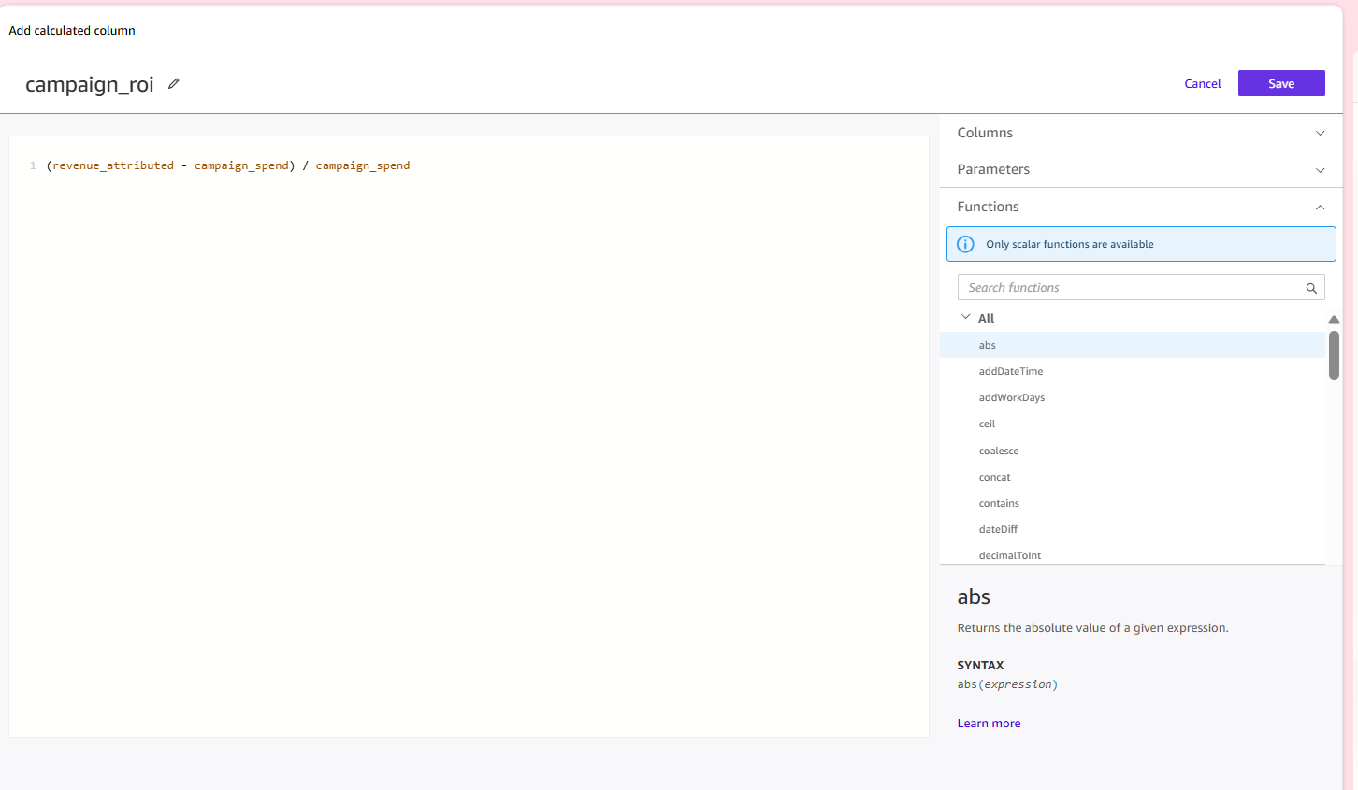
Fig. 23 — campaign_roi calculated column configuration: (revenue_attributed - campaign_spend) / campaign_spend.
4. Before clicking Save, verified it was correct that most rows would come out negative (ROI ≈ −1.0 for the majority). This is expected, not a bug. The rows with campaign_response = 1 show less-negative values (e.g. −0.422, −0.700, −0.934), driven by how much revenue that responder generated relative to their allocated spend. Even so, the metric was flagged for further review to confirm the calculation and data correctness.
5. Clicked Save in the calculated-column editor, confirmed campaign_roi appeared as the dataset's 1 calculated column, then checked Preview before publishing.
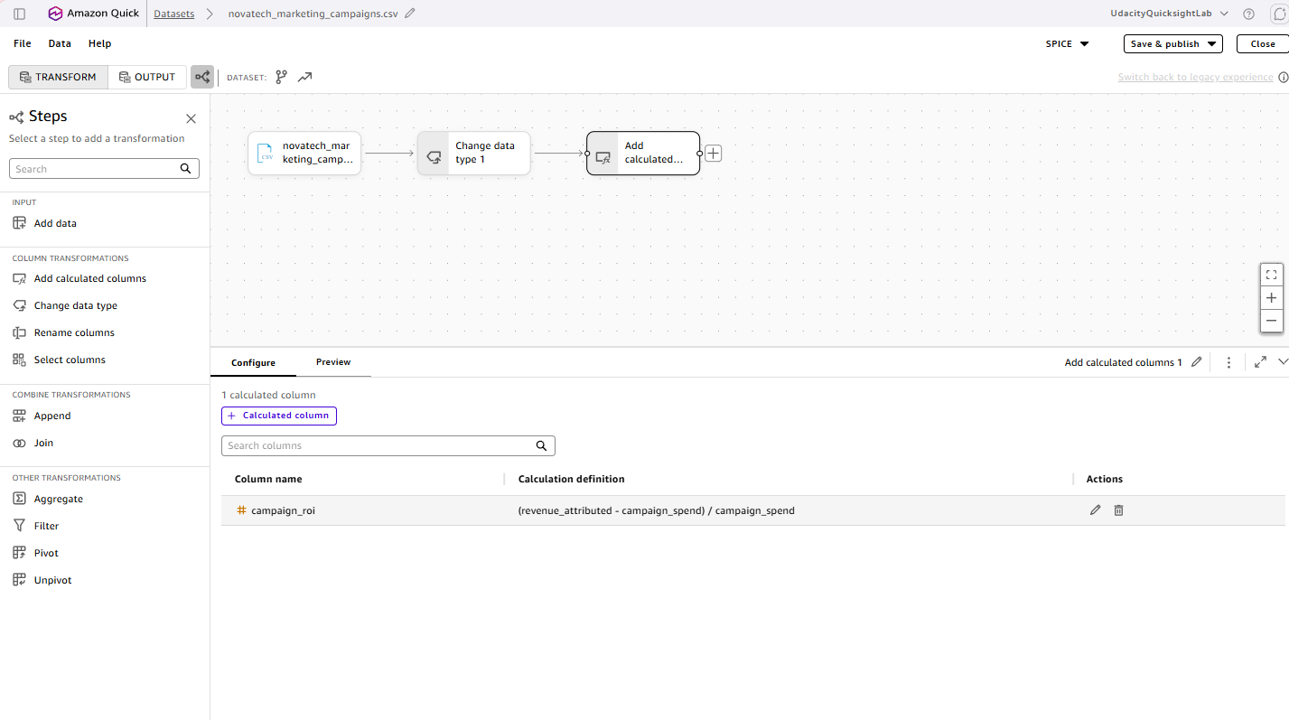
Fig. 24 — Steps canvas / Configure tab after Save, showing campaign_roi listed as the dataset's 1 calculated column.
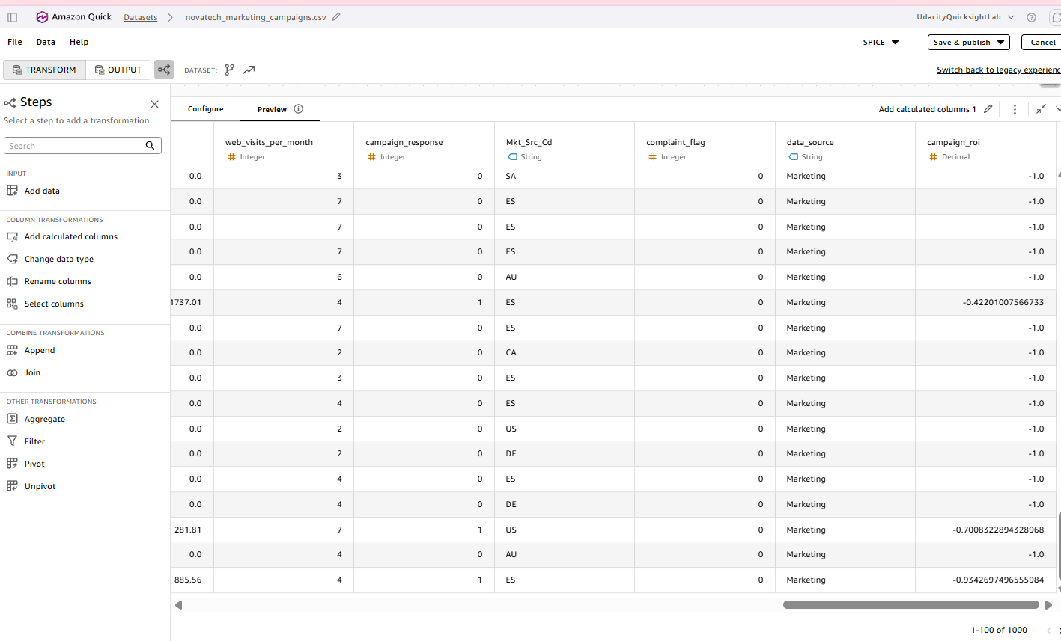
Fig. 25 — Preview tab: campaign_roi mostly -1.0 (non-responders), with less-negative values like -0.422, -0.700, -0.934 for actual responders — matching the expectation reasoned through above.

Step 8b - Investigating the negative campaign_roi average
What was checked:
- The formula itself was re-verified in the data-prep editor: campaign_roi = (revenue_attributed - campaign_spend) / campaign_spend, matching Step 8 exactly. Spot-checking individual rows confirmed the arithmetic is correct in every case (e.g. a non-responder with revenue_attributed = 0 and campaign_spend > 0 correctly returns exactly -1.0).
- The root cause of the negative average was traced to the data itself, not the formula: 72.8% of leads (1,631 of 2,240) have campaign_response = 0 and therefore revenue_attributed = 0, which produces a -1.0 (-100%) ROI for every one of those rows by definition. Only the 27.2% of leads that actually converted show a less-negative or positive per-lead ROI. This is expected behavior for lead-level marketing data, not a data quality issue.
- As an additional check, the preview was filtered to show only rows with campaign_roi > 0. Every visible row had campaign_response = 1, meaning the lead responded to the campaign. In the sample, ROI ranged from about +0.3% to +152% (for example, 1.4413, 0.7768, 0.4675, 0.3101, 1.4540, and 1.5153). 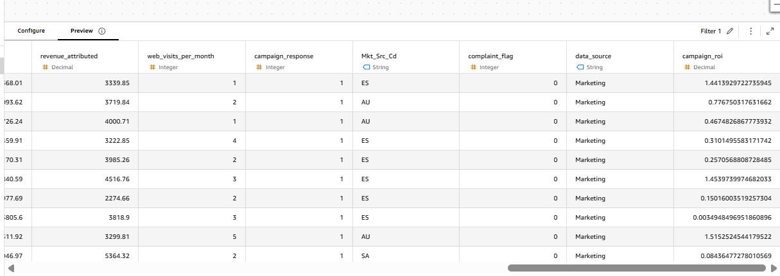
Fig. 25a — Preview filtered to campaign_roi > 0: every visible row has campaign_response = 1, with ROI values ranging from about +0.3% to +152%.

Step 9 - Publish Marketing Campaigns dataset + verify row count
1. Clicked Save & publish (top right) on the Marketing dataset editor.
2. Confirmation banner: "Saved and published successfully."
3. Navigated to Data → Datasets, opened the newly published novatech_marketing_campaigns.csv (owner: Me).
4. Dataset detail page confirms: 21 columns (the 20 original + campaign_roi), and under Refresh: "2240 rows imported (100% success)" — an exact match with both the data dictionary's expected row count and Q's answer in Verification Log entry #3 (2,240 rows). Same row-count cross-check pattern used for CRM in Step 6, applied here to Marketing.
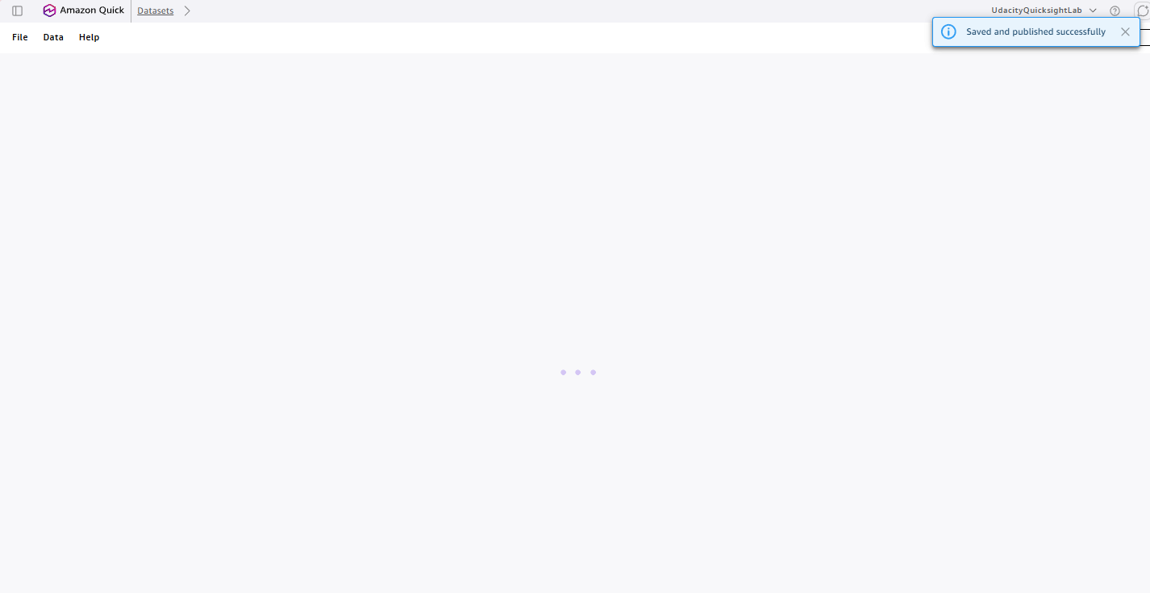
Fig. 26 — "Saved and published successfully" confirmation.
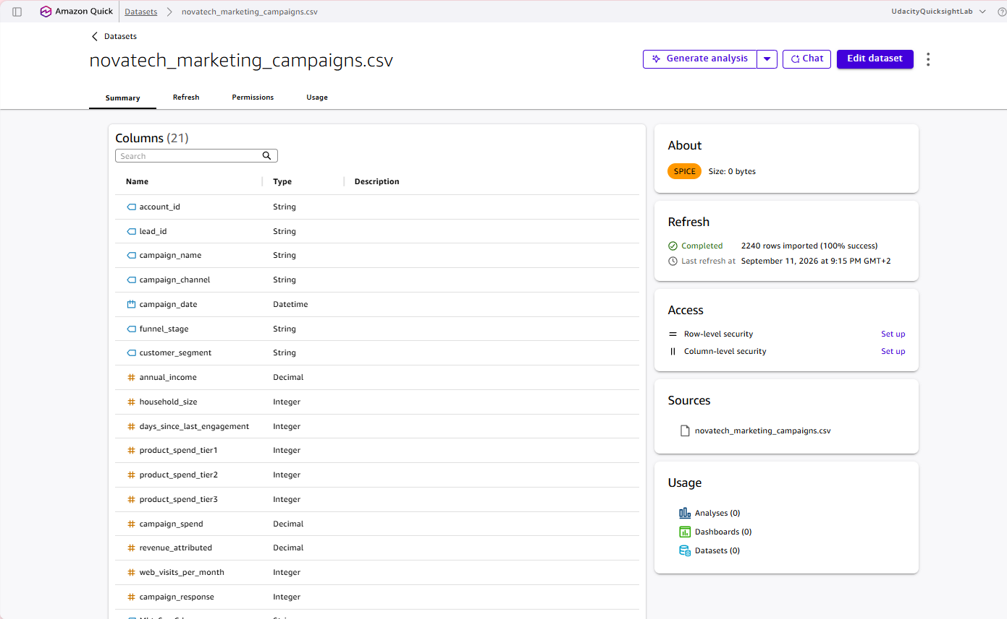
Fig. 27 — Dataset detail page: Columns (21) incl. campaign_roi, Refresh panel showing "2240 rows imported (100% success)".

Step 10 - Upload own Support Tickets dataset + check data types
1. Went to Data → Create dataset → Upload a file → selected novatech_support_tickets.csv → "Edit settings and prepare data".
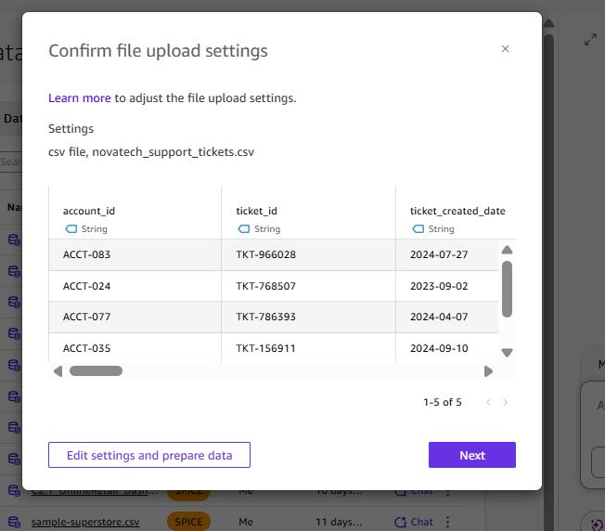
Fig. 28 — File-upload confirmation dialog for novatech_support_tickets.csv, before entering the editor.
2. QuickSight auto-suggested type changes for 9 columns. Checked every one against the data dictionary — unlike CRM (deal_value) and Marketing (annual_income), no corrections were needed this time; all 9 auto-suggested types already matched the dictionary exactly.
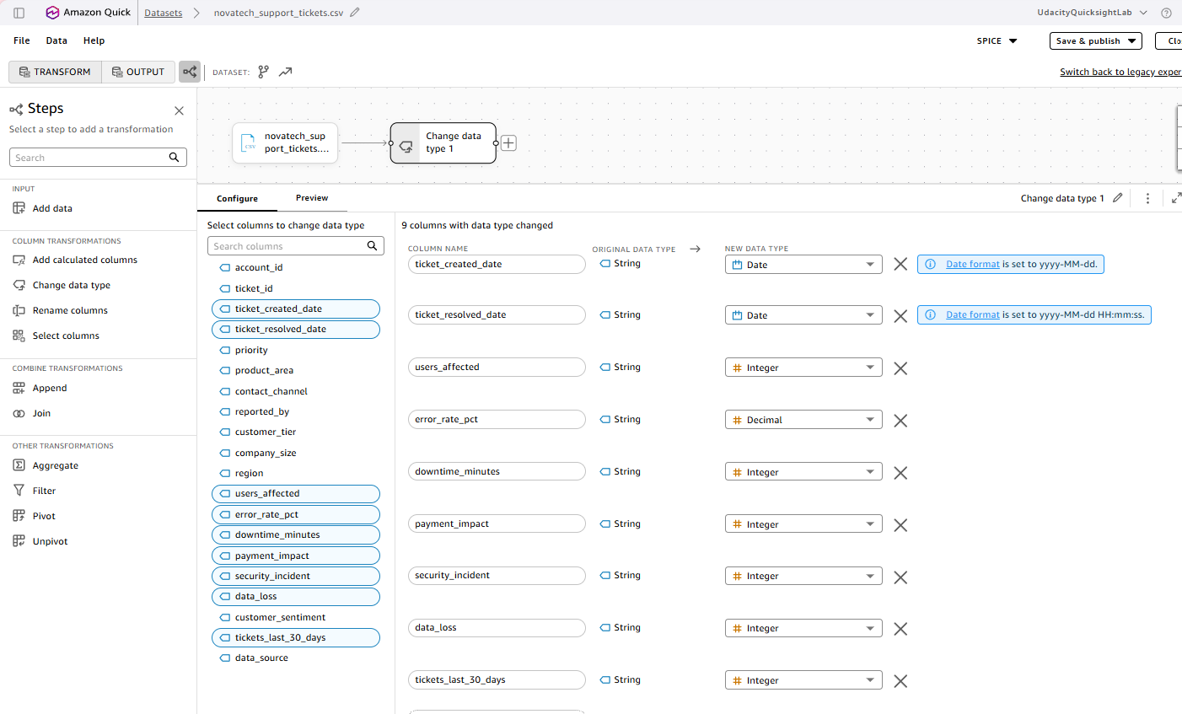
Fig. 29 — Data-prep editor with the 9 auto-suggested type changes (first 8 visible: ticket_created_date, ticket_resolved_date → Date; users_affected, downtime_minutes, payment_impact, security_incident, data_loss → Integer; error_rate_pct → Decimal).
- ticket_created_date → Date (yyyy-MM-dd) — correct
- ticket_resolved_date → Date (yyyy-MM-dd HH:mm:ss) — correct; the dictionary calls this field "DateTime," but QuickSight represents it as the same Date type with a datetime-including format string, exactly like the CRM date fields.
- users_affected, downtime_minutes, payment_impact, security_incident, data_loss, tickets_last_30_days → Integer — all correct per dictionary (confirmed tickets_last_30_days by scrolling to the bottom of the list, since it didn't fit in the first screenshot).
- error_rate_pct → Decimal — correct (dictionary: Float).
- All other columns left as String — correct per data dictionary.

Step 11 - Calculated field: resolution_time_hours (Support)
Why this metric, specifically:
- The data dictionary spells out the exact formula in its notes on ticket_resolved_date: "Students can compute resolution time as ticket_resolved_date − ticket_created_date."
- Sarah Chen's brief (Customer Health view) asks for a "Resolution Time by Priority" visual, this calculated field is what makes that visual possible.
- The rubric requires ≥2 calculated fields deriving a business metric the raw data doesn't already contain; resolution_time_hours is the Support-side counterpart to CRM's days_to_close (Step 5) and Marketing's campaign_roi (Step 8) — one derived business metric per dataset.
None of the raw columns is "resolution time" — it only exists once ticket_created_date is subtracted from ticket_resolved_date.
1. Clicked "Add calculated columns" in the left panel.
2. Named the field resolution_time_hours.
3. Formula: dateDiff({ticket_created_date}, {ticket_resolved_date}, "HH") — hours between ticket open and resolution. For the 59 rows where ticket_resolved_date is blank (still unresolved), the result comes out blank/null automatically — correct behavior, not an error.
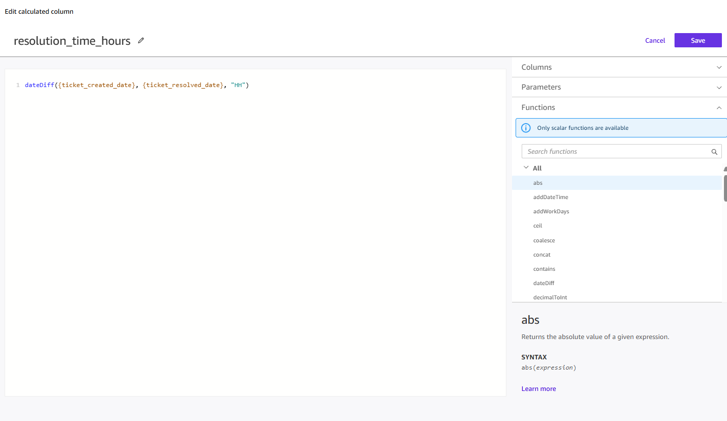
Fig. 30 — resolution_time_hours calculated column configuration: dateDiff({ticket_created_date}, {ticket_resolved_date}, "HH").
4. Clicked Save, then checked the Preview tab: resulting values ranged from single digits to low hundreds of hours (e.g. 7, 13, 14, 35, 58, 64, 81, 93, 103, 113, 115, 123, 124 in the sampled rows) — consistent with the pandas-computed average of ~56–60 hours across all priority levels calculated ahead of time.
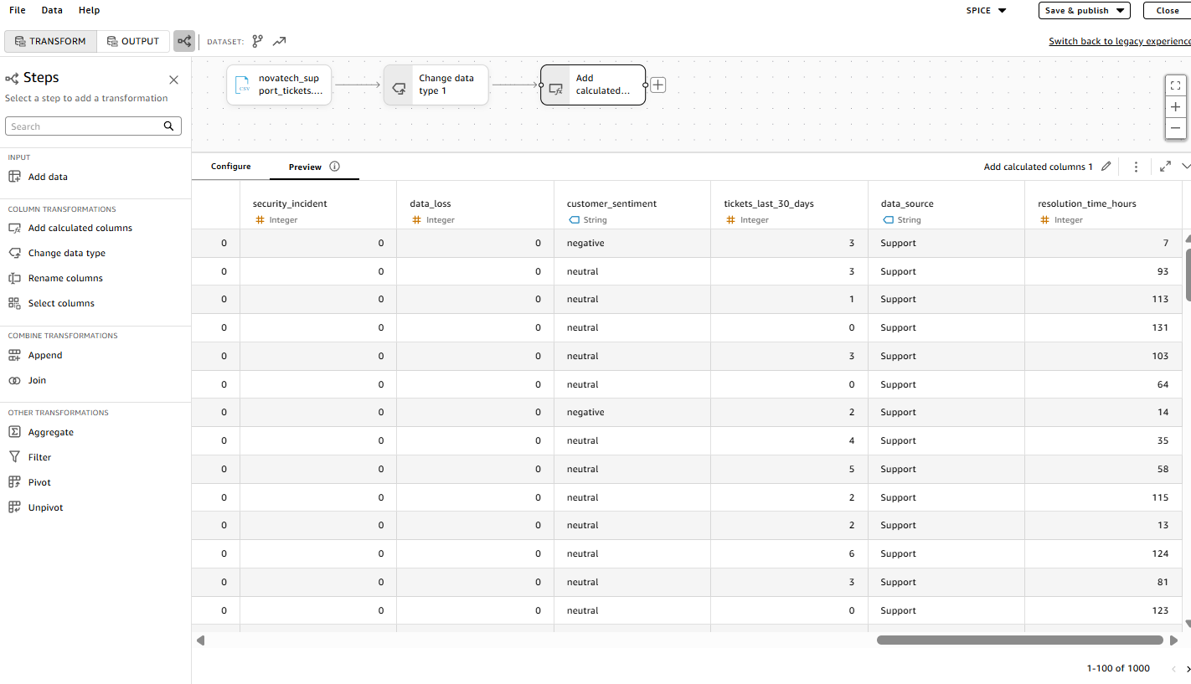
Fig. 31 — Preview tab showing the new resolution_time_hours Integer column with realistic hour values.

Step 12 - Publish Support Tickets dataset + verify row count
1. Clicked Save & publish (top right) on the Support Tickets dataset editor.
2. Confirmation banner: "Saved and published successfully."
3. Navigated to Data → Datasets, opened the newly published novatech_support_tickets.csv (owner: Me).
4. Dataset detail page confirms: 21 columns (the 20 original + resolution_time_hours), and under Refresh: "3000 rows imported (100% success)" — an exact match with both the data dictionary's expected row count and Q's answer in Verification Log entry #5 (3,000 total tickets). Same row-count cross-check pattern used for CRM (Step 6) and Marketing (Step 9), now applied to all three source datasets.
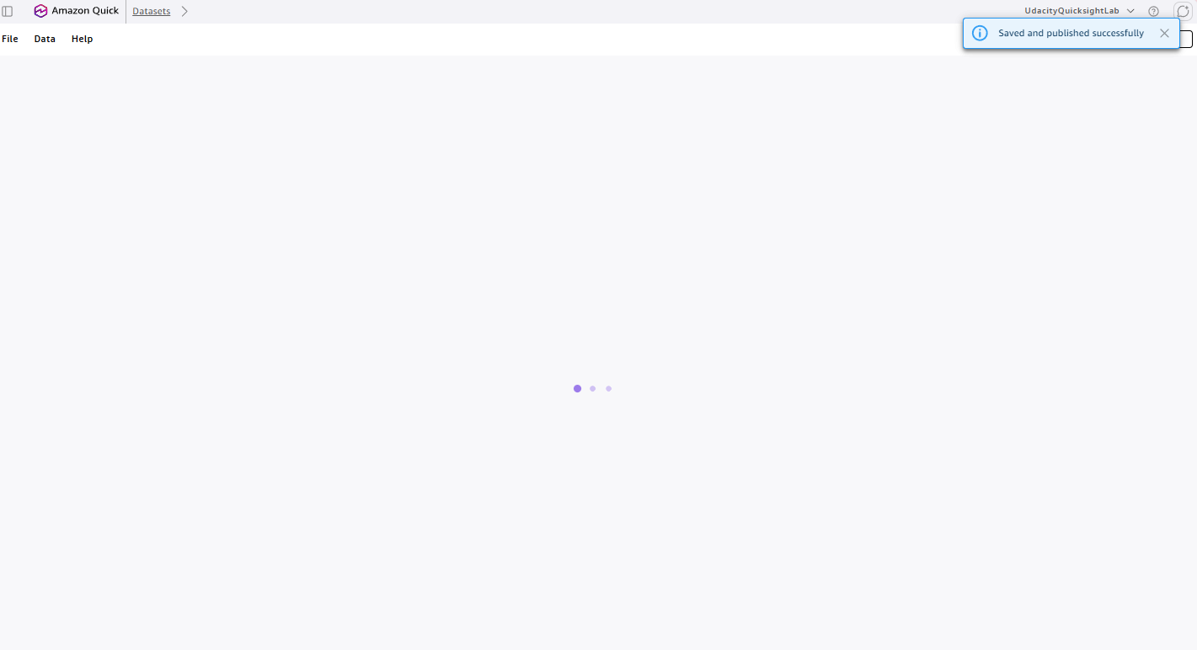
Fig. 32 — "Saved and published successfully" confirmation.
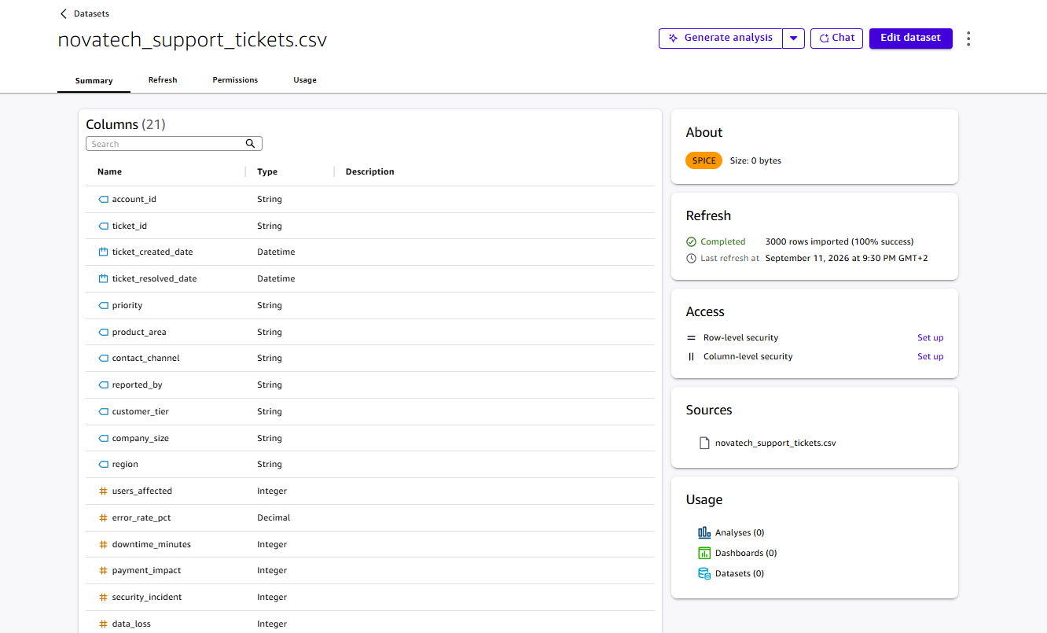
Fig. 33 — Dataset detail page: Columns (21), Refresh panel showing "3000 rows imported (100% success)".
All three source datasets are now uploaded, type-corrected, enriched with one derived calculated field each, and published to SPICE: CRM Deals (499 rows, days_to_close), Marketing Campaigns (2,240 rows, campaign_roi), Support Tickets (3,000 rows, resolution_time_hours).

Step 13 - Build the unified dataset: Join CRM + Marketing (Join 1)
Join Strategy:
- Anchor: CRM Deals. Every dollar Sarah's team tracks starts at a deal, so a left join guarantees no deal silently disappears even if an account has no marketing touch or no support ticket on file.
- CRM LEFT JOIN Marketing on account_id → simulated ~13,738 rows.
- Result LEFT JOIN Support on account_id → simulated ~63,420 rows.
- Why use a LEFT JOIN instead of an INNER JOIN? An INNER JOIN would remove deals from accounts that have no matching Marketing or Support records. Because these missing matches are expected and are not data errors, using an INNER JOIN would make the unified dataset show fewer CRM deals than it should.
- Why the row count increases: This is expected because one CRM record can match multiple Marketing and Support records. The rubric also expects the unified dataset to contain more rows than any individual source. To prevent KPIs from being overstated, later visuals use COUNT DISTINCT on the relevant ID field instead of COUNT(*).
1. Went to Data → Datasets (the list, not "Create dataset").
2. Found own novatech_crm_deals.csv, clicked its ⋮ menu.
3. Chose "Use in a new dataset" — not "Edit". "Edit" would open and modify the original CRM dataset in place; "Use in a new dataset" uses it as a starting point for a brand-new dataset, leaving the original CRM dataset untouched.
4. Renamed the new dataset to NovaTech Unified Account Dataset.
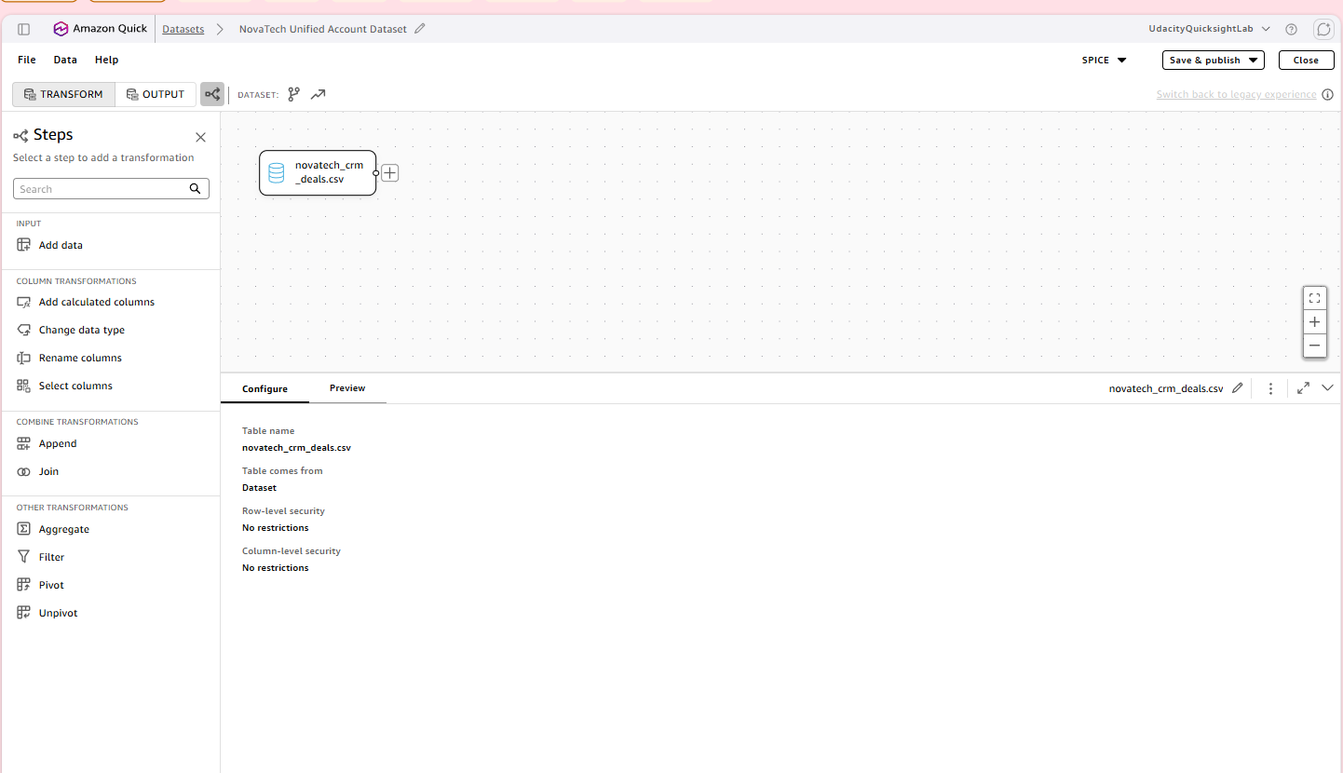
Fig. 34 — ⋮ context menu on the CRM dataset row, "Use in a new dataset" option.
5. Clicked "Add data" in the left panel → Dataset tab → selected novatech_marketing_campaigns.csv → Select.
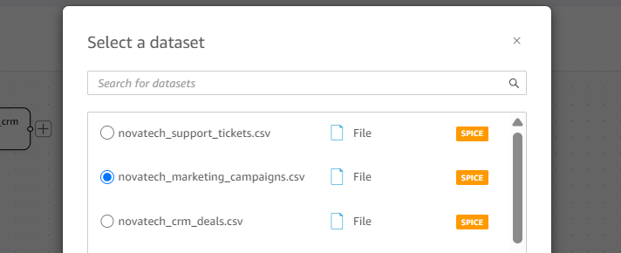
Fig. 35 — Select a dataset dialog, Marketing selected — ignoring the leftover "Joined Data" artifacts from someone else's earlier pass through this shared lab.
6. Clicked "Join" in the left panel.
7. Configured: Left table = novatech_crm_deals.csv, Right table = novatech_marketing_campaigns.csv, Join type: Left join, Join keys: account_id = account_id.
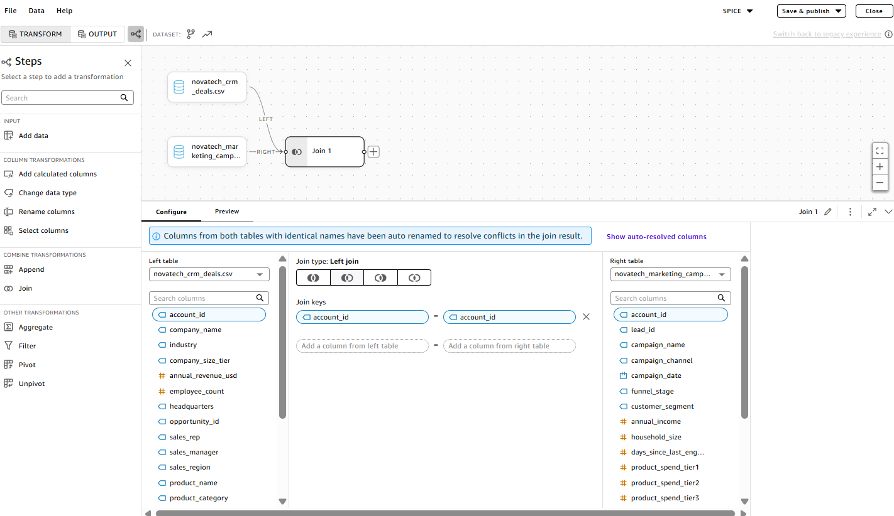
Fig. 36 — Join 1 configuration, correct as described.
8. Checked the Preview: confirmed the expected fan-out (e.g. account ACCT-082 appearing 5 times in a row, once per matching marketing touchpoint) and the expected nulls (a CRM row with no Marketing match shows blank Marketing-side columns) — both are correct LEFT JOIN behavior, not errors.
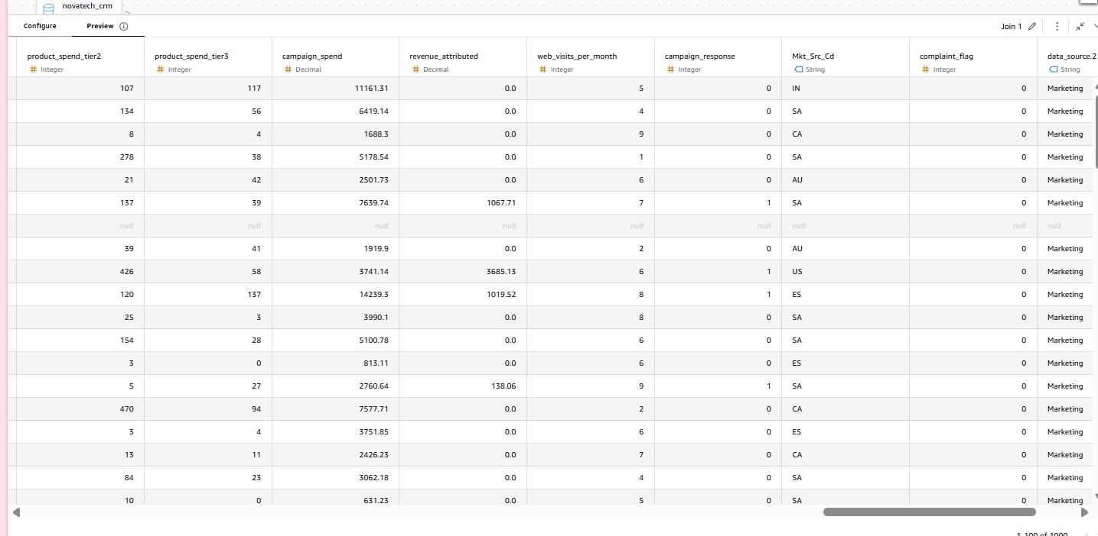
Fig. 37 — Preview tab showing the fan-out and a null-filled row for an unmatched account.
9. Opened "Show auto-resolved columns": since both tables have an account_id column, QuickSight automatically renamed the CRM (left table) one to account_id.1 and the Marketing (right table) one to account_id.2. This matters for the next join — Support Tickets must be matched against account_id.1 (the CRM-originated column, always populated) and not account_id.2 (the Marketing-originated column, null wherever Join 1 had no match).
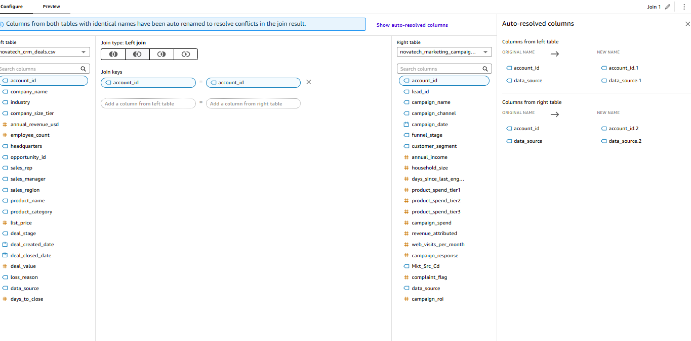
Fig. 38 — Auto-resolved columns panel showing the account_id → account_id.1 / account_id.2 rename.
Caution: the browser tab was accidentally closed before publishing at this point, and the whole in-progress join configuration was lost — QuickSight's data-prep editor does not autosave a draft. Steps 1–9 above had to be redone from scratch. Lesson: stay in the editor tab until Save & publish has been clicked.

Step 14 - Join Support Tickets (Join 2) + publish + verify row count
1. Clicked "Add data" again → Dataset → selected novatech_support_tickets.csv → Select.
2. Clicked "Join" again to create Join 2.

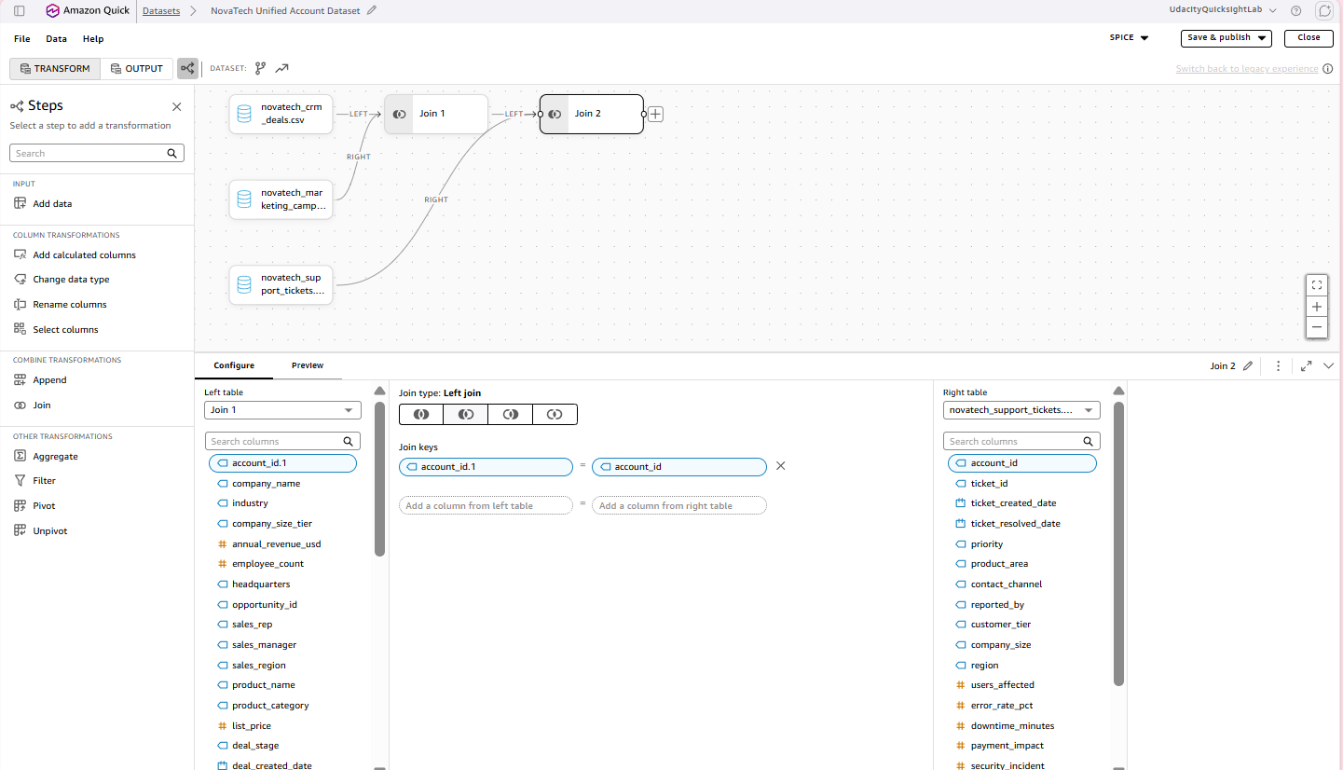
Fig. 39 — Join 2 correctly configured: Left table = Join 1, Right table = Support Tickets, keys account_id.1 = account_id.
4. Checked the Preview one more time, then clicked Save & publish.
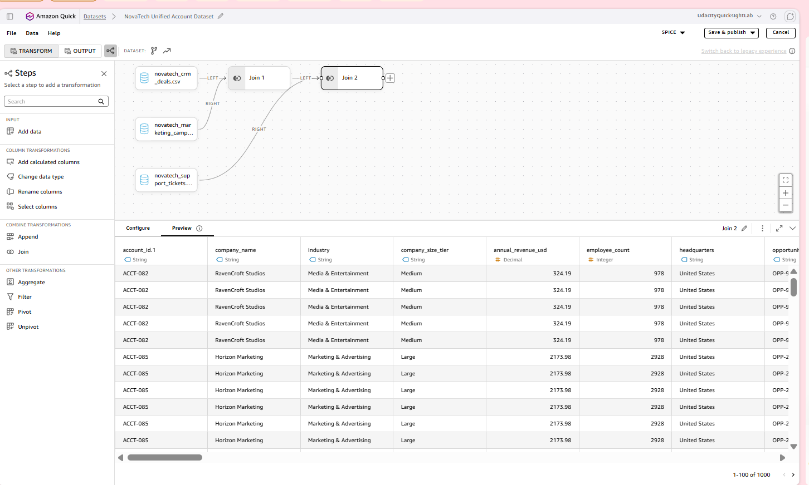
Fig. 40 — Preview of the fully 3-way-joined result, Save & publish visible top-right.
5. Went to Data → Datasets and opened NovaTech Unified Account Dataset. The dataset details showed 63 columns, including all fields from CRM, Marketing, and Support and the three calculated fields. The Refresh section showed “63,420 rows imported (100% success).
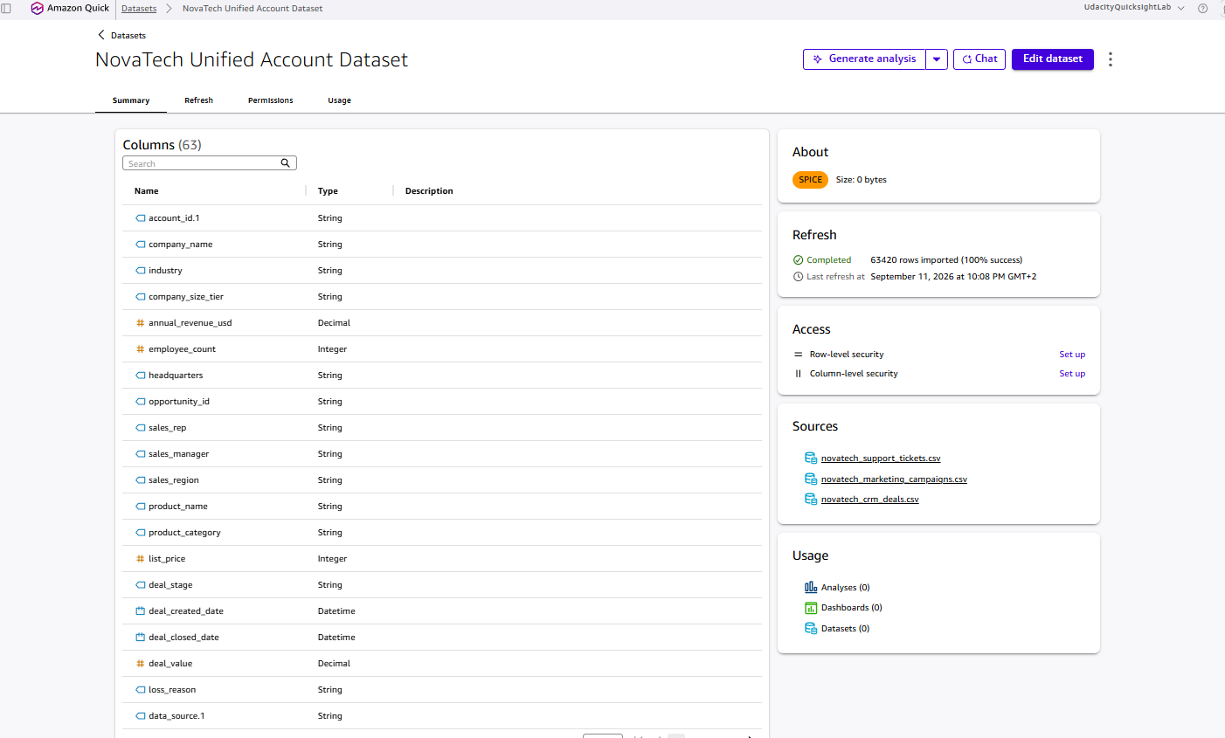
Fig. 41 — Dataset detail page: Columns (63), Refresh panel showing "63420 rows imported (100% success)", Sources listing all three CSVs.

Appendix - Verification Log (full table)
6 entries covering all three knowledge bases. Result: 6/6, all Matches.

Verification Log (full table)
# | Knowledge Base | Question Asked | Expected Answer | Q's Actual Answer | Match? | Notes
1 | NovaTech CRM Deals | How many total deals are in the CRM dataset, and how many are Won vs Lost? | 499 total deals  315 Won, 184 Lost | Total Deals: 499. Won: 315 (63.1%). Lost: 184 (36.9%). | Yes | Exact match, incl. win rate.
2 | NovaTech CRM Deals | What date range does the CRM deals data cover, and how many unique accounts are there? | Deal Created: Jun 17 2023 → Deal Closed: Jan 25 2025; 85 unique accounts | Deal Created: Jun 17 2023 → Deal Closed: Jan 25 2025; 85 unique accounts | Yes | Exact match. Deal Created range and 85 unique accounts confirmed against the data dictionary; Deal Closed range isn't listed there, so it was verified directly against the CSV
3 | NovaTech Marketing Campaigns | How many rows are in the marketing campaigns data, and what is the overall campaign response rate? | 2,240 rows; 27.2% response rate (609/2,240) | Total Rows: 2,240. Responses: 609. Rate: 27.19%. | Yes | Exact match.
4 | NovaTech Marketing Campaigns | How many rows in the marketing campaigns data have a missing or null annual_income value? | 24 rows (1.1%) | 24 rows, 1.07% of 2,240 | Yes | Match.
5 | NovaTech Support Tickets | How many total support tickets are there, and what is the breakdown by priority level? | 3,000 total — low 1,500, medium 1,050, high 400, critical 50 | 3,000 total. Low 1,500 (50%), Medium 1,050 (35%), High 400 (13.3%), Critical 50 (1.7%) | Yes | Exact match, table shown.
6 | NovaTech Support Tickets | How many support tickets have a null or missing ticket_resolved_date (still unresolved)? | 59 rows (2.0%) | 59 tickets, ~2% of 3,000 | Yes | Exact match.

